  **Update to Information form that pops up upon first opening the app – additional fields for nominated contact**

⬇   Would you like someone to contact you if you have an accident?

⬇   Yes/No checkbox

⬇   Yes checkbox has a dropdown for Country, a dropdown for State, dropdown for City, and a Contact form. Initially, Australia will be the only country to choose from. The Contact form will have the following fields.

-          Contact type *dropdown*

▪  Accident Repair Centre

▪  Vehicle Fleet Manager

▪  Personal Contact (e.g. family)

-          Name *text field*

-          Business Name (if applicable) *text field*

-          Contact phone number *text field*

-          Email address *text field*

⬇   Information from these fields to populate into “My Profile”, new section called “Nominated Contact”

⬇   Mockup form

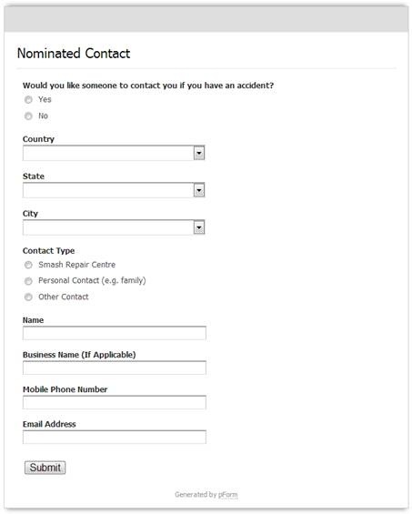

  **Arrange Replacement Car button**

⬇   Change the text in this button to “Send G.A.P. Notification”.

  **“ACCIDENT REPLACEMENT VEHICLES” text underneath “CMT” text**

⬇   Change this text to “GLOBAL ACCIDENT POSITIONING”

  Mockup

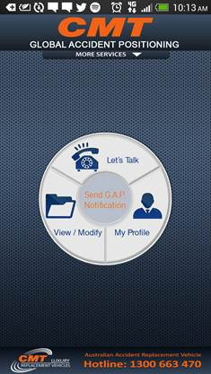

  **Arrange Replacement Car/Send G.A.P. Notification page**

⬇   After pressing the middle button to enter this page, add a new button to the centre of the page, the same size as the button on the home page. Text underneath the button should read “Send Global Accident Positioning Notification”

⬇   Incorporate a globe design into the button behind the text – this is a very bad mockup could we design a ‘logo’, possibly in the CommBank colour scheme?

⬇   Fix the ‘forgout’ typo

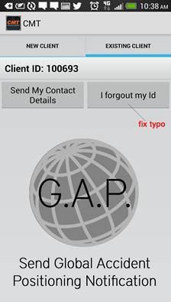

⬇   After pressing the button, the information will come through onto our data, CMT email, and their nominated contact

⬇   Email Subject: *Name* has been in a car accident

⬇   Email body:

*Name*has been in a car accident. You’ve been chosen as their nominated contact in the event of a car crash.

Their current location is _________, and they can be contacted on *Phone Number.*

If you have any questions, please contact CMT on 1300 887 712.

  **Accident Detection Feature**

⬇   Development of accident recognition feature, using combination of gyrometer, accelerometer, and location to determine if car has been in a crash.

⬇   Development of notification to pop up before sending crash information to nominated contact. Pop-up should make a message alert and vibrate and have the following textbox:

⬇   “We’ve detected that you’ve been in a car accident. Would you like a notification sent to your nominated contact?”

⬇   Two buttons: “Yes” “No”

⬇   Yes sends email, No takes no action.

  **My Profile Section**

⬇   Additional field added “Nominated Contact”

⬇   Ability to edit fields

⬇   Information from the Nominated Contact form to populate

⬇   Country

⬇   State

⬇   Contact type

⬇   Name

⬇   Business name (If Applicable)

⬇   Phone number

  **“Always on” feature**

⬇   Development and testing of feature to ensure the app is always active in the background.

This is a rough outline of what needs to be done, things can be discussed in more detail tonight or on the phone.

* What happens when contact details are filled but not yet sent?
* Would you like to populate Nominated Contact? Brings up empty fields even is values

Have previously been entered