
SOFTWARE RELEASE NOTE
& TEST EVIDENCE REPORT
Rapid Tech Insights — Application Fixes, Validation and Release Readiness
Rapid Inventory (supermarket inventory and order-management system)

Document control
Document title | Software Release Note & Test Evidence Report
Document ID | RTI-SRN-RINV-2026-001 [proposed — to be confirmed]
Document version | 1.0
Preparation date | 29 October 2026
Prepared by | alexkemboi (Git author of the release commits), with AI assistance (Claude Code) — [full name to be confirmed]
Reviewed by | [To be confirmed]
Approved by | [Pending — not approved]
Application / project | Rapid Inventory — repository github.com/alexkemboi/Supermarket-Inventory-System
Application version | 1.1.0 [proposed — the repository defines no version]
Release number | 1.1.0.291020260602 [proposed; template format Major.minor.patch.ddmmyyyyhhmn, from release commit 4555d20]
Environment | Development / test — local Docker Compose stack only. No staging or production deployment performed.
Release status | Release candidate — pending QA review and approval
Document classification | Internal — Confidential [proposed, to be confirmed]
Table of Contents
1. Document Version Control 3
2. Product Release Note 4
2.1 General Release Information 4
2.2 Purpose of Release 4
2.3 Release Overview 5
2.4 Modules and Functions Affected 5
2.5 Requirement 6
2.6 Fix Release Details 7
3. Root Cause and Fix Summary 8
3.1 INV-001 — Inventory Overselling 8
3.2 INV-002 — Slow Inventory Listing 9
3.3 INV-003 — SignalR Stock Synchronisation 9
3.4 INV-004 — Order Placement Refactoring 10
3.5 INV-005 — Low-Stock Alerts 10
4. Test Execution Summary 12
4.1 Test Summary Table 12
4.2 Test Result Classification 15
5. Screenshots and Test Evidence 16
5.1 Evidence A — Application Startup 16
5.2 Evidence B — Inventory Concurrency (INV-001) 18
5.3 Evidence C — Inventory Performance (INV-002) 22
5.4 Evidence D — SignalR Synchronisation (INV-003) 25
5.5 Evidence E — Order Placement Refactoring (INV-004) 32
5.6 Evidence F — Low-Stock Notifications (INV-005) 34
5.7 Evidence G — Final Validation 41
5.8 Evidence Traceability Matrix 43
6. Installation Guide and Environment Setup 44
6.1 Prerequisites 44
6.2 Configuration and Environment Variables 44
6.3 Installation Steps 44
6.4 Post-deployment Verification (Test Instruction) 45
7. Release Prerequisites 46
8. Rollback Procedure 47
9. Known Issues and Residual Risks 48
10. Release Acceptance and Sign-off 49

Field codes: if page numbers show as unrefreshed, right-click the table and choose Update Field → Update entire table.

1. Document Version Control
Date | Version | Author | Change History | Reviewer / Approver
29 Oct 2026 | 1.0 | alexkemboi [full name to be confirmed], AI-assisted (Claude Code) | Initial release note and test evidence report for Rapid Inventory release 1.1.0 (proposed). Rebranded from the System Release Note template v1.0.1 to Rapid Tech Insights. | [To be confirmed] / [Pending]

Source template: SystemReleaseNote.Template.1.0.1.170720241030.docx. Its sections (version control, contact details, general release information, fix release details with CRC check, installation guide and environment setup, change request, purpose, requirement, modules affected, test instruction, prerequisite, rollback process, test evidence) are retained below; the original company branding and contact details have been replaced by Rapid Tech Insights details verified on rapidtechinsights.com.

2. Product Release Note

2.1 General Release Information
Contact details
Developer / release owner | alexkemboi (Git author, all release commits) — [full name and role to be confirmed]
Support email | [To be confirmed — no application support mailbox supplied]. Company contact (verified on website): projects@rapidtechinsights.com
Support phone no. | [To be confirmed]. Company line (verified on website): +254 112 130 196
Release maker | [To be confirmed]
Release checker / QA | [To be confirmed]
General release info
Application name | Rapid Inventory — supermarket inventory and order-management system (ASP.NET Core API, Angular web app, SQL Server, SignalR)
Application version | 1.1.0 [proposed; no version is defined in the repository — frontend package.json reports 0.0.0]
Release date | [To be confirmed] — code complete 29 Oct 2026 06:02 EAT (commit 4555d20)
Release number | 1.1.0.291020260602 [proposed]. Format (Major.minor.patch.ddmmyyyyhhmn) retained from template.
Release branch | main — origin https://github.com/alexkemboi/Supermarket-Inventory-System (HEAD 4555d20 at time of testing)
Client / business unit | [To be confirmed]
Deployment environment | Verified only in a local development/test environment (Docker Compose: api, web, db). Staging/production: not performed.
Change request / issue reference | Stage 3 practical assessment brief (reported issues INV-001 … INV-005 in this document). CR / CRM case number: [To be confirmed]
Release type | Corrective (defect fixes) + performance + minor enhancement (low-stock toasts) + internal refactoring
Release status | Release candidate — engineering verification complete in test environment; QA sign-off and approval pending

2.2 Purpose of Release
This release addresses five issues reported against the supermarket inventory system. They were treated as reported symptoms until the repository, reproduction tests and runtime evidence established their causes (Section 3):
- INV-001 Concurrent customer orders can result in more stock being ordered than is available — risk of selling goods that do not exist, inaccurate inventory and customer disappointment.
- INV-002 The inventory listing page responds slowly — staff wait on every search and refresh.
- INV-003 The live stock board does not update for other connected users — staff act on stale stock figures.
- INV-004 Order placement logic has accumulated business responsibilities inside the controller — harder to change safely and to test.
- INV-005 Users need low-stock notifications when inventory falls below the reorder threshold.
Intended improvements: guaranteed inventory integrity under concurrent load across API instances, a responsive inventory page, real-time stock updates for every connected user, a maintainable order workflow, and visible low-stock alerts.

2.3 Release Overview
Changes listed here are included only where the source code and executed verification support them.
Area | Change implemented | Commit
Inventory concurrency | Single conditional SQL UPDATE … WHERE Stock >= @qty inside a transaction that also inserts the order; CK_Products_Stock_NonNegative check constraint; notifications only after commit. | 6157517
Query optimisation | Inventory list projected to ProductListDto with a join: 202 → 2 SQL commands per page. No index or cache added (not justified by the plan). | 2f076ee
SignalR synchronisation | StockUpdated always broadcast to the stock-watchers group; Angular client restarts a closed connection with backoff. | d8329cc
Order service refactoring | OrderService owns place / cancel / restock; controller maps results to HTTP. Cancel made race-safe. | 75569d9
Low-stock alerts | Global, dismissable toast in the Angular shell for LowStockAlert; per-alert ids; listener lifecycle tested. | 1bfb08b
Regression testing | xUnit integration tests on SQL Server (42), Karma specs (17), headless two-browser check, load generator. | 6bae192, 6028cbd, 280ac2d
Documentation | ROOT_CAUSE_ANALYSIS.md, SOLUTIONS.md, walkthrough script, README test section. | 4555d20
Database migration | 20261029024124_AddNonNegativeStockConstraint (adds a CHECK constraint only; no data change). | 6157517

2.4 Modules and Functions Affected
Module / Function | Previous behaviour | Change implemented | Expected or verified outcome
POST /api/orders — backend/Services/OrderService.cs (PlaceOrderAsync) | Read stock, then absolute SET Stock = @newStock; no transaction; 500 if SignalR failed after save | Conditional atomic deduction inside a transaction; post-commit best-effort notifications | Verified — TC-01…TC-14 PASS
POST /api/orders/{id}/cancel — OrderService.CancelOrderAsync | Read-check-write on status; notify before save; 6 of 10 concurrent cancels succeeded | Conditional status UPDATE in a transaction; publish after commit | Verified — TC-12, TC-43 PASS
POST /api/products/{id}/restock — OrderService.RestockAsync | Broadcast a value computed from a pre-read | Relative update + read in transaction; publish committed value | Verified — TC-34, TC-43 PASS
OrdersController (backend/Controllers) | Contained all order business logic | Thin adapter: ToActionResult(ServiceResult) | Verified — 13 contract tests identical before/after
GET /api/products — ProductsController.List | N+1: 202 SQL commands for 200 rows; tracked entities | DTO projection with join; 2 commands | Verified — median 224.9 → 11.9 ms
POST/PUT /api/products — ProductsController | Accepted negative stock | 400 "Stock cannot be negative." | Expected (guard for new constraint); not separately tested
Products table (SQL Server) | No integrity constraint on stock | CHECK ([Stock] >= 0) via EF migration | Verified — TC-11 PASS; EV-A2
SignalRStockNotifier (backend/Services/IStockNotifier.cs) | Sent StockUpdated only to the requester when a connection id was supplied | Always sends to group stock-watchers; alerts use LowStockAlertDto | Verified — TC-30…TC-35 PASS
StockRealtimeService (frontend) | Gave up after automatic reconnect failed; alerts keyed by product | Bounded restart + refresh; per-alert ids; dismiss; injectable connection | Verified by unit specs; live outage test NOT RUN
LowStockAlerts component + app shell (frontend) | Alerts only on Live board page | Toast region on every page (aria-live) | Verified — TC-52…TC-58 PASS
board.html (frontend) | track alert.productId (duplicate keys on repeat alerts) | track alert.id | Verified — Karma specs

2.5 Requirement
- A successful order must never consume more stock than exists, regardless of how many API instances process orders concurrently; stock must never be negative.
- A failed order (validation, not found, insufficient stock, or any error) must leave no order records and no stock deductions.
- The inventory list must return the same data and contract while avoiding per-row database queries.
- Stock changes must reach every connected client of the API instance; failed orders must not publish updates.
- A LowStockAlert is raised only by an order that moves stock from at-or-above the reorder threshold to strictly below it, and is shown to users in the Angular application.
- Existing request/response contracts and error semantics must be preserved. [Business Requirements Document update: to be confirmed]

2.6 Fix Release Details
Source filename | release/package/rapid-inventory-1.1.0-src-4555d20.zip (git archive of commit 4555d20)
CRC check (CRC32) | CE4AA374
SHA-256 | 18f69d171e2ad2345679f22a152fe1c7081d82d2c29912b6bbe10c82a512d503
Size / entries | 157,850 bytes / 95 entries
Package modified | 29 Oct 2026 06:19:33 (local, EAT)
Evidence | Release_Evidence/logs/EV-G6_release_package_checksums.txt (values computed, not a screenshot)
The template asks for a screenshot of the zip CRC32 and modification date; the values above were computed from the archive with Python zlib.crc32 / hashlib.sha256 and are recorded as a text artifact. An approved, signed release artifact has not yet been produced.

3. Root Cause and Fix Summary
Issue ID | Reported symptom | Confirmed root cause | Corrective action | Verification status
INV-001 | Concurrent orders can oversell stock | Read → in-memory check → absolute SET Stock = @newStock in a separate auto-commit (lost update); no transaction around deductions and order insert | Conditional atomic UPDATE … WHERE Stock >= @qty in one transaction with the order insert; CHECK constraint; post-commit notifications | PASS  Resolved in test env — TC-01…TC-14
INV-002 | Inventory list slow | N+1 queries: one Categories query per product row (202 commands per 200-row page); entity materialisation and tracking | Projection to DTO with join (2 commands); no index needed | PASS  Resolved in test env — TC-20…TC-25
INV-003 | Live board not updating for other users | StockUpdated sent to Clients.Client(requester) whenever a connection id was supplied — always the case from the inventory page | Broadcast to stock-watchers group; client restart after reconnect gives up | PASS  Resolved for single-instance deployment — TC-30…TC-35; reconnection PARTIAL; multi-instance NOT RUN
INV-004 | Business logic in controller | Controller owned validation, stock logic, persistence, transactions, notifications; unused stale OrderService duplicated it; cancel race | OrderService owns use cases; thin controller; transactional cancel/restock | PASS  Behaviour preserved — TC-40…TC-45
INV-005 | Low-stock notifications needed | Backend already emitted LowStockAlert; UI rendered it only on the Live board and keyed it by product id; stale reads made the transition unreliable | Global toast; per-alert ids; exact transition from transactional before/after values | PASS  Resolved in test env — TC-50…TC-59

3.1 INV-001 — Inventory Overselling
Confirmed cause. The original OrdersController.Place (commit fc3c873) selected the product, checked Stock < Quantity in memory and then wrote an absolute value. SQL captured from the original API (EV-B5):
SELECT TOP(2) [p].[Id], [p].[Name], [p].[UnitPrice], [p].[Stock], [p].[ReorderThreshold] FROM [Products] AS [p] WHERE [p].[Id] = @id
UPDATE [p] SET [p].[Stock] = @__newStock_1 FROM [Products] AS [p] WHERE [p].[Id] = @__line_ProductId_0
INSERT INTO [Orders] ... ; INSERT INTO [OrderLines] ... -- separate SaveChanges transaction

Two requests can both read the same stock, both pass the check and both write the same new value. Stock is not driven negative; instead more units are recorded in order lines than were deducted (baseline: 40 units sold from stock 10 with final stock 5 — EV-B1; stress script: 40 units sold while stock fell 30 → 13 — EV-B0). Deductions were auto-committed before the order insert, so a failure on a later line left earlier deductions committed.
Fix. OrderService.PlaceOrderAsync opens a transaction and, per line, executes the check and the deduction as one statement. SQL captured from the fixed API (EV-B6):
UPDATE [p] SET [p].[Stock] = [p].[Stock] - @__line_Quantity_1
FROM [Products] AS [p]
WHERE [p].[Id] = @__line_ProductId_0 AND [p].[Stock] >= @__line_Quantity_1

SQL Server must take the row's update lock before evaluating Stock >= @qty, so competing requests from any API instance serialise on the row; a request that obtains the lock after the last unit has gone re-evaluates the predicate, affects 0 rows and returns 409 Insufficient stock with a full rollback. No in-process lock is involved, so the guarantee holds across instances. CK_Products_Stock_NonNegative rejects any negative value at the database. References: backend/Services/OrderService.cs, backend/Data/AppDbContext.cs, tests/Inventory.Api.Tests/OrderConcurrencyTests.cs.

3.2 INV-002 — Slow Inventory Listing
Confirmed cause. The Angular page requests pageSize=200. ProductsController.List loaded tracked Product entities, then ran one category lookup per row: 1 count + 1 page query + 200 × SELECT TOP(2) [c].[Name] FROM [Categories] AS [c] WHERE [c].[Id] = @id = 202 commands (EV-C1). The 250,000-row Orders table is not used by this endpoint, so the seed volume was not the cause.
Fix. One projected query with an INNER JOIN to Categories, selecting only DTO columns (EV-C2, EV-C7). Execution plan: ordered clustered-index scan of PK_Products with TOP(200) (no sort) and nested-loop seeks on PK_Categories; 6 logical reads on Products (EV-C5, EV-C6). No index was added: paging already uses the PK and search is a leading-wildcard LIKE that no B-tree index can seek.
Measurement (50 sequential requests after 5 warm-ups, API restarted before each series) | Before | After
GET /api/products?pageSize=200 (inventory page) — median / p95 | 224.9 ms / 261.0 ms | 11.9 ms / 15.5 ms
…&search=Milk — median / p95 | 95.4 ms / 114.7 ms | 22.8 ms / 29.9 ms
?page=3&pageSize=50 — median / p95 | 68.6 ms / 88.7 ms | 7.2 ms / 8.7 ms
SQL commands per page request | 202 | 2
Response payload (pageSize=200) | 28,978 bytes | 28,978 bytes (unchanged)
Both series ran on the same seeded database under identical conditions (Development mode with SQL command logging enabled, which adds overhead to both).

3.3 INV-003 — SignalR Stock Synchronisation
Event flow traced. Order committed → IStockNotifier.StockUpdatedAsync → hub /hubs/stock → clients that invoked JoinStockWatchers (group stock-watchers) → Angular StockRealtimeService handler StockUpdated(productId, stock) → stockUpdated subject → Inventory/Board components patch the row. Hub route, client URL, proxy (ws: true), event names, argument shape and group join all matched.
Confirmed cause. In SignalRStockNotifier, requesterConnectionId is null ? Clients.Group(...) : Clients.Client(requesterConnectionId). The inventory page always sends its own connection id with an order, so the update went only to the ordering user. Restock sends no id — which is why restocks did reach everyone. Baseline browser check: Browser B stayed at 41 while the database held 40 (EV-D0).
Fix. Always send to the group (EV-D8); the requester applies the same value idempotently. The client now restarts a closed connection with capped backoff and reloads data once live. Updates are published only after commit, so failed orders publish nothing (EV-D6, EV-F5). Limitation: without a SignalR backplane, clients only receive events from the API instance they are connected to.

3.4 INV-004 — Order Placement Refactoring
Responsibility | Before (OrdersController) | After
Validation (empty order, quantity ≤ 0) | Controller | OrderService.ValidateOrder
Stock check and deduction | Controller (read → check → absolute write) | OrderService (conditional UPDATE in transaction)
Order construction, persistence, transaction | Controller (no transaction) | OrderService
Cancel / restock | Controller (no transaction, publish before save / stale value) | CancelOrderAsync (conditional status claim) / RestockAsync
Low-stock evaluation | Controller (inline) | OrderService.IsLowStockTransition
SignalR publication | Controller | OrderService.PublishAsync (post-commit, best effort, logged)
HTTP mapping | Mixed with business logic | OrdersController.ToActionResult(ServiceResult)

No new interfaces, repositories or layers were added — OrderService, ServiceResult and IStockNotifier already existed. Behaviour preservation is shown by 13 contract tests (status codes, { error } messages, { id } body, cancel/restock semantics) that passed on the original controller (EV-B1) and pass unchanged after the refactor (EV-E3, EV-G3). Intentional behaviour changes are limited to the defect fixes, each covered by a test that failed before.

3.5 INV-005 — Low-Stock Alerts
Threshold field | Product.ReorderThreshold (existing; seeded 15). No new field introduced.
Condition | Alert only when the order moves stock from ≥ threshold to < threshold (previous ≥ T and current < T). Exactly at T: no alert. Already below: no repeat. Restock to ≥ T re-arms.
When evaluated | Inside the order transaction from exact before/after values read under the row lock; published after commit.
SignalR event | LowStockAlert to group stock-watchers
Payload (LowStockAlertDto) | { productId, productName, stock, reorderThreshold } — captured frame: {"productId":41,"productName":"Sukuma Wiki 500g","stock":14,"reorderThreshold":15} (EV-F5)
Angular UI | LowStockAlerts toast region in the app shell (every page), aria-live="polite", dismiss button; max 5 alerts; also listed on the Live board.
Failed transactions | No alert and no stock update are published (TC-55, TC-56; EV-D6).
Delivery limitations | At-most-once: if publishing fails after commit the alert is lost (logged warning, no outbox); disconnected clients and later page loads do not see past alerts; multi-instance needs a backplane.

4. Test Execution Summary
Scope | INV-001 … INV-005: order concurrency and integrity, inventory list performance and correctness, SignalR delivery, refactoring regression, low-stock alerts, builds.
Environment | Windows 11 host (8 CPU, 16 GB); Docker 29.8.2 / Compose v5.6.0; SQL Server 2022 16.0.4305.5 container; API .NET 9 (SDK 9.0.320, ASP.NET Core 9.0.22, EF Core 9.0.10, Development mode); Angular 20.3.34, @microsoft/signalr 10.0.11; Chrome 156 headless; Node 24.21.0.
Execution date | 29 October 2026 (EAT, UTC+3). Evidence captured 02:30–03:23 UTC.
Approach | Reproduce first on the original code (commit fc3c873), then fix and re-run. Integration tests run against real SQL Server (disposable database per test class), using two independent in-process API hosts for multi-instance cases; live checks against the Docker stack; real browsers via headless Chrome DevTools Protocol; a second API process for multi-process load.
Frameworks / commands | dotnet test Inventory.sln (xUnit 2.9.3, Microsoft.AspNetCore.Mvc.Testing 9.0.10) · npx ng test --watch=false --browsers=ChromeHeadless (Karma/Jasmine) · npm run build · node seed/two-browser-check.mjs · node seed/load-test.mjs · ./seed/stress-orders.sh
Overall result | Backend 42/42 passed (baseline: 31 passed, 9 failed — the 9 reported defects). Frontend 17/17 passed. Backend build 0 warnings / 0 errors. Frontend production build succeeded. Not run: human-operated two-browser test, live reconnection outage, staging deployment, Release-build load test, multi-instance SignalR, deadlock scenario.

4.1 Test Summary Table
Test ID | Test scenario | Expected result | Actual result | Status | Evidence
Inventory concurrency
TC-01 | Order less than available stock | 200; stock reduced by qty | 200; 10 → 7 | PASS | EV-G3a
TC-02 | Order exceeding available stock | 409; no stock/order change | 409 "Insufficient stock…"; stock 4, 0 lines | PASS | EV-G3a
TC-03 | Order exactly the available stock | 200; stock 0 | 200; stock 0 | PASS | EV-G3a
TC-04 | Two API instances race for the last unit (deterministic, lock-forced) | One 200, one 409; stock 0; 1 order line | Fixed: OK, Conflict; stock 0. Baseline: OK, OK | PASS | EV-B2, EV-B1
TC-05 | 40 concurrent orders across 2 instances, stock 10 | 10 OK, 30 Conflict, stock 0, 10 units | 10 OK, 30 Conflict, stock 0, 10 units. Baseline: 40 OK, stock 5 | PASS | EV-B2, EV-B1
TC-06 | 30 concurrent mixed-quantity orders, stock 25 | Sold units = stock deducted; no reject that would fit | Consistent; baseline 73 units sold from 25 | PASS | EV-G3a
TC-07 | Later line insufficient → rollback earlier line | 409; earlier product stock unchanged; no order | 409; stock 5 unchanged; 0 orders without lines | PASS | EV-G3a
TC-08 | Later line unknown product → rollback | 404; stock unchanged | 404; stock 5 unchanged | PASS | EV-G3a
TC-09 | SignalR failure after commit (duplicate-submission risk) | 200; exactly one order and deduction | 200; stock 5 → 3; 1 line. Baseline: 500 | PASS | EV-G3a
TC-10 | Two accepted submissions | Two orders, each deducts once | Distinct ids; 10 → 6; 2 lines | PASS | EV-G3a
TC-11 | Raw negative stock write | Rejected by CK_Products_Stock_NonNegative | SqlException naming constraint; stock 1 | PASS | EV-G3a, EV-A2
TC-12 | 10 concurrent cancels of one order across 2 instances | 1 × 204, 9 × 409; stock restored once | 1 / 9; stock 10. Pre-refactor: 6 successes | PASS | EV-G3a
TC-13 | Live: 300 orders / 60 concurrent across 2 API processes, stock 80 | Accepted units = 80; stock 0 | 41 via :5080 + 39 via :5081 = 80; stock 0; consistent=true | PASS | EV-B3
TC-14 | Live: repo stress script, 40 requests | Units sold = initial stock; stock 0 | After: 29 → 0, 29 lines. Baseline: 30 → 13, 40 lines | PASS | EV-B4, EV-B0
TC-15 | Client retry after timeout (idempotency key) | No duplicate order | No idempotency key exists — not tested | NOT RUN | Section 10
TC-16 | Multi-line orders in opposite product order (deadlock) | Clean 409 / retry | Not executed | NOT RUN | Section 10
Inventory performance
TC-20 | List latency before optimisation | Baseline recorded under fixed conditions | Median 224.9 ms, p95 261.0 ms | PASS | EV-C3
TC-21 | List latency after optimisation (same conditions) | Materially faster; same payload | Median 11.9 ms, p95 15.5 ms; payload identical | PASS | EV-C4
TC-22 | Generated SQL before and after captured | Actual EF command log | 202 commands → 2 commands | PASS | EV-C1, EV-C2
TC-23 | Constant SQL command count (automated) | 2 commands for pageSize=200 | 2 (baseline 202) | PASS | EV-G3a
TC-24 | Execution plan / index behaviour | Seek/ordered scan on PKs; no sort | Ordered PK scan + TOP + nested-loop seek; 6 + 400 reads | PASS | EV-C5, EV-C6
TC-25 | Filtering, sorting, pagination correctness | Matches reference query; clamp 200; empty past end | 3 tests passed | PASS | EV-G3a
SignalR
TC-30 | Stock update in originating browser | A shows new stock | A: 17 → 16 | PASS | EV-D3
TC-31 | Stock update in another browser without refresh | B shows new stock without reload | B: 16, 4 ms after A. Baseline: B stayed 41 | PASS | EV-D4, EV-D0
TC-32 | No update after failed order | No frame; B unchanged | 0 new frames; B 14 → 14 | PASS | EV-D6, EV-F5
TC-33 | Connection and reconnection | Rejoin group, refresh data; restart after close | Unit specs pass; live outage not performed | PARTIAL | EV-G4
TC-34 | Restock broadcast to every browser (hub test) | Both clients receive | Received | PASS | EV-G3a
TC-35 | Client that left the group receives nothing | No event | No event | PASS | EV-G3a
TC-36 | Delivery across multiple API instances | Requires backplane | Not executed (known limitation) | NOT RUN | Section 10
Order placement refactoring
TC-40 | Successful order contract | 200 { id }; line persisted | Pass before and after refactor | PASS | EV-B1, EV-E3
TC-41 | Validation errors | 400 with existing messages | Pass before and after | PASS | EV-B1, EV-E3
TC-42 | Not found / insufficient stock | 404 / 409 with existing messages | Pass before and after | PASS | EV-B1, EV-E3
TC-43 | Cancel / restock contracts | 204; 409 second cancel; 400/404 | Pass before and after | PASS | EV-B1, EV-E3
TC-44 | Recent orders endpoint | Placed order listed with total | Pass before and after | PASS | EV-B1, EV-E3
TC-45 | Transactional consistency | Failed orders leave no records | See TC-07, TC-08, TC-09 | PASS | EV-G3a
Low-stock alerts
TC-50 | Stock remains above threshold | No alert | No alert (20 → 18) | PASS | EV-G3a
TC-51 | Stock reaches threshold exactly | No alert | Automated: none. Live: 0 toasts in A and B at 15 | PASS | EV-F1
TC-52 | Stock falls below threshold | One alert with current values | Automated: 1 alert (13). Live: toast "14 left · reorder at 15" | PASS | EV-F2
TC-53 | Alert delivered to all connected clients | Both browsers receive | Hub test 2/2 clients; live toast in A and B; frame captured | PASS | EV-F3, EV-F5
TC-54 | Angular notification rendering | Product, stock, threshold shown; dismissable | Karma specs pass; live screenshot | PASS | EV-F2, EV-G4
TC-55 | Failed order | No alert | None (automated + live) | PASS | EV-D6
TC-56 | Rolled-back multi-line order | No alert for earlier line | None | PASS | EV-G3a
TC-57 | 10 concurrent orders crossing threshold | Exactly one alert | One alert at 14; baseline: lost updates | PASS | EV-G3a
TC-58 | Component re-initialisation / navigation | No duplicate notifications or listeners | Karma: 1 listener, 1 toast; live: 1 toast after navigation | PASS | EV-G4, EV-F6
TC-59 | Restock above threshold re-arms | Second crossing alerts again | Alerts at 14 then 12 | PASS | EV-G3a
Final validation
TC-70 | Backend build | 0 errors | Build succeeded, 0 warnings, 0 errors | PASS | EV-G1
TC-71 | Frontend production build | Exit 0, within budgets | Exit 0; initial 388.10 kB | PASS | EV-G2
TC-72 | Backend automated suite | All pass | 42/42 | PASS | EV-G3
TC-73 | Frontend automated suite | All pass | 17/17 | PASS | EV-G4
TC-74 | Human-operated two-browser test | Manual confirmation | Automated headless two-context test performed instead | NOT RUN | —
TC-75 | Staging / production-like deployment | Deploy and smoke test | Not performed | NOT RUN | —
TC-76 | Load test on Release build | Capacity baseline | Only Development-mode measurements | NOT RUN | EV-G7

Totals: PASS 45 · NOT RUN 6 · PARTIAL 1 (52 test cases). TC IDs map to named automated tests listed in EV-G3a_backend_test_case_results.txt and the Karma log.

4.2 Test Result Classification
Status | Meaning
PASS | Executed; observed result matched the expected result.
FAIL | Executed; observed result did not match.
BLOCKED | Could not be completed because of a documented dependency or environment issue.
NOT RUN | Not executed.
PARTIAL | Only part of the required verification was completed.

No result in this report is based on code inspection alone. No test is currently FAIL or BLOCKED. Failures shown for the baseline (commit fc3c873) are the reproductions of the reported defects, not failures of this release.

5. Screenshots and Test Evidence
Screenshots were captured from the running application in two isolated headless Chrome browser contexts (separate storage and SignalR connections, viewport 1440 × 900) on 29 Oct 2026 03:18 UTC, using the Chrome DevTools Protocol. They are unedited. Log excerpts are verbatim extracts from the archived files named in each block (long lines truncated with "..."). All artifacts are in release/Release_Evidence/; the index is Evidence_Index.md.

5.1 Evidence A — Application Startup
EV-A1 Docker Compose first start: images, health, migrations, seed
Image mcr.microsoft.com/mssql/server:2022-latest Pulled
Image stage-3-assessment-api Built
Image stage-3-assessment-web Built
Container stage-3-assessment-api-1 Created
Container stage-3-assessment-web-1 Created
Container stage-3-assessment-db-1 Healthy
Container stage-3-assessment-api-1 Started
Container stage-3-assessment-web-1 Started
web-1 | Application bundle generation complete. [2.623 seconds] - 2026-10-29T02:34:43.360Z
web-1 | ➜ Local: http://localhost:4200/
api-1 | Applying migration '20261023081746_InitialCreate'.
api-1 | WITH numbers AS (
api-1 | Now listening on: http://0.0.0.0:8080
api-1 | Application started. Press Ctrl+C to shut down.
api-1 | Hosting environment: Development
api-1 | Applying migration '20261029024124_AddNonNegativeStockConstraint'.
api-1 | Now listening on: http://0.0.0.0:8080
Log excerpt EV-A1 — Docker Compose first start: images, health, migrations, seed
Evidence ID | EV-A1
Related issue / test | Installation; all issues
Evidence type | Log excerpt (docker compose up --build)
Environment | Local Docker Compose stack (api, web, db) on Windows 11 host; SQL Server 2022 (16.0.4305.5)
Captured | 29 Oct 2026 02:30–02:52 UTC
Artifact | logs/EV-A1_docker_compose_first_start_excerpt.log
What it demonstrates | Documented startup command builds/pulls images; db reports Healthy before api starts; EF applies migrations; seeding runs the 250k-order insert; API and Angular dev server start.
Observation | All three containers started; InitialCreate and later AddNonNegativeStockConstraint applied (after API restart); web bundle generated at http://localhost:4200.
Result / status | PASS  Startup workflow from README verified.

EV-A2 Service health, seeded data and integrity state
# Captured 2026-10-29T03:19:20Z on the local Docker Compose stack
$ docker compose ps
SERVICE STATUS PORTS
api Up 28 minutes 0.0.0.0:5080->8080/tcp, [::]:5080->8080/tcp
db Up 41 minutes (healthy) 0.0.0.0:1433->1433/tcp, [::]:1433->1433/tcp, 0.0.0.0:14333->1433/tcp, [::]:1433...
web Up 44 minutes 0.0.0.0:4200->4200/tcp, [::]:4200->4200/tcp

$ curl http://localhost:5080/health
{"status":"healthy"}
$ curl -o /dev/null -w '%{http_code}' http://localhost:4200/
200

-- seeded data (SQL Server)
Products 2000
Categories 20
Orders 251803
Applied migration 20261023081746_InitialCreate
Applied migration 20261029024124_AddNonNegativeStockConstraint
Check constraint CK_Products_Stock_NonNegative ([Stock]>=(0))
Products with negative stock 0
Orders without lines (placed after seed) 0

Log excerpt EV-A2 — Service health, seeded data and integrity state
Evidence ID | EV-A2
Related issue / test | Installation; INV-001
Evidence type | Command output + SQL results
Environment | Local Docker Compose stack (api, web, db) on Windows 11 host; SQL Server 2022 (16.0.4305.5)
Captured | 29 Oct 2026 03:19 UTC
Artifact | logs/EV-A2_services_health_and_seed_state.txt
What it demonstrates | Containers running, API health endpoint, web app reachable, seed counts, applied migrations, CHECK constraint and integrity counters after all testing.
Observation | /health returned {"status":"healthy"}; web 200; 2,000 products, 20 categories; both migrations applied; 0 products with negative stock; 0 orders without lines.
Result / status | PASS

5.2 Evidence B — Inventory Concurrency (INV-001)
EV-B1 Baseline reproduction on the original code
[xUnit.net 00:00:06.59] SQL commands executed: 202
Failed Inventory.Api.Tests.ProductListTests.Inventory_page_request_uses_a_constant_number_of_sql_commands [279 ms]
SQL commands executed: 202
[xUnit.net 00:00:10.76] Last-unit race results: OK, OK
[xUnit.net 00:00:11.48] 40 requests: 40 OK, 0 Conflict, other 0; final stock 5; units in order lines 40
Failed Inventory.Api.Tests.OrderConcurrencyTests.Two_instances_racing_for_the_last_unit_cannot_both_succeed [238 ms]
Last-unit race results: OK, OK
Failed Inventory.Api.Tests.OrderConcurrencyTests.Concurrent_orders_of_mixed_quantities_keep_stock_and_order_lines...
Failed Inventory.Api.Tests.OrderConcurrencyTests.Unknown_product_on_a_later_line_rolls_back_earlier_deductions [1...
Failed Inventory.Api.Tests.OrderConcurrencyTests.Many_concurrent_orders_across_two_instances_never_exceed_stock [...
40 requests: 40 OK, 0 Conflict, other 0; final stock 5; units in order lines 40
Failed Inventory.Api.Tests.OrderConcurrencyTests.Failure_on_a_later_line_rolls_back_earlier_deductions [32 ms]
Failed Inventory.Api.Tests.OrderConcurrencyTests.Notification_failure_after_commit_does_not_report_a_committed_or...
Failed Inventory.Api.Tests.LowStockAlertTests.Concurrent_orders_crossing_the_threshold_raise_exactly_one_alert [1...
Failed Inventory.Api.Tests.StockHubTests.Order_placed_by_one_browser_updates_stock_in_the_other_browser [5 s]
Total tests: 40
Passed: 31
Failed: 9
Log excerpt EV-B1 — Baseline reproduction on the original code
Evidence ID | EV-B1
Related issue / test | INV-001, INV-002, INV-003, INV-005 · TC-04, TC-05, TC-23, TC-31
Evidence type | Automated test log (xUnit, detailed)
Environment | Local Docker Compose stack (api, web, db) on Windows 11 host; SQL Server 2022 (16.0.4305.5)
Captured | 29 Oct 2026 03:21 UTC
Artifact | logs/EV-B1_backend_tests_BASELINE_before_fixes.log
What it demonstrates | The same test suite run against the original application code (worktree of 6028cbd: original code + tests) to reproduce the defects before any fix.
Observation | 40 tests: 31 passed, 9 failed. Last-unit race: both instances returned OK. 40 orders accepted for stock 10 (final stock 5). Inventory page: 202 SQL commands. Cross-browser stock update not delivered.
Result / status | PASS  Defects reproduced (expected failures on baseline).

EV-B2 Fixed code: last-unit race and concurrent burst across two API instances
Last-unit race results: OK, Conflict
40 requests: 10 OK, 30 Conflict, other 0; final stock 0; units in order lines 10

Passed OrderConcurrencyTests.Concurrent_cancellations_return_stock_only_once [226 ms]
Passed OrderConcurrencyTests.Concurrent_orders_of_mixed_quantities_keep_stock_and_order_lines_c...
Passed OrderConcurrencyTests.Database_rejects_negative_stock_even_from_a_raw_update [30 ms]
Passed OrderConcurrencyTests.Each_accepted_submission_deducts_stock_exactly_once [201 ms]
Passed OrderConcurrencyTests.Failure_on_a_later_line_rolls_back_earlier_deductions [58 ms]
Passed OrderConcurrencyTests.Many_concurrent_orders_across_two_instances_never_exceed_stock [39...
Passed OrderConcurrencyTests.Notification_failure_after_commit_does_not_report_a_committed_orde...
Passed OrderConcurrencyTests.Ordering_exactly_the_available_stock_succeeds_and_leaves_zero [45 ms]
Passed OrderConcurrencyTests.Ordering_less_than_available_stock_deducts_exactly_the_ordered_qua...
Passed OrderConcurrencyTests.Ordering_more_than_available_stock_is_rejected_without_side_effect...
Passed OrderConcurrencyTests.Two_instances_racing_for_the_last_unit_cannot_both_succeed [287 ms]
Passed OrderConcurrencyTests.Unknown_product_on_a_later_line_rolls_back_earlier_deductions [44 ms]
Log excerpt EV-B2 — Fixed code: last-unit race and concurrent burst across two API instances
Evidence ID | EV-B2
Related issue / test | INV-001 · TC-01…TC-12
Evidence type | Automated test log (xUnit, detailed)
Environment | Local Docker Compose stack (api, web, db) on Windows 11 host; SQL Server 2022 (16.0.4305.5)
Captured | 29 Oct 2026
Artifact | logs/EV-G3_backend_tests_FINAL_42_passed.log; logs/EV-G3a_backend_test_case_results.txt
What it demonstrates | Two independent API hosts on one SQL Server database. The last-unit test holds a row lock until SQL Server reports both requests blocked, then releases it so both compete at the same instant.
Observation | Last-unit race: OK, Conflict; 40 requests on stock 10: 10 OK, 30 Conflict, final stock 0, 10 units in order lines. All 12 concurrency tests passed.
Result / status | PASS

EV-B3 Live: two API processes sharing the database
mode=orders requests=200 concurrency=50 instances=http://localhost:5080,http://localhost:5081
200 via 5080: 26
409 via 5080: 74
409 via 5081: 100
throughput=259.3 req/s p50=51.6ms p95=544.0ms p99=598.8ms max=600.0ms
stock before=26 after=0 accepted units=26 consistent=true
mode=orders requests=300 concurrency=60 instances=http://localhost:5080,http://localhost:5081
200 via 5080: 41
200 via 5081: 39
409 via 5080: 109
409 via 5081: 111
throughput=180.6 req/s p50=118.8ms p95=1072.2ms p99=1190.8ms max=1218.2ms
stock before=80 after=0 accepted units=80 consistent=true

Log excerpt EV-B3 — Live: two API processes sharing the database
Evidence ID | EV-B3
Related issue / test | INV-001 · TC-13
Evidence type | Load generator output + SQL
Environment | Docker API on :5080 + separate host API process on :5081, same SQL Server database
Captured | 29 Oct 2026
Artifact | logs/EV-B3_two_api_instances_load_test.txt
What it demonstrates | Real separate processes; orders distributed round-robin. First run had a cold second instance, so it was repeated warm.
Observation | Warm run: 300 requests, 60 concurrent, stock 80 → 41 accepted via :5080 and 39 via :5081 (80 total), 220 × 409, stock 0, consistent=true.
Result / status | PASS

EV-B4 Repository stress script before and after the fix
# Captured 2026-10-29T03:22:11Z — seed/stress-orders.sh against the ORIGINAL code (commit fc3c873 code via worktree...
-- before
stock 30
order lines 0 0
$ API_URL=http://localhost:5082 PRODUCT_ID=10 REQUESTS=40 ./seed/stress-orders.sh
Concurrent requests: 40
3 200
-- after
stock 13
order lines 40 40

# Captured 2026-10-29T03:20:41Z — repository script seed/stress-orders.sh against the fixed API (localhost:5080)
-- before
stock 29
order lines 0 0
$ PRODUCT_ID=9 REQUESTS=40 ./seed/stress-orders.sh
Concurrent requests: 40
5 200
3 409
-- after
stock 0
order lines 29 29
negative stock rows 0

Log excerpt EV-B4 — Repository stress script before and after the fix
Evidence ID | EV-B4
Related issue / test | INV-001 · TC-14
Evidence type | Script output + SQL
Environment | Local Docker Compose stack (api, web, db) on Windows 11 host; SQL Server 2022 (16.0.4305.5)
Captured | 29 Oct 2026 03:20–03:22 UTC
Artifact | logs/EV-B0_stress_orders_script_BASELINE.txt; logs/EV-B4_stress_orders_script_after_fix.txt
What it demonstrates | seed/stress-orders.sh (40 concurrent single-unit orders). Baseline run against the original code on :5082; fixed run against :5080. Database counts are authoritative (the script's own tally under-counts on Git Bash for Windows).
Observation | Baseline: stock 30 → 13 while 40 units were recorded in order lines (23 units oversold). Fixed: stock 29 → 0 with exactly 29 units recorded; 0 rows with negative stock.
Result / status | PASS

5.3 Evidence C — Inventory Performance (INV-002)
EV-C1 Generated SQL before the fix (202 commands)
Executed DbCommand (2ms) [Parameters=[], CommandType='Text', CommandTimeout='30']
SELECT COUNT(*)
FROM [Products] AS [p]
Executed DbCommand (1ms) [Parameters=[@__p_0='?' (DbType = Int32), @__p_1='?' (DbType = Int32)], CommandType=...
SELECT [p].[Id], [p].[CategoryId], [p].[Name], [p].[ReorderThreshold], [p].[RowVersion], [p].[Sku], [p].[Stoc...
FROM [Products] AS [p]
ORDER BY [p].[Id]
OFFSET @__p_0 ROWS FETCH NEXT @__p_1 ROWS ONLY
Executed DbCommand (1ms) [Parameters=[@__product_CategoryId_0='?' (DbType = Int32)], CommandType='Text', Comm...
SELECT TOP(2) [c].[Name]
FROM [Categories] AS [c]
WHERE [c].[Id] = @__product_CategoryId_0
Executed DbCommand (1ms) [Parameters=[@__product_CategoryId_0='?' (DbType = Int32)], CommandType='Text', Comm...
SELECT TOP(2) [c].[Name]
FROM [Categories] AS [c]
WHERE [c].[Id] = @__product_CategoryId_0
Executed DbCommand (1ms) [Parameters=[@__product_CategoryId_0='?' (DbType = Int32)], CommandType='Text', Comm...
Log excerpt EV-C1 — Generated SQL before the fix (202 commands)
Evidence ID | EV-C1
Related issue / test | INV-002 · TC-22
Evidence type | EF Core command log (docker compose logs api)
Environment | Local Docker Compose stack (api, web, db) on Windows 11 host; SQL Server 2022 (16.0.4305.5)
Captured | 29 Oct 2026
Artifact | logs/EV-C1_inventory_list_SQL_BEFORE_202_commands.log
What it demonstrates | All SQL executed for one GET /api/products?pageSize=200 on the seeded database.
Observation | COUNT, a page query selecting all entity columns including RowVersion, then one Categories lookup per row — 202 Executed DbCommand entries in total.
Result / status | PASS  Root cause (N+1) confirmed.

EV-C2 Generated SQL after the fix (2 commands)
Executed DbCommand (2ms) [Parameters=[], CommandType='Text', CommandTimeout='30']
SELECT COUNT(*)
FROM [Products] AS [p]
Executed DbCommand (3ms) [Parameters=[@__p_0='?' (DbType = Int32), @__p_1='?' (DbType = Int32)], CommandType=...
SELECT [p0].[Id], [p0].[Name], [p0].[Sku], [c].[Name], [p0].[UnitPrice], [p0].[Stock], [p0].[ReorderThreshold]
FROM (
SELECT [p].[Id], [p].[CategoryId], [p].[Name], [p].[ReorderThreshold], [p].[Sku], [p].[Stock], [p].[UnitP...
FROM [Products] AS [p]
ORDER BY [p].[Id]
OFFSET @__p_0 ROWS FETCH NEXT @__p_1 ROWS ONLY
) AS [p0]
INNER JOIN [Categories] AS [c] ON [p0].[CategoryId] = [c].[Id]
ORDER BY [p0].[Id]
Log excerpt EV-C2 — Generated SQL after the fix (2 commands)
Evidence ID | EV-C2
Related issue / test | INV-002 · TC-22, TC-23
Evidence type | EF Core command log
Environment | Local Docker Compose stack (api, web, db) on Windows 11 host; SQL Server 2022 (16.0.4305.5)
Captured | 29 Oct 2026
Artifact | logs/EV-C2_inventory_list_SQL_AFTER_2_commands.log
What it demonstrates | Same request after the projection change.
Observation | 2 commands: COUNT and one page query joining Categories and selecting only DTO columns.
Result / status | PASS

EV-C3 Latency before and after; statistics and execution plan
BEFORE (baseline ProductsController.List)
page (pageSize=200): n=50 min=166.2ms median=224.9ms p95=261.0ms mean=222.6ms
search=Milk: n=50 min=69.8ms median=95.4ms p95=114.7ms mean=96.1ms
pageSize=50 page=3: n=50 min=54.6ms median=68.6ms p95=88.7ms mean=71.0ms
payload bytes (pageSize=200): 28978

AFTER (projected single query)
page (pageSize=200): n=50 min=8.9ms median=11.9ms p95=15.5ms mean=12.2ms
search=Milk: n=50 min=19.7ms median=22.8ms p95=29.9ms mean=23.9ms
pageSize=50 page=3: n=50 min=5.7ms median=7.2ms p95=8.7ms mean=7.5ms
payload bytes (pageSize=200): 28978

== optimized page query
Table 'Categories'. Scan count 0, logical reads 400
Table 'Products'. Scan count 1, logical reads 6
CPU time = 4 ms, elapsed time = 3 ms.
== search count (LIKE %Milk%)
Table 'Products'. Scan count 1, logical reads 41
CPU time = 8 ms, elapsed time = 9 ms.
== table sizes

|--Nested Loops(Inner Join, OUTER REFERENCES:([p].[CategoryId]))
|--Top(TOP EXPRESSION:((200)))
| |--Clustered Index Scan(OBJECT:([Products].[PK_Products] AS [p]), ORDERED FORWARD)
|--Clustered Index Seek(OBJECT:([Categories].[PK_Categories] AS [c]), SEEK:([c].[Id]=[Inve...

Log excerpt EV-C3 — Latency before and after; statistics and execution plan
Evidence ID | EV-C3
Related issue / test | INV-002 · TC-20, TC-21, TC-24
Evidence type | Benchmark output, STATISTICS IO/TIME, SHOWPLAN_TEXT
Environment | Local Docker Compose stack (api, web, db) on Windows 11 host; SQL Server 2022 (16.0.4305.5)
Captured | 29 Oct 2026
Artifact | logs/EV-C3…EV-C6 (latency before/after, statistics, plan)
What it demonstrates | 50 sequential requests after 5 warm-ups per URL, API container restarted before each series, same seeded database; SQL Server statistics and text plan for the optimised query.
Observation | Inventory page median 224.9 → 11.9 ms; payload unchanged. Products 6 logical reads; Categories 400 (200 seeks); plan has no sort and no scan of Categories.
Result / status | PASS

5.4 Evidence D — SignalR Synchronisation (INV-003)
EV-D0 Baseline: Browser B not updated
02:47:03.461 Product FPR-000021 "Hass Avocados 4 Pack" stock 41, threshold 15
02:47:04.273 Browser A: connection live, shows stock 41
02:47:04.380 Browser B: connection live, shows stock 41
02:47:04.388 Browser A: clicked Order (qty 1), expecting stock 40
02:47:04.733 Browser A: shows stock 40
02:47:09.777 Browser B: Browser B: timed out waiting for stock 40 (last value 41) -> FAIL (not updated)
02:47:09.897 Browser A: failed order shows "Order could not be placed."
02:47:11.445 Browser B after failed order: 41 (before 41, database 40) -> FAIL

Log excerpt EV-D0 — Baseline: Browser B not updated
Evidence ID | EV-D0
Related issue / test | INV-003 · TC-31 (baseline)
Evidence type | Headless two-browser check output
Environment | Local Docker Compose stack (api, web, db) on Windows 11 host; SQL Server 2022 (16.0.4305.5)
Captured | 29 Oct 2026 02:47 UTC
Artifact | logs/EV-D0_two_browser_check_BASELINE_fail.txt
What it demonstrates | seed/two-browser-check.mjs against the original notifier code.
Observation | Browser A showed 40; Browser B stayed at 41 (database 40).
Result / status | PASS  Defect reproduced.

EV-D1 Browser A — initial stock
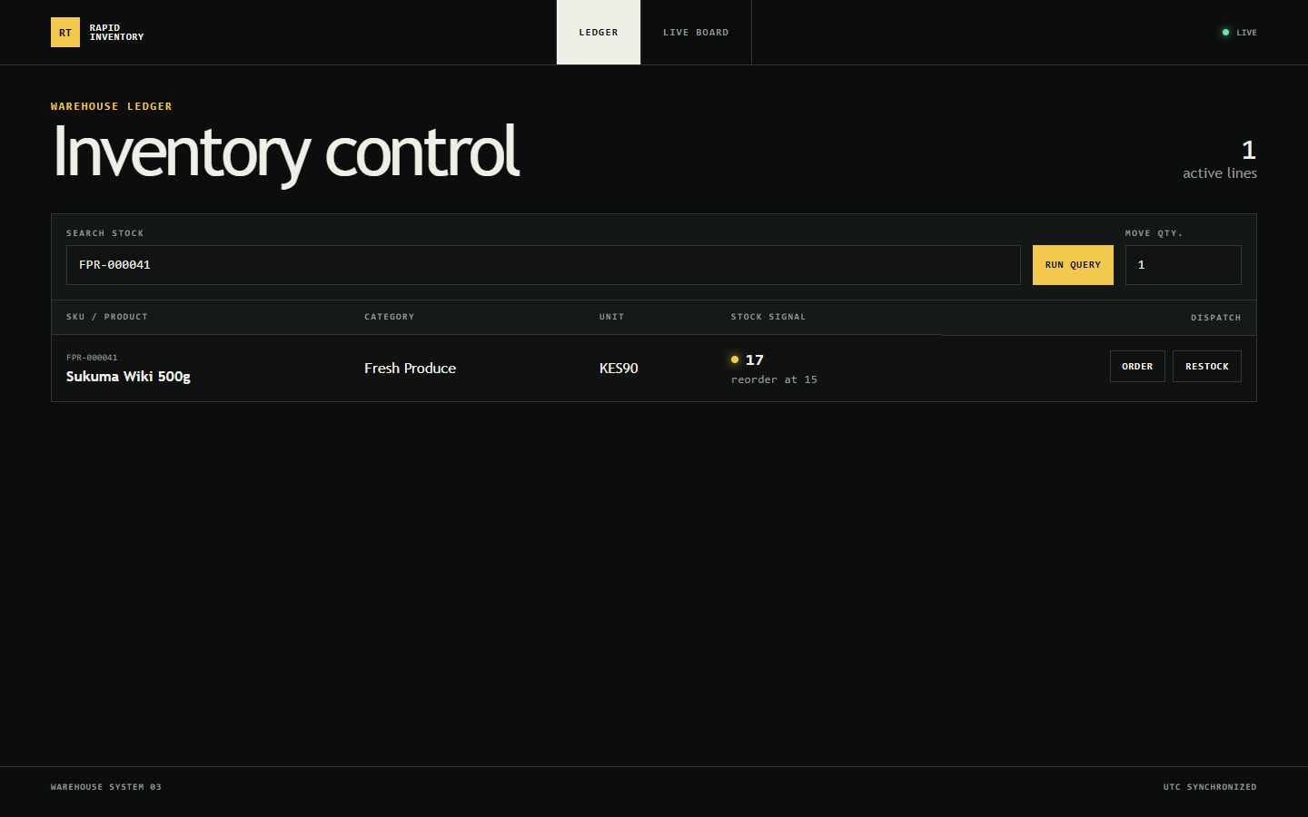
Figure EV-D1 — Browser A — initial stock
Evidence ID | EV-D1
Related issue / test | INV-003 · TC-30
Evidence type | Screenshot (headless Chrome, context A)
Environment | Local Docker Compose stack (api, web, db) on Windows 11 host; SQL Server 2022 (16.0.4305.5)
Captured | 29 Oct 2026 03:18:33 UTC
Artifact | screenshots/EV-D1_browserA_initial_stock.png
What it demonstrates | Inventory page filtered to FPR-000041 "Sukuma Wiki 500g" with live SignalR connection (status LIVE).
Observation | Stock 17, reorder at 15.
Result / status | PASS

EV-D2 Browser B — same initial stock
Figure EV-D2 — Browser B — same initial stock
Evidence ID | EV-D2
Related issue / test | INV-003 · TC-31
Evidence type | Screenshot (headless Chrome, context B)
Environment | Local Docker Compose stack (api, web, db) on Windows 11 host; SQL Server 2022 (16.0.4305.5)
Captured | 29 Oct 2026 03:18:33 UTC
Artifact | screenshots/EV-D2_browserB_initial_stock.png
What it demonstrates | Second, isolated browser context with its own SignalR connection.
Observation | Stock 17 — identical to Browser A.
Result / status | PASS

EV-D3 Browser A — after placing an order
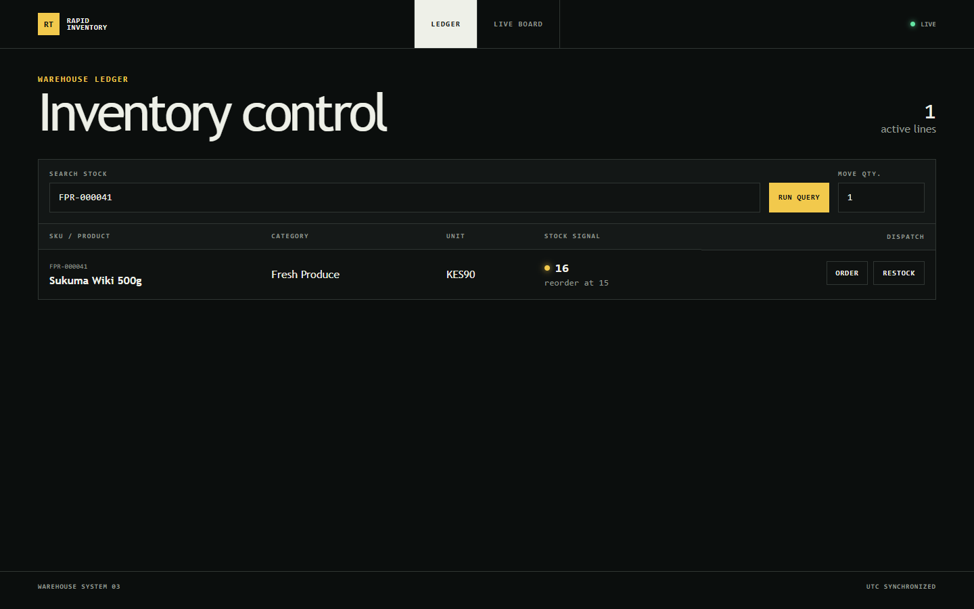
Figure EV-D3 — Browser A — after placing an order
Evidence ID | EV-D3
Related issue / test | INV-003 · TC-30
Evidence type | Screenshot
Environment | Local Docker Compose stack (api, web, db) on Windows 11 host; SQL Server 2022 (16.0.4305.5)
Captured | 29 Oct 2026 03:18:33 UTC
Artifact | screenshots/EV-D3_browserA_after_order.png
What it demonstrates | Order (qty 1) placed by clicking Order in Browser A.
Observation | Stock 16.
Result / status | PASS

EV-D4 Browser B — updated without refresh
Figure EV-D4 — Browser B — updated without refresh
Evidence ID | EV-D4
Related issue / test | INV-003 · TC-31
Evidence type | Screenshot
Environment | Local Docker Compose stack (api, web, db) on Windows 11 host; SQL Server 2022 (16.0.4305.5)
Captured | 29 Oct 2026 03:18:33 UTC
Artifact | screenshots/EV-D4_browserB_updated_without_refresh.png
What it demonstrates | Browser B was not reloaded; the value arrives via the StockUpdated SignalR event.
Observation | Stock 16, displayed 4 ms after Browser A (capture-log.txt).
Result / status | PASS

EV-D5 Browser A — failed order (quantity 100000)
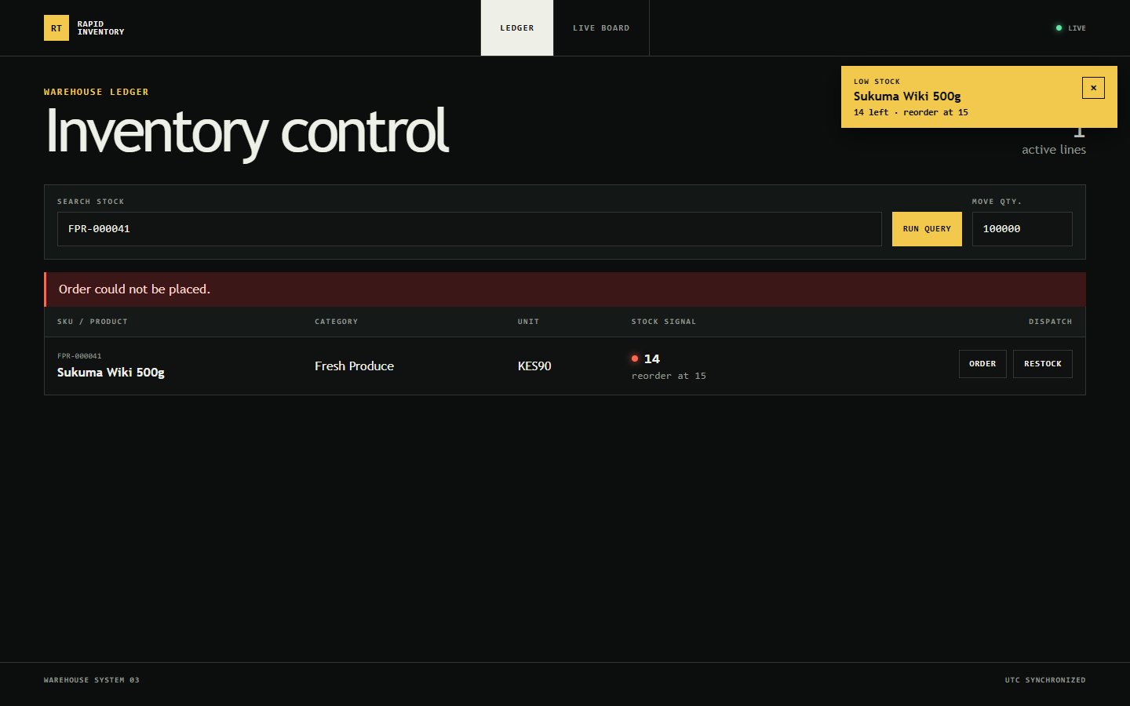
Figure EV-D5 — Browser A — failed order (quantity 100000)
Evidence ID | EV-D5
Related issue / test | INV-003 · TC-32; INV-005 · TC-55
Evidence type | Screenshot
Environment | Local Docker Compose stack (api, web, db) on Windows 11 host; SQL Server 2022 (16.0.4305.5)
Captured | 29 Oct 2026 03:18:37 UTC
Artifact | screenshots/EV-D5_browserA_failed_order_error.png
What it demonstrates | An order larger than the stock is rejected by the API (409).
Observation | Error banner "Order could not be placed."; stock remains 14.
Result / status | PASS

EV-D6 Browser B — unchanged after the failed order
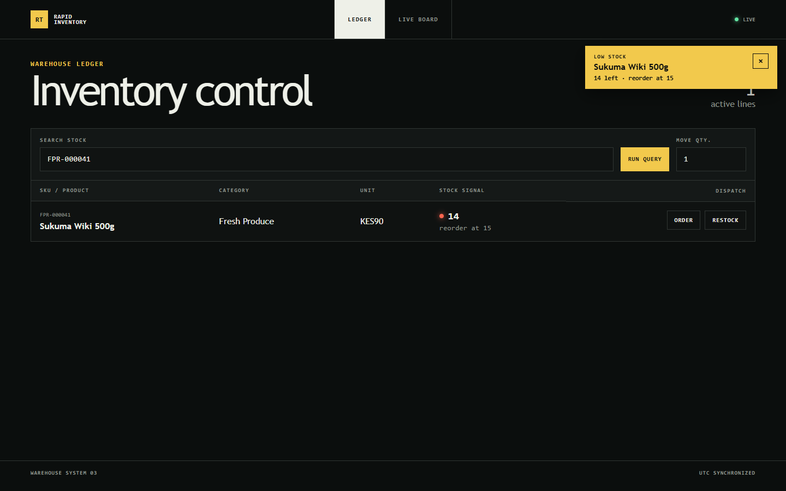
Figure EV-D6 — Browser B — unchanged after the failed order
Evidence ID | EV-D6
Related issue / test | INV-003 · TC-32; INV-005 · TC-55
Evidence type | Screenshot + frame count
Environment | Local Docker Compose stack (api, web, db) on Windows 11 host; SQL Server 2022 (16.0.4305.5)
Captured | 29 Oct 2026 03:18:37 UTC
Artifact | screenshots/EV-D6_browserB_unchanged_after_failed_order.png; screenshots/capture-log.txt
What it demonstrates | No stock update or alert should be published for a rejected order.
Observation | Stock 14 → 14; still one toast (from the earlier valid crossing); 0 new SignalR frames received by Browser B.
Result / status | PASS

5.5 Evidence E — Order Placement Refactoring (INV-004)
EV-E1 Original controller (fc3c873) — business logic in Place()
[HttpPost]
public async Task<IActionResult> Place(PlaceOrderRequest request, CancellationToken ct)
{
if (request.Lines.Count == 0)
return BadRequest(new { error = "Order must contain at least one line." });

if (request.Lines.Any(line => line.Quantity <= 0))
return BadRequest(new { error = "All line quantities must be greater than zero." });

var order = new Order { OrderDate = DateTime.UtcNow, Status = OrderStatus.Placed };
var stockChanges = new List<(int Id, string Name, int Previous, int Current, int Threshold)>();

foreach (var line in request.Lines)
{
var product = await db.Products
.Where(p => p.Id == line.ProductId)
.Select(p => new { p.Id, p.Name, p.UnitPrice, p.Stock, p.ReorderThreshold })
.SingleOrDefaultAsync(ct);

if (product is null)
return NotFound(new { error = $"Product {line.ProductId} not found." });

if (product.Stock < line.Quantity)
return Conflict(new { error = $"Insufficient stock for product {line.ProductId}." });

var newStock = product.Stock - line.Quantity;
await db.Products
.Where(p => p.Id == line.ProductId)
.ExecuteUpdateAsync(update => update.SetProperty(p => p.Stock, newStock), ct);
Source excerpt EV-E1 — Original controller (fc3c873) — business logic in Place()
Evidence ID | EV-E1
Related issue / test | INV-004
Evidence type | Source excerpt
Environment | Local Docker Compose stack (api, web, db) on Windows 11 host; SQL Server 2022 (16.0.4305.5)
Captured | 29 Oct 2026
Artifact | code/EV-E1_OrdersController_BEFORE_fc3c873.cs
What it demonstrates | Validation, stock read/check, absolute update, order construction, persistence and SignalR publishing all inside the action.
Observation | ≈ 50 lines of business logic in Place(); similar logic in Cancel() and Restock().
Result / status | PASS  Design problem confirmed.

EV-E2 Refactored controller — HTTP concerns only
public class OrdersController(AppDbContext db, OrderService orders) : ControllerBase
{
[HttpPost]
public async Task<IActionResult> Place(PlaceOrderRequest request, CancellationToken ct)
=> ToActionResult(await orders.PlaceOrderAsync(request, ct));

[HttpPost("{id:int}/cancel")]
public async Task<IActionResult> Cancel(int id, CancellationToken ct)
=> ToActionResult(await orders.CancelOrderAsync(id, ct));

[HttpPost("/api/products/{productId:int}/restock")]
public async Task<IActionResult> Restock(int productId, RestockRequest request, CancellationToken ct)
=> ToActionResult(await orders.RestockAsync(productId, request, ct));
...

private IActionResult ToActionResult(ServiceResult result) => result switch
{
ServiceResult.Ok<int> created => Ok(new { id = created.Value }),
ServiceResult.Ok => NoContent(),
ServiceResult.Invalid invalid => BadRequest(new { error = invalid.Error }),
ServiceResult.NotFound notFound => NotFound(new { error = notFound.Error }),
ServiceResult.Conflict conflict => Conflict(new { error = conflict.Error }),
_ => throw new InvalidOperationException($"Unhandled service result {result.GetType().Name}.")
};
Source excerpt EV-E2 — Refactored controller — HTTP concerns only
Evidence ID | EV-E2
Related issue / test | INV-004 · TC-40…TC-44
Evidence type | Source excerpt
Environment | Local Docker Compose stack (api, web, db) on Windows 11 host; SQL Server 2022 (16.0.4305.5)
Captured | 29 Oct 2026
Artifact | code/EV-E2_OrdersController_AFTER.cs
What it demonstrates | Actions delegate to OrderService and map ServiceResult to the same HTTP responses as before.
Observation | Place/Cancel/Restock are one-line delegations; Recent (read-only query) unchanged.
Result / status | PASS

EV-E3 Application service and regression tests
public async Task<ServiceResult> PlaceOrderAsync(PlaceOrderRequest request, CancellationToken ct = default)
{
var validation = ValidateOrder(request);
if (validation is not null) return validation;

var order = new Order { OrderDate = DateTime.UtcNow, Status = OrderStatus.Placed };
var changes = new List<StockChange>();

// Deductions and the order insert commit or roll back together. Disposing the transaction
// without committing (any early return or exception) rolls back every deduction made so far.
await using var transaction = await db.Database.BeginTransactionAsync(ct);

foreach (var line in request.Lines)
{
// Check-and-deduct is a single conditional UPDATE. SQL Server takes the row's update lock
// before evaluating "Stock >= @quantity", so concurrent requests on any API instance are
// serialized on the row and a request can only deduct stock that is still there.
var deducted = await db.Products
.Where(p => p.Id == line.ProductId && p.Stock >= line.Quantity)
.ExecuteUpdateAsync(s => s.SetProperty(p => p.Stock, p => p.Stock - line.Quantity), ct);

if (deducted == 0)

Passed OrderContractTests.Cancel_of_unknown_order_returns_404 [22 ms]
Passed OrderContractTests.Cancel_returns_stock_and_a_second_cancel_returns_409 [77 ms]
Passed OrderContractTests.Order_exceeding_stock_returns_409 [45 ms]
Passed OrderContractTests.Order_for_unknown_product_returns_404 [14 ms]
Passed OrderContractTests.Order_with_non_positive_quantity_returns_400(quantity: -3) [16 ms]
Passed OrderContractTests.Order_with_non_positive_quantity_returns_400(quantity: 0) [42 ms]
Passed OrderContractTests.Order_with_two_lines_for_the_same_product_deducts_both [63 ms]
Passed OrderContractTests.Order_without_lines_returns_400 [4 ms]
Passed OrderContractTests.Recent_orders_returns_placed_orders_with_lines_and_totals [190 ms]
Passed OrderContractTests.Restock_adds_quantity_and_returns_204 [34 ms]
Passed OrderContractTests.Restock_of_unknown_product_returns_404 [13 ms]
Passed OrderContractTests.Restock_with_non_positive_quantity_returns_400 [18 ms]
Passed OrderContractTests.Successful_order_returns_200_with_the_new_order_id [159 ms]
Source excerpt EV-E3 — Application service and regression tests
Evidence ID | EV-E3
Related issue / test | INV-004 · TC-40…TC-45
Evidence type | Source excerpt + test results
Environment | Local Docker Compose stack (api, web, db) on Windows 11 host; SQL Server 2022 (16.0.4305.5)
Captured | 29 Oct 2026
Artifact | code/EV-E4_OrderService_AFTER.cs; logs/EV-G3a_backend_test_case_results.txt
What it demonstrates | OrderService owns the transactional use case; 13 contract tests confirm unchanged HTTP behaviour.
Observation | All 13 OrderContractTests passed on the original controller (EV-B1) and after the refactor.
Result / status | PASS

5.6 Evidence F — Low-Stock Notifications (INV-005)
EV-F1 Stock exactly at the reorder threshold — no alert
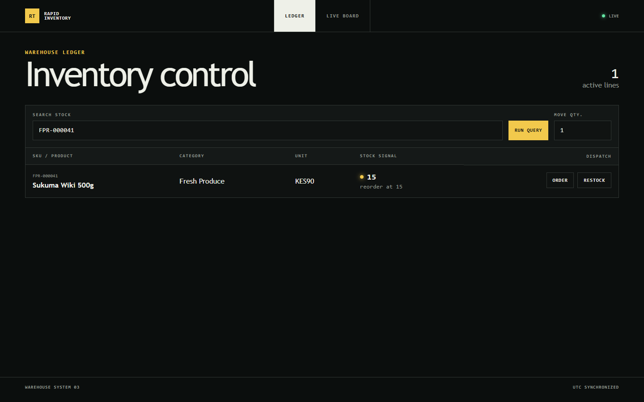
Figure EV-F1 — Stock exactly at the reorder threshold — no alert
Evidence ID | EV-F1
Related issue / test | INV-005 · TC-51
Evidence type | Screenshot (Browser B)
Environment | Local Docker Compose stack (api, web, db) on Windows 11 host; SQL Server 2022 (16.0.4305.5)
Captured | 29 Oct 2026 03:18:34 UTC
Artifact | screenshots/EV-F1_browserB_at_threshold_no_alert.png
What it demonstrates | Product stock 15 with reorder threshold 15 after an order from Browser A.
Observation | No toast in Browser A or B (0 / 0).
Result / status | PASS

EV-F2 Stock below threshold — toast in Browser A
Figure EV-F2 — Stock below threshold — toast in Browser A
Evidence ID | EV-F2
Related issue / test | INV-005 · TC-52, TC-54
Evidence type | Screenshot (Browser A)
Environment | Local Docker Compose stack (api, web, db) on Windows 11 host; SQL Server 2022 (16.0.4305.5)
Captured | 29 Oct 2026 03:18:35 UTC
Artifact | screenshots/EV-F2_browserA_low_stock_toast.png
What it demonstrates | Next order moves stock 15 → 14 (below 15).
Observation | Toast "LOW STOCK · Sukuma Wiki 500g · 14 left · reorder at 15". Cosmetic: the toast overlaps the page-heading line counter.
Result / status | PASS

EV-F3 Same alert delivered to Browser B
Figure EV-F3 — Same alert delivered to Browser B
Evidence ID | EV-F3
Related issue / test | INV-005 · TC-53
Evidence type | Screenshot (Browser B)
Environment | Local Docker Compose stack (api, web, db) on Windows 11 host; SQL Server 2022 (16.0.4305.5)
Captured | 29 Oct 2026 03:18:35 UTC
Artifact | screenshots/EV-F3_browserB_low_stock_toast.png
What it demonstrates | Browser B did not place the order.
Observation | Identical toast and stock 14 shown.
Result / status | PASS

EV-F4 Live board in Browser B lists the alert
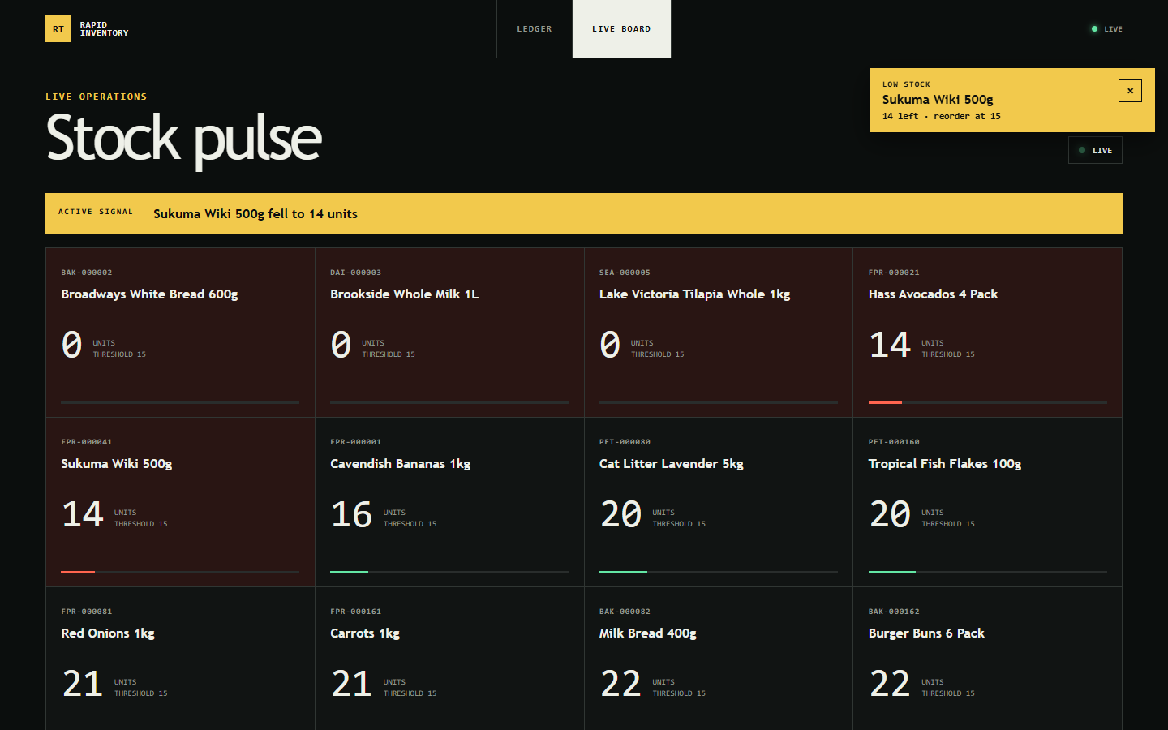
Figure EV-F4 — Live board in Browser B lists the alert
Evidence ID | EV-F4
Related issue / test | INV-005 · TC-54
Evidence type | Screenshot (Browser B, Live board)
Environment | Local Docker Compose stack (api, web, db) on Windows 11 host; SQL Server 2022 (16.0.4305.5)
Captured | 29 Oct 2026 03:18:38 UTC
Artifact | screenshots/EV-F4_browserB_live_board_alert.png
What it demonstrates | Client-side navigation to the Live board in the same session.
Observation | Alert listed in the board's signal bar and as a toast; no duplicate.
Result / status | PASS

EV-F5 Actual SignalR frames received by Browser B
"at": "2026-10-29T03:18:33.163Z",
"target": "StockUpdated",
"arguments": [
41,
16
"at": "2026-10-29T03:18:33.451Z",
"target": "StockUpdated",
"arguments": [
41,
15
"at": "2026-10-29T03:18:34.849Z",
"target": "StockUpdated",
"arguments": [
41,
14
"at": "2026-10-29T03:18:34.849Z",
"target": "LowStockAlert",
"arguments": [
"productId": 41,
"productName": "Sukuma Wiki 500g",
"stock": 14,
"reorderThreshold": 15
Log excerpt EV-F5 — Actual SignalR frames received by Browser B
Evidence ID | EV-F5
Related issue / test | INV-005 · TC-53; INV-003 · TC-31, TC-32
Evidence type | WebSocket frames (Chrome DevTools Protocol Network.webSocketFrameReceived)
Environment | Local Docker Compose stack (api, web, db) on Windows 11 host; SQL Server 2022 (16.0.4305.5)
Captured | 29 Oct 2026 03:18:33–03:18:37 UTC
Artifact | screenshots/EV-F5_signalr_frames_browserB.json
What it demonstrates | Hub invocations as received on the wire by Browser B during EV-D/EV-F.
Observation | StockUpdated 41→16, 15, 14, then LowStockAlert {productId 41, "Sukuma Wiki 500g", stock 14, reorderThreshold 15}. No frame for 15 (exact threshold) and none for the failed order.
Result / status | PASS

EV-F6 Live low-stock check incl. navigation re-initialisation
02:54:48.733 Product FPR-000021 "Hass Avocados 4 Pack" stock 17, threshold 15
02:54:49.417 Browser A: connection live, shows stock 17
02:54:49.419 Browser B: connection live, shows stock 17
02:54:49.425 Browser A: clicked Order (qty 1), expecting stock 16
02:54:49.548 Browser A: shows stock 16
02:54:49.550 Browser B: shows stock 16 without reload -> PASS
02:54:49.674 Browser A: failed order shows "Order could not be placed."
02:54:51.186 Browser B after failed order: 16 (before 16, database 16) -> PASS
02:54:52.318 Order to exactly the threshold (15): toasts A=0 B=0, expected none -> PASS
02:54:52.442 Browser A toast after falling to 14: ["Low stock | Hass Avocados 4 Pack | 14 left · reorder at 15"] -...
02:54:52.443 Browser B toast after falling to 14: ["Low stock | Hass Avocados 4 Pack | 14 left · reorder at 15"] -...
02:54:53.953 Failed order: toasts A=1 B=1, expected 1 each -> PASS
02:54:54.686 Browser B toasts after navigating away and back: 1, expected 1 -> PASS

Log excerpt EV-F6 — Live low-stock check incl. navigation re-initialisation
Evidence ID | EV-F6
Related issue / test | INV-005 · TC-51…TC-58
Evidence type | Headless two-browser check output
Environment | Local Docker Compose stack (api, web, db) on Windows 11 host; SQL Server 2022 (16.0.4305.5)
Captured | 29 Oct 2026 02:54 UTC
Artifact | logs/EV-F6_two_browser_low_stock_check.txt
What it demonstrates | seed/two-browser-check.mjs on the final build.
Observation | All 7 checks PASS, including 1 toast after navigating Browser B away and back.
Result / status | PASS

5.7 Evidence G — Final Validation
EV-G1 Builds and automated suites
$ dotnet build Inventory.sln
Build succeeded.
0 Warning(s)
0 Error(s)

$ dotnet test Inventory.sln
Total tests: 42
Passed: 42

$ npx ng test --watch=false --browsers=ChromeHeadless
TOTAL: 17 SUCCESS

$ npm run build
| Initial total | 388.10 kB | ...
Application bundle generation complete. [4.206 seconds] - 2026-10-29T02:58:02.779Z
Output location: E:\ALEX\recv\stage-3-assessment\stage-3-assessment\frontend\dist\frontend
Log excerpt EV-G1 — Builds and automated suites
Evidence ID | EV-G1
Related issue / test | TC-70…TC-73
Evidence type | Build and test logs
Environment | Local Docker Compose stack (api, web, db) on Windows 11 host; SQL Server 2022 (16.0.4305.5)
Captured | 29 Oct 2026
Artifact | logs/EV-G1_backend_build.txt; EV-G2_frontend_production_build.log; EV-G3_backend_tests_FINAL_42_passed.log; EV-G4_frontend_karma_tests.log
What it demonstrates | Final regression run on HEAD 4555d20.
Observation | Backend build 0 warnings / 0 errors; 42/42 backend tests; 17/17 Karma specs; production bundle 388.10 kB.
Result / status | PASS

EV-G5 Git history and repository status
$ git log --oneline --decorate
$ git status --short (before adding release documents)
?? release/
$ git rev-parse HEAD origin/main
$ git log --format='%h %ad %an %s' --date=iso
4555d20 2026-10-29 06:02:59 +0300 alexkemboi docs: document root causes, fixes and verification
280ac2d 2026-10-29 05:58:13 +0300 alexkemboi test: add dependency-free load generator for multi-instance order checks
1bfb08b 2026-10-29 05:55:05 +0300 alexkemboi feat: show low stock alerts as global toasts
75569d9 2026-10-29 05:51:04 +0300 alexkemboi refactor: extract order placement into OrderService
d8329cc 2026-10-29 05:48:34 +0300 alexkemboi fix: broadcast stock updates to all watching clients
2f076ee 2026-10-29 05:45:44 +0300 alexkemboi perf: remove N+1 category lookups from inventory list
6157517 2026-10-29 05:43:03 +0300 alexkemboi fix: prevent concurrent stock overselling
6028cbd 2026-10-29 05:40:03 +0300 alexkemboi test: make last-unit race deterministic across queued lock waiters
6bae192 2026-10-29 05:31:38 +0300 alexkemboi test: add SQL Server integration tests reproducing order, list and Sig...
fc3c873 2026-10-29 05:07:49 +0300 alexkemboi chore: baseline snapshot of provided project (no prior git history pre...
Log excerpt EV-G5 — Git history and repository status
Evidence ID | EV-G5
Related issue / test | Traceability
Evidence type | git log / status
Environment | Local Docker Compose stack (api, web, db) on Windows 11 host; SQL Server 2022 (16.0.4305.5)
Captured | 29 Oct 2026
Artifact | logs/EV-G5_git_history_and_status.txt
What it demonstrates | Incremental commits on main, pushed to origin; no history rewritten.
Observation | HEAD = origin/main = 4555d20 at capture; only the new release/ folder was untracked.
Result / status | PASS

5.8 Evidence Traceability Matrix
Issue | Root cause | Code change (commit / file) | Tests | Evidence | Observed result | Status
INV-001 | Lost update; no transaction | 6157517 → 75569d9 · OrderService.PlaceOrderAsync; AppDbContext; migration | TC-01…TC-14 | EV-B1…B4, EV-A2 | No oversell; stock ≥ 0; rollback | PASS
INV-002 | N+1 per-row category query | 2f076ee · ProductsController.List | TC-20…TC-25 | EV-C1…C3 | 202 → 2 cmds; 224.9 → 11.9 ms | PASS
INV-003 | Update sent to requester only | d8329cc · IStockNotifier.cs; stock-realtime.service.ts | TC-30…TC-36 | EV-D0…D6, EV-F5 | B updates without reload | PASS
INV-004 | Logic in controller; stale duplicate service | 75569d9 · OrderService; OrdersController | TC-40…TC-45 | EV-E1…E3 | 13 contracts unchanged | PASS
INV-005 | Alert UI only on board; key collisions | 1bfb08b · low-stock-alerts.ts; stock-realtime.service.ts | TC-50…TC-59 | EV-F1…F6 | Toast in all browsers; correct threshold | PASS

6. Installation Guide and Environment Setup

6.1 Prerequisites
Requirement | Version / detail | Source
Docker Desktop + Docker Compose | ≥ 6 GB memory for Docker; verified with Docker 29.8.2 / Compose v5.6.0 | README; test host
Free ports | 1433 (SQL Server), 4200 (web), 5080 (API) | README / docker-compose.yml
Container images | mcr.microsoft.com/mssql/server:2022-latest; mcr.microsoft.com/dotnet/sdk:9.0; node:24-alpine | docker-compose.yml, Dockerfiles
For running tests on a host | .NET SDK 9 (or later SDK with .NET 9 runtime), Node 20+/24, Chrome (Karma) | Test project / package.json
Network | First start downloads ≈ 3 GB of images; seeding 250,000 orders adds time | Observed

6.2 Configuration and Environment Variables
Variable | Service | Purpose
MSSQL_SA_PASSWORD, ACCEPT_EULA | db | SQL Server administrator password (development value in docker-compose.yml — must be replaced by a secret in any shared environment)
ConnectionStrings__DefaultConnection | api / tests | SQL Server connection string (do not commit production credentials)
ASPNETCORE_ENVIRONMENT, ASPNETCORE_URLS | api | Development; listens on 0.0.0.0:8080 (published as 5080)
SEED_ORDER_COUNT | api | Historical orders to seed when the database is empty (250000)
Credentials are intentionally not reproduced in this document.

6.3 Installation Steps
- Obtain the release: clone main at the release commit or extract rapid-inventory-1.1.0-src-4555d20.zip and verify CRC32 CE4AA374 / SHA-256 (Section 2.6).
- Database setup: no manual step. On API start, EF Core applies pending migrations (InitialCreate, AddNonNegativeStockConstraint) and seeds 20 categories, 2,000 products and 250,000 orders if the database is empty. For an existing database, take a backup first (Section 7).
- Environment setup: from the repository root run docker compose up --build. Wait until docker compose ps shows db as healthy and the API logs "Application started".
- Optional reset of all data: ./seed/reset.sh (runs docker compose down -v — destroys the database volume).

6.4 Post-deployment Verification (Test Instruction)
Check | How | Expected | Verified in test env
SQL Server | docker compose ps | db: Up (healthy) | PASS  EV-A2
Migrations | Query __EFMigrationsHistory; sys.check_constraints | Both migrations; CK_Products_Stock_NonNegative | PASS  EV-A2
API | http://localhost:5080/health | {"status":"healthy"} | PASS  EV-A2
Web app | http://localhost:4200 | Inventory ledger loads; header status LIVE | PASS  EV-D1
SignalR | Two browsers; order in one | Other browser updates without refresh | PASS  EV-D4
Integrity | ./seed/stress-orders.sh then compare stock and order lines | Units sold = stock deducted; stock ≥ 0 | PASS  EV-B4

Known environment issue: on hosts where a local SQL Server (e.g. SQL Express) already listens on 1433, host tools connecting to localhost,1433 reach the local instance instead of the container (containers are unaffected). During testing the container was additionally published on 14333 through an uncommitted Compose override.

7. Release Prerequisites
# | Prerequisite | Status | Note
1 | Mandatory automated regression tests pass | PASS | Backend 42/42, frontend 17/17, builds clean (test environment)
2 | Independent QA review of this report and re-execution | Outstanding | QA reviewer to be named
3 | Deployment to a staging / production-like environment and smoke test | Outstanding | Only local Docker Compose tested
4 | Database backup taken and restore tested before applying migration | Outstanding | No backup procedure evidenced
5 | Migration AddNonNegativeStockConstraint pre-check: no existing row with Stock < 0 | Outstanding for target DB | Verified 0 rows in test DB (EV-A2); migration fails if any exist
6 | Environment configuration reviewed (secrets, connection strings, CORS origin, logging level) | Outstanding | Compose uses development values
7 | Approved release artifact produced and checksummed | Partial | Source zip + CRC32/SHA-256 computed; not yet approved/signed
8 | Known issues and residual risks accepted (Section 9) | Outstanding | Business/technical owner decision
9 | If more than one API instance: SignalR backplane configured | Outstanding / conditional | Not implemented
10 | Rollback procedure reviewed and rehearsed | Outstanding | Section 8
11 | Authorised deployment approval | Outstanding | Section 10 sign-off pending

8. Rollback Procedure
Architecture: stateless API and Angular containers built from source, one SQL Server database. The only schema change is an added CHECK constraint; no columns or data were changed, so the previous application version runs correctly against the new schema.
- Decide and freeze. Stop new deployments; record the time and reason for rollback.
- Restore the previous application version. Check out the previous release commit (baseline fc3c873 or the previously deployed tag) and rebuild/redeploy the api and web images together (docker compose up --build -d api web). Backend and frontend must be rolled back as a pair: the new frontend expects group broadcasts but remains compatible with the old API; the old frontend works with the new API.
- Database: do not restore a backup to undo this release. Restoring would discard valid orders and stock movements made since deployment. Keep the database as is — the previous version is compatible with the added constraint.
- Optional schema rollback. Only if required, drop the constraint with the migration's Down step (dotnet ef database update 20261023081746_InitialCreate, which runs DropCheckConstraint). This removes no data. Note: without the constraint and with the old code, overselling can recur.
- Configuration. Restore the previous environment variables / compose file from version control.
- Post-rollback health checks. docker compose ps (db healthy), GET /health, web app loads, place and cancel one test order.
- Inventory integrity check. Run: SELECT COUNT(*) FROM Products WHERE Stock < 0 (expect 0) and compare recent order-line totals with stock movements for affected products; investigate any discrepancy before reopening.
Limitation: rollback has not been rehearsed, and no backup/restore procedure exists in the repository. A tested backup and a rollback rehearsal in staging are recommended before production release.

9. Known Issues and Residual Risks
# | Item | Impact | Recommendation
1 | No SignalR backplane | With >1 API instance, users miss updates/alerts from other instances | Redis backplane or Azure SignalR before scaling out
2 | At-most-once notifications after commit | An alert can be lost if publishing fails (logged) | Transactional outbox if delivery must be guaranteed
3 | No idempotency key | Client retry after a timeout can create a duplicate order | Idempotency-Key header + unique index
4 | Multi-line deadlock possible | Rare 500 with full rollback (not observed) | Lock products in id order or retry on error 1205
5 | Hot-product contention | Measured: doubling concurrency on one product kept throughput flat (135 → 121 req/s) and raised p50 140 → 326 ms | Shorter transactions; measure Release build
6 | Alerts not persisted | Users connecting later do not see earlier alerts | Persist or derive from current stock if required
7 | Toast overlaps heading counter | Cosmetic (EV-F2) | Offset toast region below page heading
8 | PUT /api/products overwrites stock | Admin edit can overwrite concurrent deductions | Require RowVersion from client
9 | Walkthrough video not recorded | Assessment deliverable outstanding | Record using docs/WALKTHROUGH_SCRIPT.md
10 | Brand fonts not embedded | Manrope/Inter (website) were not installed; Segoe UI used | Install brand fonts and refresh styles if required

10. Release Acceptance and Sign-off
Role | Name | Decision | Signature | Date
Developer / Release Maker | [To be confirmed] | [Pending] | [Pending] | [Pending]
QA Reviewer | [To be confirmed] | [Pending] | [Pending] | [Pending]
Technical Approver | [To be confirmed] | [Pending] | [Pending] | [Pending]
Business Owner | [To be confirmed] | [Pending] | [Pending] | [Pending]

Release recommendation
Recommendation | Ready subject to outstanding conditions
Justification | All five reported issues are resolved and verified in the test environment: the 9 baseline defect reproductions now pass, 42/42 backend and 17/17 frontend tests pass, builds are clean, and live browser and multi-process checks confirm the behaviour. No test is FAIL or BLOCKED.
Conditions before production | Independent QA review; staging deployment and smoke test; database backup and migration pre-check; configuration/secret review; acceptance of residual risks (Section 9), including a SignalR backplane if more than one API instance will run; rollback rehearsal; authorised approval (table above).
Production readiness | Not yet established. This document does not authorise deployment; no approval has been given.

