**SCHOOL DROPOUT**

**REPORT**

**ANALYSIS**

**Introduction:**

This report presents a Power BI dashboard designed to analyze and determine the target outcomes of a dataset related to education. The dataset comprises various factors, including student demographics, enrollment details, academic performance, financial indicators, and economic indicators. The primary objective of this dashboard is to identify the target categories, specifically "graduate," "dropout," and "enrolled," and explore the factors that contribute to each outcome. By analyzing the provided dataset, we aim to gain insights that can inform decision-making processes in the education sector.

**RELATIONSHIP BETWEEN GENDER AND TARGET ON THE FOCUS OF DROPOUT IN TARGET**

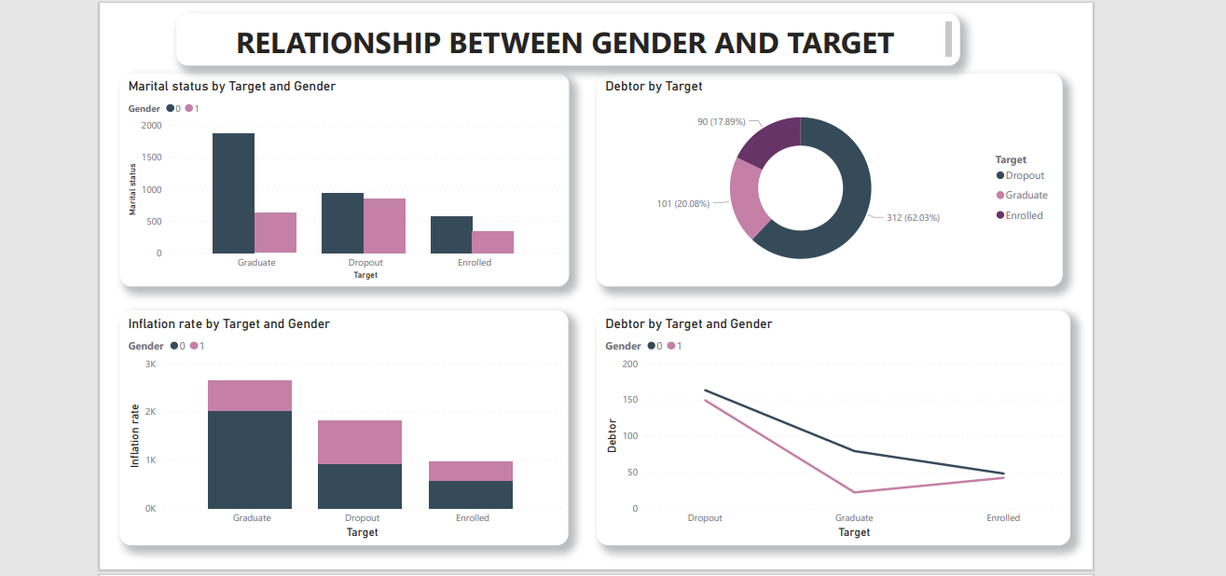

**Summary of dashboard**

In this dashboard we will focus on the effect of gender on the target on the focus to dropout, the binaries 0 represents female and male represents male. From the visualization there is a slight equal number in dropouts in both genders but a high number of graduates in females than males.

Having our focus on the inflation rate and how it affected gender in target on our focus being dropout, from the visualization it seems to be equal. But contrary also there were more female graduates than males.

On the debtor’s part the donut chart visualized that dropouts were high for those who were in debt

**Conclusion**

1. students in debt recorded a high number of dropouts in both genders’ male and female.
2. The inflation rate was also a factor despite being low in both genders.
3. Despite the inflation rate being high there was a high number of graduates in female gender.

**RELATIONSHIP BETWEEN SCHOLARSHIP AND TARGET DASHBOARD**

**Summary of dashboard**

These dashboard visualizations the rate of dropout of students with scholarship. The dropout rate of students with scholarships was recorded low as there was a significant high number of students graduating.

Female gender once again recorded a high number of graduates with scholarships as compared to the male gender.

Despite the females having a high number of graduates there was also a record high of dropout of international students with scholarships.

**Conclusion**

1. Female students with scholarships had high rate of graduates.
2. International students had a high rate of dropouts despite having scholarships.

**RELATIONSHIP BETWEEN UNEMPLOYMENT AND THE TARGET**

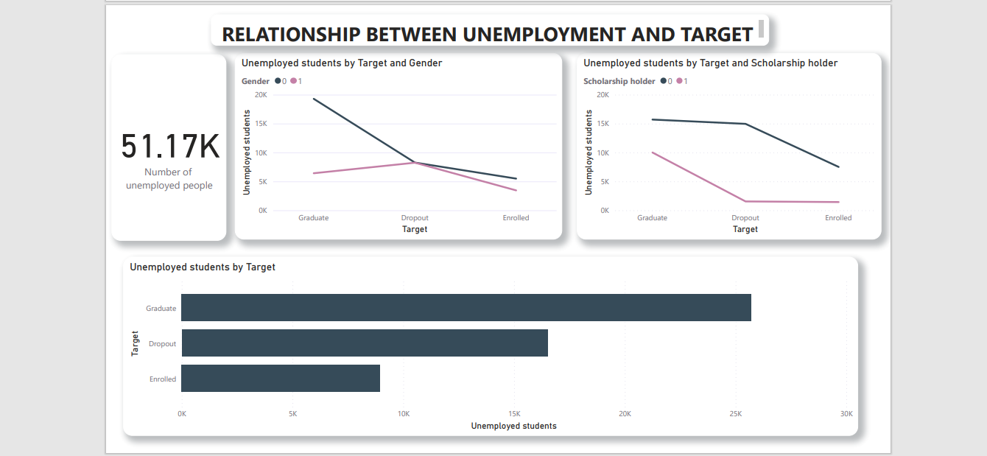

**Summary of dashboard**

Unemployed students recorded a high number of graduates, but the rate of dropout was average as compared to the enrolled rate which was recorded low among the unemployed students.

**conclusion**

1. The rate of dropout students was average.
2. The rate of dropout among unemployed students who had scholarships was low as compared to the non-scholarship holders which was recorded high.

**RELATIONSHIP BETWEEN TUTION FEES UPTO DATE AND THE TARGET**

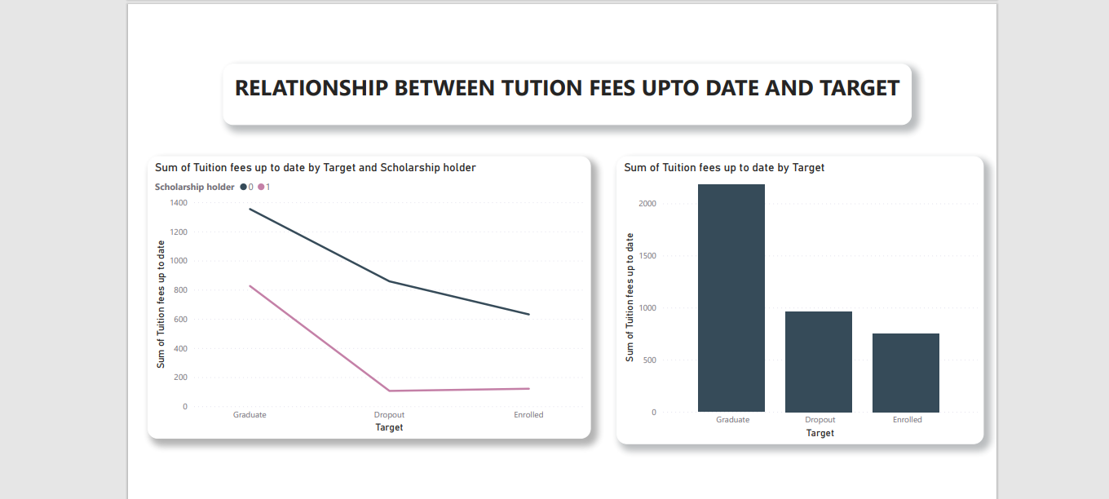

**Summary of dashboard**

Students who had paid their fees up to date had a higher chance to graduate /recorded a high graduation turn out.

Students who had scholarships had low balances and the record shows there was a low rate of drop out.

Students that dropped out had average/fees balance up to date.

**Conclusion**

1. Low rate of dropout among scholarship holders.

**RELATIONSHIP BETWEEN FATHER’S OCCUPATION / QUALIFICATION AND TARGET**

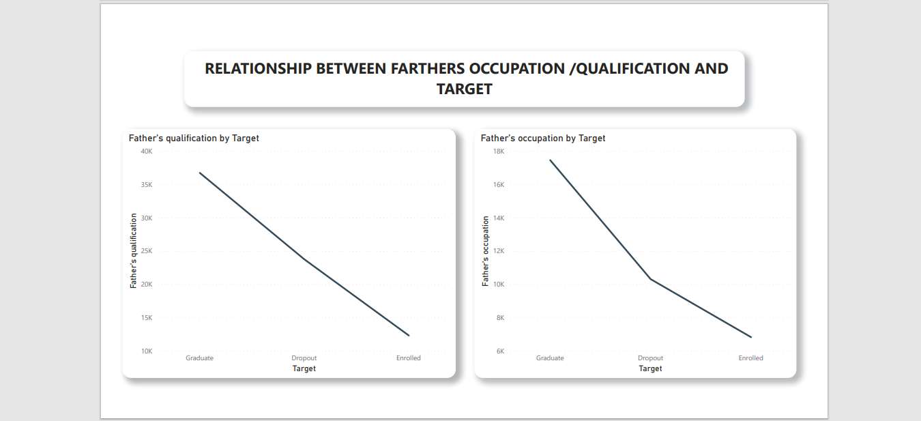

**conclusion**

1. The father’s occupation and qualification influenced as a factor as it affected the rate of dropout averagely.
2. Fathers’ occupation affected the rate of graduates positively with high numbers being recorded.

**RELATIONSHIP BETWEEN MOTHER’S OCCUPATION/QUALIFICATION AND TARGET**

**Conclusion**

1. The mother’s occupation and qualification influenced as a factor as it affected the rate of dropout averagely.
2. Mothers’ occupation affected the rate of graduates positively with high numbers being recorded.

**RELATIONSHIP BETWEEN PARENTS OCCUPATION AND TARGET**

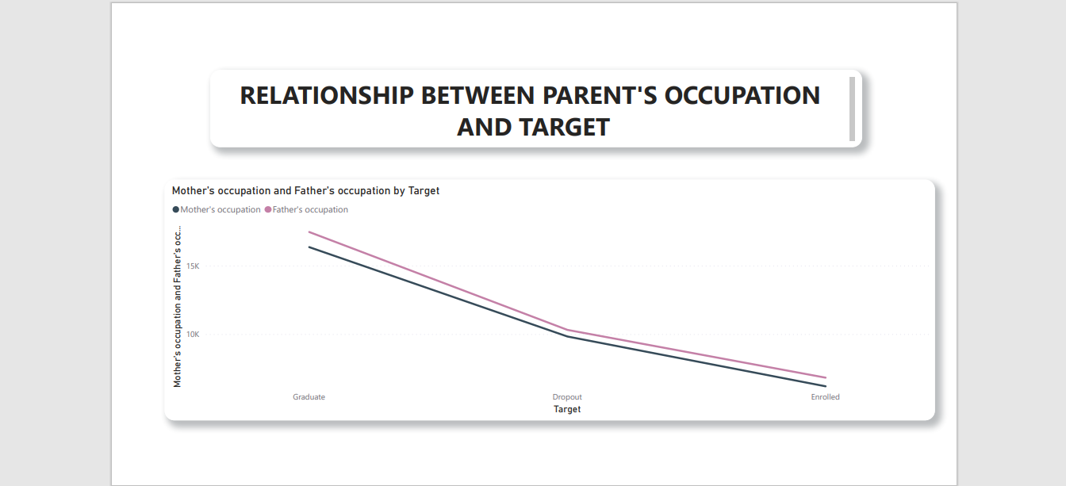

**Conclusion**

1. The parents’ occupation slightly affected the rate of dropout. slightly below average.
2. Parents’ occupation affected the graduate numbers positively with high numbers being recorded.

**RELATIONSHIP BETWEEN PARENTS QUALIFICATION AND TARGET**

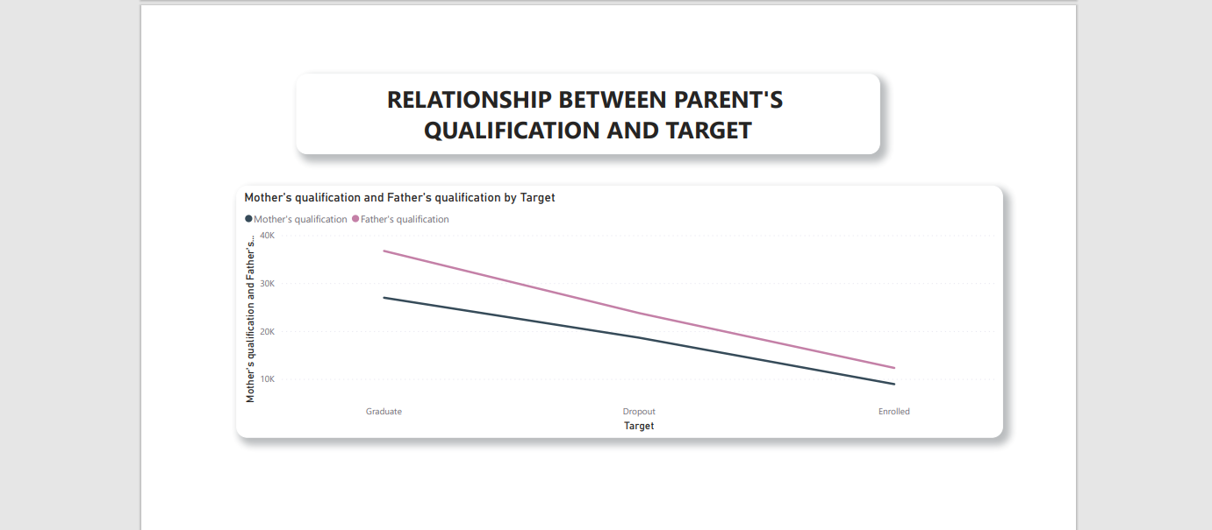

**Conclusion**

1. The parents’ qualification slightly affected the rate of dropout. slightly below average.
2. Parents’ qualifications affected the graduate numbers positively with high numbers being recorded.

**RELATIONSHIP BETWEEN GDP AND TARGET**

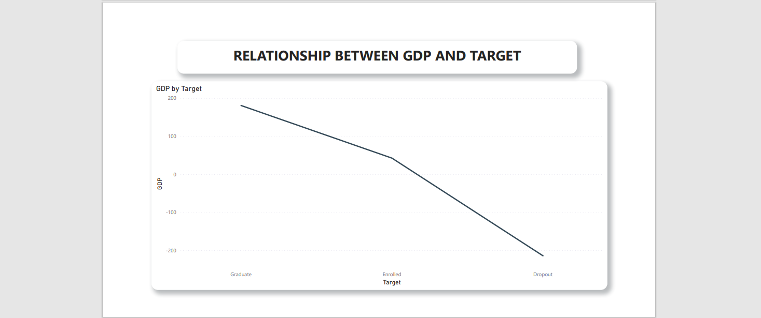

**Conclusion**

1. GDP did not affect the rate of dropouts as it was recorded negative.

**RELATIONSHIP BETWEEN INFLATION RATE AND TARGET**

**Conclusion**

The inflation rate and school drop out was below average as it was recorded at 32.12%.

**RELATIONSHIP BETWEEN INFLATION RATE ON TARGET WITH SCHOLARSHIP**

**conclusion**

Scholarship holders were not affected by the inflation rate which recorded a low number of drop outs but non-scholarship holders were drastically affected by the inflation because a high percentage of drop outs was recorded.

**RELATIONSHIP BETWEEN GDP ON TARGET WITH SCHOLARSHIP**

**Conclusion**

GDP was not a factor on the rate of dropouts because it recorded as a nehative despite the scholar holding of the students

**Factors that affected drop out among students.**

* Gender
* Inflation rate on gender
* If or not the student is a debtor
* If the student is a scholarship holder
* If the student is an international student
* If the student is an international student and a scholarship holder
* Unemployment among the students
* Ability to pay the fees up to date.
* Parents occupation and qualification