ODM pagination differs from ODT pagination (re: Headings)
This document is provided to give a working copy of a bug as reported in Python3docs Bugs #11. This bug is as follows:–
“Heading x” (x == 1 … 10) Styles contain a setting for both ‘Above’ + ‘Below’ paragraph Spacings.
If a Heading paragraph is preceded by a Page Break, then the Above setting should NOT be used, meaning that the top border of the Heading will be flush with the bottom of the page Header (how this page was setup to behave). That is also exactly how an ODT (text) document behaves. However, an ODM (master) document behaves in the reverse manner, and adds the top border in all situations. Thus ODM pagination differs from ODT pagination (disastrous in edge conditions).
Note:
The setting as described in the last paragraph above used to be affected by a setting in menu:Tools | Options | Libreoffice Writer | Compatibility | Add paragraph and table spacing at top of first page and page breaks. My own experiments suggest both that neither ODT nor ODM documents pay any attention to this setting, and also that the system reverts any change back to the default after restart.
Regardless of the veracity of my experiments the fact remains that, under exactly the same setup, ODM pagination differs from ODT pagination and that ruins page-flow.
To produce this document the following steps were taken:
- The styles from bug3.odt were loaded into this document under LO 24.8.3.2
- chapter_02.odt was loaded into Libreoffice. The first page was setup to closely show how the Heading 1 paragraph was flush with the 1st page Heading. In addition, the Libreoffice Writer | Compatibility Options dialog was placed at the top of the page (all options shown are the defaults). A screenshot was taken.
- Programming-In-Python3.odm was loaded into Libreoffice. The page in (2) was recreated with the ODM document. A screenshot was taken.
- Both screenshots were inserted into p2 below.

Examples (next page):
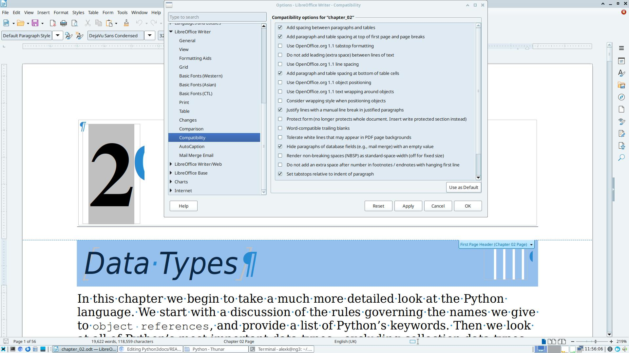Figure 11.1: chapter_02.odt screenshot
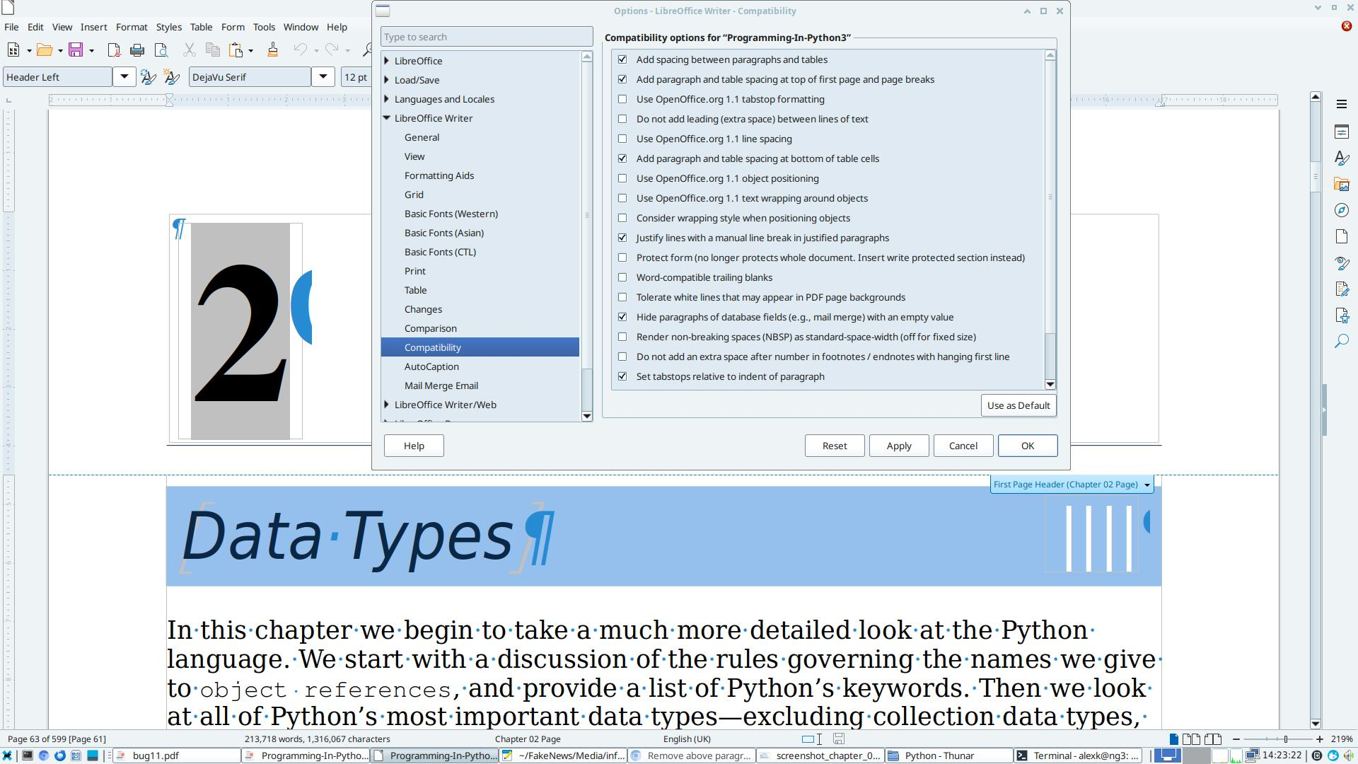Figure 11.2: Programming-In-Python3.odm screenshot

