Selecting Image Caption also Selects the Image
This document is provided to give a working copy of a bug as reported in Python3docs Bugs #2. This bug is as follows:-
original:
Selecting the whole of an image caption (eg for rename) also selects the image. If the caption is then deleted the image itself will also be deleted. The 1st letter needs to be de-selected to prevent that.
update:
In addition, if a Code Box 2 paragraph is placed immediately below the image-plus-caption, selecting all the text within the Code Box 2 paragraph will also select the image + caption above it. Deleting the text within the paragraph will then delete both the paragraph + image + caption.
These must be Frame errors.
To produce this document the following steps were taken:
- The document bug3.odt was loaded under LO 24.8.3.2 and then saved-as bug2.odt
- The example (under the Heading 2 style below) were transferred to a 2nd page.
Note:
An extra feature of the same bug was discovered during production of this example, so the Code Box 2 paragraph was kept below the image.
To easily demonstrate this problem (1):
- Click within the Image caption
- Press the <HOME> key
(cursor should show at front of ‘Figure’)
- Hold down <SHIFT> key and then press <END> key
- Note that now both image + caption are both selected
(s/b just the caption)
To easily demonstrate this problem (2):
- Do the same as (i) above, but this time start with the 1st letter of the 1st line on the Code Box 2 paragraph that is below the Image.
- Select to the end of the 1st line
(no problem)
- Select to the end of the whole paragraph
(the whole of the image above + caption + paragraph below has been selected)
(that’s greedy; deleting the paragraph will now delete everything)

Example (next page):

print(x, y, z) # prints blue green blue
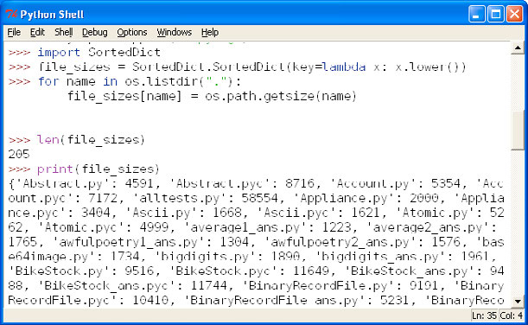Figure 2.1: idle’s Python Shell
z = y
print(x, y, z) # prints blue green green
x = z
print(x, y, z) # prints green green green

