Image Frames Interfere with Adjoining Borders
This document is provided to give a 2nd working copy of the same bug as reported in Python3docs Bugs #3, with extra information supplied.

Comment
The report (below) was made at BugZilla#164297 on Dec 12 2024. The bug was first documented at GitHub Python3Docs Bug#02 and then documented separately as Bug#03.
- Version 24.8.3.2 is affected by this bug
- Grandmother version 3.3.0.4 is affected by this bug
- All other versions between 3.3 & 24.8 are affected by this bug.
- Michael Stahl declared that “this is working as designed”™ (good grief)
I now understand that the reason that LibreOffice has been riddled with bugs for the last 7+ years is by design rather than through ignorance, laziness or inability. There now follows extra comment + demonstration of this bug:–
original bug report:
The bottom border of an image-in-frame-with-caption will coalesce with the top inline-border of a paragraph. In other words, the below-paragraph spacing of an image will be added to the internal top-spacing of the next paragraph, rather than being placed between the two entity’s borders.
Extra comment:
The original report is almost accurate (if wordy), though it is probably more accurate to say (as in the H1 Heading at top) that the Image+Caption Frame “Interferes” with adjoining borders. It also helps if a person can see this in action. These are the features to pay attention to:–
  - I believe this to be a frame bug.
  - The bug occurs with anything that is framed and is positioned next to something with a border.
  - The point below is that 3 of the paragraphs have a blue inline-border & thus the issue becomes measurable.
  - There are 5 demonstration pages below; the 1st two pages are individual examples of the two ingredients, whilst the final 3 pages are snapshots in a very short film.

How to produce this document
- This document created from scratch under 24.8.3.2.
menu:Help | About LibreOffice shows: Build
- All Styles within Python3docs chapter_01.odt then imported into this doc.
- The 1st 3 pages from bug02+.odt copied into this doc & edited.
- The image+caption “Figure 3.1: idle’s Python Shell” within chapter_01.odt then pasted into a new page (p#5) of this doc ( is anchored to a paragraph, but set to place itself at page centre-top).
There are 2 Paragraphs on that page. Before insertion the cursor was within the Pilcrow (‘¶’ - eop marker) of the 1st paragraph & the image+caption inserted via a Ctrl+V. Notice how the image nevertheless anchored itself to the 2nd paragraph. Yet another bug.
Paragraph pilcrows are displayed via either Ctrl+F10 or by placing a tick into menu:View | Formatting Marks.
- 4 paragraphs from p8 of chapter_01.odt were copied in similar fashion into another new, blank page (p#5+1).
(last 3 paragraphs are Code Box 2 (CB2) paragraphs, which have an inline text-border)
- Yet another new page (p#7) was created. 3 x plain-text (style: ‘Body Text / Text Body’) paragraphs were created on that page. The single word of text “para1”, “para2” + “para3” were placed into the relative paragraphs. That thus names the ladder of paragraphs for the image+caption to climb & descend.
Last, a 2nd copy of the same image was pasted into the pilcrow for para3. The outside frame of the image was then changed to place the image at paragraph centre-top (rather than page centre-top). Finally, a 2nd copy of the same 4 paragraphs from p#5+1 was pasted into the same pilcrow (which now was below the image).
The end result of all this is the words “para1”, “para2” at the top of p#7, followed by the image, then “para3”, then a plain-text paragraph, finally a CB2 3-line paragraph (which has an embedded blue border).
- Next, 2 new pages (p#8 + p#9) were created & all the contents of p#7 were pasted into each page. For each of those pages, the image was selected on the page and then the down-arrow cursor (↓) was pressed.
- For p#8 the cursor was pressed until the words “Let’s look … the details:” appeared above the image
- For p#9 the cursor continued to be pressed until the CB2 top-border appeared above the image.

Demonstrations:
Refer to the final pages (p#5 to p#9) for a practical demonstration of this bug.
Things to note:–
- to recap:
  - Each image+caption in all example pages is identical, with the sole exception that the p#5 image (Figure 3.1) is placed relative to the “Page text area” whereas all others are placed relative to the “Paragraph text area”. Moving the image+caption — as described in section#7 in the previous page — will actually auto-change any “Page text” placing within Setup to “Paragraph text” instead.
  - Further, each image+caption frame is set with 0 cm borders; Wrap is OFF; spacing is 0cm except for bottom = 0.5 cm.
  - All text paragraphs are identical in borders + spacing to the image+caption frame, with the sole extra wrinkle that Code Box 2 (CB2) paragraphs have the check-box selected for “do not add space between paragraphs of the same style” (which means that only the bottom para has a bottom spacing).
  - The combo of the above means that text elements will ’flow’ around the frame of the image+caption. In addition, it also means that, once selected, the image+caption frame can be moved up & down the ladder of the surrounding text paragraphs by means of the keyboard up- (↑) or down-arrow (↓) cursor.
- in p#7 (Figure 3.2):
  - The bottom spacing below ALL paragraphs + image is 0.5 cm
  - The 3 x CB2 paragraphs are surrounded by an embedded blue border & the spacing from text above to the top of the border is 0.5 cm
- in p#8 (Figure 3.3):
  - This is the clearest demonstration of the bug.
  - The text paragraph “Let’s look … the details:” is above the image+caption; notice how the text bottom spacing is too small.
  - The CB2 paragraphs are below the image+caption. Notice how the frame bottom spacing is too large.
  - Where has the CB2 top-border gone?
- in p#9 (Figure 3.4):
  - This is probably the most blatant demonstration of the bug.
  - The CB2 top-border now reappears above the image. I believe this to be a display error, in that the CB2 border ‘belongs’ to the CB2 text & should not be separated from it. The current display looks daft.
  - This daft bug has been in place for more than 7 years, and is a Grandparent gift from Apache (if I recall the heredity of LibreOffice correctly). Time to fix it, methinks.
- All frames show this bug.

Examples
(see next pages):

some words
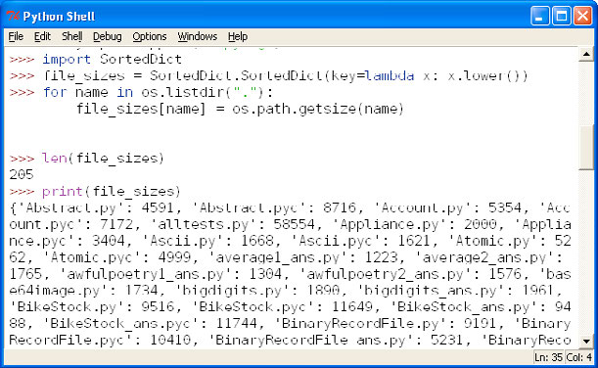Figure 3.1: idle’s Python Shell
Let’s look at a few tiny examples, and then discuss some of the details:
x = "blue"
y = "green"
z = x

para1
para2
para3
Figure 3.2: idle’s Python Shell
Let’s look at a few tiny examples, and then discuss some of the details:
x = "blue"
y = "green"
z = x

para1
para2
para3
Let’s look at a few tiny examples, and then discuss some of the details:
Figure 3.3: idle’s Python Shell
x = "blue"
y = "green"
z = x

para1
para2
para3
Let’s look at a few tiny examples, and then discuss some of the details:
x = "blue"
Figure 3.4: idle’s Python Shell
y = "green"
z = x

