Interference Between Image Borders & Paragraph Borders
This document is provided to give a working copy of a bug as reported in Python3docs Bugs #3. This bug is as follows:-
The bottom border of an image-in-frame-with-caption will coelesce with the top inline-border of a paragraph. In other words, the below-paragraph spacing of an image will be added to the internal top-spacing of the next paragraph, rather than being placed between the two entity’s borders.
To produce this document the following steps were taken:
- The styles from chapter_01.odt were loaded into this document under LO 24.8.3.2
- The image+caption “Figure-01.1: idle’s Python Shell” were copied from chapter_01.odt into this document.
- A “Code Box 2” was copied into the document below the image

Example:
print(x, y, z) # prints blue green blue
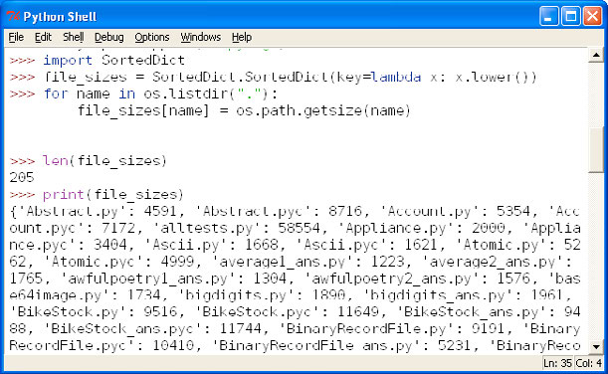Figure 1.1: idle’s Python Shell
z = y
print(x, y, z) # prints blue green green
x = z
print(x, y, z) # prints green green green

