**Deel-QA Automation/Manual candidate exam**

# Before you start

1. Please get familiar with our company here: <https://www.letsdeel.com/>
2. Write your full name and the start date of the exam in the document.
3. **All answers to the below questions should be in a Google docs / Microsoft word file.**

# Sign up

1. Sign up as an **Individual Contractor** here: **<https://dev.deel.wtf/>**

*** You will be prompted by the steps in the sign up flow.

1. Check the screenshot below from the signing up page and proceed to the test plan.

This is the account settings screen of a customer that is **signing up** to the system as an **Individual Contractor**.

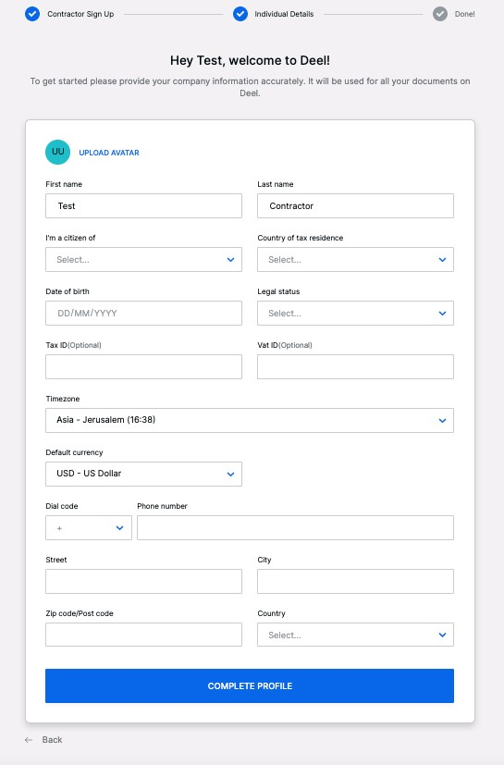

# Test Plan

Please **prepare a test plan** to fully test this screen.

* Please specify how you will test **each** of the fields above with all relevant edge cases.
* Make sure to include positive and negative tests.

# Automation

Please specify how you are going to ***automate*** the test plan in terms of:

Tools: GhostInspector (an automated browser testing service that allow you to monitor and test your websites using real browsers from the cloud).

Processes:

* Happy Sign-Up path
* Exception Validation
* Text field name asserts
* Verify the correct introduction of data in the fields (length, special characters, alphanumerical characters support) and verify the non-acceptance from the frontend.
* Empty state validations

Stages:

* Registry with only required information (Happy Sign-Up path)
* Registry with required information and optional fields.
* Registry with long names, exceeding the normal entry data.
* Registry with special characters in names, incorrect dates and wrong data.
* Registry with empty information

Reports:

* Reports from every successful stage.
* Screen Comparison between the tests.

Lighthouse reports such as:

* Time to First Byte
* Response Time
* First Contentful Paint
* Speed Index
* Visually Complete
* Time to Interactive

And those reports in different browsers, Operative System and different devices.

A Google Analytics overview to know from which device an platform our users are using most could give us a good idea in where to focus.

# Test Types

We now want to divide the automation test plan into:

Sanity (smoke) test - upon each commit.

I could run this test manually whenever a new release be sent. An End to End test must be performed to ensure that everything is running without errors. The test will not perform a new register.

Regression test - running every night.

This test could be left scheduled every night just to verify the status of the service.

An End to End test must be performed to ensure that everything is running without errors. The test will not perform a new register. We need to validate with the engineering area that the database registry data match with the people that click the registry button and ensure the health of the database and API services.

End2end test - running on weekends with heavy data.

This test suite could run every 15 minutes. This suite must go with API validations and work with notifications to ensure the good health of the connections and database where the API with drop the userdata. I recommend this type of test in order to validate the backend and frontend interaction.

Tools used:

Thundra for backend services observation

GhostInspector for user registry frontend validation.

It could be great to implement Lucky Orange in order to learn from the user which are our opportunity areas, learn and study the Dynamic Heatmaps and analyze how the user work with our registry screen.

With GhostInspector we can schedule these 3 different types of tests and have full coverage of the tests.

# Test Automation

Try writing a test automation to verify sign-up process.

It should include a **positive test:** if all data entered correctly, user should be able to sign up.

* Also **negative tests**: missing/invalid data is stopped and correct error message shown.
* Result should be in the form of a link to a GitHub repo, and an .md file explaining what is being tested and how to run it.

Good Luck!

All my tests have been uploaded to my link of my GitHub repo: <https://github.com/alexkhaleb/Deel>

Finish date: Tuesday, April 27, 2021. 23:17hrs (UTC-5)