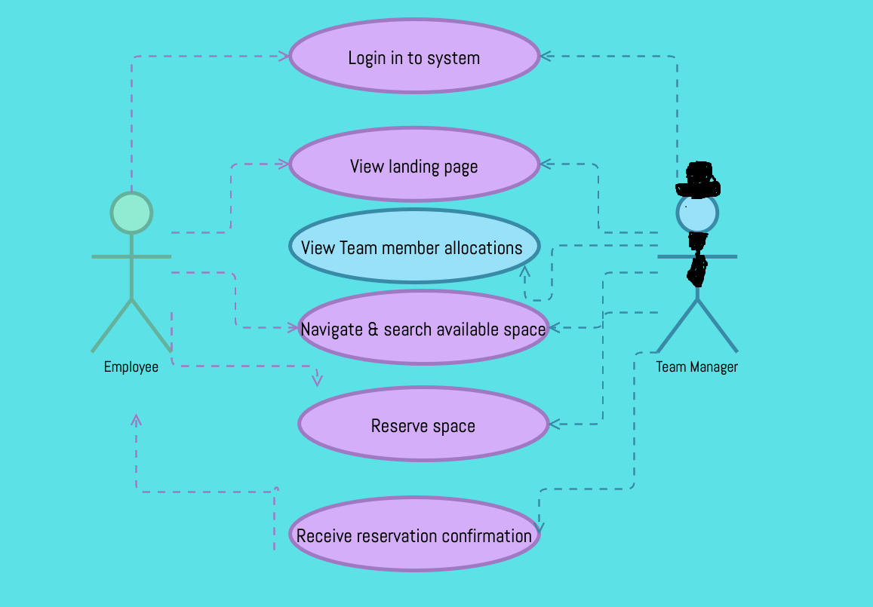

|  |  |
| --- | --- |
| Managerial view of Hot Desk Use Case |  |
| Description | Users select workspace for duration of specified time in advance & make reservations. Team manager to have ability to oversee team member reservations & allocations. |
| Actors | Team managers & reporting staff |
| Pre-conditions | Access & reporting list |
| Trigger | Need to view staff member seating |
| Main Flow of Events | Login & navigate system, view landing page, navigate to overview of team seating |
| Alternate flow | Login & navigate system, unable to view team seating/ system error. Reporting staff tables not linked |
| Pre-Condition | Staff members have made reservations, received confirmation & manager is able to view said reservations |
| Issues | System issues resulting in manager inability to view, no free space, system not correctly updated |