**Bluetooth**

**unWork**

**Assistant**

**Mouse**

***Daniel-W* – 50 Anniversary Edition**

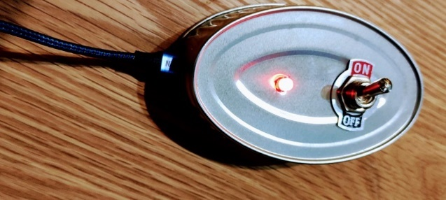Connect your MightyMouse

To make MightyMouse work, Put in hole of computer or power thing. Turn mouse on or off with switch on/off, then do what say here following to join it to PC:

On PC (windows or other thing) Go to Start > Settings > Devices > Bluetooth & other devices > Add Bluetooth or Other device

The MightyMouse now show in list of things.

Success.

Battery

The Bluetooth MightyMouse uses 1 False AA battery. To save false battery power, switch MightyMouse off when no use.

You can look false battery left power in windows set. The false battery power left percent is make random every time MightyMouse start.

Functionality of the mouse

When **ON**, every little time the mouse go some dots and you work while you not. When **OFF**, it not and you work yourself.

How MightyMouse is made:

**ESP32 Dev board** @ <https://www.espressif.com/en/products/devkits>

**Arduino IDE Code** @ <https://github.com/alexkoppelman/ESP32_BT_Mouse>

**Sardine Can** @

<https://caprabo.com>

So.. if you don't need the mouse, have **fun** anyways:

https://randomnerdtutorials.com/projects-esp32/