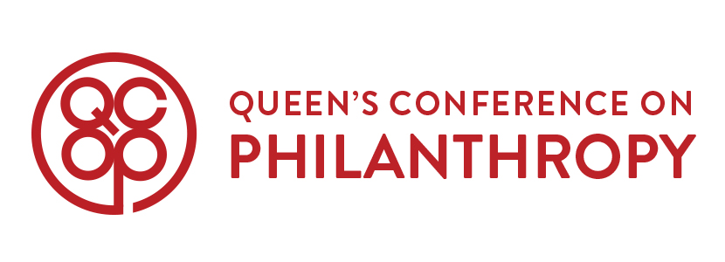

***QCOP 2017 First Year Representative Application***

*Due: Monday, October 3rd at 11:59pm*

**What is QCOP?**

Now entering its ninth year, Queen’s Conference on Philanthropy is Canada’s premier undergraduate philanthropic conference. It aims to educate, inspire, and empower delegates nationwide to discover their passion and make a difference in today’s world. The conference features a lineup of motivational speakers who have made an impact across various industries. Delegates are exposed to diverse insights on philanthropy, its evolving role in society, and numerous ways they can get involved. A series of hands-on workshops are provided to equip delegates with the tools to address, analyze, and tackle both local and global issues.

**Our Purpose**

QCOP was born after two passionate individuals shared their love in the backseat of a car. They shared their love forhumanity and discussed their desire to show their peers how anyone has the power to make a difference, whether it is big or small. QCOP strives to build a positive community among students all across Canada. A community of people who lend their time, talent, and passion in order to make our world a better place. We work to promote an inclusive and empowering environment for our executive, our phenomenal delegates, the distinguished speakers we attract, and anyone who stumbles across our social media.

**Our Mission and Vision**

As the first undergraduate conference of our kind, we dedicate ourselves to providing a rich and uplifting experience under a unified theme. We connect delegates with various philanthropic professionals and act as enablers of relationships, enterprises, and/or projects that are born out of the conference. As a hub for change-oriented dialogue and activism, we strive for a culture of creativity, a supportive community, and an ever-lasting impact.

**Our Team Character**

Plain and simple, we are the executive team with the most HEART. This means an inclusive and caring work environment, an atmosphere of creativity and fun, and in the end, a family.

QCOP Love,

**Ellen He** & **Danielle Lauzon**

QCOP 2017 Co-Chairs | qcopexec@gmail.com

**Application Information**

|  |
| --- |
| **Due Date: Monday, October 3rd at 11:59pm**  **WHEN YOUR APPLICATION IS COMPLETED, PLEASE:**  **Submit a soft-copy of your application** **via email** **to** [qcopexec@gmail.com](mailto:qcopexec@gmail.com) **and** **save the document as “First Name Last Name – QCOP Application.doc”**  (i.e. “Danielle Lauzon – QCOP Application.doc”)  **Applicants invited for an interview (to be held on October 4th, 5th, or 6th) will be contacted shortly.** |

|  |  |
| --- | --- |
| Name |  |
| Faculty/Program & Year |  |
| Email |  |
| Phone Number |  |

**Application Questions**

**GENERAL QUESTIONS**

Please answer the following three questions in 350 words or less. These general questions will help us get to know you better and assess how well you would fit into the QCOP family.

1. Why QCOP?
2. What are three of your strengths that would allow you to succeed as one of QCOP’s frosh reps? Please provide one concrete example of a specific situation where you have demonstrated each strength.
3. If you had a $100 budget to make the biggest difference, what would you do and why? Be creative!

**CREATIVE COMPONENT INSTRUCTION**

As the co-chairs of QCOP 2017, we firmly believe in the importance of building a cohesive, enthusiastic, and passionate executive committee. We understand the difficulty of displaying your true character through these applications, so here is your chance. We want to know who YOU are.

**Please come prepared with something creative to display your individuality, hilarity, or passion for life! This could be ANYTHING from a video to a piece of art. Surprise us!**

If you have any questions about this application, feel free to contact us at: [qcopexec@gmail.com](mailto:qcopexec@gmail.com). Thank you and we look forward to reading your application!

**Ellen He** & **Danielle Lauzon**

qcopexec@gmail.com