eFID 系統之動態多地區人員彈出對話框

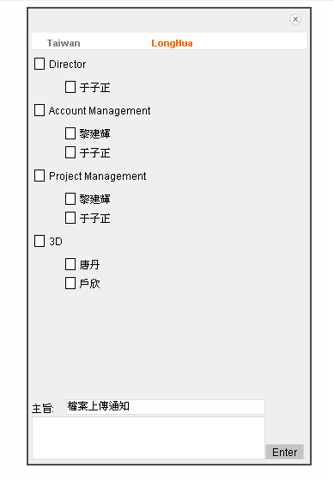

1. 該模塊是用dojo的dialog來實現的。首先在調用的也面設置dialog，如下：

<div dojoType="dialog" id="fibcMessageDialog" bgColor="white"

executeScripts="true" bgOpacity="0.5" toggle="fade"

toggleDuration="250" closeOnBackgroundClick="true">

<div dojoType="ContentPane" width="100%" executeScripts="true"

preload="true" refreshOnShow="true" cacheContent="false"

style="display: show;"

href="${pageContext.request.contextPath}/A133.do?action=loadFIBCPane&userArea=${userArea}&projectId=${model.primaryKey}">

</div>

</div>

可以看出，這個dialog裏面的內容是通過執行loadFIBCPane這個方法之後，返回的頁面。LoadFIBCPane的方法如下：

**public** ModelAndView loadFIBCPane(HttpServletRequest request, HttpServletResponse repsonse) **throws** Exception {

A220Bean a220Bean = **new** A220Bean(sessionFactory);

List locations = a220Bean.getWorkLoadingLocation();

**return** **new** ModelAndView(**this**.messageSend, "locations", locations);

}

該方法是講所有用來分類的地點查詢出來，執行之後，返回this.messageSend頁面，

<property name="messageSend" value="/pm/A100/A130/messageSend.jsp"></property> 也就是返回messageSend頁面，現在dialog中顯示的就是messageSend的頁面，

<div class="calendar_maintenance" style="overflow:auto;width:320px;text-vertical:top;padding:0px">

<div style="text-align:right;;width:100%;padding-right:5px;padding-bottom:5px">

<img style="cursor:hand" onclick="closeFIBCMessageDialog()" src="${pageContext.request.contextPath}/images/closeDiaglog.gif"></img>

</div>

<div id="addPerson" style="width:320px;padding-top:5px" class="location_option">

<c:forEach var="location" items="${locations}" varStatus="status">

<c:choose>

<c:when test="${param['userArea']==location}">

<a name="location" id="location${status.count}" class="selected" href="javascript:switchLocation('location${status.count}','${location}','${param['projectId']}')" >${location}</a><span style="width:80px"></span>

</c:when>

<c:otherwise>

<a name="location" id="location${status.count}" class="deselected" href="javascript:switchLocation('location${status.count}','${location}','${param['projectId']}')">${location}</a><span style="width:80px"></span>

</c:otherwise>

</c:choose>

</c:forEach>

</div>

<div dojoType="ContentPane" id="share_content" style="overflow-y:auto;width:320px;height:400px" executeScripts="true" preload="false" refreshOnShow="true" cacheContent="false" widgetId="share_content" name="share_content" style="display:show;" href="${pageContext.request.contextPath}/A133.do?action=getRoleUsers&location=${param['userArea']}&projectId=${param['projectId']}" onLoad="UserSelectManage.initShareUser()">

</div>

<div style="height:20px;text-align:left;padding-top:5px">

<div style="width:272px;text-align:right;"><span style="width:38px;text-align:left;float:left;padding-top:5px"><spring:message code="notification.subject.title" />:</span><span style="width:232px;;float:right"><textarea id="messageSubject" name="messageSubject" rows="" cols="" style="width:100%;height:100%"><spring:message code="notification.subject.default" /></textarea></span></div>

</div>

<div style="width:100%;height:50px">

<textarea id="messageContent" name="messageContent" rows="" cols="" style="width:272px;height:100%"></textarea><input type="button" onclick="sendFibcMessage()" value="Enter" style="width:45px;;cursor:hand;">

</div>

</div>

可以看到，這個messageSend頁面包含了頁面顯示的全部元素，包括文本框，查詢結果等。param['userArea']保存著用戶的地址，所以當頁面加載的時候，該dialog會自動的切換到和用戶同意地點的菜單。switchLocation是javascript腳本，是用來切換菜單的，

function switchLocation(link,area,projectId)

{

var currentLocation = document.getElementById(link);

var locations = document.getElementsByName("location");

for(var i=0;i<locations.length;i++){

locations[i].className = "deselected";

}

currentLocation.className = "selected";

var content = dojo.widget.byId("share_content");

content.setUrl("${pageContext.request.contextPath}/A133.do?action=getRoleUsers&location=" + area+"&projectId="+projectId);

}

可以看到，每次切換菜單的時候，都要先去執行一個getRoleUsers的方法，講需要顯示的信息查詢出來，然後講顯示的信息顯示在share_content的dojo contentPane中。

**public** ModelAndView getRoleUsers(HttpServletRequest request, HttpServletResponse repsonse) **throws** Exception {

CalendarManageModel model = **new** CalendarManageModel();

String location = request.getParameter("location");

Integer projectId = Integer.*parseInt*(request.getParameter("projectId"));

A220Bean bean = **new** A220Bean(sessionFactory);

String[] rolePrefix = (String[]) **this**.m_RolePrefix.toArray(**new** String[**this**.m_RolePrefix.size()]);

TreeMap<Role, ArrayList<User>> roleUserMap = bean.getProjectRoleUsers(rolePrefix, location, projectId);

model.setRoleUser(roleUserMap);

**return** **new** ModelAndView(m_SelectUserContentPage, "model", model);

}

執行getRoleUsers方法之後，就會返回一個SelectUserContentPage的頁面，這個頁面指向/pm/A100/A130/selectUserContentPage.jsp，所以，share_content中顯示的是selectUserContentPage.jsp的頁面。