Electronic Import Permit Web tool – ePerm. Deployment guide.

# Objective

Electronic Import Permit Webtool (ePerm) is a computer program to serve interaction related to Import Permit Applications[1]. The form of this interaction is electronic documents and records exchange between a legal entity and the state agency as well as inside the state agency.

The ePerm uses the database and administrative function defined in the Pharmadex tool.

Pharmadex is a web-based tool that helps streamline and track medicines registration for a national drug regulatory agency.

This manual describes how to install ePerm, link it to the Pharmadex database, publish it to the web, and maintain it in working condition.

You will need administrative rights in Pharmadex and on the computer, you plan to install ePerm.

# Components of ePerm

* pdex_import_permit-0.0.1-SNAPSHOT.jar – the web application built upon Spring Boot 2 and ReactJS
* application.properties – external configuration of the application
* eperm.xml – MS Windows service configuration
* eperm.exe – MS Windows service executable

# Pre-deployment

First, log in to Pharmadex as Administrator and check the roles list

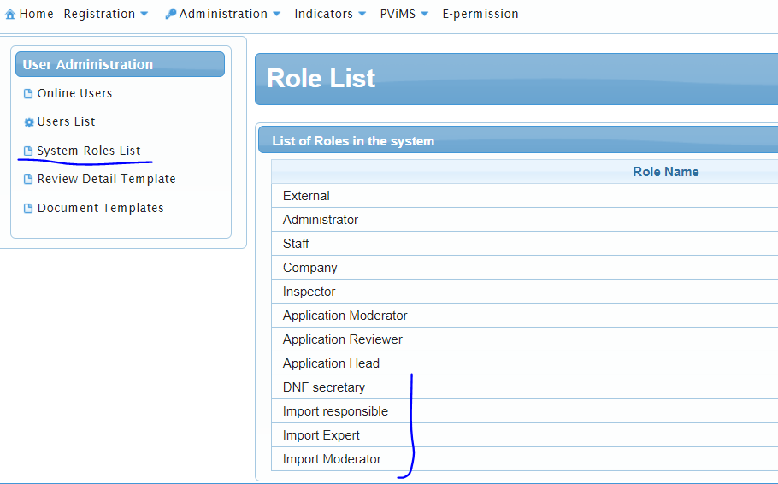

The last four roles – should be defined. In case if at least one role from this list is not defined, please ask Pharmadex Tech Support.

Second, check the Users List. At least one user should be assigned to the role Company and these roles.

Third, check access by TCP/IP protocol to the Pharmadex database from the server computer

# Deployment

## Copy software

Copy all ePerm components to some folder on the server computer. On MS-Windows the result should look like this:

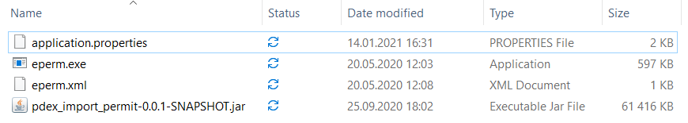

## General configuration

Please, check file application.properties. You may need to fine-tune following

|  |  |  |
| --- | --- | --- |
| **Property** | **Value** | **Example** |
| server.port | free TCP/IP port to direct access | 9292 |
| spring.datasource.url | JDBC URL to access server - database[2] | jdbc:mysql://localhost/  pdx_gen?useSSL=false&  useUnicode=yes&  characterEncoding=UTF-8&serverTimezone=UTC |
| spring.datasource.username | log in name to access the MySQL database | pharmadex |
| spring.datasource.password | password to access the MySQL database | Cnfhsq_Rhjrjlbk_45By |

### MS Windows deployment

The ePerm should run as an MS-Windows service. In [1] recommended wrapper is “winsw” (<https://github.com/winsw/winsw>).

The eprm.exe and eperm.xml are the implementation of this wrapper. Please, check eperm.xml. This configuration suit most cases.

run Command Prompt application as administrator

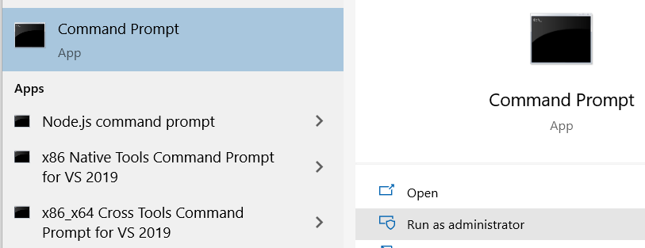

go to the folder of unpacked components and, then, execute eperm install

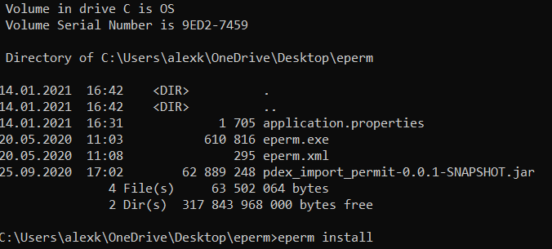

Result will be

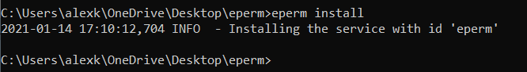

Start eperm service using Services application

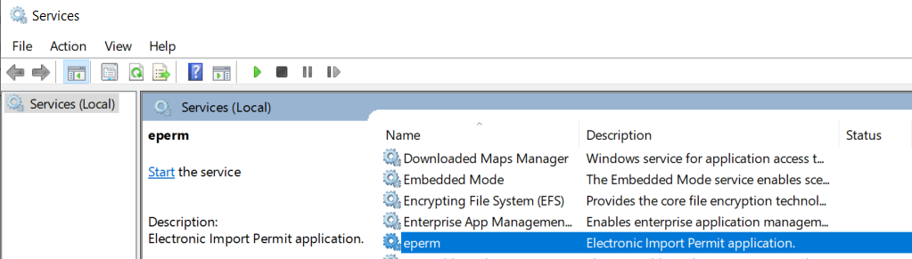

Access the web tool locally. For example, the port is 8082

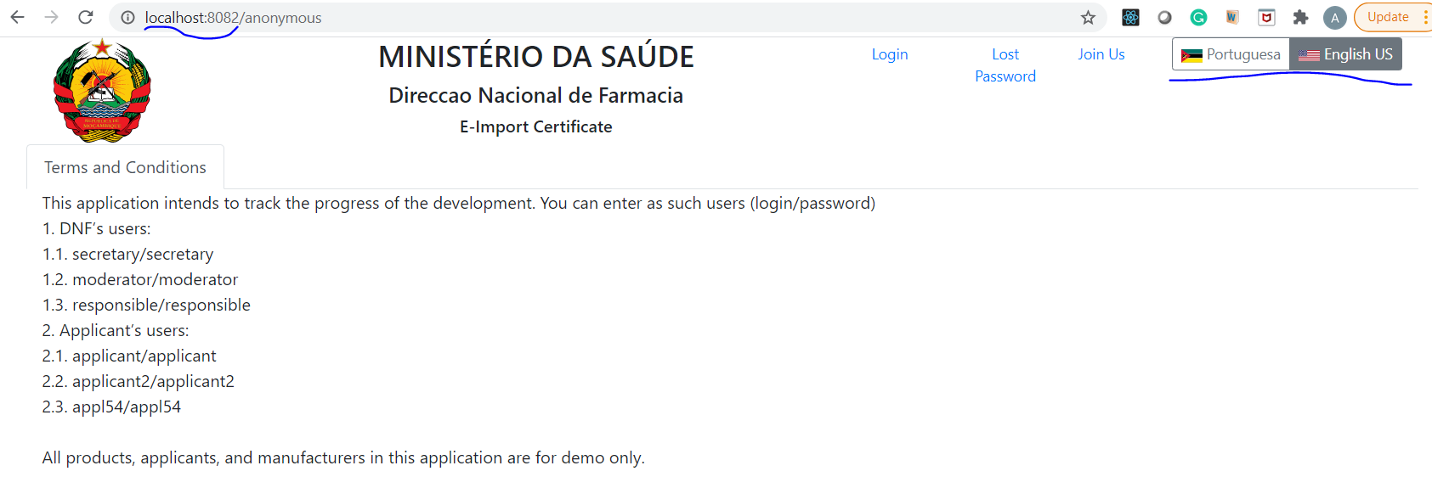

* Select language if both languages unselected
* The emblem is SVG formatted image you can find in the Pharmadex database, “workspace” table.
* Languages defined in tables “resource_bundles” and “resource_messages”
* All labels and messages are defined in “resource_messages”. You can easily found them by SQL query.

### Linux notes

The installation as the systemd service seems like a good choice. Refer to [1] and your Linux documentation for details.

The traditional place to unpack the software is a subfolder in the home directory for some non-root, non-sudo user.

Log files may be placed to the var filesystem, or to log subfolder of the base software folder.

## Maintenance

In most cases, ePerm software does not require maintenance. It will be a good idea to restart the software weekly to clean up memory and system resources like MySQL connection etc.

# References

# 1 <https://docs.spring.io/spring-boot/docs/current/reference/html/deployment.html> - Spring Boot deploym

1. The Import Permit Application is an application that should be submitted to receive import permits for medicines, vaccines, biological products, and medical products for human use. This permit may be asked and received by legal entities in accordance with the national legislative. The Import Permit Application should be verified and approved or rejected by the appropriate state agency.
2. https://dev.mysql.com/doc/connector-j/8.0/en/connector-j-reference-jdbc-url-format.html