Water Sr:Ca & Otolith Sr Data Analysis

## Water Chemistry

### Water Sr:Ca between two rivers across 7 yrs

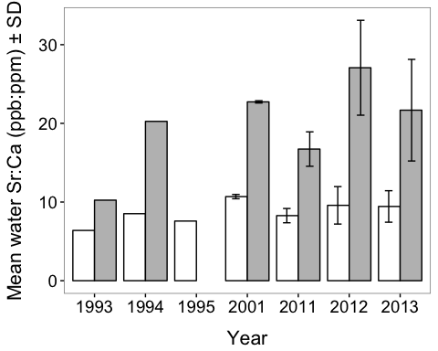

* white: Maumee River, gray: Sandusky River

### ANOVA of water Sr:Ca ~ year*site (2001, 2011, 2012, and 2013 data)

## Df Sum Sq Mean Sq F value Pr(>F)   
## year 3 75.8 25.3 2.283 0.0899 .   
## site 1 2144.0 2144.0 193.858 <2e-16 ***  
## year:site 3 116.1 38.7 3.499 0.0218 *   
## Residuals 52 575.1 11.1   
## ---  
## Signif. codes: 0 '***' 0.001 '**' 0.01 '*' 0.05 '.' 0.1 ' ' 1

### Tukey HSD (water Sr:Ca ~ year*site)

## Tukey multiple comparisons of means  
## 95% family-wise confidence level  
##   
## Fit: aov(formula = Sr.Ca ~ year * site, data = df_water4)  
##   
## $year  
## diff lwr upr p adj  
## 2011-2001 -3.00458770 -6.7838169 0.7746415 0.1634143  
## 2012-2001 -0.09622982 -3.8754590 3.6829993 0.9998878  
## 2013-2001 -1.83276431 -5.1170966 1.4515680 0.4560602  
## 2012-2011 2.90835789 -0.6949957 6.5117115 0.1534657  
## 2013-2011 1.17182340 -1.9085049 4.2521517 0.7445013  
## 2013-2012 -1.73653449 -4.8168628 1.3437939 0.4470708  
##   
## $site  
## diff lwr upr p adj  
## Sandusky River-Maumee River 12.19372 10.42179 13.96565 0  
##   
## $`year:site`  
## diff lwr upr  
## 2011:Maumee River-2001:Maumee River -2.4180993 -8.48054672 3.6443482  
## 2012:Maumee River-2001:Maumee River -1.1092333 -6.78013360 4.5616671  
## 2013:Maumee River-2001:Maumee River -1.2523004 -6.23853205 3.7339312  
## 2001:Sandusky River-2001:Maumee River 12.0425956 5.26457323 18.8206179  
## 2011:Sandusky River-2001:Maumee River 6.0430003 -0.01944717 12.1054478  
## 2012:Sandusky River-2001:Maumee River 16.3808917 9.60286942 23.1589141  
## 2013:Sandusky River-2001:Maumee River 10.9866921 5.45246009 16.5209242  
## 2012:Maumee River-2011:Maumee River 1.3088660 -4.36203434 6.9797663  
## 2013:Maumee River-2011:Maumee River 1.1657988 -3.82043279 6.1520304  
## 2001:Sandusky River-2011:Maumee River 14.4606948 7.68267249 21.2387171  
## 2011:Sandusky River-2011:Maumee River 8.4610996 2.39865209 14.5235470  
## 2012:Sandusky River-2011:Maumee River 18.7989910 12.02096868 25.5770133  
## 2013:Sandusky River-2011:Maumee River 13.4047914 7.87055935 18.9390234  
## 2013:Maumee River-2012:Maumee River -0.1430672 -4.64510527 4.3589709  
## 2001:Sandusky River-2012:Maumee River 13.1518288 6.72163225 19.5820254  
## 2011:Sandusky River-2012:Maumee River 7.1522336 1.48133323 12.8231339  
## 2012:Sandusky River-2012:Maumee River 17.4901250 11.05992843 23.9203216  
## 2013:Sandusky River-2012:Maumee River 12.0959254 6.99361556 17.1982352  
## 2001:Sandusky River-2013:Maumee River 13.2948960 7.45958768 19.1302043  
## 2011:Sandusky River-2013:Maumee River 7.2953007 2.30906912 12.2815323  
## 2012:Sandusky River-2013:Maumee River 17.6331922 11.79788387 23.4685005  
## 2013:Sandusky River-2013:Maumee River 12.2389926 7.91037145 16.5676137  
## 2011:Sandusky River-2001:Sandusky River -5.9995953 -12.77761758 0.7784271  
## 2012:Sandusky River-2001:Sandusky River 4.3382962 -3.08665526 11.7632476  
## 2013:Sandusky River-2001:Sandusky River -1.0559034 -7.36589880 5.2540920  
## 2012:Sandusky River-2011:Sandusky River 10.3378914 3.55986912 17.1159138  
## 2013:Sandusky River-2011:Sandusky River 4.9436918 -0.59054021 10.4779239  
## 2013:Sandusky River-2012:Sandusky River -5.3941996 -11.70419498 0.9157958  
## p adj  
## 2011:Maumee River-2001:Maumee River 0.9093517  
## 2012:Maumee River-2001:Maumee River 0.9984774  
## 2013:Maumee River-2001:Maumee River 0.9927858  
## 2001:Sandusky River-2001:Maumee River 0.0000209  
## 2011:Sandusky River-2001:Maumee River 0.0512981  
## 2012:Sandusky River-2001:Maumee River 0.0000000  
## 2013:Sandusky River-2001:Maumee River 0.0000020  
## 2012:Maumee River-2011:Maumee River 0.9956906  
## 2013:Maumee River-2011:Maumee River 0.9953340  
## 2001:Sandusky River-2011:Maumee River 0.0000004  
## 2011:Sandusky River-2011:Maumee River 0.0012831  
## 2012:Sandusky River-2011:Maumee River 0.0000000  
## 2013:Sandusky River-2011:Maumee River 0.0000000  
## 2013:Maumee River-2012:Maumee River 1.0000000  
## 2001:Sandusky River-2012:Maumee River 0.0000010  
## 2011:Sandusky River-2012:Maumee River 0.0048980  
## 2012:Sandusky River-2012:Maumee River 0.0000000  
## 2013:Sandusky River-2012:Maumee River 0.0000000  
## 2001:Sandusky River-2013:Maumee River 0.0000001  
## 2011:Sandusky River-2013:Maumee River 0.0006377  
## 2012:Sandusky River-2013:Maumee River 0.0000000  
## 2013:Sandusky River-2013:Maumee River 0.0000000  
## 2011:Sandusky River-2001:Sandusky River 0.1185823  
## 2012:Sandusky River-2001:Sandusky River 0.5934441  
## 2013:Sandusky River-2001:Sandusky River 0.9994458  
## 2012:Sandusky River-2011:Sandusky River 0.0003304  
## 2013:Sandusky River-2011:Sandusky River 0.1119753  
## 2013:Sandusky River-2012:Sandusky River 0.1459631

## Otolith Sr

### Data summary

## year location otoSr.ppm   
## 1993:40 Maumee :124 Min. : 395.9   
## 1994:41 Sandusky:134 1st Qu.: 800.2   
## 1995:40 Median :1097.8   
## 2001:33 Mean :1309.8   
## 2011:24 3rd Qu.:1699.8   
## 2012:38 Max. :4376.5   
## 2013:42

### ANOVA of oto Sr ~ year*location(site)

## Df Sum Sq Mean Sq F value Pr(>F)   
## location 1 61854142 61854142 420.500 < 2e-16 ***  
## year 6 10393452 1732242 11.776 1.36e-11 ***  
## location:year 6 5785234 964206 6.555 1.96e-06 ***  
## Residuals 244 35891562 147097   
## ---  
## Signif. codes: 0 '***' 0.001 '**' 0.01 '*' 0.05 '.' 0.1 ' ' 1

### Tukey HSD test (oto Sr ~ year*site)

## Tukey multiple comparisons of means  
## 95% family-wise confidence level  
##   
## Fit: aov(formula = otoSr.ppm ~ location * year, data = df_oto1)  
##   
## $location  
## diff lwr upr p adj  
## Sandusky-Maumee 980.0111 885.8752 1074.147 0  
##   
## $year  
## diff lwr upr p adj  
## 1994-1993 32.47987 -220.93565 285.895396 0.9997566  
## 1995-1993 -30.08110 -285.05612 224.893916 0.9998498  
## 2001-1993 362.06698 93.91124 630.222722 0.0015265  
## 2011-1993 -300.49793 -594.91772 -6.078133 0.0420252  
## 2012-1993 320.41171 62.10354 578.719879 0.0051249  
## 2013-1993 -88.49677 -340.41808 163.424549 0.9430562  
## 1995-1994 -62.56098 -315.97650 190.854550 0.9903446  
## 2001-1994 329.58711 62.91378 596.260447 0.0053743  
## 2011-1994 -332.97780 -626.04807 -39.907529 0.0147061  
## 2012-1994 287.93184 31.16292 544.700757 0.0169448  
## 2013-1994 -120.97664 -371.31944 129.366161 0.7813372  
## 2001-1995 392.14809 123.99235 660.303826 0.0004009  
## 2011-1995 -270.41682 -564.83661 24.002971 0.0950772  
## 2012-1995 350.49281 92.18465 608.800983 0.0014137  
## 2013-1995 -58.41566 -310.33698 193.505653 0.9930976  
## 2011-2001 -662.56491 -968.47054 -356.659279 0.0000000  
## 2012-2001 -41.65527 -312.98229 229.671744 0.9993099  
## 2013-2001 -450.56375 -715.81757 -185.309929 0.0000178  
## 2012-2011 620.90964 323.59858 918.220692 0.0000000  
## 2013-2011 212.00116 -79.77804 503.780362 0.3212385  
## 2013-2012 -408.90848 -664.20282 -153.614141 0.0000669  
##   
## $`location:year`  
## diff lwr upr  
## Sandusky:1993-Maumee:1993 584.0000000 173.0964938 994.903506  
## Maumee:1994-Maumee:1993 -246.3792460 -652.3615746 159.603083  
## Sandusky:1994-Maumee:1993 899.3816665 488.4781604 1310.285173  
## Maumee:1995-Maumee:1993 -289.5550833 -700.4585895 121.348423  
## Sandusky:1995-Maumee:1993 813.3928751 402.4893690 1224.296381  
## Maumee:2001-Maumee:1993 18.7086982 -524.8655468 562.282943  
## Sandusky:2001-Maumee:1993 1190.5854149 800.7681215 1580.402708  
## Maumee:2011-Maumee:1993 -302.7250000 -731.3734430 125.923443  
## Sandusky:2011-Maumee:1993 6.0455952 -564.5884924 576.679683  
## Maumee:2012-Maumee:1993 -0.8278509 -417.1028727 415.447171  
## Sandusky:2012-Maumee:1993 1225.6512720 809.3762502 1641.926294  
## Maumee:2013-Maumee:1993 -114.3005351 -530.5755569 301.974487  
## Sandusky:2013-Maumee:1993 551.2551377 153.9765494 948.533726  
## Maumee:1994-Sandusky:1993 -830.3792460 -1236.3615746 -424.396917  
## Sandusky:1994-Sandusky:1993 315.3816666 -95.5218396 726.285173  
## Maumee:1995-Sandusky:1993 -873.5550833 -1284.4585895 -462.651577  
## Sandusky:1995-Sandusky:1993 229.3928752 -181.5106310 640.296381  
## Maumee:2001-Sandusky:1993 -565.2913018 -1108.8655468 -21.717057  
## Sandusky:2001-Sandusky:1993 606.5854149 216.7681215 996.402708  
## Maumee:2011-Sandusky:1993 -886.7250000 -1315.3734430 -458.076557  
## Sandusky:2011-Sandusky:1993 -577.9544047 -1148.5884923 -7.320317  
## Maumee:2012-Sandusky:1993 -584.8278509 -1001.1028727 -168.552829  
## Sandusky:2012-Sandusky:1993 641.6512720 225.3762502 1057.926294  
## Maumee:2013-Sandusky:1993 -698.3005351 -1114.5755569 -282.025513  
## Sandusky:2013-Sandusky:1993 -32.7448623 -430.0234505 364.533726  
## Sandusky:1994-Maumee:1994 1145.7609126 739.7785840 1551.743241  
## Maumee:1995-Maumee:1994 -43.1758373 -449.1581659 362.806491  
## Sandusky:1995-Maumee:1994 1059.7721212 653.7897926 1465.754450  
## Maumee:2001-Maumee:1994 265.0879443 -274.7758530 804.951742  
## Sandusky:2001-Maumee:1994 1436.9646609 1052.3382422 1821.591080  
## Maumee:2011-Maumee:1994 -56.3457540 -480.2790593 367.587551  
## Sandusky:2011-Maumee:1994 252.4248413 -314.6758743 819.525557  
## Maumee:2012-Maumee:1994 245.5513952 -165.8667054 656.969496  
## Sandusky:2012-Maumee:1994 1472.0305180 1060.6124174 1883.448619  
## Maumee:2013-Maumee:1994 132.0787110 -279.3393896 543.496812  
## Sandusky:2013-Maumee:1994 797.6343838 405.4479020 1189.820865  
## Maumee:1995-Sandusky:1994 -1188.9367499 -1599.8402560 -778.033244  
## Sandusky:1995-Sandusky:1994 -85.9887914 -496.8922976 324.914715  
## Maumee:2001-Sandusky:1994 -880.6729683 -1424.2472134 -337.098723  
## Sandusky:2001-Sandusky:1994 291.2037483 -98.6135451 681.021042  
## Maumee:2011-Sandusky:1994 -1202.1066666 -1630.7551095 -773.458224  
## Sandusky:2011-Sandusky:1994 -893.3360713 -1463.9701589 -322.701984  
## Maumee:2012-Sandusky:1994 -900.2095174 -1316.4845392 -483.934496  
## Sandusky:2012-Sandusky:1994 326.2696054 -90.0054164 742.544627  
## Maumee:2013-Sandusky:1994 -1013.6822016 -1429.9572234 -597.407180  
## Sandusky:2013-Sandusky:1994 -348.1265288 -745.4051171 49.152059  
## Sandusky:1995-Maumee:1995 1102.9479585 692.0444523 1513.851465  
## Maumee:2001-Maumee:1995 308.2637816 -235.3104635 851.838027  
## Sandusky:2001-Maumee:1995 1480.1404982 1090.3232048 1869.957792  
## Maumee:2011-Maumee:1995 -13.1699167 -441.8183596 415.478526  
## Sandusky:2011-Maumee:1995 295.6006786 -275.0334090 866.234766  
## Maumee:2012-Maumee:1995 288.7272324 -127.5477893 705.002254  
## Sandusky:2012-Maumee:1995 1515.2063553 1098.9313335 1931.481377  
## Maumee:2013-Maumee:1995 175.2545482 -241.0204735 591.529570  
## Sandusky:2013-Maumee:1995 840.8102211 443.5316328 1238.088809  
## Maumee:2001-Sandusky:1995 -794.6841769 -1338.2584220 -251.109932  
## Sandusky:2001-Sandusky:1995 377.1925397 -12.6247537 767.009833  
## Maumee:2011-Sandusky:1995 -1116.1178751 -1544.7663181 -687.469432  
## Sandusky:2011-Sandusky:1995 -807.3472799 -1377.9813675 -236.713192  
## Maumee:2012-Sandusky:1995 -814.2207260 -1230.4957478 -397.945704  
## Sandusky:2012-Sandusky:1995 412.2583968 -4.0166250 828.533419  
## Maumee:2013-Sandusky:1995 -927.6934102 -1343.9684320 -511.418388  
## Sandusky:2013-Sandusky:1995 -262.1377374 -659.4163257 135.140851  
## Sandusky:2001-Maumee:2001 1171.8767166 644.0616063 1699.691827  
## Maumee:2011-Maumee:2001 -321.4336982 -878.5429839 235.675587  
## Sandusky:2011-Maumee:2001 -12.6631030 -685.1618245 659.835619  
## Maumee:2012-Maumee:2001 -19.5365491 -567.1825683 528.109470  
## Sandusky:2012-Maumee:2001 1206.9425737 659.2965546 1754.588593  
## Maumee:2013-Maumee:2001 -133.0092333 -680.6552525 414.636786  
## Sandusky:2013-Maumee:2001 532.5464395 -0.8029256 1065.895805  
## Maumee:2011-Sandusky:2001 -1493.3104149 -1901.7896904 -1084.831139  
## Sandusky:2011-Sandusky:2001 -1184.5398196 -1740.1827740 -628.896865  
## Maumee:2012-Sandusky:2001 -1191.4132658 -1586.8885806 -795.937951  
## Sandusky:2012-Sandusky:2001 35.0658571 -360.4094577 430.541172  
## Maumee:2013-Sandusky:2001 -1304.8859500 -1700.3612648 -909.410635  
## Sandusky:2013-Sandusky:2001 -639.3302771 -1014.7581764 -263.902378  
## Sandusky:2011-Maumee:2011 308.7705952 -274.7712269 892.312417  
## Maumee:2012-Maumee:2011 301.8971491 -131.9031391 735.697437  
## Sandusky:2012-Maumee:2011 1528.3762720 1094.5759837 1962.176560  
## Maumee:2013-Maumee:2011 188.4244649 -245.3758233 622.224753  
## Sandusky:2013-Maumee:2011 853.9801377 438.3744676 1269.585808  
## Maumee:2012-Sandusky:2011 -6.8734461 -581.3875576 567.640665  
## Sandusky:2012-Sandusky:2011 1219.6056767 645.0915652 1794.119788  
## Maumee:2013-Sandusky:2011 -120.3461303 -694.8602418 454.167981  
## Sandusky:2013-Sandusky:2011 545.2095425 -15.6931650 1106.112250  
## Sandusky:2012-Maumee:2012 1226.4791229 804.9010207 1648.057225  
## Maumee:2013-Maumee:2012 -113.4726842 -535.0507863 308.105418  
## Sandusky:2013-Maumee:2012 552.0829886 149.2511638 954.914813  
## Maumee:2013-Sandusky:2012 -1339.9518071 -1761.5299092 -918.373705  
## Sandusky:2013-Sandusky:2012 -674.3961342 -1077.2279591 -271.564309  
## Sandusky:2013-Maumee:2013 665.5556728 262.7238480 1068.387498  
## p adj  
## Sandusky:1993-Maumee:1993 0.0002200  
## Maumee:1994-Maumee:1993 0.7302776  
## Sandusky:1994-Maumee:1993 0.0000000  
## Maumee:1995-Maumee:1993 0.4924499  
## Sandusky:1995-Maumee:1993 0.0000000  
## Maumee:2001-Maumee:1993 1.0000000  
## Sandusky:2001-Maumee:1993 0.0000000  
## Maumee:2011-Maumee:1993 0.4886275  
## Sandusky:2011-Maumee:1993 1.0000000  
## Maumee:2012-Maumee:1993 1.0000000  
## Sandusky:2012-Maumee:1993 0.0000000  
## Maumee:2013-Maumee:1993 0.9996673  
## Sandusky:2013-Maumee:1993 0.0003648  
## Maumee:1994-Sandusky:1993 0.0000000  
## Sandusky:1994-Sandusky:1993 0.3457534  
## Maumee:1995-Sandusky:1993 0.0000000  
## Sandusky:1995-Sandusky:1993 0.8293442  
## Maumee:2001-Sandusky:1993 0.0328622  
## Sandusky:2001-Sandusky:1993 0.0000261  
## Maumee:2011-Sandusky:1993 0.0000000  
## Sandusky:2011-Sandusky:1993 0.0438064  
## Maumee:2012-Sandusky:1993 0.0002816  
## Sandusky:2012-Sandusky:1993 0.0000332  
## Maumee:2013-Sandusky:1993 0.0000034  
## Sandusky:2013-Sandusky:1993 1.0000000  
## Sandusky:1994-Maumee:1994 0.0000000  
## Maumee:1995-Maumee:1994 1.0000000  
## Sandusky:1995-Maumee:1994 0.0000000  
## Maumee:2001-Maumee:1994 0.9264251  
## Sandusky:2001-Maumee:1994 0.0000000  
## Maumee:2011-Maumee:1994 0.9999999  
## Sandusky:2011-Maumee:1994 0.9651254  
## Maumee:2012-Maumee:1994 0.7523791  
## Sandusky:2012-Maumee:1994 0.0000000  
## Maumee:2013-Maumee:1994 0.9982687  
## Sandusky:2013-Maumee:1994 0.0000000  
## Maumee:1995-Sandusky:1994 0.0000000  
## Sandusky:1995-Sandusky:1994 0.9999847  
## Maumee:2001-Sandusky:1994 0.0000090  
## Sandusky:2001-Sandusky:1994 0.3913699  
## Maumee:2011-Sandusky:1994 0.0000000  
## Sandusky:2011-Sandusky:1994 0.0000224  
## Maumee:2012-Sandusky:1994 0.0000000  
## Sandusky:2012-Sandusky:1994 0.3116050  
## Maumee:2013-Sandusky:1994 0.0000000  
## Sandusky:2013-Sandusky:1994 0.1570356  
## Sandusky:1995-Maumee:1995 0.0000000  
## Maumee:2001-Maumee:1995 0.8129507  
## Sandusky:2001-Maumee:1995 0.0000000  
## Maumee:2011-Maumee:1995 1.0000000  
## Sandusky:2011-Maumee:1995 0.8934491  
## Maumee:2012-Maumee:1995 0.5198901  
## Sandusky:2012-Maumee:1995 0.0000000  
## Maumee:2013-Maumee:1995 0.9779674  
## Sandusky:2013-Maumee:1995 0.0000000  
## Maumee:2001-Sandusky:1995 0.0001176  
## Sandusky:2001-Sandusky:1995 0.0690591  
## Maumee:2011-Sandusky:1995 0.0000000  
## Sandusky:2011-Sandusky:1995 0.0002425  
## Maumee:2012-Sandusky:1995 0.0000000  
## Sandusky:2012-Sandusky:1995 0.0551407  
## Maumee:2013-Sandusky:1995 0.0000000  
## Sandusky:2013-Sandusky:1995 0.6040534  
## Sandusky:2001-Maumee:2001 0.0000000  
## Maumee:2011-Maumee:2001 0.7937533  
## Sandusky:2011-Maumee:2001 1.0000000  
## Maumee:2012-Maumee:2001 1.0000000  
## Sandusky:2012-Maumee:2001 0.0000000  
## Maumee:2013-Maumee:2001 0.9999149  
## Sandusky:2013-Maumee:2001 0.0507739  
## Maumee:2011-Sandusky:2001 0.0000000  
## Sandusky:2011-Sandusky:2001 0.0000000  
## Maumee:2012-Sandusky:2001 0.0000000  
## Sandusky:2012-Sandusky:2001 1.0000000  
## Maumee:2013-Sandusky:2001 0.0000000  
## Sandusky:2013-Sandusky:2001 0.0000021  
## Sandusky:2011-Maumee:2011 0.8775287  
## Maumee:2012-Maumee:2011 0.5140803  
## Sandusky:2012-Maumee:2011 0.0000000  
## Maumee:2013-Maumee:2011 0.9714107  
## Sandusky:2013-Maumee:2011 0.0000000  
## Maumee:2012-Sandusky:2011 1.0000000  
## Sandusky:2012-Sandusky:2011 0.0000000  
## Maumee:2013-Sandusky:2011 0.9999846  
## Sandusky:2013-Sandusky:2011 0.0661513  
## Sandusky:2012-Maumee:2012 0.0000000  
## Maumee:2013-Maumee:2012 0.9997324  
## Sandusky:2013-Maumee:2012 0.0004695  
## Maumee:2013-Sandusky:2012 0.0000000  
## Sandusky:2013-Sandusky:2012 0.0000036  
## Sandusky:2013-Maumee:2013 0.0000052

### Basic Boxplot (Oto Sr between two rivers across 7 yrs)

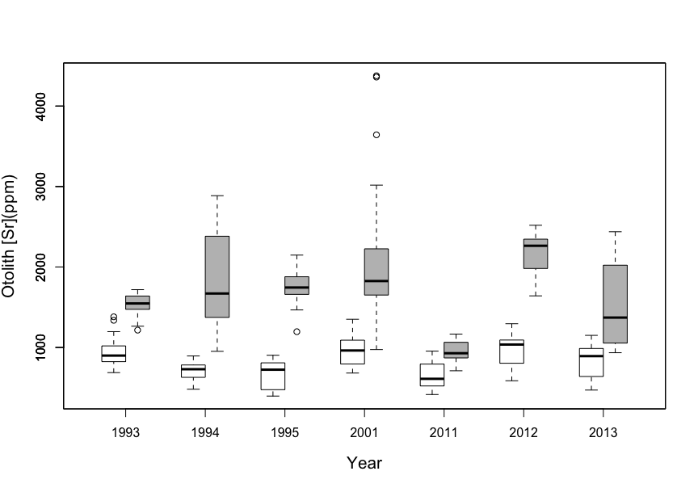

### ggplot2 Boxplot (Oto Sr between two rivers across 7 yrs)

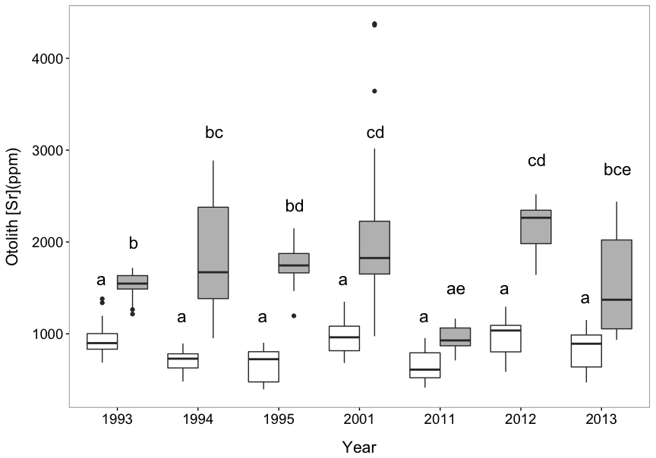

### ANCOVA of oto Sr ~ age*location)

## year location otoSr.ppm age.d   
## 1993:40 Maumee :112 Min. : 395.9 Min. : 1.000   
## 1994:36 Sandusky: 97 1st Qu.: 782.4 1st Qu.: 3.000   
## 1995:29 Median :1031.0 Median : 5.000   
## 2011:24 Mean :1208.7 Mean : 6.871   
## 2012:38 3rd Qu.:1617.0 3rd Qu.: 9.000   
## 2013:42 Max. :2643.1 Max. :23.000

#ANOVA with interaction between age and river  
mod1 <- aov(otoSr.ppm ~ age.d*location, data=df_oto2);summary(mod1)

## Df Sum Sq Mean Sq F value Pr(>F)   
## age.d 1 17820175 17820175 204.29 < 2e-16 ***  
## location 1 32016974 32016974 367.04 < 2e-16 ***  
## age.d:location 1 1298936 1298936 14.89 0.000153 ***  
## Residuals 205 17882455 87231   
## ---  
## Signif. codes: 0 '***' 0.001 '**' 0.01 '*' 0.05 '.' 0.1 ' ' 1

#ANOVA without interaction between age and river  
mod2 <- aov(otoSr.ppm ~ age.d + location, data=df_oto2);summary(mod2)

## Df Sum Sq Mean Sq F value Pr(>F)   
## age.d 1 17820175 17820175 191.4 <2e-16 ***  
## location 1 32016974 32016974 343.8 <2e-16 ***  
## Residuals 206 19181391 93114   
## ---  
## Signif. codes: 0 '***' 0.001 '**' 0.01 '*' 0.05 '.' 0.1 ' ' 1

#ANOVA of two models  
anova(mod1,mod2)

## Analysis of Variance Table  
##   
## Model 1: otoSr.ppm ~ age.d * location  
## Model 2: otoSr.ppm ~ age.d + location  
## Res.Df RSS Df Sum of Sq F Pr(>F)   
## 1 205 17882455   
## 2 206 19181391 -1 -1298936 14.891 0.0001526 ***  
## ---  
## Signif. codes: 0 '***' 0.001 '**' 0.01 '*' 0.05 '.' 0.1 ' ' 1

Note:

* Interaction between age and location is significant (F = 14.9, P < 0.001)
* Intercepts between two rivers are also significantly different (F = 343.8, P < 0.001)

### Two linear regressions

