Dynviz setup

Windows

- Download and install Processing.org exe for windows (WITH java):
http://www.processing.org/download/
- Download and install OpenCV Libraries 1.0 for windows (run the exe) (need to use the 1.0 libs for processing.org compatibility). Make sure you add the bin and lib directories to your environment variables PATH:
http://sourceforge.net/projects/opencvlibrary/files/opencv-win/1.0/
- Unzip and move the contents of the dynviz_processing libraries package to the libraries folder in the same location as the processing.exe application

Ubuntu (Linux)
- Install Processing.org executable (the following steps installed 1.2.1 on ubuntu 10.4)
$ sudo echo "deb http://ubuntu-backports.mirrormax.net/ hoary-extras main universe multiverse restricted" >> /etc/apt/sources.list

$ sudo apt-get update
$ sudo apt-get jikes
$ wget http://processing.googlecode.com/files/processing-1.2.1.tgz
$ tar -zxvf processing-1.2.1.tgz
$ rm -f processing-1.2.1.tgz
$ cd processing-1.2.1/
$ rm -f jikes
$ ln -s /usr/bin/jikes jikes
$ ./processing
_if you get an error with permissions chmod the file to allow executing, if java then gives a permissions error go into ./java/bin and give executable permissions to the executable
- Unzip and move the contents of the dynviz_processing libraries package to the libraries folder in the same location as the processing application

Now that the processing application has been installed, you need to unzip the main DynViz project do a directory on your system. (dynviz,zip).

Next run the processing application which will open up a window that looks like this:
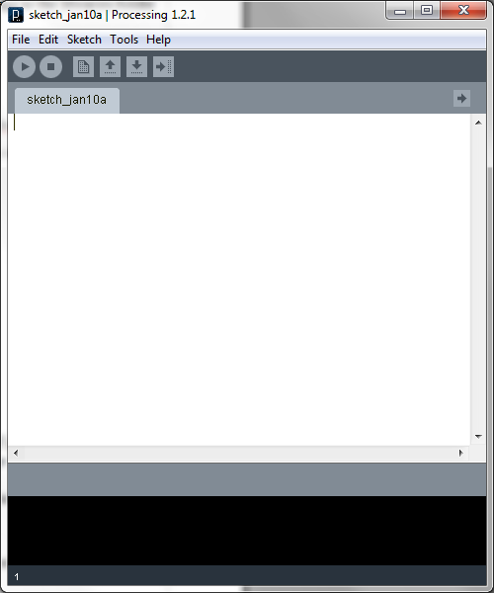
From the File menu, select “Open” and broswe to where you unzipped dynviz.zip and select dynviz.pde. This will open a window with all of the Dynviz source in it.

One of the files opened will be called “PCAPSender”, go to roughly line 321 of this file and edit the line “ private final String pcapFile =...” to have the exact path to your pcap file. For example, if on windows you have a file saved in C:\dynviz\sample.pcap the line would like this:
private final String pcapFile = "C:\\dynviz\\sample.pcap"
Remembering that you have to double up backslashes. In a directory under your home directory on ubuntu you would make the path look like this:
private final String pcapFile = "/home/<user>/dynviz/sample.pcap"
Where your user name would replace <user>.

Now click “Run” which is the arrow button on the top right corner of the application.

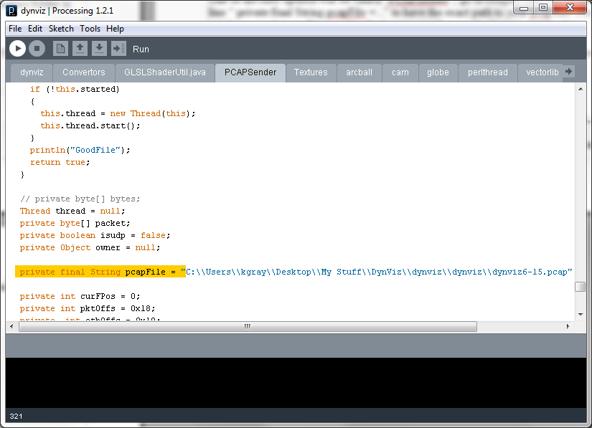
If everything goes well you should have an interactive screen that looks much like this
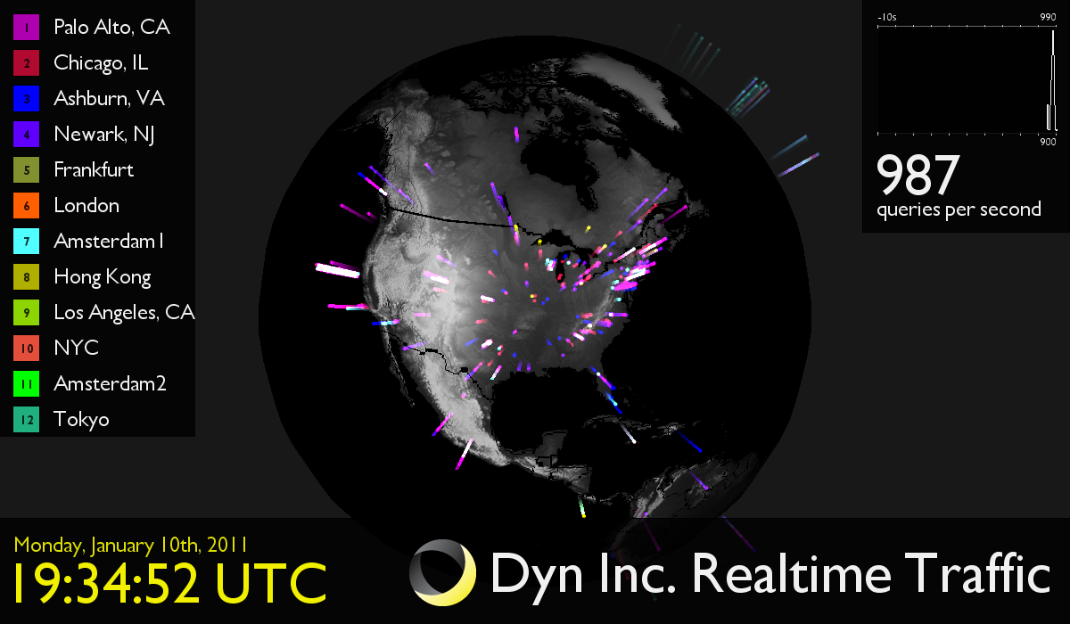
To run the application against a live server and view the real time traffic, set the variable “canUseSender” to false. The variable canUseSender is right around line 359 and would set as such
boolean canUseSender = false;

DynViz will look for a data through a stream coming through port 24642 now (thus you must open and allow that port through your firewall).

Under the dynviz folder you will have to change the data/receive.txt to be your local NIC's address (this so the socket bind will succeed).

Once all this is done, dynviz is ready to receive data.

Now on your server setup and run the perl script “dynviz-sniffer.pl” which will do exactly as it states, sniff the traffic coming through the server and send the output to your dynviz-sniffer over port 24642. All of the variables you will need to change are at the top of the file starting with the keyword “my”.

# the ip address would be the ip address of your dynviz server (where to send the stream to)
my @servers = qw( <ip address> );

# this would stay as 24642, it is the port used to send on (if you need to change it you must make the
# corresponding change on the dynviz receiver)
my $port = '24642';

# networks to add to sniffing filter (leave as is for no filtering)
my @networks;

# this is the local interface to sniff on
my $iface = 'span0';

# this is the hostname of the sending machine, used to identify the stream on the dynviz receiver)
my ($site) = (`hostname` =~ /^<sendding name>(...)/);

# vlan info to add to sniffing filter (leave as is for no filtering)
my $vlan = undef;
# the location of your GeoCityLit data file (http://www.maxmind.com/app/geolitecity or more
# specifically: http://geolite.maxmind.com/download/geoip/database/ ) this will look up locations
# by ip address
my $geoipdb = 'geoip/GeoLiteCity.dat';

# the queue length to hold packets, should not need to change this
my $pqlen = '20';

After you have updated your values simply run the perl script and it will do the packet sniffing and real time data sending for DynViz to catch and display.

