The Newshouse Phase two

# DEFINE AND IDEATE

## Melissa

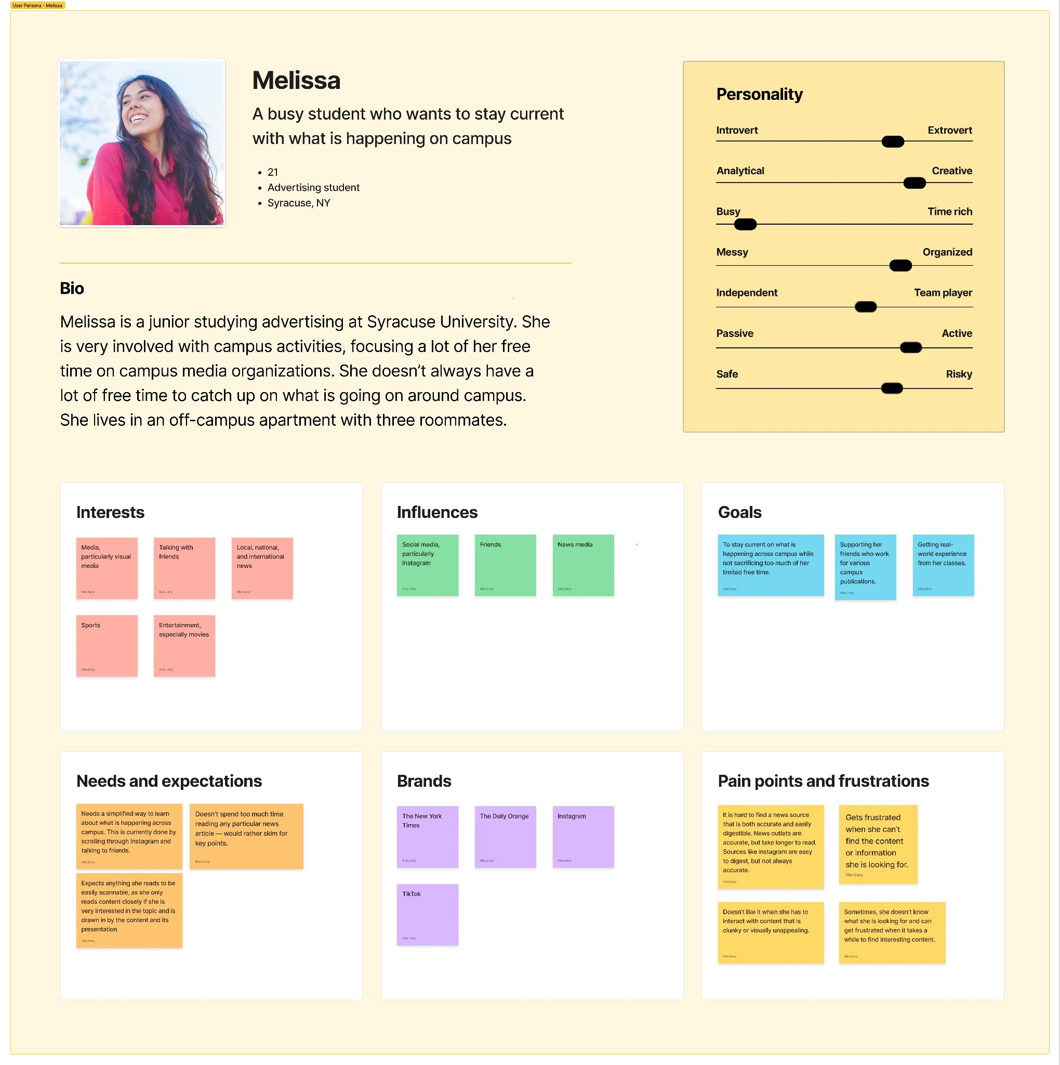

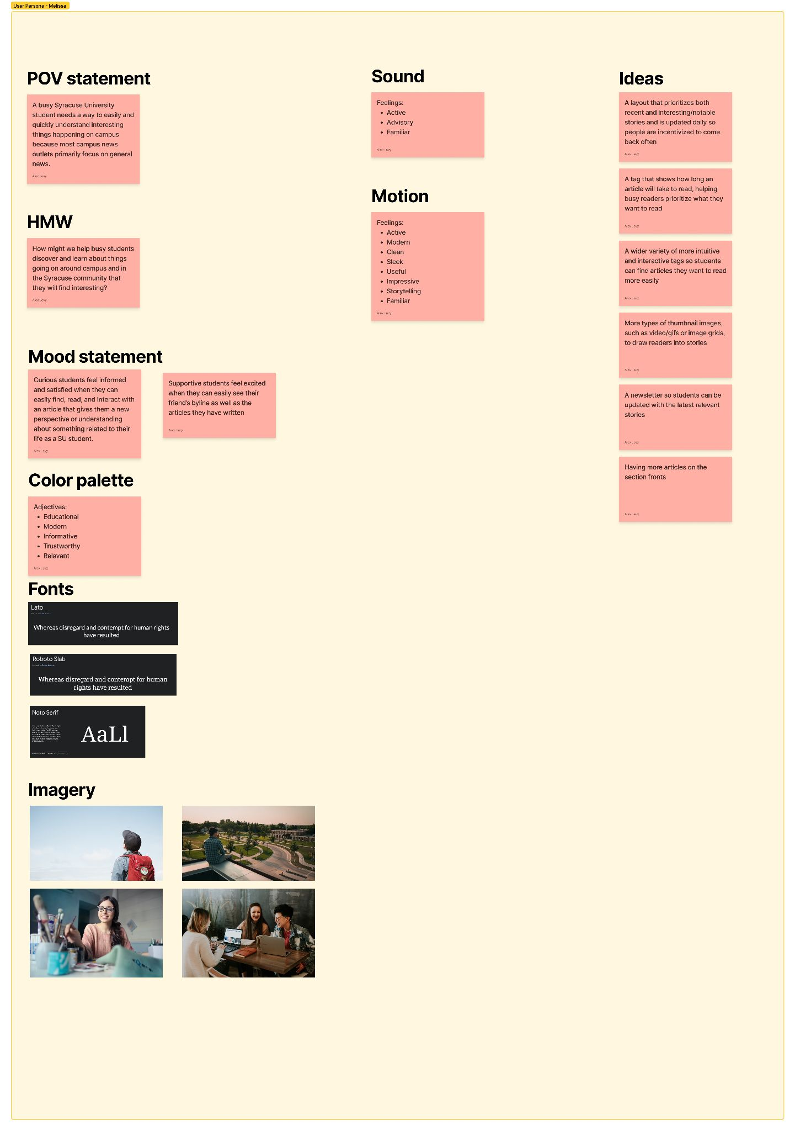

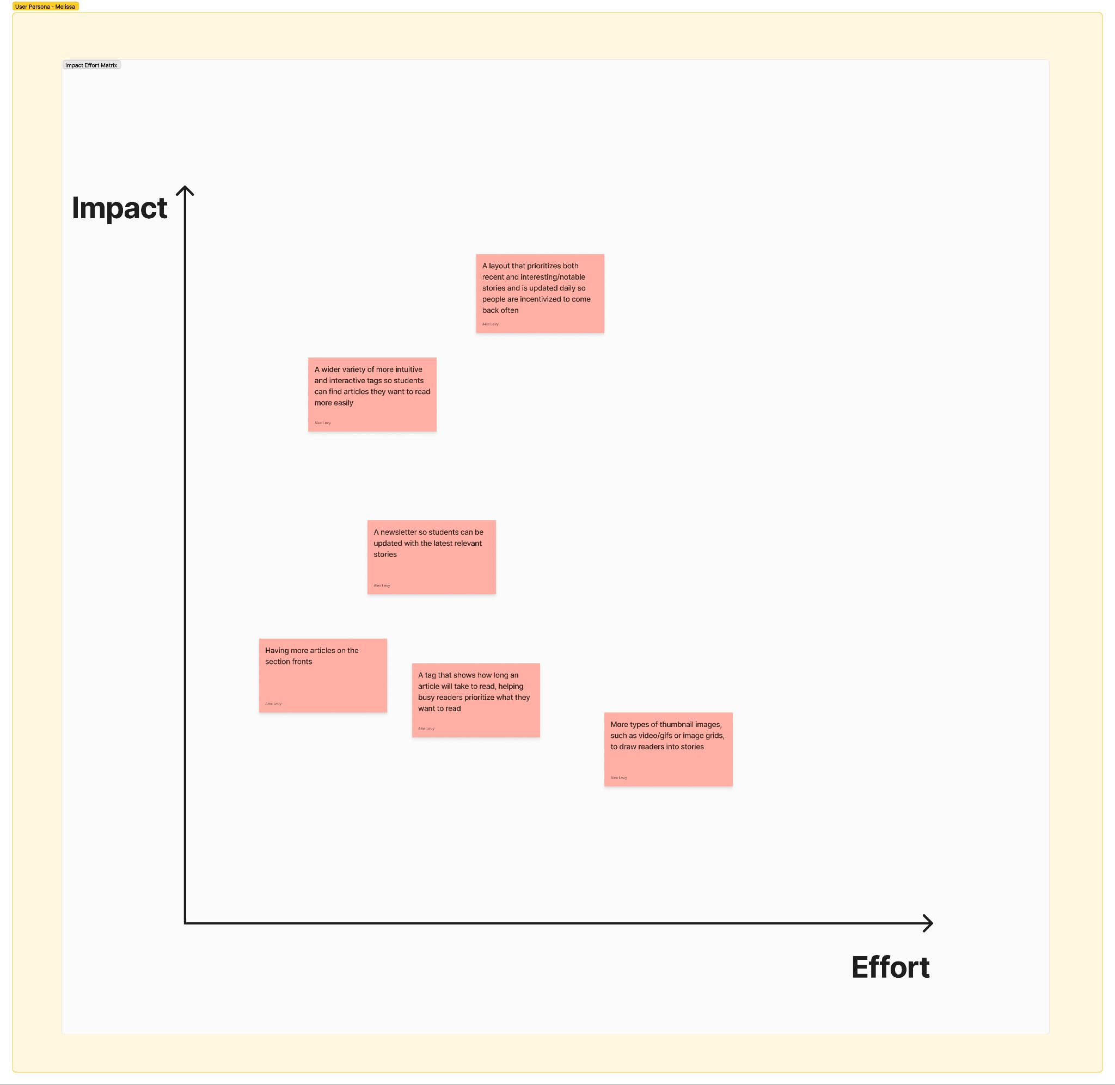

## Mia:

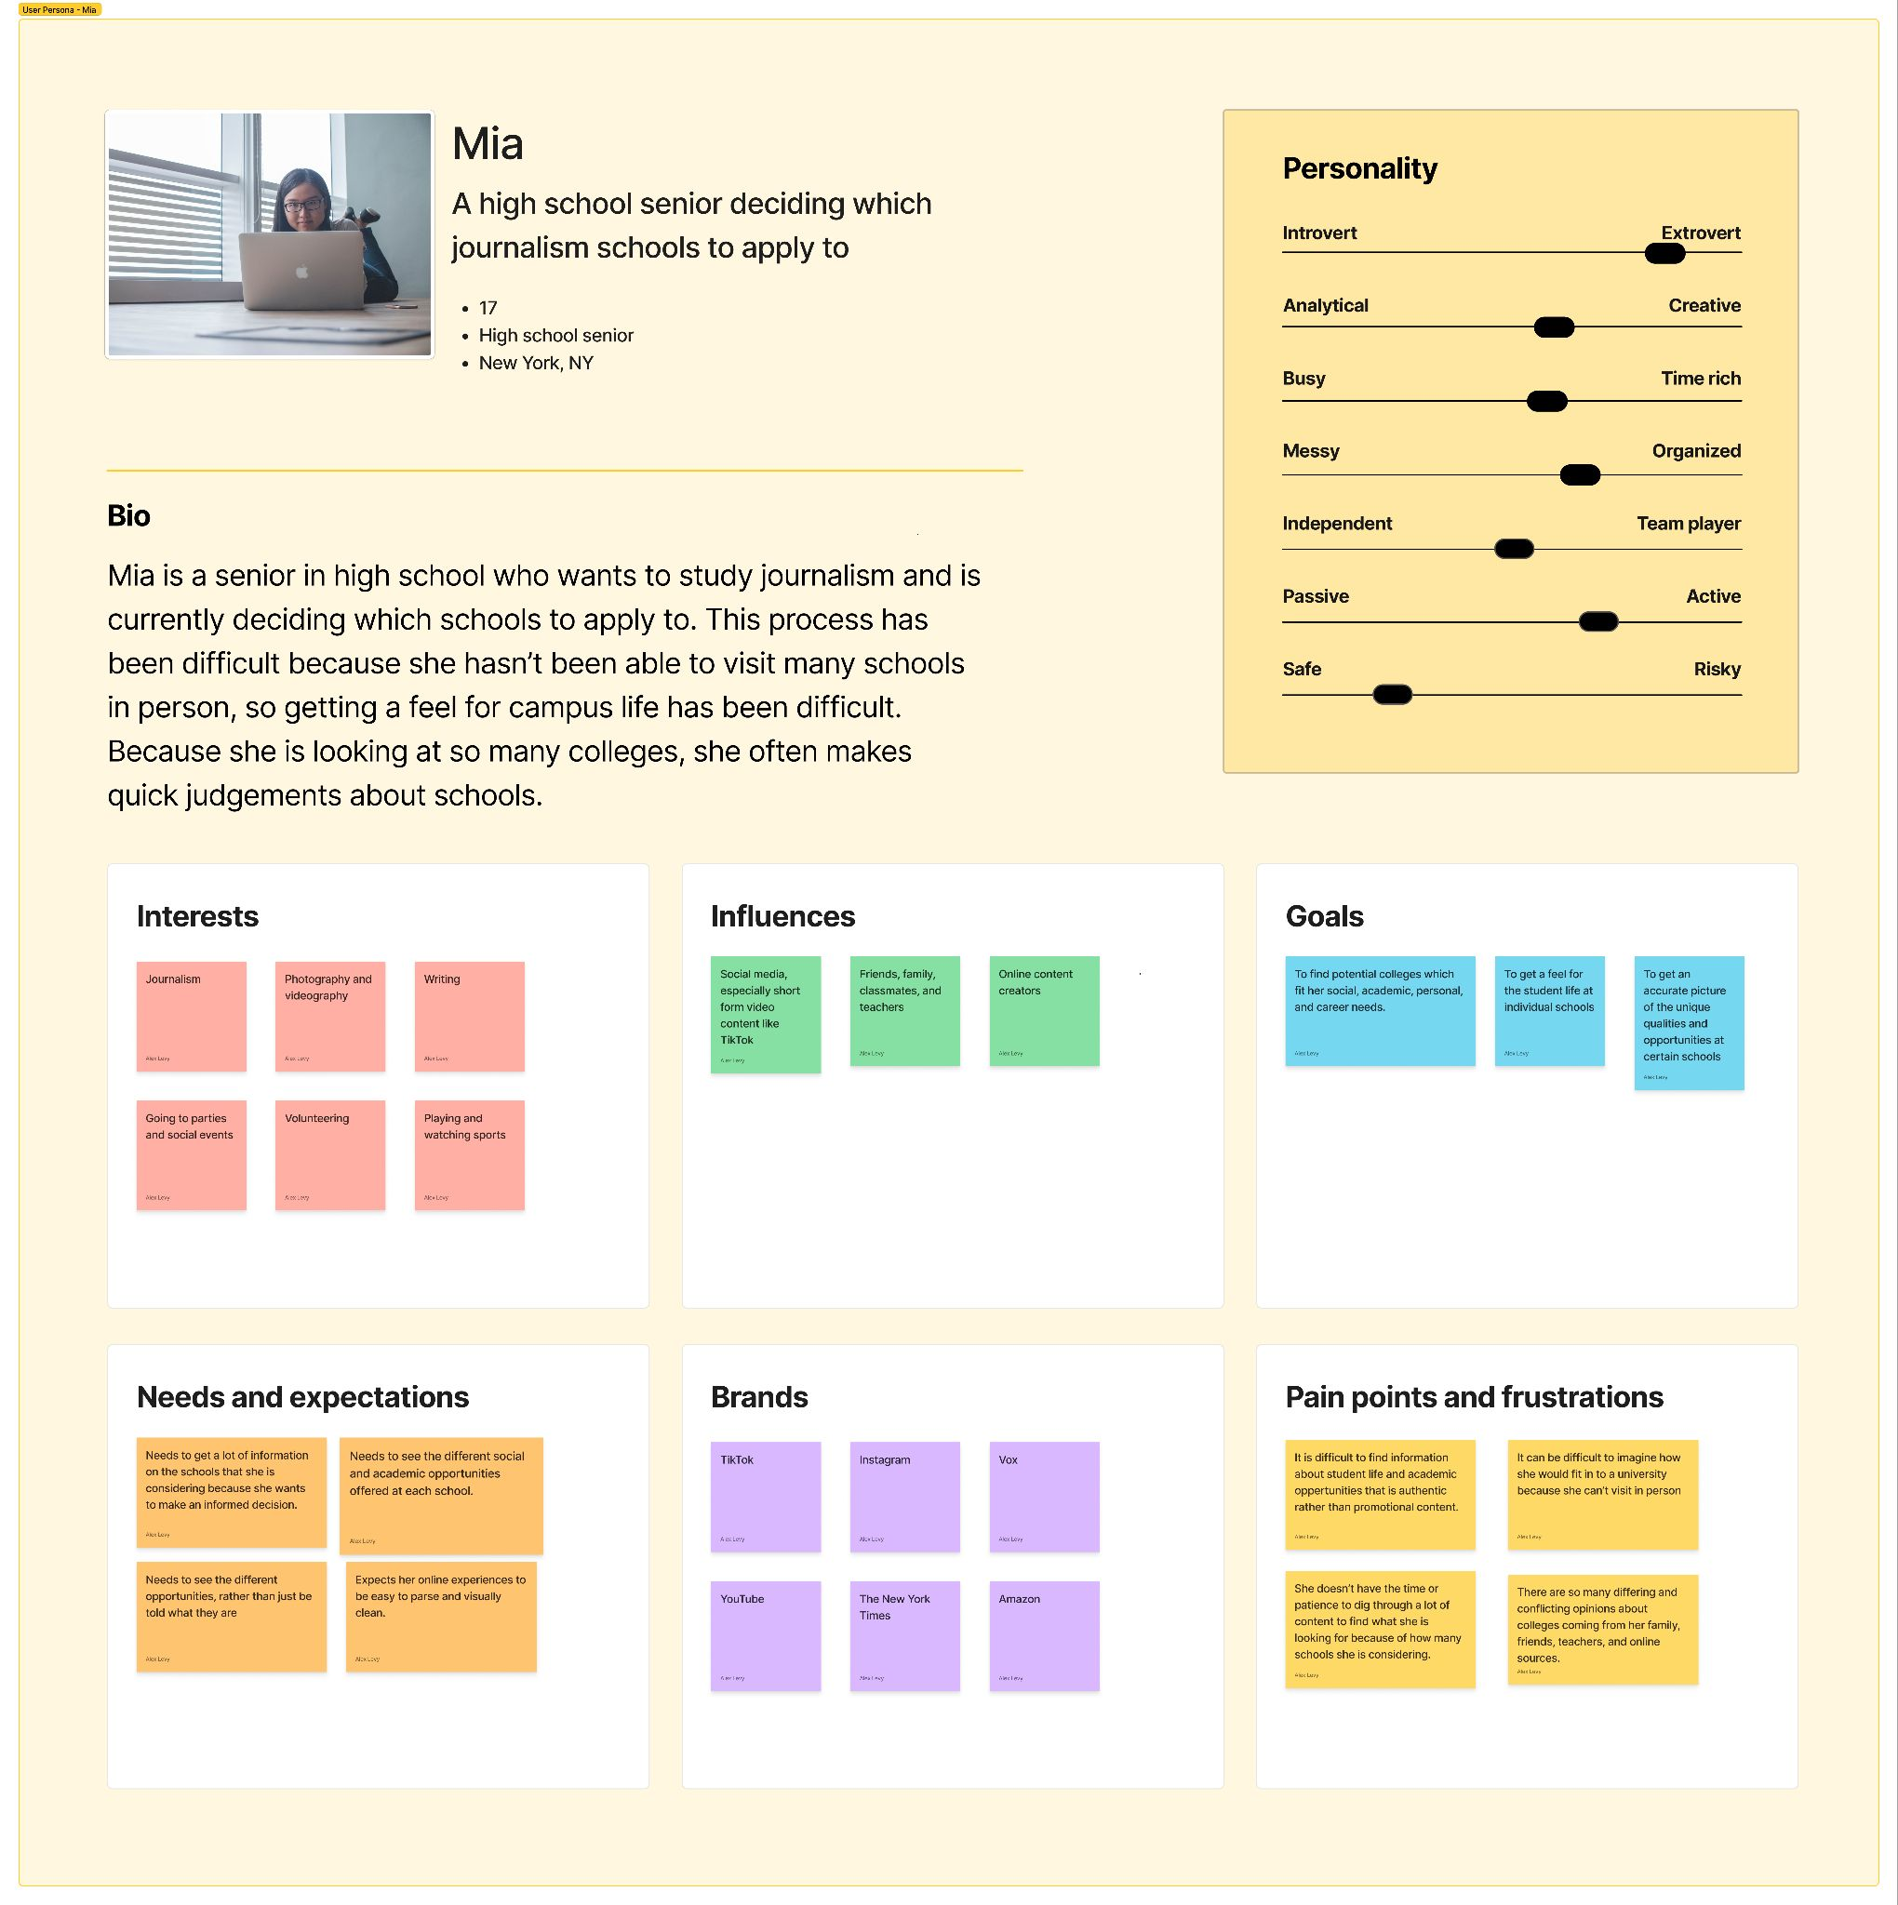

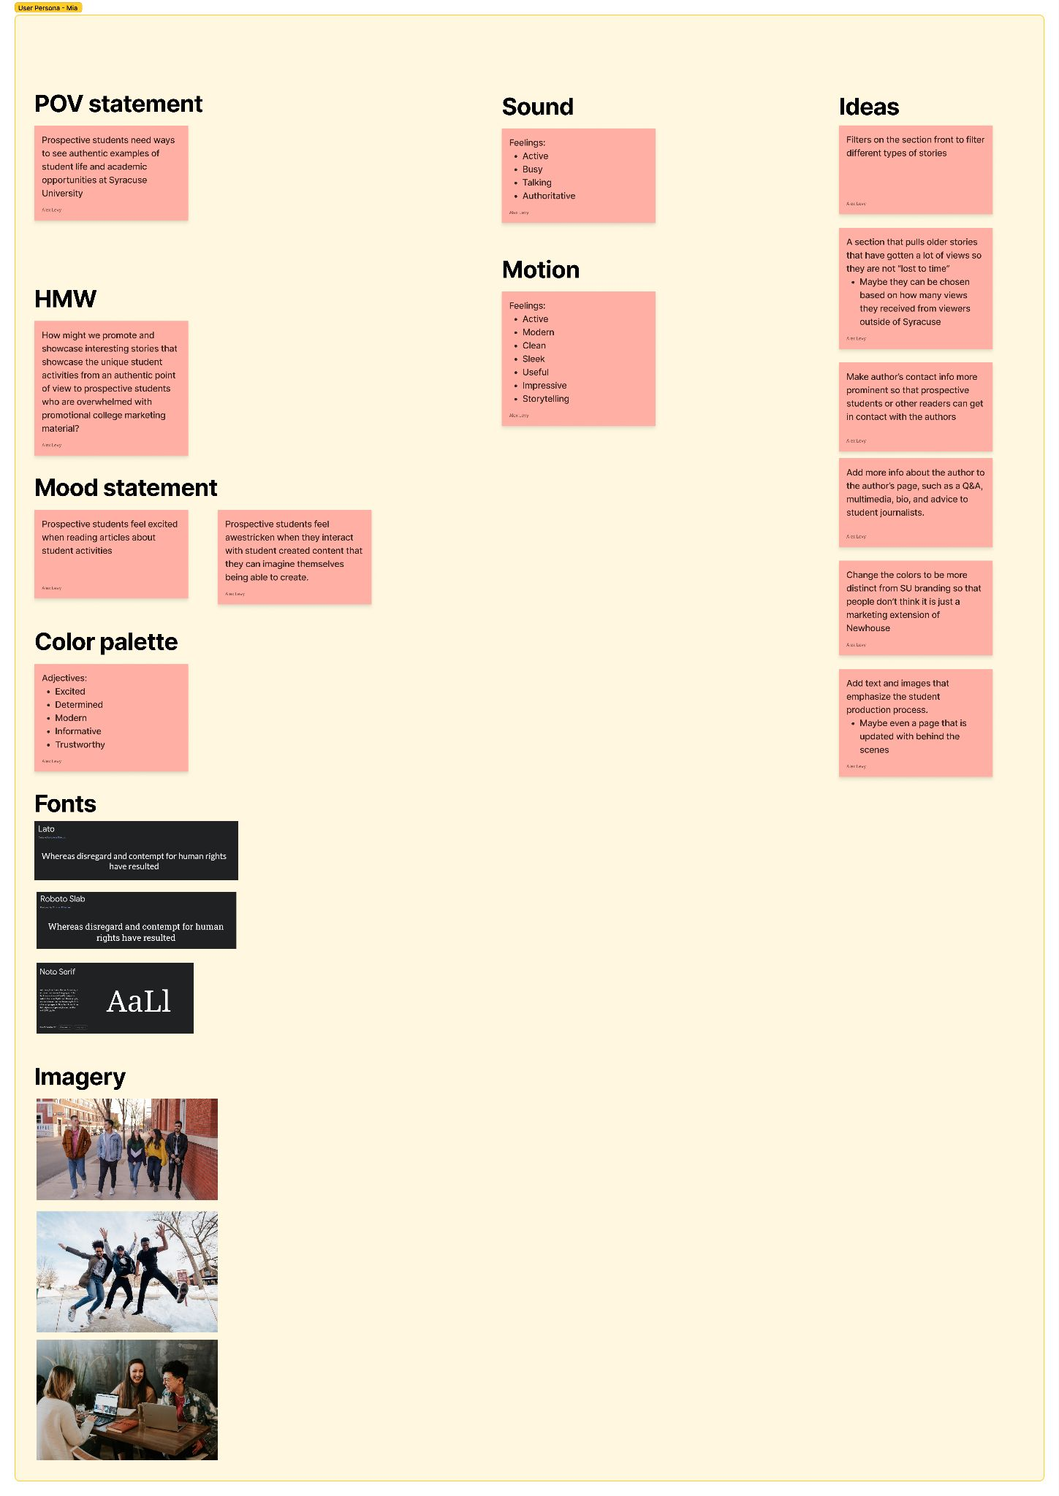

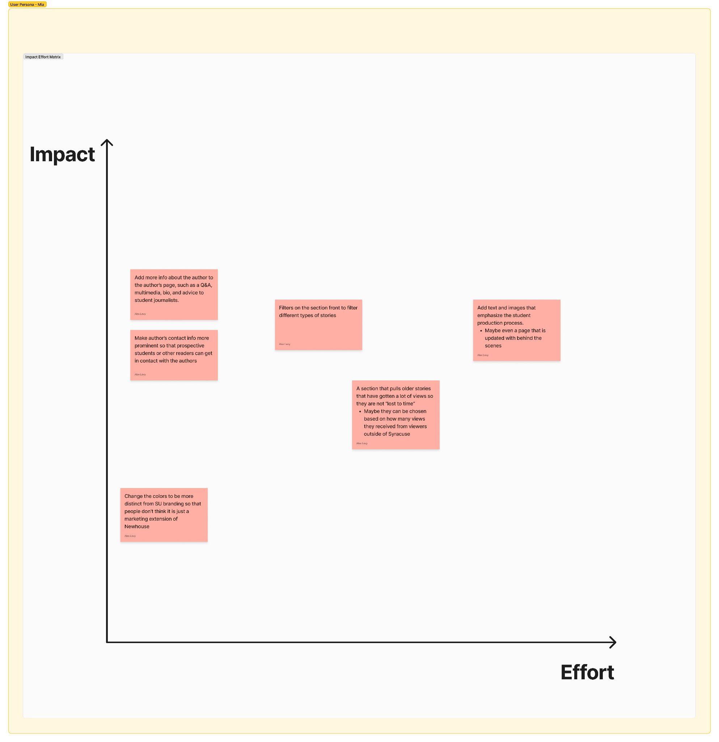

## Sophia

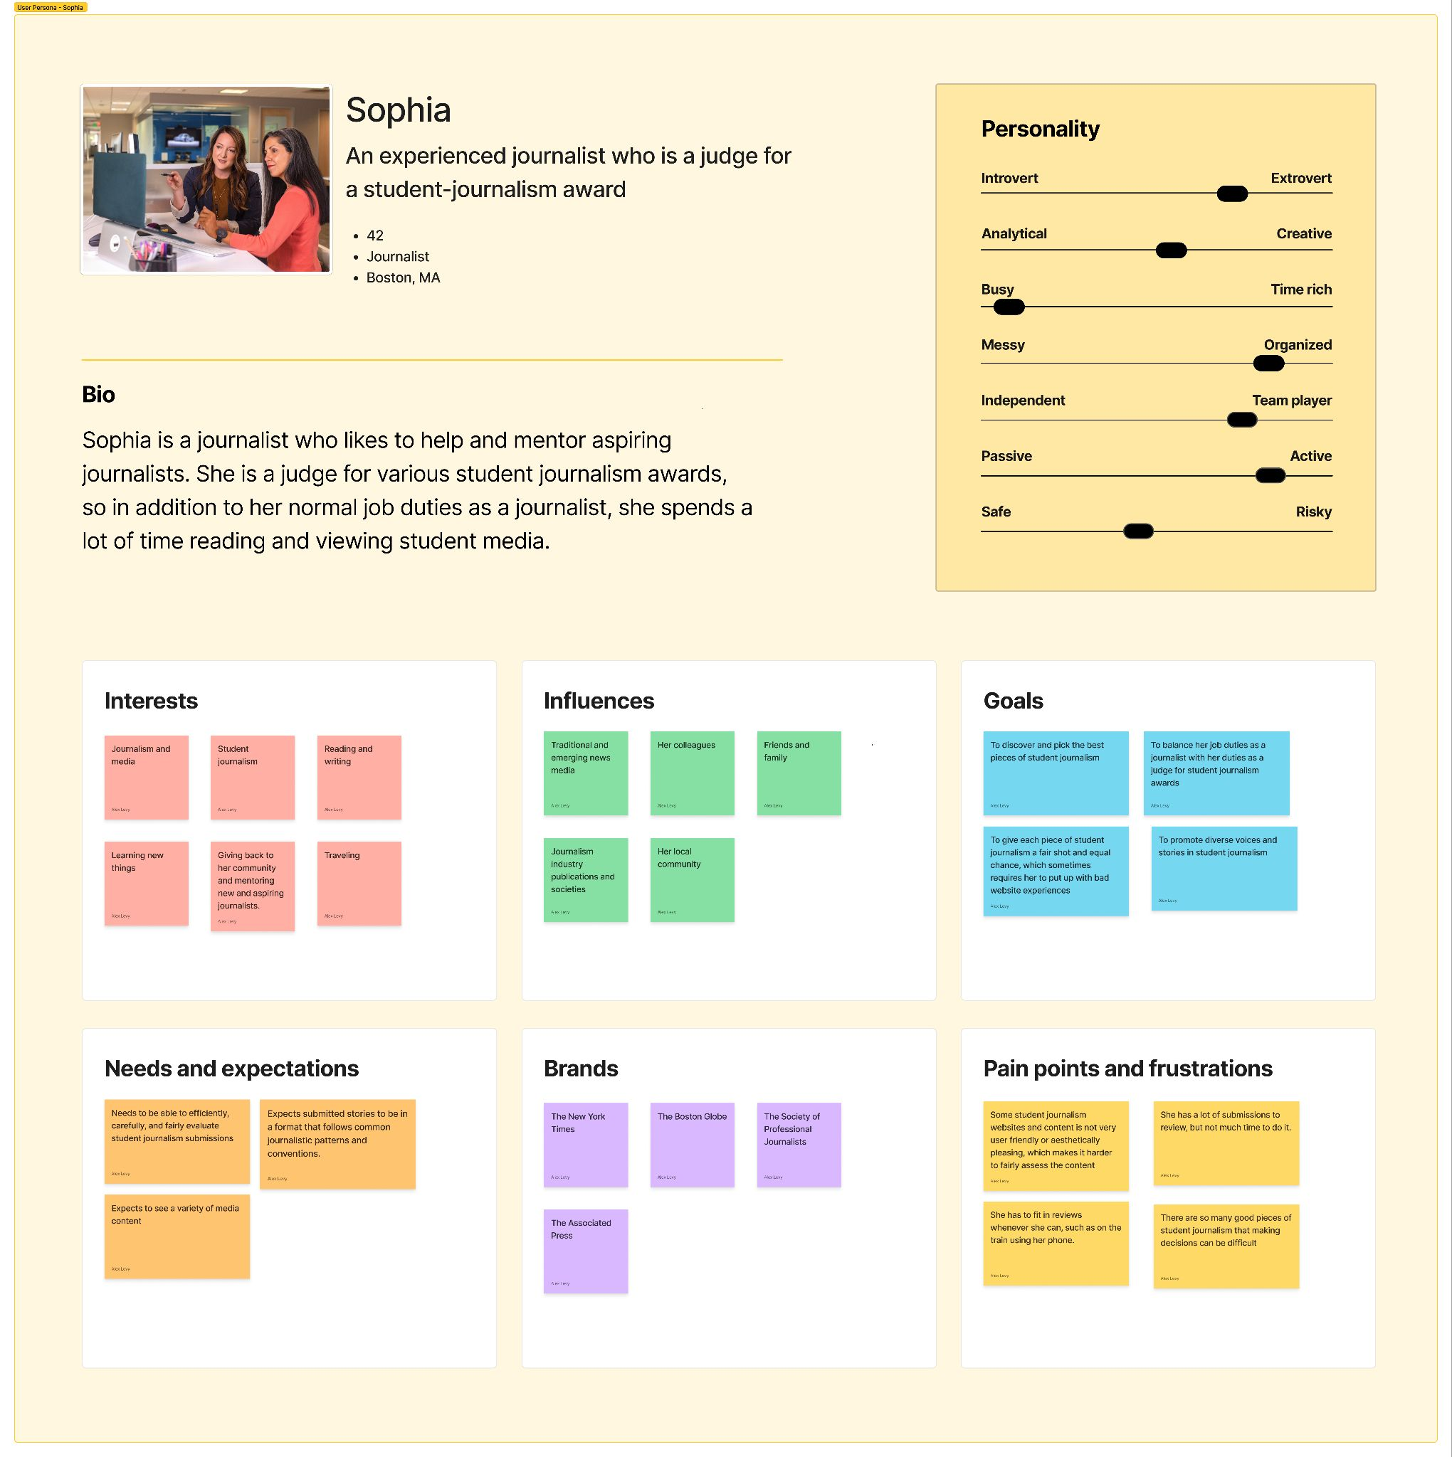

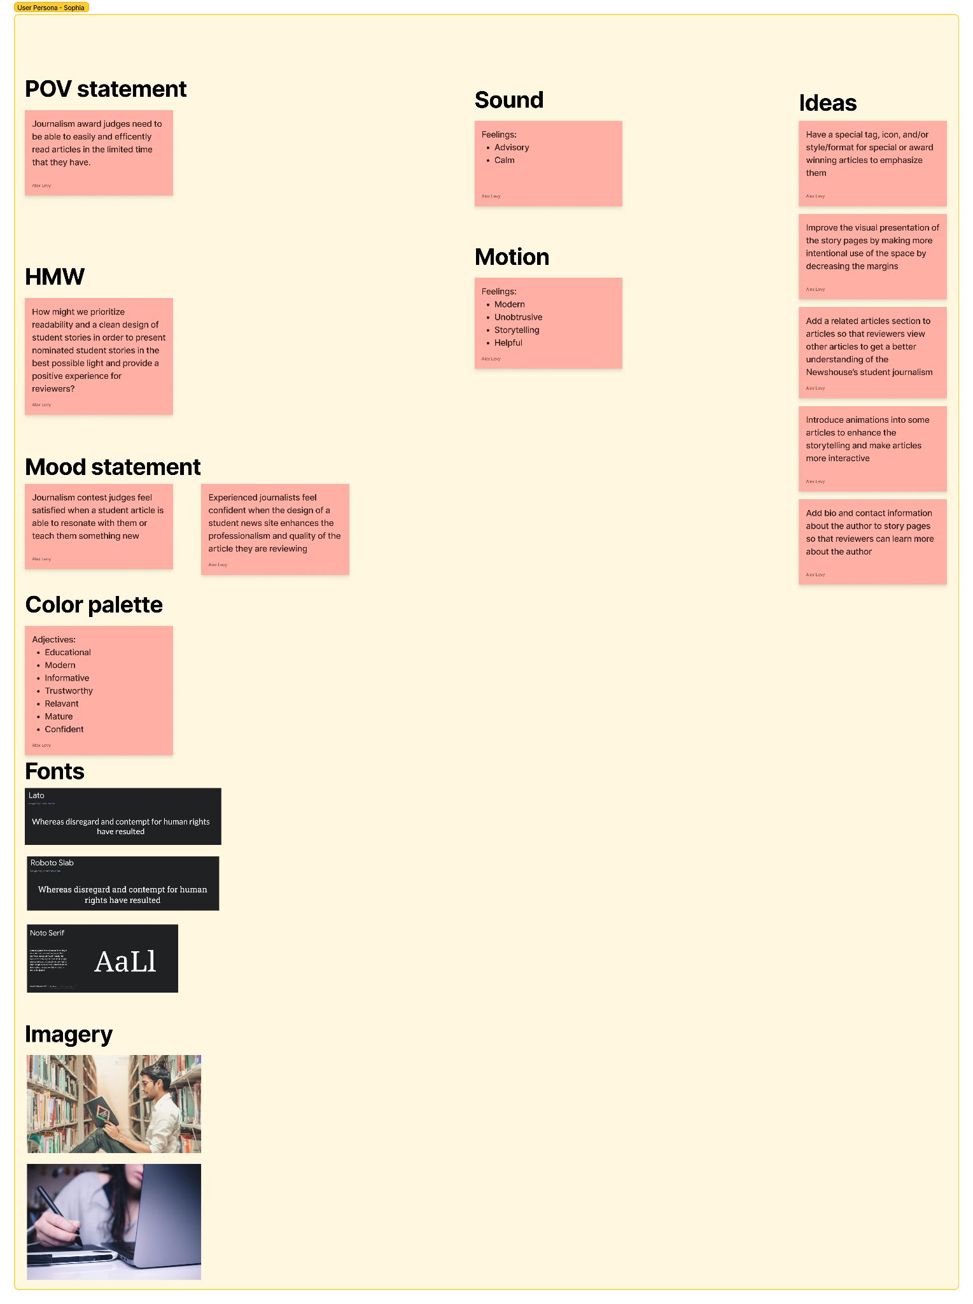

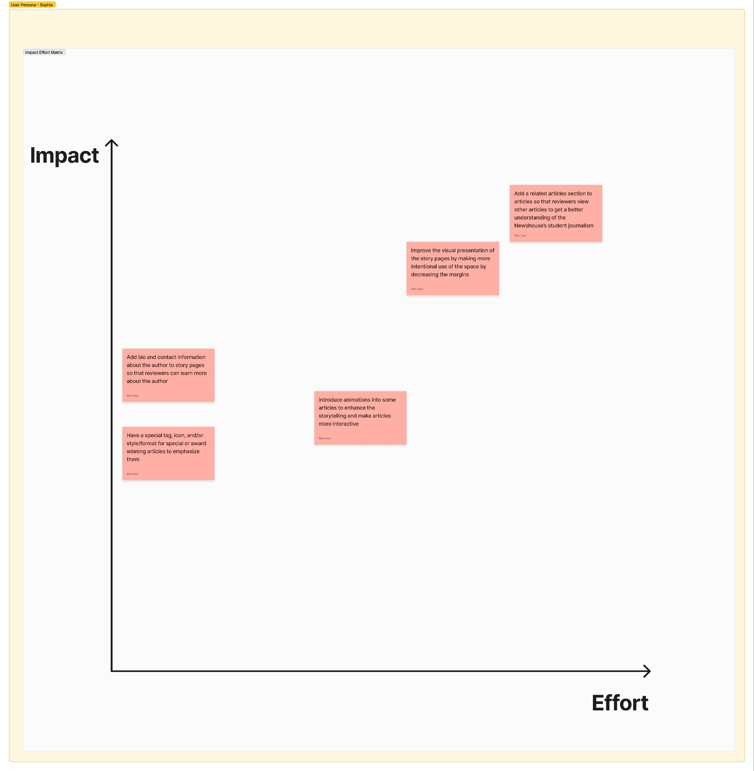

## Feature prioritization

### Do first:

* A layout that prioritizes both recent and interesting/notable stories and is updated daily so people are incentivized to come back often, and has more stories per page
* Wide variety of interactive tags that are clickable and filterable
* Add a related articles section to articles so that reviewers view other articles to get a better understanding of the Newshouse’s student journalism
* Improve the visual presentation of the story pages by making more intentional use of the space by decreasing the margins

### Do second:

* Add more author info to site at more touchpoints
* Add text and images that emphasize the student production process.
  + Maybe even a page that is updated with behind the scenes
* A tag that shows how long an article will take to read, helping busy readers prioritize what they want to read
* A newsletter so students can be updated with the latest relevant stories

## Information architecture

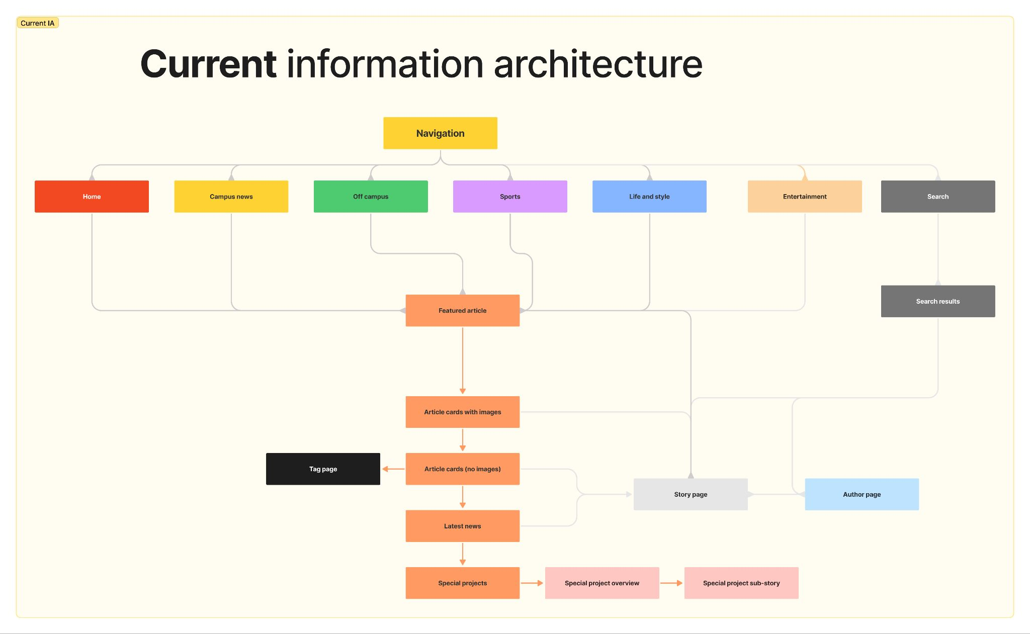

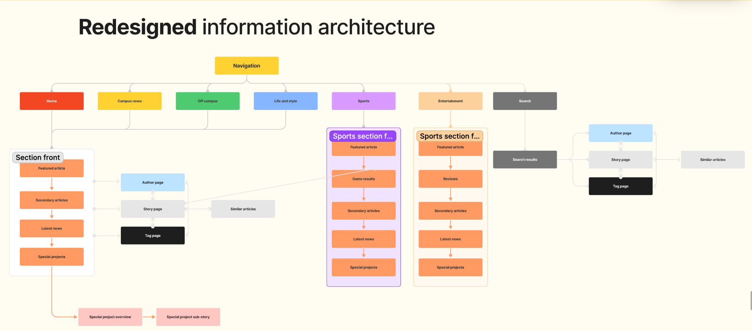

## Wireframes

### Mobile

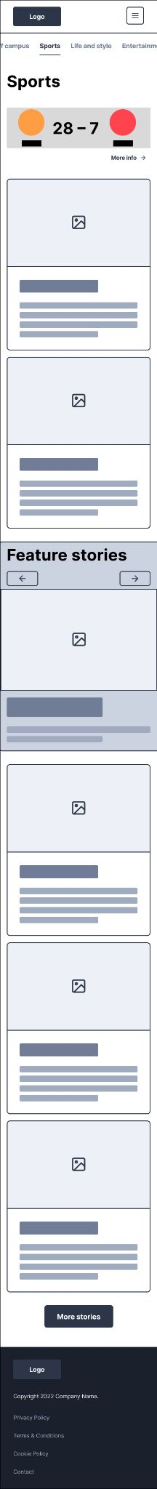

### Desktop

