Introduction

Wildfires may begin in the wildland/urban interface or in remote spots where nobody notices them and then spread quickly, igniting brush, trees, and buildings.

An increasing number of people are choosing to live in woodland settings, in or near forests, rural areas, or remote mountain sites. These homeowners enjoy the beauty that comes from being close to nature, but also face the danger of wildfire.

Wildfires are most frequent in the West, but all wooded, brush, and grassy areas are vulnerable. Kansas, Mississippi, Louisiana, Georgia, Florida, the Carolinas, Tennessee, California, and Massachusetts are especially prone to wildfires.

Classes of wildland fires include:

- Surface fires and ground fires, which burn along the ground. Surface fires are most common, and generally are started by people. Ground fires may burn on or below the ground, and usually are started by lightning.
- Crown fires that spread rapidly by wind, and move quickly by jumping along the tops of trees.

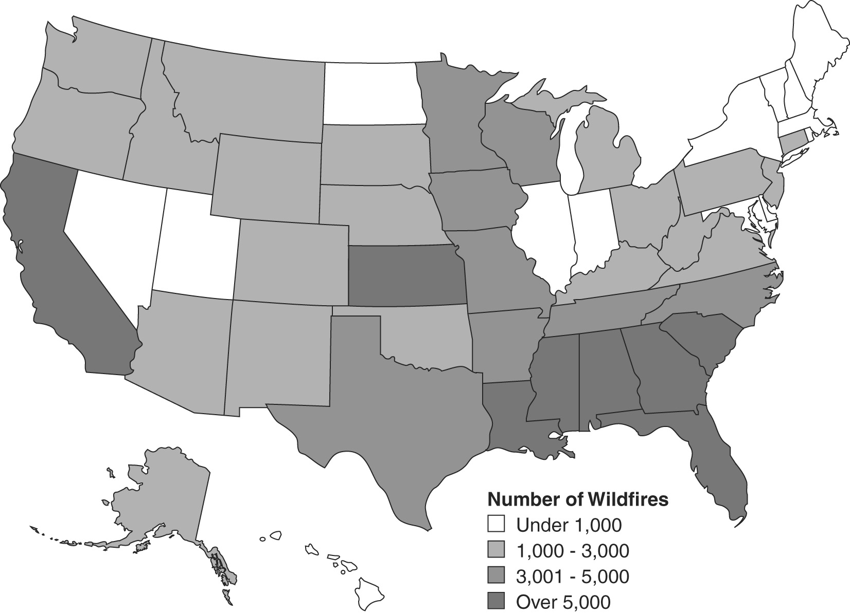

Figure 1. Typical Annual Wildfire Frequency by State

How Great Is Your Risk of Wildfire?

If you live or own a business in a wooded or rural setting, your home and/or place of business may be susceptible to wildfires.

The map on the preceding page shows typical frequency for wildfires among States in the United States.

Self-Assessment Questions:

- How many wildfires occur in your State in a typical year?

__ Under 1,000 __ 1,000-3,000 __ 3,000-5,000 __ Over 5,000

- Is your home or business located in or near a wooded or wildland area?

__ Yes __ No

Contact your local fire marshal, local forestry representative, building official, city engineer, or planning and zoning administrator to find our whether your home or place of business is in a wildfire hazard area.

Nonstructural Protective Measures

You can make your home or place of business more resistant to fire damage by taking the steps below.

    - Regularly clean roof and gutters.
    - Inspect chimneys at least twice a year. Clean them at least once a year. Keep the dampers in good working order. Equip chimneys and stovepipes with a spark arrester that meets the requirements of National Fire Protection Association Code 211. (Contact your local fire department for exact specifications on building codes.)
    - Use l/2-inch mesh screen beneath porches, decks, floor areas, and the home itself. Also, screen openings to floors, roof, and attic.
    - Consider installing protective shutters or heavy fire-resistant drapes.
    - Plant fire-resistant shrubs and trees. For example, hardwood trees are less flammable than pine, evergreen, eucalyptus, or fir trees. Introduce more native vegetation.

Creating a Safety Zone

You can create a 30- to 100-foot safety zone around your home or place of business. Within this zone, you can take steps to reduce potential exposure to flames and radiant heat.

Buildings in pine forests should have a minimum safety zone of 100 feet. If the structure sits on a steep slope, standard protective measures may not suffice. Contact your local fire department or forestry office for additional information.

To create a safety zone, take the following steps:

- Remove leaves and rubbish from under structures.
- Thin a 15-foot space between tree crowns, and remove limbs within 15 feet of the ground.
- Remove dead branches that extend over the roof.
- Prune tree branches and shrubs within 15 feet of a stovepipe or chimney outlet.
- Ask the power company to clear branches from power lines.
- Remove vines from the walls of the home.
- Mow grass regularly.
- Do not connect wooden fencing directly to your home.
- Clear a 10-foot area around propane tanks and the barbecue. Place a screen over the grill, using nonflammable material with mesh no coarser than one-quarter inch.
- Regularly dispose of newspapers and rubbish at an approved site. Follow local burning regulations.
- Place stove, fireplace, and grill ashes in a metal bucket, soak in water for 2 days, then bury the cold ashes in mineral soil.
- Store gasoline, oily rags, and other flammable materials in approved safety cans. Place cans in a safe location away from the base of buildings.
- Stack firewood at least 100 feet away and uphill from the building. Clear combustible material within 20 feet. Use only UL-approved woodburning devices.

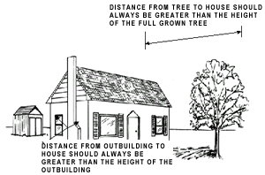  Figure 2. Clearance Around a Building | As shown in the figure, you should clear the area around your house. Rake leaves, dead limbs, and twigs. Clear all flammable vegetation.  The distance between your house and any nearby tree should always be greater than the height of the mature tree or at least 10 feet. Similarly, any outbuildings, such as storage sheds, should be at least as far away as their height.

Planning Water Needs

If a wildfire threatens your home or place of business, you will need access to water to douse flames and wet the roof or other building and landscape components to prevent ignition. Think ahead to identify a water source and ways to deliver water to fire sites.

- Identify and maintain an adequate outside water source such as a small pond, cistern, well, swimming pool, or hydrant.
- Have a garden hose(s) that is long enough to reach any area of the home and other structures on the property.
- Install freeze-proof exterior water outlets on at least two sides of the home and near other structures on the property. Install additional outlets at least 50 feet from the home.
- Consider obtaining a portable gasoline-powered pump in case electrical power is cut off.

Structural Protective Measures

Design and landscape your home with wildfire safety in mind. Select materials and plants that can help contain fire rather than fuel it.

    - Use fire-resistant or noncombustible materials on the roof and exterior structure of the dwelling, or treat wood or combustible material used in roofs, siding, decking, or trim with UL-approved fire-retardant chemicals.
    - Box in the eaves, fascias, soffits, and subfloors with fire-resistant materials like treated wood, reducing the vent sizes.
    - Enclose the underside of decks with fire-resistant materials.
    - Cover exterior walls with fire-resistant materials like stucco, stone, or brick. (Vinyl siding can melt and is not recommended.)
    - Use double-paned or tempered glass for all exterior windows.

Some roofing materials, including asphalt shingles and especially wood shakes, are less resistant to fire than others. When wildfires and brush fires spread to houses, it is often because burning branches, leaves, and other debris buoyed by the heated air and carried by the wind fall on roofs. If the roof of your house is covered with wood or asphalt shingles, you should consider replacing them with fire-resistant materials.

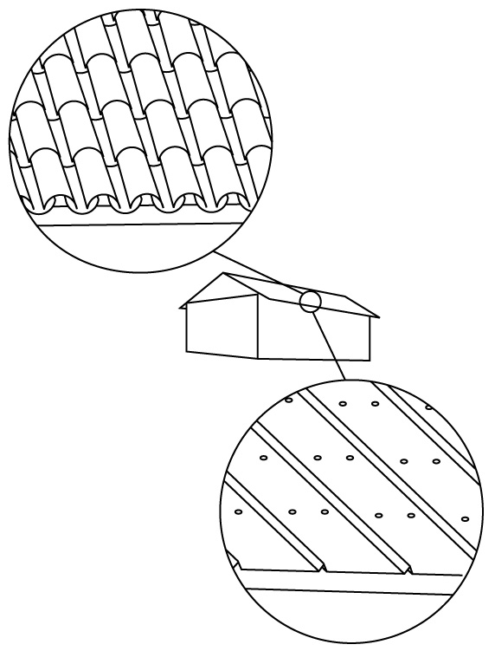  Figure 3. Fire-Resistant Roofing | As shown in the figure, you can replace your existing roofing materials with slate, terra cotta or other types of tile, or standing-seam metal roofing.  Replacing roofing materials is difficult and dangerous work. Unless you are skilled in roofing and have all the necessary tools and equipment, you will probably want to hire a roofing contractor to do the work. Also a roofing contractor can advise you on the relative advantages and disadvantages of various fire-resistant roofing materials.

Personal Safety Measures

You can take a number of steps to promote the personal safety of your family, neighbors, and/or employees.

    - Make sure that fire vehicles can get to your home or place of business. Clearly mark all driveway entrances and display your name and address. Install noncombustible street signs.
    - Post fire emergency telephone numbers.
    - Plan several escape routes away from your home or business site—by car and by foot.
    - Talk to your neighbors about wildfire safety. Plan how the neighborhood could work together if a wildfire threatens.
    - Consider how you could help neighbors who have special needs such as elderly or disabled persons. Make plans to take care of children who may be on their own if parents can’t get home.
    - Install a smoke alarm on each level of your home, especially near and in bedrooms; test monthly and change the batteries two times each year. (For commercial buildings, local building codes usually specify requirements for smoke detectors and automatic sprinkler systems.)
    - Teach each family member or employee how to use the fire extinguisher (ABC type) and show them where it’s kept.
    - Keep an approved ladder that will reach the roof of the building. Do not use if not comfortable on the ladder.
    - Keep handy household items that can be used as fire tools: a rake, axe, handsaw or chainsaw, bucket, and shovel.
    - Only fight fire if you are comfortable to do so. Ask for training from your local fire department.

Before You Evacuate

If you are warned that a wildfire is threatening your area, listen to your radio for reports and evacuation information. Have a battery-operated radio available. Follow the instructions of local officials.

If you’re sure you have time, take steps to protect your home or place of business before evacuating.

Inside

    - Close windows, vents, doors, venetian blinds, noncombustible window coverings, and heavy drapes. Remove lightweight curtains.
    - Shut off gas at the meter. Turn off pilot lights.
    - Open fireplace damper. Close fireplace screens. Move flammable furniture into the center of the home away from windows and sliding-glass doors.
    - Turn on a light in each room to increase the visibility of your home or place of business in heavy smoke.
    - Gather pets into one room. Make plans to care for your pets when you evacuate.
    - Arrange temporary housing at a friend or relative’s home or a hotel outside the threatened area.

Outside

    - Back your car into the garage or park it in an open space facing the direction of escape. Shut doors and roll up windows. Leave the key in the ignition. Ensure car does not lock when exiting the car.
    - Close garage windows and doors, but leave them unlocked. Disconnect automatic garage door openers.
    - Seal attic and ground vents with pre-cut plywood or commercial seals.
    - Turn off propane tanks.
    - Place combustible patio furniture inside.
    - Connect the garden hose to outside taps.
    - Set up the portable gasoline-powered water pump.
    - Place lawn sprinklers on the roof and near aboveground fuel tanks. Wet the roof.
    - Wet or remove shrubs within 15 feet of the home.
    - Gather fire tools.

Success Stories

Los Angeles County, California

For Karen Stevens, her family, and neighbors in the Southern Oaks section of Stevenson Ranch, it was a blessing that the planned development where they live has a 200-foot-wide greenbelt around it designed to ward off wildfires. “There were plenty of embers flying around,” said Stevens, whose home in Santa Clarita backs up to the Santa Susana Mountains.

These same mountains were set ablaze by the Simi Fire, one of 12 wildfires that burned more than 739,000 acres in five Southern California counties in October 2003. Airdrops were made on the wildfire as it came toward the Stevens’ home, and firefighters surrounded the area. Firefighters were bolstered in their fight by the mitigation measures taken.

Homes in the Stevenson Ranch planned development were all built to conform to Los Angeles County building and fire codes. All developers must comply with codes before building permits are issued. There is a multi-hazard approach to disaster-resistant construction. Wildfire mitigation measures include double-pane heat-resistant windows, concrete-slate tile roofing materials, and enclosed eaves as primary protective measures standard. There are 100-foot greenbelts planted with fire-resistant plant materials, and they have sprinkler systems. The maintenance of greenbelts is managed through the homeowners association.

To mitigate against earthquakes, homes are built on high-tension slabs and bolted onto the slabs. “Earthquake safety was important to us when we were considering buying a home here,” said Todd Stevens. “Since the experience of the wildfires, we’re very grateful for the wildfire protective measures that are required.”
Clearly, pre-fire mitigation, which cost less money than the value of the home, has protected this family’s investment.

Note: This success story shows that the couple was more focused on the earthquake hazard when they bought the house, and didn't fully appreciate the fire provisions until after they were tested by a fire.
Success Stories (Continued)

Los Alamos, New Mexico

When John and Cindia Hogan bought their home in 1994, they did so knowing that a major fire might occur in the Santa Fe National Forest that backs up to their property. John Hogan, a physical scientist with the U.S. Geological Survey and a trained, experienced firefighter, began taking steps to mitigate their home in 1996.

In 1996, Hogan contracted to have a metal roof put on their two-story, wood-frame, 2,600-square foot home located on two-thirds of an acre. He also cleared some 100 trees from the rear portion of the property, and removed flammable materials from the backyard. The cost of mitigation is estimated at about $50,000. All costs were borne by the Hogan family.

On May 10, 2000, the Hogan family evacuated from their home, and on May 11 the Cerro Grande fire—largest wildfire in New Mexico history to date—burned through their neighborhood and other areas of the community of Los Alamos. For 2 days, the Hogans believed their home was consumed by the blaze, which burned and destroyed well over 200 homes, leaving more than 400 families and individuals homeless.

But when John and Cindia Hogan returned to their home, they found it and one other adjacent house intact. Homes to the west and south of them had been destroyed. “We’re very conscious of fire danger,” Hogan said. “We consciously chose fire mitigation as a proper move.” Hogan plans on more mitigation, including removal of more trees in his yard, and put fire retardant on cedar shake paneling on the east and west walls of his home.

The most valuable information that Hogan had was his knowledge of landscape ecology, based on his work with the U.S. Geological Survey. He works with vegetation studies and fire history as well as changes in landscape.

The Cerro Grande fire caused one tree in the Hogans’ front yard to catch fire, and burned a shed and its contents at the far rear of their backyard. The only other damage from the fire was soot that entered into the dryer vent.

The home is insured for $270,000 for its structure and another $200,000 for contents. The savings, even though his property is insured, are figured at more than $450,000—the value of the structure and its contents—nine times the cost of mitigating the structure and grounds.

Of the expense of mitigating his home, Hogan said, “It was certainly worth it.”

Summary: Key Steps To Protect Against Wildfires

This lesson reviewed the following steps you can take to protect your home or business against wildfires.

- Regularly clean the roof, gutters, and chimney.
- Put mesh screening over openings.
- Consider installing protective shutters or heavy fire-resistant drapes.
- Box in the eaves, fascias, soffits, and subfloors with fire-resistant materials like treated wood, reducing the vent sizes.
- Enclose the underside of decks with fire-resistant materials.
- Cover exterior walls with fire-resistant materials like stucco, stone, or brick. (Vinyl siding can melt and is not recommended.)
- Use double-paned or tempered glass for all exterior windows.
- Create a 30- to 100-foot safety zone by removing or trimming trees and eliminating or reducing flammable materials in the area around your home or place of business.
- Ensure there is a water supply that can be used to fight fire on your property, if you are comfortable to do so.
- Select plants that can help contain fire rather than fuel it.
- Replace existing roofing materials with fire-resistant roofing.

Wildfire Protection Resources

A number of resources offer indepth information that can help you learn more about particular wildfire protection options.

To obtain copies of the documents listed below and other FEMA documents, call FEMA Publications at 1-800-480-2520. Information is also available on the FEMA website at http://www.fema.gov.

- Protecting Your Property From Fire: Dealing With Vegetation and Combustible Materials, http://www.fema.gov/fima/how2001.shtm
- Protecting Your Property From Fire: Roofing, http://www.fema.gov/fima/how2002.shtm
- “Five Hot Tips for Homeowners on the Edge,” by Herbert McLean, in American Forest, vol. 99, no. 5-6, 1993
- Guide to Landscaping for Fire Safety, 2nd. Ed., University of California, 1992
- “Firescaping: Ways To Keep Your House and Garden from Going up in Smoke,” by Joan Boulton in Horticulture, The Magazine of American Gardening, vol. 69, no. 8, 1991
- Protecting Residences From Wildfires: A Guide for Homeowners, Lawmakers, and Planners, Technical Report No. 50, U.S. Department of Agriculture, 1981
- Information is also available from the National Roofing Contractors Association, 1-800-323-9545.

Other websites offer information on protecting against wildfires, including:

- Institute for Business and Home Safety, http://www.IBHS.org
- National Fire Protection Association, http://www.nfpa.org
- Firewise Communities, http://www.firewise.org/communities

Test Yourself

The questions below review key points in protecting against wildfires. After completing the questions, you can check your answers on the answer sheet located after the course glossary.

- The most common type of wildfire is a surface fire, which generally is started
by __________________________.

- Fire-resistant roofing materials include: (Mark all that apply.)

- Tile roofing
- Asphalt shingles
- Metal roofing
- Wood shakes

3. Identify three measures that can be used to create a safety zone around a home or place of business.

________________________________________________________

________________________________________________________

________________________________________________________

4. Select the measure on the right that would be used to protect the item on the left, and write the appropriate letter on each blank space.

__ Openings  __ Chimneys  __ Gutters  __ Barbeque grill | a. Cover with mesh screening  b. Clean regularly

- States located east of the Mississippi River do not experience wildfires.

__ True __ False

