

U.S. Department of
Transportation

FEDERAL AVIATION
ADMINISTRATION

DRAFT REGULATORY EVALUATION

Removal of Regulations Allowing for Polished Frost on Wings of Airplanes

Notice of Proposed Rulemaking
(14 CFR Parts 91, 125, and 135)

Office of Aviation Policy and Plans
Operations Regulatory Analysis Branch, APO-310
Marquise J. McGraw

March 21, 2008

TABLE OF CONTENTS

EXECUTIVE SUMMARY i
I. INTRODUCTION 1
II. BACKGROUND 1
III. ACCIDENT HISTORY AND BENEFITS SIMULATION 3
IV. BENEFITS OF THE PROPOSED RULE 6
V. COST OF THE PROPOSED RULE 8
VI. CONCLUSION 15
VII. APPENDIX: LIST OF POLISHED FROST ACCIDENTS, 1982-2007 16

EXECUTIVE SUMMARY

This Notice of Proposed Rulemaking proposes to remove references in the Federal aviation regulations that allow takeoffs in situations where frost is present on wings, stabilizing surfaces, or control surfaces, when such frost has been “polished” to make it smooth. The FAA believes these changes are necessary to improve aviation safety.

For the ten-year period from 2009 to 2018, total benefits are expected to be about $460,000 ($320,000 discounted). Of these, $433,000 ($301,000 discounted) of the benefits would be realized in Alaska, while the remaining $27,000 ($19,000 discounted) would be realized in the mainland U.S.

Costs would depend on which of four alternatives (wing covers, storing the aircraft in a hangar, deicing the surface areas, or waiting for the frost to melt) are selected by operators. The FAA believes that using wing covers is the least costly alternative. Assuming operators choose to use wing covers, over the ten year period from 2009 to 2018, costs would total roughly $164,000 ($130,000 discounted). Of these, $155,000 ($123,000 discounted) would accrue to Alaska, and $9,500 ($7,500 discounted) would accrue to the mainland U.S. Since benefits exceed costs for both Alaska and the mainland U.S., the FAA concludes the proposed rule is cost-beneficial.

I. INTRODUCTION
The FAA proposes to modify §§91.527 (a), 125.221 (a), and 135.227 (a) of Chapter 14 of the CFR to remove any references that allow takeoffs in situations where frost is present on wings, stabilizing surfaces, or control surfaces, when such frost has been “polished” to make it smooth. In addition, the FAA is taking the opportunity to correct the structure of §135.227 (c). Currently, it appears the phrase beginning with “unless the aircraft has…” applies only to paragraph (c)(2). However, that clause applies to all the provisions of (c). The FAA is therefore proposing to restructure paragraph (c).

II. BACKGROUND
Currently, §§91.527 (a), 125.221 (a), and 135.227 (a) allow pilots to take off with frost adhering to wings or stabilizing or control surfaces if that frost has been polished to make it smooth. This frost is referred to as “polished frost.” This procedure first appeared in the Federal Register as Civil Air Regulation Draft Release No. 60-13, a proposed revision of part 47 of the Civil Air Regulations, on August 6, 1960. There was no preamble information or data to support or justify the procedure.

Since 1960, the FAA and others have gathered an extensive amount of data which suggests that any amount of contaminants on wings or critical surfaces could be detrimental to the flight characteristics of an aircraft. In fact, it is even more critical today than in the past that wings are clear of any contaminants upon takeoff. As a result of the design of the wings on today’s aircraft, such surfaces are much more sensitive to contaminants than those in the past. In Advisory Circular (AC) 135-17, issued on December 14, 1994, the FAA recommends that all wing frost be removed prior to takeoff, and states that if an operator desires to polish the frost, the aircraft manufacturer’s recommended procedures should be followed. No current aircraft manufacturer, however, has issued any recommended procedures for (1) polishing frost; or (2) conducting operations with polished frost. In addition, the FAA has no data to support practical guidance on determining how to polish frost on a surface to make it acceptably smooth, other than completely removing the frost and returning the airplane’s surfaces to uncontaminated smoothness. Moreover, the term “polished frost” is ambiguous since no standard of acceptable smoothness is provided. Also, means to ensure that the “polished frost” surface smoothness is equivalent to that of the uncontaminated airplane surface is operationally impractical. Subsequently, the FAA issued two Safety Alerts for Operators (SAFOs)—06002, dated March 29, 2006 and 06014, dated October 6, 2006 -- advising against the practice of polishing frost.

There have been a number of takeoff accidents that have occurred when flight crews have consciously decided to take off without removing frost from the wings of their aircraft. Following the January 4, 2002 accident at Birmingham, England, the United Kingdom Aircraft Accident Investigation Board issued Safety Recommendation 2003-54, recommended in its Safety Recommendation 2003-54 that the FAA, and all Authorities who follow FAA practice, delete all reference to ‘Polished Frost’ within their regulations and ensure that the term is expunged from Operations Manuals. In addition, the U.S. National Transportation Safety Board (NTSB) has issued numerous safety alerts urging operators to ensure that critical surfaces are free of all contamination prior to takeoff. Accordingly, the FAA has determined that any attempt at polishing frost increases the risk of unsafe flight.

III. ACCIDENT HISTORY AND BENEFITS SIMULATION
The FAA has identified eleven accidents between 1982 and 2006 in which individuals tried to “smooth” or “polish” frost on an aircraft’s wing before takeoff. Various techniques were used to do so. These included running a rope against the wing surface, brushing the frost off by hand, brushing the frost off using a broom, running a scraper across the wing surface, or, in one case, using paper towels and credit cards to remove the frost. In all eleven accidents the aircraft failed to lift off the runway during takeoff or stalled shortly after becoming airborne. A list of these eleven accidents, and the NTSB final report for each, is included in the Appendix.

Nine of these accidents involved single-engine general aviation (GA) aircraft operated under Part 91; the other two involved air taxi aircraft operating under Part 135. Of these, there were two fatal accidents, one accident involving minor injuries, and eight involving no reported injuries. One plane was destroyed, while the other 10 were substantially damaged. Six out of the 11 accidents occurred in Alaska.

The FAA used the last 20 years of available NTSB accident data (1987-2006) for the analysis. That data was subdivided into eleven ten-year periods, as shown in the table below. For each ten-year period the FAA determined how many accidents occurred within that time. As shown below in Table 1, the number of accidents occurring within each 10- year period ranged from 1 to 4.

Table 1: Polished Frost Accidents by

10-Year Period
Period | Number of Accidents
1987-1996 | 4
1988-1997 | 2
1989-1998 | 2
1990-1999 | 1
1991-2000 | 2
1992-2001 | 2
1993-2002 | 2
1994-2003 | 3
1995-2004 | 3
1996-2006 | 4
1997-2006 | 4

The FAA used this information as the basis for a simulation. The simulation was set up to provide total benefits for a given 10-year period in the future. To do so, it was assumed the distribution of accidents would roughly approximate a uniform distribution. This distribution assumes that for a given ten-year period in the future, there is an equal likelihood there would be one, two, three, or four accidents attributable to polished frost within that period. Five thousand trials were conducted, where each trial represented a future ten-year period. The expected benefits were determined by averaging the results of each of these 5,000 trials. Table 2 below lists the simulation inputs, all of which were obtained from the accident data.

Table 2: Probability Inputs Drawn From

Accident Data
Event | Probability
Probability of Fatal Accident | 0.18

Injury - Fatal Accidents:
Death | 0.62
Significant Injury | 0.38

Injury - Non-Fatal Accidents:
Significant Injury | N/A
Minor Injury | 0.05
No Injury | 0.95

Damage – Fatal Accidents
Destroyed | 0.5
Substantial Damage | 0.5

Damage – Non-Fatal Accidents
Destroyed | N/A
Substantial Damage | 1.0
Proportion of Part 125/135 Accidents in Sample | 0.18
Proportion of Accidents In Alaska | 0.55

Other assumptions incorporated into the model include:
- The discount rate is 7 percent. Discounting takes place at the end of the year.
- Benefits are assumed to be equal for each year within the simulated ten-year period which runs from 2009 – 2018.
- Each airplane flown subject to this rule has, on average, four seats. It is assumed that each seat on the plane is filled.
- Value of a fatality: $3,000,000
- Value of a serious injury: $580,700
- Value of a minor injury: $42,900
- Value of a destroyed aircraft: $629,869
- Value of a substantially damaged aircraft: $103,510

IV. BENEFITS OF THE PROPOSED RULE
The simulation estimated total benefits for both the mainland U.S. and Alaska based on all eleven accidents in the sample. Figure 3 below shows the probability distribution of total benefits associated with the entire sample of polished frost accidents. The mean was $2.5 million, the median was $311,000, and the mode was $104,000. The minimum expected benefit was $104,000 and the maximum expected benefit was $22.9 million. For the purposes of this analysis, the mean will be used to represent the expected benefit so that the effects of fatal accidents and accidents with many injuries or substantial aircraft damage are fully accounted for.

Since this rulemaking would affect only operators under Parts 125, 135, and those covered by subpart F of Part 91 (which includes all Part 91 subpart K operations, regardless of category, class, weight, powerplant or number of engines), it was necessary to adjust the total benefits from the entire sample of polished frost accidents to account for that. There are two Part 135 accidents in our sample that fall within the scope of the proposed rule. The other nine accidents in our sample involve non-commercial general aviation, which are not subject to this rulemaking. Therefore, the total benefits were reduced by a factor of 9/11, or 81.8 percent, which is the proportion of general aviation accidents in the sample. Final benefits were calculated by taking the total simulated benefits (from all eleven accidents) and multiplying by 2/11, the proportion of Part 135 accidents in the sample.
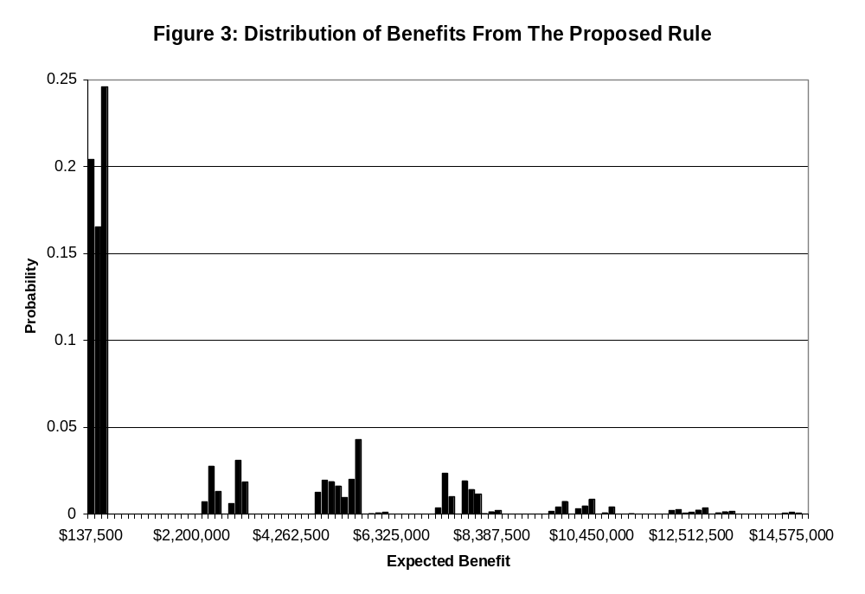
Part 125/135 benefits were allocated to Alaska and the mainland U.S. based on the number of aircraft affected by this rule in each location. Data from the FAA Flight Standards Service, AFS-
200, On-Demand and Commuter Branch, indicate that there would be a total of 188 aircraft affected by the proposed rule. Of these, 177 are in Alaska. Therefore, 177/188, or 94.1 percent of the Part 125/135 benefits were allocated to Alaska, while the remaining 5.9 percent were allocated to the mainland U.S.

Over the ten year period from 2009 to 2018, the total benefits from this proposed rule (the Part 125/135 benefits) are projected to be about $460,000 ($320,000 discounted). Of those, $433,000 ($301,000 discounted) would accrue to Alaska, while the remaining $27,000 ($19,000 discounted) would accrue to the mainland U.S.

These benefits were attributed to averted accidents, injuries, and aircraft damage. The FAA expects that under the proposed rule, pilots and operators would protect their aircraft from frost formation using wing covers. However, pilots and operators could use an approved alternative such as waiting for the frost to completely melt, storing the aircraft in a heated hangar, or deicing to remove all frost prior to takeoff. Using any of these procedures would result in wings upon takeoff that are free of frost, thereby preventing the accidents described earlier in this analysis from occurring.

V. COST OF THE PROPOSED RULE
Although the proposed rule would modify §§91.527 (a)(3), 125.221 (a), and 135.227 (a), the proposed rule would only affect a subset of those who operate under Parts 91, 125 or 135, as explained below.

Cost to Part 91 operators
This proposed rule would modify §§91.527 (a)(3), which falls within Part 91, Subpart F. This subpart provides for the operation of large and turbine-powered multiengine airplanes and all fractional ownership program aircraft (regardless of category, class, weight, powerplant or number of engines). Therefore, the revised provisions in subpart F in this proposed rule would affect the operation of all fractional ownership program aircraft under subpart K. The FAA requires that all operators file Operations Specifications documents (OpSpecs) with the FAA, providing the specifics of each operator’s deicing plans and procedures. If an operator wishes to use the polished frost technique, he must state that in his OpSpec. The FAA must then approve the OpSpec and, by extension, authorize an operator’s use of the polished frost technique.

Data provided by the FAA Flight Standards Service, AFS-200, On-Demand and Commuter Branch, shows that out of 12 Part 91, Subpart K certificate holders, none of these operators are authorized by the FAA, in their OpSpecs, to use the polished frost technique in their ground deicing programs. Since no Part 91K operators are authorized to use this technique, this proposed rule would have no effect on their current operations. Others operating under Part 91, such as recreational pilots, are not covered under §91.527. Therefore, this rulemaking would not affect other general aviation operators. As a result, the FAA concludes that this rulemaking would impose no cost on Part 91 operators.

Cost to Part 125 and 135 operators
Subparts 125.221 (a), and 135.227 (a) do apply to all Part 125 and 135 operators. However, not all Part 125 and 135 operators have the authority to polish frost. Data from the FAA’s Flight Standards Service, On-Demand and Commuter Branch (AFS-200) show the FAA has granted this authority, through their OpSpecs, to 57 operators operating 188 aircraft. Of these, 51 operators operating 177 aircraft are located in Alaska. The FAA has determined there are at least four ways affected operators can comply with the rule. These include: using wing covers, delaying takeoff until the frost melts, storing the aircraft in a heated hangar, or using deicing procedures to clear the wings of any accumulated frost. The FAA believes that using wing covers is the least costly of the four alternatives. A detailed discussion of each of these alternatives follows below.

Alternative 1: Wing Covers
Wing covers are light, durable covers made of special breathable fabrics that can be placed over an aircraft’s wing while it is not being flown. These covers protect the aircraft from precipitation and prevent frost build-up. Each set of wing covers weighs about 10 pounds. They are designed to be folded and transported with the aircraft.
The FAA makes the following assumptions in deriving its cost estimates:
- Average price per wing cover set: $400
- Each wing cover set would last, on average, five years.
- Weight of a wing cover set: 10 pounds
- Operators would carry wing covers on the aircraft for each flight.
- Incremental fuel burn for affected aircraft: 0.001 gallons per hour flown per pound of weight added
- Each aircraft flies about 124 hours per year
- Price of aviation fuel in Alaska: $6.00 per gallon
- Price of aviation fuel in the mainland U.S.: $5.00 per gallon

a) Alaska
The cost of using wing covers in Alaska was estimated by adding the cost of buying the wing covers to the additional fuel burn that would result from carrying the wing covers back and forth on trips. It is assumed that these wing covers would last for at least five years. As Table 4 below shows, there would be a cost of around $155,000 ($123,000 discounted) that would accrue to operators based in Alaska.

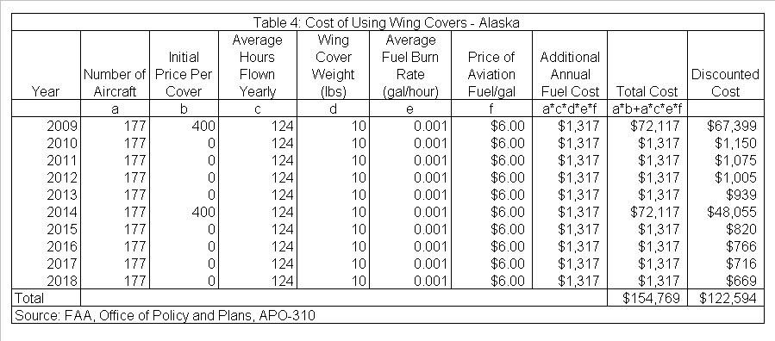
b) Mainland U.S.
A similar analysis was performed for the mainland U.S. As Table 5 below shows, there would be a cost of nearly $9,400 ($7,500 discounted).

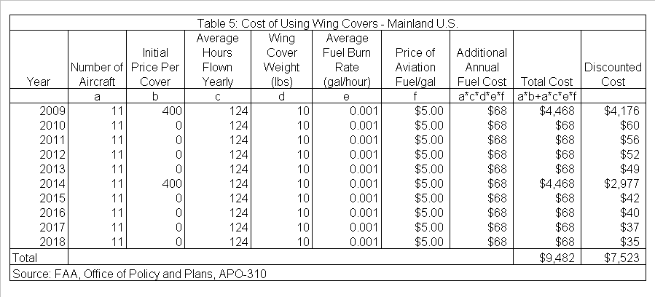
c) Total cost
As Table 6 below shows, if affected operators choose to comply with the proposed rule by buying and using wing covers, the total cost of the rule would be around $164,000 ($130,000 discounted).

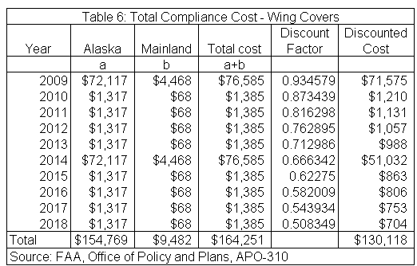

Alternative 2: Delay Takeoff
Operators would also have the choice of delaying takeoff until the frost melts from the aircraft. Operators who choose this method of compliance may incur related costs such as the time value of delay and possible loss of revenue due to canceled flights. Unfortunately, the FAA is unable to estimate the cost of delay directly. The FAA would need information on the number of flights delayed due to frost, but no such measure is available. In addition, many of the affected operators operate on demand, so for them, there may or may not be a delay cost, depending on the nature of their business.
The FAA estimated the maximum cost of delay per plane per year such that it would cost less to encounter delays than it would to buy wing covers. The annualized cost over 10 years of using wing covers is estimated by multiplying their discounted total cost ($130,000) by the capital recovery factor 0.14238. This gives an annualized cost of $18,526. Dividing by the total number of aircraft affected, 188, gives a total annualized cost of $99 per plane per year.
The FAA assumes the value of a passenger’s time is $37.20 per hour. If an operator is transporting passengers, and if one passenger is delayed as a result of this rulemaking, then waiting for the frost to melt would cost less than using wing covers if an operator incurred delays of less than 2.7 hours per plane per year. As the number of passengers increases, the applicable delay length would decrease. For example, if three passengers were delayed, the total annual delay would be about 54 minutes per plane per year. The FAA believes that operators who choose to wait until frost melts completely from their aircraft are likely to encounter delays much larger than those discussed here. Therefore, the FAA expects that in most cases operators would find that wing covers are a lower cost alternative.

The FAA realizes that many of the operators affected by this rule transport cargo rather than passengers. The FAA cannot calculate a specific “delay length” for these operators. However, if a delay as a result of this rulemaking would result in more than $99 in annual losses per aircraft, the FAA believes that the operator would be better off buying and using wing covers.

Alternative 3: Store Aircraft in a Heated Hangar
Pilots and operators may also choose to mitigate the formation of frost on their aircraft by storing these planes in a heated hangar. While this may be possible when aircraft are being stored at a large hub airport, smaller airports may not have hangars available at all. The average rent for a heated hangar, where available, is about $500 per month. The annualized cost of wing covers is about $99 per plane. In most cases, the FAA expects that operators would find that wing covers are a lower-cost alternative.

Alternative 4: Deicing
The final alternative under consideration is deicing. Not all airports have deicing facilities in place. At those airports that do have them, the FAA estimates that deicing to remove frost would range from $60-$100 per application. However, facilities vary in the deicing fees they charge. Therefore, the FAA has calculated the maximum fee that an owner or operator could pay per plane per year to remove frost by deicing and be better off than he would if he bought wing covers. The annualized cost of wing covers is about $99. If the total annual cost of deicing is less than $99, then operators should choose to deice. However, it is clear that having more than one deicing application per year would cost significantly more. In most cases, the FAA expects that operators would find that wing covers are a lower-cost alternative.

The FAA calls for comments on the cost estimates discussed above, and requests that all comments be supported with clear and relevant economic documentation.

VI. CONCLUSION
Operators and pilots would have several alternatives to choose from to deal with frost that may have accumulated on the wings of their aircraft. After reviewing each alternative, the FAA recommends the use of wing covers as the lowest-cost alternative. Assuming operators choose to do so, over the ten year period from 2009 to 2018, they would incur total costs of roughly $164,000 ($130,000 discounted). Of these, $155,000 ($123,000 discounted) would accrue to Alaska, and $9,500 ($7,500 discounted) would accrue to the mainland U.S. Benefits total roughly $460,000 ($320,000 discounted). About $433,000 ($301,000 discounted) in benefits would accrue to Alaska, while the remaining $27,000 ($19,000 discounted) would accrue to the mainland U.S. Since benefits exceed costs for both Alaska and the mainland U.S., the FAA concludes the proposed rule is cost beneficial. The FAA calls for comments on this determination and requests that all comments be accompanied by clear and detailed supporting economic documentation.

VII. APPENDIX: LIST OF POLISHED FROST ACCIDENTS, 1982-2007
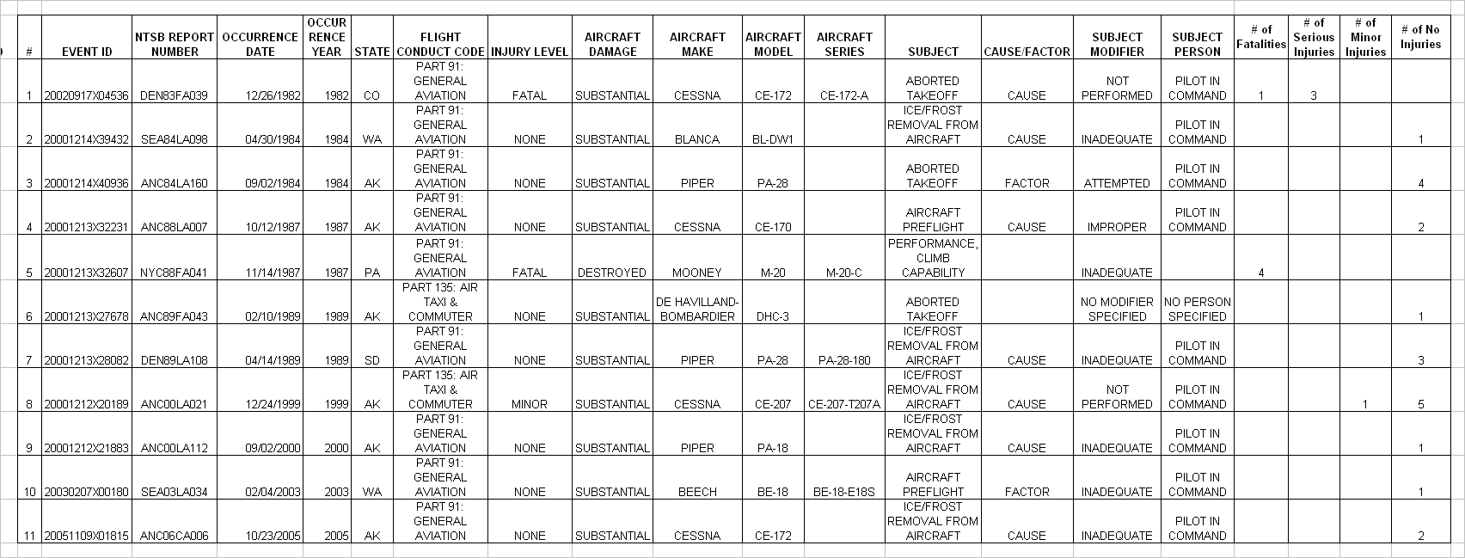

# | NTSB FINAL REPORT | NTSB CAUSE REPORT
1 | WHEN A WITNESS ARRIVED AT THE ARPT, THE ACFT WAS AT THE FUEL PUMPS & THE PLT HAD THE PREHEATER ATTACHED. THE WITNESS RPRTD THERE WAS FROST ON THE ACFT & THE PLT BRUSHED THE LOOSE FROST OFF WITH HIS HANDS. THE PLT ASKED FOR A WINDOW SCRAPER, WHICH WAS PROVIDED, BUT THE WITNESS DID NOT KNOW WHAT HE DID WITH IT. AFT REFUELING, THE PLT STARTED THE ENG & REMAINED ON THE RAMP A SHORT TIME BFR TAXIING. A TKOF WAS INITIATED FROM THE 5300 FT RWY IN CALM WND CONDS. THE ELEV & TEMP WERE 9927 FT MSL & 2 DEG F. REPORTEDLY, THE ACFT ROLLED FOR MORE THAN 3/4 OF THE RWY LENGTH BEFORE BCMG AIRBORNE. THE WITNESS RPRTD THAT AFTER LIFT-OFF, THE ACFT DID NOT GAIN ALTITUDE, BUT REMAINED LOW, BGN A LFT TURN, THEN WENT DOWN.ANOTHER WITNESS OBSVD THE ACFT FALL FROM A LOW ALT & CRASH IN A LFT WING LOW ATTITUDE. A PAX RPRTD THE PLANE SEEMED TO SLOW DWN & LOSE ALT AFT TKOF, AS IF IT WAS TOO HVY. HOWEVER, DISREGARDING ANY FROST/ICE, THE ACFT WAS ESTIMATED 88 LBS BLO THE MAX WT LMT. NO PREIMPACT, MECHANICAL FAILURE WERE FOUND WITH THE AIRFRAME OR ENG.
2 | ACCORDING TO FAA INSPECTORS, THE PLT POLISHED THE LOWER LEADING EDGES OF WINGS BEFORE DEPARTING, AS THEY WERE COVERED WITH FROST. THE PLT STATED THAT DURING CLIMB OUT THE ACFT ENTERED AN INADVERTENT STALL, FOLLOWED BY A THREE POINT LANDING ONTO SOFT FIELD. THE ACFT FLIPPED INVERTED.
3 | THE ACFT COLLIDED WITH A CAR DURING AN ABORTED TAKEOFF. THE PLT SAID THAT THE ACFT WOULD NOT ATTAIN FLYING SPEED SO HALFWAY DOWN THE RWY SHE ABORTED THE TAKEOFF. SHE ALSO SAID THAT SHE AND HER PASSENGERS REMOVED FROST OFF THE ACFT FOR ABOUT 25 MINUTES BEFORE THE ATTEMPTED TAKEOFF. THE AIRSPEED INDICATOR NEVER MOVED OFF OF ZERO AND SHE DID NOT ATTEMPT TOGET THE ACFT OFF THE GROUND.
4 | THE PLT RPRTD THERE WAS FROST ON THE ACFT & THAT A ROPE HAD BEEN USED TO SMOOTH IT OFF. HE THEN INITIATED A TAKEOFF FROM A DRY LAKE BED. AFTER LIFT-OFF, THE ACFT SETTLED BACK TO THE GROUND & STRUCK A BERM AT THE END OF THE TAKEOFF AREA.
5 | WHILE GETTING FUEL, THE PILOT OF THE MOONEY M20C AND HIS 3 PALS WERE ATTEMPTING TO REMOVE FROST WITH PAPER TOWELS AND PLASTIC CREDIT CARDS AFTER BEING TOLD BY THE FUEL TRUCK DRIVER THAT THE ARPT HAD NO ICE REMOVAL SOLUTION. A WITNESS STATED THAT AS THE ATTEMPT WAS BEING MADE TO REMOVE THE FROST & ICE, MORE FROST AND ICE WAS FORMING. WITNESSES WHO OBSERVED THE AIRCRAFT ON THE TAKEOFF STATED THE ROLL WAY VERY LONG; THE CLIMB AND TURNING BANK WAS STEEP; AND THAT THE AIRCRAFT DESCENT ANGLE WAS STEEP. THE ACFT COLLIDED WITH TREES AND BURST INTO FLAMES.
6 | THE PLT RPRTD THAT BEFORE THE FLT, THE WINGS & STABILIZER WERE SWEPT, LEAVING A LAYER OF 'POLISHED' FROST. FREIGHT WAS LOADED & THE ACFT WAS SERVICED TO BRING THE FUEL LEVEL UP TO 120 GAL. AFTER START, TAXI & RUN-UP, THE PLT BEGAN HIS TAKEOFF FROM THE APPROACH END OF THE 10,300 FT RWY (WITH 35' MP & 2250 RPM). AT ABOUT 100 FT AGL, HE ADJUSTED THE POWER (TO 30' MP & 2000 RPM) & RAISED THE FLAPS TO CLIMB AT 82 KTS. HOWEVER, THE ACFT DID NOT CLIMB & WOULD NOT ACCELERATE IN LEVEL FLT. THE PLT INCREASED THE POWER (TO 31' MP & 2100 RPM), BUT HE BELIEVED THERE WAS A DEFINITE LOSS OF POWER. SUBSEQUENTLY, THE ACFT WAS DAMAGED WHEN THE PLT ABORTED THE TAKEOFF ON SNOW COVERED TERRAIN BEYOND THE END OF THE RWY. NO PRE-ACDNT PART FAILURE OR MALFUNCTION OF THE ACFT OR ENG WAS FOUND. AN INV REVEALED THE ENTIRE ACFT WAS COVERED WITH A COATING OF FROST. COMPANY RECORDS SHOWED THE EMPTY WEIGHT OF THE ACFT WAS 5088 LBS; THE ACFT'S ACTUAL EMPTY WEIGHT WAS 5285 LBS. AN FAA INSPECTOR CALCULATED THAT THE TAKEOFF GROSS WEIGHT EXCEEDED THE MAX LIMIT BY 130 LBS. | FAILURE OF THE PILOT TO REMOVE FROST FROM THE AIRCRAFT. CONTRIBUTING FACTORS WERE: IMPROPER WEIGHT AND BALANCE AND SNOW COVERED TERRAIN.
7 | THE PLT RPRTD THE ACFT SEEMED TO FUNCTION NORMALLY DRG THE TAKEOFF ROLL; HOWEVER, AFTER LIFT-OFF, IT WOULD NOT CLIMB ABOVE GROUND EFFECT. HE SAID IT JUST CLEARED LOW TREES APRX 300 TO 400 FT FROM THE END OF THE RWY, THEN IT STALLED INTO A FENCE. NO PREIMPACT PART FAILURE OR MALFUNCTION WAS FOUND. BEFORE THE FLT, THE TEMP WAS SLIGHTLY BELOW FREEZING &THERE WAS FROST ON THE ACFT. A MECHANIC STATED THE FROST WAS WIPED OFF THE WINGS & TAIL BEFORE THE FLT. BEYOND THE DEPARTURE END OF THE RUNWAY, THE TERRAIN WAS NOT SUITABLE FOR AN ABORTED TAKEOFF. ALSO, THE PLT RPRTD THAT THE FENCE 'SAVED THE DAY' AS THERE WERE SIGNIFICANT OBSTRUCTIONS BEYOND THE FENCE. | FAILURE BY THE PILOT TO ASSURE ADEQUATE REMOVAL OF FROST FROM THE AIRCRAFT WHICH RESULTED IN A STALL/MUSH.
8 | THE CERTIFICATED COMMERCIAL PILOT, WITH FIVE PASSENGERS ABOARD, WAS DEPARTING RUNWAY 18 ON A SCHEDULED COMMUTER FLIGHT. THE PILOT STATED THAT THE FLIGHT'S ORIGINAL DEPARTURE TIME WAS DELAYED FOR TWO HOURS DUE TO ICE FOG, AND LOW VISIBILITY. HE SAID THAT JUST AFTER TAKEOFF, THE ENGINE SURGED FOLLOWED BY A LOSS OF POWER. THE AIRPLANE COLLIDED WITH SNOW-COVERED TERRAIN DURING AN OFF-AIRPORT EMERGENCY LANDING, AND SUSTAINED SUBSTANTIAL DAMAGE TO THE PROPELLER, FUSELAGE, AND WINGS. FOLLOWING RETRIEVAL OF THE AIRPLANE, AN FAA AIRWORTHINESS INSPECTOR EXAMINED THE AIRPLANE, AND FOUND NO MECHANICAL ANOMALIES. WHILE STILL ATTACHED TO THE AIRPLANE, THE ENGINE WAS STARTED AND RUN AT IDLE. THE ENGINE LATER PRODUCED FULL POWER ON AN ENGINE TEST STAND. A PILOT-RATED ALASKA STATE TROOPER, WITH EXTENSIVE EXPERIENCE IN THE ACCIDENT AIRPLANE MAKE AND MODEL, EXAMINED THE AIRPLANE SOON AFTER THE ACCIDENT. HE SAID THE WINGS, HORIZONTAL STABILIZER, AND ELEVATORS HAD AN ACCUMULATION OF FROST. | THE PILOT'S FAILURE TO REMOVE FROST FROM THE AIRPLANE PRIOR TO FLIGHT, AND AN INADVERTENT STALL/MUSH.
9 | THE PILOT TOLD THE NTSB INVESTIGATOR DURING A TELEPHONE INTERVIEW ON SEPTEMBER 2, THAT DURING HIS PREFLIGHT HE NOTED FROST ON THE WINGS AND TAIL SECTION OF THE AIRPLANE. HE DESCRIBED REMOVING THE FROST WITH A ROPE, AND HE BELIEVED HE HAD ADEQUATELY CLEANED THE LIFTING SURFACES. THE PILOT SAID THE AIRPLANE CLIMBED TO BETWEEN FIVE AND TEN FEET ABOVE THE OFF AIRPORT GRAVEL BAR, AND THEN THE RIGHT WING STALLED. HE SAID THE RIGHT WING STRUCK THE GROUND AND THE AIRPLANE CARTWHEELED. THE PILOT SAID HE BELIEVED FROST ON THE AIRPLANE'S WINGS CAUSED THE STALL. THE PILOT WROTE IN HIS NTSB PILOT/OPERATOR REPORT ON SEPTEMBER 10, THAT THE WINDS WERE GUSTY AT THE TIME OF THE ACCIDENT. HE WROTE THAT AS SOON AS THE AIRPLANE LIFTED OFF, A GUST 'CAUGHT THE AIRCRAFT AND FORCED THE RIGHT WING DOWN.' THE AIRPLANE SUSTAINED SUBSTANTIAL DAMAGE TO THE RIGHT WING, TAIL ASSEMBLY, AND EMPENNAGE. | THE PILOT'S INADEQUATE REMOVAL OF FROST FROM THE AIRPLANE, AND THE INADVERTENT STALL DURING TAKEOFF. A FACTOR WAS WIND GUSTS.
10 | THE PILOT REPORTED THAT DURING THE PREFLIGHT HE NOTED ICE AND FROST ADHERING TO THE AIRPLANE. AFTER APPLYING GLYCOL HE POLISHED AND BRUSHED OFF THE FROST. THE PILOT WARMED UP THE ENGINES BEFORE TAKING OFF TO STAY IN THE PATTERN "TO CLEAR THE AIRPLANE OF THE ICE, AND TO MAKE SURE EVERYTHING WAS WORKING PROPERLY." BEFORE RELEASING THE BRAKES, THE PILOT BROUGHT THE POWER UP TO MAKE SURE EVERYTHING WAS IN THE GREEN. THE PILOT STATED THAT FOR TAKEOFF, HE "TRIED TO BABY THE ENGINES USING A LESS THAN MAX POWER FOR THE DEPARTURE." THE TAIL OF THE AIRPLANE CAME UP ABOUT 3/4 OF THE WAY DOWN THE RUNWAY. SEEING THE END OF THE RUNWAY, MORE POWER WAS ADDED AND THE AIRCRAFT LIFTED OFF. THE LANDING GEAR WAS RAISED WHEN A POSITIVE RATE WAS ATTAINED. SHORTLY AFTER GEAR RETRACTION THE PILOT STATED THAT, "I FELT THE AIRPLANE MUSHING, LIKE A STALL. I THEN ADDED MORE POWER, BUT THE AIRCRAFT KEPT MUSHING, AND THEN IT IMPACTED TERRAIN WITH POWER ON BOTH ENGINES." THE AIRCRAFT CAME TO REST IN AN OPEN FIELD LOCATED APPROXIMATELY 1/4 MILE FROM THE END OF THE RUNWAY. AFTER THE ACCIDENT, ICE WAS STILL NOTED ADHERING TO MOST OF THE AIRPLANE. | THE PILOT'S FAILURE TO ADEQUATELY REMOVE ICE/FROST FROM THE AIRCRAFT AND TO MAINTAIN AIRSPEED DURING THE INITIAL CLIMB AFTER TAKEOFF. AN INADEQUATE PREFLIGHT WAS A FACTOR.
11 | THE PRIVATE CERTIFICATED PILOT WAS DEPARTING UPHILL FROM A 1,950 FEET LONG RUNWAY ON A TITLE 14, CFR PART 91 LOCAL AREA PERSONAL FLIGHT. THE PILOT INDICATED THAT PRIOR TO DEPARTURE, THE UPPER WING SURFACES OF THE AIRPLANE HAD A LAYER OF FROST, BUT HE SMOOTHED THE SURFACE WITH A BROOM. DURING THE TAKEOFF ROLL, THE PILOT SAID THE AIRPLANE BECAME AIRBORNE IN GROUND EFFECT TO AN ALTITUDE OF ABOUT 2 FEET, ABOUT 300 FEET BEFORE THE END OF THE RUNWAY. THE AIRPLANE STALLED AND COLLIDED WITH ALDER BUSHES ABOUT 75 FEET BEYOND THE END OF THE RUNWAY. THE AIRPLANE RECEIVED DAMAGE TO THE WINGS, FUSELAGE, AND ENGINE. | THE PILOT'S INADEQUATE REMOVAL OF FROST FROM THE WINGS, AND HIS FAILURE TO ATTAIN ADEQUATE AIRSPEED DURING TAKEOFF INITIAL CLIMB, WHICH RESULTED IN A STALL AND COLLISION WITH TERRAIN. FACTORS CONTRIBUTING TO THE ACCIDENT WERE THE PILOT'S DELAYED ABORTED TAKEOFF, AND AN INADVERTENT STALL.

§§91.527 (a)(3), which falls within Part 91, Subpart F, provides for the operation of large and turbine-powered multiengine airplanes and all fractional ownership program aircraft (regardless of category, class, weight, powerplant or number of engines). Therefore, the revised provisions in subpart F in this proposed rule would affect the operation of all fractional ownership program aircraft under subpart K. The FAA has reviewed the Management Specifications for part 91 K operators and has found that no part 91 subpart K operator has an authorized deicing program that incorporates the polished frost procedure. Also, operators of smaller general aviation aircraft would not be affected by this rulemaking. As a result, the scope of this analysis was limited to Part 125 and 135 operations.
In Alaska, 74% of the affected aircraft are single-engine aircraft, 21% are twin-engine, and 5% are piston rotorcraft. The 124 hours comes from the weighted average of the standard hours flown by aircraft type used by APO: 0.74 x 112 + 0.21 x 143 + 0.05 x 226 = 124 hours. The FAA assumes this statistic is similar for aircraft used in the mainland U.S.

