Name____________________________________

Intermediate Wildland Fire Behavior, S-290

Pre-Course Work

The pre-course work is designed to ensure that students come to class with a basic understanding of the fire environment in order to learn Intermediate Fire Behavior concepts.

The pre-course work is divided into seven parts that correspond to questions on the pre-qualifying test. Complete the pre-qualifying test using the information on the Student CD.

When you have completed the pre-qualifying test, mail it back to the course coordinator in the provided envelope. You must receive a passing score of 70% or higher to be considered for admittance to the course.

Part 1 – FLAME (FireLine Assessment Method)

Objective: To introduce students to the FLAME publication and relate to “what makes for big changes” within the wildland fire environment.

Read the article, “The FLAME (FireLine Assessment Method) Idea in a Nutshell,” by Jim Bishop. This is an interesting and new process by which you can quickly determine a change in fire behavior utilizing a simple assessment method and how big the change will be.

Exercise: What is your “Rate of Spread?” Measure out a known distance, say 100 to 200 yards. Then do the following:

- Walk the measured distance; note your time.
Time:____________

- Jog the measured distance; note your time.
Time:____________

- Run the measured distance; note your time.
Time:____________

Record these times in Part 1 of the pre-qualifying test, noting your change from walking to running.

Part 2 – Basic Firefighter Math

Objective: Define and apply the concept of ratios and percentages.

A ratio is a proportional relationship of one value to another such as the ratio of gas to oil in a chain saw fuel mix. Ratios can be written as a fraction (½) or in ratio notation (1:2). The value of a ratio is the division of the first number by the second number.

Example: A chain saw manufacturer specifies that the proper fuel mix is 32:1, which means, one unit of 2-cycle oil is added to 32 units of gas.

Ever hear the phrase, “Do not exceed a two to one (2:1) work/rest ratio?” This means for every two hours worked, one hour of rest (or off-shift time) is provided.

If you work a 16 hour shift, how many hours of rest are you supposed to have?

Answer: 16 hrs worked, 24 hours available in a day.
24 hours – 16 hrs = 8 hrs of rest time available.

Does this meet the 2:1 ratio?

By applying work hours to rest hours as a ratio:

16 hrs/8 hrs is the ratio, and by simplifying (dividing each by 8) we get 2/1 or 2:1, or 2x.

Note that 2x indicates a two-fold increase, or two times the original value. This makes it easier to visualize in the fire environment.

As part of a map scale, a representative fraction is also a ratio. Common 7.5 minute topography maps have a representative fraction of 1:24,000, which means every 1 unit of map distance is equal to (represents) 24,000 units of actual ground distance. Note that a common unit of measure when working with representative fractions is inches.

A percent compares things to one another, or the amount less than or greater than a common base of 100 (70 right answers out of 100 possible = 0.7 or 70%). We then relate this percentage to some threshold or relevant value to give meaning. For example, we know that a 10% slope is a slight incline, not terribly difficult to walk up. But a 70% slope is steep, requiring much more energy to climb. To determine a percent, you divide the ratio fraction and multiply by 100. What is the percentage if you score 37 correct answers out of a possible 48?

Answer: 37/48 = .771 x 100 = 77% (rounded).

Slope is expressed as a percentage and determining slope percent is based on a ratio by applying this formula: Slope% = rise (in elevation)/run (horizontal distance) x 100 between two points. Note that run is always a flat map distance, not the incline distance you would walk from one point to another.

Given a rise of 500 feet in elevation and a horizontal distance between two points of 1200 feet, we plug these numbers into the equation and can determine slope %.

Answer: 500 feet rise/1200 feet run = .416 x 100 ~ 42% (rounded).

To test your understanding, answer the questions under Part 2 of the pre-qualifying test.

Part 3 - Maps

Objectives:

- Identify important elements found on a map legend.
- Identify features commonly found on topographic maps.
- Determine aspect from a topographic map.

A map is designed for the purpose of permitting you to visualize a portion of the earth's surface, drawn to a specified scale, with pertinent features properly positioned to facilitate planning and organizing operations. Maps, although drawn to a scale, are not absolutely accurate because they represent a curved and uneven surface on a flat piece of paper. Furthermore, photocopying, scanning, or other graphic reproductions can further skew a map. Care must be taken to ensure that the map you are using reflects true map distance to ground distance measurements.

There are three basic types of maps:

1. Planimetric Maps

Planimetric maps show the positions of features without showing their relationship to the hills and valleys of the land. They can include rivers, lakes, roads, boundaries, or other human-made, symbolic features. For example:

a. Common road maps

Road atlas, street maps, and Thomas Guides.

b. Specific area maps

Preplan maps, floor plan maps, storm drain, sewer and water system maps.

c. Schematic maps

Agency maps (unit, aviation, resource, district response maps).

2. Topographic Maps

Topographic maps show both the horizontal and vertical (relief) positions of features. Topographic maps are often referred to as quadrangles or quads, for example:

a. Contour maps

These are the most common method of representing the shape and elevation of the land. A contour is a line of equal elevation on the ground that delineates the same elevation above or below a specific reference elevation, usually sea level.

  - Shaded-relief maps

These are pictorial. They are shaded to simulate sunlight on the terrain. This shadow effect accentuates the shape of the physical features.

For fire behavior purposes, we generally work with topographic maps.

3. Orthophoto Maps

Orthophoto maps depict terrain and other features by color-enhanced photographic images. It is an aerial photograph of the land.

Some orthophoto maps are overlain with contour lines and other features commonly associated with topographic maps. These maps are corrected for scale and are the same size as U.S.G.S. quads.

Key map parts:

Map Legend: A legend shows information needed to interpret a map. Each type of map has information represented in a different way relating to its subject matter. The legend can explain map scales, symbols, and color.

Map Scale: The map scale indicates the ratio or proportion of the horizontal distance on the map to the corresponding horizontal distance on the ground.

Representative Fraction (R.F.) Scale: Expresses the ratio of the map distance to the ground distance in like units of measurements. It is usually written as a fraction or ratio. A representative fraction is always written with the map distance as one. A representative fraction of 1/24,000 (1:24,000) means that one UNIT of measurement (inches, millimeters, feet, etc.) on the map is equal to 24,000 of the SAME UNITS on the ground. You CANNOT mix units in a representative fraction. If it is one INCH on the map, it is 24,000 INCHES on the ground.

Graphic scale (G.S.) or Comparison Scale: This is entirely different. It usually COMPARES map distances to the ground distance in DIFFERENT units of measurements. Usually a graphic scale is a line marked off on a map indicating so many inches or millimeters equal so many feet, kilometers, chains, or miles on the ground. A comparison scale of 1" to 2000 feet means that 1 inch on the map is proportioned to 2000 feet on the ground. We are comparing inches and feet which are DIFFERENT UNITS of measurement.

Table 9, found in the Fire Behavior Appendix B is a useful tool to easily see map scale conversion factors of various representative fractions.

Contour Lines: A contour line is a line on a map or chart connecting all points of the same elevation. Any point on a contour line is the same elevation as all the other points on the same line. In other words, contour lines connect points of equal elevation.

Contour Interval: This is the difference in elevation between two adjacent contour lines. On U.S.G.S. maps they could be drawn at any elevation, but in practice they are drawn at intervals of 1, 5, 10, 20, 40, and 80 feet. Occasionally you will find a map with a 25 foot contour interval or metric units, but not often.

Index Contour: To make the contours easier to read, every fifth one is printed darker and has the elevation marked every so often in the line. The thinner or lighter colored contour lines are called intermediate contours.

Contours have certain general characteristics. Following are characteristics which are not rules but guidelines that are helpful in many cases.

- Usually have smooth curves. Exceptions are large outcrops of rocks, cliffs, and fractured areas of the earth's surface.

- Are "V" shaped in stream beds and narrow valleys. The point of the "V" always points uphill or upstream.

- Are usually "U" shaped on ridges with the "U" bottom pointing down the ridge.

- Are usually "M" or "W" shaped just upstream from stream junctions.

- Tend to run perpendicular to streams.

- Tend to parallel each other, each approximately the shape of the one above it and the one below it.

- Do not cross or touch. Exception is overhanging cliffs.

- Do not fork.

- Never end on the map, only at the map edges and sometimes at overhanging cliffs.

- Indicate steep terrain by being closely spaced.

- Indicate a uniform slope by being equally spaced.

- Indicate depressions or pit by a hachured (short lines extending from the contour line at right angles) contour line joined forming a circle.

- Indicate elevation in feet above mean sea level in index contours.

Contour characteristic terminology:

- Depression: A low place in the ground having no outlet for surface drainage.

- Hill: Naturally occurring mass of earth whose crest or summit is at a lower elevation than a mountain.

- Mesa: A flat-topped mountain bounded on all sides by steep terrain.

- Ridge: Long narrow elevation of land, often located on a mountainside.

- Saddle: Ridge between two hills or summits.

- Valley: Stretch of low land lying between hills or mountains and sometimes occupied by a stream.

- Slope: An inclined ground surface that forms an angle with the horizontal plane (flat ground). The degree of inclination, steepness, is also called slope.

- Aspect: The compass direction that a slope faces. By visualizing the contours on a topographic map, aspect can be determined even though the map is a flat surface. Widely spaced contours indicate a gentle slope, probably not a well defined aspect. But contours closely spaced indicate steep terrain and aspect can easily be determined.

To test your understanding, answer the questions under Part 3 of the pre-qualifying test.

Part 4 – Fire Environment Visualization

Objective: Identify common visual indicators used to estimate size and distance, and be able to relate to fire spread rate and flame lengths.

Determining distances from known points on a map is rather simple. But when you are in the field, it is another matter, unless you can relate to something known. How long are those flame lengths? Or how fast is this fire spreading? Obviously direct measurement is the most accurate way to make determinations. But how do you physically measure flame length on a high intensity fire? Is it important to know spread distance in feet or chains per hour? Using references in the field (something of known length or size) are very good aids to make calculated estimates of fire behavior. Learn to visualize the fire environment.

Visualization tools: What is the average canopy height of the trees? Telephone poles are about 30 feet tall. Fence posts are about 5 feet tall. How tall is the brush or grass you are standing next to, which is also the same fuel the fire is consuming? By relating flame length to the height of a known object, you can come up with a ratio to estimate. Example: Trees in the area are 40 feet tall. Flame lengths are one-half the height of the trees. Average flame length is about 20 feet (.5x the height of the trees in this example).

An effective way to estimate rate of spread is to know how much time it takes to burn between two known points. To determine spread distance, measure the distance between two points. Start timing when fire reaches the first point, and stop timing when fire reaches the second point. This establishes a ratio, which then can be mathematically applied to a unit of measure and time (ft/min, chains/hour, or miles/hour).

Other aids include using the odometer in a vehicle or by pacing to establish known ground distance. Range finders are useful if you have one. Barbed wire fence posts are about 1 rod (16.5 feet) apart. The distance between 4 fence posts then is 1 chain (66 feet). Although more variable, the distance between telephone poles is about 132 feet. On a larger scale and using a map, you can relate terrain features to distance and get a good idea of how quickly a fire is advancing.

Another hint: Most detection reports list a time of discovery. By estimating how far the fire has traveled upon your arrival and noting your arrival time, you can determine fire spread. But a word of caution: the fire environment is dynamic (changing with time and space). What occurred in the past may be of value, but may not apply to the current situation or what could happen in the near future. For safety reasons, base all your actions on current conditions, the forecasted expected conditions, and what the fire is doing (fire behavior).

Awareness and relationships tend to be more important than actual measurements. In this course you are going to learn more about fire events which don’t require a lot of math or figuring. When is the next “Big Change” coming? Is it very little, such as a 2-fold (2x) increase, or is it a big change, such as a 60-fold (60x) change? When the change happens, are fire fighters at risk? Is there enough time to get to a safety zone when the change comes? Understanding the fire environment along with the magnitude of the “big change” is the key.

To test your understanding, answer the questions under Part 4 of the pre-qualifying test.

Part 5 – Basic Principles of Fire Behavior

Objective: Understand basic fire behavior principles presented in S-190, Introduction to Fire Behavior.

To test your understanding, answer the questions under Part 5 of the pre-qualifying test.

Part 6 – Fuel Groups/Models

Objective: Introduce student to fire behavior fuel groups and general fuel model characteristics within each fuel group.

Review the article, “Anderson’s Aids for Determining Fuel Models for Estimating Fire Behavior.”

To test your understanding, answer the questions under Part 6 of the pre-qualifying test.

Part 7 – Fireline Handbook - Appendix B

Objectives:

- Identify the four primary fuel groups as listed in Appendix B of the Fireline Handbook.
- Describe and interpret the Fire Characteristics Chart and Table 14.
- Read the Modified Beaufort Scale for Estimating 20 Foot Wind Speed.

Note how Appendix B of the Fireline Handbook is organized. The Fire Characteristics Chart is often referred to as a “hauling chart.” Within each major flame length group, a picture denotes what resource type is effective and can withstand fireline intensity. Table 14 helps to summarize interpretations of the “hauling chart.”

Using the Chart (example):

Known rate of spread equals 10 chains per hour, and flame length is about 4 feet.

1. Draw a line across to where 10 chains intersects the 4 foot flame length curve.

2. Draw a line down to the x-axis (heat per unit area).

3. You now know the heat per unit area equals about 500 BTUs. Since there is a direct relationship between flame length and fireline intensity, you also know that the intensity is 100 BTUs, and at which point the fire is too intense to safely attack (direct) by firefighters.

Suppose there is a 10-fold change in rate of spread due to forecasted strong afternoon winds. In this situation, the chart is useful to estimate flame length and fireline intensity since heat per unit area usually remains constant.

To test your understanding, answer the questions under Part 7 of the pre-qualifying test.

Pre-Qualifying Test

Name____________________________________ Score_______________
Home Unit__________________

Part 1 – Flame and “Your Personal Rate of Spread.”

- Your walking distance time = ___________________.

- Your jogging distance time = ___________________.

- Your running distance time = ___________________.

- What was your established distance?

- From the FLAME publication, if a fire experiences a 10-fold increase in wind (EWS ratio) and the fire moves from litter to crown, what is the increase in expected rate of spread?

- From the FLAME publication, what factors drive huge, and sometimes rapid changes in Rate of Spread?

Part 2 – Basic Firefighter Math (Be sure and show your work, not just the answer.)

1. You are asked to prepare five gallons of mixed pump gas for a Mark 3 pump. The proper fuel mix is 32 to 1 (32:1) or 32x (times) the parts of gas to one part oil. How much 2 cycle oil (oz) is needed to prepare five gallons of mixed fuel?

2. The forward rate of spread of a wildland fire is 20 times (20x) the backing rate of spread. Write this as a fraction and in ratio notation.

3. Your crew boss instructs you to pick up tools from supply. He wants 3x the number of pulaskis to shovels. There are 20 people in your crew; each crew member is issued only one tool. How many pulaskis and shovels do you request from supply?

4. Your wage is $12 per hour and you worked 60 hours (flat rate, no premium pay for overtime) on the Uncle Sam fire. Taxes and other deductions from your pay total $216.

What is the ratio of withholding to what you earned? Simplify.

What percent is being withheld from your pay?

How many hours did you work just to pay for the withholdings?

What is the ratio of total hours worked vs. number of hours to pay for withholdings?

5. If there is a 1200 feet change in elevation, over a horizontal distance of one mile, what is the % slope?

6. If you have an 18 in. rise in elevation along a 6 foot stick, what would the slope be?

Part 3 – Maps

1. Draw a profile (horizontal line) showing the elevations from point a to point b. At each contour intersection, draw a vertical line up to the corresponding elevation. Put a dot at the correct height profile then connect the dots.

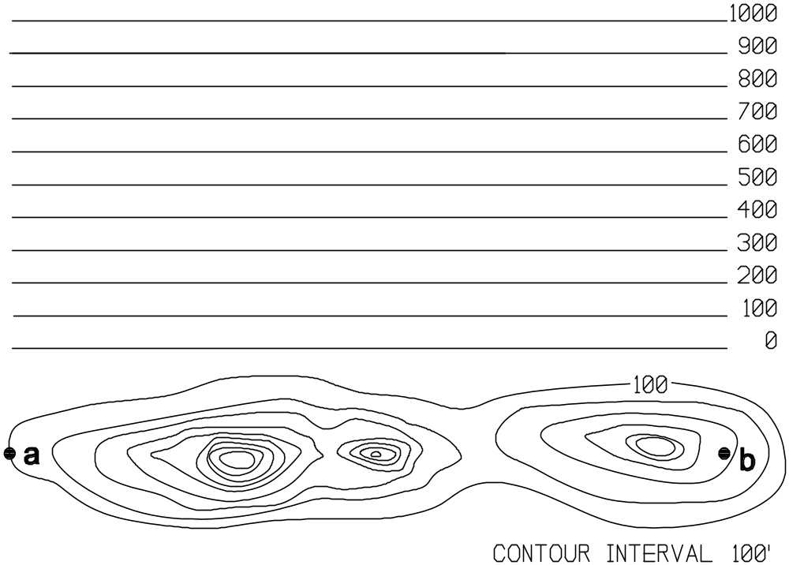

Using the map provided:

2. How many inches per mile does the map represent?

3. What is the map scale of this map? With inches as a unit of measure, what does this ratio mean?

4. One inch on this map equals how many feet on the ground?

5. What is the contour interval of your map?

6. What is an index contour?

7. Choosing from the Map Feature List in the table below, write in the map feature displayed for each point.

Point Corresponding Map Feature | Map Feature List
A | North Aspect
B | East Aspect
C | Bench Mark
D | Canyon Bottom or Valley
E | West Aspect
F | Intersecting Drainage
G | Ridgeline
H | South Aspect
I Bench Mark ( free answer) | Intermittent Stream
J | Hill Top

Part 4 – Visualization Exercise

Two hours ago, you initially observed forward fire spread between two fence posts taking 10 minutes. Currently you observe that it is taking just 4 minutes to burn between fence posts. Fuel and topography have not changed.

Your crew is working 8 fence posts in front of the main fire, and requires 30 minutes more to complete the line, and another 5 minutes to get safely out of the way. Assuming all things remain constant:

- Will the crew complete the line before the fire arrives at their location? Show your calculations.

- Can they get safely out?

- What else could you do in order to complete the section of line and still allow time to get to the safety zone?

- What other fire behavior indicators would help with your decision?

2. From your answers in Part 1 (your Rate of Spread), what is the change, expressed as a ratio, from walking to jogging? How many times faster were you able to run the distance?

Part 5 – Basic Principles of Fire Behavior Test

1. Three environmental factors that affect wildland fire behavior are:

a. fuels, solar radiation, weather
b. fuels, RH, temperature
c. fuels, weather, topography
d. large fuels, fine fuels, topography

2. List four factors of topography which can influence fire ignition and spread.

3. List five weather factors which may produce rapid fire spread.

4. What is the general wind?

5. What are local winds? Give two examples.

6. When a cold front or thunderstorm is expected, what is the most significant weather change you can expect?

7. Winds associated with a cold front are strongest when?

8. Describe the intensity and direction of the winds produced by a thunderstorm.

9. Describe the effect relative humidity has on wildland fire behavior.

10. List four visible indicators of a stable airmass, and four visible indicators of an unstable airmass.

Stable

Unstable

Part 6 – Fuel Groups/Models Test

1. What are the four fuel groups in the Fire Behavior Prediction System (FBPS)?

2. For each fuel group, how many fuel models are in each?

3. Give the four fuel timelag categories used to classify dead fuel. Then give the range of fuel sizes for each category.

4. What fuel size is most responsible for the spread of fire?

- List seven fuel characteristics of fuels which affect fire behavior.

- Which fuel models have a live fuel loading?

- Which fuel group is most common in the area you work?

Part 7 – Fireline Handbook - Appendix B

1. What is the range in moisture of extinction within each of the four fuel groups? On which page of the appendix did you find your information?

Using the Fire Behavior Characteristics Chart for light fuels found on page B-57, list the major flame length divisions marked, and associated fireline intensities. For each of the major divisions, list interpretations that affect tactics and firefighter safety.

3. The spread rate of a going fire is 10 chains per hour, with three foot flame lengths.

a. What is the Heat per Unit Area?

b. What is the Fireline Intensity?

c. There is a 10-fold increase in rate of spread for this afternoon. What is the expected flame length and fire intensity?

4. At the moment, light winds are blowing across the fire, but in the distance, a large flag is fully extended. Looking at the tree tops, saplings are swaying violently, even some larger trees sway noticeably.

Use the Beaufort scale for estimating 20-foot windspeed in Appendix B and give a range of estimated windspeed based on these observations.

What might this indicate later in the day?

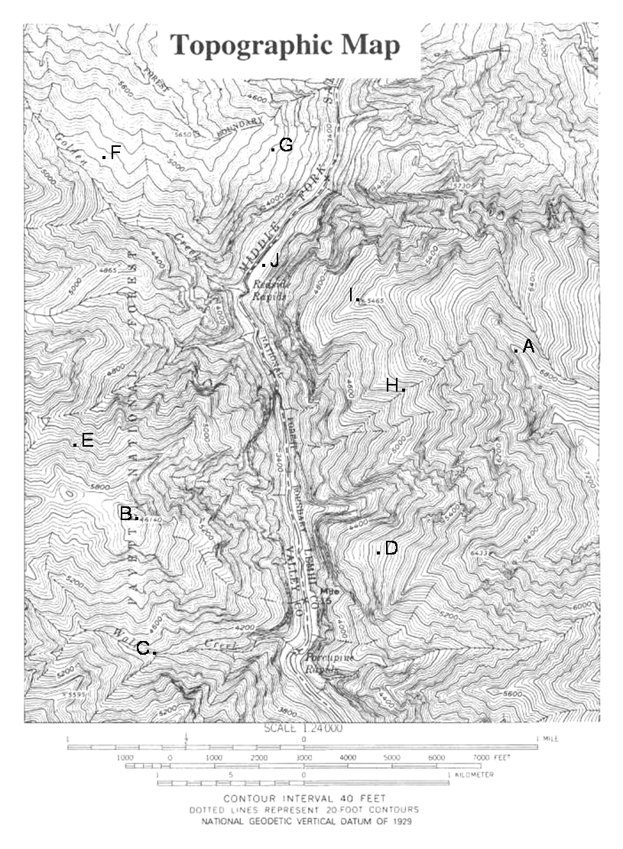
Pre-Qualifying Test
ANSWER KEY

Part 1 – Flame and “Your Personal Rate of Spread”

Your walking distance time = ___________________. (1 pt)

Your jogging distance time = ___________________. (1 pt)

Your running distance time = ___________________. (1 pt)

What was your established distance? (1 pt)

From the FLAME publication, if a fire experiences a 10-fold increase in wind (EWS ratio) and the fire moves from litter to crown, what is the increase in expected rate of spread? (2 pts)

60-fold (60x) increase

From the FLAME publication, what factors drive huge, and sometimes rapid changes in Rate of Spread? (2 pts)

EWS or effective wind speed, accounts for the greatest change factors.

Change in fuel type (litter, crown, grass).

Fine fuel moisture – significant for crown fire and spotting potential.

Part 2 – Basic Firefighter Math (Be sure and show your work, not just the answer.)

1. You are asked to prepare five gallons of mixed pump gas for a Mark 3 pump. The proper fuel mix is 32 to 1 (32:1) or 32x (times) the parts of gas to one part oil. How much 2 cycle oil (oz) is needed to prepare five gallons of mixed fuel? (2 pts)

32 oz x 4 qts x 5 gal = 640 oz.
640/x =32/1, where x = 20 oz.

2. The forward rate of spread of a wildland fire is 20 times (20x) the backing rate of spread. Write this as a fraction and in ratio notation. (2 pts)

20/1 or 20:1

3. Your crew boss instructs you to pick up tools from supply. He wants 3x the number of pulaskis to shovels. There are 20 people in your crew; each crew member is issued only one tool. How many pulaskis and shovels do you request from supply? (2 pts)

15/5 = the 3:1 ratio
15 pulaskis, 5 shovels

4. Your wage is $12 per hour and you worked 60 hours (flat rate, no premium pay for overtime) on the Uncle Sam fire. Taxes and other deductions from your pay total $216. (4 pts)

  - What is the ratio of withholding to what you earned? Simplify.

$12/hr x 60 = $720 earned
216/720 simplified is 3/10 or 3:10

  - What percent is being withheld from your pay?

216/720 x 100 = 30%

  - How many hours did you work just to pay for the withholdings?

216/$12 = 18 hours

  - What is the ratio of total hours worked vs. number of hours to pay for withholdings?

60/18 simplified is 10/3 or 10:3.
For every 10 hours worked, 3 hours goes towards withholdings.

5. If there is a 1200 feet change in elevation, over a horizontal distance of one mile, what is the % slope? (2 pts)

1200/5280 x 100 = 22.7 (23% rounded)

6. If you have an 18 in. rise in elevation along a 6 foot stick, what would the slope be? (2 pts)

rise/run x 100 = 18/72 x 100 = 25% slope

Part 3 – Maps

1. Draw a profile (horizontal line) showing the elevations from point a
to point b. At each contour intersection, draw a vertical line up to the corresponding elevation. Put a dot at the correct height profile, then
connect the dots. (4 pts)

Using the map provided:

2. How many inches per mile does the map represent? (2 pts)

2.64 inches = 1 mile

3. What is the map scale of this map? With inches as a unit of measure, what does this ratio mean? (2 pts)

1:24,000; 1 inch map distance is equal to 24,000 inches ground distance

4. One inch on this map equals how many feet on the ground? (2 pts)

2,000 feet

5. What is the contour interval of your map? (2 pts)

40 feet

6. What is an index contour? (2 pts)

A bold, or darker contour line. Every fifth contour is this way, and every so often the elevation is marked within an index contour.

7. Choosing from the Map Feature list in the table below, write in the map feature displayed for each point. (10 pts)

Point Corresponding Map Feature | Map Feature List
A Ridgeline | North Aspect
B Hilltop/Peak | East Aspect
C Intersecting Drainage | Bench Mark
D West Aspect | Canyon Bottom or Valley
E North Aspect | West Aspect
F South Aspect | Intersecting Drainage
G East Aspect | Ridgeline
H Intermittent Stream | South Aspect
I Bench Mark | Intermittent Stream
J Canyon Bottom or Valley | Hill Top

Part 4 – Visualization Exercise

Two hours ago, you initially observed forward fire spread between two fence posts taking 10 minutes. Currently you observe that it is taking just 4 minutes to burn between fence posts. Fuel and topography have not changed.

- Your crew is working 8 fence posts in front of the main fire, and requires 30 minutes more to complete the line, and another 5 minutes to get safely out of the way. Assuming all things remain constant: (2 pts each)

a. Will the crew complete the line before the fire arrives at their location? Show your calculations.

Fire advancing in 32 minutes to crew. Yes, but 30 minutes to complete line + 5 minute escape = 35 minutes. Line can be completed, but not enough time to get out safely.

b. Can they get safely out?

If 5 minutes is needed, then no. Marginal at best, more information needed to support decision.

c. What else could you do in order to complete the section of line and still allow time to get to the safety zone?

Keep a close watch on fire, speed up if safe to do so, but don’t take any unnecessary risk. Safety of crew is highest priority. See if additional support is available, such as an engine.

d. What other fire behavior indicators would help with your decision?

Fireline intensity and flame length: if > than 4 foot flame lengths, need to get out.

- From your answers in Part 1 (Your Rate of Spread), what is the change, expressed as a ratio, from walking to jogging? How many times faster were you able to run the distance? (2 pts)

Note: Student answers based on their values from Part 1. No set answer, but have to check their math.
Part 5 – Basic Principles of Fire Behavior

1. Three environmental factors that affect wildland fire behavior are: (1 pt)

a. fuels, solar radiation, weather
b. fuels, RH, temperature
c. fuels, weather, topography
d. large fuels, fine fuels, topography

2. List four factors of topography which can influence fire ignition and spread. (4 pts)

Lay of the land, natural/artificial barriers, slope, aspect, elevation

3. List five weather factors which may produce rapid fire spread. (5 pts)

Temperature increases, relative humidity decreases, Inversion breaking, wind shifts, approach of cold front, approach of thunderstorm, strong or high winds.

4. What is the general wind? (2 pts)

An unobstructed wind, which is not influenced by topography, vegetation, buildings, etc., usually measured at 20 feet above the surface. Often referred to as the 20-foot windspeed.

5. What are local winds? Give two examples. (3 pts)

Wind which is terrain induced or modified, such as slope, and valley winds, sea and land breezes, wind blowing through saddles, etc.

6. When a cold front or thunderstorm is expected, what is the most significant weather change you can expect? (3 pts)

Stronger (higher) wind speed, and change in wind direction.

7. Winds associated with a cold front are strongest when? (2 pts)

In the vicinity of the front, either just before the front arrives, or just after the front has passed.

8. Describe the intensity and direction of the winds produced by a thunderstorm. (2 pts)

Strong, gusty downdrafts with cell over fire, fanning out in all directions. With an approaching cell, increased updrafts towards the cell. Downdrafts can exceed 50 mph.

9. Describe the effect relative humidity has on wildland fire behavior. (2 pts)

Decrease in RH means a decrease in fine dead fuel moisture and increased fire behavior. Increasing RH means fuel moisture is also increasing and eventually will decrease fire behavior.

10. List four visible indicators of a stable airmass, and four visible indicators of an unstable airmass. (8 pts)

Stable

Smoke flattens out, not much rise
Horizontal clouds (stratus)
Calm conditions
Haze

Unstable

Smoke rises vertically
Vertical clouds – cumulous
Strong winds
Clear atmosphere
Dust devils, fire whorls

Part 6 – Fuel Groups/Models

1. What are the four fuel groups in the Fire Behavior Prediction System (FBPS)? (2 pts)

Grass, brush, timber, slash

2. For each fuel group, how many fuel models are in each? (2 pts)

Grass – 3 Timber – 3
Brush – 4 Slash – 3

3. Give the four fuel timelag categories used to classify dead fuel. Then give the range of fuel sizes for each category. (4 pts)

1 hr – 0 to .25 in
10 hr - .25 to 1 in
100 hr – 1 to 3 in
1000 hr – 3+ in material

4. What fuel size is most responsible for the spread of fire? (2 pts)

The 1 hr fuel class or fine dead fuel.

5. List seven fuel characteristics of fuels which affect fire behavior. (7 pts)

Fuel loading, size and shape, compactness, moisture content, horizontal continuity, vertical arrangement, chemical content.

6. Which fuel models have a live fuel loading? (2 pts)

Fuel Models 2, 4, 5, 7, 10

7. Which fuel group is most common in the area you work? (1 pt)

This will be quite variable, with no right or wrong answer. It gets students to think about his/her own fire environment. Give points for writing something down.

Part 7 – Fireline Handbook - Appendix B

1. What is the range in moisture of extinction within each of the four fuel groups? On which page of the appendix did you find your information?
(4 pts)

Grass – 12 to 25% Timber – 25 to 30%
Brush – 20 to 40% Slash – 15 to 25%
Appendix B, page B-21

2. Using the Fire Behavior Characteristics Chart for light fuels found on page B-57, list the major flame length divisions marked, and associated fireline intensities. For each of the major divisions, list interpretations that affect tactics and firefighter safety. (6 pts)

1 to 4 feet – 100 BTU; safe for FFTRs
8 to 11 feet – 1000 BTU; haul equipment
4 to 8 feet – 500 BTU; haul FFTRs
11+ feet – all tactics ineffective

3. The spread rate of a going fire is 10 chains per hour, with three foot flame lengths.

a. What is the Heat per Unit Area? (1 pt)

300 Btu/ft²

b. What is the Fireline Intensity? (1 pt)

About 75-80 Btu/ft/sec.

c. There is a 10-fold increase in rate of spread for this afternoon. What is the expected flame length and fire intensity? (2 pts)

Fireline Intensity is about 550 Btu/ft/sec.
Flame Length is between 8-9 feet.

4. At the moment, light winds are blowing across the fire, but in the distance, a large flag is fully extended. Looking at the tree tops, saplings are swaying violently, even some larger trees sway noticeably. (4 pts)

Use the Beaufort scale for estimating 20-foot windspeed in Appendix B and give a range of estimated windspeed based on these observations.

Moderate Breeze – 13 to 18 mph.

What might this indicate later in the day?

The wind could surface to the fire later in the day and greatly increase fire behavior, or there might be a front approaching.

