UNITED STATES DEPARTMENT OF THE INTERIOR
U.S. GEOLOGICAL SURVEY

Thermodynamic Data for Modeling Acid Mine Drainage Problems:
Compilation and Estimation of Data for Selected Soluble Iron-Sulfate Minerals

by

Bruce S. Hemingway, Robert R. Seal, II, and I-Ming Chou³

Open-File Report 02-161

Abstract
Enthalpy of formation, Gibbs energy of formation, and entropy values have been compiled from the literature for the hydrated ferrous sulfate minerals melanterite, rozenite, and szomolnokite, and a variety of other hydrated sulfate compounds. On the basis of this compilation, it appears that there is no evidence for an excess enthalpy of mixing for sulfate-H₂O systems, except for the first H₂O molecule of crystallization. The enthalpy and Gibbs energy of formation of each H₂O molecule of crystallization, except the first, in the iron(II) sulfate - H₂O system is -295.15 and -238.0 kJ·mol⁻¹, respectively. The absence of an excess enthalpy of mixing is used as the basis for estimating thermodynamic values for a variety of ferrous, ferric, and mixed-valence sulfate salts of relevance to acid-mine drainage systems.

Introduction
Remediation of problems that arise from release of the components of soluble minerals to ground and surface waters associated with active and abandoned mines will require geochemical modeling of the rock-water interactions. Such models will depend upon an extensive thermodynamic data base. However, thermodynamic data necessary for such modeling calculations are limited. This report is a summary of the procedures used to develop a database for hydrous iron sulfate compounds during the mid-1990s at the U.S. Geological Survey.
The soluble iron-sulfate minerals are an important group of phases with regard to acid-mine drainage. These minerals include melanterite FeSO₄·7H₂O, rozenite FeSO₄·4H₂O, szomolnokite FeSO₄·H₂O, copiapite Fe²⁺Fe³⁺₄(SO₄)₆(OH)₂·20H₂O, römerite Fe²⁺Fe³⁺₂(SO₄)₄·14H₂O, coquimbite Fe³⁺₂(SO₄)₃·9H₂O, kornelite Fe³⁺₂(SO₄)₃·7H₂O, rhomboclase (H₃O)Fe³⁺(SO₄)₂·3H₂O, voltaite K₂Fe²⁺₅Fe³⁺₄(SO₄)₁₂·18H₂O, and halotrichite-bilinite Fe²⁺(Al,Fe³⁺)₂(SO₄)₄·22H₂O, among others. The compounds have been shown to play important roles in controlling the extreme mine-drainage compositions from Iron Mountain mine, California, which reaches pH values less than zero and total iron concentrations over 100 grams per liter (Nordstrom and Alpers, 1999). They are also found in numerous other acid-mine drainage settings (Alpers and others, 1994; Jambor and others, 2000).
Despite the importance of the phases, much of the thermodynamic data necessary for such modeling calculations are not available, or are of questionable quality. For example, considerable uncertainty exists in the location of the reaction:
FeSO₄·4H₂O + 3H₂O_{(g)} = FeSO₄·7H₂O (1),
(where “g” refers to gas) in terms of temperature and relative humidity (RH). Published estimates of the relative humidity associated with this reaction at 25 °C range from a low of ~15 % (Pribylov, 1969) to a high of ~95 % (DeKock, 1982) with a distinct clustering around 60 to 80 % (Fig. 1). Results of the ongoing investigations studying dehydration equilibria between melanterite and rozenite of Chou and others (1999; 2002) are similar to the results of Malinin and others (1979) and yield an equilibrium relative humidity of approximately 63 %.
This paper reviews the experimental data for soluble iron- and other sulfate phases and uses these data to construct models for estimating thermodynamic data at 298.15 K and 1 bar for phases for which no experimental data exist. Even though our estimations of thermodynamic properties will greatly enhance the ability to model the geochemistry of acid-mine drainage, they only serve as interim solutions to our inadequate understanding of these systems. A more rigorous treatment must await experimental determination of thermodynamic properties.

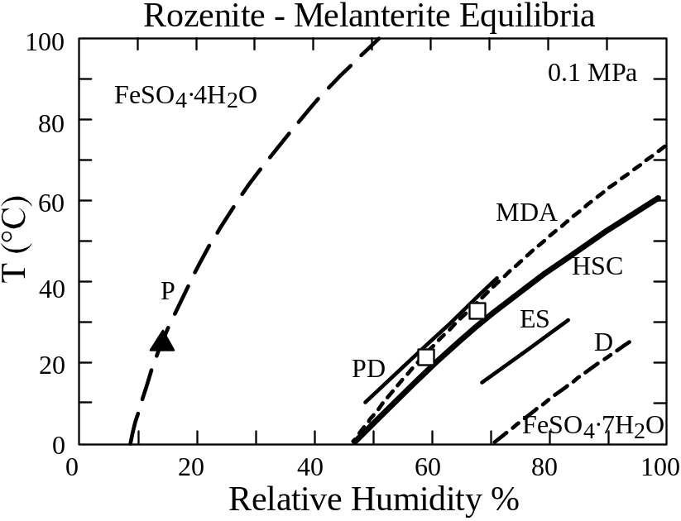
Figure 1. Comparison of estimates for the reaction of rozenite + H₂O to melanterite as a function of temperature and relative humidity. Open squares are results of Malinin and others (1979); filled triangle is result of Pribylov (1969). Sources of curves are: P, Pribylov (1969); PD, Parkinson and Day (1981); MDA, Malinin and others (1979); HSC, this study; ES, Ehlers and Stiles (1965); D, DeKock (1982).

Ferrous sulfates and their hydrates
Five different ferrous-sulfate hydrate minerals have been identified and described in the literature. They are, in order of increasing hydration: szomolnokite FeSO₄·H₂O, rozenite FeSO₄·4H₂O, siderotil FeSO₄·5H₂O, ferrohexahydrite FeSO₄·6H₂O, and melanterite FeSO₄·7H₂O. In nature, melanterite and rozenite are the most commonly reported phases, followed by szomolnokite and siderotil (Alpers and others, 1994). Ferrohexahydrite is extremely rare (Fleischer, 1963). Laboratory studies of evaporating waters and field observations have defined a general crystallization sequence of these minerals beginning with melanterite, followed by rozenite, which in turn is followed by szomolnokite; following szomolnokite are mixed valence salts followed by ferric salts (Buurman, 1975; Nordstrom and Alpers, 1999; Jambor and others, 2000). Notably absent from the crystallization sequence are ferrohexahydrite and siderotil. Jambor and Traill (1963) concluded that siderotil was not a stable phase in the binary (FeSO₄ - H₂O) system, and required at least 5 mole % of copper substituting for iron to stablize it relative to melanterite and rozenite. In addition, Ehlers and Stiles (1965) were able to reverse the transition from melanterite to rozenite at near ambient temperatures and relative humidities between 70 and 80 % without the appearance of siderotil and ferrohexahydrite. Therefore, on the basis of these observations, it would appear that melanterite, rozenite, and szomolnokite are the stable hydrates in the binary (FeSO₄ - H₂O) system at ambient conditions.
The thermodynamic data available for hydrated ferrous sulfates consist of enthalpy of formation values for melanterite, szomolnokite (Adami and Kelley, 1963), and rozenite (determined from the data of Larson and others, 1968), and entropy values for melanterite (Lyon and Giauque, 1949), rozenite (DeKock, 1982), and szomolnokite (Pribylov, 1969). The Gibbs energy of formation can be calculated for melanterite, rozenite and szomolnokite, where corrections have been made to insure internal consistency of ancillary thermodynamic data.

Enthalpy of formation (Δ_{f}H°)
In the iron(II) system, there appears to be little or no excess enthalpy of mixing for H₂O and ferrous sulfate (except for the addition of the first H₂O molecule). If the enthalpy of formation of szomolnokite (FeSO₄·H₂O) is subtracted from the equivalent value for melanterite (FeSO₄·7H₂O) and divided by 6, the difference in the number of H₂O molecules of hydration, the resulting value of -295.15 kJ·mol⁻¹ for each added H₂O molecule may be used to estimate the value for the enthalpy of formation of rozenite (FeSO₄·4H₂O). The value of -295.15 kJ·mol⁻¹ compares favorably with the value of -294.8 kJ·mol⁻¹ derived from data compiled for numerous hydrated sulfate salts relative to monohydrates and the value of -304.2 kJ·mol⁻¹ derived from data compiled for numerous hydrated sulfate salts relative to anhydrous sulfates, as described below. The thermodynamic data used in these calculations are from Wagman and others (1982) unless otherwise stated. The value estimated by the summation of the enthalpy of formation of szomolnokite and 3 times the value derived above for the contribution of one H₂O molecule is –2,129.1 kJ·mol⁻¹ compared with the measured value for rozenite of –2,129.2 kJ·mol⁻¹. Using this model, we estimate the enthalpy of formation of ferrohexahydrite (FeSO₄·6H₂O) and siderotil (FeSO₄·5H₂O) as -2,719.3 and -2,424.3 kJ·mol⁻¹, respectively.
Hydrated sulfate minerals of other group VIIIA and adjacent group VIIA, IB and IIB elements of the Periodic Chart show (1) a similar value to that derived for the iron-sulfate hydrates for the contribution of H₂O to the enthalpy of formation, and (2) support for the model of no excess enthalpy of mixing associated with hydration for the metal sulfate- H₂O system as limited above (Figs. 2 and 3). For cobalt (7 hydrate and 6 hydrate), nickel (7 hydrate and 4 hydrate), manganese (7 hydrate and 4 hydrate), copper (5 hydrate and 1 hydrate), zinc (7 hydrate and 1 hydrate), and cadmium (8/3 hydrate and 1 hydrate) hydrated sulfates, the estimated contributions for one H₂O are -296.33, -290.74, -293.73, -298.45, -295.54, and -293.91 kJ·mol⁻¹, respectively. Using these values, we may estimate the enthalpies of formation of other hydrates of these cations and compare the estimated and experimental values. For CoSO₄·H₂O, CuSO₄·3H₂O, FeSO₄·4H₂O, MnSO_{4·}·H₂O, MnSO₄·5H₂O, NiSO₄·6H₂O, and ZnSO₄·6H₂O, the estimated and measured values for the enthalpy of formation are summarized in Table 1. The differences between the estimated and experimental values are all well within experimental error and thus support this model for the estimation of enthalpy values.
The finding that there is no excess enthalpy of mixing in the metal sulfate- H₂O system is important because many of the phases found in nature will deviate in H₂O content from that given for the end-member. This model justifies calculation of the enthalpy of formation of such materials with non-integer values for the H₂O content. In further support of this hypothesis, we may calculate the enthalpy contribution of one H₂O

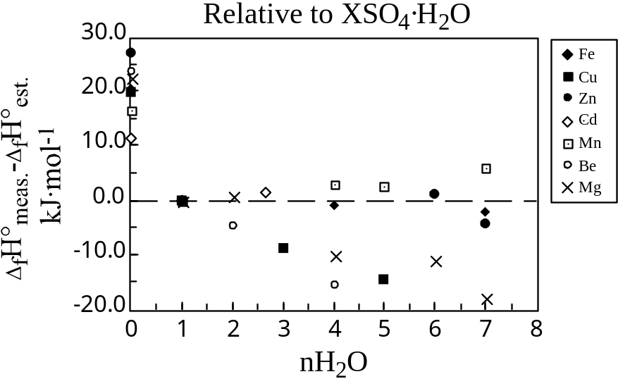
Figure 2. Deviation of estimated enthalpy of formation values (Δ_{f}H°_{est.}) from measured values (Δ_{f}H°_{meas.}) for metal-sulfate salts relative to the value for XSO₄·H₂O. Calculations were made assuming an enthalpy contribution for each H₂O molecule of -294.8 kJ·mol⁻¹. Note that data for Be and Mg salts (group IIA) were not used to generate the values for the enthalpy contribution of additional H₂O molecules because of greater structural differences of these compounds relative to the groups VIIA, VIIIA, IB, and IIB salts (see text).

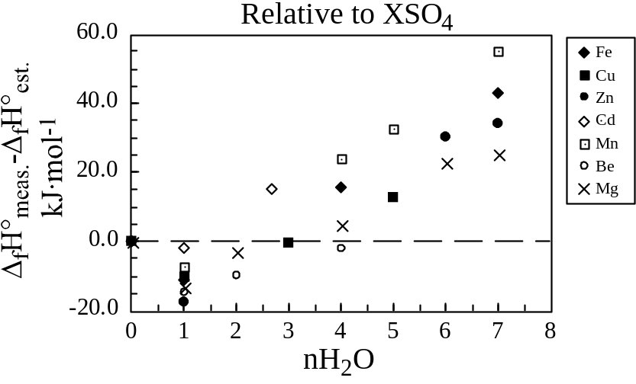
Figure 3. Deviation of estimated enthalpy of formation values (Δ_{f}H°_{est.}) from measured values (Δ_{f}H°_{meas.}) for metal-sulfate salts relative to the value for XSO₄. Calculations were made assuming an enthalpy contribution for each H₂O molecule of -304.2 kJ·mol⁻¹. The distinct slope in the data is due to the difference between the enthalpy contribution of the first H₂O molecule of crystallization relative to that of subsequent H₂O molecules of crystallization (see text). Note that data for Be and Mg salts (group IIA) were not used to generate the values for the enthalpy contribution of additional H₂O molecules because of greater structural differences of these compounds relative to the groups VIIA, VIIIA, IB, and IIB salts (see text).

Table 1. Comparison of measured and estimated enthalpy of formation values for selected metal sulfates relative to the elements and ideal O₂, S₂, and H₂ gases at 298.15 K and 1 bar.
Formula | Enthalpy of formation from elements
 | kJ•mol⁻¹
 | Measured* | Estimated
FeSO₄·4H₂O | -2,129.2 | -2,129.1
CoSO₄·H₂O | -1,199.6 | -1,201.9
NiSO₄·6H₂O | -2,682.8 | -2,685.6
MnSO₄·H₂O | -1,376.5 | -1,376.9
MnSO₄·5H₂O | -2,553.1 | -2,551.8
CuSO₄·3H₂O | -1,684.3 | -1,682.7
ZnSO₄·6H₂O | -2,777.5 | -2,782.2
*All data are from Wagman and others (1982), except for the datum for CoSO₄·H₂O, which is from Goldberg and others (1966), and the datum for FeSO₄·4H₂O, which is from Larson and others (1968).

molecule from the difference between the enthalpies of formation of UO₂SO₄·3H₂O and UO₂SO₄·1H₂O, which yields -300.95 kJ·mol⁻¹ per H₂O. We use this value to calculate the enthalpies of formation of UO₂SO₄·3.5H₂O and UO₂SO₄·2.5H₂O and compare them to the experimental values given for these phases: -2,906.3 (estimated) and -2,900.8 (measured), and -2,603.8 (estimated) and -2,607.1 (measured) kJ·mol⁻¹, respectively. Again, the differences between the estimated and experimental values are within the experimental error.
The enthalpy contribution, except for the first H₂O molecule, is different for each chemical system, that is, for Fe versus Mn or Cu. The differences are small and within the experimental error of such calculations, which suggests that there will not be large enthalpies of mixing for the H₂O component as trace elements substitute for the end-member cations. The average value for the contribution of one H₂O to the enthalpy of formation of the group VIIA, VIIIA, IB, and IIB hydrated sulfates is -294.8 ± 2.4 kJ·mol⁻¹. For the groups IA, IIA, IIIA, IVA and VA hydrated sulfates (sulfates of Be, Ca, Mg, La, Zr, and mixed K-Mg, K-Zn, K-Cu, K-Al, Na-Al, and Na-Zn), the value appears to be somewhat larger, about -298 to -300 kJ·mol⁻¹ probably due to greater structural differences. There are not sufficient data at this time to determine the value for the group VIA hydrated sulfates, but data from (Cr(H₂O)₆)₂(SO₄)₃·nH₂O phases suggest a value close to the group VIIIA value.
The enthalpy contribution of the first H₂O molecule also varies with the cation, but again the calculated values are in agreement within experimental error. Using data from Fe, Mn, Co, Cu, Cd, and Zn sulfate and sulfate hydrate, the average enthalpy contribution for the first H₂O molecule is -313.8 ± 5.7 kJ·mol⁻¹. This value is more negative by 19 kJ·mol⁻¹ than the average value for additional H₂O molecules of hydration. Thus, when considered in terms of hydration from an anhydrous salt, the average enthalpy contribution per H₂O molecule is -304.2 ± 7.9 kJ·mol⁻¹, which has a larger uncertainty than that based on hydration of a singly hydrated salt (-294.8 ± 2.4 kJ·mol⁻¹). However, for cases where an experimentally determined value for a singly hydrated salt is lacking, this value may be sufficient as a first-order approximation.

Gibbs energy of formation (Δ_{f}G°)
The Gibbs energy of formation is the primary thermodynamic quantity needed for modeling rock-water interactions, when solubility data are not available. Few values of the Gibbs energy of formation have been determined for the soluble iron sulfates. The procedure used to estimate the Gibbs energies listed in Table 2 are discussed below.
The Gibbs energy of formation is related to the enthalpy of formation through the following thermodynamic equality:
Δ_{f}G° = Δ_{f}H° - TΔ_{f}S° (2),
where Δ_{f}S° is the entropy of formation at temperature T in kelvins. It has been standard practice to add a constant amount for the entropy contribution of each H₂O to the value of the anhydrous metal sulfate to estimate the entropy of the higher hydrates for which no experimental data are available (e.g., DeKock, 1982, or Latimer, 1952). This would suggest that there is little or no excess Gibbs energy of mixing for the metal sulfate-H₂O system, except for the first H₂O molecule.

Table 2. Thermodynamic properties for selected soluble iron sulfates relative to the elements and ideal O₂, S₂, and H₂ gases at 298.15 K and 1 bar.
Phase | Formula | Formation from elements |  |  | References*
 |  | Entropy | Enthalpy | Gibbs Energy | S | H/G
 |  | J•mol⁻¹•K⁻¹ | kJ•mol⁻¹ | kJ•mol⁻¹

Aqueous species
Fe²⁺ | Fe²⁺ | 101.6 | -90.0 | -90.5 | 1 | 1
Fe³⁺ | Fe³⁺ | 278.4 | -49.0 | -16.28 | 1 | 1
H₂O | H₂O | 188.8 | -241.8 | -228.6 | 4 | 4

Ferrous sulfates
FeSO₄ | FeSO₄ | 120.96 | -932.2 | -828.3 | 9 | 5
Szomolnokite | FeSO₄•H₂O | 157.7 | -1,243.69 | -1,081.2 | 8 | 6
Rozenite | FeSO₄•4H₂O | 282.4 | -2,129.2 | -1,795.2 | 10 | 10
Siderotil | FeSO₄•5H₂O | 323.6 | -2,424.3 | -2,033.9 | 10 | 10
Ferrohexahydrite | FeSO₄•6H₂O | 368.0 | -2,719.4 | -2,271.9 | 10 | 10
Melanterite | FeSO₄•7H₂O | 409.2 | -3,012.6 | -2,507.75 | 7 | 1
Halotrichite | FeAl₂(SO₄)4•22H₂O | 1,166 | -11,041 | -9,306 | 10 | 10

Ferric sulfates
Fe₂(SO₄)₃ | Fe₂(SO₄)₃ | 282.8 | -2,581.9 | -2,254.4 | 2 | 3
Kornelite | Fe₂(SO₄)₃•7H₂O | 590.6 | -4,692.2 | -3,793.7 | 10 | 10
Coquimbite | Fe₂(SO₄)₃•9H₂O | 670.1 | -5,288.2 | -4,250.6 | 10 | 10
Ferricopiapite | Fe₅(SO₄)₆O(OH)·20H₂O | 1,396 | -11,767 | -9,899 | 10 | 10

Mixed ferrous-ferric sulfates
Copiapite | Fe⁺²Fe₄(SO₄)₆(OH)₂·20H₂O | 1,444 | -11,824 | -9,971 | 10 | 10
Römerite | Fe⁺²Fe₂(SO₄)₄·14H₂O | 943 | -7,730 | -6,486 | 10 | 10
Bilinite | Fe⁺²Fe₂(SO₄)₄·22H₂O | 1,243 | -10,121 | -8,410 | 10 | 10
Voltaite | K₂Fe⁺²₅Fe₄(SO₄)₁₂·18H₂O | 1,959 | -16,860 | -14,499 | 10 | 10
*References: 1. Parker and Khodakovskii (1995); 2. Barany and Adami (1965); 3. Pankratz and Weller (1969); 4. Cox and others (1989); 5. Adami and Kelly (1963); 6. Larson and others (1968); 7. Lyon and Giauque (1949); 8. DeKock (1982); 9. Pribylov (1969); 10. This study.

The available thermodynamic data for the ferrous sulfate hydrates are sufficient to develop a model for the contribution of each H₂O molecule to the Gibbs energy of formation in nearly the same detail used in the enthalpy of formation calculations. Four Gibbs energy of formation values are available for use in estimating the contribution of each H₂O molecule. The difference in the Gibbs energies of formation of the anhydrous sulfate and the heptahydrate (7) divided by the number of H₂O molecules yields a value of -241.3 kJ·mol⁻¹ for the contribution of one H₂O molecule. This value must be modified. It was shown above that the enthalpy contribution of the first H₂O molecule is larger than that for additional H₂O molecules. In the ferrous sulfate system, the difference was 20.1 kJ·mol⁻¹ in the enthalpy of formation. This difference divided by 7 is the estimated correction factor required above and yields a value of -238.4 kJ·mol⁻¹ for the contribution of H₂O molecules greater than the first to the Gibbs energy. The Gibbs energy of formation for melanterite is based upon the enthalpy of formation reported by Adami and Kelley (1963) and the entropy reported by Lyon and Giauque (1949). The measurements of the heat capacity of melanterite between 1 and 300 K (Lyon and Giauque, 1949) fully account for the magnetic heat capacity expected for Fe²⁺ and thus for the magnetic entropy.
We may also calculate the contribution of one H₂O molecule to the Gibbs energy of formation by dividing the difference in the Gibbs energy values of rozenite and szomolnokite by 3. This calculation yields -238.0 kJ·mol⁻¹ for the contribution of one H₂O molecule, in good agreement with the value calculated above. This value was used to calculate the estimated Gibbs energy values listed in Table 2 beginning with the experimental Gibbs energy value for melanterite. The values calculated for the Gibbs energy of formation by this method may be compared with the experimental values, respectively, for rozenite (-1,795.2 vs. -1,795.9 kJ·mol⁻¹) and szomolnokite (-1,081.2 vs. -1,081.9 vs. kJ·mol⁻¹).
In support of the value just selected, we may examine the values for the contribution of additional H₂O molecules to the Gibbs energy in other hydrated metal sulfate systems. Using the same phases as listed above in the enthalpy calculations unless otherwise stated, for Co, Ni (7 hydrate and 6 hydrate), Zn, Cu, and Cd sulfate hydrates, we calculate -238.06, -237.22, -238.45, -240.41, and -237.85 kJ·mol⁻¹, respectively, for the contribution of one additional H₂O molecule. The average of these values is -238.4 kJ·mol⁻¹. This value is in obviously good agreement with the values calculated above for the ferrous sulfate hydrates.
It should be noted that this estimation scheme empirically describes the available data, but in the strictest sense, does not satisfy the thermodynamic properties of ideal mixtures. For ideal mixtures, the Gibbs energy of mixing is described by the relationship:
ΔG _{ideal mixing} = RT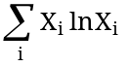 (3),
where R = 8.3144 J·mol⁻¹·K⁻¹ and X is the mole fraction in the binary FeSO₄·(H₂O·6□) - FeSO₄·7H₂O. For rozenite (X = 0.5), the ΔG _{ideal mixing} should be -1.7 kJ·mol⁻¹ at 298.15 K as opposed to a value of -0.725 kJ·mol⁻¹ based on the data in Table 2 (Fig. 4). The uncertainty in the measured Δ_{f}G° value is at least ± 1.5 kJ·mol⁻¹. Therefore, the measured value is within the limits of its uncertainty with respect to ideal mixing assuming that the values for the end members are accurate. Without more data on the Gibbs energy of intermediate hydrates in various systems, the present study chooses to retain the additive scheme described above because of its success in empirically describing the available data. However, the reader is urged to carefully scrutinize equilibria calculated using these estimates to insure consistency with natural assemblages and other constraints.

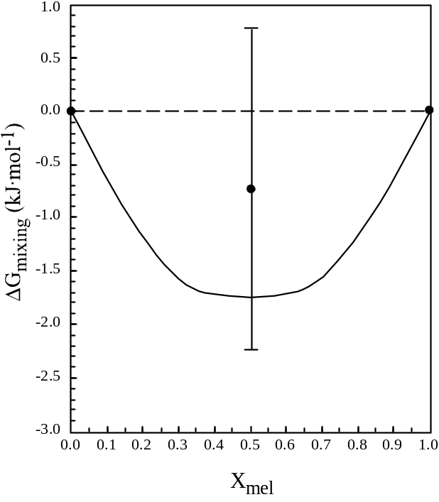
Figure 4. Variation of the ideal Gibbs energy of mixing with mole fraction of melanterite along the join FeSO₄·(H₂O·6□) (szomolnokite) - FeSO₄·7H₂O (melanterite) at 298.15K. Solid curve represents ideal mixing calculated on the basis of equation 2. Solid circles represent experimentally determined values for szomolnokite (X = 0.0), rozenite (X = 0.5), and melanterite (X = 1.0). Note that the uncertainty on the Δ_{f}G° value for rozenite is at least ± 1.5 kJ·mol⁻¹ and is indicated by the vertical bracket.

Entropy (S°)
The entropy of the ferrous sulfate phases listed in Table 2 may be estimated from the equality given above and the values for the Gibbs energy and enthalpy of formation. It should be noted that these values should be used with great care. Because the entropy derived in this manner is based upon the small difference between two large numbers each with an associated uncertainty, the uncertainty in the entropy is an order of magnitude larger than that for the Gibbs energy or enthalpy of formation. This approach is followed to maintain internal consistency of the thermodynamic data listed in Table 2.

Ferrous aluminum sulfate hydrate
The enthalpy (-11,008.3 kJ·mol⁻¹) and Gibbs energy (-9,277.6 kJ·mol⁻¹) of formation of halotrichite FeAl₂(SO₄)₄·22H₂O are estimated from the summation of the properties of Al₂(SO₄)₃·6H₂O, melanterite, and the values calculated above for the contribution of 9 additional H₂O molecules. The enthalpy of formation of halotrichite (-11,008.1 kJ·mol⁻¹) was also calculated from the summation of the enthalpy of Al₂(SO₄)₃·18H₂O (alunogen?) plus that for rozenite. The two values estimated for the enthalpy of formation of halotrichite are derived from two different sets of data and the results agree to better than 0.1 percent. However, the correct formula for alunogen appears to have 17 H₂O molecules of crystallization and not 18, and the value listed by Wagman and others (1982) for alunogen is an estimate taken from Kelley and others (1946). The properties of FeAl₂O₄ were compared with the summation of the properties of Al₂O₃ plus fictive FeO (Robie and Hemingway, 1995). Both the enthalpy and Gibbs energies of formation estimated for FeAl₂O₄ by the summation method were low by about 0.2 percent. The differences between the measured and estimated values for the enthalpy and Gibbs energy of formation increases as the difference in mineral structure increases, for example, 1.6 percent for fayalite vs. the oxides FeO and SiO₂. Chen (1975) has proposed a method for estimating thermodynamic properties based on a knowledge of these interrelationships (e.g., Hemingway and Sposito, 1996, p. 97). A factor (0.997) was used to adjust the estimated values for the enthalpy and Gibbs energy of formation because the reference materials are close in chemistry and structure in terms of the model used by Chen (1975). The entropy of halotrichite is calculated from the equality given above and the values estimated here. The estimated value for the entropy of halotrichite derived from the adjusted values for the enthalpy of formation and the Gibbs energy is about 6 percent smaller than the summation of entropies following the reaction described above. The entropy follows a similar trend to the properties described in the Chen (1975) model. The value of 6 percent will be used in calculations discussed below to estimate the correction necessary when using a summation approach to estimate the entropy of the hydrated sulfates.

Ferric sulfates and their hydrates
Thermodynamic data for ferric sulfate phases are very limited. Wagman and others (1982) gave a value for the enthalpy of formation of anhydrous Fe₂(SO₄)₃, -2,581.5 kJ·mol⁻¹, that is based on the calorimetric study by Barany and Adami (1965). The heat capacity of anhydrous ferric sulfate between 50 and 300 K was reported by Pankratz and Weller (1969). Using these data, DeKock (1982) calculated the Gibbs energy of ferric sulfate. The Gibbs energy calculated by DeKock (1982) will be incorrect because the entropy is missing 14.9 J·mol⁻¹·K⁻¹ in magnetic entropy per Fe³⁺ in the compound (see for example, Gopal, 1966). Cooke and others (1956) have shown that the magnetic heat capacity anomaly that can be expected for salts of Fe³⁺ can occur at very low temperatures. In the case of Fe(NH₃CH₃)(SO₄)₂·12H₂O, a good model for the phases examined here, the maximum in the heat capacity anomaly arising from the magnetic contribution of Stark splitting in Fe³⁺ was seen at 0.33 K. They also concluded that the total magnetic heat capacity, and thus the magnetic entropy, could be accounted for in the measurements they made between about 0.2 and 20 K. The estimated entropy reported by Pankratz and Weller (1969) for ferric sulfate did not include a contribution for the magnetic entropy of Fe³⁺. The entropy for ferric sulfate is 282.6 J·mol⁻¹·K⁻¹ (Pankratz and Weller, 1969) plus 2 times 14.9 J·mol⁻¹·K⁻¹ or 312.4 J·mol⁻¹·K⁻¹, and the Gibbs energy of formation is -2,263.0 kJ·mol⁻¹.
The values derived in the preceding paragraph represent the reference values upon which the estimated values for the ferric sulfate hydrate phases reported in Table 2 are based. The difference in the enthalpies of formation of La₂(SO₄)₃ and La₂(SO₄)₃·9H₂O is 2,706.7 kJ·mol⁻¹ or about 300.7 kJ·mol⁻¹ per H₂O molecule. This value is used to estimate the enthalpy of formation of coquimbite (Fe₂(SO₄)₃·9H₂O). Assuming that the first H₂O molecule contributes more than subsequent H₂O molecules and following the model discussed above, we estimate the contribution of the additional H₂O molecules to be -298 kJ·mol⁻¹ of H₂O and use this value to calculate the enthalpy of formation of kornelite (7 hydrate) from the value estimated for coquimbite. The entropies of coquimbite and kornelite are estimated following the procedure described by DeKock (1982) in which the contribution of each H₂O molecule is taken as 39.75 J·mol⁻¹·K⁻¹. The Gibbs energies of the two phases are calculated from these data and the equality given above.
The enthalpy of formation and entropy for ferricopiapite were estimated from the summation of these properties for 2 coquimbite, goethite, and 2 H₂O (H₂O value as derived above). The entropy of goethite (60.38 J·mol⁻¹·K⁻¹) was taken from Khodakovsky and others (1991). These values were adjusted in accordance with the differences noted above for summation data.

Mixed ferrous and ferric sulfates
There are few thermodynamic data for mixed ferrous and ferric compounds so the model used to estimate the thermodynamic data for this type of phase is similar to that used for halotrichite. The mixed iron sulfate hydrate phases are assumed to have slightly larger (about 0.3 percent) enthalpies of formation than the summation of values for the ferrous and ferric sulfate hydrates. The enthalpy of formation for bilinite and römerite are calculated from the sum of the properties of kornelite and melanterite (and plus 8 H₂O molecules for bilinite). The entropies are calculated from the same summation procedure and corrected by 6 percent as noted above. The Gibbs energies are calculated from these values using the equality given above. The values for copiapite are estimated using the same model as for the other mixed valence iron sulfates, but a correction is made for the substitution of (OH)₂ for SO₄. The correction is derived from the difference in the properties of FeSO₄ and Fe(OH)₂ (359.4 kJ·mol⁻¹ and 19.5 J·mol⁻¹·K⁻¹, respectively, for the enthalpy and entropy). The values for voltaite are derived from the summations and suggested adjustments of the enthalpy of formation and entropy for 5 szomolnokite, 2 kornelite, K₂SO₄, and -1 H₂O.

Estimated uncertainties
The uncertainties estimated for the enthalpy and Gibbs energy of formation values, relative to the elements, derived from the model calculations used in this study are between 0.3 and 0.7 percent, with the values for the ferrous and ferric phases at the low end and those of the mixed phases at the high end.

References
Adami, L.H. and Kelley, K.K., 1963, Heats of formation of two crystalline hydrates of ferrous sulfate: U.S. Bur. Mines Rept. Inv. 6260, 7 p.
Alpers, C.N., Blowes, D.W., Nordstrom, D.K., and Jambor, J.L., 1994, Secondary minerals and acid mine-water chemistry, in The Environmental Geochemistry of Sulfide Mine-wastes, Blowes, D.W. and Jambor, J.L., eds., Mineral. Assoc. Canada Short Course Notes, v. 22, p. 249-269.
Barany, R., and Adami, L.H., 1965, Heats of formation of anhydrous ferric sulfate and indium sulfate: U.S. Bur. Mines Rept. Invest. 6687, 8 p.
Buurman, P., 1975, In vitro weathering products of pyrite: Geologie en Mijnvouw, v. 54, p. 101-105.
Chen, C.H., 1975, A method of estimation of standard free energies of formation of silicate minerals: Am. J. Sci., v. 275, p. 801-817.
Chou, I-M., Seal, R.R., II, and Hemingway, B.S., 1999, Determination of melanterite-rozenite and chalcanthite-bonattite equilibria by the humidity buffer technique: In Ninth Annual V.M. Goldschmidt Conference, LPI Contribution No. 971, Lunar and Planetary Science Institute, Houston, p. 54-55.
Chou, I-M., Seal, R.R., II, and Hemingway, B.S., 2002, Determination of melanterite-rozenite and chalcanthite-bonattite equilibria by the humidity measurements at 0.1 MPa: American Mineralogist, v. 87 , p. 108-114.
Cooke, A.H., Meyer, H., and Wolf, W.P., 1956, Thermal and magnetic properties of ferric methylammonium sulphate: Proc. Roy. Soc. London, v. A237, p. 404-412.
Cox, J.D., Wagman, D.D., and Medvedev, V.A., 1989, CODATA key values for thermodynamics: Hemisphere, New York, 271 p.
DeKock, C.W., 1982, Thermodynamic properties of selected transition metal sulfates and their hydrates: U.S. Bur. Mines Info. Circ. 8910, 45 p.
Ehlers, E.G., and Stiles, D.V., 1965, Melanterite-rozenite equilibrium: Amer. Mineral., v. 50, p. 1457-1461.
Fleischer, M., 1963, New mineral names: Amer. Mineral., v. 48, p. 433.
Goldberg, R.N., Riddell, R.G., Wingard, M.R., Hopkins, H.P., Wulff, C.A., and Hepler, L.G., 1966, Thermochemistry of cobalt sulfate and hydrates of cobalt and nickel sulfates: J. Phys. Chem., v. 70, p. 706-710.
Gopal, E.S.R., 1966, Specific heats at low temperatures: Plenum Press, New York, 240 p.
Hemingway, B.S. and Sposito, G., 1996, Chapter 3. Inorganic aluminum-bearing solid phases: in The Environmental Chemistry of Aluminum, G. Sposito, ed., CRC Press, Boca Raton, FL, p. 81-116.
Jambor, J.L., and Traill, R.J., 1963, On rozenite and siderotil: Can. Mineral., v. 7, p. 751-763.
Jambor, J.L., Nordstrom, D.K., and Alpers, C.N., 2000, Metal-sulfate salts from sulfide mineral oxidation: In: Alpers, C.N., Jambor, J.L., and Nordstrom, D.K., eds., Sulfate minerals: crystallography, geochemistry, and environmental significance, Reviews in Mineralogy and Geochemistry, v. 40, p. 305-350.
Kelley, K.K., Shomate, C.H., Young, F.E., Naylor, B.F., Salo, A.E., and Huffman, E.H., 1946, Thermodynamic properties of ammonium and potassium alums and related substances, with reference to extraction of alumina from clay and alunite: U.S Bureau of Mines Technical Paper 688, 104 p.
Khodakovsky, I.L., Westrum, E.F., Jr., and Hemingway, B.S., eds., 1991, International Geothermodynamic Tables. Guidelines and Set of Prototype Tables: CODATA Task Group on Geothermodynamic Data, BETA-Review copy available from editors, 256 p.
Larson, J.W., Cerutti, P., Garber, H.K., and Hepler, L.G., 1968, Electrode potentials and thermodynamic data for aqueous ions. Copper, zinc, cadmium, iron, cobalt, and nickel: J. Phys. Chem., v. 72, p. 2902-2907.
Latimer, W.M., 1952, The oxidation states of the elements and their potentials in aqueous solutions, Prentice Hall, New York, 392 p.
Lyon, D.N. and Giauque, W.F., 1949, Magnetism and the third law of thermodynamics. Magnetic properties of ferrous sulfate heptahydrate from 1 to 20° K. Heat capacity from 1 to 300° K: J. Amer. Chem. Soc., v. 71, p. 1647-1657.
Malinin, A.A., Drakin, S.I., and Ankudimov, A.G., 1979, Equilibrium dehydration pressures of salt crystal hydrates: Russian Journal of Physical Chemistry, v. 53, p. 1332-1333.
Nordstrom, D.K. and Alpers, C.N., 1999, Negative pH, efflorescent mineralogy, and consequences for environmental restoration at the Iron Mountain Superfund site, California: Proc. Natl. Acad. Sci. USA, v. 96, p. 3455-3462.
Pankratz, L.B. and Weller, W.W., 1969, Thermodynamic data for ferric sulfate and indium sulfate: U.S. Bur. Mines Rept. Invest. 7280, 9 p.
Parker, V.B., and Khodakovskii, I.L., 1995, Thermodynamic properties of the aqueous ions (2⁺ and 3⁺) of iron and the key compounds of iron: J. Phys. Chem. Ref. Data, v. 24, no. 5, p. 1699-1745.
Parkinson, K.J., and Day, W., 1981, Water vapor calibration using salt hydrate transitions. Journal of Experimental Botany, v. 32, p. 411-418.
Pribylov, K.B., 1969, Determination of the thermal effects of the dehydration of FeSO₄·7H₂O: Russ. J. Inorg. Chem., v. 14, p. 168-169.
Robie, R.A. and Hemingway, B.S., 1995, Thermodynamic properties of minerals and related substances at 298.15 K and 1 bar (10⁵ Pascals) pressure and at higher temperatures: U.S. Geol. Surv. Bull. 2131, 461 p.
Wagman, D.D., Evans, W.H., Parker, V.B., Schumm, R.H., Halow, I., Bailey, S.M., Churney, K.L., and Nuttall, R.L., 1982, The NBS tables of chemical thermodynamic properties. Selected values for inorganic and C₁ and C₂ organic substances in SI units: Jour. Phys. Chem. Ref Data, 11, Sup. 2.

This report is preliminary and has not been edited or reviewed for conformity with U.S. Geological Survey editorial standards.
U.S. Geological Survey, 953 National Center, Reston, VA 20192
U.S. Geological Survey, 954 National Center, Reston, VA 20192

