
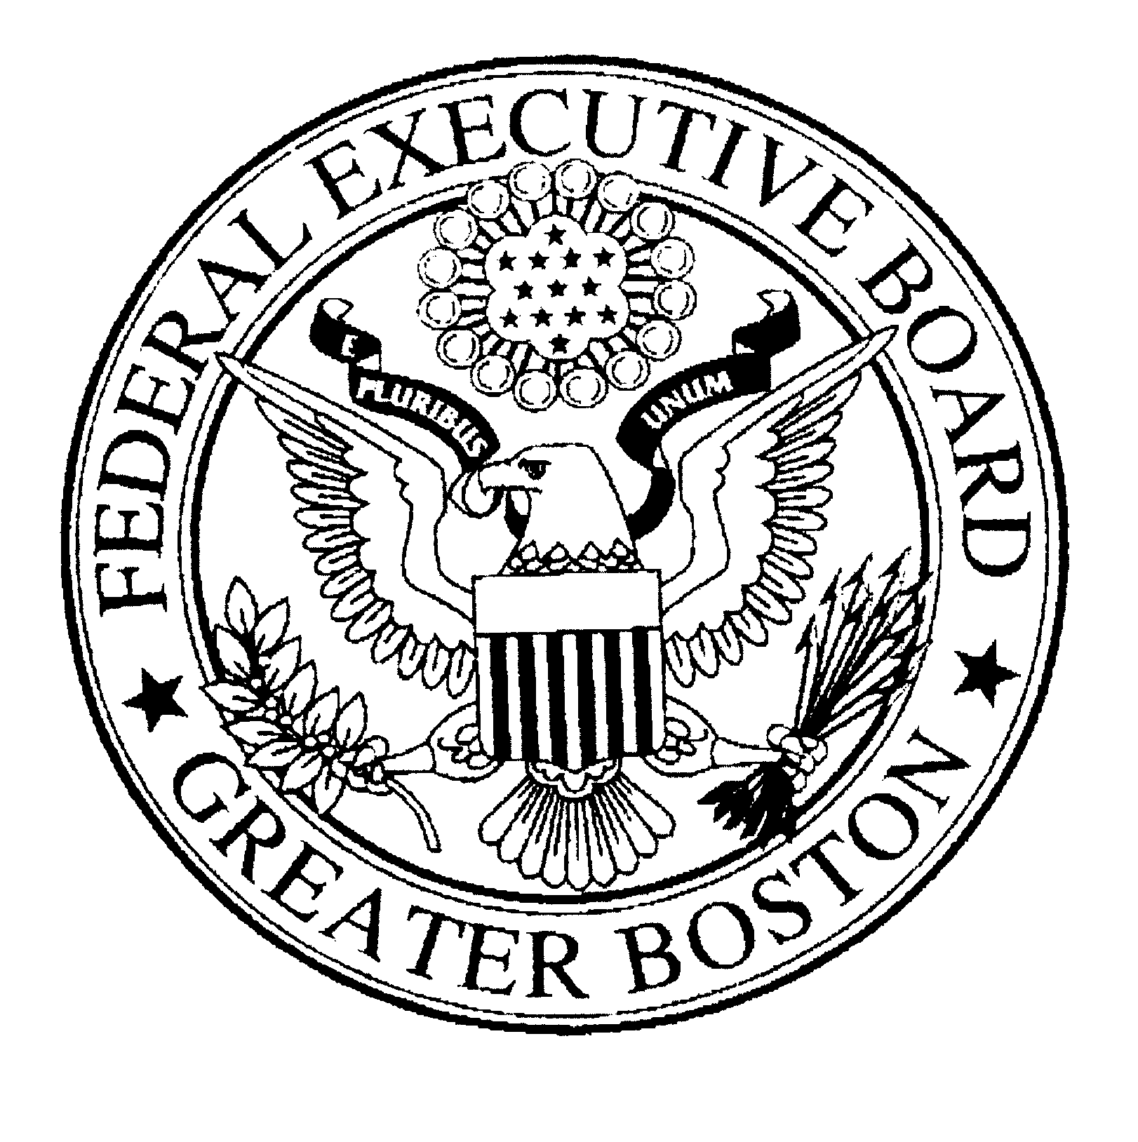

ANNUAL REPORT
Fiscal Year 2008

GREATER BOSTON
FEDERAL EXECUTIVE BOARD*
Thomas P. O’Neill, Jr. Federal Building
10 Causeway Street, Suite 178
Boston, MA 02222
(617) 565-6769
www.boston.feb.gov

*This FEB is funded by the by the
US Department of Homeland Security

TABLE OF CONTENTS

Executive Summary ………………………………………………………………… 3

About the FEB ………………………………………………………………………… 4

Massachusetts Federal Workforce Demographics ………………………………… 5

Fiscal Year 2008 Results
- Emergency Preparedness, Employee Safety & Security ……….................. 3
- Human Capital Readiness ………………………………………………… 3
- Foundational Activities …………………………………………………… 3

Priority Areas for 2009 …………………………………………………………………… 7, 9, 10

Agencies Represented in 2008 Board of Directors …………………………………………9

Cost Avoidance Template for FEB Activities ………………………………………………11-12

Organizational Chart ………………………………………………………………………. 13

EXECUTIVE SUMMARY

The Greater Boston FEB fosters communication, coordination and collaboration among Federal agencies in New England. We produce new ideas to and approachs to advance National initiatives in the field. We identify strategic partners, bring them together and inspire them to work towards a common goal.

In 2008, the US Office of Personnel Management (OPM) continued to refine and define the FEB lines of business and national strategic plan. The Greater Boston FEB, thanks to its’ leadership and support of its’ Councils and Committees, successfully met the mandates under each line of business and the national strategic plan.

FEB LINES OF BUSINESS
- Emergency Preparedness, Employee Safety & Security
- Human Capital Readiness
- Foundational Activities

NOTABLE BOSTON ACCOMPLISHMENTS IN 2008
- Creating, testing and utilizing a Boston FEB special interest group in United State Public Private Partnership (usp3.org) emergency communication platform and mentoring other FEBs to do the same;

- Expanded inclusion of state and local officials in Emergency Decision and Notification strategy;

- Outreach and support for 3 military organizations impacted by upcoming Base Realignment and Closure;

- Full review and revamping of Shared Neutrals Program;

- Recruitment & retention programs, including Public Service Awards, Diversity Training and Veterans outreach;

- Our Combined Federal Campaign raised more than $2.5 million for local, national and international charities;

ACKNOWLEDGEMENTS
The Boston FEB achieved valuable results during a year of leaner budgets and tighter resources. We provided a variety of cost-effective programs and activities in response to the needs and expectations of our member agencies.

We are grateful for the support of our member agencies and commitment of agency leaders in helping us achieve our goals. Thank you!

ABOUT FEDERAL EXECUTIVE BOARDS
By Presidential Directive in 1961, President John F. Kennedy established Federal Executive Boards (FEBs) to achieve better interagency coordination and communication among Federal departments and activities outside of Washington, DC. In 1982, the Executive Office of the President transferred authority for the FEB functions to the US Office of Personnel Management (OPM), which today maintains oversight of the FEB program.

The need for effective coordination among Federal organizations’ field activities was clear then and is even more important in today’s environment. Approximately 88% of all Federal employees work outside of the National Capital area and most Federal programs are implemented through the regional and local offices of Federal departments and agencies. Our regional and local Federal officials are the Federal government’s principal representatives to the vast majority of our nation’s citizens.

The Boards function in four general areas: (1) providing a forum for the exchange of information between Washington and the field about programs, management methods and administrative issues; (2) coordination of local approaches to national programs as approved by the Director, OPM; (3) communication from Washington to the field of management initiatives and other concerns for the improvement of coordination; and (4) referral to the national level of problems that cannot be revolved locally.

Today, there are 28 FEBs located in areas with a significant Federal population. The Board is comprised of the highest ranking local officials from each Federal agency in the FEB area. Board leadership and structure consists of elected officers (Chair and Vice Chair) and Committees and Councils specific to FEB programs. FEB staff manages the daily operations of the board.

FUNDING AND OTHER SUPPORT
Administrative funding for the Greater Boston FEB was provided by the US Department of Homeland Security (DHS) in 2008.

Thank you to the DHS Office of the Chief Human Capital Officer for funding the staff position and to DHS / Federal Emergency Management Agency for supporting the operational budget. Thank you also to GSA New England for their continued support of the FEB’s full service office and other in-kind contributions.

DID YOU KNOW?
- FEBs have recently been included in several key national preparedness documents, including the National Response Framework released in March 2008.
- The US Office of Personnel Management (OPM) and the Federal Emergency Management Agency (FEMA) signed a Memorandum of Understanding in August 2008 formally outlining the FEB network’s role in communications during emergencies.
- FEB staff were called upon by Members of Congress to provide testimony on a range of issues in 2008

MASSACHUSETTS DEMOGRAPHICS

THE FEDERAL WORKFORCE BY THE NUMBERS
- The US Government is the area’s largest employer among public and private employers.
- There are approximately 78,000 civilian Federal employees (includes full and part time) in more than 300 work sites.
- There are more than 3,000 active duty members of the armed forces and 13 military installations in Massachusetts.
- There are upwards of 17,000 postal employees in Massachusetts.
- More than 43,000 Federal retirees reside here.
- More than 450,000 veterans live and work here.
- Approximately 190 Federal agencies maintain a presence here.

MASS FACTS
- Boston is the regional city for the New England Region.
- Massachusetts has 10 Congressional Districts.
- There are 6 Federal Executive Associations in each New England, including in Maine, New Hampshire, Vermont, Rhode Island, Connecticut and Western Massachusetts.
- Massachusetts draws more than 100,000 Federal travelers annually on US Government business. (Numbers do not include contractors.)
_______________________________________________

ABOUT THE BOARD
- The “senior-most” person at each Federal agency with a presence in the region is a member of the full board by virtue of the position. (5 CFR Part 960)
- 190 Federal agency heads comprise our full board.
- The FEB’s Board of Directors consists of 21 elected members plus ex officio.
- The Board of Directors is a representative group of Federal civilian, military, political appointee, postal and law enforcement agencies.
- The GSA and OPM, as central management agencies of the US Government, are ex officio members of the Board of Directors.
- Three core Homeland Security Agencies, including FEMA, the Coast Guard & the Federal Protective Service, are ex officio members of Boston’s Board of Directors.
- The National Weather Service also holds an ex officio position.
______________________________________________

GET INVOLVED IN 2009!
Discover the best ways to get the most out of your FEB. Contact us now to learn how to best become engaged in 2009. We’ll put together a customized plan that identifies how you can “get active” in ways that accommodate your busy schedule and is mutually beneficial.

Visit www.boston.feb.gov to learn more

*Sources: US Census Bureau, US Office of Personnel Management, Department of Defense
I. EMERGENCY PREPAREDNESS, EMPLOYEE SAFETY & SECURITY
Chair: Arthur Cleaves, Regional Administrator, FEMA Region 1

This Council acts in an Advisory capacity in the areas of emergency readiness and response for the purpose of (1) ensuring interagency communication and collaboration in times of emergency; (2) pooling resources to support the safety and protection of the Federal workforce; and (3) educating the Federal workforce on health and safety issues;

Activity Category: Training, Exercises and Educational Forums
- Hosted an interagency tabletop exercise for the 21-member Board of Directors in order to implement our Emergency Decision & Notification Plan and practice decision-making and succession relative to our Plan (August 2008;)
- Hosted the Centers for Disease Control Briefing focusing on Federal Points of Distribution (PODS,) a national health initiative; (August 2008 ;)
- Served as a keynote speaker for a forum focusing on Individual Preparedness for the USDA Farm Service Agency’s Massachusetts State Office All Hands off site in Mystic, CT (August 2008;)

Activity Category: Communication & Information-Sharing
The Boston FEB prides itself on its information-sharing and communications abilities. We strive to ensure that agency decision-makers have accurate, up-to-date and consistent information, particularly during emergency situations, in order to make informed decisions.

- Established and maintained a 24/7/365 database of contacts for local Federal agency leaders; Collected data by sending a certified letter to the more than 190 Federal agency heads (August 2007 ;)
- Actively utilized the United States Public & Private Partnership (usp3.org) during several extreme weather events in winter 2007/8 and other local and national emergencies; USP3 is supported by both the FBI and the US Department of Homeland Security;
- Actively hosted a COOP Working Group, chaired by GSA Regional Administrator Dennis R. Smith, as a forum for the exchange of ideas, lessons learned, best practices at both the worker and executive levels;
- Actively maintained a unified Emergency Decision and Notification Plan, led by the US Coast Guard District Commander RADM Timothy Sullivan, and supported by their 24-hour command center; This center enabled top FEB officials to collaborate with subject-matter experts, and others, during emergencies;
- Shared our 2004 After Action Report entitled “Federal Workforce Planning for the Democratic National Convention: A National Special Security Event” and served as an advisor for the 2008 national Political Conventions in Minnesota and Denver, respectively;
- Actively distributed guidance and policy documents in a timely manner from key Administration officials during Hurricane Gustav and Ike;
- Actively distributed the newly published guidance and on-line training materials relative to the National Response Framework released in March 2008;
- Prepared and shared Human Capital Guidance re: potential regional transit strike;

Activity Category: Building & Maintaining Relationships
The Boston FEB strives to develop, maintain and strengthen meaningful working relationships with Federal, state, local and tribal emergency management, public safety and law enforcement officials in an effort to develop strategies for coordinated planning and response.

- Became fully engaged with FEMA Region 1 staff and activities including in its newly created National Preparedness Directorate. Actively supported and participated in FEMA Regional Interagency Steering Committee (RISC) meetings and Regional Advisory Council (RAC) meetings; These forums provided an opportunity to network and learn from key Federal, state, local and tribal leaders;
- Became a member and fully engaged with InfraGard – Boston Chapter, a professional organization hosted by the FBI that fosters public / private partnerships to enhance preparedness; Attended quarterly meetings and established working relationships with a variety of private sector principals;
- Actively participated in the reinvigoration of the Federal Health and Safety Councils, hosted by OSHA, in MA and New England;

Additional Contributions
- Director Ainsworth chaired the National FEB Emergency Preparedness, Employee Safety & Security Council in 2008. This Council discusses issues and provides guidance to the FEB network relative to this line of business and liaises with OPM, FEMA and other Administration officials;
- Director Ainsworth testified before the US Senate Subcommittee on Government Management, the Federal Workforce and the District of Columbia in September 2007 during a hearing entitled “The Role of Federal Executive Boards in Pandemic Preparedness.” The hearing was called as a follow up to a General Accountability Office report on the same topic published in May 2007;
“Thank you for all that you do to keep the Federal Employees in the area informed. I have really appreciated this essential communications link during my tenure as the USCG Group Commander and Deputy Sector Commander in Boston.”
John C. O’Connor III, Ed.D, Commander, US Coast Guard

“Thank you so much for your updates. They are much appreciated. With your help, I was recently able to connect with FEMA re: our COOP efforts.”
Greg Hodgdon, New England Area Manager, Office of Emergency Management & Safety, Citizenship and Immigration Services

Priorities for 2009
- To expand service area by collecting and maintaining 24/7/365 contact information and establishing a special interest group within USP3, for senior agency leaders in the remaining 5 New England states and Western Massachusetts;
- To host a comprehensive interagency tabletop exercise focusing on one of the five national preparedness scenarios;

II. HUMAN CAPITAL READINESS
Chair: Nancy Aiello, Field Director, IRS Andover Campus

This Council acts in an advisory capacity in the area of human capital readiness for the purpose of: (1.) prioritizing annual activities based on the needs assessment of the local Federal community and OPM directives; (2.) pooling resources and experiences to support and advance the capacity of the Federal workforce; and (3.) fostering partnership with professional and community groups to raise awareness and promote public service;

Activity Category: Human Capital Best Practices Forums
- Sponsored a human capital briefing for regional Federal human resources professionals featuring a human capital briefing by OPM Deputy Associate Director Sydney Smith-Heimbrock;
- Hosted a leadership development candidate to research and develop a formal FEB Leadership Development program;
- Redesigned our Shared Neutrals Program to meet the evolving needs of Federal agencies relating to mediation;
- Hosted interagency Diversity committee, chaired by the Social Security Administration, consisting of representatives of 20 Federal agencies, to address issues impacting the furtherance of Diversity in the Federal workplace;

Activity Category: Human Capital Training*
- Sponsored pre-retirement seminars for b both CSRS and FERS employees;
- Sponsored Workers Compensation training for Managers;
- Sponsored EEO refresher, mandatory for Federal EEO professionals;
- Facilitated Delegated Examining Unit recertification training for local human resources professionals;
- Sponsored leadership training entitled: “Motivating Employees in an Environment of Continuous Change” – a priority area based on our 2008 needs assessment;
- Hosted Diversity Training featuring a wide-range of speakers and addressing significant topics impacting the furtherance of diversity in the Federal workplace;

Activity Category: Recruitment & Retention / Public Service Outreach*
- Conducted resume-writing training for US Air Force employees;
- Continued to provide briefings entitled “Trends in Federal Hiring” to a variety of constituency groups, including several local colleges and universities; Young Government Leaders Boston Chapter; State Department Leadership Development Day; Lee Hecht Harrison outplacement firm:
- Conducted briefing entitled “Landscape of the Local Federal Workforce” for 2 military organizations to be impacted by Base Realignment and Closure in 2009;
- Sponsored the 33rd annual Excellence in Government Awards ceremony to recognize the accomplishments and excellence among the local Federal workforce;
- Actively supported and participating in Public Service Recognition Week activities across the region;

Additional Contributions
- Served as an instructor for Presidential Classroom, a public service program geared towards high school students, domestic and international;
- Coordinated distribution of Hatch Act on line briefing materials for Federal agencies to distribute prior to the Presidential primary season;
- Coordinated Constitution Day observations throughout September;

“I just wanted to thank you for sharing the Boston Globe article on the book “Bowling Alone” declining civic engagement by Robert Putnam. It was one of the most thought provoking articles on diversity that I have read” . Larry Lofton, Hatchery Manager, North Attleboro NFH
“Thank you for sharing the news of OPM’s new video library. We have great resources in this new library. Thank you for the communication!” Elizabeth Leon, Human Resources Specialist, Volpe National Transportation Systems Center

Priority Areas for 2009
- Facilitate priority placement via ICTAP for several hundred employees who will be impacted by reductions in force via entity closure and base realignment and closure;
- Host Presidential Transition Training for Managers and Supervisors;
- Revitalize Shared Neutrals Program by implementing recommendations of review Committee;

*See attached chart for cost saving estimates

2008 Officers

Chair Vice Chair
Steven D. Ricciardi, Special Agent in Charge Suzanne Biermann, Regional Administrator
US Secret Service USDA Food and Nutrition Service

Past Executive Chair
Diane P. LeBlanc, Regional Administrator
National Archives & Records Administration

Agencies represented on Board of Directors
IRS; National Park Service; Social Security Administration; Census Bureau; US Department of Labor; FAA; Postal Service; Defense Contract Management Agency; US Army Corps of Engineers; Environmental Protection Agency; US Army Natick Soldiers Systems Center; HUD; EEOC; US Department of Transporation; GSA; Federal Protective Service; FEMA; National Weather Service;
III. FOUNDATIONAL ACTIVITIES
Chair: Diane P. LeBlanc, Regional Administrator, National Archives & Records Administration

This Council acts in an advisory capacity for the purposes of developing and implementing local coordinated approaches for programs and cooperative activities as outlined in CFR Part 960.107 and set forth in our annual work place.

Activity Category: Combined Federal Campaign (CFC)
- Local Federal Coordinating Committee, chaired by Kathleen Ludgate, Regional Director, US Census Bureau, provided strong leadership, accountability and oversight for the Eastern Massachusetts CFC;
- CFC Chair RADM Timothy Sullivan troubleshooted problems, provided increased visibility and demonstrated strong leadership and support for the large CFC;
- Provided supervision, management and mentoring for CFC Executive team;
- Facilitated and collected approximately $2.5 million in pledges to benefit the more than 2,500 charitable organizations affiliated with the CFC;
- Led a breakout session at the CFC National Conference;

Activity Category: Outreach to Veterans
- Co-sponsored a “Welcome Home” event for returning soldiers of the Iraq and Afghanistan conflicts, in cooperation with the Boston VA Healthcare System and the National Archives & Records Administration;
- Supported various Veterans commemoration ceremonies;

Activity Category: Community Outreach
- Briefed each of the 6 New England Federal Executive Associations and Councils on the new FEB lines of business and national strategic plan;
- Hosted scholarship program to award three one-time scholarships of $1000 each in memory of three local Federal employees we lost in 2008;
- Created and distributed a comprehensive Directory of Federal Agencies for use by various constituency groups, including Congressional staff;
- Facilitated the Congressman John Joseph Moakley Award for Exemplary Public Service to honor the accomplishments of staff of the New England Congressional delegation;
- Liaised with Federal Public Affairs & External Affairs officers to promote mutually beneficial items of interest to the Federal community;
- Hosted three Passport Days for Federal employees, family & friends to promote new regulations under the Western Hemisphere Travel Initiative and expanded need for use of passports worldwide;

Priority Areas for 2009
- Participate in the National CFC Committee;
- Expanded outreach to Veterans Service Organizations to promote Careers with the Federal Government;
- Provide assistance to the US Army Workplace Warriors Program to identify meaningful, short-term work assignments within local Federal agencies;

Cost Avoidance Template for the FEB Network

Eastern Massachusetts Combined Federal Campaign | $2.5 million total pledges in 2007

Awards & Recognition | # of Attendees | # Awards Presented | Other
Excellence in Government Awards | 325 representing more than 30 Federal agencies  May 2008 | 14 | Competitive categories designed to reflect the current Federal workforce
Speaker Thomas P. O’Neill, Jr. Award for Exemplary Public Service | N/A  May 2008 | 1
Senator Paul E. Tsongas Award for Exemplary Public Service | N/A | 2 | 2008 Recipients nominated by Congresswoman Niki Tsongas: Community Advocates Nancy and Richard Donahue;
Congressman John Joseph Moakley Award for Exemplary Public Service | N/A | 1 plus 4 finalists | Awarded to staff of the New England Congressional delegation and nominated by a Member of Congress;
5th annual scholarships: presented in memory of 3 Federal employees were lost unexpectedly this year: | N/A | 3  In memory of:  Allan Deblasio (DOT)  Peter Manning (DOT)  Sandy McGrath (IRS) | $1000 in value  Full and part time Federal employees and their dependent children eligible to apply;
Combined Federal Campaign Awards | N/A | 396 Eagle Awards | Presented to those who pledge $1000 or more through the charitable drive;

Cost Avoidance Template for the FEB Network (cont.)

FEB Sponsored Training | Market Price | FEB Price | # attendees | Cost savings | Estimated Cost Avoidance
CSRS (1-day) Pre Retirement Seminar | $199/ person | $50 / person | 200 | $149 / person | $29800 +/-
FERS (1-day) Pre Retirement Seminar | $199/ person | $50 / person | 225 | $149 / person | $33525 +/-
Workers Compensation for Managers | $199/ person | No Cost | 50 | $199 / person | $9950 +/-
EEO Refresher Course | Est. $500/ person plus travel | $25 / person  No travel necessary | 40 | Est. $475+ / person | $10900 +/-
Delegated Examining Unit Recertification Course | $500/ person plus travel | $200 / person | 50 | Est. $300 / person plus travel | $15000 +/-
Hatch Act On Line Training brochure | N/A | No Cost | N/A | (Time) | N/A
Motivating Employees in an Environment of Continuous Change* | $5400/ day | $199 / person | 25 | N/A | Priority based on 2008 needs assessment of Federal community
Resume Writing Training for Air Force Employees* | $5000/ day plus travel expenses | No Cost | 1200 | $10,000 | Priority for US Air Force based on business practice change
Leadership Development Seminar for Department of State employees* (half day) | $5000/ day | No Cost | 225 | $5000 | Held in conjunction with Consular Affairs Leadership Development day internationally
Total |  |  |  |  | $122,275 +/-
