Combating Counterfeiting and Enabling Traceability in the Global Healthcare Supply Chain by using the EAN.UCC System

UCC comments to Docket Number #2003N0361

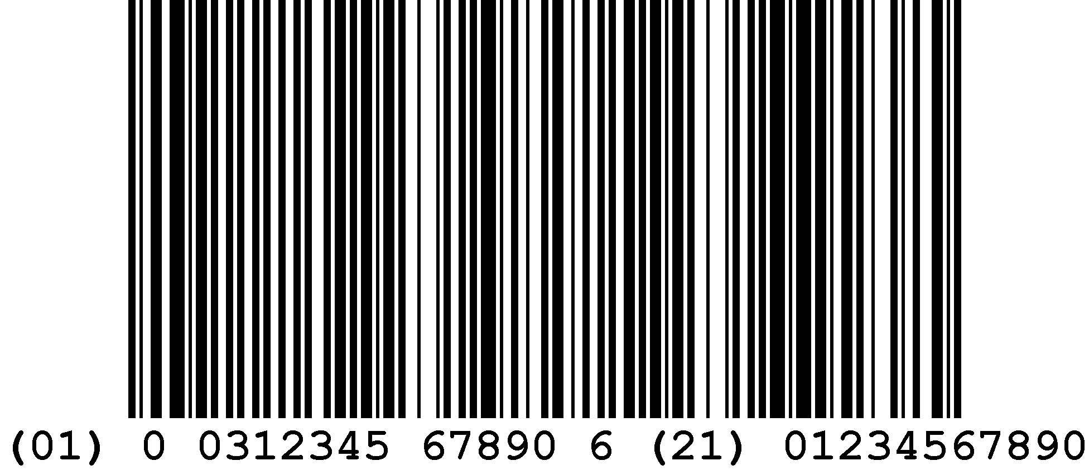

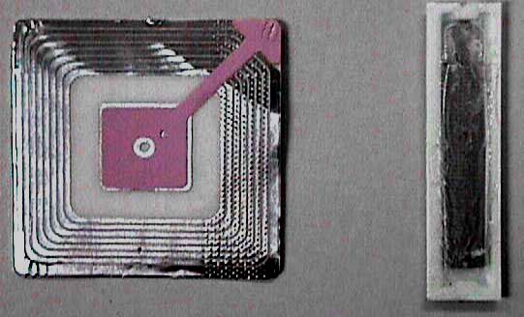



October 2003

EXECUTIVE SUMMARY

The Food and Drug Administration (FDA) has announced a task force to examine and combat counterfeiting of pharmaceuticals. Earlier this year the FDA announced a proposed rule mandating bar coding of all pharmaceuticals and biologics. This proposed rule required the use of EAN.UCC system linear symbols. Many healthcare associations suggested to the FDA adoption of the entire EAN.UCC system for auto identification of healthcare products.
The EAN.UCC System already has the tools available to combat counterfeiting using bar-coded GTIN and serial numbers. Manufacturers can greatly reduce counterfeiting by assigning a specific serial number to every item they produce. Any item without a serial number is immediately spotted as a fake. And even if a counterfeiter managed to produce phony serial numbers for counterfeit goods, retailers, police and customs officials could refer to the manufacturer's database to find that the GTINs in question are bogus, or are duplicates of existing codes.
- The first method to combat counterfeiting is the Global Trade Item Number (GTIN). The GTIN is a unique identifier for a trade item and is recognized in over 104 countries. The GTIN, combined with a serial number and / or lot number, can identify packages from individual unit of use through intermediate and up to cases with precision (coupled with databases). This information (GTIN, serial and lot number) can be bar coded now with available commercial equipment and can be mapped to EPC.
- The second method to combat counterfeiting is the SSCC (Serialized Shipping Container Code). The SSCC acts as an individual license plate for logistics units. The SSCC is widely used in the retail supply chain today. As with individual packages, pallets can be serialized and tracked across the supply chain globally. (Appendix C)
- The third method to combat counterfeiting is the Global Individual Asset Identifier (GIAI). The GIAI identifies individual assets to provide tracking and tracing capabilities, facilitate maintenance, and provide equipment management and control. The GIAI has been adopted by the United States Department of Defense to identify their assets.
The EAN.UCC system data structures will be apart of the EPC structure, insuring that an anti-counterfeiting effort started with bar codes will be able to migrate to RFID chips.

UCC comments to Docket Number #2003N0361

BACKGROUND

“On July 16, 2003, FDA launched a major initiative to more aggressively protect American consumers from counterfeit drugs. Counterfeit prescription drugs are not only illegal but also are also inherently unsafe. The initiative is designed to:
Better identify the risks and threats from counterfeit drugs, establish a public and private coalition to fight drug counterfeiting and distribution, and develop new tools to aid in identifying, deterring and combating counterfeiting.
As part of the initiative, FDA will create an internal task force to explore the use of modern technologies and other measures, such as stronger enforcement, to make it more difficult to distribute counterfeit drugs. The task force will submit its initial findings and recommendations in 60 days and will issue a final report in six months, after public comment.”

PURPOSE OF THIS PAPER

This paper explains the power of the EAN.UCC System to combat counterfeiting with current bar codes and data structures. It also explains how these data structures will be migrated to the Electronic Product Code (EPC). There is no need for the FDA to wait for EPC. Counterfeiting can be combated today with the use of the EAN.UCC System barcodes (appendix A) and data structures (Appendix B and C) and then when applicable use the complementary technology of RFID.

UCC comments to Docket Number #2003N0361

DISCUSSION

2003 FDA Proposed Rule on Bar Coding
In a proposed rule announced March 14, 2003, the FDA mandated bar coding of all pharmaceutical and biologic products using EAN.UCC linear symbologies. The UCC responded to this rule applauding the FDA initiative but suggesting that the entire system be adopted rather than its linear symbologies. When the FDA selects the entire EAN.UCC the healthcare industry can evolve with the entire global marketplace rather than be attached to a potential obsolete technology. Several healthcare associations, i.e. HDMA, NAHIT, and AIM, also urged this approach. The wisdom of their advice is apparent with this new FDA initiative on counterfeiting. The EAN.UCC System has had symbology and data structures in place to serialize every pharmaceutical product with a unique serial number. These data structures can be applied now on every level of pharmaceutical packaging with the tradition linear code such as UCC/EAN-128 or Composite with U.P.C., RSS or UCC/EAN-128. (Appendix A). In addition to consumable items, logistics units and fixed assets can be tracked using the EAN.UCC system

EAN.UCC System

The EAN.UCC System is a universally accepted identification and communication system that facilitates efficient global commerce and business communication. This global language of business and healthcare comprises a standard numbering system and identification carriers to provide global users with the means to uniquely identify items, assets, and physical locations for automatic data capture and processing in electronic data processing applications. Most importantly, the system includes a series of standard data structures; called Application Identifiers (AIs), which allow companies to encode secondary information about a product. In healthcare, AIs are employed for one of the most important logistics tasks: the tracking and tracing of medical products.
The EAN.UCC System utilizes a wide variety of integrated data carrier technologies to provide seamless communication throughout the supply chain. These numbers (GTINs) are integrated into electronic commerce and encoded in machine-readable carriers. Thus, these numbers enable the linking together of the information flow of business transactions to the physical flow of trade items. The identification standards are the foundation of The Global Language of Business®
The first method to combat counterfeiting is the Global Trade Item Number (GTIN). The GTIN is a unique identifier for a trade item and is recognized in over 104 countries. The GTIN, combined with a serial number and / or lot number, can identify packages from individual unit of use through intermediate and up to cases with precision (coupled with databases). This information (GTIN, serial and lot number) can be bar coded now with available commercial equipment and can be mapped to EPC.

The second method to combat counterfeiting is the SSCC (Serialized Shipping Container Code). The SSCC acts as an individual license plate for logistics units. The SSCC is widely used in the retail supply chain today. As with individual packages, pallets can be serialized and tracked across the supply chain globally. Over 85 Million SSCCs are utilized annually in only two of the largest retail chains in the United States. For more complete information about SSCC please see attached document titled “Serial Shipping Container Code.”

The third method to combat counterfeiting is the Global Individual Asset Identifier (GIAI). The GIAI identifies individual assets to provide tracking and tracing capabilities, facilitate maintenance, and provide equipment management and control. The GIAI has been adopted by the United States Department of Defense to identify their assets. For more complete information about GIAI please see attached document titled “Global Individual Asset Identifier.”

The machine-readable carriers are approved bar code symbologies but other technologies, such as radio frequency tags (EPC), will be added. Following the principles and design of the EAN.UCC System means that users can design applications to process EAN.UCC data automatically. The system logic guarantees that data captured from approved machine-readable carriers produces unambiguous electronic messages.

Global Trade Item Number

The GTIN (Global Trade Item Number) is the foundation of the EAN.UCC System for uniquely identifying trade items (products and services) sold, delivered, warehoused, and billed throughout the retail and commercial distribution channels. It provides an accurate, efficient and economical means of controlling the flow of products and information through the use of an all-numeric identification system. The Global Trade Item Number (GTIN) is the EAN.UCC System identifier for trade items, which encompasses both products and services. GTINs provide the capability to deliver unique identification worldwide. The most commonly recognized and used GTINs are encoded in U.P.C. and EAN-13 symbols, GTINs are utilized on products and cases and are a key component of e-commerce transactions and communications. Users can be confident that a GTIN, when used correctly, will uniquely identify their products as they pass through the global supply chain to the ultimate end user. This global identification system ensures that the corresponding electronic communications will contain information unique to their company and products.
For more than 25 years the EAN.UCC System has incorporated the National Drug Code, as well as the National Health Related Item Code (NHRIC). Since the creation of the Universal Product Code (U.P.C.) in the early 1970’s, a NDC can be embedded within a Global Trade Item Number (GTIN). The National Drug Code (NDC) identifies pharmaceutical products and the National Health Related Item Code (NHRIC) identifies medical/surgical products. Furthermore, the EAN.UCC system provides identifiers for lot number and expiration.

Application Identifiers

Most of the bar codes that are used in the marketplace carry only the GTIN. However, there is a need to provide other information in a bar code that is specific to this particular item or set of similar items. But, a difficulty then arises. With multiple information segments in one bar code, it is difficult to tell where one information segment ends and the next segment begin. For example, suppose you wanted to tell a trading partner that product 30614141000869 was produced in batch number 43. Would you express this as 3061414100086943 or 4330614141000869?
How would the application software know which string of numbers is used to identify the product and which is used to identify the batch? The EAN•UCC system uses a bar code that can carry special identifier to define and separate multiple data structures. These two-, three-, or four-digit numbers, called Application Identifiers (AI). (Please refer to Appendix A for abbreviated AI list)

The EAN•UCC system has established more than 100 Application Identifiers. The heart of the AI system is the AI Table and the associated AI definitions contained in the General EAN•UCC Specifications. For example, (00) is the AI for Identification of Logistics Unit (SSCC). The format for this AI is n2+n18 (two digits for the 00 and 18 digits for the SSCC). The data title is SSCC.

Counterfeiting and Traceability

Premise

One of the best ways to combat counterfeiting is through a layering approach. The EAN.UCC system allows for serialization for the consumable unit at the unit dose, each packaging level and the logistics unit. For fixed assets the Global Individual Assent Identifier can be used.

Manufacturers can greatly reduce counterfeiting by assigning a specific ID number/ serial number to every item they produce. See Appendix A for examples of GTIN and Serial number in EAN.UCC symbols. Any item without a serial number is immediately spotted as a fake. And even if a counterfeiter managed to produce phony serial numbers for counterfeit goods, retailers, police and customs officials could refer to the manufacturer's database to find that the GTINs in question are bogus, or are duplicates of existing codes.

UCC comments to Docket Number #2003N0361

Current Application

Today manufacturers can bar code serial numbers on all their products at all levels of packaging. The technology and the printing capacity exist. However, this is not an inexpensive task for the manufacturers, or for the remainder of the healthcare supplies chain.

The manufacturers after assigning a GTIN to a product would have to serialize each product. Each item would have to be bar-coded at the time of production and the information stored in a database for future use (See Table 1 below). As stated above the EAN.UCC System already has the standards necessary to accomplish this
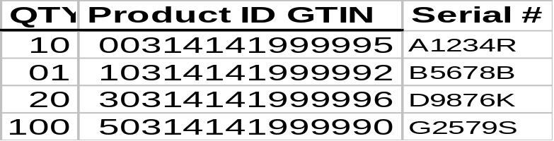task.

TABLE 1

Serial Shipping Container Code (SSCC)

Another method to combat counterfeiting at the logistics level is the SSCC (Serialized Shipping Container Code). The SSCC acts as an individual license plate for logistics units. The SSCC is widely used in the retail supply chain. As with individual packages, pallets can be serialized and tracked across the supply chain globally. Two retail chains use the SSCC to track 85 million packages yearly. For more complete information about SSCC please see attached document titled “Serial Shipping Container Code.”

Global Individual Asset Identifier (GIAI)

The third method to combat counterfeiting is the Global Individual Asset Identifier (GIAI). The GIAI identifies individual assets to provide tracking and tracing capabilities, facilitate maintenance, and provide equipment management and control. The GIAI has been adopted by the United States Department of Defense to identify their assets under the UID program. For more complete information about GIAI please see attached document titled “Global Individual Asset Identifier”

UCC comments to Docket Number #2003N0361

AUTO-ID

The Uniform Code Council (UCC) established EPCGlobal USA, a not-for-profit organization, to develop and oversee commercialization and technical standards for the Electronic Product Code™ (EPC) Network. This is an important next step in the research effort initiated by the Auto-ID Center at MIT and is critical to making the EPC Network real.

Automatic Identification is the umbrella term for technologies that allow machines (typically computers) to automatically identify objects. Radio Frequency Identification (RFID) is one type of automatic identification technology. Objects are labeled with "tags" (a microchip with a radio frequency antenna) that store data, which defines that object in a structured manner. Using radio waves, the "reader" wakes up the tags and automatically captures that data, which can then be processed.

The EPC Network is comprised of five fundamental elements that enable the automatic identification and tracking of physical objects in real time:
1) Electronic Product Code (EPC)
2) ID System (Radio Frequency Readers and Tags)
3) Object Name Service (ONS)
4) Physical Markup Language (PML)
5) Savant (software that directs and routes EPC and associated information)

The Auto-ID Center's research has focused on developing these five critical elements of the EPC Network. The Center is also developing some of the software that will help manage the flow of data. This will create a global system that can revolutionize how products are manufactured, tracked, sold, and recycled.

EPC Network technology enables the identification of unique objects. That is, an individual package, container, or dose from a given manufacturing lot can be identified within the Electronic Product Code. Ubiquitous mass serialization, and the ability to identify each unique primary package will be key to taking anti-counterfeiting solutions in pharmaceuticals to the next level. Authenticity of physical product and authenticity of product identity can be verified to provide a more robust solution.
In addition, the EPC Network brings hardware and software solutions to the problem. Sophisticated tags could wrestle with the issues of physical product tampering while the information technology backbone could lend itself to EPC verification, Track (control and knowledge of where the object is at any time) and Trace (pedigree - the building of history behind the object).

Bar codes are well established and provide unprecedented benefits for manufacturers and retailers. EPC will be complementary to the symbologies currently used in the EAN.UCC System, which includes the U.P.C., Reduced Space Symbology® (RSS), and UCC/EAN-128. The UCC and EAN recommend that companies currently considering Reduced Space Symbology (RSS) should implement it now because the increased ID capability provided by RSS will provide immediate benefit and help prepare data systems for EPC. GTIN is part of the data structure incorporated in the EPC.

While EPC represents a potential new standard to uniquely identify products, the UCC and EAN International are working with the Auto-ID Center to ensure that a migration path exists between current bar code standards and the new EPC. Development of standards for the EPC will utilize existing standards development methodologies, such as the Global Standards Management Process (GSMP).

CONCLUSION

DON’T WAIT, USE THE EAN.UCC SYSTEM NOW TO COMBAT COUNTERFEIT DRUGS. The healthcare industry does not have to wait for the EPC to combat counterfeiting. The use of EAN.UCC System bar code symbologies and data structure can be used immediately. As EPC matures the data structures will be incorporated in the EPC.

About the Uniform Code Council
The Uniform Code Council, Inc. (UCC) is a not-for-profit organization
dedicated to the development and implementation of standards-based,
global supply chain solutions. Under its auspices, the UCC operates two
wholly-owned subsidiaries, UCCnet and RosettaNet, and it co-manages
its global EAN•UCC System with EAN International. UCC-based
solutions, including business processes, XML standards, EDI transaction
sets, and the bar code identification standards of the EAN•UCC System
are currently used by nearly one million member companies worldwide.
Visit www.uc-council.org for more information.

Contact John Roberts at jroberts@uc-council.org

UCC comments to Docket Number #2003N0361

Appendix A

UCC/EAN-128 symbol with concatenated GTIN and Serial Number

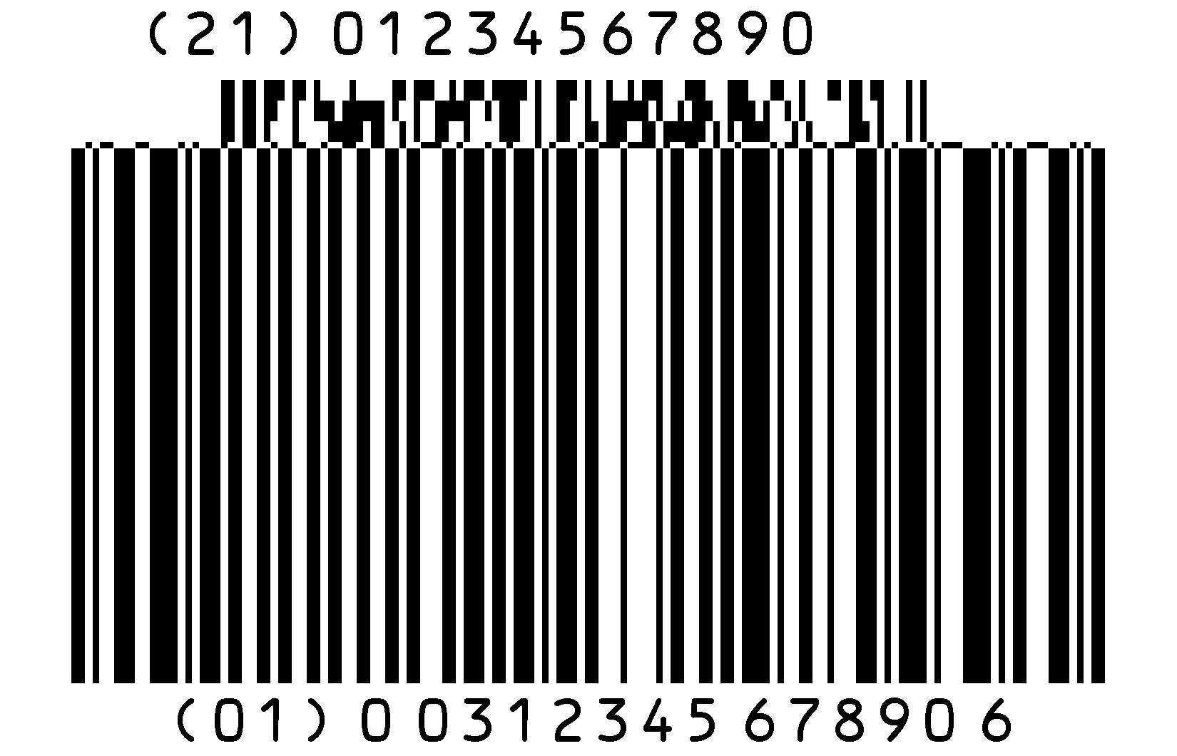

UCC/EAN-128 with Composite containing GTIN in UCC/EAN-128 and Serial Number in Composite

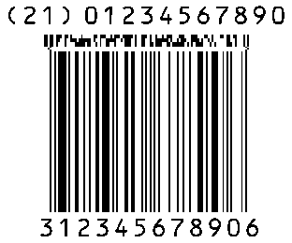

U.P.C. and Composite with GTIN in UPC and Composite containing Serial Number

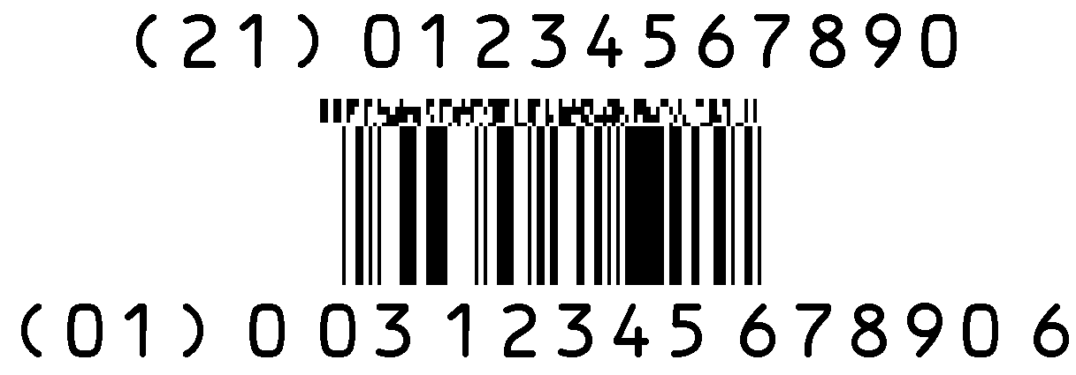

Reduced Space Symbology with Composite containing GTIN (in RSS) and Serial Number in Composite.
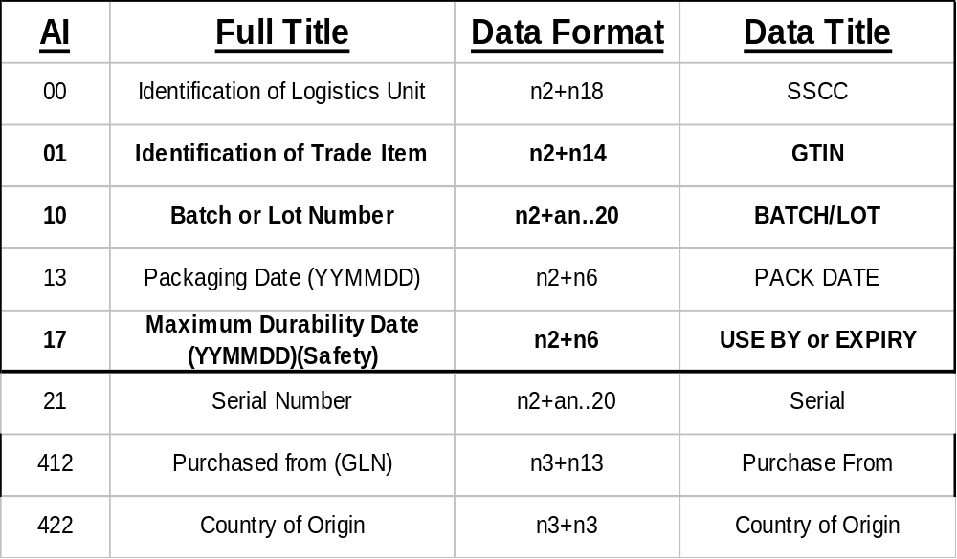UCC comments to Docket Number #2003N0361

FDA website, http://www.fda.gov/oc/initiatives/counterfeit/

