“”
USDA Foreign Agricultural Service
GAIN Report

Global Agriculture Information Network
Template Version 2.07

Required Report - public distribution
Date: 10/27/2003
GAIN Report Number: SP3027
SP3027
Spain
Citrus
Annual
2003

Approved by:
Lloyd J. Fleck
U.S. Embassy
Prepared by:
Diego Pazos

Report Highlights: Despite this summer’s heat wave, Spain’s 2003/04 citrus crop is expected to reach a record output of 6.1 million tons. Growers are beginning to benefit from investments made in upgrading orchards, replacing less profitable varieties and improving programs to control diseases and pests. Citrus exports are likely to reach new highs in 2003/04, expanding beyond last season’s record of 3.4 million tons (July/June).

Includes PSD Changes: Yes
Includes Trade Matrix: Yes
Annual Report
Madrid [SP1]
[SP]

Executive Summary 3
Production 4
Fresh Oranges 4
Fresh Tangerines 4
Fresh Lemons 5
Grapefruit 5
Other Fresh Citrus 6
Orange Juice 6
Crop Area 6
Consumption 7
Trade 7
Fresh Oranges 7
Fresh Tangerines 8
Fresh Lemons 8
Fresh Other Citrus 8
Orange Juice 8
Policy 8
Marketing 9
Tables 10

Executive Summary

According to official estimates, total 2003/04 citrus production should reach a record 6.1 million tons or about three percent higher than last season’s record output. Orange and mandarin production are expected to rise about 3 percent, while that for lemons will rise by 10 percent. Although this summer’s heat wave delayed fruit development and increased the incidence of fallen fruit, recent rains have helped orchards to recover; indeed, rains during the last few weeks could increase the size of oranges and lemons, while delaying the harvest of early clementines.

There are several factors contributing to the continued expansion of citrus production:

-Lemon orchards that were re-grafted with the higher-quality Fino variety (replacing Verna) are coming into production. This re-grafting process is continuing and should yield further improvements in output during the next few years.

-Orchards that were replanted with varieties resistant to tristeza are also beginning to produce.

-Overall orchard area is expanding, mainly in Andalucia.

-The area planted to clementines also continues to expand. Part of this expansion reflects the replanting of orchards from Satsumas to clementines. Low-cost, canned Satsuma segments from China are increasingly competitive in international markets, encouraging Spanish producers to shift to clementines.

Total Spanish citrus exports during 2002/2003 (July/June) rose to a record 3.4 million tons, almost 4 percent higher than in 2001/02. About 85 percent was exported to other EU countries. With a larger citrus crop and high prices for apples and pears in the EU, another record is likely for MY 2003/04.

Since Spain is a major citrus producer and exporter, U.S. citrus exporters have few market opportunities here.

NOTE: Current exchange rate is
1 euro = $1.16.

Production

Fresh Oranges

The 2003/04 orange crop is forecast at 3 million tons, about three percent higher than the previous crop. Abundant precipitation during October 2003 should help fruit development and water levels in reservoirs should be adequate to meet orchard needs during the remainder of the season. The irrigation system and pest control programs are very sophisticated in most citrus areas. Spain continues to produce primarily high quality table-type varieties, notably Navelina, Lanelate and Navelate and Valencia Late, which comprise the bulk of orange exports. Production of other varieties, with the exception of Salustiana, continues to decline; these are being replaced by clementines. Producers are expecting good prices this marketing year due to reduced supplies of apples and pears in the EU. Most Spanish citrus producers are part-time farmers who have non-farm income to invest in new technologies, irrigation systems, orchard re-conversion to new varieties and investment in new orchards.

The area planted to orange varieties in 2002 was as follows:

Variety of orange | Area (hectares)
Navelina | 47,458
Valencia Late | 21,499
Lanelate | 15,951
Navelate | 11,862
Salustiana | 9,739
Washington Navel | 9,401
Other | 19,588
Total | 135,498

During the 5-year period of 1997-2002, the Navelina, Lanelate, Navelate and Salustiana varieties increased their combined area by 16,535 hectares, while the Washington Navel, Valencia Late and other varieties fell by 18,582 hectares. During the last two years, an increase in the overall area planted to oranges has been reported.

Fresh Tangerines

The total 2003/04 tangerine crop is expected to rise again to about 2.02 million tons, mainly due to the continued expansion of clementine area. Recent wet weather has been favorable for tangerines; fruit quality and size are reported to be good. The only down side of the rains has been a delay in the harvest of early tangerines. In order to increase the quality of fruit, the Government of the Region of Valencia is enforcing a program to reduce the population of Mediterranean fruit fly (Ceratitis Capitata) in production areas. In addition, in order to prevent seed development in fruit, the government has banned apiaries in clementine areas. Since growers are shifting orchards from oranges and Satsumas to clementines, further increases in clementine production are likely for the next few years.

The area planted to tangerine varieties in 2002 was as follows:

Variety of tangerine | Area (hectares)
Clemenules | 38,256
Marisol | 9,781
Ortanique | 8,323
Clemenvilla | 8,318
Hernandina | 7,376
Satsumas | 9,463
Other Clementines | 32,545
Total | 114,062

During the period 1997-2002, the area planted with clementines rose by 21,000 hectares while the area planted with Satsumas declined by 2,700 hectares. Good opportunities for clementines in international markets have encouraged the increase in planted area. Conversely, the strong competition of Chinese processed Satsuma segments in international markets has discouraged continued production of Satsumas. The area planted in clementines is expected to expand further in the next few years.

Fresh Lemons

The 2003/04 lemon crop is estimated at about 1,048,000 tons, ten percent higher than last season. During the last few years, farmers have been replacing the Verna variety with the higher-quality Fino variety. About 70 percent of Finos are harvested between October and May. Due to the larger crop, the amount of lemons delivered to processors could rise to about 210,000 tons in MY 2003/04. High stocks of essential lemon oils and lemon juice in Argentina will likely discourage deliveries beyond that level

The area planted to lemon varieties in 2002 was as follows:

Variety of lemon | Area (hectares)
Fino | 22,686
Verna | 18,919
Other | 3,603
Total | 45,208

During the period 1997-2002, the area planted with Verna lemons declined by 5,199 hectares, while that allocated to Fino and other varieties rose by 3,304 hectares. Producers hope to improve fruit quality in order to compete with Argentine lemons in international markets from October to May.

Grapefruit

Although the official estimate of the 2003/04 crop is about 27,000 tons, some growers believe it may reach about 37,000 tons. The difference seems to be expectations for yield: growers believe it will be extremely high, at about 70 tons per hectare. Spanish exports amounted to 33,870 tons during the period July 2002/June 2003. In addition, some 3,844 tons were delivered to processors.

Other Fresh Citrus

Bitter oranges are the only product included under the "Other Citrus" category. The 2002/3 crop was estimated at around 16,327 tons, or 12 percent lower than in previous year. The bulk of the production is delivered to processors and the balance, exported.

Orange Juice

An estimated 640.000 tons of fresh oranges -- including unsubsidized oranges -- were delivered to processors in MY 2002/03, yielding about 56,000 tons of orange juice (65 Brix). Deliveries during 2003/04 are likely to be higher due to the expected larger crop. Oranges are not grown specifically for juice production; rather, oranges going to juice processors are primarily those that have been rejected for fresh consumption. Most orange juice plants are located near the orchards in Valencia and Andalucia.

Note: On average, 2.4 kilograms of fresh oranges yield 1 Kg of single strength orange juice (11Brix) of good quality; 11.5 Kg of fresh fruit yield 1 Kg. of concentrated orange juice (65Brix).

Spanish Citrus Production Forecast, 2003/04
(Tons)
Region | Sweet Oranges | Tangerines | Lemons | Grapefruit | Other Citrus* | TOTAL
Valencia | 1,742,783 | 1,671,067 | 347,471 | 5,295 | 0 | 3,766,616
Murcia | 179,315 | 59,650 | 545,000 | 14,600 | 0 | 798,565
Andalucia | 974,779 | 177,462 | 144,785 | 7,260 | 16,327 | 1,320,613
Catalonia | 47,000 | 110,000 | 1,000 | 125 | 0 | 158,125
Balearic Is. | 20,000 | 2,000 | 2,000 | 0 | 0 | 24,000
Others | 32,880 | 1,015 | 8,400 | 100 | 0 | 42,395
TOTAL | 2,996,757 | 2,021,194 | 1,048,656 | 27,380 | 16,327 | 6,110,314

*Bitter Oranges.

Crop Area

The data in the table below and in the PS&Ds are based the last official crop area survey, which was performed in 2002. Total area in the Valencia region has increased marginally in the last few years. In addition, an increase in area has been reported in Andalucia, mainly in the provinces of Sevilla and Huelva. According to trade sources, citrus area could expand by another 5 percent in the next few years. During the period 1997-2002 the area planted with mandarins rose from 96,827 hectares to 114,062 hectares, while the area for lemons declined from 46,830 hectares to 45,207 hectares. The success of Spain’s tangerine sector in recent years has led to replacement of older orange and Satsuma orchards with clementines. In addition, new varieties of early and late season clementines are replacing traditional ones, as the export and domestic markets pay comparatively higher prices for this "extended season" fruit. Regarding the age, 27 percent of the orchards planted with clementines are less than four years old; 20 percent of orange orchards are less than four years old; and 15 percent of lemon orchards are less than four years old.

Spanish Citrus Area, CY 2002
(Hectares)
Region | Sweet Oranges | Tangerines | Lemons
Valencia | 75,865 | 96,500 | 13,482
Murcia | 11,932 | 4,781 | 28,188
Andalucia | 42,636 | 3,724 | 2,779
Catalonia | 3,168 | 4,220 | 70
Balearic Is. | 1,899 | 156 | 349
TOTAL | 135,500 | 114,062 | 45,207

Consumption

Given the expected record crop, total citrus consumption for 2003/04 should also expand. The citrus industry funds promotional campaigns each year to increase or maintain consumption. Fresh oranges account for over a quarter of total fresh fruit consumed in Spain. Despite strong competition from other beverages, orange juice remains the favorite juice, with consumption totaling 210 million liters (11 Degree Brix) in 2002/03. Of this total, fresh, chilled and frozen juice amounted to 32 million liters. Total annual per capita consumption of orange juice is estimated at about 5.3 liters. Among other citrus fruits, bitter oranges are produced mainly for processing into marmalades and other preparations; about 90 percent is used in the domestic market and the rest is exported for processing.

In the PSD tables, the number for fresh consumption is residual and includes losses of weight during export and other losses.

Trade

Fresh Oranges

Orange exports declined to 1.43 million tons in 2002/03 (July/June), a drop of about 2 percent below the previous season. Exports in 2003/4 should to increase slightly due to shortages of apples and pears in the EU. Spain’s traditional markets are Germany, France, Netherlands, UK, Poland and Belgium; shipments generally begin in October and continue through the following September. Spain exports about half of its total crop. About 40 to 50 percent of total exports are shipped in October - December and then progressively taper off.

Orange imports mostly meet demand during the summer, arriving from South Africa, Argentina, Brazil and Uruguay. The volume of imports varies widely, depending on local supplies. However, higher imports are likely in the next few years to meet demand during the peak summer tourist season.

Fresh Tangerines

During the 2002/2003 (July/June) season, tangerine exports totaled 1.43 million tons, 2 percent lower than in the previous season. Due to the good crop expected in 2003/04, exports should also rise. In December 2001, Spanish clementines were banned in the U.S. market after larvae of Mediterranean fruit fly (Ceratitis Capitata) were found in several shipments. The ban was removed on October 15, 2002, and exports of clementines to the U.S. market have resumed. During the period October 2002 - June 2003, Spain exported 54,500 tons of clementines to the U.S.

Fresh Lemons

During the period November 2002 - June 2003, lemon exports totaled 414,805 tons, marginally higher than in the same period of the previous year. Exports to the U.S. during this period totaled only 2,829 tons, or some 10,000 tons lower than the same months of 2001/02. With expectations for a higher crop in 2003/04, exports are likely to rise in the coming season.

Fresh Other Citrus

Some 3,096 tons of bitter oranges were exported during calendar 2001, while only 169 tons of other citrus were imported. A lower expected crop this season might restrict exports.

Orange Juice

Orange juice exports for 2003/04 should be higher than in the previous season due to the expected record crop of oranges. A large percentage of juice exports, mainly to other EU countries, is "single strength". However, exports of liquid concentrate (with a Brix value not exceeding 20) amounted to 73,770 tons during 2001/02 (Nov-October); France was the major buyer, taking 51,000 tons. Larger exports of this liquid concentrate are expected for the next few years. For imports, about 60 percent of the total tonnage is concentrate and the balance, "single strength."

The Spanish Customs Office does not provide data on the volume of orange juice trade; consequently, the trade matrix reflects the value of imports and exports in euros. In order to be consistent with data in the PS&D table (where production is based on 65 degrees Brix) trade figures have been estimated by this office.

Policy

EU Regulation 1092/2001 lays down detailed rules for the application of Council Regulation 2202/96, which introduced an aid scheme for producers of certain citrus fruits. The scheme provides a subsidy to growers who deliver their crops to processors. Subsidies are only available on a maximum quantity (or "threshold") of fruit delivered.

Citrus processing thresholds for 2002/03 (MT)
 | Oranges | Lemons | Grapefruit | Mandarins
Community thresholds | 1,500,236 | 510,600 | 6,000 | 384,000
Spanish thresholds | 600,467 | 192,198 | 1,919 | 270,186
Payments for processing, 2002/03 (Euros/100 kilograms)
Multiyear contracts | 11.27 | 10.47 | 4.28 | 10.47
Contract covering a single marketing year | 9.80 | 9.10 | 3.72 | 9.10
Individual producers | 8.82 | 8.19 | 3.35 | 8.19

The quantity of grapefruit delivered to processors in MY 2002/03 was over the processing quota established for Spain; consequently, on October 20, 2003, the EU Commission reduced the 2003/04 payment for Spanish grapefruit delivered to processor by 54.14 percent. Thus, the payment per hectare been established as follows:

Payments for processing grape fruit (2003/04) | Multiyear contract | Contract covering a single marketing year | Individual producers
Euros/100 kilograms | 4.80 | 4.17 | 3.76

No penalties have been set for processing mandarins, lemons and oranges.

Marketing

As a major citrus producer, Spain offers few opportunities for U.S. citrus exporters. Spain does play an important role as a U.S. competitor, particularly in Europe, where Spanish fruit is generally very price competitive.

In an effort to increase consumption and exports of Spanish oranges and clementines, about 8.5 million euros will be spent in eight promotional campaigns during the 2003/04 season. Participants include the EU; Intercitrus, which represents the citrus sector; ICEX, Spain’s agency responsible for export promotion; and the regional governments of Valencia, Murcia, Catalonia and Andalucia. The largest promotions will take place in Belgium, Netherlands, Austria, Denmark, Finland, Sweden, Ireland and Spain itself. Intercitrus, together with ICEX, spent about $700,000 to promote tangerines in the United States during November - December, 2002. Another promotion is planned for November - December, 2003. The EU, Spain, Italy and Greece, as well as Intercitrus and farmers’ organizations also plan to promote consumption of citrus in Poland, Switzerland, Czech Republic, Russia and Hungary.

Tables

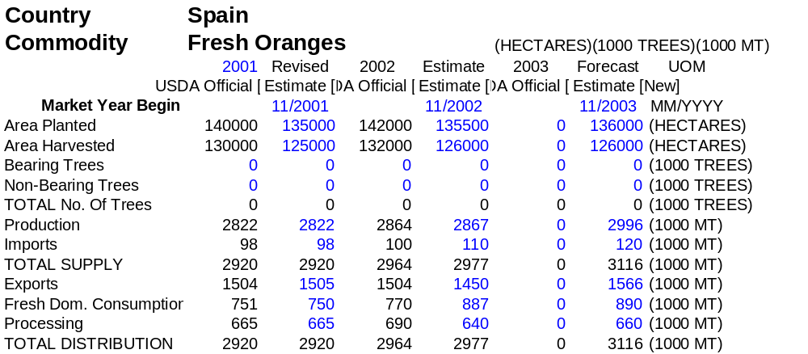

Import Trade Matrix
Country |  | Spain
Commodity |  | Fresh Oranges
Time Period |  | MY(Nov/Oct |  | Units: |  | MT
Imports for: |  | 2000 |  |  |  | 2001
U.S. |  | 0 |  | U.S. |  | 0
Others |  |  |  | Others
South Africa |  | 40588 |  |  |  | 38035
Argentina |  | 37527 |  |  |  | 16495
Uruguay |  | 24670 |  |  |  | 16027
Brazil |  | 25301 |  |  |  | 8046
Netherlands |  | 14558 |  |  |  | 5458
Portugal |  | 3400 |  |  |  | 4333
Morocco |  | 20271 |  |  |  | 513
Total for Others |  | 166315 |  |  |  | 88907
Others not Listed |  | 17459 |  |  |  | 9278
Grand Total |  | 183774 |  |  |  | 98185
Export Trade Matrix
Country | Spain
Commodity | Fresh Oranges
Time Period | MY(Nov/Oct. |  | Units: |  | MT
Exports for: | 2000 |  |  |  | 2001
U.S. | 0 |  | U.S. |  | 0
Others |  |  | Others
Germany | 348499 |  |  |  | 425570
France | 274012 |  |  |  | 352576
Netherlands | 126812 |  |  |  | 161856
UK | 87404 |  |  |  | 100467
Poland | 78759 |  |  |  | 88661
Belgium | 60527 |  |  |  | 70681
Italy | 32178 |  |  |  | 43930
Sweden | 26795 |  |  |  | 37016
Czech Republi | 23426 |  |  |  | 25025
Swtzerland | 22300 |  |  |  | 24639
Total for Others | 1080712 |  |  |  | 1330421
Others not Listed | 165716 |  |  |  | 174484
Grand Total | 1246428 |  |  |  | 1504905
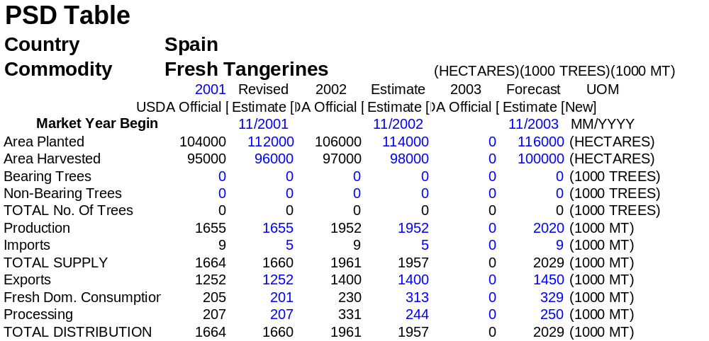

Import Trade Matrix
Country | Spain
Commodity | Fresh Tangerines
Time Period | MY(Nov/Oc | Units:
Imports for: | 2000 |  | 2001
U.S. | 0 | U.S. | 0
Others |  | Others
Argentina | 801 |  | 1488
Uruguay | 2437 |  | 1121
France | 1698 |  | 958
Netherlands | 384 |  | 704
Peru | 423 |  | 278
Total for Others | 5743 |  | 4549
Others not Listed | 3808 |  | 475
Grand Total | 9551 |  | 5024

Export Trade Matrix
Country | Spain
Commodity | Fresh Tangerines
Time Period | MY | Units: | MT
Exports for: | 2000 |  | 2001
U.S. | 94612 | U.S. | 33303
Others |  | Others
Germany | 330690 |  | 347911
France | 244696 |  | 279523
UK | 122687 |  | 124406
Poland | 65116 |  | 83683
Netherlands | 76504 |  | 74712
Italy | 51978 |  | 60889
Belgium | 38811 |  | 37270
Czech Republic | 24258 |  | 28142
Switzerland | 27501 |  | 25427
Sweden | 25567 |  | 25363
Total for Others | 1007808 |  | 1087326
Others not Listed | 127667 |  | 131679
Grand Total | 1230087 |  | 1252308

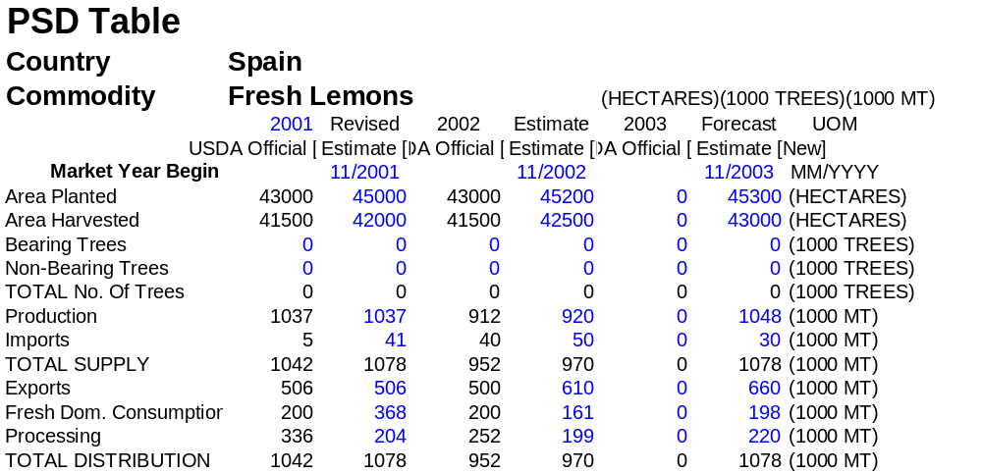

Import Trade Matrix
Country |  | Spain
Commodity |  | Fresh Lemons
Time Period |  | MY(Nov/Oc) |  |  | Units: |  |  | MT
Imports for: |  | 2000 |  |  |  |  |  | 2001
U.S. |  | 0 |  |  | U.S. |  |  | 0
Others |  |  |  |  | Others
Argentina |  | 27688 |  |  |  |  |  | 35987
Uruguay |  | 3065 |  |  |  |  |  | 1564
France |  | 1607 |  |  |  |  |  | 1480
South Africa |  | 1126 |  |  |  |  |  | 544
Total for Others |  | 33486 |  |  |  |  |  | 39575
Others not Listed |  | 5495 |  |  |  |  |  | 1046
Grand Total |  | 38981 |  |  |  |  |  | 40621
Export Trade Matrix
Country | Spain
Commodity | Fresh Lemons
Time Period | MY(Nov/Oc |  |  | Units: |  |  | MT
Exports for: | 2000 |  |  |  |  |  | 2001
U.S. | 3471 |  |  | U.S. |  |  | 21116
Others |  |  |  | Others
Germany | 103174 |  |  |  |  |  | 100858
France | 97124 |  |  |  |  |  | 85519
Poland | 77994 |  |  |  |  |  | 72022
Italy | 27135 |  |  |  |  |  | 38154
Russia | 43621 |  |  |  |  |  | 33426
UK | 40886 |  |  |  |  |  | 34629
Netherlands | 31086 |  |  |  |  |  | 23446
Czech Republic | 12307 |  |  |  |  |  | 10946
Belgium | 12475 |  |  |  |  |  | 11110
Switzerland | 10657 |  |  |  |  |  | 10076
Total for Others | 456459 |  |  |  |  |  | 420186
Others not Listed | 70852 |  |  |  |  |  | 65070
Grand Total | 530782 |  |  |  |  |  | 506372
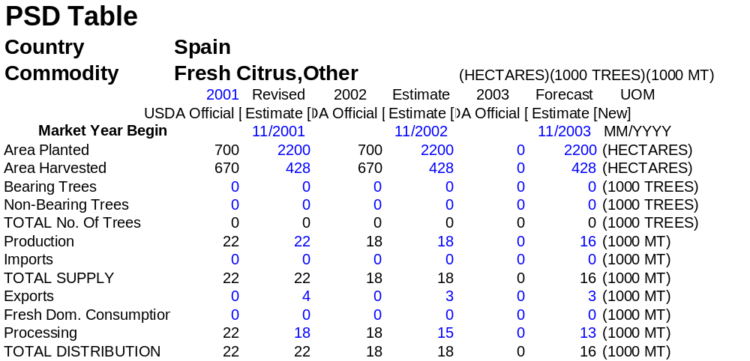

Import Trade Matrix
Country | Spain
Commodity | Fresh Citrus,Other
Time Period | MY(Nov/O) |  | Units: |  | MT
Imports for: | 2000 |  |  |  | 2001
U.S. | 0 |  | U.S. |  | 0
Others |  |  | Others
Netherlands |  |  |  |  | 274
France | 33 |  |  |  | 39
Mexico | 105 |  |  |  | 0
Total for Others | 138 |  |  |  | 313
Others not Listed | 68 |  |  |  | 0
Grand Total | 206 |  |  |  | 313
Export Trade Matrix
Country |  | Spain
Commodity |  | Fresh Citrus,Other
Time Period |  | MY(Nov/O) |  | Units: |  | MT
Exports for: |  | 2000 |  |  |  | 2001
U.S. |  | 0 |  | U.S. |  | 0
Others |  |  |  | Others
France |  | 80 |  |  |  | 2319
Germany |  | 47 |  |  |  | 1031
Italy |  | 39 |  |  |  | 339
Sweden |  | 0 |  |  |  | 136
Portugal |  | 32 |  |  |  | 96
Belgium |  | 0 |  |  |  | 96
UK |  | 121 |  |  |  | 46
Total for Others |  | 319 |  |  |  | 4063
Others not Listed |  | 68 |  |  |  | 32
Grand Total |  | 387 |  |  |  | 4095

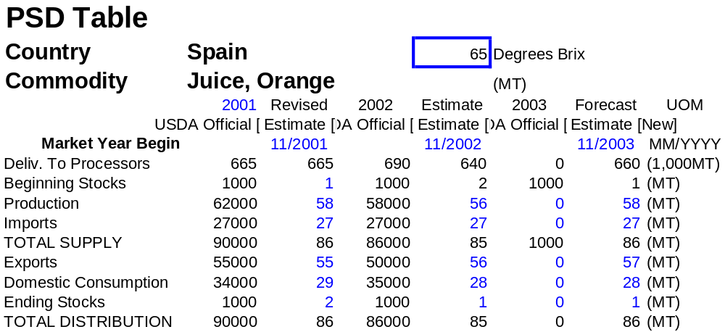

Import Trade Matrix
Country | Spain
Commodity | Juice, Orange
Time Period | MY | Units: | Million Euros
Imports for: | 2000 |  | 2001
U.S. | 0 | U.S. | 0
Others |  | Others
Netherlands | 20 |  | 21
Germany | 14 |  | 16
Belgium | 12 |  | 10
France | 3 |  | 3
Total for Others | 49 |  | 50
Others not Listed | 14 |  | 11
Grand Total | 63 |  | 61

Export Trade Matrix
Country | Spain
Commodity | Juice, Orange
Time Period | MY | Units: | Million Euros
Exports for: | 2000 |  | 2001
U.S. |  | U.S.
Others |  | Others
France | 82 |  | 100
Germany | 11 |  | 14
Portugal | 2 |  | 2
Belgium | 2 |  | 2
Total for Others | 97 |  | 118
Others not Listed | 8 |  | 1
Grand Total | 105 |  | 119

