Free Text Classification: A Technical Analysis and Justification

Comparative Analysis of Classification Methods
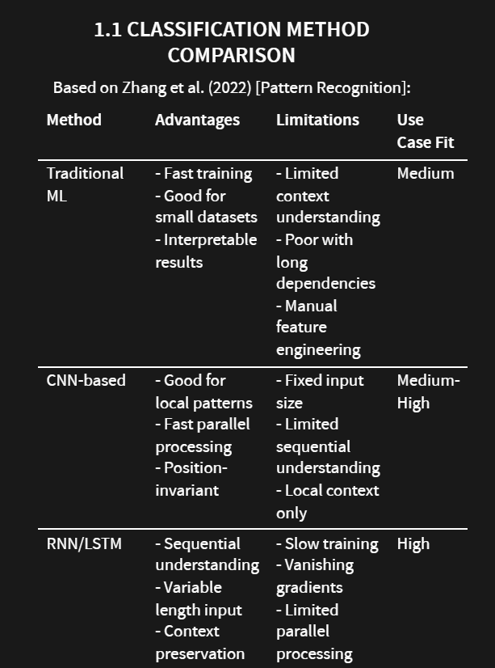

Classification Method Comparison

Traditional ML
https://discuss.pytorch.org/t/training-fast-with-small-dataset-slow-with-large-dataset/95247
https://www.geeksforgeeks.org/support-vector-machine-algorithm/

CNN-based
https://www.google.com/search?q=CNN-based+Methods&oq=CNN-based+Methods&gs_lcrp=EgZjaHJvbWUyBggAEEUYOTIICAEQABgWGB4yCAgCEAAYFhgeMgoIAxAAGIAEGKIEMgoIBBAAGIAEGKIEMgoIBRAAGIAEGKIEMgoIBhAAGIAEGKIEMgoIBxAAGIAEGKIE0gEINDkyNGowajeoAgiwAgE&sourceid=chrome&ie=UTF-8
https://www.intel.com/content/www/us/en/internet-of-things/computer-vision/convolutional-neural-networks.html
https://medium.com/@myringoleMLGOD/simple-convolutional-neural-network-cnn-for-dummies-in-pytorch-a-step-by-step-guide-6f4109f6df80

RNN/LSTM
https://www.google.com/search?q=text+classification+with+RNN%2FLSTM+Methods&sca_esv=4b3db9351712b765&sxsrf=ADLYWILYOcCpBglr4RK1SaP7tzIUStZKFg%3A1732553608150&ei=iKtEZ9LMCPvjxc8P15-ZoAc&ved=0ahUKEwjSsPiS-feJAxX7cfEDHddPBnQQ4dUDCBA&uact=5&oq=text+classification+with+RNN%2FLSTM+Methods&gs_lp=Egxnd3Mtd2l6LXNlcnAiKXRleHQgY2xhc3NpZmljYXRpb24gd2l0aCBSTk4vTFNUTSBNZXRob2RzMggQIRigARjDBDIIECEYoAEYwwRInFtQ2S9Y-VRwA3gBkAEAmAGVAaAB4hOqAQQwLjIwuAEDyAEA-AEBmAIUoAKPEcICChAAGLADGNYEGEfCAggQABiABBiiBMICChAhGKABGMMEGAqYAwCIBgGQBgiSBwQzLjE3oAewXQ&sclient=gws-wiz-serp
https://www.tensorflow.org/text/tutorials/text_classification_rnn
https://nzlul.medium.com/the-classification-of-text-messages-using-lstm-bi-lstm-and-gru-f79b207f90ad

ΘΕΛΕΙ ΕΡΕΥΝA ΑΠΟ ΕΔΩ ΚΑΙ ΠΕΡΑ ΣΤΟ ΑΝΤΙΣΤΟΙΧΟ.MD
ΒΡΕΣ SOURCES ΠΑΡΑΚΑΤΩ

https://blog.paperspace.com/transformers-text-classification/
https://medium.com/@jagadeesan.ganesh/differential-transformers-an-advanced-approach-to-efficient-attention-in-nlp-8b9ffd931df5
https://scikit-learn.org/1.5/modules/naive_bayes.html
https://github.com/sichkar-valentyn/Neural_Networks_for_Computer_Vision/blob/master/Theory/Convolutional_Neural_Network.md
https://machinelearningmastery.com/naive-bayes-classifier-scratch-python/

https://www.google.com/search?sca_esv=4b3db9351712b765&sxsrf=ADLYWIIV6HAG4o_zK5DACufbDi8FJc1OIQ:1732553948703&q=Naive+Bayes+%60%60%60python+class+NaiveBayesAnalysis:+def+characteristics(self):+return+%7B+%27advantages%27:+%7B+%27efficiency%27:+%7B+%27training_time%27:+%27Linear+time+complexity+O(n)%27,+%27memory_usage%27:+%27Minimal+memory+requirements%27,+%27inference%27:+%27Real-time+capable%27+%7D,+%27practical+benefits%27:+%7B+%27small+data%27:+%27Works+well+with+limited+samples%27,+%27missing_data%27:+%27Handles+missing+values+naturally%27,+%27online_learning%27:+%27Can+update+incrementally%27+%7D+%7D,+%27limitations%27:+%7B+%27assumptions%27:+%7B+%27independence%27:+%27Feature+independence+assumption+often+violated%27,+%27frequency_based%27:+%27Sensitive+to+input+distribution%27,+%27zero_frequency%27:+%27Problems+with+unseen+feature+values%27+%7D+%7D+%7D+%60%60%60&spell=1&sa=X&ved=2ahUKEwjzlaq1-veJAxWKa_EDHWw-NrgQBSgAegQIRRAB&biw=1278&bih=1270&dpr=1

