# Feedback Control of Peak Inspiratory Pressure in High-Frequency Jet Ventilation

This example develops and simulates a feedback controller that regulates the peak pressure generated by a high-frequency jet ventilator. High-frequency ventilation is a type of mechanical ventilation that is based on respiratory rates that greatly exceed the rate of normal breathing. A common application is in lung injury treatment for infants.

## Model

The model consists of a Dashboard that can be used to specify mechanical ventilation parameters, a peak pressure controller and the plant that simulates a mechanical ventilator as well as the patient’s lung.

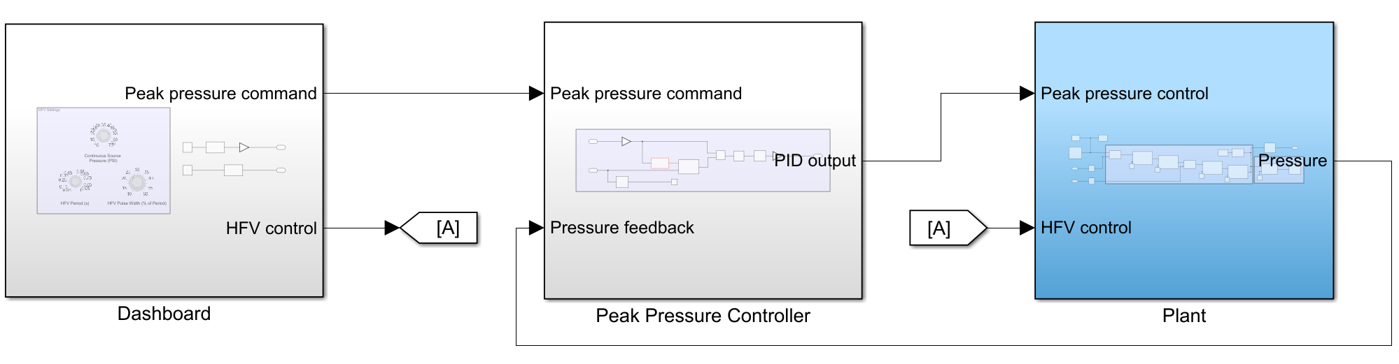

## Plant subsystem

The plant subsystem was implemented with Simscape™ and models a mechanical ventilator using a pressure source, air valves and connecting tubes. The plant also models a test lung as a piston connected to a spring-damper system.

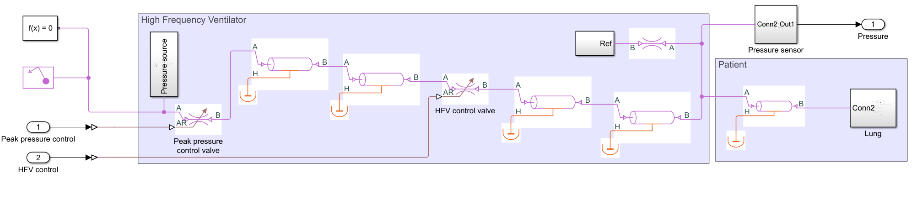

## Control Logic subsystem

The control logic subsystem tracks the peak pressure command using a PID controller and a peak detector that extracts the peaks from the pressure sensor measurements. The output of the PID controller is used to control the peak pressure valve in the plant based on pressure feedback.

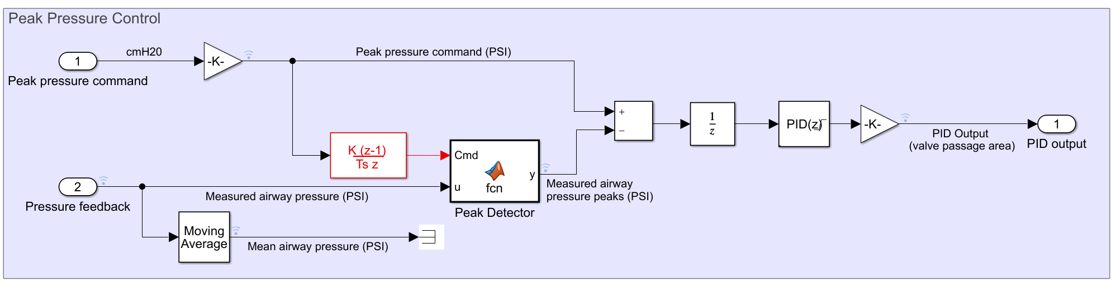

# Dashboard

The Dashboard is responsible for generating the signal that controls the flow-interruption valve in the plant. The selected settings determine the characteristics of the high-frequency jet stream generated by interrupting the high-pressure source in the plant.

The peak pressure command tracked by the peak pressure controller is also generated in this subsystem.

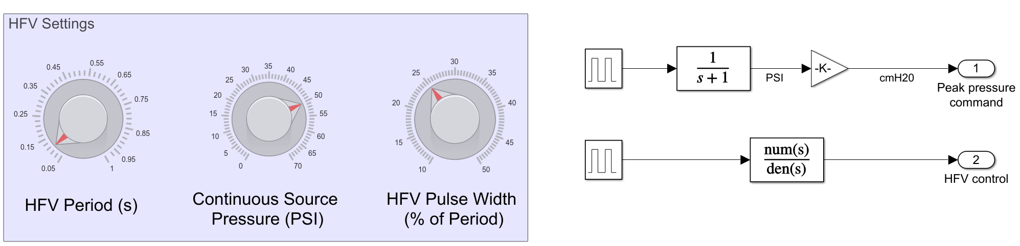

## Simulation Results

The following figures show the results from the Simulation Data Inspector. The first row illustrates the peak pressure tracking behavior of the PID controller. The second row shows the actual measured pressure as well as the corresponding mean pressure applied by the mechanical ventilator. Notice that the measured pressure consists of high-frequency jet streams created by the flow-interruption valve. Finally, the third row illustrates the response of the test lung to the mean airway pressure.

