Beat the Bell: Class-Schedule-Aware Stockout Prediction and Pre-emptive YouBike Rebalancing for Campus Stations
Final Project Proposal (HW1) · Introduction to Artificial Intelligence (TAICA, Fall 2026) · Group 54
Team members
國立中山大學 B124020041 林沛霆 · 國立中山大學 B134020002 陳佳晨 · 國立中山大學 B134020008 林詩穎

Abstract
Docks near a university empty within minutes of a class ending. Because the timetable makes this surge predictable, we cast rebalancing as an AI decision problem: one truck moves bikes before the bell instead of after the stockout. We (i) reconstruct censored demand and the operator’s actual truck moves from public trip records and inventory snapshots, (ii) learn a schedule-aware, calibrated predictor of P(stockout within h min) per station, and (iii) plan truck routes by rolling-horizon search that minimizes expected unmet rentals plus travel cost. We evaluate on 13 months of open NTU data and demonstrate live around NSYSU, expecting to avoid about half of unmet rentals.
1. Introduction
1.1. Motivation
Taipei’s YouBike 2.0 alone served 46 million trips in 2023 [3]. Around universities it fails in one specific way: bikes are plentiful during lectures and vanish when class ends. Fig. 1(a) quantifies this for the 59 NTU campus stations over 20 weekdays [2]: the campus count drops from 584 to 392 bikes within 20 minutes of the 12:10 bell and by 41% after the 17:20 bell; after 18:00 about 30% of stations are empty. Fig. 1(b) is our campus: twelve minutes after NSYSU’s 17:00 bell on 28 Sep 2026, 4 of the 25 stations within 1.5 km were empty, all on the KRT side, while the gymnasium held 48 bikes. The bikes exist; they stand at the wrong stations at a moment the timetable predicts.
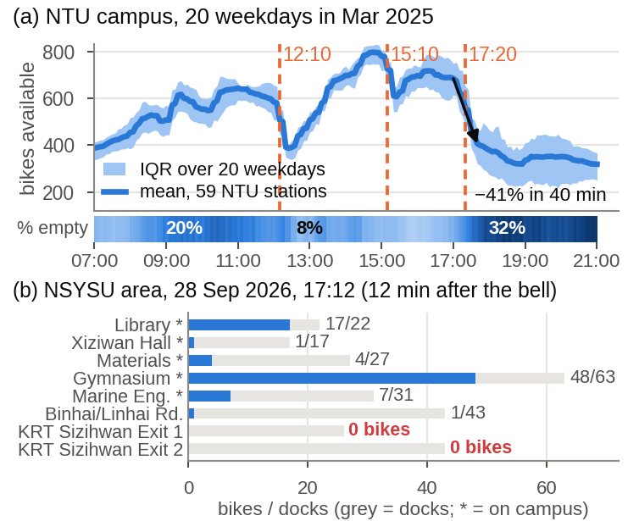
Figure 1. Class-end stockouts are real and predictable. (a) Mean bikes available at 59 NTU campus stations over 20 weekdays, Mar 2025 [2]; orange = period ends; strip = share of empty stations. (b) NSYSU at 17:12, 28 Sep 2026 [12].
1.2. Problem definition
Station i has capacity c_{i} and inventory s_{i}(t); rentals r_{i}(t) and returns q_{i}(t) are counts whose rates depend on time of day, day of week and, our key assumption, the time to the next bell b(t). Rentals are censored: when s_{i}(t) = 0, lost rentals are unrecorded. One truck of capacity Q visits stations with travel times d_{ij}. Before each bell we choose a route and load plan π minimizing expected unmet rentals over a horizon H plus β·travel time under capacity and deadline constraints. This is the course’s rational-agent view: acting under uncertainty to maximize expected utility, coupling probabilistic reasoning, learning and search.
1.3. Existing solutions and literature
Static repositioning is a routing-and-inventory problem [4]; dynamic repositioning combines forecasts with heuristics or mixed-integer programs [5, 6]; recent work uses spatio-temporal reinforcement learning [7]. Two ingredients matter on a campus yet are rarely combined: censored-demand estimation by simulation [8] or censored Gaussian processes [9], and inferring the operator’s unpublished truck moves by subtracting trip flows from inventory changes [10]; on Taipei data this reveals 18–20 thousand unexplained bike moves on 12 Mar 2025, peaking at 07–09 and 18–20. A 2025 NTU thesis optimized dispatch near NTU with survival-model demand on one month of trips [11]. No published work, to our knowledge, (a) uses the class timetable as an explicit signal, (b) outputs calibrated stockout probabilities rather than point forecasts, or (c) tests transfer between campuses; NSYSU has never been studied and Kaohsiung publishes no trip data, so transfer is the practical question.
1.4. Proposed solution
Fig. 2 shows the pipeline. Open NTU data (hourly trips [1]; 10-minute inventory over 416 days [2]) serve to reconstruct demand and operator moves, to train a schedule-aware gradient-boosting predictor with reliability checks, and to drive a rolling-horizon route planner; policies are compared in a replay simulator fed with real trips. The predictor is then ported to NSYSU with a few weeks of locally logged inventory [12] for a live web demo that recommends a pre-bell truck plan (Fig. 3). Contributions: (1) an uncertainty-aware pre-emptive rebalancing method reproducible from open data; (2) the first quantification of class-end stockouts at NTU and NSYSU; (3) an NTU→NSYSU transfer study.
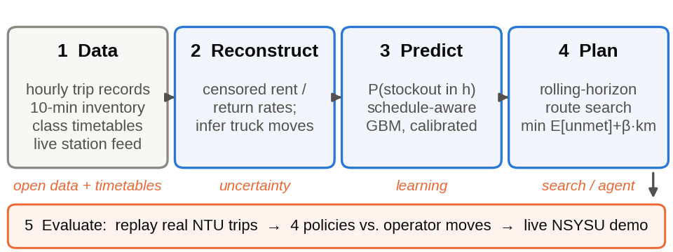
Figure 2. Proposed pipeline and the course unit each stage exercises.
2. Method
2.1. Demand reconstruction
Per station-hour, Δs_{i} = q_{i} − r_{i} + m_{i} + ε, with m_{i} the operator’s net truck move; residuals |Δs − (q − r)| ≥ 5 over 3-hour windows are labelled as moves [10], giving an observed operator policy. For censoring, minutes with s_{i} = 0 are dropped from the exposure of a Poisson rate model, so λ_{r} reflects only time when a rental was possible [8, 9].
2.2. Schedule-aware stockout prediction
Features per station and 10-minute slot: minutes to the next and since the last bell (NTU periods end at 12:10, 15:10, 17:20; NSYSU on the hour), day of week, week of semester, lagged flows (1–3 h, same slot last week), current stock, capacity and stock at the three nearest stations. Baselines: persistence and seasonal mean; then LightGBM with Poisson objectives for rentals and returns; Monte-Carlo roll-out of the inventory over h ∈ {15, 30, 60} min, giving P(s_{i}(t+h) = 0). Metrics: Brier score, AUC and expected calibration error (ECE), since the planner consumes probabilities. Transfer: train on NTU, test on NSYSU with 0–4 weeks of local data.
2.3. Pre-emptive planner and evaluation
State: truck position and load, station stocks and predicted rates; actions: (station, ±k bikes); objective J(π) = Σ_{i} E[max(0, D_{i} − s_{i})] + β·T(π), with D_{i} the predicted demand. Every 10 minutes we rank stations by expected unmet rentals, build a greedy surplus-to-deficit route under capacity Q and the bell deadline, and improve it by 2-opt local search and simulated annealing. A discrete-event replay simulator consumes real held-out trips (Apr–Jun 2025): a rental is served only if stock > 0, otherwise it counts as unmet, while the truck follows the policy under test. We compare none, reactive (after an observed stockout), predictive-point and predictive-probabilistic (ours), plus the inferred operator moves, which must first reproduce observed inventories (R² > 0.8). Metrics: unmet rentals, empty station-minutes, truck-km.
3. Expected Results
On the NTU replay we expect, relative to no rebalancing, reactive dispatch to remove about a fifth of unmet rentals, point-forecast dispatch about 40% and the probabilistic policy about half. For the predictor we expect AUC > 0.85 and ECE < 0.05 at h = 30 min; at NSYSU, a zero-shot drop that closes to within 5 AUC points after 2–4 weeks of local data. The live demo (Fig. 3) shows, before each NSYSU bell, stockout probabilities and one truck route with the rentals it saves. Fig. 4 gives the schedule. Fallbacks: without Kaohsiung history all quantitative results come from NTU; if probabilities do not beat point forecasts the calibration study is still reported; if local search is late, greedy dispatch with one-step lookahead is used.
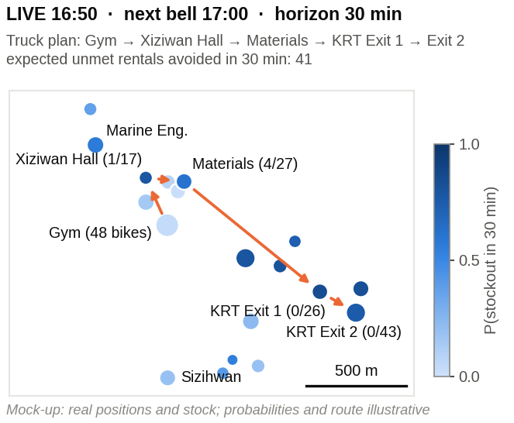
Figure 3. Mock-up of the live NSYSU demo (real station positions and stock; probabilities and route illustrative).
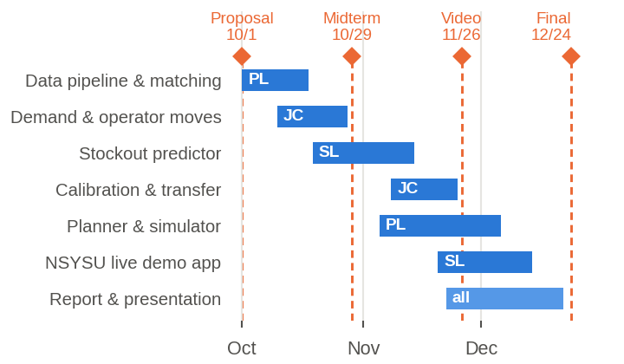
Figure 4. Schedule, milestones and owners (PL 林沛霆, JC 陳佳晨, SL 林詩穎).
References
[1] 臺北市政府交通局. 臺北市公共自行車 2.0 租借紀錄, 2020–2026, data.taipei.
[2] C.-X. Jian. youbike-historical-data (10-min Taipei YouBike 2.0 inventory snapshots), GitHub, 2024–2025.
[3] 報導者 The Reporter. 台北市 YouBike 多熱門？數據告訴你, Apr. 2024.
[4] T. Raviv et al. Static repositioning in a bike-sharing system: models and solution approaches. EURO J. Transp. Logist., 2(3):187–229, 2013.
[5] J. Liu et al. Rebalancing bike sharing systems: A multi-source data smart optimization. In KDD, 2016.
[6] S. Ghosh et al. Dynamic repositioning to reduce lost demand in bike sharing systems. J. Artif. Intell. Res., 58:387–430, 2017.
[7] Y. Li, Y. Zheng, and Q. Yang. Dynamic bike reposition: A spatio-temporal reinforcement learning approach. In KDD, 2018.
[8] A. Negahban. Simulation-based estimation of the real demand in bike-sharing systems in the presence of censoring. Eur. J. Oper. Res., 277(1):317–332, 2019.
[9] D. Gammelli et al. Estimating latent demand of shared mobility through censored Gaussian processes. Transp. Res. Part C, 120:102775, 2020.
[10] H. Luo et al. Estimating rebalancing activities and vehicle use for existing station-based bike share systems. Transportation, 2026.
[11] 周欣儀. 臺大校總區周遭 YouBike 2.0 使用行為與調度優化研究. 碩士論文, 國立臺灣大學機械工程學系, 2025.
[12] YouBike 即時站點資料 (apis.youbike.com.tw); 交通部 TDX (tdx.transportdata.tw); 高雄市開放資料 kcgoa-00000595-e5c.

