Set up Git on Mac:

Download Address: http://git-scm.com/downloads

Using the default Settings.

Check if installed successfully:

Open Terminal, type in git version. Get the version.



Register A GitHub Account. (Skipped)

I’ve already created a GitHub repository. The link is: <https://github.com/alexliu0809/ScenarioWeek_Group4_UCL.git>

I’ve already put my Notes and the handbook into the repository.

The steps to cooperate through GitHub:

For everyone in our team, firstly we need to create an empty folder in our local machine and make it a repository.

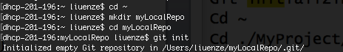

After that, we connect to the remote repository, using the following commands:

“git remote add origin https://…”

//to connect to remote repository

“git fetch origin”

//fetch data to origin

“git checkout master”

//switch to local master branch

“git merge origin/master”

//synchronize master with remote repository.

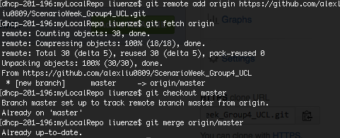

By now, your folder myLocalRepo should have the documents on the websites:

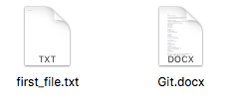

Then, you can copy your source code to local repository folder. So it looks like these:



Now we add and commit our source code to our local repository. Using the following commands:

“git add .”

// ‘.’means add everything. So we could add all the source code files at the same time.

“commit –m “Message””

//commit to local repository with a message or comment

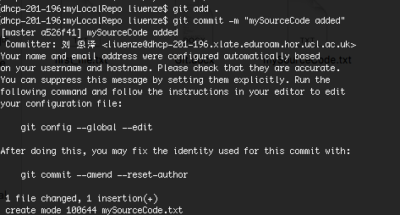

Finally, we push our changes to remote repository:

“git push origin master”

So the web looks like these now:

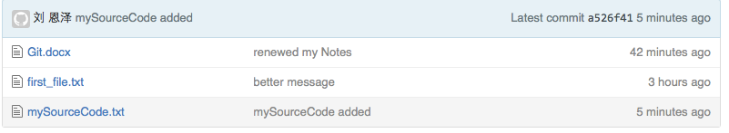

//with source code uploaded.

Every time we try to upload our code, follow these steps:

1.Commit your source code to local depository:

“git add .”

//add all

“git commit –m “Message””

//commit

2.Fetch from remote repository:

“git fetch origin”

//fetch data to origin

3.Merge your master with origin/master

“git checkout master”

//switch to local master branch

“git merge origin/master”

//synchronize master with remote repository.

4.Upload your code

“git push origin master”

//push your code.