编译原理程序设计实验报告

——实验题目
班级：计算机1606班 姓名：戚子强 学号：20164625

实验亮点部分
1. 第三次实验分别用4种方式（递归子程序下降法、LL(1)分析法、LR(0)分析法和算符优先分析法）实现四元式语法制导翻译；

2. 第二次实验分别用4种方式（递归子程序下降法、LL(1)分析法、LR(0)分析法和算符优先分析法）实现语义分析；

3. 第一次实验的词法分析器支持C99多数词法，可以分析该词法分析器源代码本身。

第一次实验报告
实验目标：
词法分析扫描器的设计实现。
实验内容：
（包括：概要设计、数据结构、流程图、关键函数等有选择填写）
基本思想是首先从文件内读取源代码内容，以空格、Tab和回车区分每一个独立的单位，这个“单位”可能是一个关键字、变量或者其他类型；再利用开头符号进行第一次分拣，分拣后再继续读入字符到一个字符串变量中，直到一个界符出现；接下来登记这个字符串并进行合理分类，生成对应的Token串。
Token格式设计如下：
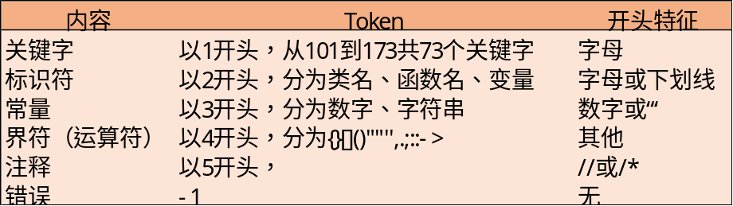
程序流程图如下：
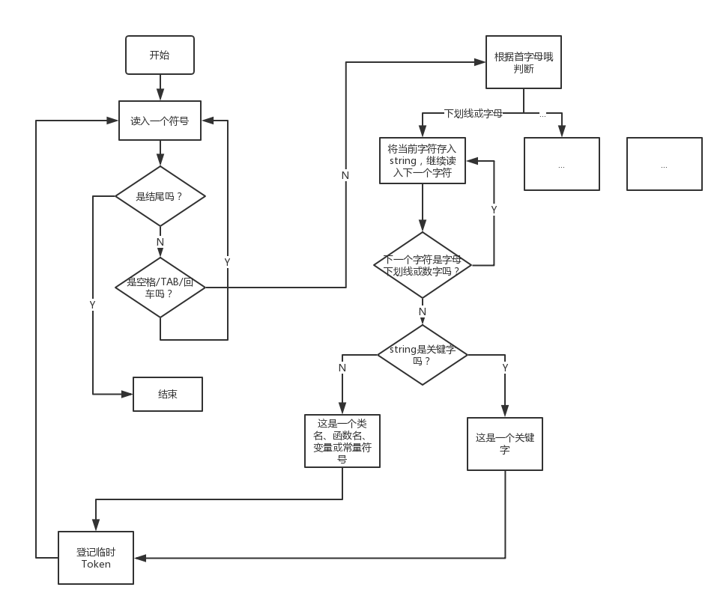

源程序代码：（加入注释）
/************************************************************
FileName:WordFilter.cpp
Function: Design and Implementation of Lexical Analysis Scanner
*************************************************************/
#include <iostream>
#include <fstream>
#include <string>
#include <cassert>
#include "IsKeywords.h"
using namespace std;

/*
public class tokens
{
int tokenId;
string tokenType, tokenValue;
tokens *next = new tokens;
}
*/

int main()
{
char ch; //当前读入的字符
string str; //单词单位
int token; //TOKEN格式详见文件token.xlsx
string fileName = "a.txt"; //从文件读入
ifstream infile;
infile.open(fileName.data());
assert(infile.is_open());
infile >> noskipws;
infile >> ch;
//分别记录标识符、常量和界符，如果后续出现重复的词语则不再新增token，只与旧的token关联
string identifier[1024], constant[1024], boundary[1024];
int idNum = 0, conNum = 0, bounNum = 0;

while(!infile.eof() && ch!=EOF)
{
//过滤换行、Tab或空格
if(ch=='\n'||ch=='\t'||ch==' ')
{
infile >> ch;
}

//若是字母或下划线开头，是变量、函数或类名或者关键字
else if((ch>='a' && ch<='z') ||
(ch>='A' && ch<='Z') ||
(ch == '_'))
{
str = "";
token = 0;
while((
(ch>='a' && ch<='z') ||
(ch>='A' && ch<='Z') ||
(ch == '_') ||
(ch>='0'&&ch<='9')) &&
(!infile.eof()) )
{
str = str + ch;
infile >> ch;
}
cout<<"("<<str<<",";

//判断是否是关键字
token = isKeywords(str);
if(token != 0) cout<<token<<")"<<endl;

//以字母或下划线开头的，不是关键字就是标识符
/*
else
{
identifier[idNum++] = str;
token = 200 + idNum; cout<<token<<endl;
}
*/
else
{
int haveId = 0;
for(int i = 0; i < idNum; i++)
{
if(identifier[i] == str)
{
token = 200 + i;
cout<<token<<")"<<endl;
haveId = 1;
break;
}
}
if(haveId == 0)
{
identifier[idNum++] = str;
token = 200 + idNum;
cout<<token<<")"<<endl;
}
}
}

//若是数字开头，一定是数字常量
else if(ch>='0' && ch<='9')
{
//token = 3;
str = "";
while(((ch>='0' && ch<='9')||(ch == '.')) && !(ch=='\n'||ch=='\t'||ch==' ') && (!infile.eof()) )
{
str = str + ch;
infile >> ch;
}
constant[conNum++] = str;
token = 300 + conNum;
cout<<"("<<str<<","<<token<<")"<<endl;
}

//若是引号开头，一定是字符(串)常量
else if(ch == '\'' || ch == '\"')
{
// token = 3;
str = "";
str = str + ch;
infile >> ch;
while(ch != '\'' && ch != '\"' && !infile.eof())
{
str = str + ch;
infile >> ch;
}
str = str + ch;
infile >> ch;
constant[conNum++] = str;
token = 300 + conNum;
cout<<"("<<str<<","<<token<<")"<<endl;
}

//若是//或者/*开头，是注释
else if(ch == '/')
{
infile >> ch;

//单行注释
if(ch == '/')
{
token = 501;
str = "//";
infile >> ch;
while(ch != '\n' && !infile.eof())
{
str = str + ch;
infile >> ch;
}
cout<<"("<<str<<","<<token<<")"<<endl;
}

//多行注释
else if(ch == '*')
{
token = 502;
str = "/*";
infile >> ch;
while(!infile.eof())
{
str = str + ch;
infile >> ch;
if(ch == '*')
{
infile >> ch;
if(ch == '/')
{
str = str + "*/";
infile >> ch;
cout<<"("<<str<<","<<token<<")"<<endl;
break;
}
else
{
str = str + "*";
}
}
}
}

//判断注释有错误情况
else
{
token = -1;
cout<<"(/"<<","<<token<<")"<<endl;
}
}

//其他情况，是运算符(界符)
else
{
token = 4;
str = "";
/*
while((!((ch>='a' && ch<='z')||(ch>='A' && ch<='Z')||(ch == '_')||(ch>='0'&&ch<='9')||(ch=='\n'||ch=='\t'||ch==' '||ch=='/')))&& (!infile.eof()))
{
str = str + ch;
infile >> ch;
}
*/
str = str + ch;
infile >> ch;
int haveBoun = 0;
for(int i = 0; i < bounNum; i++)
{
if(boundary[i] == str)
{
token = 400 + i;
cout<<"("<<str<<","<<token<<")"<<endl;
haveBoun = 1;
break;
}
}
if(haveBoun == 0)
{
boundary[bounNum++] = str;
token = 400 + bounNum;
cout<<"("<<str<<","<<token<<")"<<endl;
}
}
}
infile.close();
return 0;
}

/************************************************************
FileName:IsKeywords.h
Function: Determine whether the given word is the keyword.
*************************************************************/
#include <string>
#include <iostream>
using namespace std;

string keywords[73] =
{
"asm",
"do",
"if",
"return",
"typedef",
"auto",
"double",
"inline",
"short",
"typeid",
"bool",
"dynamic_cast",
"int",
"signed",
"typename",
"break",
"else",
"long",
"sizeof",
"union",
"case",
"enum",
"mutable",
"static",
"unsigned",
"catch",
"explicit",
"namespace",
"static_cast",
"using",
"char",
"export",
"new",
"struct",
"virtual",
"class",
"extern",
"operator",
"switch",
"void",
"const",
"false",
"private",
"template",
"volatile",
"const_cast",
"float",
"protected",
"this",
"wchar_t",
"continue",
"for",
"public",
"throw",
"while",
"default",
"friend",
"register",
"true",
"delete",
"goto",
"reinterpret_cast",
"try",
"alignas",
"alignof",
"char16_t",
"char32_t",
"constexpr",
"decltype",
"noexcept",
"nullptr",
"static_assert",
"thread_local"
};

int isKeywords(string str)
{
for(int i = 0; i < 72; i++)
{
if(str == keywords[i])
return (101 + i);
}
}

程序运行结果：（截屏）
输入：
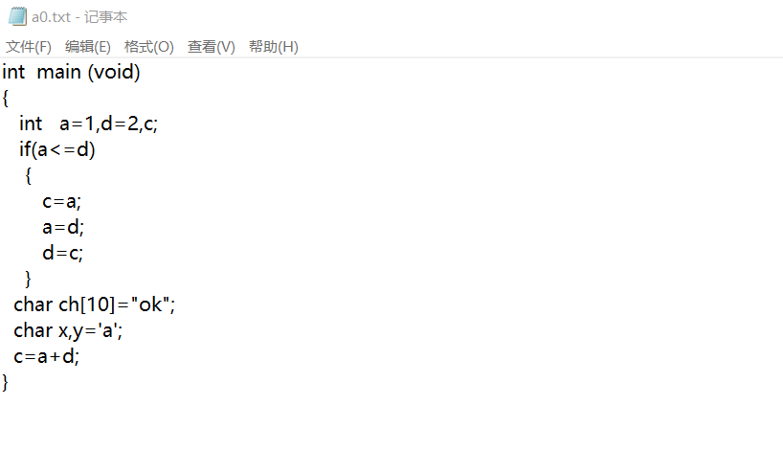
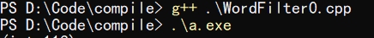

输出：
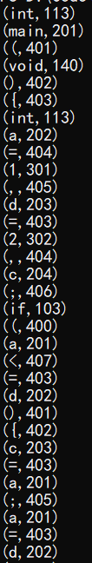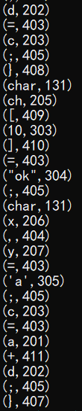

思考问题回答：（如果有）

第二次实验报告
实验目标：

表达式语法分析器的设计实现

实验内容：
（包括：概要设计、数据结构、流程图、关键函数等有选择填写）
首先，利用第一次实验的结果，即token串，进行切词，作为输入；然后利用四种不同的文法分析方式进行文法分析，具体有：递归子程序下降法、LL(1)分析法、LR(0)分析法、算符优先分析法；分别进行了实现，并用以下示例进行验证：
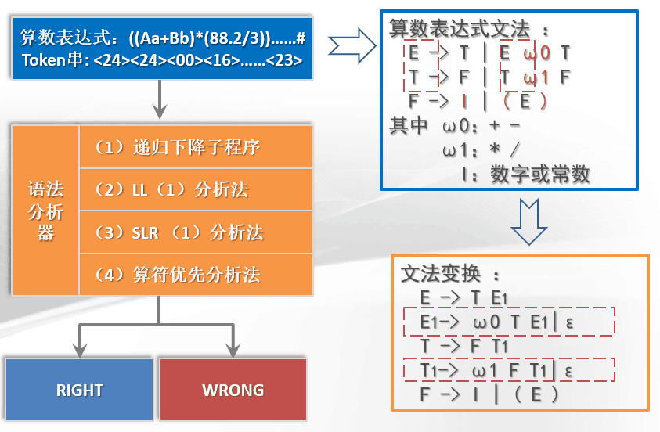

2.1 Token输入格式调整
为了后续实验方便，每一个文法分析器的输入都是一个一维数组，这个数组就是从文件读取代码后所形成的TOKEN串，例如：
113,201,401,140,402,403,407...
代表：
int main(){}
调整后的提供TOKEN串的文件如下：
/************************************************************
FileName:WordFilter1.h
Function: Provide token strings to grammar parsers from file.
*************************************************************/

#include <iostream>
#include <fstream>
#include <string>
#include <cassert>
using namespace std;

void wordFilter(int* tokens)
{
char ch; //当前读入的字符
string str; //单词单位
int token; //TOKEN格式详见文件token.xlsx
string fileName = "a0.txt"; //从文件读入
ifstream infile;
infile.open(fileName.data());
assert(infile.is_open());
infile >> noskipws;
infile >> ch;
//分别记录标识符、常量和界符，如果后续出现重复的词语则不再新增token，只与旧的token关联
string identifier[1024], constant[1024], boundary[1024];
int idNum = 0, conNum = 0, bounNum = 0;

while(!infile.eof() && ch!=EOF)
{
//过滤换行、Tab或空格
if(ch=='\n'||ch=='\t'||ch==' ')
{
infile >> ch;
}

//若是字母或下划线开头,是变量
else if((ch>='a' && ch<='z') ||
(ch>='A' && ch<='Z') ||
(ch == '_'))
{
str = "";
token = 0;
while((
(ch>='a' && ch<='z') ||
(ch>='A' && ch<='Z') ||
(ch == '_') ||
(ch>='0'&&ch<='9')) &&
(!infile.eof()) )
{
str = str + ch;
infile >> ch;
}
cout<<"("<<str<<",";

int haveId = 0;
for(int i = 0; i < idNum; i++)
{
if(identifier[i] == str)
{
token = 200 + i;
cout<<token<<")"<<endl;
tokens[tokenNumNow++] = token;
haveId = 1;
break;
}
}
if(haveId == 0)
{
identifier[idNum++] = str;
token = 200 + idNum;
cout<<token<<")"<<endl;
tokens[tokenNumNow++] = token;
}
}

//若是数字开头，是数字常量
else if(ch>='0' && ch<='9')
{
//token = 3;
str = "";
while(((ch>='0' && ch<='9')||(ch == '.')) && !(ch=='\n'||ch=='\t'||ch==' ') && (!infile.eof()) )
{
str = str + ch;
infile >> ch;
}
constant[conNum++] = str;
token = 300 + conNum;
cout<<"("<<str<<","<<token<<")"<<endl;
tokens[tokenNumNow++] = token;
}

//若是引号开头，是字符(串)常量
else if(ch == '\'' || ch == '\"')
{
// token = 3;
str = "";
str = str + ch;
infile >> ch;
while(ch != '\'' && ch != '\"' && !infile.eof())
{
str = str + ch;
infile >> ch;
}
str = str + ch;
infile >> ch;
constant[conNum++] = str;
token = 300 + conNum;
cout<<"("<<str<<","<<token<<")"<<endl;
tokens[tokenNumNow++] = token;
}

//+-*/()#，是运算符(界符)
else if(ch == '+'||ch == '-')
{
str = "";
str = str + ch;
infile >> ch;
token = 401;
cout<<"("<<str<<","<<token<<")"<<endl;
tokens[tokenNumNow++] = token;
}

else if(ch == '*'||ch == '/')
{
str = "";
str = str + ch;
infile >> ch;
token = 402;
cout<<"("<<str<<","<<token<<")"<<endl;
tokens[tokenNumNow++] = token;
}

else if(ch == '(')
{
str = "";
str = str + ch;
infile >> ch;
token = 403;
cout<<"("<<str<<","<<token<<")"<<endl;
tokens[tokenNumNow++] = token;
}

else if(ch == ')')
{
str = "";
str = str + ch;
infile >> ch;
token = 404;
cout<<"("<<str<<","<<token<<")"<<endl;
tokens[tokenNumNow++] = token;
}

else if(ch == '#')
{
str = "";
str = str + ch;
infile >> ch;
token = 405;
cout<<"("<<str<<","<<token<<")"<<endl;
tokens[tokenNumNow++] = token;
}

else
{
cout<<"ERROR!"<<endl;
tokens[tokenNumNow++] = 999;
infile >> ch;
}
}
infile.close();
/*
for(int i = 0; i < tokenNumNow; i++)
{
cout<<"token"<<i<<":"<<tokens[i]<<endl;
}
*/
}

2.2 递归子程序下降法
程序流程图如下所示：
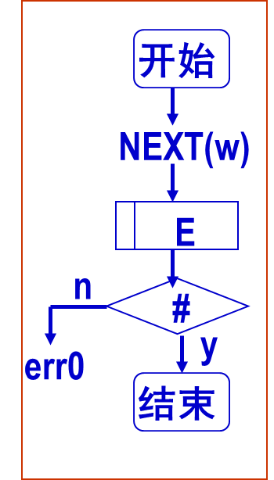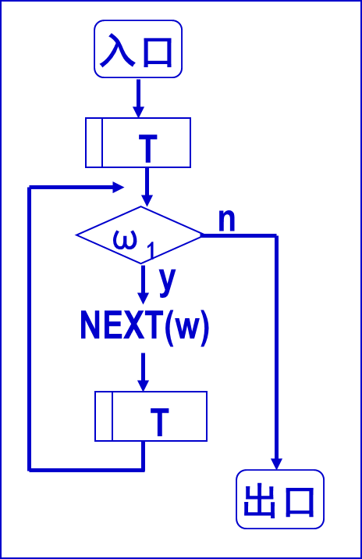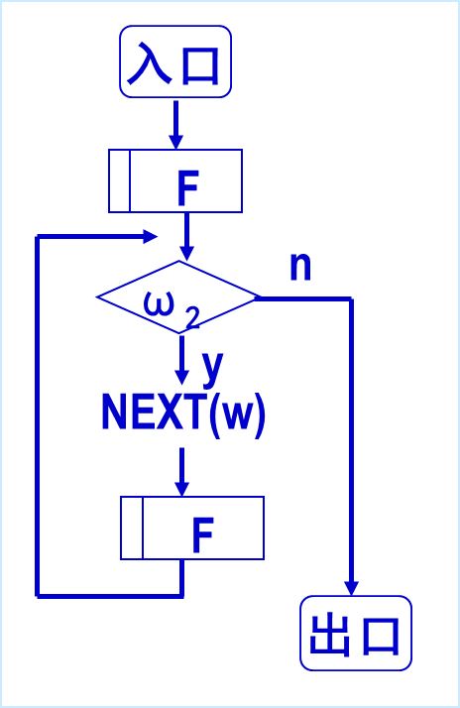
主程序 子程序T 子程序E

源程序代码：（加入注释）

/************************************************************
FileName:ParserRD.cpp
Function: A recursive subprogram descent method is used for
grammar analysis.
*************************************************************/

#include <iostream>
#include <string>
#include "WordFilter1.h"
using namespace std;
int tokens[1024], tokenNumNow = 0;
void functionE();
void functionT();
void functionF();
bool flag = 1;

int main()
{
//生成TOKEN串并保存在全局变量tokens中
wordFilter(tokens);
//进入子程序E
functionE();
//如果没有发生错误并且最后token只剩下#
if(flag == 1 && tokens[tokenNumNow] == 405)
cout<<"Successful!"<<endl;
else
cout<<"Error!"<<endl;
return 0;
}

void functionE()
{
//进入子程序T
functionT();
//如果从T出来后，紧接着后面字符是+或者-
while(tokens[tokenNumNow]==401)
{
cout<<tokens[tokenNumNow]<<endl;
tokenNumNow++;
//继续进入子程序T
functionT();
}
}

void functionT()
{
//进入子程序T
functionF();
//如果从T出来后，紧接着后面字符是*或者/
while(tokens[tokenNumNow] == 402)
{
cout<<tokens[tokenNumNow]<<endl;
tokenNumNow++;
//继续进入子程序T
functionF();
}
}

void functionF()
{
int flagF1=0,flagF2=0;
//如果当前字符是一个变量或者常量I
if(tokens[tokenNumNow]>=200 && tokens[tokenNumNow]<=399)
{
flagF1=1;
cout<<tokens[tokenNumNow]<<endl;
tokenNumNow++;
}
//若当前字符是{
else if(tokens[tokenNumNow]==403)
{
cout<<tokens[tokenNumNow]<<endl;
tokenNumNow++;
//进入子程序E
functionE();
//从T出来后，紧接着后面字符是否是}
if(tokens[tokenNumNow]==404)
{
flagF2 = 1;
cout<<tokens[tokenNumNow]<<endl;
tokenNumNow++;
}
}
else
{
flag = 0;
}
//进入F后字符要么是变量/常量要么是{，否则出错
if(!flagF1 && !flagF2)
{
flag = 0;
}
}

程序运行结果：（截屏）
输入：
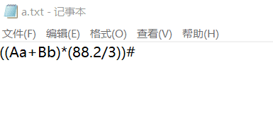
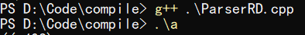
输出：
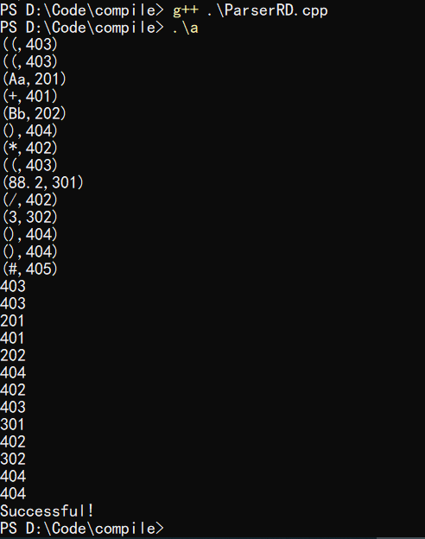

2.3 LL(1)分析法
LL(1)分析法的流程图大致如下：
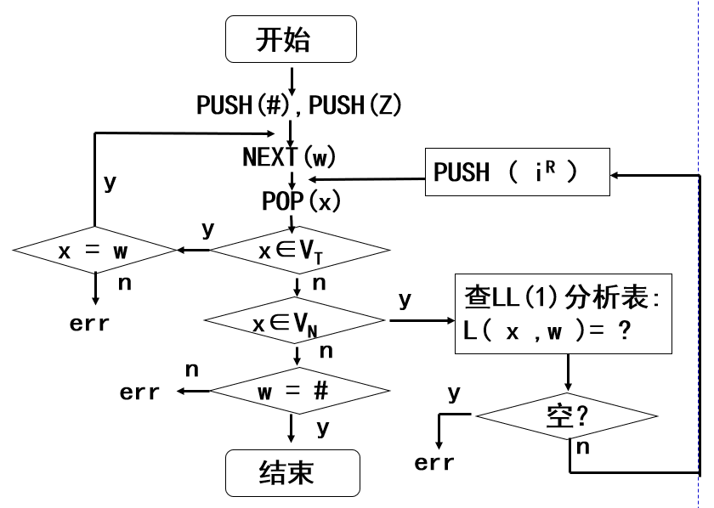
LL(1)分析表如下：
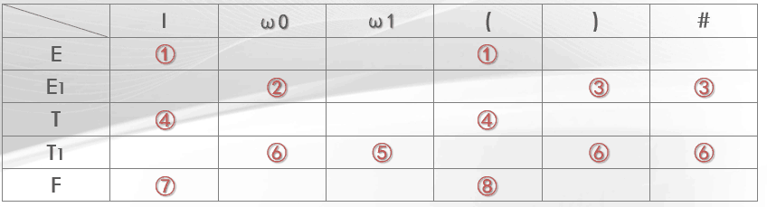

源程序代码：（加入注释）

/************************************************************
FileName:ParserLL.cpp
Function: LL (1) analysis method is used for grammar analysis.
*************************************************************/

#include <iostream>
#include <stack>
#include "WordFilter1.h"
using namespace std;
void reverseStack(int order);
int lookupTable(char x, int w);
bool endIsRight(char x, int w);
stack<char> s;
int tokens[1024], tokenNumNow = 0;
bool flag = 1;
//产生式逆序压栈
char E[2] = {'T','R'};
char R[3] = {'W','T','R'};
char T[2] = {'F','Y'};
char Y[3] = {'M','F','Y'};
char F[3] = {'(','E',')'};
//终结符表
char endSymbol[6] = {'I','W','M','(',')','#'};
//LL（1）分析表
int analysisTable[5][6] =
{
1, 0, 0, 1, 0, 0,
0, 2, 0, 0, 3, 3,
4, 0, 0, 4, 0, 0,
0, 6, 5, 0, 6, 6,
7, 0, 0, 8, 0, 0
};

int main()
{
char x;
int w;
wordFilter(tokens);
s.push('#');
s.push('E');

while(x != '#')
{
x = s.top();
s.pop();
w = tokens[tokenNumNow];
cout<<"x="<<x<<","<<"w="<<w<<endl;
bool xIsEndSymbol = 0;
for(int i = 0; i < sizeof(endSymbol);i++)
{
//若栈顶符号是终结符，当前token移进
if (x == endSymbol[i])
{
xIsEndSymbol = 1;
if(endIsRight(x,w)) {tokenNumNow++; break;}
else {flag = 0;break;}
}
}
//若x不是中介符号，逆序压栈
if(xIsEndSymbol == 0)
{
int orderhere = lookupTable(x,w);
if(orderhere == 0){flag = 0; break;}
else{reverseStack(orderhere);}
}
}
if(flag == 1 && x == '#' && w == 405)
cout<<"Successful!"<<endl;
else
cout<<"Error!"<<endl;
return 0;
}

//返回选择的产生式序号
int lookupTable(char x, int w)
{
int row, column;
switch(x)
{
case 'E':{row = 0;break;}
case 'R':{row = 1;break;}
case 'T':{row = 2;break;}
case 'Y':{row = 3;break;}
case 'F':{row = 4;break;}
default:{cout<<"ERROR::at LookupTable();"<<endl;break;}
}
switch(w)
{
case 401:{column = 1;break;}
case 402:{column = 2;break;}
case 403:{column = 3;break;}
case 404:{column = 4;break;}
case 405:{column = 5;break;}
default:{column = 0;break;}
}
cout<<"choose:"<<analysisTable[row][column]<<endl;
return analysisTable[row][column];
}

//按照产生式序号进行逆序压栈
void reverseStack(int order)
{
switch(order)
{
case 1:{for(int i = sizeof(E)-1; i>=0;s.push(E[i]), i--);break;}
case 2:{for(int i = sizeof(R)-1; i>=0;s.push(R[i]), i--);break;}
case 4:{for(int i = sizeof(T)-1; i>=0;s.push(T[i]), i--);break;}
case 5:{for(int i = sizeof(Y)-1; i>=0;s.push(Y[i]), i--);break;}
case 8:{for(int i = sizeof(F)-1; i>=0;s.push(F[i]), i--);break;}
case 3:{break;}
case 6:{break;}
case 7:{s.push('I');break;}
default:{cout<<"ERROR!"<<endl;break;}
}
}

//判断栈顶符号（终结符）与当前token是否对应
bool endIsRight(char x, int w)
{
switch(x)
{
case 'I':{if(w >= 200 && w < 399) return 1;else return 0;break;}
case 'W':{if(w == 401) return 1;else return 0;break;}
case 'M':{if(w == 402) return 1;else return 0;break;}
case '(':{if(w == 403) return 1;else return 0;break;}
case ')':{if(w == 404) return 1;else return 0;break;}
case '#':{if(w == 405) return 1;else return 0;break;}
default:{cout<<"ERROR::at endIsRight();"<<endl;return 0;break;}
}
}

程序运行结果：（截屏）
输入：
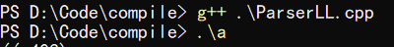

输出：
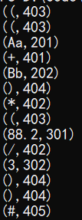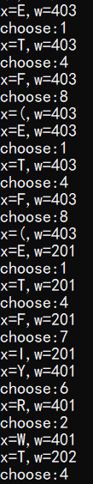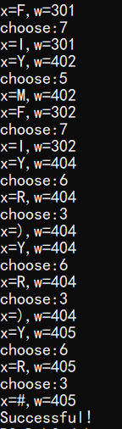
（其中，x是栈顶符号，w是当前token符号，choose代表选择的产生式）

2.4 LR(0)分析法
流程图大致如下：
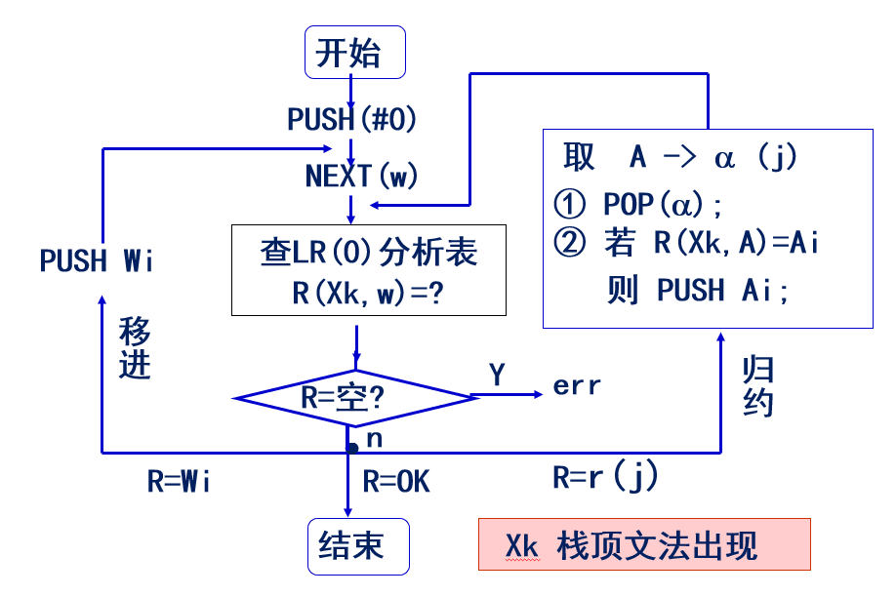
LR（0）分析表如下：
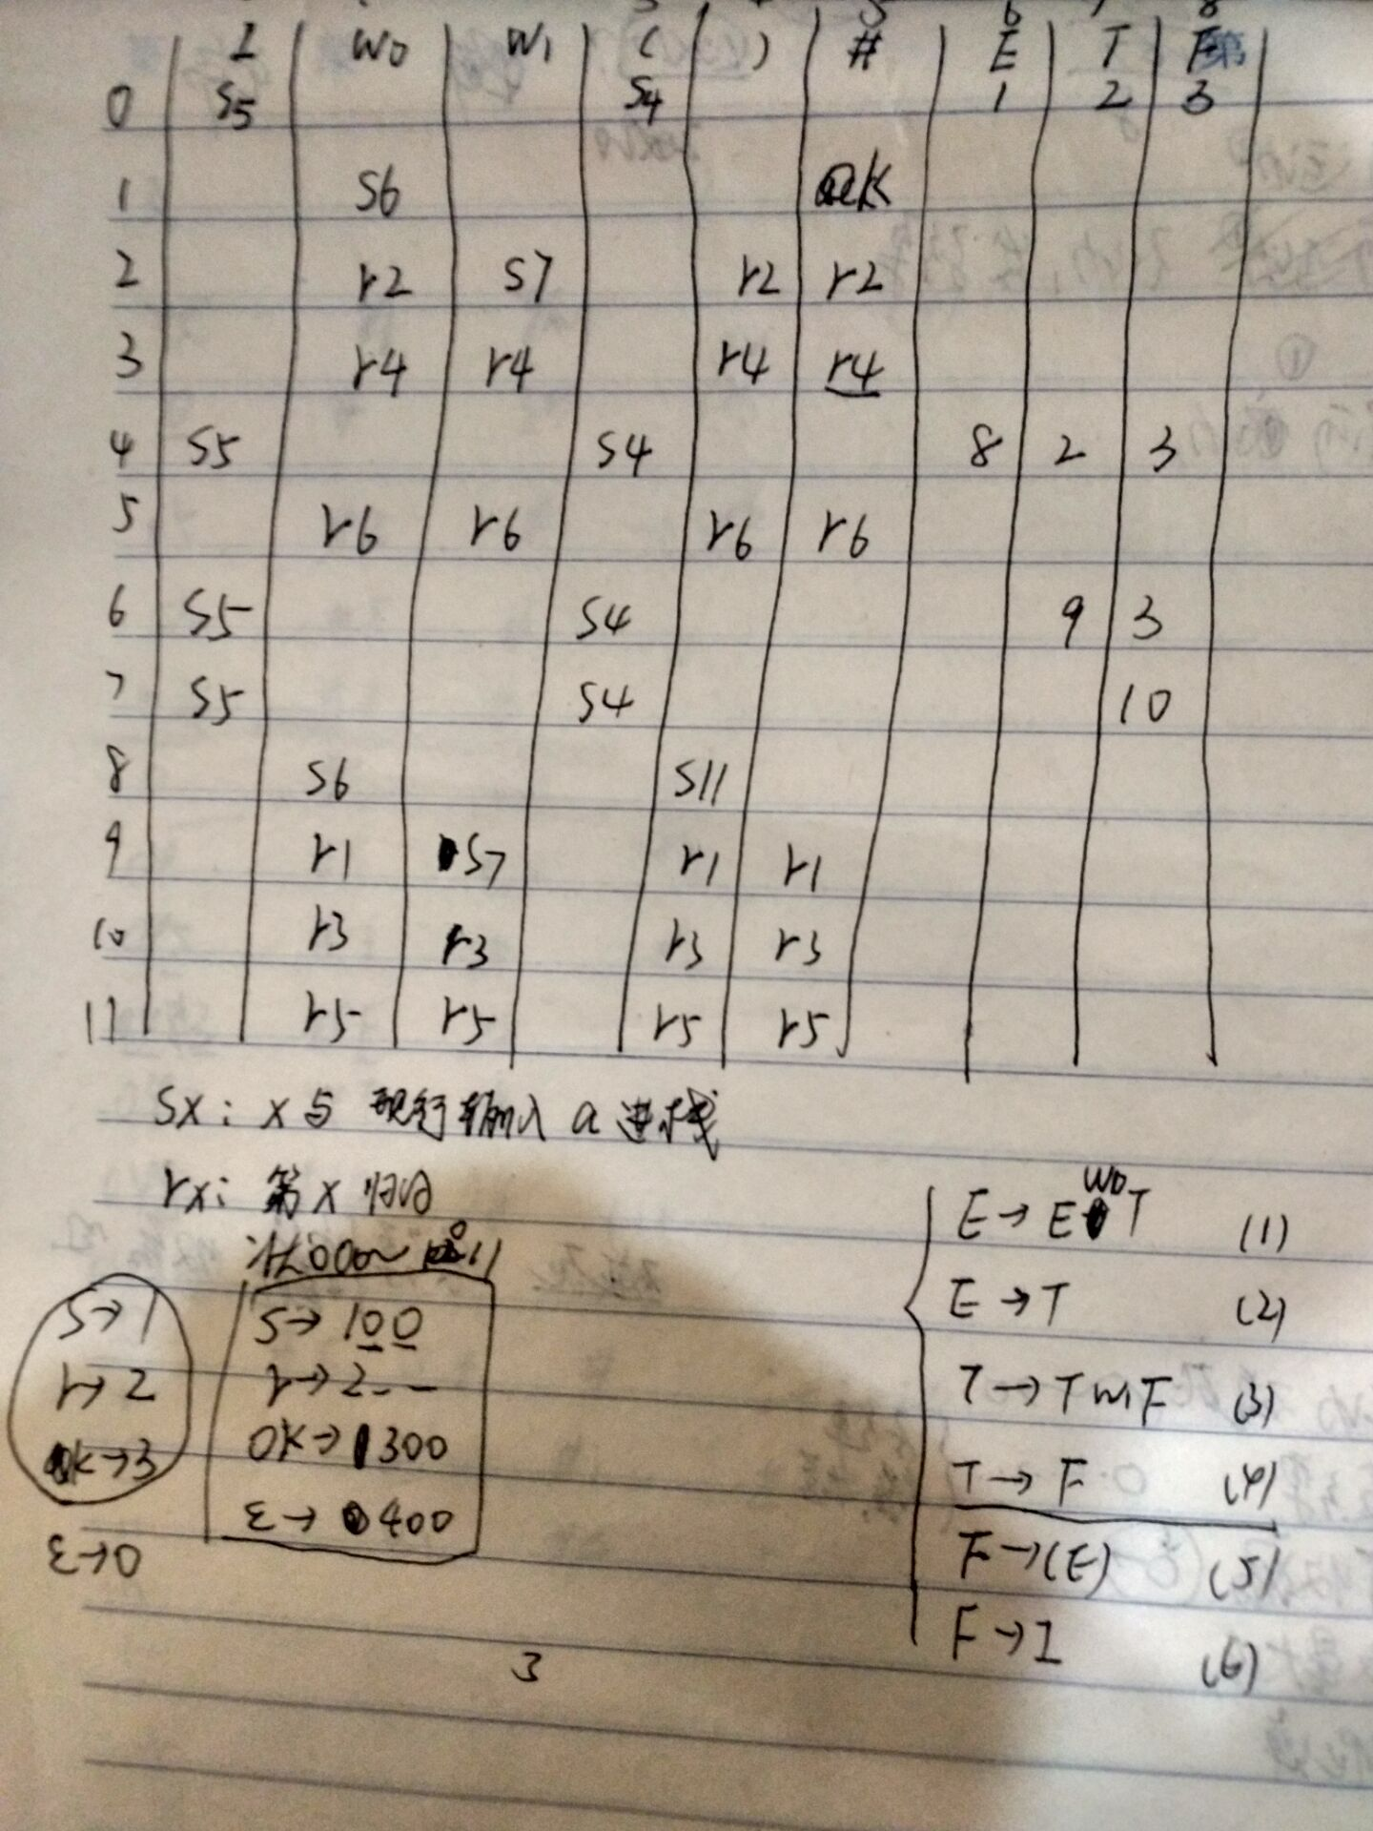
其中， Sx指把下一状态x和现行输入符号w移进栈；Rx指按文法的第x个产 生式进行归约；OK表示分析成功；空白格为出错。在程序中，状态采用0~11表示，Sx使用101~111表示，Rx使用201~207表示，OK使用300表示，空格使用400表示。这样更容易直接用数组和数字来判断状态。具体程序流程图如下：
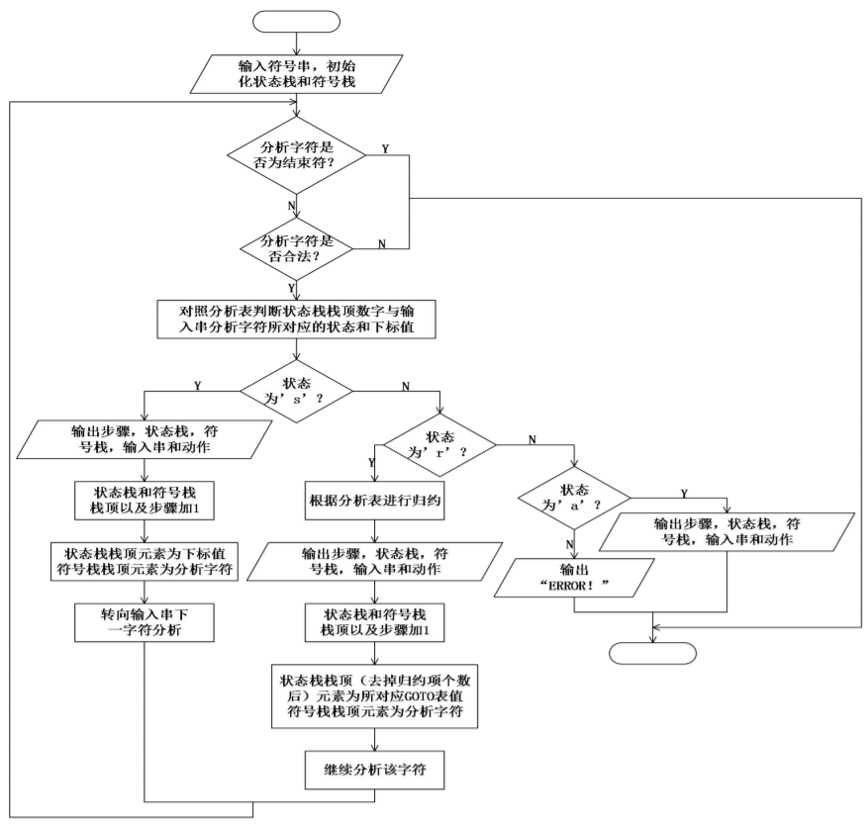

源程序代码：（加入注释）
/************************************************************
FileName:ParserLR0.cpp
Function: LR (0) analysis is used for grammar analysis.
*************************************************************/

#include <iostream>
#include <stack>
#include "WordFilter1.h"
using namespace std;
//LR(0)分析表
int analysisTable[12][9] =
{
// I W0 W1 ( ) # E T F
105,400,400,104,400,400, 1, 2, 3,
400,106,400,400,400,300,400,400,400,
400,202,107,400,202,202,400,400,400,
400,204,204,400,204,204,400,400,400,
105,400,400,104,400,400, 8, 2, 3,
400,206,206,400,206,206,400,400,400,
105,400,400,104,400,400,400, 9, 3,
105,400,400,104,400,400,400,400, 10,
400,106,400,400,111,400,400,400,400,
400,201,107,400,201,201,400,400,400,
400,203,203,400,203,203,400,400,400,
400,205,205,400,205,205,400,400,400
};
int getPlusCode(int x, int w);
int getReduceCode(int x, char c);
char getSymbol(int w);
void reduceSymbolStack(int order);
int tokens[1024], tokenNumNow = 0, flag = 2;
stack<int> statusStack;
stack<char> symbolStack;

int main()
{
wordFilter(tokens);
statusStack.push(0);
symbolStack.push('#');
int x, w, code1, code2;
char c;
while(flag!=0 && flag!=1)
{
x = statusStack.top();
w = tokens[tokenNumNow];
c = symbolStack.top();
//code1得到LR(0)分析表中Sx或Rx的值
code1 = getPlusCode(x,w);
cout<<"code1="<<code1<<endl;
if(code1 == 400)
flag = 0;
else if(code1 == 300)
flag = 1;
//移进
else if(code1>100 && code1<200)
{
statusStack.push(code1 - 100);
symbolStack.push(getSymbol(w));
tokenNumNow++;
}
//归约
else if(code1>200 && code1<300)
{
reduceSymbolStack(code1 - 200);
c = symbolStack.top();
x = statusStack.top();
//code2是状态转换序号
code2 = getReduceCode(x,c);
cout<<"code2="<<code2<<endl;
if(code2 > 10 || code2 < 0)
flag = 0;
else
{
statusStack.push(code2);
}
}
else
{
flag = 0;
}
}
if(flag == 1)
cout<<"Successful"<<endl;
else
cout<<"Error"<<endl;
return 0;
}

//获取移进或归约序号
int getPlusCode(int x, int w)
{
int row, column;
row = x;
switch(w)
{
case 401:{column = 1;break;}
case 402:{column = 2;break;}
case 403:{column = 3;break;}
case 404:{column = 4;break;}
case 405:{column = 5;break;}
default:{column = 0;break;}
}
return analysisTable[row][column];
}

//获取状态转换序号
int getReduceCode(int x, char c)
{
int row, column;
row = x;
switch(c)
{
case 'E':{column = 6;break;}
case 'T':{column = 7;break;}
case 'F':{column = 8;break;}
default:{cout<<"ERROR::at getReduceCode();"<<endl;flag = 0;break;}
}
return analysisTable[row][column];
}

//获取token对应的分析表符号
char getSymbol(int w)
{
char res;
switch(w)
{
case 401:{res = 'w';break;}
case 402:{res = 'm';break;}
case 403:{res = '(';break;}
case 404:{res = ')';break;}
case 405:{res = '#';break;}
default:{res = 'i';break;}
}
return res;
}

//归约动作
void reduceSymbolStack(int order)
{
switch(order)
{
case 1:{symbolStack.pop();symbolStack.pop();statusStack.pop();statusStack.pop();statusStack.pop();break;}
case 2:{symbolStack.pop();symbolStack.push('E');statusStack.pop();break;}
case 3:{symbolStack.pop();symbolStack.pop();statusStack.pop();statusStack.pop();statusStack.pop();break;}
case 4:{symbolStack.pop();symbolStack.push('T');statusStack.pop();break;}
case 5:{symbolStack.pop();symbolStack.pop();symbolStack.pop();symbolStack.push('F');statusStack.pop();statusStack.pop();statusStack.pop();break;}
case 6:{symbolStack.pop();symbolStack.push('F');statusStack.pop();break;}
default:{cout<<"ERROR::at reduceSymbolStack()"<<endl;flag = 0;break;}
}
}

程序运行结果：（截屏）
输入：
输出：
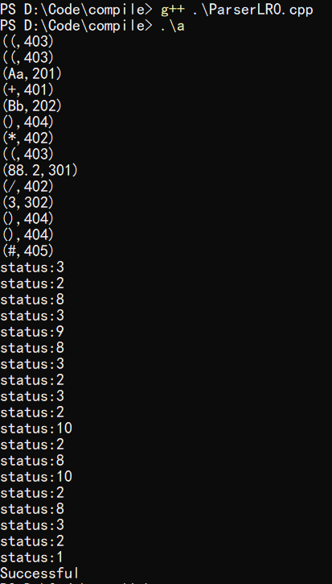

2.4 算符优先分析法
算符优先关系表如下：
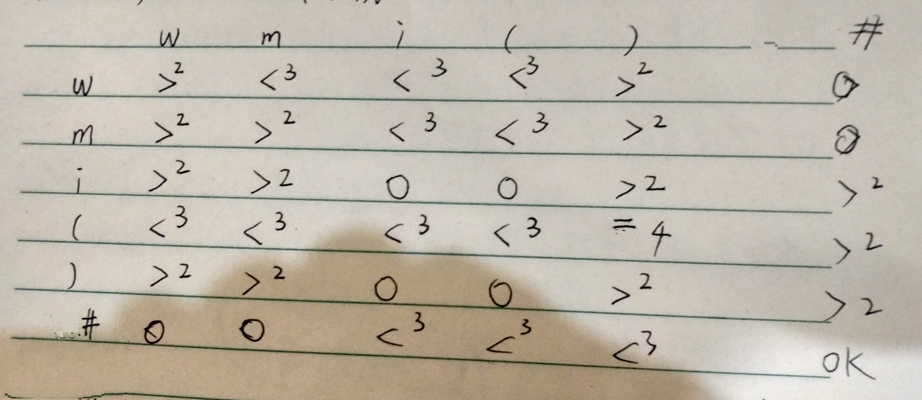
在程序中，空格为0，即失败，OK为1，>为2，<为3，=为4。

源程序代码：（加入注释）

/************************************************************
FileName:ParserSF.cpp
Function: Operator-first method is used for grammar analysis.
*************************************************************/

#include <iostream>
#include <stack>
#include "WordFilter1.h"
using namespace std;
//算符优先关系表
int relationTable[6][6] =
{
// +,*,i,(,),#
2,3,3,3,2,0,
2,2,3,3,2,0,
2,2,0,0,2,2,
3,3,3,3,4,2,
2,2,0,0,2,2,
0,0,3,3,3,1
};//Error:0,OK:1,>:2,<:3,=:4
int getRelation(char x, int w);
char getSymbol(int w);
int tokens[1024], tokenNumNow = 0;
stack<char> symbolStack;
int flag = 2;

int main()
{
char x;
int w;
wordFilter(tokens);
symbolStack.push('#');
x = symbolStack.top();
w = tokens[tokenNumNow];
while(flag!=0 && flag!=1)
{
x = symbolStack.top();
w = tokens[tokenNumNow];
if(x!='V')
{
int relation = getRelation(x,w);
cout<<"x="<<x<<",w="<<w<<",r="<<relation<<",";
if(relation==3 || relation==4) //移进
{
cout<<"Move In."<<endl;
symbolStack.push(getSymbol(w));
tokenNumNow++;
}
else if(relation==0 || relation==1)
{
flag = relation;
}
else if(relation == 2) //归约
{
cout<<"Reduction."<<endl;
switch(x)
{
case 'i':{symbolStack.pop();symbolStack.push('V');break;}
case ')':{symbolStack.pop();symbolStack.pop();symbolStack.pop();symbolStack.push('V');break;}
default:{flag = 0;cout<<"War::at Guiyue;"<<endl;break;}
}
}
}

else
{
cout<<"x="<<x<<",w="<<w<<",r=";
symbolStack.pop();
x = symbolStack.top();
if(x == 'V') {flag = 0;cout<<"x2=V"<<endl;break;}
int relation = getRelation(x,w);
cout<<relation<<",";
if(relation==3 || relation==4) //移进
{
cout<<"Move In."<<endl;
symbolStack.push('V');
symbolStack.push(getSymbol(w));
tokenNumNow++;
}
else if(relation==0 || relation==1)
{
flag = relation;
}
else if(relation == 2) //归约
{
cout<<"Reduction."<<endl;
if(x=='w' ||x=='m')
{
symbolStack.pop();
}
else
{
cout<<"?V,?!=+-*/"<<endl;
flag = 0;
}
}
}
}
x = symbolStack.top();
if(flag == 1 && w == 405 && x == '#')
cout<<"Successful!"<<endl;
else
cout<<"Error!"<<endl;
return 0;
}

//获取栈顶符号和当前输入符号的关系
int getRelation(char x, int w)
{
int row, column;
switch(x)
{
case 'w':{row = 0;break;}
case 'm':{row = 1;break;}
case 'i':{row = 2;break;}
case '(':{row = 3;break;}
case ')':{row = 4;break;}
case '#':{row = 5;break;}
default:{cout<<"Err::at getRelation();"<<endl;break;}
}
switch(w)
{
case 401:{column = 0;break;}
case 402:{column = 1;break;}
case 403:{column = 3;break;}
case 404:{column = 4;break;}
case 405:{column = 5;break;}
default:{column = 2;break;}
}
return relationTable[row][column];
}

//获取token对应的符号
char getSymbol(int w)
{
char symbol;
switch(w)
{
case 401:{symbol = 'w';break;}
case 402:{symbol = 'm';break;}
case 403:{symbol = '(';break;}
case 404:{symbol = ')';break;}
case 405:{symbol = '#';break;}
default:{symbol = 'i';break;}
}
return symbol;
}

程序运行结果：（截屏）
输入：

输出：
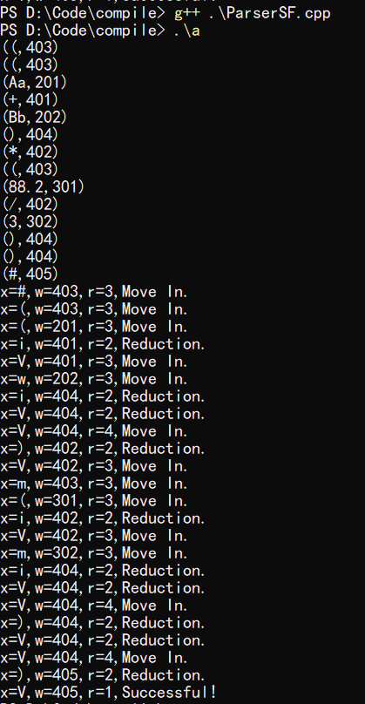

第三次实验报告

实验目标：

设计实现四元式语法制导翻译文法。

3.1 递归子程序下降法

实验内容：
（包括：概要设计、数据结构、流程图、关键函数等有选择填写）
流程图如下所示：
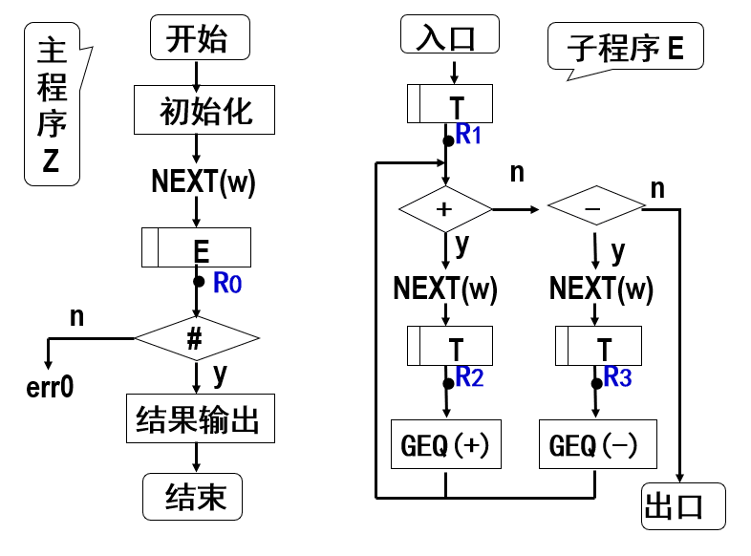
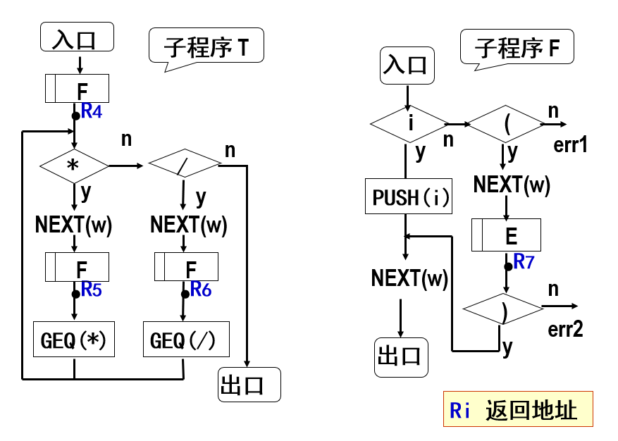

在原来的实验二的递归子程序下降法代码基础上，在合适的地方加上四元式翻译动作。
源程序代码：（加入注释）

/************************************************************
FileName:GenerationRD.cpp
Function: Recursive subroutine descent method is used for
Quaternion grammar-guided translation.
*************************************************************/

#include <iostream>
#include <string>
#include <stack>
#include "WordFilter1.h"
using namespace std;
int tokens[1024], tokenNumNow = 0;
void functionE();
void functionT();
void functionF();
bool flag = 1;
stack<int> symbol, wm;
int temp = 1001;

int main()
{
wordFilter(tokens);
functionE();
if(flag == 1 && tokens[tokenNumNow] == 405)
cout<<"Successful!"<<endl;
else
cout<<"Error!"<<endl;
return 0;
}

void functionE()
{
functionT();
while(tokens[tokenNumNow]==401)
{
//cout<<tokens[tokenNumNow]<<endl;
wm.push(tokens[tokenNumNow]);
tokenNumNow++;
functionT();
//从E进入的T子程序跳出时，输出四元式
cout<<"("<<wm.top()<<" "<<symbol.top();
wm.pop();
symbol.pop();
cout<<" "<<symbol.top()<<" "<<temp<<")"<<endl;
symbol.pop();
symbol.push(temp);
temp = temp+1;
}
}

void functionT()
{
functionF();
while(tokens[tokenNumNow] == 402)
{
//cout<<tokens[tokenNumNow]<<endl;
wm.push(tokens[tokenNumNow]);
tokenNumNow++;
functionF();
//从T进入的F子程序跳出时，输出四元式
cout<<"("<<wm.top()<<" "<<symbol.top();
wm.pop();
symbol.pop();
cout<<" "<<symbol.top()<<" "<<temp<<")"<<endl;
symbol.pop();
symbol.push(temp);
temp = temp+1;
}
}

void functionF()
{
int flagF1=0,flagF2=0;
if(tokens[tokenNumNow]>=200 && tokens[tokenNumNow]<=399)
{
flagF1=1;
//cout<<tokens[tokenNumNow]<<endl;
symbol.push(tokens[tokenNumNow]);
tokenNumNow++;
}
else if(tokens[tokenNumNow]==403)
{
//cout<<tokens[tokenNumNow]<<endl;
tokenNumNow++;
functionE();
if(tokens[tokenNumNow]==404)
{
flagF2 = 1;
//cout<<tokens[tokenNumNow]<<endl;
tokenNumNow++;
}
}
else
{
flag = 0;
}
if(!flagF1 && !flagF2)
{
flag = 0;
}
}

程序运行结果：（截屏）
输入：
输出：
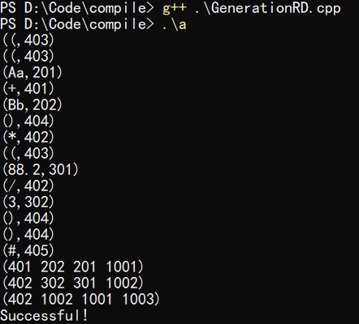

输出说明：每个四元式的前三项是使用token代替，与上方对照可知；四元式最后一项用四位数字XXXX代替t1、t2、t3...tn；因token中未对*/做区分，因此后两项均为“402”。

3.2 LL(1)方法
实验内容：
LL（1）分析表如下：
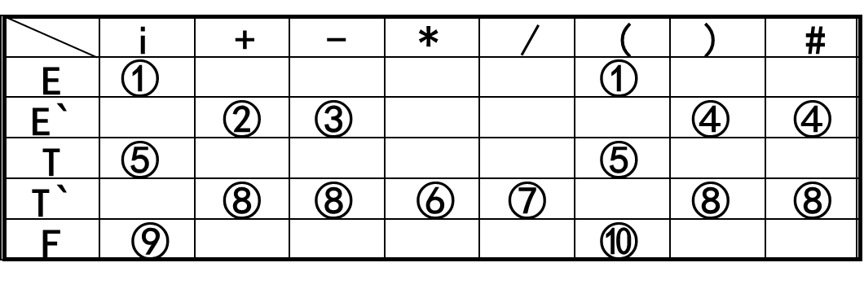
跟递归子程序下降法相似，需要在合适的地方插入翻译语义动作函数。
源程序代码：（加入注释）

/************************************************************
FileName:GenerationLL.cpp
Function: LL (1) method is used for Quaternary grammar-guided translation.
*************************************************************/

#include <iostream>
#include <stack>
#include "WordFilter1.h"
using namespace std;
void reverseStack(int order);
int lookupTable(char x, int w);
bool endIsRight(char x, int w);
stack<char> s;
stack<int> symbol, wm;
int tokens[1024], tokenNumNow = 0, temp = 1001;
bool flag = 1;
//产生式逆序压栈
char E[2] = {'T','R'};
char R[3] = {'W','T','R'};
char T[2] = {'F','Y'};
char Y[3] = {'M','F','Y'};
char F[3] = {'(','E',')'};
//终结符表
char endSymbol[6] = {'I','W','M','(',')','#'};
//LL（1）分析表
int analysisTable[5][6] =
{
1, 0, 0, 1, 0, 0,
0, 2, 0, 0, 3, 3,
4, 0, 0, 4, 0, 0,
0, 6, 5, 0, 6, 6,
7, 0, 0, 8, 0, 0
};

int main()
{
char x;
int w;
wordFilter(tokens);
s.push('#');
s.push('E');

while(x != '#')
{
x = s.top();
s.pop();
w = tokens[tokenNumNow];
//cout<<"x="<<x<<","<<"w="<<w<<endl;
bool xIsEndSymbol = 0;
for(int i = 0; i < sizeof(endSymbol);i++)
{
if (x == endSymbol[i])
{
xIsEndSymbol = 1;
if(endIsRight(x,w))
{
if(w>200 && w<400)
{
symbol.push(w);
//cout<<"symbol.top:"<<symbol.top()<<endl;
}
else if(w==401||w==402)
wm.push(w);
tokenNumNow++;
break;
}
else {flag = 0;break;}
}
}
if(xIsEndSymbol == 0)
{
int orderhere = lookupTable(x,w);
if(orderhere == 0){flag = 0; break;}
else{reverseStack(orderhere);}
}
}
if(flag == 1 && x == '#' && w == 405)
cout<<"Successful!"<<endl;
else
cout<<"Error!"<<endl;
return 0;
}

int lookupTable(char x, int w)
{
int row, column;
switch(x)
{
case 'E':{row = 0;break;}
case 'R':{row = 1;break;}
case 'T':{row = 2;break;}
case 'Y':{row = 3;break;}
case 'F':{row = 4;break;}
default:{cout<<"ERROR::at LookupTable();"<<endl;break;}
}
switch(w)
{
case 401:{column = 1;break;}
case 402:{column = 2;break;}
case 403:{column = 3;break;}
case 404:{column = 4;break;}
case 405:{column = 5;break;}
default:{column = 0;break;}
}
//cout<<"choose:"<<analysisTable[row][column]<<endl;
return analysisTable[row][column];
}

void reverseStack(int order)
{
switch(order)
{
case 1:{for(int i = sizeof(E)-1; i>=0;s.push(E[i]), i--);break;}
case 2:{for(int i = sizeof(R)-1; i>=0;s.push(R[i]), i--);break;}
case 4:{for(int i = sizeof(T)-1; i>=0;s.push(T[i]), i--);break;}
case 5:{for(int i = sizeof(Y)-1; i>=0;s.push(Y[i]), i--);break;}
case 8:{for(int i = sizeof(F)-1; i>=0;s.push(F[i]), i--);break;}
case 3:{break;}
case 6:{break;}
case 7:{s.push('I');break;}
default:{cout<<"ERROR!"<<endl;break;}
}
}

bool endIsRight(char x, int w)
{
switch(x)
{
case 'I':{if(w >= 200 && w < 399) return 1;else return 0;break;}
case 'W':{if(w == 401) return 1;else return 0;break;}
case 'M':{if(w == 402) return 1;else return 0;break;}
case '(':{if(w == 403) return 1;else return 0;break;}
case ')':
{
if(w == 404)
{
//插入语义动作
cout<<"("<<wm.top()<<" "<<symbol.top();
wm.pop();
symbol.pop();
cout<<" "<<symbol.top()<<" "<<temp<<")"<<endl;
temp++;
return 1;
}
else
return 0;
break;
}
case '#':{if(w == 405) return 1;else return 0;break;}
default:{cout<<"ERROR::at endIsRight();"<<endl;return 0;break;}
}
}

程序运行结果：（截屏）
输入：

输出：
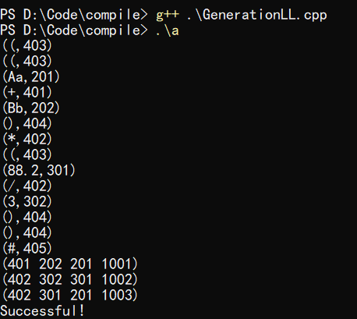

3.3 LR(0)方法

实验内容：
翻译文法如下所示：
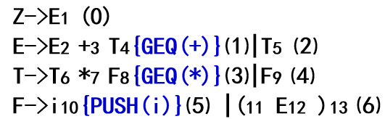

源程序代码：（加入注释）

/************************************************************
FileName:GenerationLR0.cpp
Function: LR(0) method is used for Quaternary grammar-guided translation.
*************************************************************/

#include <iostream>
#include <stack>
#include "WordFilter1.h"
using namespace std;
int analysisTable[12][9] =
{
// I W0 W1 ( ) # E T F
105,400,400,104,400,400, 1, 2, 3,
400,106,400,400,400,300,400,400,400,
400,202,107,400,202,202,400,400,400,
400,204,204,400,204,204,400,400,400,
105,400,400,104,400,400, 8, 2, 3,
400,206,206,400,206,206,400,400,400,
105,400,400,104,400,400,400, 9, 3,
105,400,400,104,400,400,400,400, 10,
400,106,400,400,111,400,400,400,400,
400,201,107,400,201,201,400,400,400,
400,203,203,400,203,203,400,400,400,
400,205,205,400,205,205,400,400,400
};
int getPlusCode(int x, int w);
int getReduceCode(int x, char c);
char getSymbol(int w);
void reduceSymbolStack(int order);
int tokens[1024], tokenNumNow = 0, flag = 2, temp = 1001;
stack<int> statusStack, symbol, wm;
stack<char> symbolStack;

int main()
{
wordFilter(tokens);
statusStack.push(0);
symbolStack.push('#');
int x, w, code1, code2;
char c;
while(flag!=0 && flag!=1)
{
x = statusStack.top();
w = tokens[tokenNumNow];
c = symbolStack.top();
code1 = getPlusCode(x,w);
//cout<<"code1="<<code1<<endl;
if(code1 == 400)
flag = 0;
else if(code1 == 300)
flag = 1;
else if(code1>100 && code1<200)
{
//移进
statusStack.push(code1 - 100);
symbolStack.push(getSymbol(w));
if(w>200 && w<400)
symbol.push(w);
else if(w==401||w==402)
wm.push(w);
tokenNumNow++;
}
else if(code1>200 && code1<300)
{
//归约
reduceSymbolStack(code1 - 200);
//四元式输出
if(code1-200==1||code1-200==3)
{
cout<<"("<<wm.top()<<" "<<symbol.top();
wm.pop();
symbol.pop();
cout<<" "<<symbol.top()<<" "<<temp<<")"<<endl;
temp++;
}

c = symbolStack.top();
x = statusStack.top();
code2 = getReduceCode(x,c);
cout<<"status:"<<code2<<endl;
if(code2 > 10 || code2 < 0)
flag = 0;
else
{
statusStack.push(code2);
}
}
else
{
flag = 0;
}
}
if(flag == 1)
cout<<"Successful"<<endl;
else
cout<<"Error"<<endl;
return 0;
}

int getPlusCode(int x, int w)
{
int row, column;
row = x;
switch(w)
{
case 401:{column = 1;break;}
case 402:{column = 2;break;}
case 403:{column = 3;break;}
case 404:{column = 4;break;}
case 405:{column = 5;break;}
default:{column = 0;break;}
}
return analysisTable[row][column];
}

int getReduceCode(int x, char c)
{
int row, column;
row = x;
switch(c)
{
case 'E':{column = 6;break;}
case 'T':{column = 7;break;}
case 'F':{column = 8;break;}
default:{cout<<"ERROR::at getReduceCode();"<<endl;flag = 0;break;}
}
return analysisTable[row][column];
}

char getSymbol(int w)
{
char res;
switch(w)
{
case 401:{res = 'w';break;}
case 402:{res = 'm';break;}
case 403:{res = '(';break;}
case 404:{res = ')';break;}
case 405:{res = '#';break;}
default:{res = 'i';break;}
}
return res;
}

void reduceSymbolStack(int order)
{
switch(order)
{
case 1:{symbolStack.pop();symbolStack.pop();statusStack.pop();statusStack.pop();statusStack.pop();break;}
case 2:{symbolStack.pop();symbolStack.push('E');statusStack.pop();break;}
case 3:{symbolStack.pop();symbolStack.pop();statusStack.pop();statusStack.pop();statusStack.pop();break;}
case 4:{symbolStack.pop();symbolStack.push('T');statusStack.pop();break;}
case 5:{symbolStack.pop();symbolStack.pop();symbolStack.pop();symbolStack.push('F');statusStack.pop();statusStack.pop();statusStack.pop();break;}
case 6:{symbolStack.pop();symbolStack.push('F');statusStack.pop();break;}
default:{cout<<"ERROR::at reduceSymbolStack()"<<endl;flag = 0;break;}
}
}

程序运行结果：（截屏）
输入：
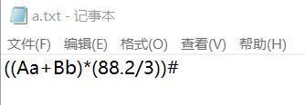

输出：
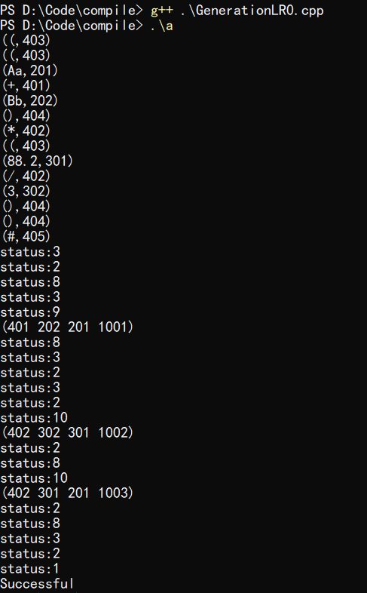

3.4 算符优先方法
实验内容：
翻译文法：
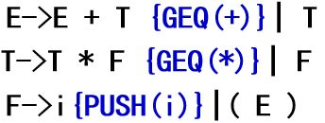

算符优先分析表：
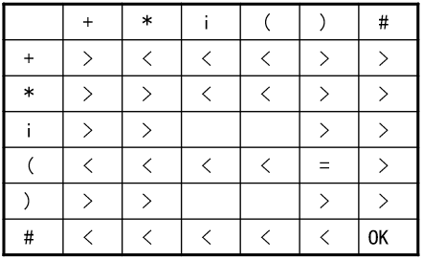

源程序代码：（加入注释）

/************************************************************
FileName:GenerationSF.cpp
Function: Quaternion grammar-guided translation using operator-first method.
*************************************************************/

#include <iostream>
#include <stack>
#include "WordFilter1.h"
using namespace std;
int relationTable[6][6] =
{
// +,*,i,(,),#
2,3,3,3,2,0,
2,2,3,3,2,0,
2,2,0,0,2,2,
3,3,3,3,4,2,
2,2,0,0,2,2,
0,0,3,3,3,1
};//Error:0,OK:1,>:2,<:3,=:4
int getRelation(char x, int w);
char getSymbol(int w);
int tokens[1024], tokenNumNow = 0;
stack<char> symbolStack;
stack<int> symbol, wm;
int flag = 2;
int temp = 1001;

int main()
{
char x;
int w;
wordFilter(tokens);
symbolStack.push('#');
x = symbolStack.top();
w = tokens[tokenNumNow];
while(flag!=0 && flag!=1)
{
x = symbolStack.top();
w = tokens[tokenNumNow];
if(x!='V')
{
int relation = getRelation(x,w);
cout<<"x="<<x<<",w="<<w<<",r="<<relation<<endl;
if(relation==3 || relation==4) //移进
{
symbolStack.push(getSymbol(w));
if(w>200 && w<400)
symbol.push(w);
else if(w==401||w==402)
wm.push(w);
tokenNumNow++;
}
else if(relation==0 || relation==1)
{
flag = relation;
}
else if(relation == 2) //归约
{
switch(x)
{
case 'i':{symbolStack.pop();symbolStack.push('V');break;}
case ')':{symbolStack.pop();symbolStack.pop();symbolStack.pop();symbolStack.push('V');break;}
default:{flag = 0;cout<<"War::at Guiyue;"<<endl;break;}
}
}
}

else
{
symbolStack.pop();
x = symbolStack.top();
if(x == 'V') {flag = 0;cout<<"x2=V"<<endl;break;}
int relation = getRelation(x,w);
if(relation==3 || relation==4) //移进
{
symbolStack.push('V');
symbolStack.push(getSymbol(w));
if(w>200 && w<400)
symbol.push(w);
else if(w==401||w==402)
wm.push(w);
tokenNumNow++;
}
else if(relation==0 || relation==1)
{
flag = relation;
}
else if(relation == 2) //归约
{
if(x=='w' ||x=='m')
{
symbolStack.pop();
cout<<"("<<wm.top()<<" "<<symbol.top();
wm.pop();
symbol.pop();
cout<<" "<<symbol.top()<<" "<<temp<<")"<<endl;
temp++;
}
else
{
cout<<"?V,?!=+-*/"<<endl;
flag = 0;
}
}
}
}
x = symbolStack.top();
if(flag == 1 && w == 405 && x == '#')
cout<<"Successful!"<<endl;
else
cout<<"Error!"<<endl;
return 0;
}

int getRelation(char x, int w)
{
int row, column;
switch(x)
{
case 'w':{row = 0;break;}
case 'm':{row = 1;break;}
case 'i':{row = 2;break;}
case '(':{row = 3;break;}
case ')':{row = 4;break;}
case '#':{row = 5;break;}
default:{cout<<"Err::at getRelation();"<<endl;break;}
}
switch(w)
{
case 401:{column = 0;break;}
case 402:{column = 1;break;}
case 403:{column = 3;break;}
case 404:{column = 4;break;}
case 405:{column = 5;break;}
default:{column = 2;break;}
}
return relationTable[row][column];
}

void intoStack(int relation)
{
switch(relation)
{
case 3:{}
}
}

char getSymbol(int w)
{
char symbol;
switch(w)
{
case 401:{symbol = 'w';break;}
case 402:{symbol = 'm';break;}
case 403:{symbol = '(';break;}
case 404:{symbol = ')';break;}
case 405:{symbol = '#';break;}
default:{symbol = 'i';break;}
}
return symbol;
}

程序运行结果：（截屏）
输入：
输出：
