I used a tool from <http://www.caesum.com/> called “Stegsolve” (http://www.caesum.com/handbook/Stegsolve.jar) that has the ability to easily try different combinations of bits to use to extract data from a PNG file, playing around with this I found that using bits 0 of the RGB values produced what appeared to be an ELF file.

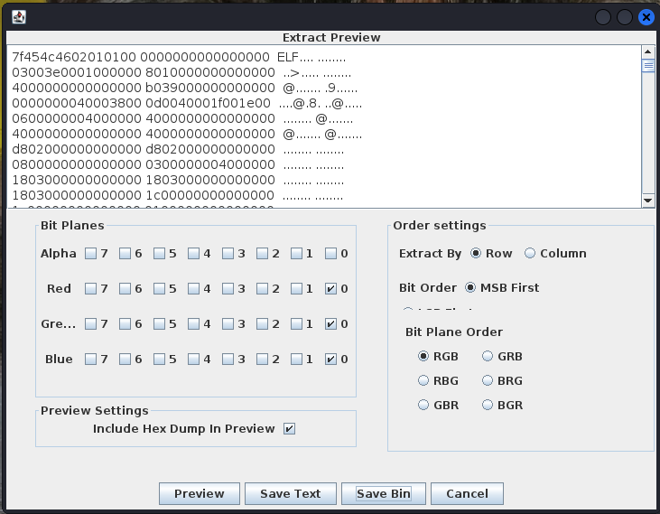

I then saved the ELF file to a binary and it produced the flag: FLAG{sTEgO_C4n_bE_3@5y}

