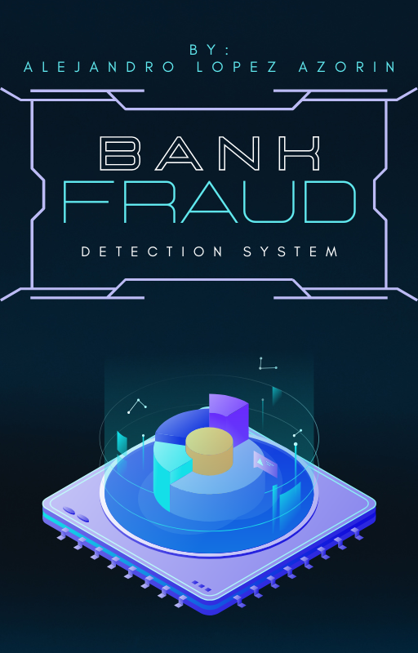

INDEX
1. Introduction 2
2. Project Overview 2
3. Features 2
4. Project Structure 3
5. Installation 4
6. Running the Project 4
7. Machine Learning Model 4
8. API Usage 5
9. Logging 5
10. Testing 6

1. Introduction
This project simulates a bank fraud detection system using a combination of OOP and machine learning. The system models users, transactions, banks, and analysts, where an AI model predicts the likelihood of a transaction being fraudulent.
The main goal is to demonstrate ML integration into a real-world scenario and to create a modular, testable Python project.

2. Project Overview
The project consists of:
- Users performing deposits, withdrawals, and transfers.
- Banks coordinating transactions and calling analysts for approval.
- Analysts using a trained ML model to assess transaction risk.
- Transactions that log all activities for traceability.
Additionally, the project includes a FastAPI interface to expose the ML model for external clients.

3. Features
- User Management: Create users, check balances, perform transactions.
- Fraud Detection: ML model predicts fraud probability (p_fraud) and fraud status (is_fraud).
- Manual Review: Analysts can approve or block suspicious transactions.
- Logging: Full traceability of transactions, decisions, and ML predictions.
- API: FastAPI endpoint to submit transaction data and receive predictions.
- Unit & Integration Testing: Pytest tests covering classes and API endpoints.

4. Project Structure
Bank Fraud Detection System/
- README.pdf
- requirements.txt # Needed libraries and packages
- main.py # Demo program
- api.py # API’s configuration
- data/ # Needed data for ML model training
  - raw_data.csv
  - data_cleaner.py # Cleans raw_data.csv y returns cleaned_data.csv
  - cleaned_data.csv
  - add_concept_to_data.csv # Adds concepts and Is_fraud columns to cleaned_data.csv and returns final_data.csv
  - final_data.csv #Data ready for ML model training
- ML/
  - train_model.py # Trains ML model and saves the model as model.pkl
  - model.pkl # Trained model
  - predict.py # Uses model.pkl in order to make predictions
  - utils.py # Auxiliar functions of predict.py
- bank_system/
  - user.py # Class User
  - bank.py # Class Bank
  - analyst.py # Class Analyst
  - transaction.py # Class Transaction
- tests/ #unit testing for bank_system and API’s
  - test_user.py
  - test_bank.py
  - test_analyst.py
  - test_transaction.py
  - test_api.py

5. Installation
- Clone the repository:
git clone <your-repo-url>
cd project_root
- Create a virtual environment:
python -m venv venv
source venv/bin/activate # Linux/Mac
venv\Scripts\activate # Windows
- Install dependencies:
pip install -r requirements.txt

6. Running the Project
- Demo (CLI): Run main.py to simulate transactions locally.
- Train ML Model: Execute train_model.py to train and save the model.
- FastAPI: Run api.py to start the API server: uvicorn api:app –reload
- Access the API documentation at http://127.0.0.1:8000/docs.

7. Machine Learning Model
- Model: Logistic Regression with TfidfVectorizer for the Concept column and StandardScaler for numeric features.
- Features: Amount, time_sin, time_cos, Is_Night, Concept.
- Target: Is_Fraud (1 = fraud, 0 = safe).
- Dataset: final_data.csv with probabilistic assignment of fraud based on amount, time, and concept.
- Metrics Achieved:
Accuracy: 0.77
ROC-AUC: 0.82
Precision / Recall / F1-scores vary for fraud and safe classes.

8. API Usage
Endpoint: /predict (POST)
Request body(.json):
{
"amount": 51000,
"concept": "urgent crypto investment",
"local_time": "22:30:00"
}
Response body(.json):
{
"is_fraud": 1,
"p_fraud": 0.92
}
- The API allows external clients to receive ML predictions without needing the full project.
- local_time is sent as a string in "HH:MM:SS" format.

9. Logging
- Purpose: Track all transactions, analyst decisions, and ML predictions.
- Logging Levels:
  - INFO: Transaction creation, approvals, and rejections.
  - WARNING: Manual review required.
- Example: In transaction.py, logger.info records each new transaction.
- Logs are saved in logs/bank_system.log and include timestamps.

10. Testing
- Unit Tests: For User, Bank, Analyst, Transaction.
- Integration Tests: Full bank transaction flows.
- API Tests: Using fastapi.testclient to validate /predict endpoint.
- Tests are runned with “python -m pytest” on a cmd on the main directory of the project

