ASpectrum — connections
How the QMTECH Cyclone IV core board, the QM_Atrix adapter, the ESP32 system controller and the microSD card are wired (state of 14 October 2026)

1. Overview
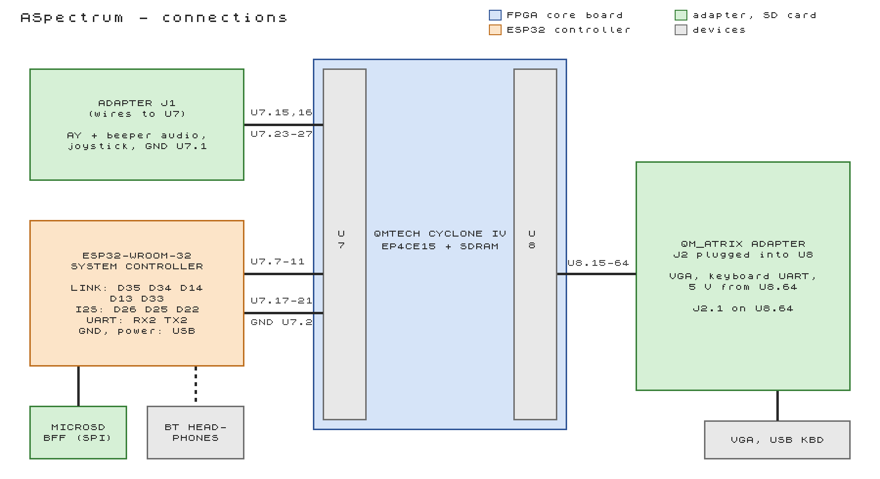
Figure 1. What plugs into which header of the core board.
Part | Connected to | Carries
QM_Atrix adapter, J2 | U8, plugged in directly (J2.1 on U8.64) | VGA, USB keyboard module, 5 V for the adapter
QM_Atrix adapter, J1 | U7, by wires | AY and beeper audio to the amplifier, Kempston joystick, ground
ESP32-WROOM-32 DevKit | U7.7-11, U7.17-21 + ground, by wires | SPI link for the tape loader, sound as I2S, UART for the F3 Bluetooth menu
Adafruit MicroSD BFF | the ESP32, by wires | SD card (SPI) for the tape loader, 3.3 V
Bluetooth headphones / speaker | the ESP32, by radio (A2DP) | the Spectrum's sound

All FPGA pins are 3.3 V (LVTTL) and not 5 V tolerant. Every signal on the headers is 3.3 V: the adapter makes its own 3.3 V for its pull-ups, the keyboard module's UART is 3.3 V, and the ESP32 is a 3.3 V part.

2. The core board headers
U7 is the left header and U8 the right one (32 x 2 pins each). On both: pins 1/2 ground, 3/4 3.3 V, 61/62 ground, 63/64 VIN (5 V). The numbering was read from the QMTECH schematic: check 1/2, 3/4, 61/62 and 63/64 with a meter before connecting anything new. Full header map: docs/BOARD_PINOUT.md.
On-board | Pin / use
50 MHz oscillator | T2
KEY0 (button farther from the long edge) | W13: reset of everything
KEY1 | Y13: not used
LED | E4: on = turbo; fast blink = no ROMs in the flash (program the .jic)
SDRAM, configuration flash | on the board, nothing to wire

3. Adapter J2 on U8
J2 is plugged straight into U8 with J2 pin 1 on U8 pin 64 (so J2 pin k sits on U8 pin 65 - k). J2 pin 2 is cut off on the adapter, because it would sit on VIN. U8 pins not listed are not connected on the adapter.
Header pin | FPGA pin | Goes to | Signal | Dir | Notes
U8.64 | - | J2.1 5V0 | 5 V | power | feeds the adapter: its 3.3 V regulator, keyboard module, audio amplifier
U8.61, 62 | - | J2.4, J2.3 | GND |  | VGA ground return
U8.59 | M20 | BL | VGA_B_LOW | out
U8.57 | N20 | BH | VGA_B | out
U8.55 | B22 | GL | VGA_G_LOW | out
U8.53 | C22 | GH | VGA_G | out
U8.51 | D22 | RL | VGA_R_LOW | out
U8.49 | E22 | RH | VGA_R | out
U8.47 | F22 | HS | VGA_HSYNC | out
U8.45 | H22 | VS | VGA_VSYNC | out
U8.19, 17 | AA19, AA18 | keyboard module J5.2 / J5.3 | KBD_A, KBD_B | in | UART 115,200 from the USB keyboard module (both inputs)
U8.16, 15 | AB17, AA17 | J2.49, J2.50 = GND | GND_TIE | in | grounded by the adapter: never drive
U8.1-14 (above the adapter) are not used. U8.5 and U8.6 are clock-only inputs of the FPGA: never use them for anything else.

4. Adapter J1, wired to U7
J1 hangs outside the core board; its signals go to U7 by wires. Do not wire J1.1 (5 V) or J1.2 (3.3 V): the adapter is powered through J2.
Header pin | FPGA pin | Goes to | Signal | Dir | Notes
U7.1 | - | J1.3 GND | GND |  | ground wire in the bundle
U7.15 | J1 | J1.17 AY | AUDIO_AY | out | sigma-delta; 68 Ω + 100 nF filter on the adapter
U7.16 | J2 | J1.19 Beeper | AUDIO_BEEPER | out | port FE bit 4
U7.23 | C1 | J1.15 Up | JOY_UP_N | in | 3.3 kΩ pull-ups on the adapter, active low
U7.24 | C2 | J1.11 Down | JOY_DOWN_N | in
U7.25 | B1 | J1.9 Left | JOY_LEFT_N | in
U7.26 | B2 | J1.7 Right | JOY_RIGHT_N | in
U7.27 | B3 | J1.13 Fire | JOY_FIRE_N | in

J1.5 (the adapter's 50/60 switch) is not connected: the video mode is chosen with F8.

5. ESP32 system controller and microSD card
A 30-pin ESP32-WROOM-32 DevKit (CP2102, USB-C) with the sketch ASpectrum/esp32/esp32.ino. It owns the microSD card, runs the tape loader and the Bluetooth audio, and talks to the FPGA over an SPI link with an interrupt line, an I2S sound input and a UART. The ESP32 drives the link and I2S clocks. ESP32 pins are given by their DOIT 30-pin board labels.
ESP32 board pin | Signal | Dir | FPGA board pin | FPGA pin | Notes
D35 | ESP_MISO | FPGA → ESP32 | U7.7 | R1 | link data to the ESP32; D35 is input-only
D34 | ESP_IRQ | FPGA → ESP32 | U7.8 | R2 | interrupt, active high; D34 is input-only
D14 | ESP_SCK | ESP32 → FPGA | U7.9 | P1 | link clock, 8 MHz; FPGA pull-up
D13 | ESP_MOSI | ESP32 → FPGA | U7.10 | P2 | link data to the FPGA; FPGA pull-up
D33 | ESP_CS_N | ESP32 → FPGA | U7.11 | N1 | link select; FPGA pull-up (idle while the ESP32 boots)
D26 | BT_BCLK | ESP32 → FPGA | U7.17 | H1 | I2S bit clock, 1.4112 MHz; FPGA pull-up
D25 | BT_LRCK | ESP32 → FPGA | U7.18 | H2 | I2S word select, 44.1 kHz; FPGA pull-up
D22 | BT_DATA | FPGA → ESP32 | U7.19 | F1 | sound, 16-bit; ESP32 pull-down
RX2 (GPIO16) | BT_TX | FPGA → ESP32 | U7.20 | F2 | F3 menu commands, 115,200 baud
TX2 (GPIO17) | BT_RX | ESP32 → FPGA | U7.21 | E1 | answers and events; FPGA pull-up
GND | GND |  | U7.1 / U7.2 | - | required; run it alongside the signal wires

The microSD card (Adafruit MicroSD BFF) is wired to the ESP32 only. The BFF's jumpers are unchanged (CS = its TX pin); keep 10 µF + 100 nF across 3.3 V and ground at the BFF; its other pins stay unconnected.
ESP32 board pin | BFF pin | Signal | Notes
D18 | JP3.2 SCK | SD SCK | ESP32 VSPI, 20 MHz
D19 | JP3.3 MISO | SD MISO | ESP32 pull-up; a 10k-47k resistor to 3.3 V is better
D23 | JP3.4 MOSI | SD MOSI
D5 | JP1.7 TX | SD CS
3V3 | JP3.5 3.3V | 3.3 V | from the ESP32 board
GND | JP3.6 GND | GND

- Power: from the ESP32's own USB-C port (a phone charger is fine), or 5 V from U7.63/64 into the ESP32's VIN pin. Never 5 V on any signal pin.
- Direction check: the FPGA's TX goes to the ESP32's RX2, and the ESP32's TX2 to the FPGA's RX; I2S data and link MISO go from the FPGA to the ESP32.
- Either side unplugged is safe: pull-ups and a pull-down keep the lines quiet; the Spectrum boots and runs without the ESP32 (no SD card, no Bluetooth).
- USB on the ESP32 is for programming and debugging (a terminal at 115,200 baud shows the loader's messages and takes the Bluetooth commands). Pairing is done from ASpectrum: F3 opens the Bluetooth menu.
- Pins avoided on the ESP32 on purpose: GPIO12 (the FPGA's pull-ups would select 1.8 V flash at boot), GPIO2 and GPIO15 (boot strapping), GPIO6-11 (flash).
- Keep the wires short (under ~20 cm). Wiring test: tests/Test_wires/ checks every wire and the SD card and reports on the ESP32's USB port.

6. Power
What | From
Core board | its own power input (USB or 5 V); everything else on the FPGA side is fed from it
QM_Atrix adapter | 5 V from U8.64 through J2.1; the adapter makes its own 3.3 V
USB keyboard module | 5 V via the adapter (USB power only; its UART is 3.3 V)
microSD BFF | 3.3 V from the ESP32 board
ESP32 DevKit | its own USB-C, or 5 V from U7.63/64 into VIN

7. Before switching on
- Meter check of the header power pins (section 2) after any change in the wiring.
- No wire from J1.1 / J1.2 or any 5 V pin to a signal pin; U8.15/16 (grounded by the adapter) are never outputs.
- The configuration flash holds an ASpectrum image (or nothing): a demo image could drive header pins against the adapter.
- Ground wires present on U7 (J1 bundle and ESP32).
- Support the adapter's J1 side with a spacer, so the cables do not lever on U8.

