LSpectrum — connections
How the QMTECH Cyclone IV core board, the Extra_PCB_CycloneIV I/O board, the ESP32 system controller and the microSD card are wired (state of 23 October 2026)

1. Overview
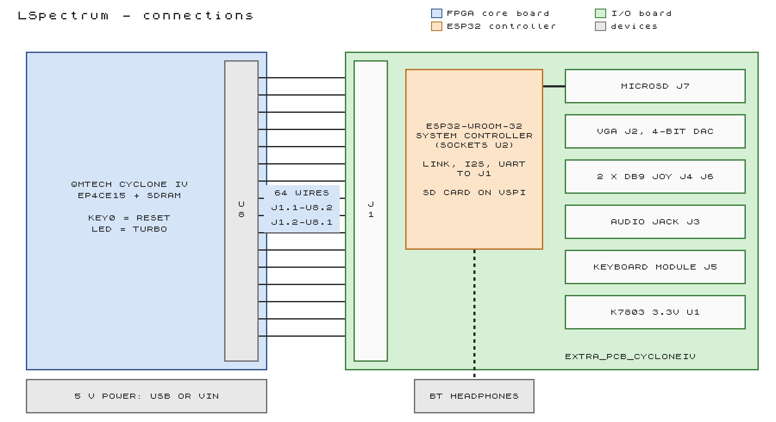
Figure 1. The core board, the I/O board and what plugs into the I/O board.
Part | Connected to | Carries
Extra_PCB_CycloneIV I/O board | core board U8, by 64 short wires from its J1, each pin pair swapped | VGA, keyboard, audio, two joysticks, the ESP32's link, I2S and UART, 5 V for the I/O board
ESP32-WROOM-32 DevKit | sockets U2 on the I/O board | SPI link for the tape loader, sound as I2S, UART for the F3 Bluetooth menu, the microSD card
microSD card | socket J7 on the I/O board, wired to the ESP32 | SD card (SPI) for the tape loader
Bluetooth headphones / speaker | the ESP32, by radio (A2DP) | the Spectrum's sound

All FPGA pins are 3.3 V (LVTTL) and not 5 V tolerant. Every signal between the boards is 3.3 V: the I/O board makes its own 3.3 V for its pull-ups and the SD card, the keyboard module's UART is 3.3 V, and the ESP32 is a 3.3 V part.

2. The core board headers
U7 is the left header (not used) and U8 the right one (32 x 2 pins each). On both: pins 1/2 ground, 3/4 3.3 V, 61/62 ground, 63/64 VIN (5 V). The numbering was read from the QMTECH schematic: check 1/2, 3/4, 61/62 and 63/64 with a meter before connecting anything new. Full header map: docs/BOARD_PINOUT.md.
On-board | Pin / use
50 MHz oscillator | T2
KEY0 (button farther from the long edge) | W13: reset of everything
KEY1 | Y13: back to the machine menu
LED | E4: on = turbo; fast blink = no ROMs in the flash (program the .jic)
SDRAM, configuration flash | on the board, nothing to wire

3. I/O board J1 to core board U8
The I/O board sits beside the core board, its J1 holes directly opposite U8. The two are joined by 64 short wires with each pin pair swapped: J1 pin 2k-1 goes to U8 pin 2k, and J1 pin 2k to U8 pin 2k-1 (J1.1 to U8.2, J1.2 to U8.1, and so on). Each power pair carries the same net on both pins (ground, 3.3 V, ground, 5 V), so power stays correct; the signals land on the FPGA pins below, which is what the LSpectrum pin assignment expects.
I/O board J1 | Core board U8 | FPGA pin | Signal | Dir | Notes
1 | 2 | - | GND |  | ground
2 | 1 | - | GND
3, 4 | 4, 3 | - | (3.3 V) |  | not connected on the I/O board
5, 6 | 6, 5 | AB11, AA11 | - |  | not connected (clock-only FPGA inputs)
7 | 8 | AB13 | ESP_SCK | in | ESP32 D14, link clock 8 MHz
8 | 7 | AA13 | ESP_MOSI | in | ESP32 D13
9 | 10 | AB14 | ESP_CS_N | in | ESP32 D33
10 | 9 | AA14 | ESP_MISO | out | ESP32 D35
11 | 12 | AB15 | ESP_IRQ | out | ESP32 D34
12 | 11 | AA15 | BT_BCLK | in | ESP32 D26, I2S
13 | 14 | AB16 | BT_LRCK | in | ESP32 D25, I2S
14 | 13 | AA16 | BT_DATA | out | ESP32 D22, I2S
15 | 16 | AB17 | BT_TX | out | ESP32 RX2 (GPIO16), F3 menu
16 | 15 | AA17 | BT_RX | in | ESP32 TX2 (GPIO17)
17 | 18 | AB18 | KB_IN | in | keyboard module J5.3
18 | 17 | AA18 | AUDIO_AY | out | AY, sigma-delta; RC filter on the board
19 | 20 | AB19 | KB_OUT | in | keyboard module J5.2
20 | 19 | AA19 | AUDIO_BEEP | out | beeper, port FE bit 4
21 | 22 | AB20 | JOY1_UP_N | in | J4 pin 1; 3.3 kΩ pull-ups on the board
22 | 21 | AA20 | JOY1_DOWN_N | in | J4 pin 2
23 | 24 | Y21 | JOY1_LEFT_N | in | J4 pin 3
24 | 23 | Y22 | JOY1_RIGHT_N | in | J4 pin 4
25 | 26 | W21 | JOY1_FIRE_N | in | J4 pin 6
26 | 25 | W22 | JOY2_UP_N | in | J6 pin 1
27 | 28 | V21 | JOY2_DOWN_N | in | J6 pin 2
28 | 27 | V22 | JOY2_LEFT_N | in | J6 pin 3
29 | 30 | U21 | JOY2_RIGHT_N | in | J6 pin 4
30 | 29 | U22 | JOY2_FIRE_N | in | J6 pin 6
31-44, 46, 48 | 31-44, 45, 47 | - | - |  | not connected
45 | 46 | H21 | VGA_VS | out | 22 Ω + 6.8 pF on the board
47 | 48 | F21 | VGA_HS | out | 22 Ω + 6.8 pF on the board
49, 51, 50, 52 | 50, 52, 49, 51 | E21, D21, E22, D22 | VGA_R[3:0] | out | 523 Ω, 1.05 kΩ, 2.1 kΩ, 4.22 kΩ (bit 3 to 0)
53, 55, 54, 56 | 54, 56, 53, 55 | C21, B21, C22, B22 | VGA_G[3:0] | out | same DAC
57, 59, 58, 60 | 58, 60, 57, 59 | N19, M19, N20, M20 | VGA_B[3:0] | out | same DAC
61 | 62 | - | GND
62 | 61 | - | GND
63 | 64 | - | VIN 5 V | power | feeds the whole I/O board
64 | 63 | - | VIN 5 V | power

The 3.3 V pins (J1.3/4) are not used by the I/O board: it makes its own 3.3 V from the 5 V. U8.5 and U8.6 are clock-only inputs of the FPGA: never use them for anything else.

4. Connectors on the I/O board
Connector | Use
J2 VGA (DB15 HD) | 4 bits per colour (binary-weighted resistor DAC into the monitor's 75 Ω, 0.7 V full scale). LSpectrum outputs ZX normal colours as level 14 of 15 and bright as 15.
J4, J6 joysticks (DB9 male) | Atari/Kempston pinout: 1 up, 2 down, 3 left, 4 right, 6 fire, 8 ground. Mode chosen with F4: both Kempston (port 1F, default), J4 Kempston + J6 Cursor, or Interface 2 (J4 Sinclair 1, J6 Sinclair 2).
J3 audio (3.5 mm jack) | AY + beeper mixed, mono on tip and ring, line level (about 0.75 V peak to peak, ~600 Ω): for an amplifier with its own volume control, not for headphones directly.
J5 keyboard module | USB-HID to UART module on 4 pins: 1 GND, 2 KB_OUT, 3 KB_IN, 4 +5 V. UART 115,200 baud at 3.3 V; the FPGA reads both lines (data = KB_OUT AND KB_IN).
J7 microSD | on the ESP32 (section 5), 10 kΩ pull-ups on CS, CMD and DAT0-2, 100 nF + 10 µF at the socket.
U2 ESP32 sockets | two 1x15 female sockets for the 30-pin ESP32 DevKit.
U1 K7803 | 5 V to 3.3 V switching module for the pull-ups and the SD card.

5. ESP32 system controller and microSD card
A 30-pin ESP32-WROOM-32 DevKit (CP2102, USB-C) with the sketch ESP32/v2/v2.ino, plugged into the I/O board. It owns the microSD card, runs the tape loader and the Bluetooth audio, and talks to the FPGA over an SPI link with an interrupt line, an I2S sound input and a UART. The ESP32 drives the link and I2S clocks. ESP32 pins are given by their DOIT 30-pin board labels.
ESP32 board pin | Signal | Dir | J1 / U8 | FPGA pin | Notes
D35 | ESP_MISO | FPGA → ESP32 | 10 / 9 | AA14 | link data to the ESP32; D35 is input-only
D34 | ESP_IRQ | FPGA → ESP32 | 11 / 12 | AB15 | interrupt, active high; D34 is input-only
D14 | ESP_SCK | ESP32 → FPGA | 7 / 8 | AB13 | link clock, 8 MHz; FPGA pull-up
D13 | ESP_MOSI | ESP32 → FPGA | 8 / 7 | AA13 | link data to the FPGA; FPGA pull-up
D33 | ESP_CS_N | ESP32 → FPGA | 9 / 10 | AB14 | link select; FPGA pull-up (idle while the ESP32 boots)
D26 | BT_BCLK | ESP32 → FPGA | 12 / 11 | AA15 | I2S bit clock, 1.4112 MHz; FPGA pull-up
D25 | BT_LRCK | ESP32 → FPGA | 13 / 14 | AB16 | I2S word select, 44.1 kHz; FPGA pull-up
D22 | BT_DATA | FPGA → ESP32 | 14 / 13 | AA16 | sound, 16-bit; ESP32 pull-down
RX2 (GPIO16) | BT_TX | FPGA → ESP32 | 15 / 16 | AB17 | F3 menu commands, 115,200 baud
TX2 (GPIO17) | BT_RX | ESP32 → FPGA | 16 / 15 | AA17 | answers and events; FPGA pull-up
VIN, GND | 5 V, GND |  | 63, 64 / 1, 2 | - | power from the core board through J1

ESP32 board pin | microSD (J7) | Signal | Notes
D18 | CLK | SD SCK | ESP32 VSPI, 20 MHz
D19 | DAT0 | SD MISO | 10 kΩ pull-up on the board
D23 | CMD | SD MOSI | 10 kΩ pull-up
D5 | DAT3 | SD CS | 10 kΩ pull-up

- Direction check: the FPGA's TX goes to the ESP32's RX2, and the ESP32's TX2 to the FPGA's RX; I2S data and link MISO go from the FPGA to the ESP32.
- ESP32 unplugged is safe: the FPGA's pull-ups keep the lines quiet; the Spectrum boots and runs without the ESP32 (no SD card, no Bluetooth).
- USB on the ESP32 is for programming and debugging (a terminal at 115,200 baud shows the loader's messages and takes the Bluetooth commands). Pairing is done from LSpectrum: F3 opens the Bluetooth menu.
- Pins avoided on the ESP32 on purpose: GPIO12 (the FPGA's pull-ups would select 1.8 V flash at boot), GPIO2 and GPIO15 (boot strapping), GPIO6-11 (flash).

6. Power
What | From
Core board | its own power input (USB or 5 V); everything else is fed from it
I/O board | 5 V (VIN) from U8.63/64 through J1.64/63; U1 (K7803) makes its 3.3 V
USB keyboard module | 5 V on J5.4 (USB power only; its UART is 3.3 V)
ESP32 DevKit | 5 V into VIN from the I/O board
microSD card | 3.3 V from U1 on the I/O board

7. The Cyclone 10 LP core board (10CL025)
QMTECH's 10CL025YU256 core board has the same size and the same two headers at the same places; the I/O board is wired to its U8 in the same way, each pin pair swapped. The power pins are the same (1/2 and 61/62 ground, 3/4 3.3 V, 63/64 VIN); pins 5/6 are ground on this board. Every signal keeps its J1 and U8 pin; only the FPGA ball behind the pin differs (full table: docs/BOARD_PINOUT.md). Not tried on hardware yet (11 November 2026).
On-board | Pin / use
50 MHz oscillator | E2
KEY0 (SW1) | F3: reset of everything
KEY1 | no button on the board: header U7 pin 7 (ball G1), weak pull-up; a button to ground may be wired there
nCONFIG button (SW3) | reloads the flash: back to the machine menu
LED D1 | N9
SDRAM, configuration flash | on the board, nothing to wire

- U8 pins 39 to 44 are configuration pins of the FPGA as well (DEV_OE, DEV_CLRN, INIT_DONE, CRC_ERROR, nCEO, CLKUSR). The I/O board has no signal there: leave them unconnected.
- The flash must hold the image built for this board (AMenu/10cl025/output_files/L.jic); the EP4CE15 image does not configure a 10CL025.

8. Before switching on
- Meter check of the header power pins (section 2) after any change in the wiring.
- Continuity check of the swapped wiring: J1.1 to U8.2 and J1.2 to U8.1 (ground), J1.63 to U8.64 and J1.64 to U8.63 (5 V), and no short between 5 V and ground.
- The configuration flash holds the LSpectrum image built for this I/O board.
- ESP32 and keyboard module plugged in the right way round (pin 1 / silkscreen).
- The wires are short and the two boards fixed to each other, so the wires do not lever on U8.

