Data Center Load Growth in Virginia
Probabilistic Data Center Load Forecast and Its Capital and Rate Implications, 2025–2035
Territory: Dominion Energy Virginia (PJM DOM zone)
Alexandre Ly · Independent Research · October 05, 2026

Repository: github.com/alexly0329-cpu/dominionenergy_forecast · Model: dc_load_model.ipynb · Workbook: model/capital_rate_model.xlsx

1. Executive Summary
Data center load in Dominion Energy Virginia (PJM DOM zone) is likely to add 12,957 MW of peak demand by 2035 (90% range: 8,661–16,569 MW), on top of roughly -396 MW of organic growth (-0.2% per year). By 2030, the median incremental load is 6,623 MW. These figures treat announced capacity as a probability-weighted pipeline, not a certainty: the de-duplicated pipeline contains 46 projects totaling 17,530 MW of grid capacity, of which only the stage-weighted expectation is counted, and the range allows for shared shocks that would hit many projects at once.
Serving the Base case requires approximately $83.4B of incremental generation and transmission/distribution capital through 2035 ($58.6B in the Low case, $112.8B in the High case), expanding the utility's rate base by $64.7B and raising annual net income by about $3,297M by 2035.
Because data centers operate at roughly 80% load factor, each megawatt of peak brings about 7.0 GWh of annual sales. In the Base case the system-average rate in 2035 is 15.35 ¢/kWh versus 13.93 ¢/kWh in a no-new-data-center counterfactual, +10.1% (higher). Across scenarios the 2035 rate effect ranges from +8.1% to +12.0%.
The central risk is asymmetric. If 25% of the data center load the system is built for fails to materialize after 2030, the 2035 average rate effect becomes +13.8% with no protective tariff, but +5.3% under a GS-5-style large-load tariff (minimum charges of 85% of contracted transmission and distribution demand and 60% of generation demand) combined with 25% upfront customer contribution.
Our Base-case 2035 system peak is 37,013 MW, -8.5% versus PJM 2026 Load Forecast (derived) (2026); Section 8 compares the two forecasts.
Recommendation. Plan generation and transmission to the median forecast (12,957 MW of new data center peak by 2035), stage procurement with explicit decision gates tied to signed Electric Service Agreements, and condition large-load interconnection on tariff protections that place stranded-cost risk on the customers that create it. The three assumptions that most deserve further diligence are data center load factor, marginal energy cost, and capital cost.

2. Background and Problem
Electric utilities and regional transmission organizations have revised their long-term load forecasts upward repeatedly since 2022, driven largely by data center interconnection requests. Unlike most load growth, data center demand arrives in large, lumpy blocks (100–1,000+ MW per campus), runs nearly flat around the clock, and is announced years before it is energized. Planners face a two-sided error: under-building risks reliability shortfalls and emergency procurement; over-building risks stranded assets whose cost falls on all ratepayers.
This report asks three questions for Dominion Energy Virginia (PJM DOM zone):
- How much incremental peak and energy demand will data centers plausibly add by 2030 and 2035, with explicit uncertainty?
- What generation and grid capital does that demand require, and how does it flow into rate base, revenue requirement, and customer rates?
- How is the risk of forecast error distributed between the utility, its shareholders, data center customers, and other ratepayers?

Key concepts
Table 1. Glossary of planning and ratemaking terms
Term | Meaning
MW vs. MWh | MW is instantaneous demand (drives capacity build); MWh is energy over time (drives fuel cost and revenue).
Load factor | Average load ÷ peak load. Data centers run near-flat; residential load is far more variable.
Reserve requirement (IRM / FPR) | PJM's installed reserve margin (IRM) is extra installed capacity above peak; the forecast pool requirement (FPR) expresses the same requirement in accredited (ELCC) megawatts per megawatt of peak.
ELCC / accreditation | Share of a resource's nameplate that counts toward reliability. Solar and storage count for far less than nameplate.
Rate base | Net invested capital on which the regulator allows a return.
Revenue requirement | Rate base × allowed return + depreciation + O&M + fuel + taxes. Rates = revenue requirement ÷ sales.
CIAC / minimum bill | Tariff tools that shift construction or stranded-asset cost onto the large customer.

3. Data and Methods
The analysis is a reproducible pipeline (Figure 1). Hourly load and weather data produce a weather-normalized organic baseline with historical data center load removed. A hand-curated, stage-tagged project pipeline is converted into probabilistic incremental load via Monte Carlo simulation. Incremental load is translated into accredited capacity need, nameplate build by technology, capital, rate base, revenue requirement, rates, and earnings.
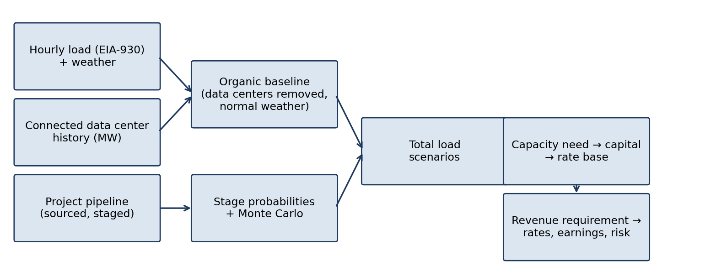
Figure 1. Analytical pipeline from raw data to rate impact.
Table 2. Data sources
Input | Source | Notes
Hourly demand | EIA-930 Hourly Electric Grid Monitor, PJM, DOM sub-region | 2019-01-01 to 2025-12-31
Weather | Meteostat / Open-Meteo, stations Dulles, Richmond, Norfolk | population-weighted hourly temperature
Historical data center load | Utility investor disclosures and regulatory filings | cumulative connected MW by year
Project pipeline | County planning records, utility disclosures, company releases, trade press | 46 de-duplicated projects
Accreditation and reserve requirement | PJM ELCC class ratings and FPR/IRM for 2027/2028 | Appendix A
Resource mix | Dominion 2024 Integrated Resource Plan (as reported by DiGangi) | Section 6.1
Capital and O&M costs | EIA Annual Energy Outlook 2025 assumptions; GridLab (gas turbines) | 2024 dollars, inflated
Financial parameters | SCC final order PUR-2025-00058; statutory tax rates | ROE, equity ratio
Prices | EIA Virginia electricity profile; Monitoring Analytics State of the Market | retail rate, wholesale energy
Benchmark forecasts | PJM Long-Term Load Forecast; utility IRP | zonal summer peak

Method choice and alternatives
Public data and Monte Carlo simulation were chosen because every input can be audited and because data center load arrives as discrete, uncertain projects whose combined outcome is best described as a probability distribution. The alternatives considered were fixed scenarios alone (the standard utility planning approach), a top-down econometric model (rejected because data center load has too short a history to fit), and expert surveys. Because shared shocks such as an AI investment slowdown, equipment shortages, or local opposition would affect many projects at once, the simulation includes a common shock to build probabilities and timing in every draw (Section 5.2).

Pipeline compilation and use of AI tools
Every pipeline row was compiled by hand from a public source, with the source URL and a verbatim capacity quote recorded (Appendix B). An AI assistant was used to help write the analysis code and to locate published sources. Every numeric input is either taken from a cited source or labeled as an assumption in Appendix A; the most influential assumptions are tested in Section 7.1.

4. Baseline Load Forecast

4.1 Removing historical data center load
Historical system load already embeds several gigawatts of data center demand. Extrapolating the raw trend would therefore double count growth that is later added from the pipeline. We subtract the disclosed cumulative connected data center capacity (× 0.80 load factor) from each year's daily peak and energy before fitting, producing an organic series. In the forecast, data centers already connected (5,866 MW as of 2025) are held constant and form part of the counterfactual; energized projects are excluded from the pipeline overlay so they are counted exactly once.
Table 3. Historical cumulative connected data center capacity (MW)
Year | Connected MW | Source
2018 | 0 | Definition (additions measured from end of 2018)
2022 | 3,067 | Swinhoe (DCD), author's calculation: >4,000 MW connected 2019-2023 minus 933 MW connected in 2023
2023 | 4,000 | Swinhoe (DCD): 94 data centers, more than 4 GW connected 2019-2023
2024 | 4,933 | ESTIMATE: 2023 pace (933 MW, 15 data centers) carried forward; Swinhoe (DCD) reports 15 more expected in 2024
2025 | 5,866 | ESTIMATE: 2023 pace (933 MW per year) carried forward

4.2 Model specification and validation
Daily organic peak and energy are regressed on cooling and heating degree-days (base 65°F, linear and quadratic), day-of-week, federal holidays, and a linear time trend. The model is trained on data through 2023 and evaluated on 2024 onward. The fitted organic trend is -0.05% per year for peak and -0.40% per year for energy.
On the holdout period the peak model achieves a daily MAPE of 5.05%, versus 14.33% for a seasonal-naïve benchmark and 16.77% for a trend-only model. The energy model's MAPE is 4.26%. Because the highest fitted day in a year sits below the actual annual peak (the actual peak day also carries a large positive residual), annual peak predictions add the average gap observed in the training years.
Table 4. Holdout validation of the organic baseline models
Target | Model MAPE % | Seasonal-naïve MAPE % | Trend-only MAPE % | R² (train) | Trend %/yr
Daily peak | 5.05 | 14.33 | 16.77 | 0.907 | -0.05
Daily energy | 4.26 | 12.03 | 14.80 | 0.921 | -0.40

Table 5. Annual organic peak, holdout years
Year | Actual annual peak MW | Max fitted day MW | Predicted annual peak MW | Error %
2024 | 19,274 | 18,933 | 18,530 | 3.9
2025 | 20,264 | 21,306 | 20,903 | 3.2

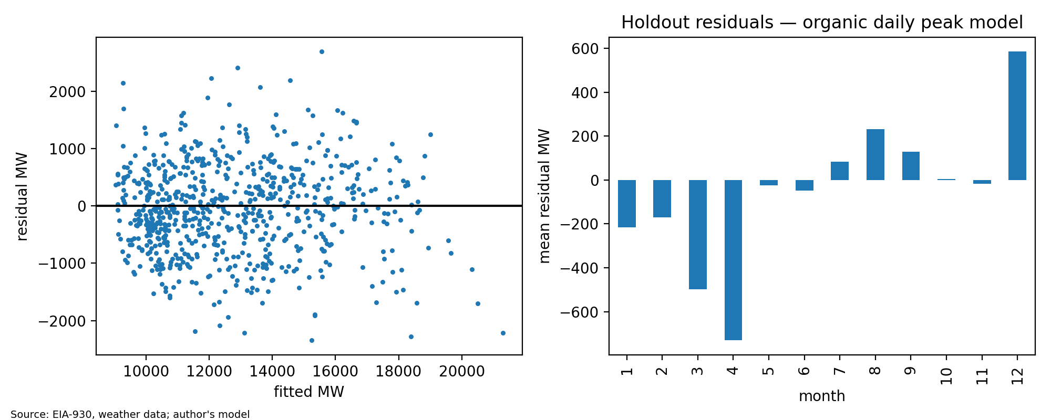
Figure 2. Holdout residuals of the daily organic peak model: residual vs fitted (left) and mean residual by month (right).
Mean monthly residuals reach ±5.8% of peak, and 4 month(s) show bias larger than chance would explain (the largest, April (-5.8% of peak)). Adding month indicators to the model is the natural next refinement.

4.3 Normal-weather projection
Each projection year is simulated under every historical weather year (7 years) and the results are averaged, so heat waves that set the annual peak are preserved rather than smoothed away by averaging temperatures first. The 90th percentile across weather years gives a hot-year range. The counterfactual baseline (organic load plus existing data center load held flat) reaches 23,887 MW in 2035.
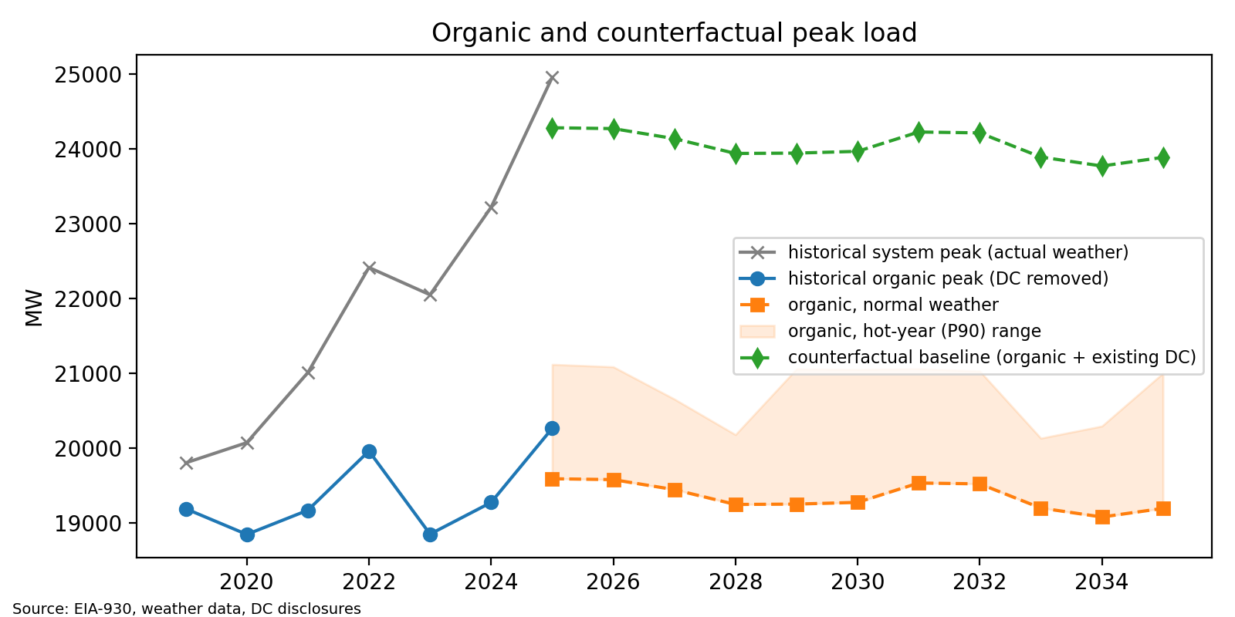
Figure 3. Historical system and organic peak, with normal-weather organic projection and counterfactual baseline.
Table 6. Counterfactual baseline by year
Year | Organic peak MW | Organic hot-year (P90) MW | Existing data centers MW | Baseline peak MW | Baseline energy GWh
2025 | 19,591 | 21,119 | 5,866 | 24,283 | 132,490
2026 | 19,579 | 21,087 | 5,866 | 24,272 | 132,242
2027 | 19,445 | 20,656 | 5,866 | 24,138 | 131,975
2028 | 19,247 | 20,180 | 5,866 | 23,939 | 131,974
2029 | 19,252 | 21,059 | 5,866 | 23,944 | 131,515
2030 | 19,275 | 21,052 | 5,866 | 23,968 | 131,283
2031 | 19,534 | 21,062 | 5,866 | 24,226 | 131,041
2032 | 19,522 | 21,030 | 5,866 | 24,215 | 131,011
2033 | 19,199 | 20,133 | 5,866 | 23,892 | 130,528
2034 | 19,079 | 20,295 | 5,866 | 23,772 | 130,286
2035 | 19,194 | 21,002 | 5,866 | 23,887 | 130,066

5. Data Center Pipeline and Probabilistic Overlay

5.1 The pipeline
We compiled 46 de-duplicated data center projects (Appendix B), each with a source URL and verbatim capacity quote. Each is tagged to one of six stages: announced, zoned, interconnection request, electric service agreement (ESA) signed, under construction, energized. Where only IT load was reported, grid load was estimated with a PUE of 1.3. Likely duplicates (same county and developer, capacity within 20%, timing within two years) were collapsed to the most advanced stage.
Table 7. Pipeline funnel by stage
Stage | Projects | MW (grid)
Announced | 6 | 3,081
Zoned | 3 | 2,450
Interconnection request | 0 | 0
ESA signed | 30 | 9,291
Under construction | 7 | 2,708
Energized | 0 | 0

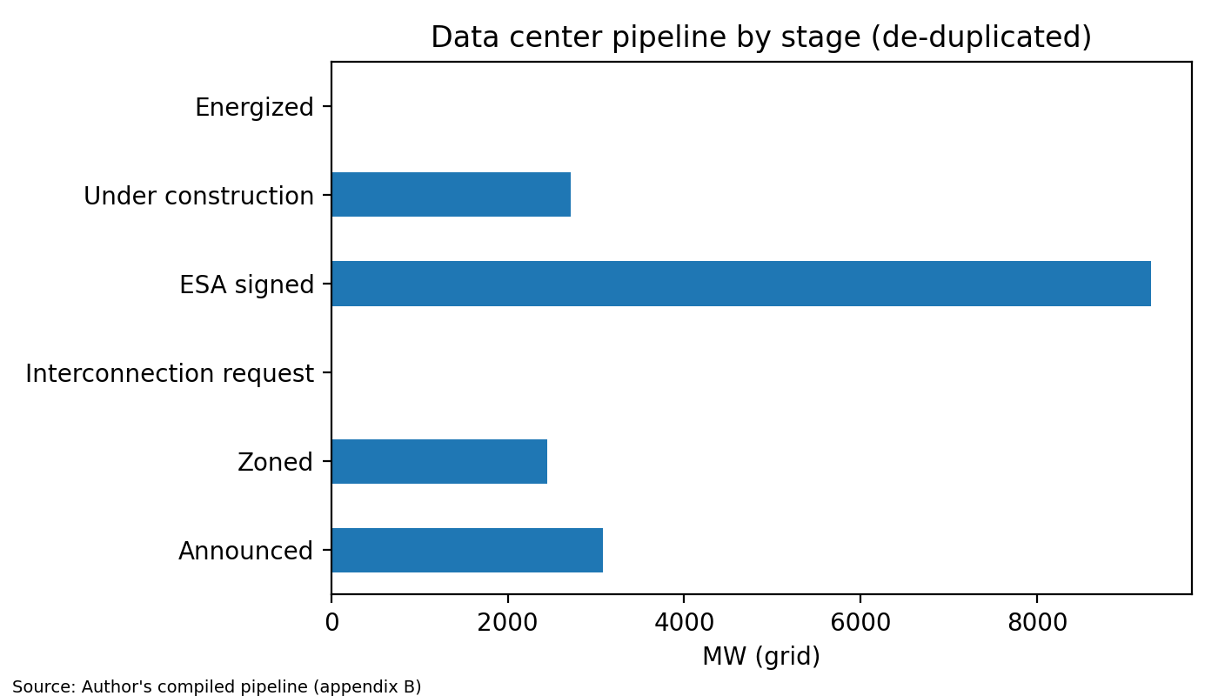
Figure 4. De-duplicated pipeline capacity by development stage.

5.2 Stage probabilities and timing
Each project is modeled as a random variable: probability of being built (by stage), delay beyond the stated commercial operation date (lognormal, σ = 0.5), and a linear ramp to full load. An additional term represents not-yet-announced projects (0/150/400 MW per year in Low/Base/High). Energized projects are excluded from the overlay because they are already in the historical connected series.
Table 8. Stage-based build probabilities and timing assumptions
Stage | P(built) Low | P(built) Base | P(built) High | Median delay (yr) | Ramp (yr)
Announced | 0.10 | 0.20 | 0.35 | 2.0 | 4
Zoned | 0.25 | 0.40 | 0.55 | 1.5 | 4
Interconnection request | 0.35 | 0.50 | 0.65 | 1.5 | 3
ESA signed | 0.65 | 0.80 | 0.90 | 1.0 | 3
Under construction | 0.85 | 0.92 | 0.97 | 0.5 | 3
Energized | 1.00 | 1.00 | 1.00 | 0.0 | 1

Base probabilities are anchored to evidence that most early-stage requests never materialize: only 13% of the capacity that entered U.S. interconnection queues in 2000–2020 had reached commercial operation by the end of 2025 (Rand et al.), and utilities expect actual data center load to be a small fraction of what is requested, with industry estimates of five to ten times more requests than projects built (Martucci), which supports probabilities of 0.20–0.50 for announced, zoned, and interconnection-request projects. Contractual commitment sharply raises completion odds, since the 12.0 GW Dominion holds under electric service agreements ("Dominion Q2 2026 Slides") will face GS-5 minimum charges of 85% of contracted transmission and distribution demand and 60% of generation demand, plus collateral, from January 2027 (Pampaloni), which supports probabilities of 0.80 for ESA-signed and 0.92 for construction-stage projects. No pre-energization stage is treated as certain, because large Virginia proposals continue to fail, including a 2,100-acre, 37-building Prince William County campus withdrawn in July 2026 (Zhang and Siddiki).
Projects are not independent: an AI investment slowdown, equipment shortages, or local opposition would affect many of them at once. Each Monte Carlo draw therefore applies one shared shock that shifts every project's build probability (logit-scale standard deviation 0.75) and one shared multiplier on delays (log-scale standard deviation 0.4). Both spreads are assumptions; the independent-project range is reported alongside for comparison.

5.3 Results
Table 9. Incremental data center peak load by scenario and Monte Carlo percentile
Year | Low (MW) | Base (MW) | High (MW) | Monte Carlo 5th pct. | Monte Carlo median | Monte Carlo 95th pct.
2025 | 8 | 158 | 409 | 11 | 159 | 324
2026 | 169 | 483 | 993 | 200 | 466 | 743
2027 | 707 | 1,216 | 2,007 | 666 | 1,256 | 1,841
2028 | 1,922 | 2,768 | 3,951 | 1,588 | 2,742 | 3,947
2029 | 3,506 | 4,874 | 6,640 | 2,853 | 4,663 | 6,543
2030 | 5,118 | 7,068 | 9,456 | 4,238 | 6,623 | 9,161
2031 | 6,499 | 9,013 | 12,012 | 5,517 | 8,491 | 11,566
2032 | 7,857 | 10,919 | 14,509 | 6,720 | 10,255 | 13,652
2033 | 8,719 | 12,150 | 16,148 | 7,692 | 11,655 | 15,139
2034 | 9,178 | 12,886 | 17,229 | 8,323 | 12,507 | 16,073
2035 | 9,234 | 13,126 | 17,753 | 8,661 | 12,957 | 16,569

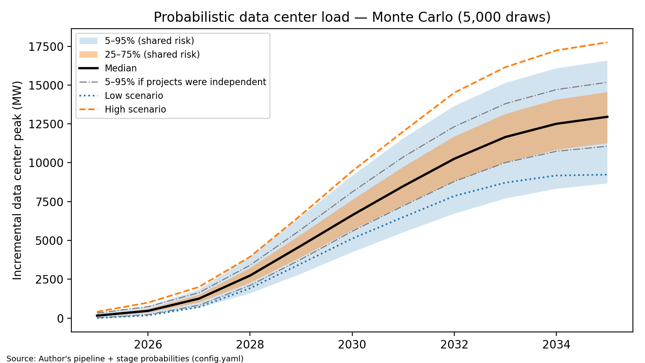
Figure 5. Monte Carlo distribution of incremental data center peak load (5,000 draws) with deterministic Low/High scenarios.
The median path reaches 6,623 MW in 2030 and 12,957 MW in 2035; the 5th–95th percentile band in 2035 spans 8,661–16,569 MW, compared with 11,060–15,179 MW if projects were treated as independent. The deterministic Base scenario (13,126 MW in 2035) sits above the Monte Carlo median because delays are drawn from a skewed distribution: projects can slip later but never arrive early.

6. Capital Plan and Rate Impact

6.1 From load to capacity
Each year's increase in incremental peak is multiplied by PJM's forecast pool requirement (0.926 accredited MW per MW of peak, equivalent to the installed reserve margin once capacity is counted at its ELCC rating) to give an accredited capacity need, allocated across technologies in fixed proportions, and converted to nameplate by dividing by each technology's effective load-carrying capability. Transmission and distribution capital is added per kW of incremental peak.
Table 10. Resource mix and cost assumptions
Technology | Share of accredited need | ELCC | Capital $/kW | Fixed O&M $/kW-yr | Book life (yr)
Gas combined cycle | 47% | 0.74 | 2,200 | 12 | 30
4-hour storage | 28% | 0.58 | 1,580 | 41 | 15
Solar (tracking) | 11% | 0.08 | 1,379 | 23 | 30
Small modular reactor | 14% | 0.95 | 9,314 | 124 | 60

The resource mix reflects the generation additions in Dominion Energy Virginia's 2024 Integrated Resource Plan, which proposes 5.9 GW of natural gas, 12 GW of solar, 4.5 GW of battery storage, and 1.34 GW of small modular reactors through 2039 (DiGangi, "Dominion Unveils"). Weighting each technology by its accredited capacity gives shares of 47% gas, 28% storage, 11% solar, and 14% nuclear; offshore wind is excluded because most of it is already committed independently of data center growth. Accreditation values are PJM's effective load-carrying capability (ELCC) class ratings for the 2027/2028 capacity auction: 74% for gas combined cycle, 58% for four-hour storage, 8% for tracking solar, and 95% for nuclear (PJM Interconnection, ELCC Class Ratings). Overnight capital and fixed O&M costs for storage, solar, and small modular reactors are taken from the Energy Information Administration's Annual Energy Outlook 2025 assumptions (U.S. Energy Information Administration, Assumptions). The combined-cycle capital cost of $2,200/kW reflects recent project costs of $2,000/kW or more rather than EIA's lower estimate, because turbine shortages have sharply raised prices (GridLab). Book lives and transmission and distribution cost per kW are assumptions.
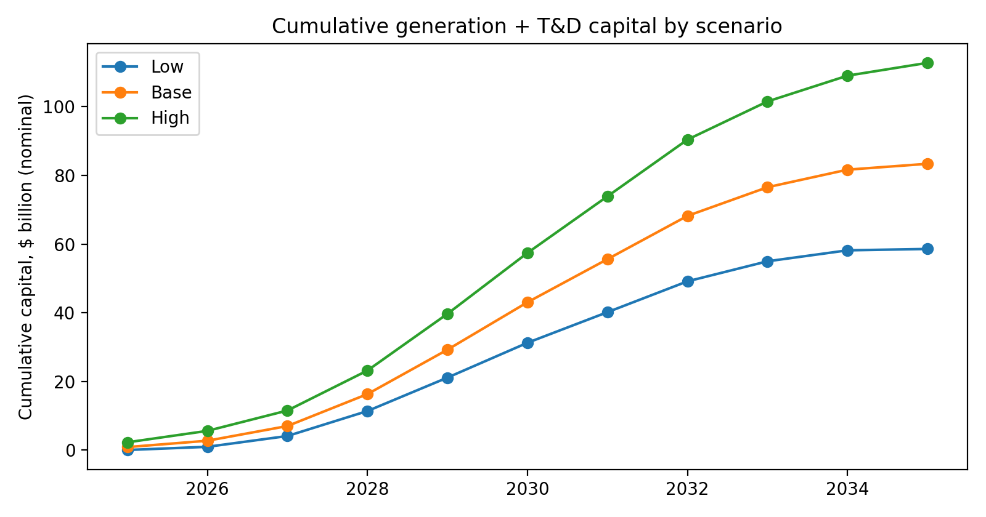
Figure 6. Cumulative generation and T&D capital by scenario (nominal $).
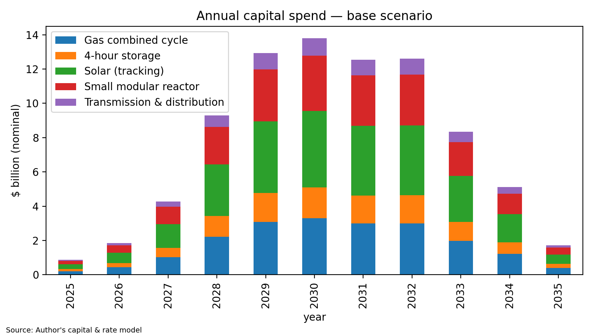
Figure 7. Base case annual capital by technology.
Cumulative 2025–2035 capital is $58.6B (Low), $83.4B (Base) and $112.8B (High).

6.2 Revenue requirement, rates and earnings
Capital enters rate base net of any contribution-in-aid-of-construction and is depreciated straight-line over book life. The incremental revenue requirement is rate base × pre-tax weighted cost of capital plus depreciation, fixed O&M, and incremental energy. The allowed return on equity of 9.8% and equity ratio of 52.0% are those approved in Dominion's 2025 biennial review (Virginia State Corporation Commission; Pampaloni); the cost of debt (5.0%) is an assumption, and the tax rate (25.7%) combines the 21% federal and 6% Virginia corporate rates. Incremental energy is priced at $50.73/MWh, PJM's 2025 load-weighted average real-time price (Monitoring Analytics). In the counterfactual, the system-average rate stays at Virginia's 2024 average retail price of 10.62 ¢/kWh in real terms (U.S. Energy Information Administration, "Virginia Electricity Profile"), a statewide figure used as a proxy for Dominion's territory.
Table 11. Headline results, 2030 and 2035
Case | Year | Data center peak MW | Total peak MW | Cum. capital $B | Rate base $B | Counterfactual rate ¢/kWh | Scenario rate ¢/kWh | Δ rate % | Δ net income $M
Low | 2030 | 5,118 | 29,085 | 31.3 | 27.5 | 12.32 | 13.30 | +8.0 | 1,404
Low | 2035 | 9,234 | 33,121 | 58.6 | 45.3 | 13.93 | 15.06 | +8.1 | 2,311
Base | 2030 | 7,068 | 31,035 | 43.1 | 37.8 | 12.32 | 13.56 | +10.1 | 1,927
Base | 2035 | 13,126 | 37,013 | 83.4 | 64.7 | 13.93 | 15.35 | +10.1 | 3,297
High | 2030 | 9,456 | 33,424 | 57.4 | 50.2 | 12.32 | 13.82 | +12.2 | 2,558
High | 2035 | 17,753 | 41,640 | 112.8 | 87.5 | 13.93 | 15.60 | +12.0 | 4,461
Monte Carlo median | 2030 | 6,623 | 30,591 | 40.3 | 35.3 | 12.32 | 13.49 | +9.6 | 1,800
Monte Carlo median | 2035 | 12,957 | 36,844 | 82.6 | 64.5 | 13.93 | 15.37 | +10.3 | 3,289

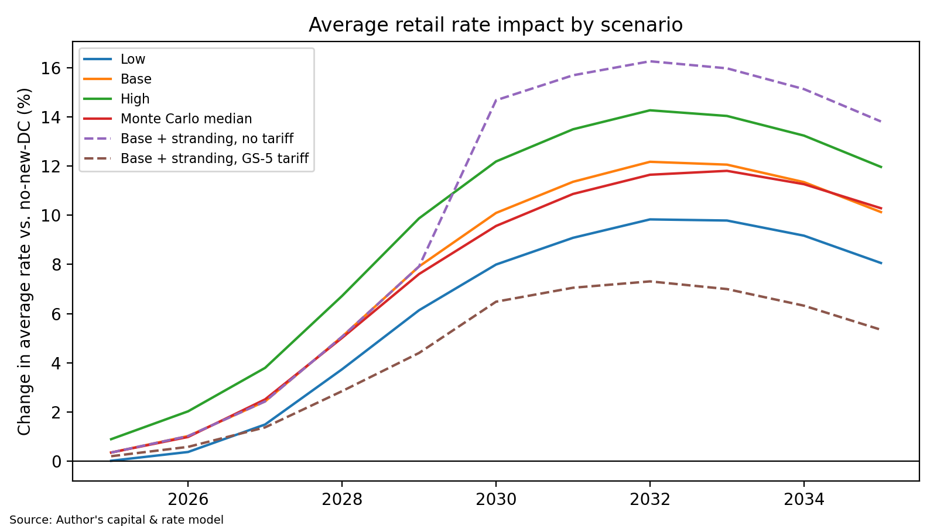
Figure 8. System-average rate impact by scenario versus the no-new-data-center counterfactual, including stranded-load stress cases.
In the Base case, 2035 average rates are +10.1% relative to the counterfactual. The increase indicates that the incremental capital and energy cost per kWh of new sales exceeds the current system-average cost. Rate base grows by $64.7B and shareholder net income by roughly $3,297M per year by 2035, illustrating the regulated utility's structural incentive to serve this load.
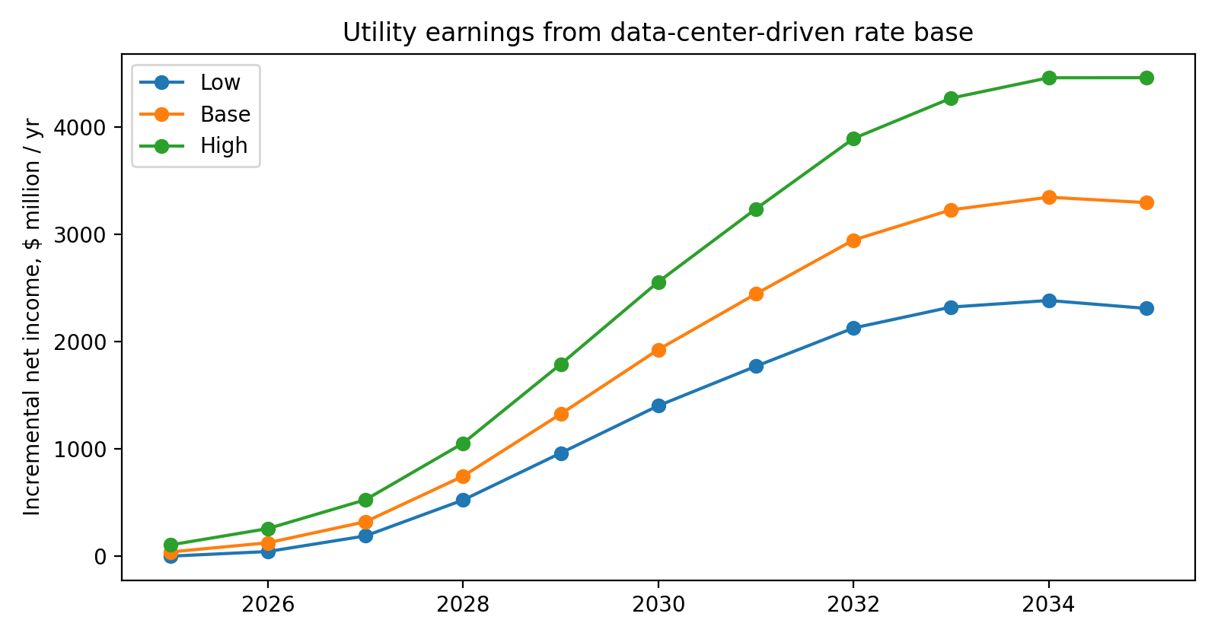
Figure 9. Incremental utility net income from data center-driven rate base.

7. Scenario and Risk Analysis

7.1 Sensitivities
Table 12. One-at-a-time sensitivities ranked by swing (Base case = +10.1%)
Driver (low / high input) | 2035 Δ rate % (low input) | 2035 Δ rate % (high input) | Swing (pp)
DC load factor 0.50 / 0.90 | +21.6 | +7.1 | 14.5
Energy cost ±30% | +4.2 | +16.1 | 11.9
Capital cost ±20% | +4.6 | +15.7 | 11.1
Upfront customer share (CIAC) 0% / 25% | +11.6 | +4.3 | 7.3
Data center build-out: Low / High scenario | +8.1 | +12.0 | 3.9
Reserve requirement ±0.05 | +8.5 | +11.7 | 3.2
Inflation 1.5% / 4% | +11.4 | +8.4 | 3.0
ROE ±100bp | +8.7 | +11.6 | 2.9
T&D cost per kW ±50% | +9.2 | +11.1 | 2.0

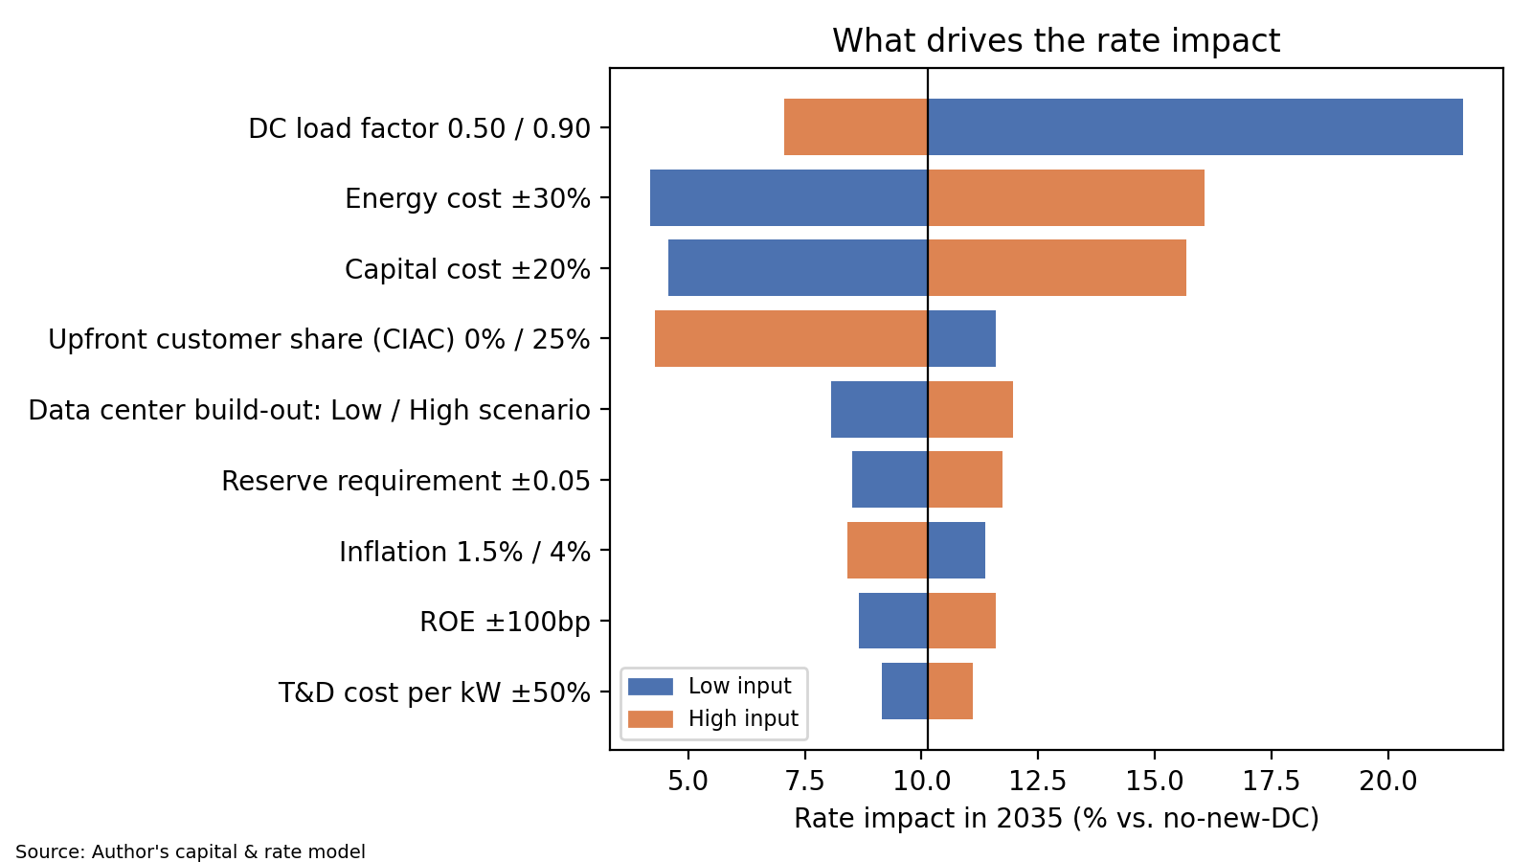
Figure 10. Tornado chart: 2035 system-average rate impact versus counterfactual.
The three most consequential assumptions are data center load factor, marginal energy cost, and capital cost. These, rather than model mechanics, should be the focus of further diligence and of any regulatory discovery. The low data center load-factor case uses the 50% average capacity utilization assumed in national data center energy estimates (Shehabi et al. 6).

7.2 Stranded-asset stress and who pays
We stress the Base case by assuming 25% of the data center load the system was built for after 2030 never arrives, while the associated plant remains in rate base. Without tariff protection the 2035 rate effect worsens from +10.1% to +13.8%. Under a GS-5-style tariff, the customers whose load did not arrive still pay 85% of the fixed transmission and distribution cost and 60% of the fixed generation cost built for them (Pampaloni), and pay 25% of construction cost upfront; the effect is then +5.3%, with minimum charges recovering $664M in 2035.
Table 13. Who pays: 2035 rate outcomes under stranded-load stress
Case | 2035 rate ¢/kWh | Δ vs counterfactual % | Minimum-charge revenue $M | Stranded MW
Base | 15.35 | +10.1 | 0 | 0
Base + stranding, no tariff | 15.86 | +13.8 | 0 | 1,767
Base + stranding, GS-5 tariff | 14.68 | +5.3 | 664 | 1,767

In practice, residential customers bear part of the generation and transmission cost of new load through class cost-of-service allocation: Virginia's legislative auditor found that data centers currently pay their full cost of service, but projected that a typical Dominion residential customer's generation- and transmission-related costs could still rise by $14 to $37 per month in constant dollars by 2040 as the system expands to serve them (Joint Legislative Audit and Review Commission). Regulators have since begun shifting this burden: in July 2026 the State Corporation Commission ordered Dominion to directly assign the substations and connecting lines built for large loads to those customers and approved a 12-coincident-peak transmission allocation that cut the proposed residential increase from $2.90 to $0.94 per month (DiGangi, "Dominion Ordered"). Because this report models only system-average rates, the residential effects shown here are indicative, and the true residential impact depends on how future cost-of-service studies allocate data-center-driven costs among classes.

8. Comparison to Utility and ISO Forecasts
Table 14. This report versus official forecasts (total system peak)
Source | Vintage | Year | Official MW | This report 5th pct. | This report Base | This report 95th pct. | Gap %
PJM 2026 Load Forecast (derived) | 2026 | 2030 | 31,095 | 28,206 | 31,035 | 33,129 | -0.2
PJM 2026 Load Forecast (derived) | 2026 | 2035 | 40,448 | 32,548 | 37,013 | 40,457 | -8.5

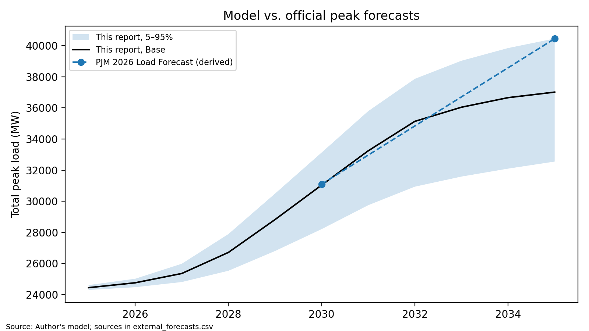
Figure 11. Base case and 5–95% range versus published forecasts.
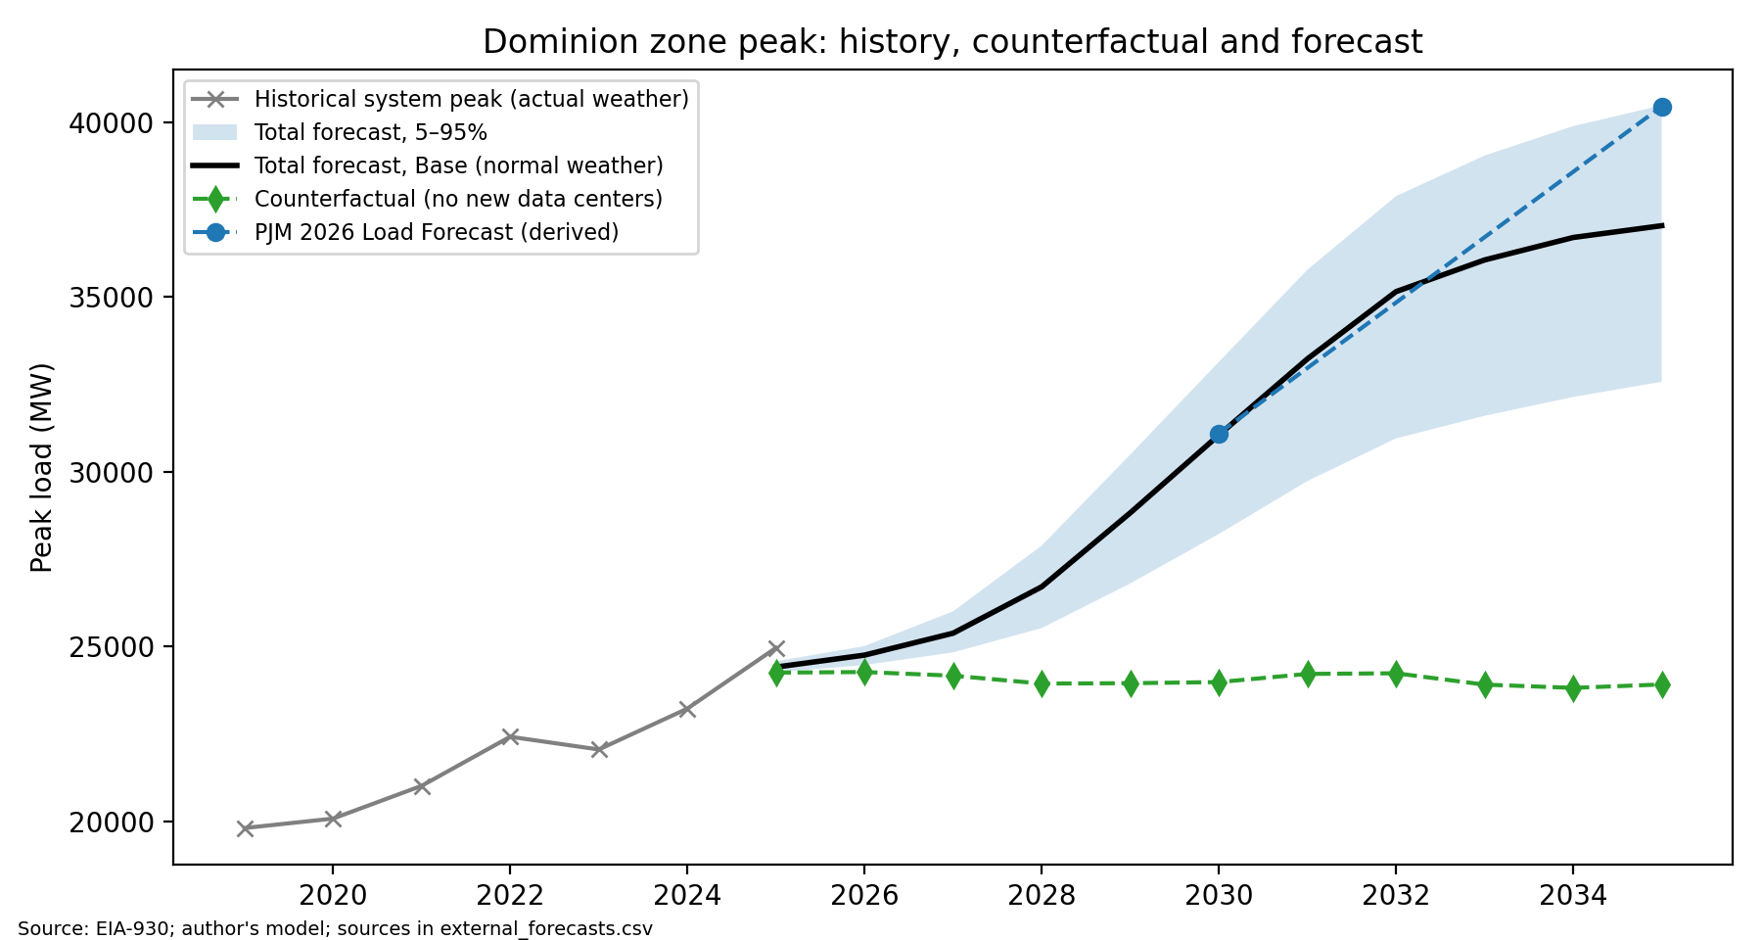
Figure 12. Historical peak, counterfactual baseline and total forecast with official forecasts.
Differences between this forecast and official projections arise from identifiable assumptions. To size each one, the corresponding setting is switched to the official forecast's value, the model is rerun, and the change in the projected peak is recorded below.

9. Limitations
- The EIA-930 footprint (PJM, DOM sub-region) does not exactly match the utility's retail service territory, and the counterfactual retail rate is a statewide average.
- Weather is proxied by three stations with assumed population weights.
- Removing historical data center load depends on disclosed connected capacity and an assumed load factor.
- Stage probabilities are judgmental, anchored to cited completion statistics; they and the size of the shared shock are dominant sources of uncertainty.
- Capacity is assumed to be built in the year of need; construction lead times, supply-chain constraints, and interconnection delays are not modeled.
- The rate analysis is system-average; class cost-of-service allocation is not modeled, so residential impacts are indicative.
- Capacity-market price effects, fuel price volatility, and federal tax credit changes are outside scope.
- Capital costs are drawn from national benchmarks adjusted for inflation, not from project-specific bids; book lives, T&D cost per kW, cost of debt, and upfront contribution shares are assumptions.

10. Conclusion and Recommendation
Treating data center announcements as a probability-weighted pipeline rather than a certainty yields a 2035 incremental peak of 12,957 MW (90% range 8,661–16,569 MW), $83.4B of capital, and a Base-case system-average rate effect of +10.1% relative to a world without new data centers. The distribution of outcomes is wide, and the downside, stranded capacity, falls on all customers unless tariff design prevents it.
We recommend that planners: (1) size firm procurement to the Base case and hold options for the High case; (2) tie each procurement tranche to signed ESAs with collateral; (3) adopt a large-load tariff with minimum-bill and CIAC provisions; and (4) refresh this forecast annually, prioritizing evidence on data center load factor, marginal energy cost, and capital cost.
Rising local opposition is a material risk that this model does not quantify directly. Large proposals have already been withdrawn or rejected in Prince William County (Zhang and Siddiki); if such outcomes become common, the Low scenario becomes more likely than the Base case. Because every input is public, the same method can be applied to any territory facing large-load growth by swapping in that utility's load data, project pipeline, and resource plan.

Appendix A. Assumptions Register
Every model input as set in the notebook's Assumptions cell, with its source. Inputs labeled "Assumption" are not taken from a published source; the most influential are tested in Section 7.1.
Table 15. Assumptions register
Parameter | Value | Source
anchor_to_base_year | False | Modeling choice
exclude_energized_from_overlay | True | Modeling choice (avoids double counting)
eia_route | electricity/rto/region-sub-ba-data | U.S. Energy Information Administration, "Hourly Electric Grid Monitor"
load_start | 2019-01-01T00 | Data availability (EIA-930)
load_end | 2025-12-31T23 | Data availability (EIA-930)
base_year | 2024 | Modeling choice
horizon_start | 2025 | Modeling choice
horizon_end | 2035 | Modeling choice
train_end_year | 2023 | Modeling choice (holdout design)
test_start_year | 2024 | Modeling choice (holdout design)
degree_day_base_f | 65 | Standard 65°F degree-day convention
dc_load_factor | 0.8 | Assumption (no published source; see Sect. 7.1 where tested); low case = 50% average utilization (Shehabi et al. 6)
dc_pue_default | 1.3 | Assumption (applies only where a project reports IT load only)
stage_delay_sigma | 0.5 | Assumption
unannounced_sd | 100 | Assumption
mc_draws | 5000 | Modeling choice
mc_correlated | True | Modeling choice
mc_common_logit_sd | 0.75 | Assumption (shared-risk spread)
mc_common_delay_sd | 0.4 | Assumption (shared-risk spread)
seed | 42 | Modeling choice (reproducibility)
fpr | 0.926 | PJM Interconnection, "2027/2028 BRA FPR" (IRM 20.0%, FPR 0.9260)
td_capex_per_kw_peak | 400 | Assumption (no published source; see Sect. 7.1 where tested)
marginal_energy_cost_per_mwh | 50.73 | Monitoring Analytics (2025 PJM load-weighted average LMP)
inflation | 0.025 | Assumption (no published source; see Sect. 7.1 where tested)
equity_share | 0.52035 | Virginia State Corporation Commission (52.035%)
roe | 0.098 | Virginia State Corporation Commission; Pampaloni (9.8%)
tax_rate | 0.257 | Statutory rates: 21% federal + 6% Virginia
cost_of_debt | 0.05 | Assumption (no published source; see Sect. 7.1 where tested)
ciac_share | 0.05 | Assumption (no published source; see Sect. 7.1 where tested)
tariff_ciac_share | 0.25 | Assumption informed by DiGangi, "Dominion Ordered" (direct-assignment order)
retail_rate_2024_c_kwh | 10.62 | U.S. Energy Information Administration, "Virginia Electricity Profile" (statewide proxy)
stranded_year | 2030 | Stress-test design
stranded_share | 0.25 | Stress-test design
gs5_min_td | 0.85 | Pampaloni (GS-5: 85% T&D, 60% generation)
gs5_min_gen | 0.6 | Pampaloni (GS-5: 85% T&D, 60% generation)
report_years | [2030, 2035] | Modeling choice
stage_prob.low.announced | 0.1 | Rand et al.; Martucci; "Dominion Q2 2026 Slides"; Pampaloni; Zhang and Siddiki (Sect. 5.2)
stage_prob.low.zoned | 0.25 | Rand et al.; Martucci; "Dominion Q2 2026 Slides"; Pampaloni; Zhang and Siddiki (Sect. 5.2)
stage_prob.low.interconnection_request | 0.35 | Rand et al.; Martucci; "Dominion Q2 2026 Slides"; Pampaloni; Zhang and Siddiki (Sect. 5.2)
stage_prob.low.esa_signed | 0.65 | Rand et al.; Martucci; "Dominion Q2 2026 Slides"; Pampaloni; Zhang and Siddiki (Sect. 5.2)
stage_prob.low.construction | 0.85 | Rand et al.; Martucci; "Dominion Q2 2026 Slides"; Pampaloni; Zhang and Siddiki (Sect. 5.2)
stage_prob.low.energized | 1.0 | Rand et al.; Martucci; "Dominion Q2 2026 Slides"; Pampaloni; Zhang and Siddiki (Sect. 5.2)
stage_prob.base.announced | 0.2 | Rand et al.; Martucci; "Dominion Q2 2026 Slides"; Pampaloni; Zhang and Siddiki (Sect. 5.2)
stage_prob.base.zoned | 0.4 | Rand et al.; Martucci; "Dominion Q2 2026 Slides"; Pampaloni; Zhang and Siddiki (Sect. 5.2)
stage_prob.base.interconnection_request | 0.5 | Rand et al.; Martucci; "Dominion Q2 2026 Slides"; Pampaloni; Zhang and Siddiki (Sect. 5.2)
stage_prob.base.esa_signed | 0.8 | Rand et al.; Martucci; "Dominion Q2 2026 Slides"; Pampaloni; Zhang and Siddiki (Sect. 5.2)
stage_prob.base.construction | 0.92 | Rand et al.; Martucci; "Dominion Q2 2026 Slides"; Pampaloni; Zhang and Siddiki (Sect. 5.2)
stage_prob.base.energized | 1.0 | Rand et al.; Martucci; "Dominion Q2 2026 Slides"; Pampaloni; Zhang and Siddiki (Sect. 5.2)
stage_prob.high.announced | 0.35 | Rand et al.; Martucci; "Dominion Q2 2026 Slides"; Pampaloni; Zhang and Siddiki (Sect. 5.2)
stage_prob.high.zoned | 0.55 | Rand et al.; Martucci; "Dominion Q2 2026 Slides"; Pampaloni; Zhang and Siddiki (Sect. 5.2)
stage_prob.high.interconnection_request | 0.65 | Rand et al.; Martucci; "Dominion Q2 2026 Slides"; Pampaloni; Zhang and Siddiki (Sect. 5.2)
stage_prob.high.esa_signed | 0.9 | Rand et al.; Martucci; "Dominion Q2 2026 Slides"; Pampaloni; Zhang and Siddiki (Sect. 5.2)
stage_prob.high.construction | 0.97 | Rand et al.; Martucci; "Dominion Q2 2026 Slides"; Pampaloni; Zhang and Siddiki (Sect. 5.2)
stage_prob.high.energized | 1.0 | Rand et al.; Martucci; "Dominion Q2 2026 Slides"; Pampaloni; Zhang and Siddiki (Sect. 5.2)
stage_delay_median_yrs.announced | 2.0 | Assumption
stage_delay_median_yrs.zoned | 1.5 | Assumption
stage_delay_median_yrs.interconnection_request | 1.5 | Assumption
stage_delay_median_yrs.esa_signed | 1.0 | Assumption
stage_delay_median_yrs.construction | 0.5 | Assumption
stage_delay_median_yrs.energized | 0.0 | Assumption
stage_ramp_yrs.announced | 4 | Assumption
stage_ramp_yrs.zoned | 4 | Assumption
stage_ramp_yrs.interconnection_request | 3 | Assumption
stage_ramp_yrs.esa_signed | 3 | Assumption
stage_ramp_yrs.construction | 3 | Assumption
stage_ramp_yrs.energized | 1 | Assumption
unannounced_mw_per_yr.low | 0 | Assumption
unannounced_mw_per_yr.base | 150 | Assumption
unannounced_mw_per_yr.high | 400 | Assumption
resource_shares.gas_cc | 0.47 | DiGangi, "Dominion Unveils" (2024 IRP additions) × PJM ELCC ratings
resource_shares.storage_4h | 0.28 | DiGangi, "Dominion Unveils" (2024 IRP additions) × PJM ELCC ratings
resource_shares.solar | 0.11 | DiGangi, "Dominion Unveils" (2024 IRP additions) × PJM ELCC ratings
resource_shares.smr_nuclear | 0.14 | DiGangi, "Dominion Unveils" (2024 IRP additions) × PJM ELCC ratings
elcc.gas_cc | 0.74 | PJM Interconnection, ELCC Class Ratings
elcc.storage_4h | 0.58 | PJM Interconnection, ELCC Class Ratings
elcc.solar | 0.08 | PJM Interconnection, ELCC Class Ratings
elcc.smr_nuclear | 0.95 | PJM Interconnection, ELCC Class Ratings
capex_per_kw.gas_cc | 2200 | GridLab
capex_per_kw.storage_4h | 1580 | U.S. Energy Information Administration, Assumptions (2024 $)
capex_per_kw.solar | 1379 | U.S. Energy Information Administration, Assumptions (2024 $)
capex_per_kw.smr_nuclear | 9314 | U.S. Energy Information Administration, Assumptions (2024 $)
fom_per_kw_yr.gas_cc | 12.31 | U.S. Energy Information Administration, Assumptions (2024 $)
fom_per_kw_yr.storage_4h | 40.62 | U.S. Energy Information Administration, Assumptions (2024 $)
fom_per_kw_yr.solar | 22.91 | U.S. Energy Information Administration, Assumptions (2024 $)
fom_per_kw_yr.smr_nuclear | 123.88 | U.S. Energy Information Administration, Assumptions (2024 $)
book_life_yrs.gas_cc | 30 | Assumption (no published source; see Sect. 7.1 where tested)
book_life_yrs.storage_4h | 15 | Assumption (no published source; see Sect. 7.1 where tested)
book_life_yrs.solar | 30 | Assumption (no published source; see Sect. 7.1 where tested)
book_life_yrs.smr_nuclear | 60 | Assumption (no published source; see Sect. 7.1 where tested)
book_life_yrs.td | 45 | Assumption (no published source; see Sect. 7.1 where tested)

Appendix B. Data Center Project Pipeline
Table 16. De-duplicated pipeline (full table with quotes in data/processed/pipeline.csv)
ID | Campus | Developer | County | MW (grid) | Stage | Expected online | Source URL
P001 | Lake Anna Technology Campus | Amazon Web Services | Louisa | 420 | Under construction | 2027 | https://insidethedatacenter.com/articles/virginia-data-cente
P002 | Stafford Technology Campus | STACK Infrastructure | Stafford | 1,000 | Under construction | 2027 | https://insidethedatacenter.com/articles/virginia-data-cente
P003 | VA1 campus | CleanArc Data Centers | Caroline | 900 | Under construction | 2026 | https://insidethedatacenter.com/articles/virginia-data-cente
P004 | Richmond campus (Technology Creek Drive) | Iron Mountain | Henrico | 200 | Under construction | 2027 | https://insidethedatacenter.com/articles/virginia-data-cente
P005 | MD-VA1 | Menlo Digital | Fairfax | 62 | Under construction | 2026 | https://insidethedatacenter.com/articles/virginia-data-cente
P006 | Shannon Hill campus | EdgeCore | Louisa | 1,100 | Announced | 2027 | https://insidethedatacenter.com/articles/virginia-data-cente
P007 | Dahlgren West | Dahlgren Innovation Hub / Oasis Digital | King George | 1,200 | Zoned | 2027 | https://insidethedatacenter.com/articles/virginia-data-cente
P008 | Tuckahoe Technology Park | Tract | Goochland | 900 | Announced | 2027 | https://insidethedatacenter.com/articles/virginia-data-cente
P009 | Powhatan Data Center Campus | Province Group | Powhatan | 350 | Zoned | 2027 | https://insidethedatacenter.com/articles/virginia-data-cente
P010 | Culpeper Technology Zone campus (expansion) | EdgeCore | Culpeper | 236 | Announced | 2027 | https://insidethedatacenter.com/articles/virginia-data-cente
P011 | Upper Magnolia Green data center | Google | Chesterfield | 900 | Zoned | 2031 | https://www.datacenterdynamics.com/en/news/dominion-to-build
P012 | TA Realty Loudoun campus | TA Realty | Loudoun | 430 | Announced | 2027 | https://www.intelligentcio.com/north-america/?p=33477
P013 | STACK Ashburn | STACK Infrastructure | Loudoun | 144 | Announced | 2026 | https://www.blackridgeresearch.com/blog/list-of-largest-upco
P014 | NVA-06 Leesburg | STACK Infrastructure | Loudoun | 72 | Under construction | 2026 | https://www.blackridgeresearch.com/blog/list-of-largest-upco
P015 | Gainesville Crossing (building under construction) | Corscale | Prince William | 54 | Under construction | 2025 | https://www.blackridgeresearch.com/blog/list-of-largest-upco
P016 | Gainesville Crossing (remainder of campus) | Corscale | Prince William | 271 | Announced | 2027 | https://www.blackridgeresearch.com/blog/list-of-largest-upco
AGG-ESA-001 | Dominion ESA aggregate (unnamed) 2027-1 | UNKNOWN | UNKNOWN | 310 | ESA signed | 2027 | https://www.investing.com/news/company-news/dominion-q2-2026
AGG-ESA-002 | Dominion ESA aggregate (unnamed) 2027-2 | UNKNOWN | UNKNOWN | 310 | ESA signed | 2027 | https://www.investing.com/news/company-news/dominion-q2-2026
AGG-ESA-003 | Dominion ESA aggregate (unnamed) 2027-3 | UNKNOWN | UNKNOWN | 310 | ESA signed | 2027 | https://www.investing.com/news/company-news/dominion-q2-2026
AGG-ESA-004 | Dominion ESA aggregate (unnamed) 2027-4 | UNKNOWN | UNKNOWN | 310 | ESA signed | 2027 | https://www.investing.com/news/company-news/dominion-q2-2026
AGG-ESA-005 | Dominion ESA aggregate (unnamed) 2027-5 | UNKNOWN | UNKNOWN | 310 | ESA signed | 2027 | https://www.investing.com/news/company-news/dominion-q2-2026
AGG-ESA-006 | Dominion ESA aggregate (unnamed) 2027-6 | UNKNOWN | UNKNOWN | 310 | ESA signed | 2027 | https://www.investing.com/news/company-news/dominion-q2-2026
AGG-ESA-007 | Dominion ESA aggregate (unnamed) 2028-1 | UNKNOWN | UNKNOWN | 310 | ESA signed | 2028 | https://www.investing.com/news/company-news/dominion-q2-2026
AGG-ESA-008 | Dominion ESA aggregate (unnamed) 2028-2 | UNKNOWN | UNKNOWN | 310 | ESA signed | 2028 | https://www.investing.com/news/company-news/dominion-q2-2026
AGG-ESA-009 | Dominion ESA aggregate (unnamed) 2028-3 | UNKNOWN | UNKNOWN | 310 | ESA signed | 2028 | https://www.investing.com/news/company-news/dominion-q2-2026
AGG-ESA-010 | Dominion ESA aggregate (unnamed) 2028-4 | UNKNOWN | UNKNOWN | 310 | ESA signed | 2028 | https://www.investing.com/news/company-news/dominion-q2-2026
AGG-ESA-011 | Dominion ESA aggregate (unnamed) 2028-5 | UNKNOWN | UNKNOWN | 310 | ESA signed | 2028 | https://www.investing.com/news/company-news/dominion-q2-2026
AGG-ESA-012 | Dominion ESA aggregate (unnamed) 2028-6 | UNKNOWN | UNKNOWN | 310 | ESA signed | 2028 | https://www.investing.com/news/company-news/dominion-q2-2026
AGG-ESA-013 | Dominion ESA aggregate (unnamed) 2029-1 | UNKNOWN | UNKNOWN | 310 | ESA signed | 2029 | https://www.investing.com/news/company-news/dominion-q2-2026
AGG-ESA-014 | Dominion ESA aggregate (unnamed) 2029-2 | UNKNOWN | UNKNOWN | 310 | ESA signed | 2029 | https://www.investing.com/news/company-news/dominion-q2-2026
AGG-ESA-015 | Dominion ESA aggregate (unnamed) 2029-3 | UNKNOWN | UNKNOWN | 310 | ESA signed | 2029 | https://www.investing.com/news/company-news/dominion-q2-2026
AGG-ESA-016 | Dominion ESA aggregate (unnamed) 2029-4 | UNKNOWN | UNKNOWN | 310 | ESA signed | 2029 | https://www.investing.com/news/company-news/dominion-q2-2026
AGG-ESA-017 | Dominion ESA aggregate (unnamed) 2029-5 | UNKNOWN | UNKNOWN | 310 | ESA signed | 2029 | https://www.investing.com/news/company-news/dominion-q2-2026
AGG-ESA-018 | Dominion ESA aggregate (unnamed) 2029-6 | UNKNOWN | UNKNOWN | 310 | ESA signed | 2029 | https://www.investing.com/news/company-news/dominion-q2-2026
AGG-ESA-019 | Dominion ESA aggregate (unnamed) 2030-1 | UNKNOWN | UNKNOWN | 310 | ESA signed | 2030 | https://www.investing.com/news/company-news/dominion-q2-2026
AGG-ESA-020 | Dominion ESA aggregate (unnamed) 2030-2 | UNKNOWN | UNKNOWN | 310 | ESA signed | 2030 | https://www.investing.com/news/company-news/dominion-q2-2026
AGG-ESA-021 | Dominion ESA aggregate (unnamed) 2030-3 | UNKNOWN | UNKNOWN | 310 | ESA signed | 2030 | https://www.investing.com/news/company-news/dominion-q2-2026
AGG-ESA-022 | Dominion ESA aggregate (unnamed) 2030-4 | UNKNOWN | UNKNOWN | 310 | ESA signed | 2030 | https://www.investing.com/news/company-news/dominion-q2-2026
AGG-ESA-023 | Dominion ESA aggregate (unnamed) 2030-5 | UNKNOWN | UNKNOWN | 310 | ESA signed | 2030 | https://www.investing.com/news/company-news/dominion-q2-2026
AGG-ESA-024 | Dominion ESA aggregate (unnamed) 2030-6 | UNKNOWN | UNKNOWN | 310 | ESA signed | 2030 | https://www.investing.com/news/company-news/dominion-q2-2026
AGG-ESA-025 | Dominion ESA aggregate (unnamed) 2031-1 | UNKNOWN | UNKNOWN | 310 | ESA signed | 2031 | https://www.investing.com/news/company-news/dominion-q2-2026
AGG-ESA-026 | Dominion ESA aggregate (unnamed) 2031-2 | UNKNOWN | UNKNOWN | 310 | ESA signed | 2031 | https://www.investing.com/news/company-news/dominion-q2-2026
AGG-ESA-027 | Dominion ESA aggregate (unnamed) 2031-3 | UNKNOWN | UNKNOWN | 310 | ESA signed | 2031 | https://www.investing.com/news/company-news/dominion-q2-2026
AGG-ESA-028 | Dominion ESA aggregate (unnamed) 2031-4 | UNKNOWN | UNKNOWN | 310 | ESA signed | 2031 | https://www.investing.com/news/company-news/dominion-q2-2026
AGG-ESA-029 | Dominion ESA aggregate (unnamed) 2031-5 | UNKNOWN | UNKNOWN | 310 | ESA signed | 2031 | https://www.investing.com/news/company-news/dominion-q2-2026
AGG-ESA-030 | Dominion ESA aggregate (unnamed) 2031-6 | UNKNOWN | UNKNOWN | 310 | ESA signed | 2031 | https://www.investing.com/news/company-news/dominion-q2-2026

Appendix C. Output Files
Table 17. Output files (outputs/tables/ unless noted)
File | Contents
baseline_annual.csv | Organic and counterfactual baseline peak and energy by year
baseline_validation.csv, baseline_annual_peak_holdout.csv, baseline_residuals_by_month.csv | Model accuracy on holdout years
pipeline_dedup.csv, pipeline_funnel.csv | De-duplicated project pipeline; projects and MW by stage
dc_scenarios.csv | Deterministic Low/Base/High incremental data center load
dc_fan.csv, dc_fan_independent.csv | Monte Carlo percentiles with and without shared shocks
total_load_scenarios.csv | Baseline + data center = total system load by scenario
model_results.csv, headline_table.csv | Full capital → rate base → rates → earnings chain; key results
sensitivity_tornado.csv | One-at-a-time sensitivities
benchmark.csv | Comparison with official forecasts
model/capital_rate_model.xlsx | All of the above in one workbook

Works Cited
DiGangi, Diana. "Dominion Ordered to Directly Assign Some Transmission Costs to Data Centers." Utility Dive, 12 Aug. 2026, www.utilitydive.com/news/dominion-energy-scc-transmission-costs-data-center/827693/. Accessed 4 Oct. 2026.
---. "Dominion Unveils Plans to Add 21 GW of Clean Energy, 5.9 GW of Gas Generation by 2039." Utility Dive, 16 Oct. 2024, www.utilitydive.com/news/dominion-integrated-resource-plan-irp-renewables-natural-gas/729989/. Accessed 4 Oct. 2026.
"Dominion Q2 2026 Slides: Data Centers Surge, Offshore Wind 81% Done." Investing.com, 31 July 2026, www.investing.com/news/company-news/dominion-q2-2026-slides-data-centers-surge-offshore-wind-81-done-93CH-4828982. Accessed 4 Oct. 2026.
GridLab. The New Reality of Power Generation: An Analysis of Increasing Gas Turbine Costs. GridLab, Sept. 2025, gridlab.org/wp-content/uploads/2025/09/GridLab_Gas-Turbine-Costs-Report-1.pdf. Accessed 4 Oct. 2026.
Joint Legislative Audit and Review Commission. Data Centers in Virginia. Report no. 598, Commonwealth of Virginia, Dec. 2024, jlarc.virginia.gov/landing-2024-data-centers-in-virginia.asp. Accessed 4 Oct. 2026.
Martucci, Brian. "A Fraction of Proposed Data Centers Will Get Built. Utilities Are Wising Up." Utility Dive, 15 May 2025, www.utilitydive.com/news/a-fraction-of-proposed-data-centers-will-get-built-utilities-are-wising-up/748214/. Accessed 4 Oct. 2026.
Monitoring Analytics. 2025 Annual State of the Market Report for PJM. Monitoring Analytics, LLC, 24 Apr. 2026, www.pjm.com/-/media/DotCom/committees-groups/committees/mc/2026/20260424-special/2025-annual-state-of-the-market-report-for-pjm.pdf. Accessed 4 Oct. 2026.
Pampaloni, Hanna. "SCC Approves New Data Center Rate Class for Dominion." Loudoun Now, 25 Nov. 2025, www.loudounnow.com/news/scc-approves-new-data-center-rate-class-for-dominion/article_02d5fa0c-1ed8-4771-b57d-c24765739854.html. Accessed 4 Oct. 2026.
PJM Interconnection. "2027/2028 BRA FPR and IRM." PJM Members Committee, 23 July 2025, www.pjm.com/-/media/DotCom/committees-groups/committees/mc/2025/20250723/20250723-item-02---2027-2028-bra-fpr-and-irm---presentation.pdf. Accessed 4 Oct. 2026.
---. ELCC Class Ratings for the 2027/2028 Base Residual Auction. PJM Interconnection, www.pjm.com/-/media/DotCom/planning/res-adeq/elcc/2027-28-bra-elcc-class-ratings.pdf. Accessed 4 Oct. 2026.
Rand, Joseph, et al. Queued Up: 2026 Edition, Characteristics of Power Plants Seeking Transmission Interconnection as of the End of 2025. Lawrence Berkeley National Laboratory, May 2026, eta-publications.lbl.gov/publications/us-interconnection-queue-data-0. Accessed 4 Oct. 2026.
Shehabi, Arman, et al. 2024 United States Data Center Energy Usage Report. Lawrence Berkeley National Laboratory, Dec. 2024, eta-publications.lbl.gov/publications/2024-lbnl-data-center-energy-usage-report. Accessed 4 Oct. 2026.
U.S. Energy Information Administration. Assumptions to the Annual Energy Outlook 2025: Electricity Market Module. U.S. Department of Energy, Apr. 2025, www.eia.gov/outlooks/aeo/assumptions/. Accessed 4 Oct. 2026.
---. "Hourly Electric Grid Monitor (Form EIA-930)." U.S. Energy Information Administration, www.eia.gov/electricity/gridmonitor/. Accessed 4 Oct. 2026.
---. "Virginia Electricity Profile 2024." U.S. Energy Information Administration, 10 Nov. 2025, www.eia.gov/electricity/state/virginia/. Accessed 4 Oct. 2026.
Virginia State Corporation Commission. Final Order, Case No. PUR-2025-00058. Commonwealth of Virginia, 25 Nov. 2025, npr.brightspotcdn.com/b6/ac/706130b64d2b8eee6a9832b97e48/20251125-virginiascc-dominionenergyruling.pdf. Accessed 4 Oct. 2026.
Zhang, Fengxiu, and Saba Siddiki. "What Virginia's Data-Center Backlash Shows about How Americans Feel Right Now — and It's Not Just Anger." Fortune, 28 Sept. 2026, fortune.com/2026/09/28/virginia-data-center-backlash/. Originally published in The Conversation. Accessed 4 Oct. 2026.

