**Distributed Systems**

**Assignment 1**

**Muresan Ioan-Alexandru**

**30442**

**Contents**

I Project specification **3**

II Use-Case model **3**

III Architectural design **5**

3.1 Conceptual architecture 5

IV Supplementary specifications **6**

4.1 Non-functional requirements 6

V Testing **7**

5.1 Testing methods/frameworks 7

5.2 Future improvements 7

VI Bibliography **7**

1. Project specification

The objective of this project is to design a web application capable of monitoring the energy consumption of certain devices registered within the database. The administrator of the system will be able to log in, create new user accounts, manage existing accounts, but also create and manage new device entries in the system’s database. Also, the admin will be able to create connections between users and their personal devices. The regular application client (user) will be able to log in, see their devices and information about them, and then select a date for which to see the consumption.

1. Use-case model

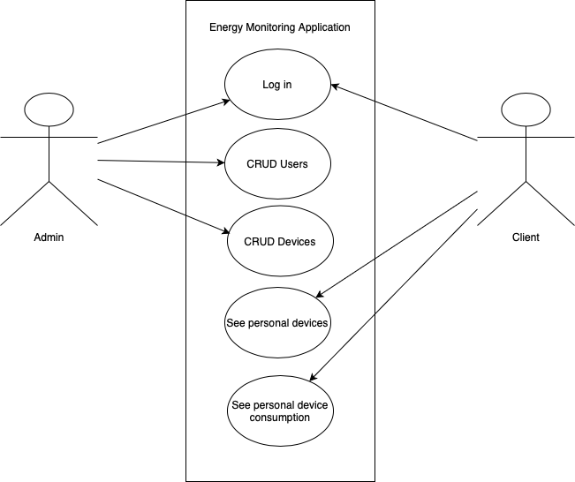

Above we can see the use-case diagram displayed, showing all the user functionalities which have been previously mentioned.

III. Architecture

The following conceptual architecture diagram explains the design of this application:

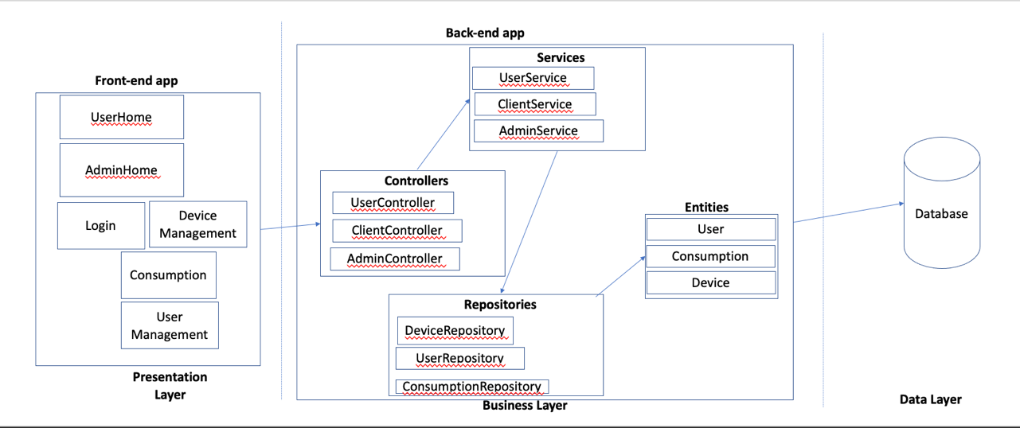

Below, we can observe the CI/CD architecture of the project, split into three docker containers: one for the MySql database, one for the Spring back-end of the application and finally a container for the react front-end of the application.

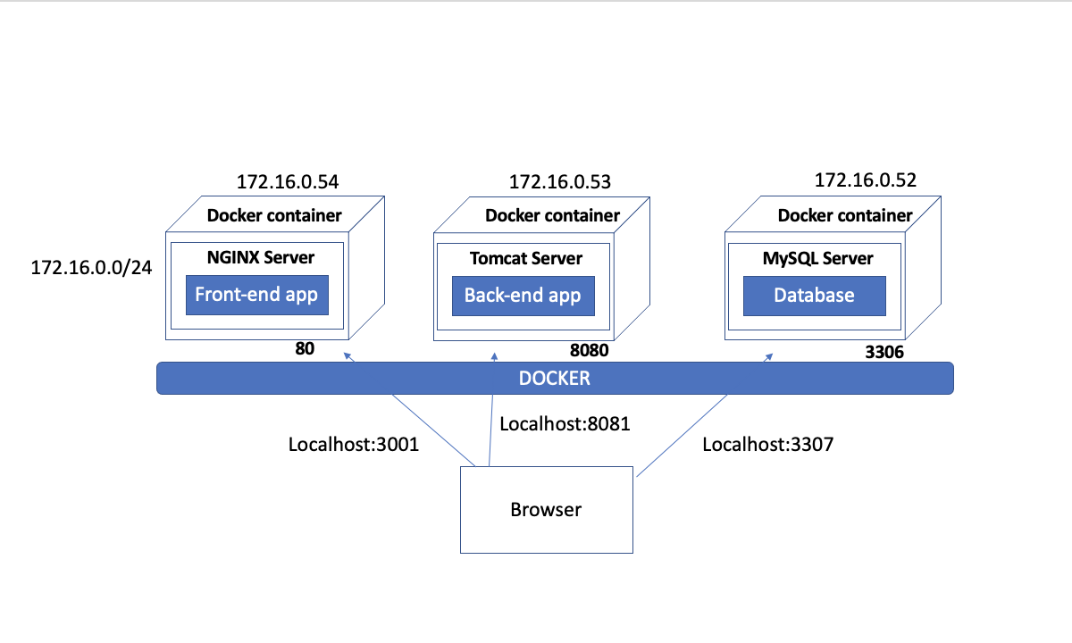

IV. Supplementary specifications

Among the non-functional requirements of this application, we could mention:

* The interface should be easy to understand and use, by being expressive.
* The text should be easy to see and read for the general user.
* The user should be able to click on the proper date that they wish to select.

V. Testing

For the testing of this application various data has been introduced into the database, and tested from the user interface (website), as well as through Postman requests.

Among further developments I could mention improving the aspect of the graphical user interface, improving the security of the application