Github and GitLab Overview

Alejandro Martinez

East Los Angeles College

CIS 112: JavaScript Programming

Professor Rodriguez

Introduction

Event listeners are the most important part of javascript. They allow you to manipulate what a user is seeing based on what they are doing and what they have triggered. The following definitions will be used:

1. A trigger is used to trigger a specified event
2. An event is something like a click or submit that is being tracked by a listener
3. A listener is watching for events. If a certain form is submitted or a section is clicked, it allows a certain portion of code to activate.

For this assignment I will be demonstrating the power of event listeners by demonstrating the event listeners used in my connect 4 game made from HTML, CSS, and JavaScript. There are a few different event listeners that I am using in this project.

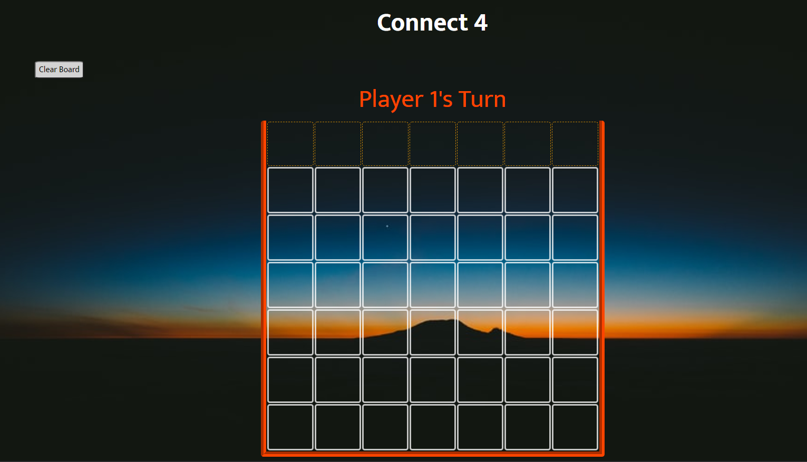

The first thing the player will see is an empty board but if they hover over the top row of translucent squares the first event listener activates from the hover.  
 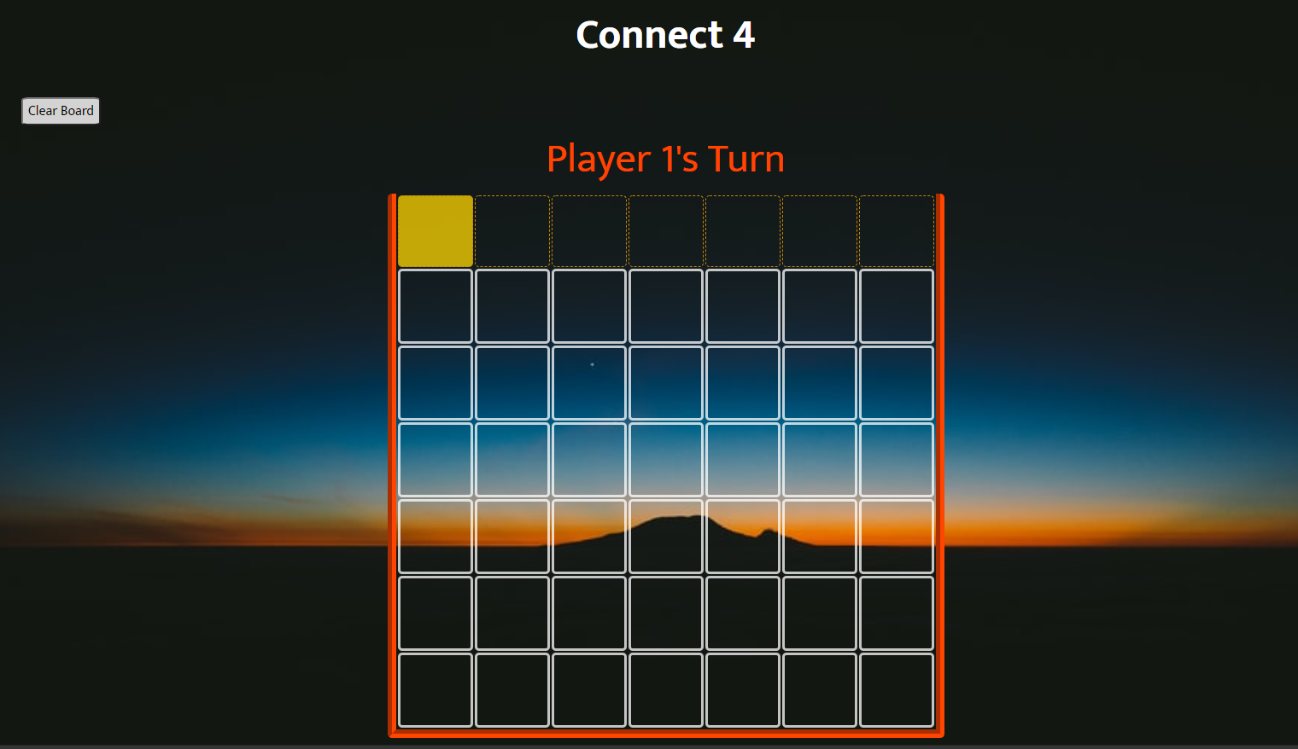

A square highlights over the hovered tile and indicates which column will be dropped into if clicked on. So now if a user clicks on one of the squares a piece will drop with an animation and that is an example of a click event.

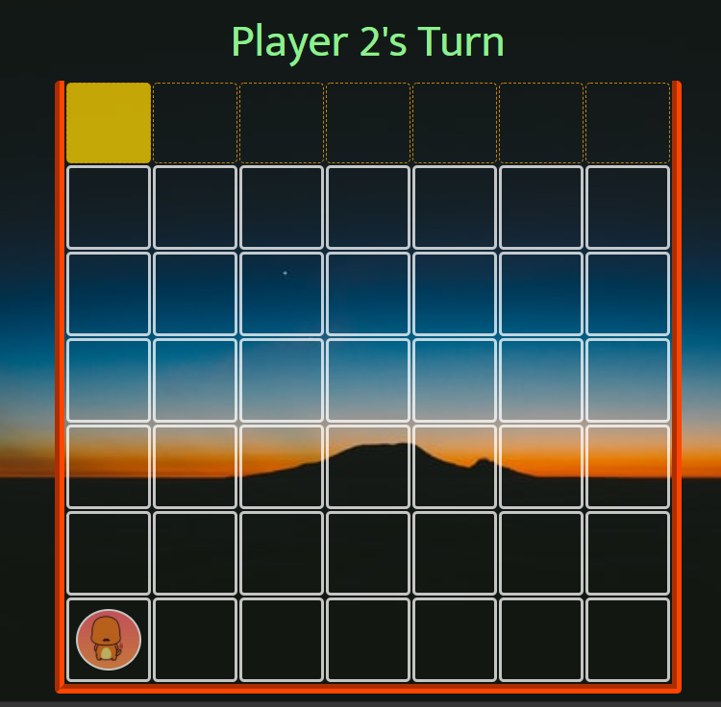

There are three things that are tied to the event listener of a click. The first thing it does is drop the piece in the selected column and first it checks to make sure the column has space, second checks to see if a win condition is met, and then finally switches to player two and that is indicated in the top row above the board. This process continues back and forth triggering the same event listeners as the game goes on. Once a win condition is met then another trigger has occurred and a few more things happen.  
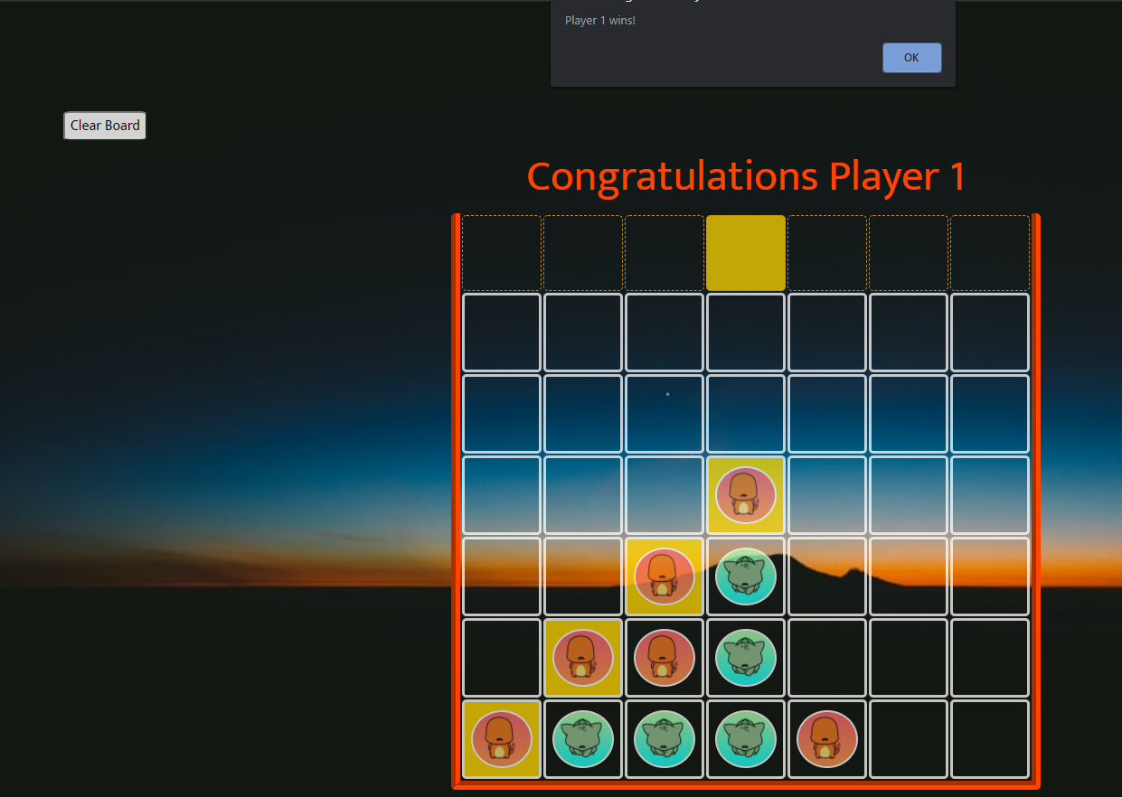

We can see that the event listeners trigger the win condition to be shown, an alert pops up to declare a winner, the message indicating the players turn changes and now all of the tiles are disabled so that no more clicks will be registered. The player can push the clear board button and it listens for a click that is waiting to clear the board to start the game over. Event listeners are very powerful and are really behind the popularity of JavaScript. Being able to create elements on a page without refreshing is really at the core of what JavaScript is about.

# References

Duckett, J. (n.d.). JavaScript and jQuery. In J. Duckett, *Interactive Front End and Web Development.*