Nutrientry: Fasting and Calorie Tracker

Alejandro Martinez

East Los Angeles College

CIS 112: Javascript Programming

Professor Rodriguez

Abstract

The form regarding a user’s health is progressing and now has all the math behind it working. By inputting a user’s physical information they are able to get a lot of information about their current health and where they need to go. There is a keto calorie breakdown for people that are choosing to go keto with their diet which can aid in rapid weight loss with long term health benefits of training the body to better use fat reserves rather than burning glucose for energy.



Figure : Calculate Health Stats Page

The form is being generated using the WTForms library in python and the math was being done with javascript but I decided to focus more on keeping that information in the database we have setup so I converted the code to python instead. There is a lot of calculations happening behind the scenes to get all of the information for a user including TDEE,BMI,Ideal Weight for a user, and how long it would take with an ideal diet to get to their healthy weight. 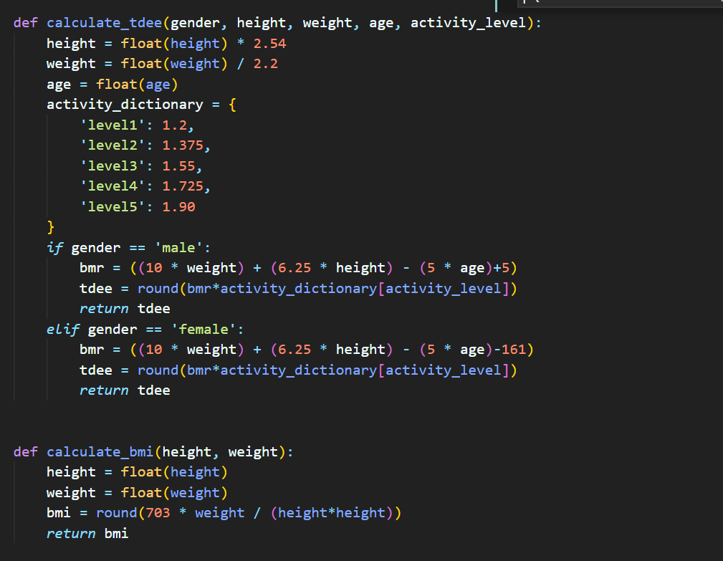

Figure : Functions for Calculating Health Levels

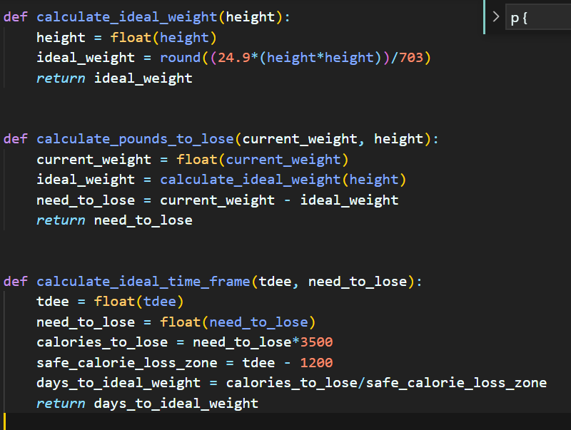

Figure : Additional Health Functions

Once a user submits their information on the calculate health page, we add those stats as the current stats for a user if previous stats already exist, if they don’t exist and the user tries to go to the dashboard they are instead redirected and told to input their stats otherwise no information can be displayed for them.

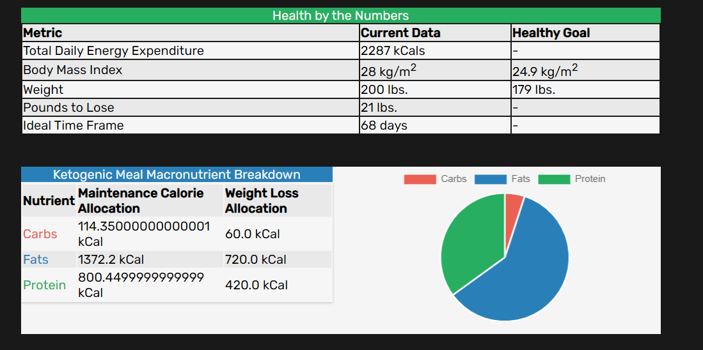

Figure : Dashboard Information

The dashboard provides a user with all of the information that they might need to make goals for themselves. I am using chart js on this page to dynamically display the information regarding the different Macronutrients.

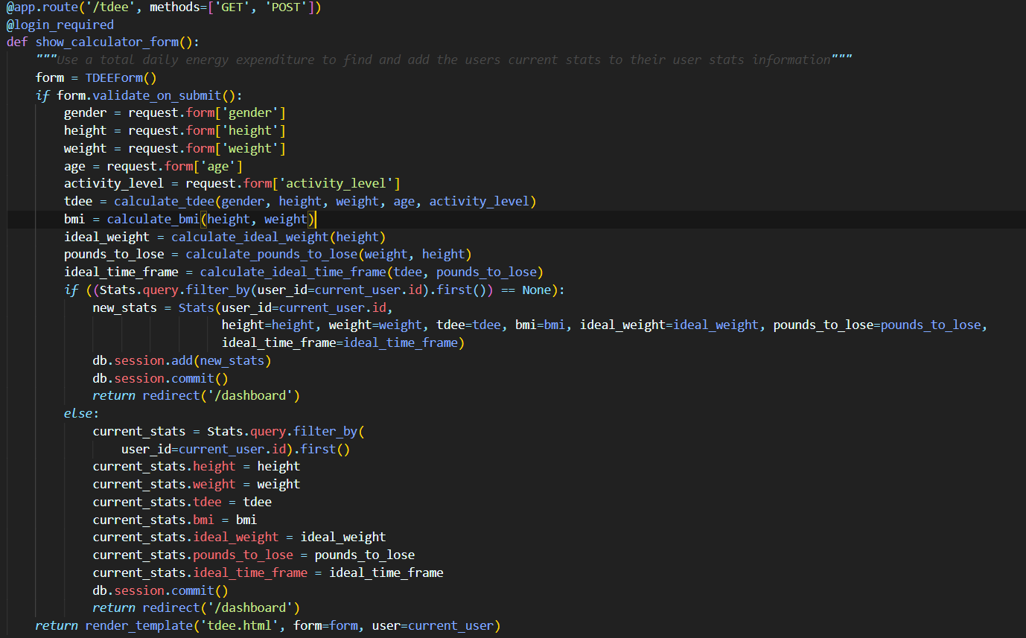

Figure : Logic behind the dashboard

Nutrienty Proposal

# References

(n.d.). Retrieved from Fat Secret: https://www.fatsecret.com/Diary

(n.d.). Retrieved from Lose It!: https://www.loseit.com/

Kruger, J. (2006, July 19). *Dietary and physical activity behaviors among adults successful at weight loss maintenance*. Retrieved from Springer Link: https://link.springer.com/article/10.1186/1479-5868-3-17

UnderArmour. (n.d.). Retrieved from My Fitness Pal: https://www.myfitnesspal.com/food/diary