Bootstrap: A CSS Framework

Alejandro Martinez

East Los Angeles College

CIS 112: Javascript Programming

Professor Rodriguez

Abstract

Bootstrap 4 (Soon to be Version 5) is a css framework that makes quick work of many tasks that would be more time consuming without the use of Bootstrap. Bootstrap is ideal for making quick projects look presentable but you might find yourself trying to customize Bootstrap rather than just writing the CSS from scratch.

Bootstrap works by providing a large css file that the user can draw certain classes from to give everything a uniformed look as long as the user follows the documentation. The different classes allow the user to achieve a good looking product very quickly. As can be seen in the example below:

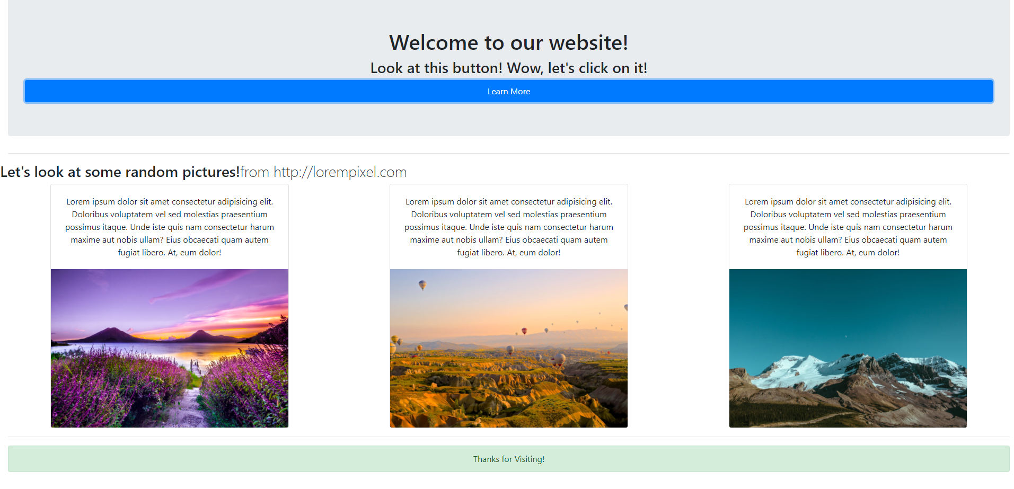

Figure : Bootstrap example

By providing a user a means to access an easy form of styling, than that lets a person focus more on the layout and user experience portion of a web app or project. I will use bootstrap when starting with a project if I need to show someone, specifically because it gives everything a more easily polished look. One of the best things about bootstrap is how simple it is to use. You can just copy the examples from the documentation and strip away features or pieces of the component that you do not need. When using Bootstrap I highly recommend using it with the documentation open. There are certain elements in HTML that can be a bit of a pain to style but bootstrap makes it all easy.   
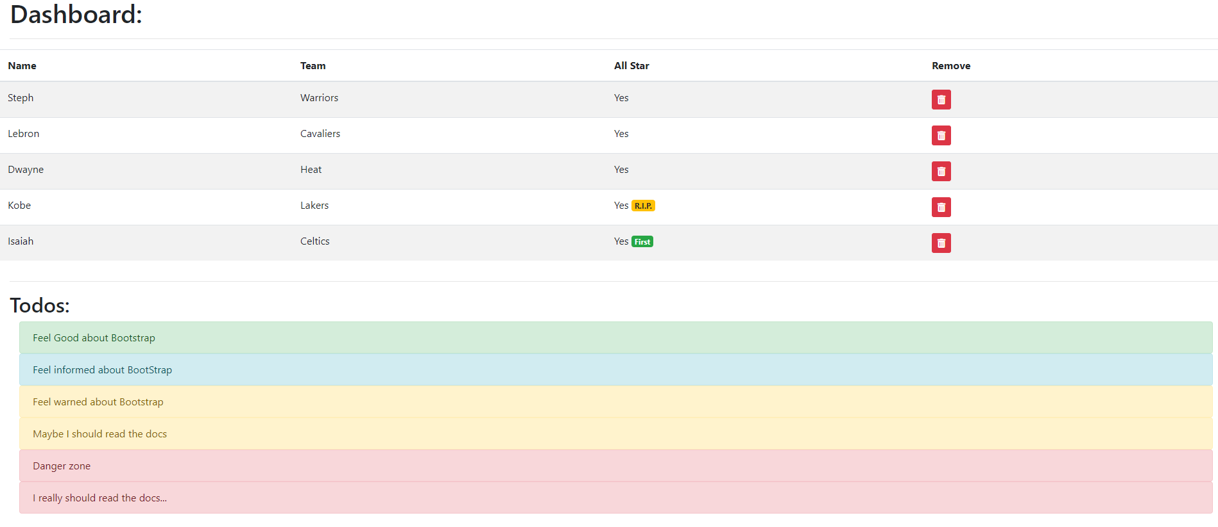

Figure : Bootstrap Table Example

As we can see in the above example it styles a table very uniformly and we can even apply colors and certain stylings to specific by giving objects that class. In the above example you can see the alerts are different colors which are being given by giving the div a class of “alert danger” or “alert warning” or “alert success”. Depending on the color you want you can assign these colors to the different elements. Bootstrap also works very well with fontawesome. Font awesome is an icon library but the characters are seen as text so you can also color the icon by giving it a class. It is really useful for this kind of short term project and prototyping.

Bootstrap Overview

# References

(n.d.). Retrieved from Bootstrap4 Docs: https://www.getbootstrap.com/