# Progress Report Two

**Subject**: First Report of Fall 2020

October 19th, 2020

To: xshan@uh.edu cc: peiuh4@gmail.com mailto:

Dr. Xiaonan Shan

4796 Calhoun Rd,

Room W306 Houston, TX 77004

Dr Shan,

Thank you for your guidance on this project throughout the previous semester. While we have faced many obstacles with the ongoing pandemic and shipping of parts for our prototype, I am pleased to say that we are remaining on schedule! Our team has been hard at work ensuring that we meet our timeline and that all of our research meets your expectations. We can say, with confidence, that we have nearly completed phase two of the deliverables and we are nearing our first flight tests.

Within this report, you will find all of the information related to our past progress and the timeline for the prototype completion. All of these reports have been completed to our personal quality standard, and I can personally assure you that everything is in place for a final, successful semester. Within the appendix of this report, you can find previous report material for ease of access.

Thank you once again for the advice and time that you have committed to this project throughout the 2020 school year. We look forward to programming, constructing, and testing our quadcopter so that it may suit your research purposes. We hope that our further contributions to this project will allow you to better carry out your research and help the Greater Houston Area.

All the best,

Alex Magyari, Leslie Nix, Ai Nguyen, and Sang Nguyen

**University of Houston**

**Cullen College of Engineering**

# 9/21/2020

**Autonomous Aerial Vehicle for Real-Time Air**

**Quality Measurements**

**Team 10**

**Sponsor: Dr. Xiaonan Shan**

**Project Manager: Dr. Pei**

**Team members: Alex Magyari (Team Leader)**

**Leslie Nix**

**Sang Nguyen**

**Ai Nguyen**

Abstract

In 2019, Dr. Xiaonan Shan, professor in Electrical Department in University of Houston, worked on the project to create a Real-Time Air Quality Measurement Sensor. This project will provide an aerial transportation method for that sensor. Based on the sensor’s specifications, our unmanned aerial vehicle (UAV) is designed to carry up to a 1000 [g] load. The UAV is designed as a self-navigating quadcopter which will be able to fly through a potentially chaotic environment while the UAV operator remains at a safe distance. The drone is constructed using a polycarbonate frame with the dimensions being just large enough to safely secure the air quality sensor. Based on the design, the drone has a thrust-to-weight ratio of 1.9 and can produce 5416 [g] of lifting capacity. It will operate at forward speed of 6-10 [m/sec] and an operation range only limited by battery capacity. The drone uses a MSP432 LauchPad for the flight control unit, a SparkFun Dead Reckoning GPS module for self-navigation, CC2650M for the BlueTooth module, and a 9 degreeof-freedom gyroscope sensor. The flight code is designed in modular fashion which will separate the program into individual blocks to allow ease of use. The users can communicate to the drone via the built-in BLE module to add or remove GPS waypoints for the drone to navigate. The goals of this project are divided into 2 semesters. For the first semester (Spring 2020), the team needs to achieve goal for module designs; for the second semester, we need to combine modules with the microcontroller and complete all tests for the drone. We have currently achieved all goals for first phase including the project timeline, application interface, and a fully researched parts list.

## 1. Purpose

The overall purpose of this project is to provide an aerial transportation method for a preexisting air quality sensor package developed by Dr. Shan’s team. Specifically, the transportation method must be unmanned and have the ability to be operated from a significant distance so as to ensure the operator’s safety.

## 2. User Analysis and Product Specification

The customers for this product can range from research teams to government agencies to environmental agencies to members of the private sector who want to ensure their factories are meeting environmental regulations. This product will be used to transport an air quality sensor over a use- guided path. It is essential that the user can operate the system from a significantly far distance so that they do not inhale any airborne particles that the sensor will be detecting. Three final deliverables are expected: a physical transportation unit that will carry the air-quality sensor, an onboard controller to move the transportation unit, and a controller that the user can utilize to interact with the transportation system.

## 3. Overview Diagram

The overview diagram in Figure 1 displays the interactivity between all final deliverables of the project. These deliverables will work in harmony to ensure that an operator can control the quadcopter from a significant distance relative to the quadcopter’s area of operation.

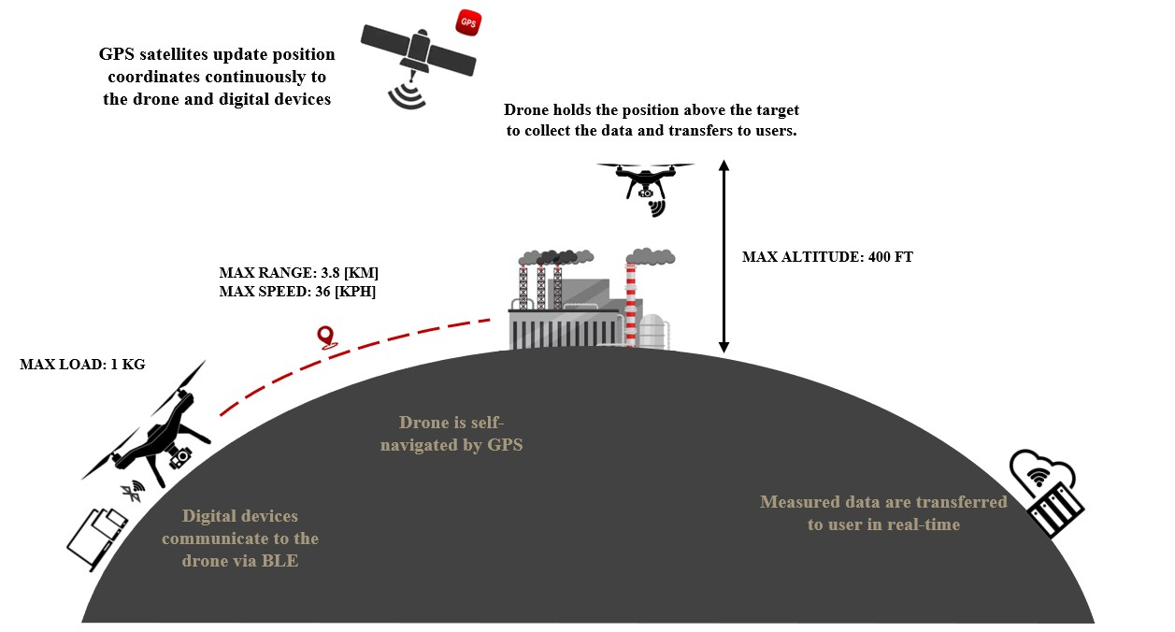

**Figure 1:** Overview Diagram of Autonomous Aerial Vehicle for Real-Time Air Quality Measurements.

## 4. Design Considerations

To organize the goals of project, the design is divided in two parts: the flight control unit, or the microcontroller, and physical drone construction. In this project, the design for flight control unit will be concentrated in low energy consumption by using components and programs which are optimized for energy consumption. Therefore, the large portion of the energy provided by the battery will be used for rotors, in turn extending the time flight.

Based on the Overview Diagram, the drone’s microcontroller is designed to incorporate following features: wireless communication via Bluetooth Low Energy, GPS (global positioning system) Navigation, and motor control via high frequency pulse width modulation. The largest concern with our microcontroller is its compatibility with external modules, such as BLE and GPS capabilities. The microcontroller’s specifications have to meet requirements such as ease of use/handle so that the operator can control the drone. The minimum frequency of the Pulse Width Modulation from the controller must meet 16 [MHz] for as this is the required frequency for the motors. Further, the board must have various types of memory, such as flash, Read Only Memory and Ready Access Memory so that all of the information obtained from the sensors and Bluetooth module can be stored for quick access by the flight control unit. The flight control unit must also have a minimum 40 General Purpose Input/Output Pins, as the number of sensors and motors required for this project will need at most 40 pins. Following our research, the MSP432P401R LaunchPad andTM4C123G LaunchPadare best suited for our requirements. The MSP432 LauchPad has the highest level of consideration, as it uses less power than the TM4C123G and has more GPIO ports.[1]

For the wireless communication feature, we decided using a BLE module that is easily incorporated with the MSP432, the BOOSTXL-CC2650MA board. As stated before, low energy consumption is the main concentration for choosing features, Bluetooth Low Energy consumes an insignificant amount of energy, so much so that it is inconsequential. Further, the BLE module must use a Bluetooth controller version 4.0 or higher. Similarly, to BLE, GPS Navigation must follow requirements such as ease of use, reliable, optimize cost, high performance and it must be compatible with MSP432.

The second part of our design is drone construction. As stated in the purposes section, the drone’s mission is to carry the real-time sensor to the position dictated by the user. Therefore, the drone mechanism must be designed to be able to lift the weight, which includes the weight of drone itself and the weight of the sensor. Based on the measurement of the sensor provided by Dr. Shan, the dimensions are approximately 5 [in] x 5 [in], and its mass is about 500 [g]. From those measurements, we have decided that the drone will be a quadcopter. The quadcopter design has proven to be sturdy enough to carry loads similar to the sensor, and can provide stability at medium-to-low altitudes.

According to our research and sensor dimension, the frame for quadcopter must be a minimum 5 [in] x 5 [in] to fit the sensor. However, due to the concern of the weight, we decided that the size should be as close to 5 [in] x 5 [in] as possible. Arguably, the most important aspect of the drone construction is the four rotors with their most distinguishing property bring the thrustto-weight ratio. Our research shows that we should aim for the thrust-to-weight ratio to be anywhere from 1.8 to 2 [2]. That number is determined because it satisfied our design requirements which are able to carry the sensor, perform a flight under a light breeze, and minimize the weight of four rotors as well as the project’s cost.

To pick the right motor, we must prioritize the thrust which it can produce along with the weight and cost of the motor. Our estimation shows that the total weight of drone combined with the sensor is about 1300[g]. Therefore, with the thrust-to-weight ratio being anywhere from 1.8 to 2, each motor must produce around 1.25 [kN] of thrust [3]. To achieve this, the rotor must spin from 25000 to 30000 [revolutions/minute]. To achieve that value, our motors need to have a minimum 2500 [Kv] and to be operated in a range of voltage from 10 [V] to 12 [V] [4]. Of course, the chosen rotors have to meet all specifications which are listed above and be under our budget.

The next part in drone construction that must be considered is the battery. The battery needs to be chosen carefully because it provides the energy for the entire system, and any flight failures due to the battery malfunctioning can cause the entire system to fail. Based on the specification of the drone, we decided using a Lithium Polymer battery, having at least 6 cells and 1500mAh for capacity. 6S Lithium Polymer can provide potential up to 22.2 [V] which satisfies for rotor operation, and 1500mAh can provide enough energy to the drone for 30 minutes of continuous flight. The battery must be light-weight since this will likely be the heaviest part of the drone. Besides those parts which we have listed above, there are several parts like general LED’s for a system heartbeat, a power distribution board, plastic rotors for the motor, and basic wiring. However, these parts consume an arbitrarily small amount of energy and an inconsequential weight, so they will be chosen only to fit the general requirements of drone.

## 5. Constraints

**Table 1** Constraints and factors

|  |  |  |
| --- | --- | --- |
| **Constraint** |  | **Limiting Factors** |
| **Flight Time** | • | Battery Life |
|  | • | Drone Speed |
| **GPS Accuracy** | • | Weather |
|  | • | Distance to satellite |
| **Budget** | • | Sponsor Donations |
|  | • | Department Contribution |
| **Time to Prototype** | • | CoVid-19 |
|  | • | Parts ordering |

Table 1 summarizes the constraints in our project that need to be considered and addressed to ensure the project’s success. First is the flight time, one of the main features of drone. There are many factors that affect flight time, such as drone's weight, weather, drone's speed, drone's battery quality, … Our drone is expected to fly about 16.5 minutes, enough to complete a round trip to the specified destination.

Second is the GPS Accuracy: The navigation system may not work properly because at some locations the GPS signal is unstable. What user receive depends on additional factors, including satellite geometry, receiver design features/quality, and weather conditions (such as chemical fire, acid rain).

Next is Budget. Budgets can come from many different sources. Some are from the student's own pocket, but this source is quite limited. Some are from the department but must wait for approval. It also may come from donations of sponsors, but this source is difficult to find.

The last one is Schedule. Due to the Covid pandemic, the schedule was slightly pushed back. Meeting is not easy, and the lab is only open at certain times. Therefore, our schedule is restricted more so than it would have been during a typical semester.

## 6. Deliverables

Our project has two main deliverables: the application to control with the drone, and the drone itself. While the air quality sensor is the primary motivation for this project, it has already been designed and tested by Dr. Shan’s research team. Instead, we will be focusing our efforts on the design and implementation of the drone and the method in which the user controls it.

The method for the control of the quadcopter will be via GPS coordinates sent from a user control application. The motivation for using an application is that it will one, keep costs low as near everyone has access to a smart phone, and two, there are a vast array of widely available application design tools that we can use to implement a solution that is both easy to program and is intuitive for the user. The application will only have a few primary functions: selecting GPS coordinates via Google Maps API, deciding the hoover time for each position, and all data are uploaded to the drone's flight controller via Bluetooth Low Energy.

The second deliverable, the drone meant to carry the load of the air-quality monitor, will be the main focus of our work. The flight controller will operate the drone motors, adjusting the speed of each individual motor so as to alter the motion of the drone so that it moves to each coordinate. The flight controller must have Bluetooth capabilities so that it may receive the coordinates from the application. The drone has GPS function to determine its position in realtime and send to flight controller to control direction of the drone. Our final demonstration will show the drones ability to maneuver to each individual uploaded GPS coordinate along with its ability to carry the air-quality monitor.

This product will have a few main specifications that differentiate it from typical drones.

These specifications can be seen in Table 2.

**Table 2** Drone specifications.

|  |  |
| --- | --- |
| KEY SPECIFICATIONS | |
| **Maximum Distance** | ~4 miles round trip* |
| **Maximum Battery Life** | 16.5 [min]* |
| **Application Controlled** | Yes |
| **On-board GPS** | Yes |
| **On-board Bluetooth (BLE)** | Yes |
| **Weight (No load)** | 3.4 [lbs] |
| **Single or General Purpose** | Single Purpose |

The key specification of the drone is that its maximum distance is not limited by the ability to communicate with the user, which is the downfall of the standard drone. Since this design features autonomous control, the maximum distance is only limited by the battery life. The maximum distance and maximum battery life of the drone are evaluated based on a 4-Cell 1500mAh battery, operation at 14.8 [V], net weight (with load) of 4.4 [lbs] and a maximum battery discharge of 90%. These values can be improved by upgrading the battery with higher capacity with inconsequential of weight. The application is designed as mobile UI app which can be installed on any Android, iOS, or Google device.

## 7. Test Plan

Figure 2below depicts the projects goals for the remainder of the project timeline which is more fully described in Section 6. Schedule, below. Due to time constraints and logistical challenges encountered during the Spring 2020 semester, several goals which were originally slated for Spring 2020 completion have been delayed to the current semester. Remaining originally planned Fall 2020 goals are depicted in blue. The team remains confident that the project target objective will be completed on-time due to the work performed on other project tasks through the Summer 2020 break.

The target objective for this project is as follows: after receiving a set of GPS coordinates representing the desired flightpath from the user, the quadcopter and its real time sensor package load will begin to follow the desired flightpath within a three-meter margin of error in each direction (latitude, longitude, and altitude) at a forward flight speed of 2-4 [m/sec]. After completing the flight, the quadcopter will return to land at its starting location.

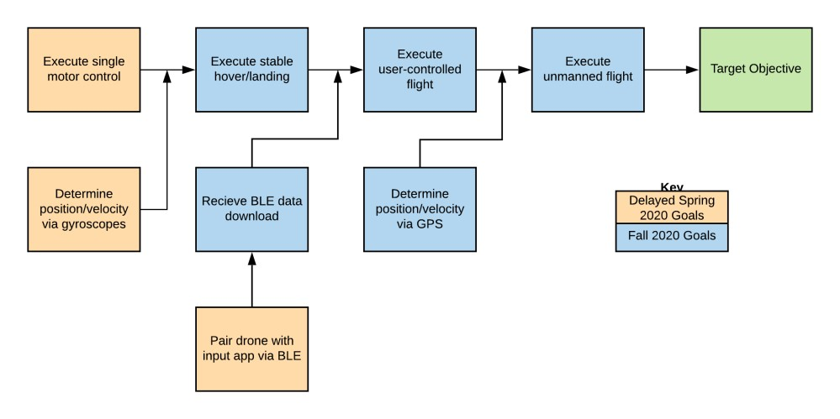

**Figure 2:** Goal Analysis

Tables 3 and 4, below, indicate the requirements for each of the goals outlined in the Goal Analysis (Figure 2).

**Table 3.** Test plan for outlined goals, part 1/2.

|  |  |  |  |  |
| --- | --- | --- | --- | --- |
|  | **Execute Single Motor Control** | **Determine position/velocity via gyroscopes** | **Pair drone with**  **input app via**  **BLE** | **Execute stable hover/landing** |
| **R**  **e q u**  **i**  **r e**  **m**  **e n**  **t s** | Able to drive the motor in both positive and negative directions up to 2500 rpm | Able to calculate current velocity, position, and orientation within  250ms | Establish communication between phone application and quadcopter Bluetooth module | Able to take off, hover at 2 meters for 1 minute in still (indoor) conditions while carrying sensor package |
| Motor speed and direction is made selectable, within 5 rpm, by varying the input signal from the flight controller |  |  | Gyroscope data does not show deviations in relative orientation of more than 5 degrees |
| The thrust produced by the motor achieves the desired thrust-to-weight ratio of 1.8 – 2.0 |  |  |  |

**Table 4.** Test plan for outlined goals, part 2/2**.**

|  |  |  |  |  |
| --- | --- | --- | --- | --- |
|  | **Receive BLE data download** | **Execute user-controlled flight** | **Determine position/velocity via GPS** | **Execute unmanned flight** |
| **R**  **e q u**  **ir e**  **m**  **e n**  **ts** | Able to receive data from app with minimal packet loss and load data into flight controller software | Able to be flown in still (indoor) conditions at a forward and climb speed of 2-4 m/sec while carrying load | Able to determine position via GPS module with 3 meters accuracy and import data into flight controller software | Able to follow a provided flight path in still (indoor) conditions within a 3 meters margin of error |
|  | Able to execute shallow turns,  lateral and vertical movement in response to user input via BLE with low latency (less than 500ms) |  |  |

## 8. Schedule

An overview of the updated project’s planned schedule is shown in **Figure 3**, below.Further, a summary of the task completion status can be seen in **Table 5**.

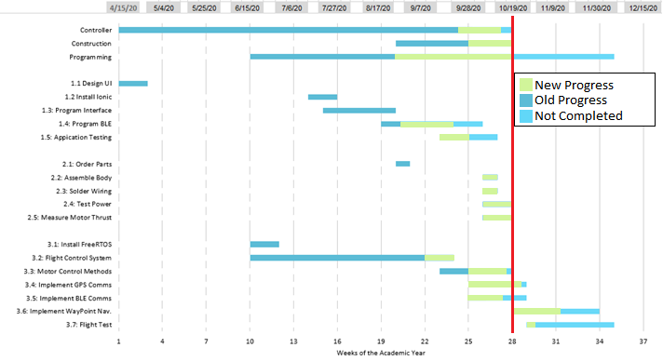

**Figure 3:** Overview of Fall 2020 Project Schedule

**Table 5:** Table of Tasks for the Project.

|  |  |  |  |
| --- | --- | --- | --- |
| TASK | SUB-TASK | ACCOMPLISHEMENTS | ROADBLOCK |
| Application Controller | UI Design | Previously Completed |  |
| Ionic Installation | Previously Completed |  |
| Program Interface | Previously Completed |  |
| BLE-Programming |  | Waiting on BLE from FCU |
| Application debugging | Thoroughly tested multiple use cases |  |
| Construction | Order parts | All parts received |  |
| Assemble body | Body assembled |  |
| Solder Wiring | All components connected, wrapped | Inappropriate ESC firmware – purchased new ESCs |
| Test Power, Measure Thrust | Completed sweep of motor function with oscilloscope input  All motors operating independently | Battery failures – purchased new batteries |
| Flight Controller | Install Free RTOS | Previously Completed |  |
| Program Flight Control System | Installed I2C for peripherals  Installed UART for PC debugging |  |
| Program Motor Control Methods | Programmed PWM signal |  |
| Implement GPS Communication | Programmed NMEA decoder  Programmed GPS input signal |  |
| Implement BLE Communication | Established the connections  Send and Receive signals | Lack of knowledge and documentations about BLE. |
| Implement Waypoint Navigation | Constructed the waypoint navigation method |  |
| Perform Flight Test |  | Wait for drone built. |

### 8.1. Drone Controller

The drone is controlled via a mobile application, as the user will select GPS waypoints within the application and upload them to the drone over BLE. The only portion of this task that was designated for semester one was the UI design, a task that was successfully completed. The proposed application layout can be seen in section A6.1.

Come the start of the Fall 2020 semester, the task of developing the application controller remained. Since then, the majority of the application has been completed. Features such as the ability to add or remove drone waypoints, edit hover times at set waypoints, drag waypoints to new positions, reset GPS coordinates, estimate drone battery usage in relation to the flight path, and modify various features pertinent to drone operation have all since been implemented.

Screenshots from the developed application can be seen in Figure 3. Figure 3 a displays the basic layout of the application. The interactive map can be seen at the top of the screen, with four user defined waypoint positions. The fire location can also be seen on the map. Figure 3 b displays the popup when a user adds or edits a waypoint; here, the user can change how long the drone hovers at the set location and records air quality data. Figure 3 c shows the remaining interface not visible in the previous images. This displays the drones estimated flight time, battery usage, and buttons to modify drone parameters such as weight, battery size, and travel speed.

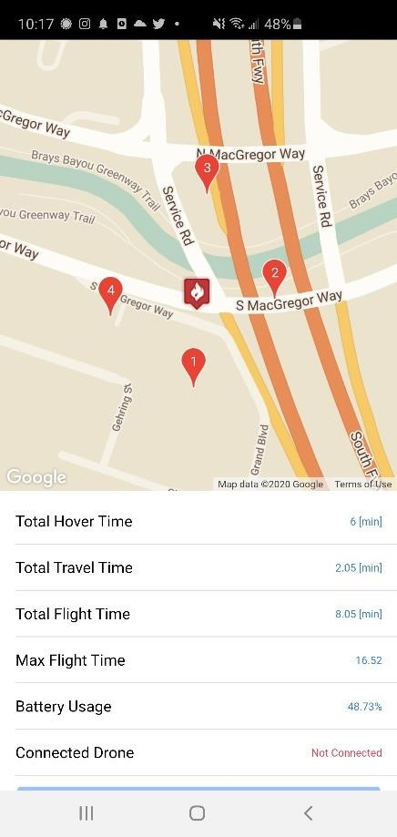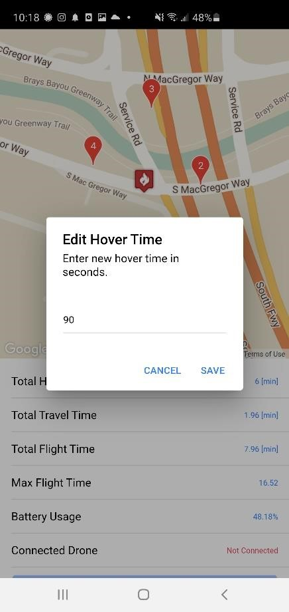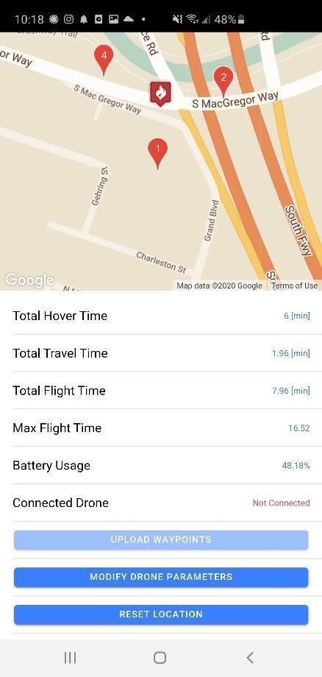

**a) Application Map b) Waypoint Edit c) Button Interface**

#### Figure 3 – Developed Drone Control Application

The sole remaining task for the application is the integration of BLE, as that is a feature than cannot be successfully constructed until the flight control unit has the capability to communicate via BLE. Once the drone can send and receive Bluetooth characteristics, the application will have a clear development path for Bluetooth operation. Until that point, we as the development team do not have a way to test Bluetooth communication, and therefor do not wish to develop a potentially erroneous communication protocol.

### 8.2. Construction

Construction of the quadcopter body, including soldering of components and insulation of those connections, has been completed. Although some difficulties arose upon testing of the electronic speed controllers (ESCs) gifted to the team by the department, which required an attempt to replace the proprietary firmware on these components, construction of the quadcopter was completed ahead of schedule after ordering new ESCs with an appropriate firmware already installed, as well as additional batteries due to battery charging faults. Additionally, all motors were able to be calibrated and controlled individually using an external source (oscilloscope), as well as measurement of each motor’s thrust output to ensure the desired thrust-to-weight ratio outlined in the test plan (Table 3, above). The team’s progress in this task has resulted in early completion of all subtasks, and therefore no future work is expected in this task area.

### 8.3. Programming

The project has seen good progress in this task since the closing of the Spring 2020 Academic term. Specifically, significant progress was made in regards to the installation of the flight computer operating system as well as the design, modeling, and simulation of the flight environment: this includes both the linear control models for tuning of various autonomous flight parameters as well as a nonlinear simulation model to reduce the time and burden of testing the physical hardware. Additionally, the flight control system contains the framework for processing incoming sensor data, making the hardware integration subtasks more straightforward. The remaining subtasks and their associated completion requirements as outlined in the aforementioned test plan in Tables 3 and 4 are as follows: implementation of the motor control methods (Execution of Single Motor Control, Determine Position/Velocity via Gyroscopes, Execute Stable Hover/Landing); establishing GPS and BLE communications (Pair Drone with Input App via BLE, Receive BLE Data Download); implementation of the GPS Waypoint navigation (Determine Position/Velocity via GPS), and a final series of flight tests (Execute User-Controlled Flight, Execute Unmanned Flight).

## 9. Budget

The total budget allowance for this project, as determined by discussions between the team, the project sponsor, and the University of Houston Department of Electrical and Computer Engineering is $500US. Additional expenditures due to the inappropriate firmware on the ESCs, which required new ESCs to be ordered, as well as additional batteries, has increased the total expenditures of this project to approximately $250, leaving a net balance of $250. The total budget overview is shown in Figure 4, below.

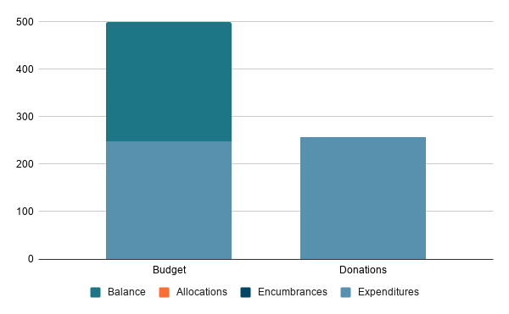

**Figure 4:** Total Project Budget for Autonomous Air-Quality Sensing Quadcopter

**10. Standards**

Various standards, from both the government and private sector, have guided our planning and construction process. A summary of those standards can be seen in **Table 5**.

**Table 5**. Drone's Standards from Government and Retail Market

|  |  |
| --- | --- |
| **Drone’s Standards** | |
| **Government Drone Standards** | **Retail Drone Standards** |
| **Weight:** 55 lbs (25kg)  **Groundspeed:** 100 mph (87 knots)  **Altitude:** 400 feet Above ground level  **Minimum weather visibility:** 3 miles  **Schedule:** 30 minutes before official sunrise to 30 minutes after official sunset. | **Standard Flight Time:** 15 minutes  **Standard Control Method:** RC Controller  **Typical Features:**   * Camera * Interchangeable Batteries * Possible app interaction * Flight stabilization * Auto-Landing Feature |

**a) Government’s standard**

Air transport is not as complicated and dangerous as road transport or maritime transport, but it also needs to follow strict regulations from the government to maintain a safe airspace for not only you, but others flying as well. Here are some basic rules for small unmanned aircraft from Part 107 Guidelines from FAA (Federal Aviation Administration).

The total weight including the drone, its attached systems, payload and cargo should not exceed 55 lbs. Although the drone's engine is developing day by day, that doesn't mean it can carry a large payload. The weight limit makes the drone fly more stable and the user can control it more easily.

Maximum groundspeed of 100 mph and maximum altitude of 400 feet above ground level. The higher the fly, the more likely the drone is to crash with a civil aircraft or helicopter. The regulation of altitude and speed limits aims to ensure not only the safety of the flying vehicles but also the safety of people.

Flight time is daylight-only operations, meaning 30 minutes before sunrise until 30 minutes after sunset. Users cannot see the drone's vision directly but have to go through the camera and GPS. Therefore, flying at night or in low light conditions makes it impossible for the user to have a sweeping view and to be unable to fully control the drone.

Users must stand in an open place and have a good view to make sure the flight is conducted within visual line of sight and avoid standing on moving vehicles or aircraft. In addition, the user must also guarantee the drone is not flying too far where the user is standing.

As with any vehicle, a drone operator needs a license and a drone needs to be registered. The drone user is either licensed or supervised by a licensed drone user. You need to be over 16 years old, pass knowledge and practice tests from the FAA to be awarded a license.

**b) Retail Drone Standards**

According to the FAA (Federal Aviation Administration) in 2018, there were more than 1 million registered drones, including 122,000 public and commercial drones. The FAA also predicts that the number will rise to 4 million by 2021. With the advancement of technology, drones become cheaper and cheaper, leading to widespread use and ease of control. Like the government, the drone retail market has its own set of rules.

The battery quality is improving day by day, the world record for the longest flight time of a drone up to 4 hours and 40 minutes. However, the average flight time of a consumer drone is still between 10 and 20 minutes. It sounds short, but it is suitable for short-term drone purposes such as photography, video recording, surveillance, research, or inspecting.

Drone controllers work by sending radio signals from the remote control to the drone and telling it what to do. That is why the drone controller is called the RC controller. Each remote control has different features, but all have the basic features, such as the left stick of controlling the drone up and down or spinning; the right stick is to redirect the drone to left to right, backward or forward. Some controllers also feature GPS to track the drone's location, BLE for receiving drone signals and data, and a monitor so users can use a smartphone to fly FPV (first person view).

There is a stereotype that every drone has a camera attached. This is not true because depending on the intended use the drone will or may not have a camera. However, it does speak of the importance and popularity of camera drones. The camera is used by both professional and amateur drone users. Cameras make it possible for drones to take pictures, record videos, collect data and events without the need for giant and complex flying vehicles like helicopters. Camera type, video resolution, megapixels and media storage format those are the user's requirements when investing in the camera on the drone.

In addition to the above features, the retail drone market has rules about batteries that can be interchangeable, as long as it fits the drone in terms of physical size, capacity, and voltage which gives the drone enough power to fly further and longer. Another feature is the interaction between the drone and the smartphone, which makes it possible for the user to store images and data from the drone, or locations the drone flies over. Another important feature is the ability to automatically balance and stabilize in flight, or the ability to land safely.

**11. Risks**

The mitigation plan for each of the risks outlined in **Figure 5**. Briefly, the most severe risk identified (Unable to correctly flash ESCs) was indeed encountered by the team and mitigated by the purchase of new ESCs, as described inSection 8.2 of this report as well as in **Table 6**. This risk will therefore be removed from future reports. The further risks identified by the team are currently being considered and mitigated as outlined in **Table 6** primarily by prioritizing the completion of the task involved and adding additional logic to the flight control software.

|  |  |  |  |  |  |  |
| --- | --- | --- | --- | --- | --- | --- |
| Probability | 5 |  |  |  |  |  |
| 4 |  |  |  |  |  |
| 3 |  |  | BLE not implemented | Power failure during flight test | Unable to correctly flash ESCs |
| 2 |  |  |  | Motor control logic not implemented |  |
| 1 |  |  | Application controller sends incorrect GPS waypoints |  |  |
|  | 1 | 2 | 3 | 4 | 5 |
| Consequence | | | | | |

**Figure 5:** Probability and its consequence from Risk Management

**Table 6.** Risk Mitigation Strategy

|  |  |
| --- | --- |
| Risk, by Severity | Mitigation Plan |
| Unable to correctly flash ESCs | Purchase new ESC hardware with proper firmware |
| Power failure during flight test | Implementation of low battery voltage flight abort procedure |
| Motor control logic not implemented | Prioritize task; use manual flight control |
| BLE not implemented | Prioritize task; use direct flight controller programming |
| Application controller sends incorrect GPS waypoints | No action required |

## 12. Conclusion

The purpose of our project is to design and implement an Autonomous Aerial Vehicle for RealTime Air Quality Measurements. Over this past month, we have made progress with both product planning and product construction. With regards to planning, we have evaluated multiple risks and developed unique mitigations plans. With regards to construction, we have completed the drone build, enabled all motor functions, implemented the GPS module, gyroscope, and altimeter. Before our next report, we are anticipating running our first flight tests.

Aside from the risks identified in the risk matrix, we do not see any true obstacles to the completion of this project. We are, by our own measurement, firmly ahead of schedule. We have full confidence that the project will be completed before the conclusion of the semester.

## APPENDIX I

### A1. Drone Performance Calculations

The motion of the drone is represented in Newton’s Second Law with the following diagram:

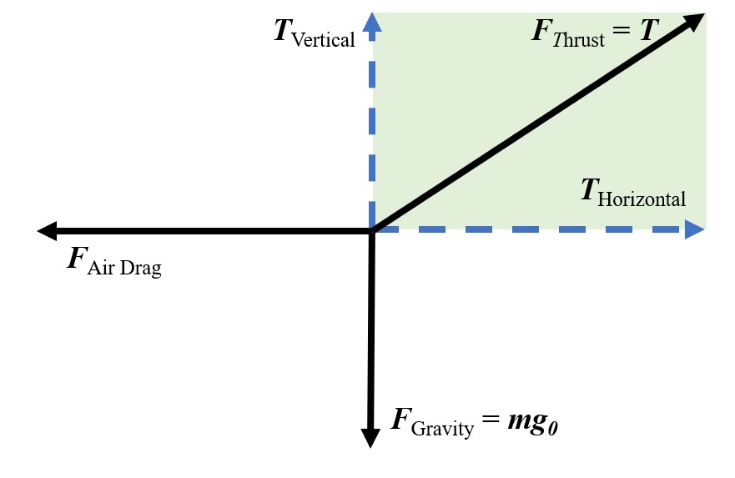

*Figure A.1: Motion Model Analysis Diagram.*

𝐹𝑇ℎ𝑢𝑟𝑠𝑡 − 𝐹𝐺𝑟𝑎𝑣𝑖𝑡𝑦 − 𝐹𝐴𝑖𝑟𝐷𝑟𝑎𝑔 = 𝑚𝑎

Derived Equations from Newton’s Second Law analysis [6]:

𝐹𝑇𝑂 = 𝑔𝑇0

−1 (𝑚)

𝑃𝑚𝑎𝑥 = 𝑐𝑜𝑠

𝑇0

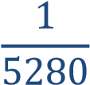 𝑣𝑚𝑎𝑥 = 𝑉𝑙𝑜𝑎𝑑. 𝑘𝑣. 𝑃𝑖𝑡𝑐ℎ. . . sin(𝑃𝑚𝑎𝑥) .

2.

𝑣 = 𝑎0 + 𝑎. 𝑡

𝐹𝑇 = 𝐹𝑇0. (𝑣𝑚𝑎𝑥 − 𝑣𝑛−1) − 𝐹𝑑𝑛 −1

𝑣𝑚𝑎𝑥

𝐹𝑑 =  . 𝜌. 𝐶𝑑 [(𝐴𝑓𝑟𝑜𝑛𝑡. 𝑐𝑜𝑠(𝑃𝑚𝑎𝑥 − 𝑃𝑚𝑜𝑡𝑜𝑟)) + (𝐴𝑡𝑜𝑝. 𝑠𝑖𝑛(𝑃𝑚𝑎𝑥 − 𝑃𝑚𝑜𝑡𝑜𝑟))] . 𝑣𝑛2−1

𝑻𝟎 = 𝑡𝑜𝑡𝑎𝑙 𝑡ℎ𝑟𝑢𝑠𝑡 𝑜𝑓 𝑚𝑜𝑡𝑜𝑟 [𝑘𝑔]

𝑭𝑻𝟎 = 𝐹𝑜𝑟𝑐𝑒 𝑜𝑓 𝑡ℎ𝑢𝑟𝑠𝑡 (𝑖𝑛 𝑛𝑒𝑤𝑡𝑜𝑛𝑠)𝑎𝑡 0 𝑣𝑒𝑙𝑜𝑐𝑖𝑡𝑦

𝑭𝑻 = 𝑛𝑒𝑡 𝑓𝑜𝑟𝑐𝑒 𝑜𝑓 𝑡ℎ𝑢𝑟𝑠𝑡 𝑖𝑛 𝑛𝑒𝑤𝑡𝑜𝑛𝑠

𝑭𝒅 = 𝑑𝑟𝑎𝑔 𝑓𝑜𝑟𝑐𝑒

𝑷𝒎𝒐𝒕𝒐𝒓 = 𝑝𝑖𝑡𝑐ℎ 𝑎𝑛𝑔𝑙𝑒 𝑜𝑓 𝑡ℎ𝑒 𝑚𝑜𝑡𝑜𝑟 𝑟𝑒𝑎𝑙𝑡𝑖𝑣𝑒 𝑡𝑜 𝑡ℎ𝑒 𝑓𝑟𝑎𝑚𝑒𝑠 ℎ𝑜𝑟𝑖𝑧𝑜𝑛𝑡𝑎𝑙 𝑎𝑥𝑖𝑠 𝑷𝒎𝒂𝒙 = 𝑚𝑎𝑥 𝑝𝑖𝑡𝑐ℎ 𝑎𝑛𝑔𝑙𝑒 𝑤𝑖𝑡ℎ𝑜𝑢𝑡 𝑙𝑜𝑠𝑖𝑛𝑔 𝑠𝑙𝑡𝑖𝑡𝑢𝑑𝑒

𝑘𝑔

𝝆 = 𝑎𝑖𝑟 𝑑𝑒𝑛𝑠𝑖𝑡𝑦 = 1.225 𝑚3

𝑪𝒅 = 𝑑𝑟𝑎𝑔 𝑐𝑜𝑒𝑓𝑓𝑖𝑐𝑖𝑒𝑛𝑡, 𝑣𝑎𝑟𝑖𝑒𝑠 𝑏𝑦 𝑜𝑏𝑗𝑒𝑐𝑡 𝑠ℎ𝑎𝑝𝑒

𝑨𝑓𝑟𝑜𝑛𝑡 = 𝑎𝑟𝑒𝑎 𝑜𝑓 𝑡ℎ𝑒 𝑓𝑟𝑜𝑛𝑡 𝑜𝑓 𝑡ℎ𝑒 𝑞𝑢𝑎𝑑 𝑖𝑛 𝑚2

𝑨𝑡𝑜𝑝 = 𝑎𝑟𝑒𝑎 𝑜𝑓 𝑡ℎ𝑒 𝑡𝑜𝑝 𝑜𝑓 𝑡ℎ𝑒 𝑞𝑢𝑎𝑑 𝑖𝑛 𝑚2

𝑚

𝒈 = 𝑔𝑟𝑎𝑣𝑖𝑡𝑦 = 9.81 𝑠2

𝒕 = 𝑡𝑖𝑚𝑒 𝑖𝑛 𝑠𝑒𝑐𝑜𝑛𝑑𝑠

𝒎 = 𝑚𝑎𝑠𝑠 𝑜𝑓 𝑞𝑢𝑎𝑑 𝑖𝑛 𝑘𝑔

𝒗𝒎𝒂𝒙 = 𝑚𝑎𝑥 𝑎𝑡𝑡𝑎𝑖𝑛𝑎𝑏𝑙𝑒 𝑣𝑒𝑙𝑜𝑐𝑖𝑡𝑦 = 𝑣𝑒𝑙𝑜𝑐𝑖𝑡𝑦 𝑤𝑖𝑡ℎ 𝑛𝑜 𝑑𝑟𝑎𝑔 𝑓𝑜𝑟𝑐𝑒 𝒗 = 𝑣𝑒𝑙𝑜𝑐𝑖𝑡𝑦

𝒗𝒍𝒐𝒂𝒅 = 𝑏𝑎𝑡𝑡𝑒𝑟𝑦 𝑣𝑜𝑙𝑡𝑎𝑔𝑒 𝑢𝑛𝑑𝑒𝑟 𝑙𝑜𝑎𝑑

𝑷𝒊𝒕𝒄𝒉 = 𝑝𝑟𝑜𝑝𝑒𝑙𝑙𝑒𝑟 𝑝𝑖𝑡𝑐ℎ

𝒂 = 𝑎𝑐𝑐𝑒𝑙𝑒𝑟𝑎𝑡𝑖𝑜𝑛

|  |  |  |  |  |  |  |  |  |  |
| --- | --- | --- | --- | --- | --- | --- | --- | --- | --- |
| **Frame Info** | **Frame Weight** | **Frame Height** | **Frame length** | **Frame width** | **Arm Length** | **Arm**  **Height** | **Arm Width** | **Cd** | **ρ** |
| 0.285 [kg] | 80 [mm] | 340 [mm] | 340 [mm] | 254  [mm] | 6 [mm] | 10 [mm] | 1 | 1.2  [kg/m3] |
| **Motor/Prop Info** | **Motor Diameter** | **Motor Height** | **Motor Voltage** | **Pitch** | **Thrust per**  **Motor** | **Motor angle** | **Battery Weight** | **Cells** | **VLoad** |
| 29.5  [mm] | 19.5 [mm] | 2550 [kv] | 6’’ | 1.354 [kg] | 400 | 0.256 [kg] | 6 | 13.6 [V] |
| **Calculated Values** | **Area Top** | **Area Front** | **Vmax m/s** | **Theoretical Vmax** | **Total T** | **Max Time** | **Max Drag** | **Max MPH** | **Max KPH** |
| 0.126 [m2] | 0.033 [m2] | 67.92 [m/s] | 151.94 [m/s] | 5.416 [kg] | 15 [mins] | 2.15 [kg] | 62.47 | 100.53 |

**Table A.1**: The theorical calculation data for drone specifications.

Table A.1 the input values and calculated values of drone specifications using equations which derived from Newton’s Second Law. The calculation using the hardware specification and average value for drag coefficient like. The calculation is calculated at max value for drone performance; therefore,Vload is used 13.6 [V] which is the idle operation voltage for motor. The flight time is calculated based on 1.3 [A] for idle current of motor, and four motor consume

66.66% power of entire system.

**A2. Notable Flight Code Subsystems**

Figures A.2 and A.3 depict Simulink block diagrams of the notable Flight Code subsystems.

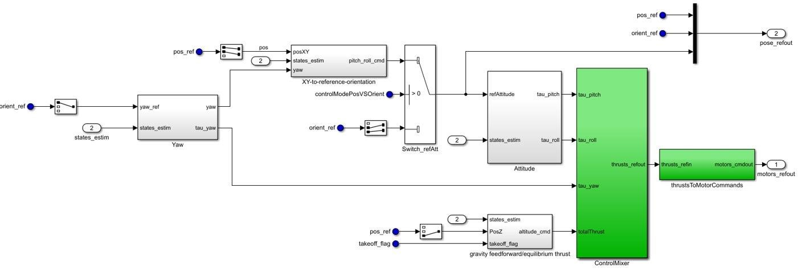

**Figure A.2:** Flight Controller Block Diagram

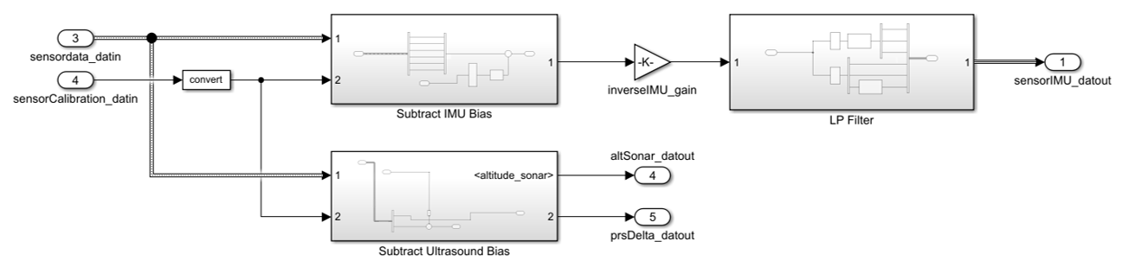

**Figure A.3:** Sensor Processing Block Diagram

### A3. Current drone regulations (Old Information)

* Fly at or below 400 feet
* Keep your drone within sight
* Don't fly in restricted airspace
* Don't fly near other aircraft, especially near airports
* Don't fly over groups of people
* Don't fly over stadiums or sports events
* Don't fly near emergency response efforts such as fires
* Don't fly under the influence

### A4. Problem and Need (Old Information)

Frequent chemical fires in the Houston area leave local residents wondering which, if any, hazardous materials they may be exposed to, and accurate real-time measurements allow for more accurate responses from emergency responders and local authorities to keep citizens safe while responding to the dangers imposed by the fire.

The current project sets out to learn which aerosolized byproducts are produced from chemical fires in real time while keeping human operators at a safe distance. To obtain measurements throughout the potentially contaminated site, an airborne transportation vehicle for a real-time sensor package would be the only appropriate choice given the spatial dimensions of a fire and resulting smoke plume – namely altitude. Correlating these measurements with the aerial vehicle’s flight path allows for quick tracking of air quality, which is of primary concern to both emergency responders as well as citizens who live or work in the area near such fires. In this way, this project has the potential to limit the human suffering caused by these tragedies.

### A5. Deliverables (Old Information)

Our project has two main deliverables: the application to control the drone, and the drone itself. While the air quality sensor is the primary motivation for this project, it has already been designed and tested by Dr. Shan’s research team. Instead, we will be focusing our efforts on the design and implementation of the drone and the method in which the user controls it.

The method for the control of the quadcopter will be via GPS coordinates sent from a user-controlled application. The motivation for using an application is that it will one, keep costs low as near everyone has access to a smart phone, and two, there are a vast array of widely available application design tools that we can use to implement a solution that is both easy to program and is intuitive for the user. The application will only have primary functions: selecting GPS coordinates via Google Maps API and uploading those coordinates to the drone's flight controller via Bluetooth Low Energy. During our final demonstration, we will show all views available in the application and discuss how the user interacts with them to control the drone.

The second deliverable, the drone meant to carry the load of the air-quality monitor, will be the main focus of our work. The flight controller will operate the drone motors, adjusting the speed of each individual motor so as to alter the motion of the drone so that it moves to each coordinate. The flight controller must have Bluetooth capabilities so that it may receive the coordinates from the application. Our final demonstration will show the drones ability to maneuver to each individual uploaded GPS coordinate along with its ability to carry the airquality monitor.

## A6. Engineering Specifications

### A6.1 Drone Hardware and Sensors

There are many specifications to keep in mind when building a drone. Depending on the intended use, the way to choose materials is also different. Table 1, below, summarizes the two general aspects of the project: the physical parameters and the quadcopter’s performance.

* Size: Because the primary purpose of this project is to carry the air quality sensor, we have chosen a frame that is large enough to attach each of the four motors and be capable of lifting itself and the 2 [kg] air quality sensor. Therefore, we have selected a 34 [cm] x 34 [cm] frame, and after adding a sensor, the height would be around 80 [mm].
* Flight time: Given the objective forward flight speed of no more than 10 [m/s] and the calculated current draw from the battery, as well as the air quality testing constraints of potential users, the drone will be able to deliver a maximum 15-minute flight time.
* Battery: The chosen battery a Lithium-Ion Polymer (Li-Po) which is capable of providing more power due to its higher capacity and a lower internal resistance at a reduced weight compared to other battery chemistries.
* Range: To ensure the safety of the quadcopter operator as per our user’s required product specifications, the project require a large range of operation. Due to the limitations imposed by the maximum forward speed and flight time, the drone is only able to operate at a maximum straight-line distance of 1 [km], with the usable range dependent on the specific waypoints chosen by the user.

**Table 1.** Hardware Specifications

|  |  |  |  |  |
| --- | --- | --- | --- | --- |
| **Physical Specification** | **Frame Dimension** | 33.4 [cm] x 33.4 [cm] | **Motors** | 34,680 RPM [MAX] |
| **Total Weight** | 2795 [g] (sensor is attached) | **Propeller – length** | Diameter: 8" |
| Pitch: 6" |
| **Drone Weight** | 795 [g] | **Microcontroller** | MSP432 |
| **Drone Height** | 80 [mm] | **GPS Module** | NEO-6M |
| **Wheelbase** | 472 [mm] | **BLE Module** | CC2650 |
| **Thrust-to-**  **Weight Ratio** | 1.9 | **Gyroscope Sensor** | PMU6500 |
| **Performance** | **Maximum Speed** | 36 km/h | **Altitude** | 122 [m] |
| **Operation Distance** | Up to 1000 [m] | **Operation Temperature** | 50 to 120 [°F] |
| **Thrust** | 5.416 [kg] | **Battery** | Lithium-Ion 6S  (22.2V,  1550mAh) |
| **Flight Time** | Up to 13 minutes | **Wind Speed** | 7 to 11 [km/h] |

Figure 2, below, shows the theorical calculation for performance of the velocity versus the acceleration and distance based on classical Newtonian dynamics. The four motors provide total 5.416 [kg] of thrust at maximum performance, and this amount of thrust provide the force for drone reach maximum acceleration 15.408 [m/s2] at start time. After that, the velocity of the drone increases rapidly while acceleration decrease due to decrement of the thrust. The slope of velocity curve decreases after 2.5 [seconds], and at this time the velocity reaches 23.59 [m/s2]. After that, the velocity curve increases slowly and stabilizes at 3.5 [seconds]. After this time, the velocity of the drone changes negligibly and reaches maximum speed at 4 [seconds]. At this time, the drone has traveled approximately 90 [m]. However, in the high-fidelity simulation of the overall system, the model is unable to afford these theorical values nor are they necessary for achieving our product specifications.

**Figure 2:**

Performance of Quadcopter Dynamics

0

10

20

30

40

50

60

70

80

90

100

0

0.5

1

1.5

2

2.5

3

3.5

4

**Drone Speed Performance**

Acceleration

Distance

Velocity

[

m/s

]

[

m/s

2

]

[

m

]

Figure 3, below, shows the hardware layout and the construction of the drone. The carbon fiber frame is the backbone of the drone. Each motor is attached to the end of each arm of the frame. The center part, consisting of the Power Distribution Board and the battery, is the heart of the drone. From this “heart,” the power source is distributed all over the drone, helping the drone to operate smoothly. The BLE module received signals from the user so that the drone can be programmed to follow specific waypoints. The GPS module allows the quadcopter to determine its current position, which further allows it to faithfully follow the pre-programmed waypoints provided by the user. Additionally, an inertial measurement unit (IMU) consisting of three gyroscopes and a three-directional accelerometer to determine each of the six degrees of motion, as well a barometer/thermistor and ultrasound module to determine altitude are required for proper operation and stabilization of the quadcopter. Each of these modules are connected to the drone's "brains," an MSP432 Launchpad with different wires. The MSP432 contains the flight code, which accepts and stores the waypoints determined by the user and adjusts the rotation speed of each motor, thereby controlling the speed and direction of travel of the drone.

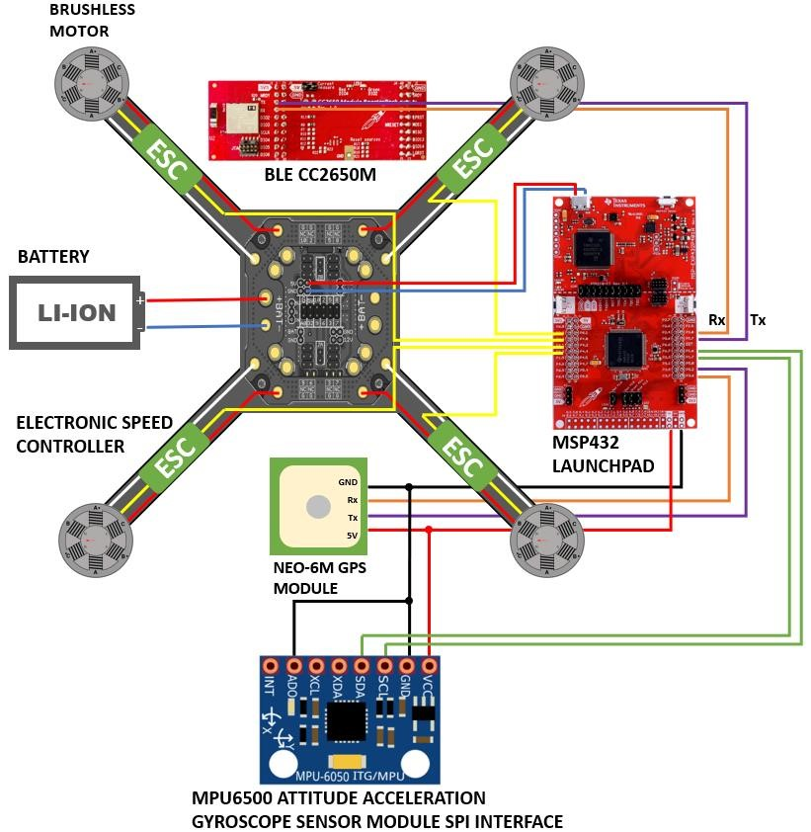

**Figure 3:** Hardware Construction Diagram

### A6.2 Flight Code

For this deliverable, the flight code, depicted in Figure 4, is the software that will run on the quadcopter’s processor and autonomously control its flight per the user’s instructions. The flight code was built in Simulink as part of the model that will be used for testing and verification of the product. Table 2, below, outlines the product specifications for this subsystem.

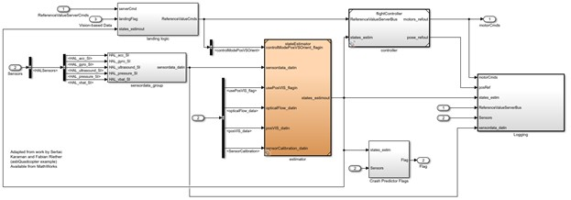

**Figure 4.** Simulink Model of Flight Code

**Table 2.** Flight Code Specifications

|  |  |
| --- | --- |
| **Specification** | **Description** |
| Modular Design | Each function within the flight code will be contained to its own programmatic “block” to allow ease |
| Data Logging | Logging of actual flight data into a *.mat file which can be uploaded from the quadcopter after flight. Logged data includes the motor commands issued by the flight controller, the position and orientation of the quadcopter, the estimated states of the system (roll, pitch, yaw, and three-dimensional position), and the output data from the system. |
| Abort Procedures | The flight code includes logic to immediately attempt to land the quadcopter should an outlier condition be observed. These conditions include a forward velocity of more than 10 [m/sec], an altitude of less than 2[m] while not executing take-off or landing, a deviation of more than 15[m] from the intended flight path, or a deviation of more than 20% of the estimated states of the system compared to the measured states determined from the sensors. |
| Flight Controller | Tuning of the flight controller prioritizes stable, level flight (deviation of no more than 5 degrees for relative orientation) by ensuring no steady-state error and minimizing the step- |
|  | response rise time (< 2 seconds) and maximum overshoot (<10%) of each individual controller (6 total). |

### A6.3 Application

The application will be used to upload GPS coordinates to the drone. Application requirements and performance metrics are outlines in Table 3**.**

**Table 3 –** Application Requirements

|  |  |
| --- | --- |
| **Requirement** | **Description** |
| BlueTooth Connectivity | The mobile application will communicate with the Flight Control Unit via Bluetooth transmission. New flight coordinates and hover times for each coordinate will be uploaded to the drone over BlueTooth communication. The coordinates and flight timing must be uploaded to the drone with 100% accuracy. |
| Ability to add/remove GPS Coordinates | The user must be able to both add and remove GPS coordinates in a path so that they can dictate where the drone flies so that it may log air-quality data. Without the ability to add and remove waypoints, the user will not have a way to direct where the drone flies. The user must be able to input and edit at least 20 different waypoints, with each waypoint including latitude and longitude positional data. |
| Map View and List View of GPS  Coordinates | The map and list views will provide ease of access for viewing and editing the flight path data. The map will provide a view of the drone route, and allow easily placed waypoints. The list will be a comprehensive view of all the points the drone will fly to and how long it will hover there to collect data. The map and list must show every waypoint that the user has input. |
| Select Hover Time for Each Coordinate | When the user places a new waypoint in the path for the drone, they must select how long the drone should hover in place to log sensor data. This is to prevent the drone from flying the path too quickly without logging enough data. |

The features outlined in Table 3can be compiled into one comprehensive application that the user can easily navigate, displayed in Figure 5. This figure outlines the expected display of the application, along with button and grid layouts. The **‘+’** button on the map will allow the user to add new waypoints by touching a location on the map, and the **‘–’** button will allow the user to remove waypoints by touching the waypoint they would like removed. Further, when a user inserts a new waypoint, they will be asked to input a hover time for that particular point. A summary of each point will be displayed in the list view below the map, where a user will also be able to edit waypoint information.

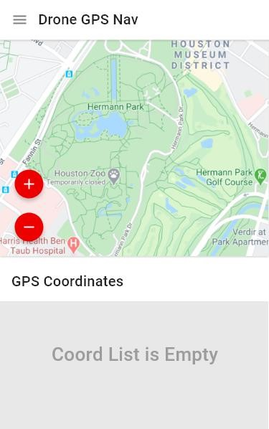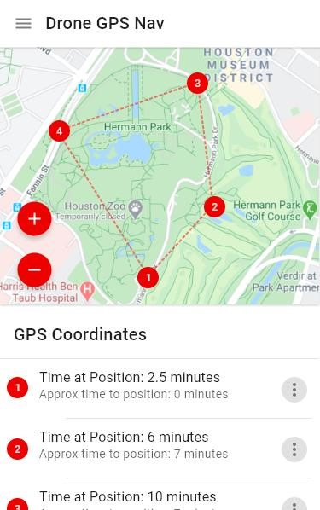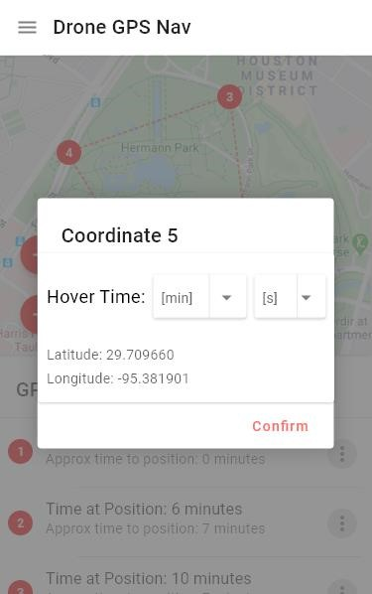

**Figure 5 –** Application-Visuals Expectations Outline

### References

|  |  |
| --- | --- |
| **[1]** | “SimpleLink™ MSP432P401R high-precision ADC LaunchPad™ Development Kit MSP-EXP432P401R This product has been released to the market and is available  for purchase. For some products, newer alternatives may be available.,” *MSPEXP432P401R SimpleLink™ MSP432P401R high-precision ADC LaunchPad™ Development Kit | TI.com*. [Online]. Available: [http://www.ti.com/tool/MSPEXP432P401R#technicaldocuments.](http://www.ti.com/tool/MSP-EXP432P401R#technicaldocuments) [Accessed: 05-Apr-2020]. |
| **[2]** | “Thrust to Weight Ratio,” *NASA*. [Online]. Available:  [https://www.grc.nasa.gov/www/k-12/airplane/fwrat.html.](https://www.grc.nasa.gov/www/k-12/airplane/fwrat.html) [Accessed: 05-Apr-2020]. |
| **[3]** | *Estimate Propeller Static Thrust*. [Online]. Available:  [https://rcplanes.online/calc_thrust.htm.](https://rcplanes.online/calc_thrust.htm) [Accessed: 05-Apr-2020]. |
| **[4]** | Jack, “Brushless Motor KV To RPM Calculator,” *Quadcopter diy, quadcopter controller knowledges build quadcopter and quadcopter design by yourself*, 16-Aug2017. [Online]. Available: [http://www.rcdronegood.com/brushless-motor-kv-to-rpm/.](http://www.rcdronegood.com/brushless-motor-kv-to-rpm/) [Accessed: 05-Apr-2020]. |
| **[5]** | *“Lumenier QAV-RXL 2 - 10"* FPV Quadcopter Frame,” GetFpv. [Online]. Available:  [https://www.getfpv.com/lumenier-qav-rxl-2-10-fpv-quadcopter-frame.html.](https://www.getfpv.com/lumenier-qav-rxl-2-10-fpv-quadcopter-frame.html) [Accessed: 05-Apr-2020]. |
| **[6]** | “Part 7: The Equations for Speed,” *Quadstar Drones*, 12-Mar-2020. [Online].  Available: https://quadstardrones.com/the-equations-for-speed/. [Accessed: 01-May-2020]. |