Steps. Week 1.

*Steps to perform various tasks related to the introductory topics.*

**Steps to establish an account on Overleaf (**[**https://www.overleaf.com/**](https://www.overleaf.com/)**)**

* Go to <https://www.overleaf.com/> and sign up/sign in
* Upon signing in you will be directed at your dashboard with all of your project summarized in the right panel.
* Use “New Project “ button on the upper left to start a new document
* You can prepare your latex documents on this web page, download them, invite people to collaborate, keep track of corrections and so on.

**Steps to establish account on XSEDE** (<https://www.xsede.org>)

* Go to <https://www.xsede.org>
* Establish account on XSEDE
* E-mail Dr. Alekseenko your login name, so that he can add you to the allocation
* When allocation will be active you will receive and e-mail inviting you to establish an account on Bridges (<https://www.psc.edu>) which is part of Pittsburgh Supercomputing Center (PSC)
* Enroll in XSEDE DUO Multi-Factor Authentication system by visiting <https://portal.xsede.org/mfa/> and following the enrollment steps. Using a smartphone is probably the easiest way to authenticate.

**Steps to establish account on Bridges** (<https://www.xsede.org>)

* Once you added to the Bridges allocation by Dr. Alekseenko, XSEDE will notify PSC about that and they will assign you a login name (may be different from XSEDE login name) and send an e-mail with invitation to set up an account. It will look something like this:   
  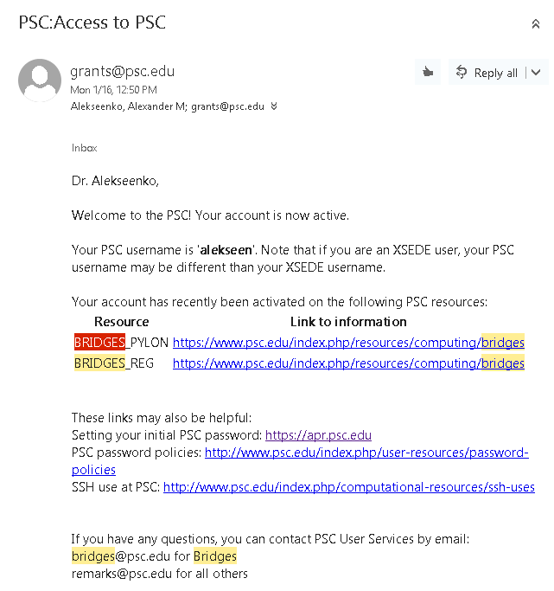
* If necessary go to <https://apr.psc.edu> to set up your password.
* You should now be able to log in to Bridges using either XSEDE account or the PSC account. (see steps on logging in later)

**Steps to download an ssh shell for windows from CSUN IT:**

1. Go to <https://www.csun.edu/itr/downloads/index.cgi>.
2. Log in using your CSUN credentials
3. Download SSH Secure Shell Client
4. Install SSH Secure Shell Client

**Steps to download PUTTY**

Putty is a command shell for windows that can be used to connect to remote computers and to start programs, move files etc.

Here is the link that came from Wikipedia page for Putty. However, please use antivirus and other precautions to make sure the software is not rigged.

<http://www.chiark.greenend.org.uk/~sgtatham/putty/download.html>

**Steps to download FILEZILLA**

Filezilla is a software for Windows that allows to transfer files between your windows computer and a remote computed using secure protocols.

Here is a link to download Filezilla. As before, use precaution when installing the software, use antivirus to check that downloaded files are safe.

https://filezilla-project.org/download.php?type=client

**Steps to log in to an XSEDE computer**

There are at least three ways to log in into an XSEDE computer. We will describe two: (a) using SSH Secure Shell and XSEDE login portal, (b) by logging into a Pittsburgh Supercomputer Center (PSC) computer using XSEDE login and password and (c) by logging into a PSC computer using PSC login and password. Note that XSEDE has other computer systems (other than PSC). Other computer systems may have different way to log in. Although there should not be too different.

*Accessing PSC Bridges through XSEDE portal. Windows users*

1. Start either SSH Secure Shell Client or Putty.
2. If this is your first login or if you did not save the connection to the profile you may want to safe the login parameters under a suitable name. Then next time, you will not have to re-type all the parameters.
3. Use you XSEDE login and password to open an SSH connection to login.xsede.org  
   Below are screen shots of the process.
4. Using SSH Secure Shell:
   1. Use Manue File-> Quick Connect
   2. Type host name (login.xsede.org) and User Name
   3. 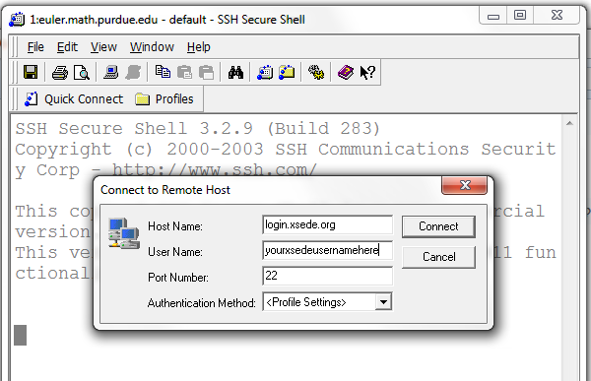  
      click connect
   4. If this is the first time you are connecting to this server, the SSH software will prompt you to safe the public key of the host. Click “Yes” to safe the key.
   5. The ssh connection will prompt you for password. Type your XSEDE password
   6. If you password was correct, the system will ask you for the DOU authentication response. If you use your smart phone to authenticate, open the DUO app and tap on the gray key icon that is to the right and in the same line as the XSEDE icon. A 6-digit number will be displayed. Enter this number in the DOU authentication prompt.
   7. If all steps are done correctly, you will be logged in and will see the command line:  
      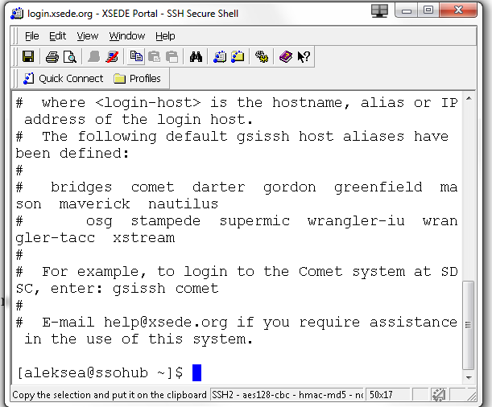
   8. You are now logged into a computer at XSEDE. There is no much to do here, it is only a place of access to other computer systems. So, we need to proceed with logging into our final destination – the supercomputer that will run our programs. In this example, we will login to PSC Bridges computer.  
        
      In the command prompt type:  
        
      gsissh –p 2222 bridges.psc.xsede.org  
        
      and click Enter
   9. You will now be connected to one of the login nodes of bridges.psc.xsede.org. This is the computer where you compile and run programs and generate and use simulation data.
   10. By default you are placed into your home directory. Type a command “ls” to see any folders or files in your home directory. If you leave this directory and ever need to come back, type “cd $HOME” to go straight back here. Other directories that are available to you are /pylon1/ms560hp/yourusername and /pylon1/ms560hp/yourusername. You can learn this and a whole a lot more in the Bridges user manual at https://www.psc.edu/index.php/bridges/user-guide
5. Using Putty:
   1. When you start Putty, a connection menu will open. Type the host name and select the SSH connection button  
        
      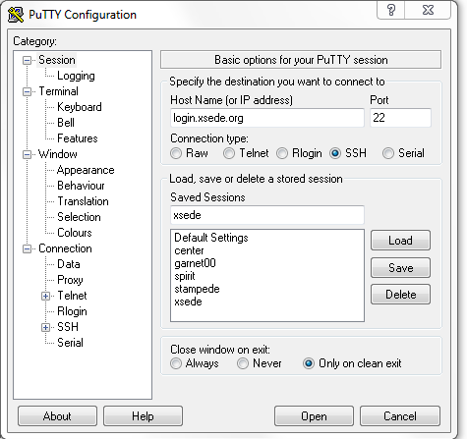  
      If you have not done it earlier, you may choose a name for the “Saved Sessions” and click “Save” button. This will create a record of your login that will show up on the list of Saved Sessions. Later you can select a saved session and click the “Load” button to restore the settings of the session. Once the host name is selected, click “Open”
   2. If this is your first login to this server from this software, you will see the prompt to safe the public key. Click “Yes”  
      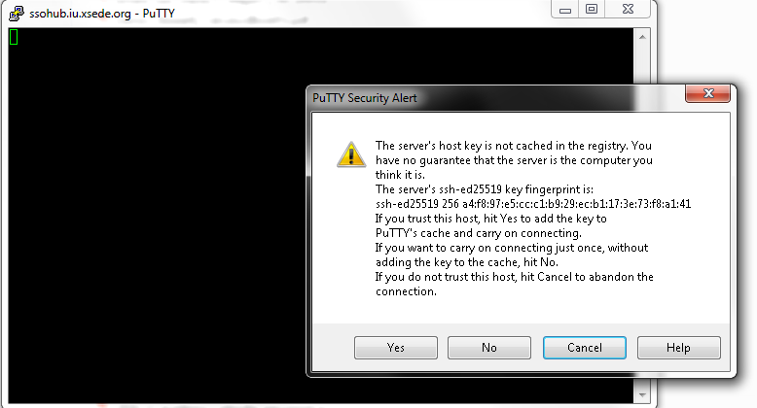
   3. You will be asked for your login name and a password:  
      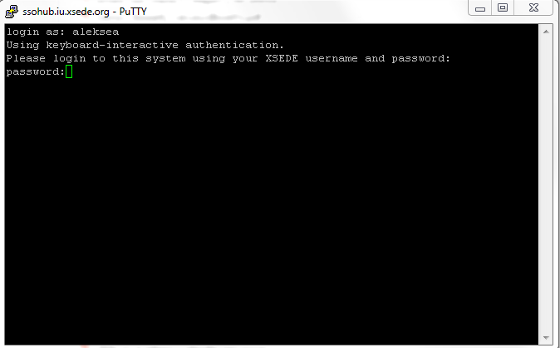
   4. If you type the password correctly, the system will ask for the second authentication. You will have an option to use the DUO app on your smart phone or to receive a call. The menu will lokk something like this  
      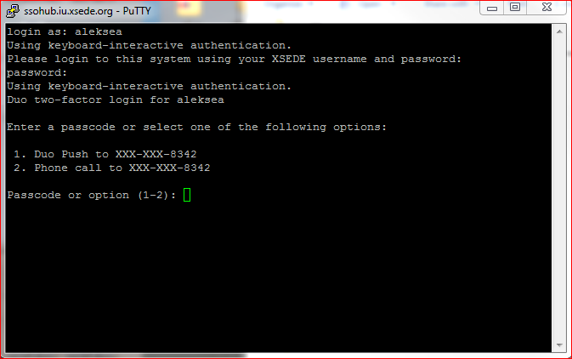
   5. If you choose 1 in the previous menu, the system will send a signal to your smart phone. If you have installed DUO applet, it will receive the DUO message. When you open it, it and will ask of you to “Approve” the log in attempt. When you tap “Approve”, you will be logged in into the XSEDE portal login. Your smart phone will close the application after you tap “Approve” (or “Deny”). If you choose 2, a the XSEDE system will call you and a robot voice will ask if you are expecting the call. If you do, you will be asked to press any key. Once you press a key, you will be logged in.
   6. If you typed all your credentials correctly, and followed all the steps above, you will be logged into the XSEDE portal:   
      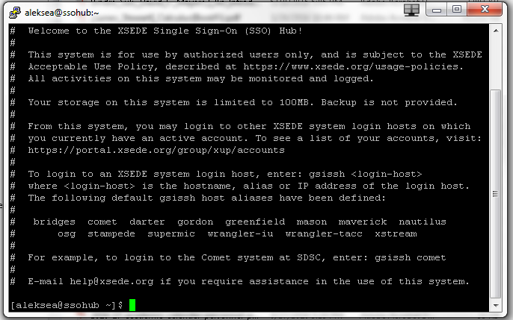
   7. There is no much to do here. This is just an access point to XSEDE Resources. To access TACC computer Stampede, type in the command prompt:  
        
      gsissh –p 2222 bridges.psc.xsede.org  
        
      and click Enter
   8. And you are in!   
      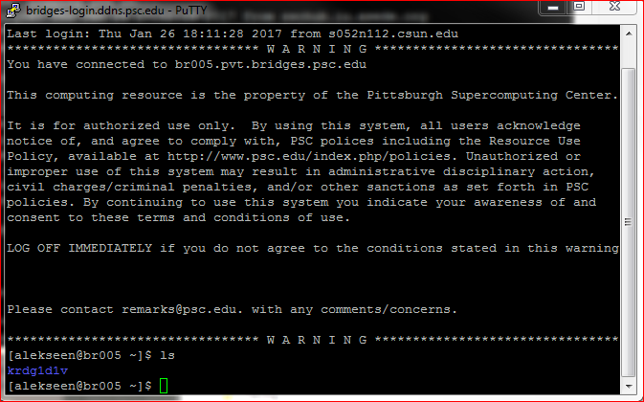  
      Please pay attention to the message that you receive at your login. You can see your file storage allocations and how much of your allocation is used.

*Accessing PSC Bridges through XSEDE portal. Linux or Mac users*

If you are a Linux or a Mac user, you are in great luck! Both Linux and Mac have command shells build in that allow to go login into a remote computer. You will have to start a terminal window or command shell --- whatever the heck it is called in your computer and type a command like this:  
  
ssh [yourzsedeusername@login.xsede.org](mailto:yourzsedeusername@login.xsede.org)  
  
You will be prompted your password and the rest of the steps are identical to steps (b)--(e) above

See? It was so simple! You did a great job! You now can access your XSEDE allocation computers! Now let us discuss how to move files to your XSEDE computer.

*Accessing PSC Bridges directly. Windows users*

1. Start either SSH Secure Shell Client or Putty.
2. If this is your first login or if you did not save the connection to the profile you may want to safe the login parameters under a suitable name. Then next time, you will not have to re-type all the parameters.
3. You can connect to Bridges either using your XSEDE login and password or the PSC login and password. We will go over the process using PUTTY. Connection using ssh shell is similar.
4. Connection to Bridges using XSEDE credentials:
   1. When you start Putty, a connection menu will open. Type the host name bridges.psc.xsede.org or bridges.psc.edu and use port 2222 and select the SSH connection button. Either hostname will connect you to Bridges, but you must specify port 2222.   
      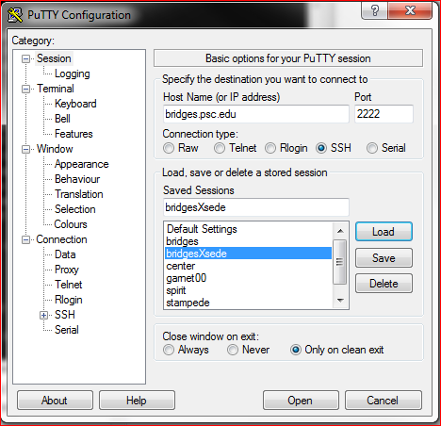  
        
      If you have not done it earlier, you may choose a name for the “Saved Sessions” and click “Save” button. This will create a record of your login that will show up on the list of Saved Sessions. Later you can select a saved session and click the “Load” button to restore the settings of the session. Once the host name is selected, click “Open”
   2. If this is your first login to this server from this software, you will see the prompt to safe the public key. Click “Yes”  
      
   3. You will be asked for your login name and a password:   
      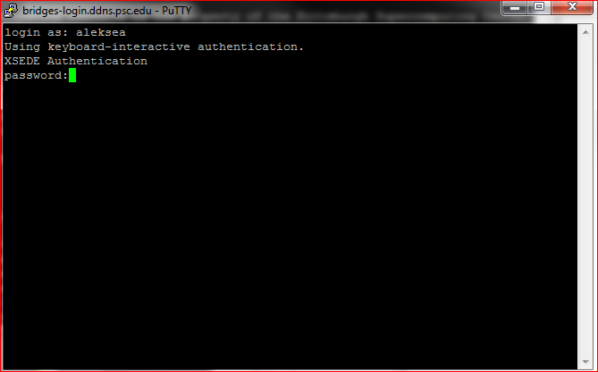
   4. If you type the password correctly, the system will ask for the second authentication. You will have an option to use the DUO app on your smart phone or to receive a call. The menu will look something like this  
      
   5. If you choose 1 in the previous menu, the system will send a signal to your smart phone. If you have installed DUO applet, it will receive the DUO message. When you open it, it and will ask of you to “Approve” the log in attempt. When you tap “Approve”, you will be logged in into the XSEDE portal login. Your smart phone will close the application after you tap “Approve” (or “Deny”). If you choose 2, a the XSEDE system will call you and a robot voice will ask if you are expecting the call. If you do, you will be asked to press any key. Once you press a key, you will be logged in.
   6. If you typed all your credentials correctly, and followed all the steps above, you will be logged into a Bridges login node:   
      
5. Connecting to Bridges using PSC credentials.
   1. When you start Putty, a connection menu will open. Type the host name bridges.psc.xsede.org or bridges.psc.edu and use port 22 and select the SSH connection button. Either hostname will connect you to Bridges, you may use (the default) port 22 with the PSC credential.   
      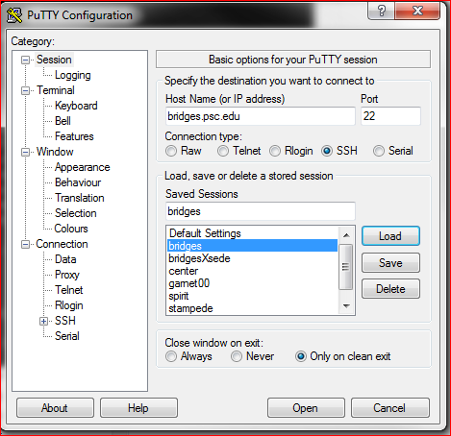  
      If you have not done it earlier, you may choose a name for the “Saved Sessions” and click “Save” button. This will create a record of your login that will show up on the list of Saved Sessions. Later you can select a saved session and click the “Load” button to restore the settings of the session. Once the host name is selected, click “Open”
   2. If this is your first login to this server from this software, you will see the prompt to safe the public key. Click “Yes”  
      
   3. You will be asked for your login name and a password:   
      
   4. Currently, Bridges does not use multiple authentication. If you typed the password correctly, you will be logged into a Bridges login node:   
      
   5. Please pay attention to the message that you receive at your login. You can see your file storage allocations and how much of your allocation is used.

*Accessing PSC Bridges direclty. Linux or Mac users*

If you are a Linux or a Mac user, you are in great luck! Both Linux and Mac have command shells build in that allow to go login into a remote computer. You will have to start a terminal window or command shell --- whatever the heck it is called in your computer and type a command like this:  
  
ssh [yourzsedeusername@bridges.psc.edu](mailto:yourzsedeusername@bridges.psc.edu)  
  
You will be prompted your password and the rest of the steps are identical to steps (b)--(e) above

**Steps to transfer files between your XSEDE computer and your local computer**

There are several ways to transfer the files between your local computer and an xsede computer. Windows users can use SSH Secure Shell to transfer files using a familiar interface. Unfortunately, SSH Secure Shell that is offered by CSUN is outdated and can not communicate to Stampede (but it can to some other computers). Therefore for Stampede SSH Secure Shell can not be used. Also, Windows users can use Filezilla to create a secure connection and transfer files. However, this normally will require to type in password every time you need to transfer a file. This is very tiring, but works for small transfer jobs. Both SSH Secure Shell and Filezilla will, however, fail if you need to transfer large files. It can take as little as 100 MB to fail for slow internet connection and to 1 GB for fast connections. The connection is pretty much times out after a while and if your file did not finish transferring, the transfer will freeze. You will have a portion of the file on the hard drive. The most simple way to see that you did not move the entire file is to compare the file sizes on the sender and receiver sides. If one is significantly shorter, then the transfer most likely failed. On Linux and Mac files can be transferred by the “scp” command in the terminal. One just have to figure from and where to the files will be copied on the local machine. Linux and Mac shells are a bit better about keeping the connection alive. However, the “scp” is still not the best way to transfer large files.

Fortunately, XSEDE has a great way to transfer large (and small) files using Globus Connect (<https://www.globus.org/>). All you have to do is to download a small program (daemon) from Globus Connect available for Windows, Mac, and Linux that will turn your computer into an access point. You can then use internet browser to log into the Globus connect webpage and transfer files using web interface. The speed of these transfers was amazing so far as compared to plain ssh copying.

*Steps to move files between XSEDE and a local computer using Globus online.*

1. Create an account on https://www.globus.org/.
   1. First go to the webpage and click the “Log In” button in the upper right corner.
   2. This will bring you to the auth.globus.org web page where you need to login either using an organizational login or Globus ID.
   3. Logging in using Globus ID:
      1. There will be a link to log in usig Globus ID – currently you need to click on the word Globus ID to be redirected.
      2. In the login using Globus ID page you will be able to type your Globus ID login and Password or to create a new Globus ID. If you do not wish to create a Globus ID you can try to log in using your Google account (see next).
   4. Logging in using organizational account.
      1. The fall out menu on the login page will show quite a bit of organizations that are working with Globus. Currently CSUN is not there, but other CSUs are. I am assuming if we start working with them, you will be able to use CSUN id and password to log in.
      2. There is GOOGLE listed on the list of organizations – you can try logging in with your google account. It seems to be working.
   5. Once you logged in you will see a window for transferring files. It looks like this   
      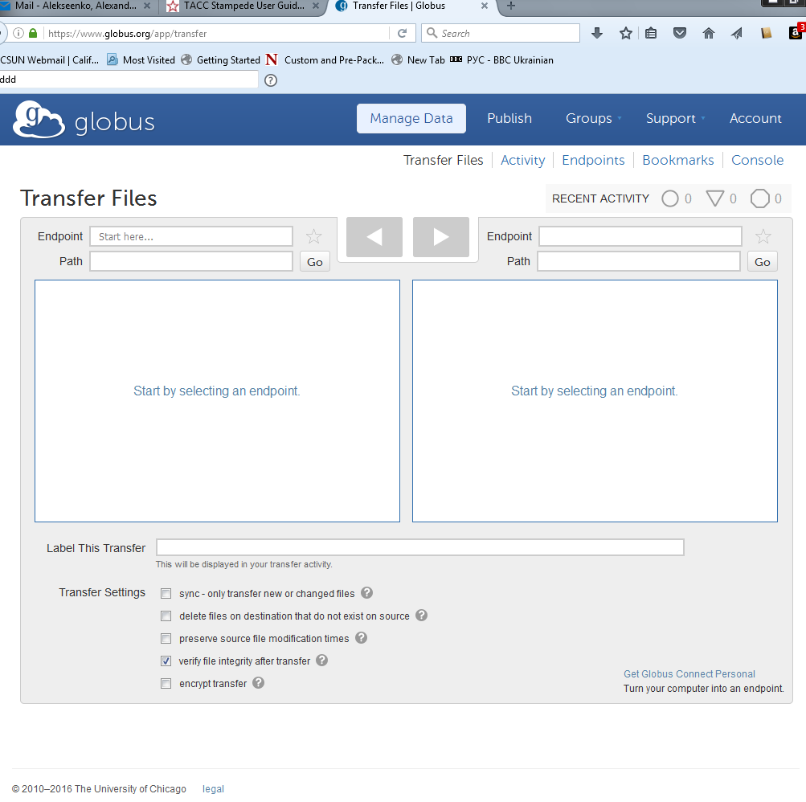  
      If you will be forwarded to a different window, do not panick: you can return to this window by clicking on the link “Transfer Files”, Other useful links include “Account” and “Support” and “Manage Data”.
2. Download and Install a Globus deamon to run on your computer. This will turn your computer into an access point and you will be able to move files around.
   1. A good starting place is to go to <https://docs.globus.org/faq/transfer-sharing/> and read a little bit about the file transfers using Globus online. In the list of topics scroll to “How can I transfer files to and from my laptop or desktop?”. This will lead you to the paragraph describing how this can be done using Globus Connect Personal. Click on the words “Globus Connect Personal” to be re-directed to the page wehre you can download the software that turns your computer into a Globus End point.
   2. Go to [https://www.globus.org/globus-connect-personal](https://www.globus.org/globus-connect-personal/) Download and install the software. Follow the link corresponding to your operation system. The webpage provides step-by step instructions.
3. Start the Globus Connect Personal software on your computer.
   1. Instructions for Windows:
      1. Start the Globus Connect Personal software on your computer. If you are running Windows, you will not see much. As soon as the program is started it Windows will send it on the background. If you try to start it again, you will see something like this:  
         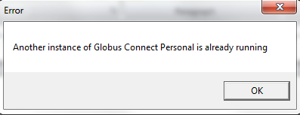  
         This means that Globus Connect Personal is already running.
      2. You can find an icon for the running software in the “Menu for Hidden Icons” in the right or lower portion of the Windows icon bar located on the side of the display. This is what is looks like in Windows 7  
           
         That little white triangle in the middle is it. Click on it. On Windows 7 you will see something like this   
         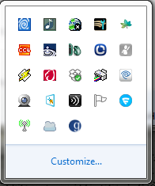
      3. Right-Click on the icon for Globus Connect Personal  
         and select “Options” in the fall out menu  
         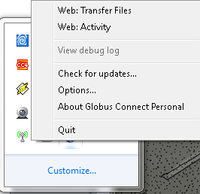  
          you should see something like this:  
         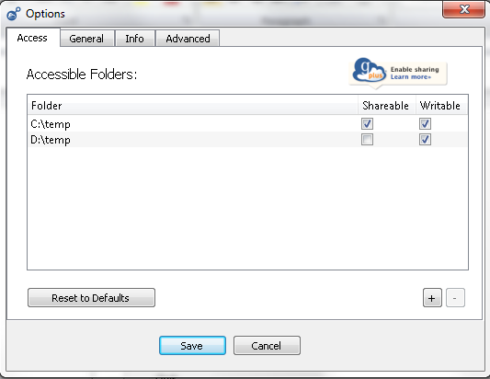  
         Select menu “Access” to see directories which Globus Connect Personal can access.
      4. Use the “+” or “-“ buttons to add or remove directories from this list.
      5. Note that these are the directories that online and the whole worlds will see through Globus Connect -- Please do not use these directories to store your personal data and do not grant access to directories that have such data.
4. Transferring files using internet-based interface.
   1. Go to [www.globus.org](http://www.globus.org) and log in. Proceed to Manage Data -> Transfer Files window. Usually, you are being transferred straight to this window from the log-in. You will see empty file boxes that are ready to use to transfer files between two endpoints. It will look something like this   
      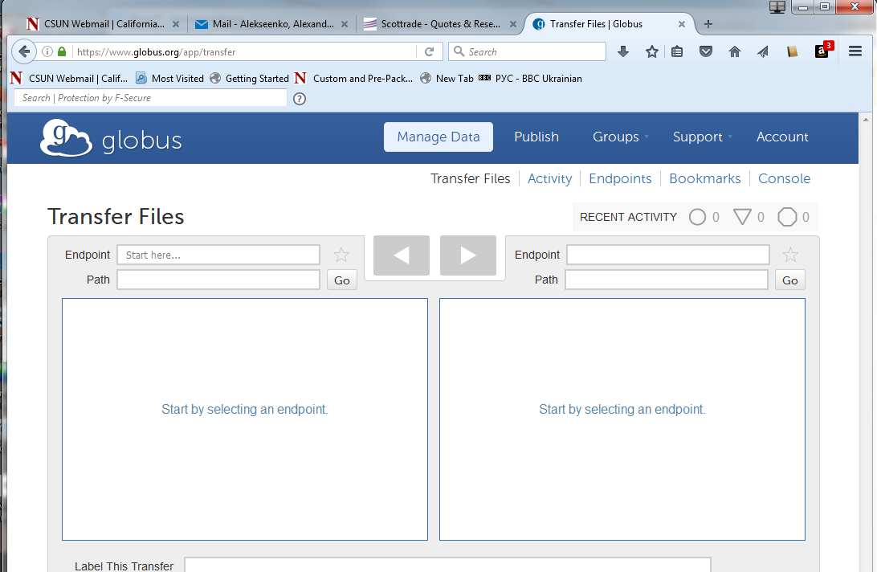
   2. In one the windows, select your computer as an end point. For that click in the field “Endpoint”. A menu will open with a list of endpoints. You need to find one that looks like your name – this should be your local computer. Here is what mine looks like:  
      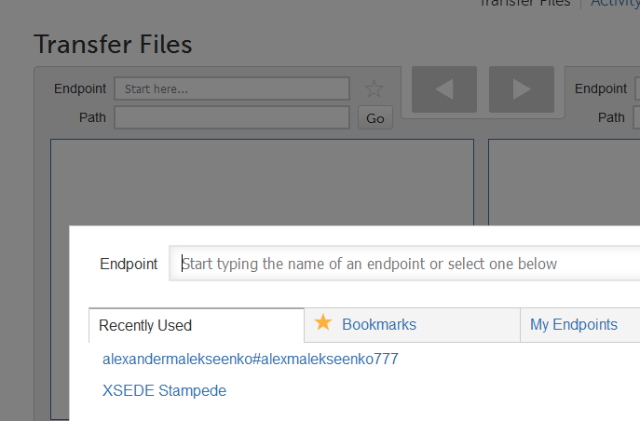
   3. Select the endpoint that corresponds to your computer. If Globus Connect Personal endpoint is running on your computer, you should see the directories in the file box that are open for sharing. These are the directories you included into access list in previous steps. If Global Connect Personal is Running and still the file box is empty, you should probably check if you have any directories open for sharing. Use directions to the previous step to open access to designated directories. In the example below access is granted to C/temp/  
      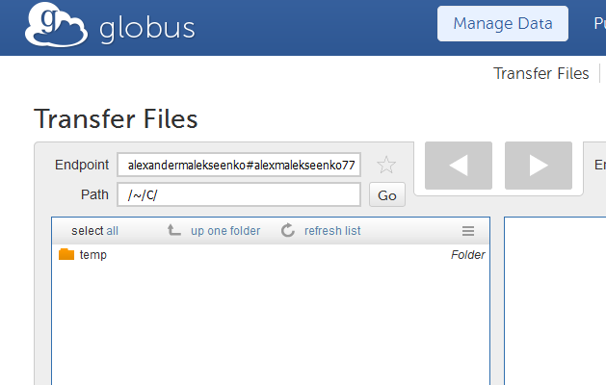
   4. Select the remote endpoint in the second filebox – the place where you want to move file to (or from). In the example below, XSEDE Stampede computer was selected as the second endpoint. On the XSEDE computer you have access to your $HOME directory.   
      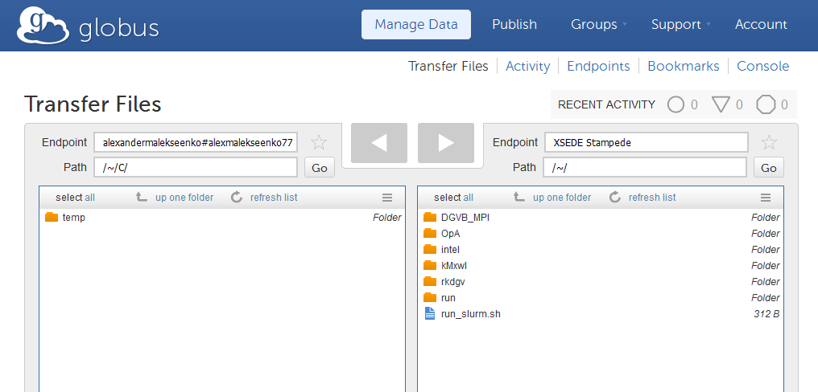
   5. Select the files you need to transfer and press the Blue button with the triangle to submit a transfer request. The request will be processed rather quickly and you will receive a notification in the e-mail when files are successfully transferred.   
      