Steps. Week 3 Spring 2019. Part A

*Steps to perform the first computation using pre-set run of Fast Fourier Boltzmann (FFB) code.*

**Steps to copy the FFB0D OpenMP code to Bridges HPC**

* Go to course Canvas page to download an archive file FFBOpenMP_working_Bridges02062019.zip
* Safe the file on your local computer.
* Unpack the files and place the entire content with subdirectories in a directory accessible to Globus Online.
* Login to Bridges. Example below is using Putty. SSH shell is similar
* Open Putty, log in into the Bridges HPC using one of the methods described in Steps for Week 1. You will see something like this:   
  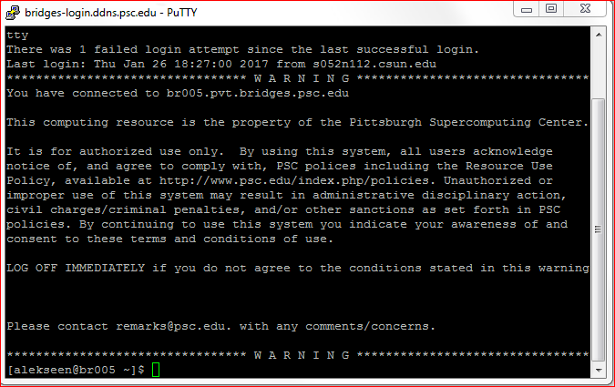
* By default you will be logged into your home directory. To see contents of your home directory use command  
   ls  
  you will be able to see files and directories that are located in your home directory. To create a new directory, execute the command   
   lmkdir FFB0D   
  if the execution is successful, the system will not send any feedback. To verify that the directory has been creates, execute ls one more time:  
  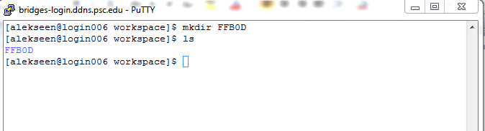as you can see, a new directory **FFB0D** has been created. You can switch into the new directory by typing   
   cd FFB0D  
  and you can check if there are any files there using ls . If the directory is still empty, you will see no files  
  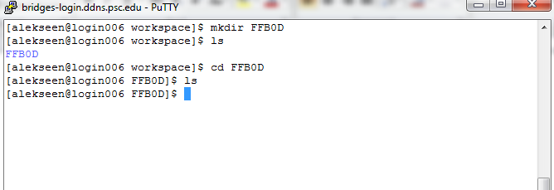  
  to return to the home directory use   
   cd ..  
  That will bring you one level up in the directory tree.
* Next you need to transfer files from your computer to the Bridges HPC. The next example is using Globus online:
  + Start Globus Online personal on your computer. Locate it in the background software fall out menu icon  
     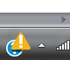
  + Open the background software menu icon  
    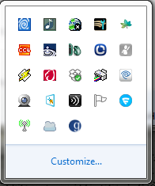
  + Right-Click on the icon for Globus Connect Personal  
    and select “Web: Transfer Files” in the fall out menu  
    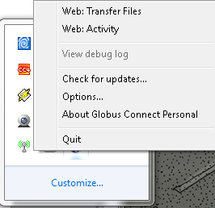
  + Your browser will open on the Globus Online Transfer Files page. Select your computer endpoint and open the folder that contains the code. On the opposite panel open “PSC Bridges with XSEDE authentication” end point. You will see something like this   
    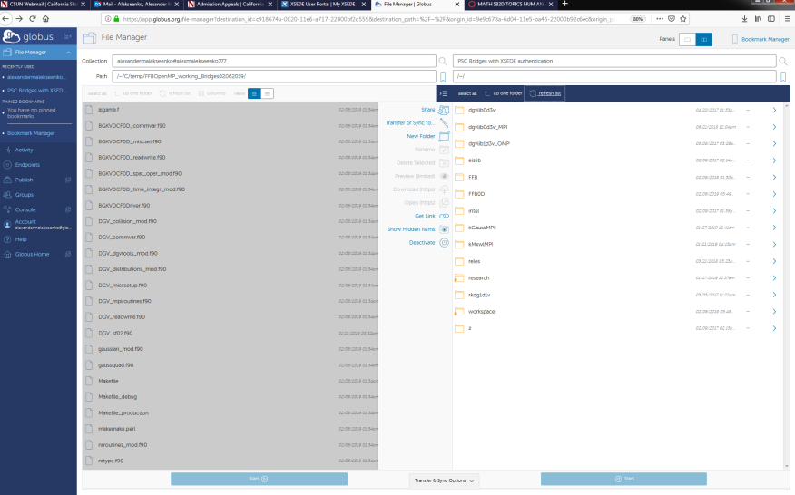
  + Open the directory FFB0D by double clicking on the icon, select all items in the left panel and press the blue button with a triangle pointing to the right to request a transfer  
    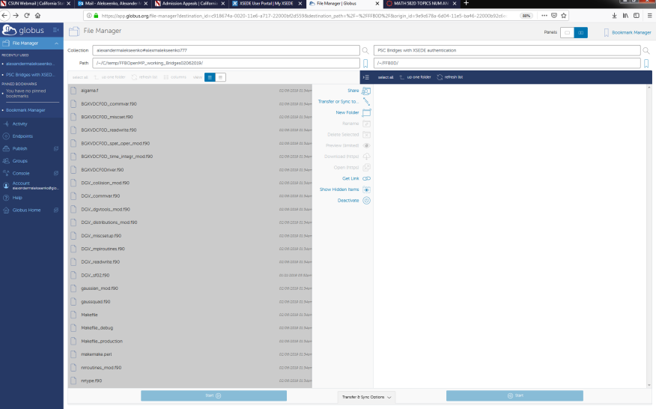
  + When the transfer will be completed, you will receive a confirmation e-mail. At that time, switch to the Putty terminal and verify that all files are there.  
    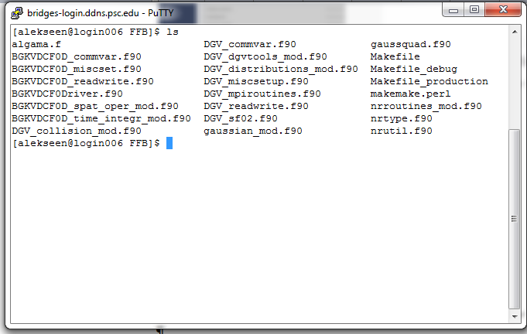

**Steps to compile the FFB0D code on Bridges HPC**

* Good News. Under the normal conditions you do not need to do much. Switch to the directory FFB0D in your home directory on Bridges.
* If you did all the copying states correctly, you should have all source files (*.f90) in place and the file titles “Makefile”.
* “Makefile:”
  + Entries of the Makefile were adjusted to run on Bridges using Intel Fortran compiler. We just need to verify that the environmental variables are set up for Intel compiler. This can be done by using   
      
    module list   
      
    command:   
      
    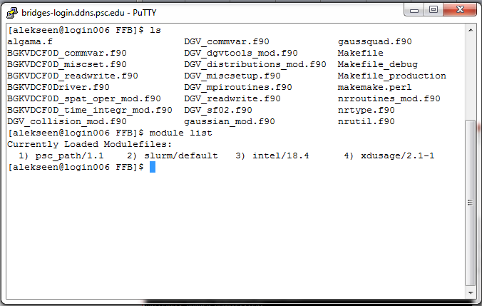
  + If the “intel/compilers” module is not loaded, or Makefile is missing, or Makefile was modified, check sections on how to work with Makefile and compilers below.
* Type the command  
    
  make  
    
  and see what happens. If everything above was done correctly and all the components are in place, you should see something like this  
  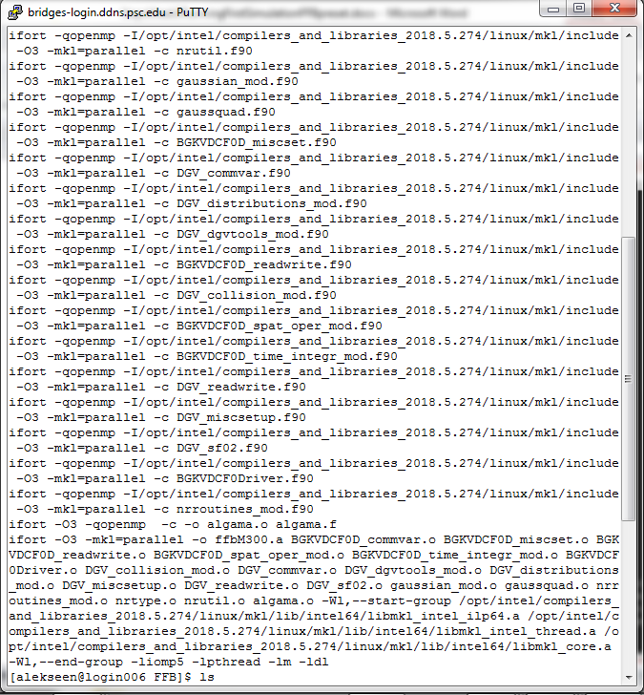
* If you type **ls** to check the content of the directory, you will see a new file **ffbM300.a** which is the executable  
  