Steps. Week 12 Processing Simulation Results of Spatially Homogeneous Relaxation.

You are expected to select a reference temperature between 2000 K and 4000 K, but not 4000 K and perform several simulations of the spatially homogeneous relaxation. The parameters of the simulations will be all the same except dt. You will change dt to dt/2 and dt/4. It may be that you will have to also run dt/8 and dt/16. In the end you will have several directories with results.

* A directory with results looks something about this:   
  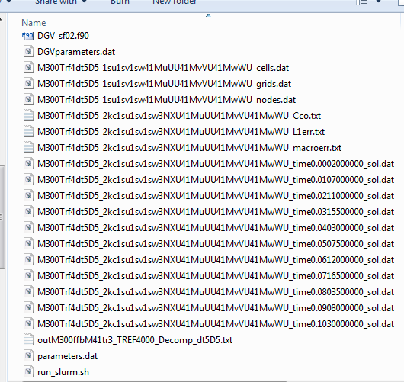  
    
  As you can see, we save DGV_sf02.f90, DGVparameters.dat, parameters.dat, the code output files, the contents of folders sol080909, results, and moments.
* In this project, we mostly are interested in the values of macroparameters, that were computed in the process or solution and saved into a file. Files that store macroparameters can be identified by their names endings “_macroerr.txt”. In particular in this directory, the file that contains records of macroparameters is   
    
  M300Trf4dt5D5_2kc1su1sv1sw3NXU41MuUU41MvVU41MwWU_macroerr.txt  
    
  It is a text file in which there are a few lines of information recorded about the simulation. After these lines, the values of the macroparameters are listed through comma. Every new line is a new time record.
* The file “_macroerr.txt” can be easily imported in Excel or other spreadsheet. In Excel you select   
    
  tab Data🡪 Get External Data 🡪 From Text   
    
  Then navigate to the “_macroerr.txt” file you are going to import, e.g,.  
  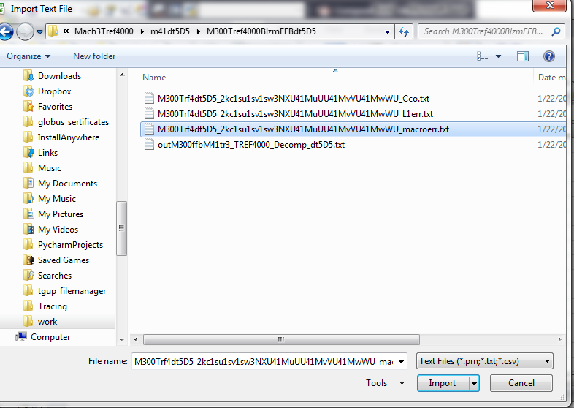
* Once the file is selected, an import wizard will ask how to import data. Select “Delimeted”  
  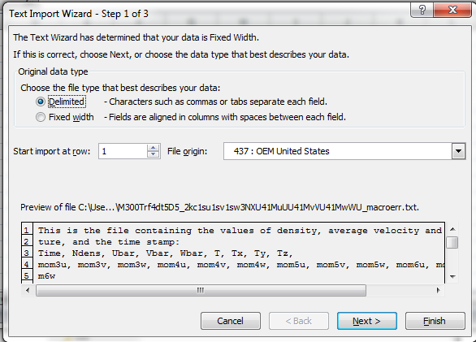
* And on the next step, select separated by comma.  
  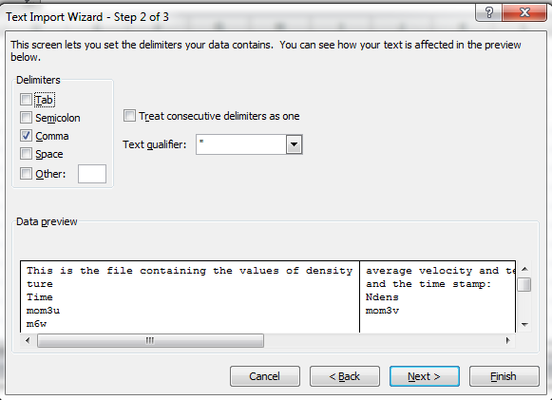  
  Because this is exactly how the numbers are separated. You can clich “Finish” after this step.
* Here is a possible final result:   
  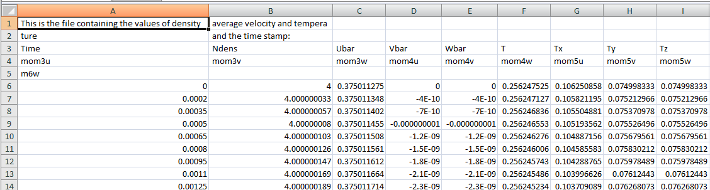You can notice the that the first lines are garbles, However, beginning from line 6, the values of macroparameters are arranged in a table.
* We only care about the first nine columns. Here is the meaning of the columns given in their respective order:  
    
  Time, Density, u- component of the bulk velocity, v-component of the bulk velocity, w-component of the bulk velocity, temperature, three directional temperatures,  
    
  T_u = \int_{\R^3} (u-\bar{u})^2 f(t,u,v,w) du dv dw  
  T_v = \int_{\R^3} (v-\bar{v})^2 f(t,u,v,w) du dv dw  
  T_v = \int_{\R^3} (w-\bar{w})^2 f(t,u,v,w) du dv dw  
    
  Initially, these directional temperatures are different. However, when the solution is at continuum all three are equal to (1/3)T.  
    
  We will specifically track the dynamics of these changes.
* We note that density, bulk velocity, and temperature are preserved quantities in spatially homogeneous flow. As a result any changed in these moments are due to numerical errors.
* There is a file provided on Canvas,   
    
  [SpatialHomRelaxM300.xlsx](https://canvas.csun.edu/courses/59553/modules/items/1809579)  
    
  This file contains results obtained by other codes. Use this file to import your results and create plots to compare. You should be able to plot the DSMC solution and your solution on the same coordinate axes, in a single plot. The following detail are important:   
  + In the graphs, time goes on the horizontal axis.
  + Time on graphs is measured in mean free times.
  + You simulations are using dimensionless time, so it has to be converted to mean free time units
  + DCMS time column is in mean free time
  + The vertical axis is the directional temperatures
  + In graphs, values of directional temperature are normalized by their final state, which is 1/3 of the solution temperature. Use value of the temperature from column 6.
  + When preparing graphs, plot both Tx, Ty for DSMC and Your solutions.