Actors

Sales Assistant
Sales Assistant is a person who is responsible of managing customer and customer site information. If there are needs on managing customer’s information or customer site, creating, updating and marking for deletion. Sales person makes those necessary changes or marking for deletion, but all those changes need to be confirmed by authorized sales assistant.
Sales Planning
Sub-system; according to specific customer, sales’ planning is going to use information from customers for setting up discount rates and etc.
Order Processing
Sub-system which is going to use existing customers and customer sites information.

Services

Registering new customer/ customer site
Updating customer/customer site
Confirm customer/customer site update
Mark customer/customer site to be deleted
Display customer/ customer site information

Use Cases

Diagram:
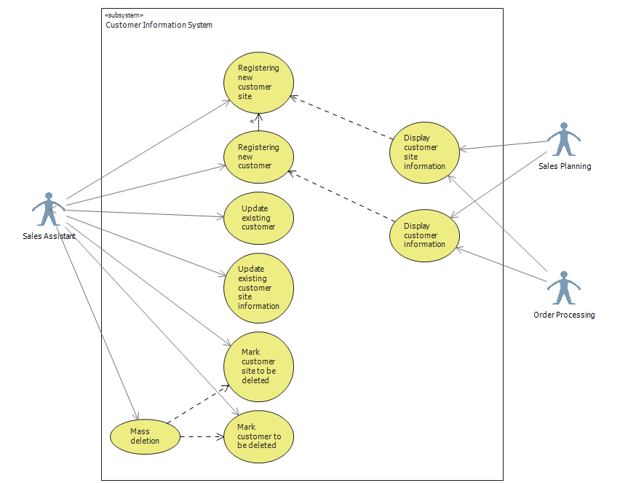
Descriptions:
Use Case | Registering new customer
Actor: | Sales assistant
Pre-condition: | Customer wants to have permanent registration in Lahjapaja system or Lahjapaja contacts potential customer;  Sales assistant logged in into the system.  Information about company’s creditability is checked by some responsible employee
Goal: | Acquiring information about the customer and preparing it for the final acceptance of relationship with him.
1 | Sales assistant press new customer button
2 | Sales Assistant inserts company name, invoicing and delivery address, contact person information (name, tel. number, email, address) and other possible info.
3 | Fill the creditability information.
4 | Based on the creditability information and turnover of the company:  - discount rate %  - credit limit
5 | Selects the customer group
6 | Selects terms of payment, terms of delivery
7 | Conract agreement (references) and status?!!?!
8 | Press Save button to store the inserted information
8 | New customer is stored in the system's database.

Use Case | Registering new customer site
Actor: | Sales assistant
Pre-condition: | Customer site will contact LahjaPaja or Lahjapaja will contact the customer;  Basic customer information is stored in the system;  sales Assistant logged in the system  Sales Assistant and Register Customer page or Display customer page is opened in front of him/her ;
Goal: | Acquiring information about new customer site for the order processing purposes
1 | Sales assistant press new customer site button On Register/ Update customer page or Display Customer page.
2 | Based on the customer ID or name of the customer the screen will show customer information/ The new customer information are being inserted into the system
3 | The customer site information is added to other customer sites/ the customer site information is inserted as the consequent process of Registering new customer use case.  The addresses, customer group, discount group credit limit, terms of payment and terms of delivery, addresses, contact person information, additional information is pre-filled based on the information valid for HQ.  The Site name, is newly inserted and Customer site ID is generated.
4 | Press Save button to store site information into the system

Use Case | Update existing customer
Actor: | Sales assistant
Pre-condition: | Customer or someone in house notifies of changes or errors in stored data  Sales Assistant Logged in the system  Display customer page is opened in front of him/her ;
Goal: | Updating of data in the system
1 | Sales Assistant selects the desired Customer by its name or ID
2 | Press Update Customer Button.
2 | Based on the customer ID or name the screen Register/Update Customer will show customer information.
3 | Alter existing customer's information if needed.
4 | Press Save Button to store altered information.

Use Case | Update existing customer site information
Actor: | Sales assistant
Pre-condition: | Customer or someone in house notifies of changes or errors in stored data  Sales assistant logged in;  Display customer page is opened in front of him/her ;
Goal: | The existing information about customer site is updated and stored in the system
1 | Sales Assistant selects the desired Customer Site by its name or ID
2 | Press Update Button
3 | System deliver all information about particular customer site and opens the Register/Update customer site
4 | Alter existing customer site information if needed.
5 | Press Save Button to store altered information.

Use Case | Mark customer site to be deleted
Actor: | Sales assistant
Pre-condition: | Particular customer site is not needed in the system anymore  Lahjapaja’s decision to delete  Sales assistant logged in;  Opened Display Customer;
Goal: | The existing information about customer site is marked to be deleted from system
1 | Sales Assistant selects the desire customer site by its name or ID
2 | Sales Assistant presses Update Customer site button
3 | The Update Customer Site page will open with prefilled data fields
4 | Sales Assistant checks Mark For Deletion checkbox
5 | The system will prompt the user again, if s/he is sure
6 | Press Save Button to apply the changes
7 | Customer site will wait for mass deletion process.

Use Case | Mark customer to be deleted
Actor: | Authorized Sales assistant
Pre-condition: | Customer is not interested anymore in business;  Lahjapaja’s decision to delete;  Sales assistant logged in;  Opened Display Customer;
Goal: | The existing information about customer is marked to be deleted from the system
1 | Sales Assistant selects needed customer by its name or ID
2 | Checks if customer has any sites more (by system)
3 | The Update Customer page will open with prefilled data fields
4 | Sales Assistant checks Mark For Deletion checkbox
5 | The system will prompt the user again, if s/he is sure to mark for the deletion.
6 | Press Save Button to apply the changes

Use Case | Mass deletion
Actor: | Sales Assistant with special permission
Pre-condition: | Certain customer or customer sites were marked for deletion by some sales assistant  Sales Assistant logged in as the actor with special permission;  Display customer page is open and list of marked customer or sites is available;
Goal: | The existing information about customer or site is deleted from the system
1 | Responsible actor filters the customers or sites by status (marked to be deleted)
2 | Press Mass Delete Button
3 | Confirmation window will appear
4 | Confirm Deletion

Use Case | Display customer information
Actor: | Sales Planning subsystem/Order processing subsystem
Pre-condition: | There is a need in utilizing customer information.  Customers’ information is stored in the system and is available to be displayed.  The actor has access to the database tables with information about customer or/and customer sites.
Goal: | The acquired information about a customer is utilized.
1 | The actor selects a customer according to the actor’s needs.
2 | The customer information is displayed on the screen: company name, invoicing and delivery address, contact person information, way of delivery and other possible information based on the UI of the subsystem.

Use Case | Display customer site information.
Actor: | Sales Planning subsystem/Order processing subsystem
Pre-condition: | There is a need in utilizing customer site information. Customer sites’ information is stored in the system and is available to be displayed.  The actor has access to the database tables with information about customer or/and customer sites.
Goal: | The acquired information about a customer site is utilized according to particular actor’s requirements.
1 | The actor selects a customer site according to corresponding subsystem architecture and the actor’s needs.
2 | The customer site information is displayed on the screen: company name, invoicing and delivery address, contact person information, way of delivery and other possible information based on the UI of the subsystem.
3 | The actor chooses the desired information and processes it according to corresponding subsystem needs.

Class Model
Class name | Group
Definition | Group represents unique groups of customers
Attributes | groupId | Numeric, 2 digits, obligatory/ Alphabetic, 3 characters. Identifies customer group uniquely | The system gives the value from a counter when creating Group /Inserted manually by user  (The implementation way will be decided later on)
Attributes | groupName | 30 characters, obligatory
Associations | Association with Customer  - A group has zero or more customers
Responsibilities
Volume | For the moment we have 3 customer groups, however the number might change in the future. Usually the number of different customer groups is less than 10.

Customer
Class name | Customer
Definition | One of main entities representing a real company as customer
Attributes | customerID | Numeric, 6 digits, obligatory | The system gives the value from a counter when creating Customer
Attributes | name | Alphabetic,30 characters, obligatory
Attributes | visitingAddress | 4 * 35 characters, obligatory
Attributes | postalAddress | 4 * 35 characters, obligatory | If all of the four fields are blank, the delivery address will be used also as postal address.
Associations | Association with Group  Customer belongs to 1 group
Associations | Association with Contact person  Customer has 1 contact person
Associations | Association with Contract  Customer has 1 contract
Responsibilities
Volume | The present number of customers is about 250. Yearly increase is estimated to be about 20-25%. Passive customers with no sales during the fiscal year will be deleted in year shift.

Contact Person
Class name |  | Contact Person
Definition |  | Contact Person is the entity responsible for communicating with LahjaPaja OY.
Super class |  | -
Attributes
Contact Person ID | Numeric, 4 characters, Mandatory |  | The unique identification number of the Contact Person generated automatically by the system
Name | Alphabetic, 30 characters, Mandatory |  | The name of the contact person
PhoneNumber | Digits, 15 characters, Mandatory |  | The telephone number on the contact person
Email | Alphabetical, 30 characters |  | The email contact on the contact person
Address | 4 * 35 characters,  If all of the four fields are blank, the postal address will be used. |  | The post address on the contact person
Operations
Create
Update
Delete
Associations
Association with Customer – the one or many contact persons are connected to the Customer
Association with Customer Site - the one or many contact persons are connected to the Customer
Responsibilities
Knows attributes of the Contact Person class
Volume |  | As many as there are customers in the database

Contract
Class name |  | Contract
Definition |  | Contract is the entity responsible for communicating with LahjaPaja OY.
Super class |  | -
Attributes
Contract Id | Numeric, 5 characters, Mandatory |  | Unique identifier of the class
Terms of Delivery | Alphabetic, unlimited amount of characters |  | Definition of terms of delivery
Terms of Payment | Alphabetic, unlimited amount of characters |  | Definition of the rules of payment
Credit Limit | Numeric, 7 characters |  | Specification of the credit limit
Discount Rate | Numeric, 2 characters |  | Specification of the Discount Rate
Operations
Create
Update
Delete
Associations
Association with Customer – the one or many contact persons are connected to the Customer
Association with Customer Site - the one or many contact persons are connected to the Customer

Responsibilities
Knows attributes of Contract class

Volume |  | As many as there are customers in the database

Customer site.
Class name | Customer site
Definition | Customer site is a customer independent business entity, which orders Lahjapaja’s products.
Super class | -
Attributes | Customer site ID | numeric, 6 digits, obligatory | The system gives the value from a counter when registering new Customer site.
 | Name | Alphabetic, 30 characters | Site’s name according to customer site representative.
 | Delivery address | 4*35 characters. All of the four fields must not be blank. | Address to which items should be sent.
 | Postal address | 4*35 characters. If all four fields are blank, the delivery address will be used also as postal address. | A postal address of the customer site.
 | Payment disruption | default value: no disruptions. Accounts receivables updates | Defines whether the site had payment disruptions or not.
 | Sales | numeric, 7 digits. Contains the year-to-date monetary value of customers’ sales. Initial value 0. Invoicing system updates. | Monetary value of sales for the customer site.
 | Date of the last sale | date. Initial value “not defined”. Invoicing system updates. | Date of the last sale performed.
 | Way of delivery | ?30 characters. | The way delivery should be performed.
Operations | Create
 | Update
 | Delete
Associations | Association with Customer  each Customer contains 1 to many Customer sites
Association with Contract
each Customer site is signed with 0 or 1 Contract
Association with Contact person
- each Contact person can be a representative for several (1 or many) Customer sites
Responsibilities | Takes care of Customer site information.
Volume | - There are approximately 4 Customer sites per Customer. The present number of Customers is about 250, therefore number of Customer sites is close to 1000. Each year 20-25% increase is expected.

IdGenerator

Class name |  | IdGenerator
Definition |  | IdGenerator is a class used to generate unique identifier to any other object when it is created.
Super class |  | -
Attributes | Counter |  | numeric, 6 digits, obligatory
Associations |  | -
Responsibilities |  | -
Operations |  | Give value of the counter and increase the value by one

