Alexandru Mancas

15/02/2023 |

World GDP Report

This report aims to provide an analysis of the World Gross Domestic Product (GDP) data set and to create visually appealing and informative visualisations using Tableau.

Table of Contents

1. **Introduction**
   1. Overview of the report,
   2. Importance of data analysis in today’s world.
2. **Policies to be adhered to when working with data**
   1. Overview of the General Data Protection Regulation (GDPR),
   2. Why is it important for data analysts to be aware of such policies.
3. **Overview of the Wealth of Nations data set using Excel** 
   1. Protecting the document,
   2. Applying filters,
   3. Creating charts,
   4. Applying macros.
4. **Tableau visualisations** 
   1. Overview of Tableau and its features,
   2. Importing the Wealth of Nations data set to Tableau,
   3. Creating a dashboard.
5. **Reflection**

# **Introduction**

1. **Overview of the report**

With the help of Excel and Tableau, this report seeks to give an in-depth examination of the Wealth of Nations data collection as well as visually appealing and educational visualizations. The report will go through a number of data analysis-related topics, such as rules that must be followed when dealing with data, an overview of the Wealth of Nations data set using Excel, and a dashboard utilizing Tableau visualization.

1. **Importance of data analysis in today’s world**

Data analysis is an essential part of modern business and decision-making. With the ever-increasing amount of data generated by businesses and individuals, the ability to make sense of this data and draw meaningful insights has become more important than ever. Data analysis allows organizations to identify trends, patterns, and relationships in data, leading to improved decision making and ultimately, better business outcomes. As a data analyst, it is important to have a deep understanding of data, tools, and techniques to extract insights from data.

# **Policies to be adhered to when working with data**

1. **Overview of the General Data Protection Regulation (GDPR)**

The General Data Protection Regulation (GDPR) is a regulation in EU law on data protection and privacy for all individuals within the European Union and the European Economic Area. It came into effect on May 25, 2018, and replaces the 1995 Data Protection Directive. The GDPR sets strict standards for how personal data should be collected, processed, and stored, and gives individuals greater control over their personal data.

1. **Why is important for data analysts to be aware of such policies.**

As a data analyst, it is important to be aware of data protection policies such as GDPR, as it directly impacts the work we undertake. When working with personal data, it is important to ensure that we are collecting, processing and storing data in a way that is compliant with data protection laws. Failing to do so can result in significant fines and damage to an organization’s reputation. We have a responsibility to ensure data is used ethically and responsibly, and that individuals’ privacy rights are protected.

# **Overview of the Wealth of Nations data set using Excel.**

The first step in analyzing the Wealth of Nations data set is to open the excel table and familiarize ourselves with its content. The Excel table contains three tabs, but for the purpose of this analysis, we will be focusing on the first tab labeled 'GDP’. This tab contains information on the Gross Domestic product of various countries over a specified period.

It is important to take the time to understand the content of data set, including the columns, variables, and the units of measurement used. Understanding the data set is crucial for being able to effectively analyze the data and draw meaningful insights and conclusions. Once familiarized with the data set, we can begin manipulating it in excel to prepare it for analysis. This may include adding filters, changing data types, protecting the file, and creating charts to visually represent the data. The use of macros can also be helpful in automating repetitive tasks and streamlining the analysis process.

1. **Protecting the document**

In order to protect a document in Excel, we can use password protection to control who can view, edit, or make changes to the document. These are the following steps to password protect our document:

1. Open the excel document we want to protect,
2. Click on the **File** tab in the ribbon, then select Info from the left-hand column,
3. Click on **Protect Workbook** and then select **Encrypt with Password**,
4. Enter a password in the **Encrypt document**, in this case **123**, and click **OK**,
5. Re-enter the password to confirm it, then click **OK**,
6. **Save** the document.

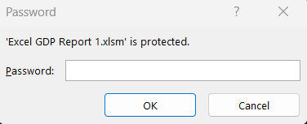

Figure 1

It is important to password protect Excel Documents for several reasons:

* Security
  + Password protection helps to keep confidential information secure by preventing unauthorized access,
* Data privacy
  + Password protection helps to ensure that personal information is not disclosed to unauthorized individuals,
* Compliance
  + In some industries, there may be regulations or laws that require the protection of sensitive information.

1. **Applying filters**

To turn a sheet into a table in Excel, we can use the “Format as Table” feature. These are the following steps to do so:

1. Select the range of cells that are being turned into a table,
2. Go to the **Home** tab in the ribbon, then click on the **Format as Table** button in the Styles section,
3. Choose a table style from the drop-down menu that appears,
4. If the range of cells selected does not include headers, select the checkbox for “My table has headers”,
5. Click OK to turn the range into a table.

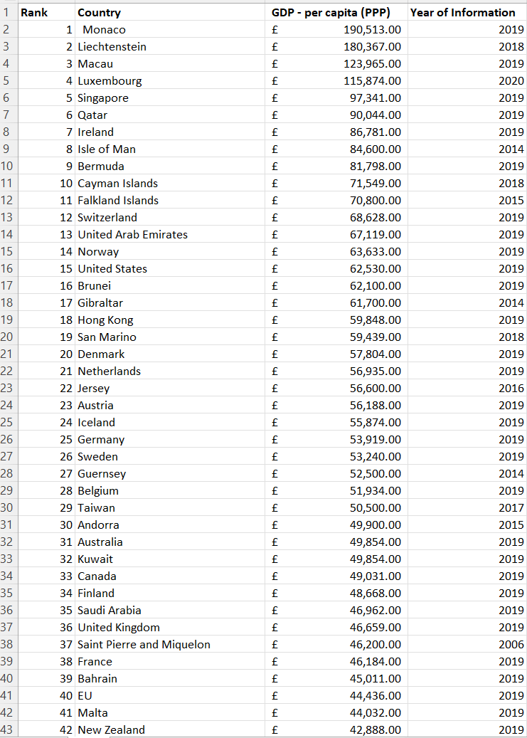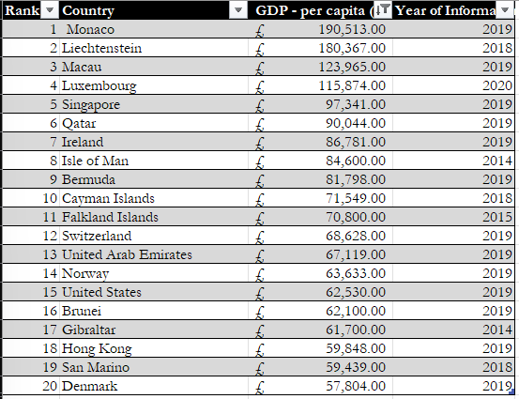

Figure 2

Figure 3

Above we can see the transition of the sheet (figure 2) into a table (figure 3). Filters were applied to the table using the dropdown function. The filters applied included the top 20 countries in relations to their GDP per capita. Another filter was previously applied, which was to showcase data from 2019 only, but for the purpose of future visualization and formatting the filter was removed.

Turning a sheet into a table has several benefits:

* Structured data
  + Tables provide a structured format for organizing data, making it easier to sort, filter, and manipulate data,
* Formatting
  + Tables come with built-in formatting, making it easy to create professional-looking reports and dashboards,
* Data validation
  + Tables allow us to apply data validation rules, helping to ensure the accuracy and consistency of our data.

1. **Creating charts:**

To create a chart in Excel, we can follow these steps:

1. **Select the data** we want to include in the chart, in this case Rank, Country, and GDP per capita,
2. Click on the **Insert** tab in the menu,
3. Choose the **chart type**. For this task I chose a **bar chart** as I believe it represents our dataset best,
4. Customize by adding a title, labels,

Figure 4

Creating charts helps to visualize the data, making it easier to understand and interpret. Additionally, this can help to identity patterns, trends, and anomalies in the data that might be harder to spot in a table. As we can see from Figure 4, identifying the country with largest GDP is quick and simple.

1. **Applying macros**

Macros are a useful tool in Excel for automating tasks, ensuring consistency, and reducing the risk of errors in data analysis. There are a number for ways to create macros however for the purpose of this task I decided to use the record macros tool. Below are the steps I took to create the macros.

1. Click on the **View** tab, and then click on **Macros in the Macros Group**,
2. In the Macros dialogue box, enter a name for the macro and then click OK (figure 7),
3. Click on the **Record Macro** button (figure 5),
4. Undertake the action that you want to automate, in this case Copy, Save and Print. So in the example of Save, the action would be to open File, and then click Save,
5. When finished performing the action, click on **Stop Recording** (figure 6),
6. To apply the macros, I created three buttons using the Insert shape function in Excel and assigned each macro to the corresponding button (figure 8).

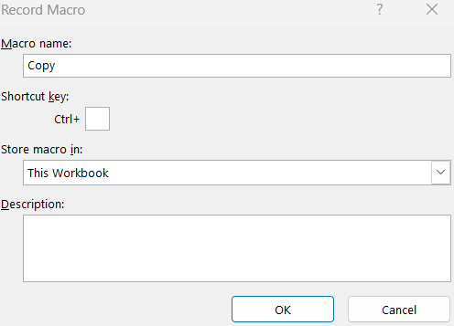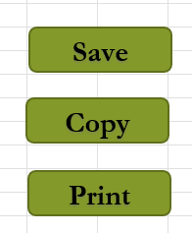

Figure 5

Figure 6

Figure 7

In order to a create a more professional appearance for the Excel document, we can add headers and footers. By adding these headers and footers, we can make our work look more polished and organized, while also including further relevant information such as name, date, and course title. This provides context and can help when sharing work with others. This can be seen in figure 9.

Figure 8

**HEADER**

**FOOTER**

Figure 9

# **Tableau Visualization**

1. **Overview of Tableau and its features**

Tableau is a data visualization tool which allows users to create dynamic and interactive visualizations from a variety of data sources. Its key features include a drag and drop interface which is intuitive, data blending, interactive dashboards and mobile optimization. Tableau is a great tool for data analysis as it is easy to use, allows users to use different types of data and create powerful and interactive visualizations which can be used in meetings with colleagues, clients and stakeholders.

1. **Import the Wealth of nations data set**

Importing a data set on Tableau is a straightforward process, however we must make sure that our data is relevant and the connections between the data sets is set.

To import a data set on Tableau we can follow these steps:

1. First step is to **connect to data**. Click on Connect to Data in the start page, then select Microsoft Excel,
2. Choose the excel file you wish to connect, in this case the Wealth of Nations data set,
3. **Review** the data. Tableau will display a preview of the data in our file. Here we must make sure that the data is **labeled correctly**. In this case, Tableau does a good job at correctly identifying the data,
4. There are three sheets we must set **relationships** between, GDP, Life Expectancy, and Smartphones. The matching fields in all sheets is Country, therefore this field was selected for the creation of the relationship,
5. Once satisfied with the data preview, click Sheet1 to import the data into a new worksheet,
6. We are now ready to **create visualizations**.

Figure 10



Figure 11

1. **Creating a dashboard**

Before creating our visualizations and final dashboard, we must be aware of our clients requirements. Our clients require a dashboard which is suitable for colorblind people. Additionally, they are only interested in the top 20 highest ranking countries, therefore the visualizations must reflect this.

For my dashboard I decided to use four different types of visualizations. The first is a bar chart which showcases the top 20 countries ranked by life expectancy. This can be seen in Figure 12. From this chart we can deduce that Australia is the highest ranked country in terms of life expectancy. This means that people living in Australia tend to have the longest life expectancy compared to any other country around the world.

Figure 12

For my second visualisation, I created a packed bubbles chart showcasing the top 20 ranked countries by smartphone users. This can be seen in Figure 13. From this chart we can see that China is ranked first in terms of smartphone usage. This can be linked to China’s 1.4 billion people population.

Figure 13

As a third visualisation, I decided to look at GDP per capita. Here, I created a tree map of the top 20 countries ranked by GDP per Capita. This can be seen in Figure 14. As we can see from the Chart, Monaco is ranked highest in terms of GDP per capita.

Figure 14

Finally, the fourth visualization created is a highlight table. I believe highlight tables are some of the best ways to visualize data as they are simple and easy to understand. The table is ranked order and colour coordinated. The chart can be seen below.

Figure 15

These are the four visualizations I made to create my dashboard. As seen, they apply the clients requirements as they are suitable for colour blind people and showcase the top 20 ranked countries. You can follow this link to visualize and interact with the dashboard:

<https://public.tableau.com/app/profile/alex.mancas/viz/Report1_16759566644840/Dashboard1?publish=yes>

Figure 16

# **Reflection**

Overall, I am pleased to say that this project went pretty well. I was able to create some great visualizations that helped to convey the data in a clear and informative way. I am proud of the accuracy of with which I performed the tasks, and the final report that I put together is comprehensive and covered everything I needed it to.

That said, there are areas where I can improve. For example, I could work on creating more interactive and better designed visualizations to make the data even more engaging and easy to understand. I also had some trouble creating macros in Excel, which caused a bit of a slowdown, but eventually found a solution and was able to get things back on track.

Overall, I believe I covered every aspect of this project, and created an informative report, but there is always room for improvement. I am looking forward to taking what we have learned from this project and applying it to the next one!