Workload, Schedule Congestion, and Injury Risk in the NBA: A Time-to-Event Perspective

Author: Alexander Lachlan Martin
Supervisors: Haresh Suppiah
22585136@students.ltu.edu.au
H.Suppiah@latrobe.edu.au

Abstract: A single paragraph of about 200 words maximum. For research articles, abstracts should give a pertinent overview of the work. We strongly encourage authors to use the following style of structured abstracts, but without headings: (1) Background: Place the question addressed in a broad context and highlight the purpose of the study; (2) Methods: briefly describe the main methods or treatments applied; (3) Results: summarize the article’s main findings; (4) Conclusions: indicate the main conclusions or interpretations. The abstract should be an objective representation of the article and it must not contain results that are not presented and substantiated in the main text and should not exaggerate the main conclusions.
Keywords: keyword 1; keyword 2; keyword 3 (List three to ten pertinent keywords specific to the article yet reasonably common within the subject discipline.)

0. How to Use This Template
The template details the sections that can be used in a manuscript. Note that each section has a corresponding style, which can be found in the “Styles” menu of Word. Section titles given are for articles.
Remove this paragraph and start section numbering with 1.

1. Introduction
The introduction should briefly place the study in a broad context and highlight why it is important. It should define the purpose of the work and its significance. The current state of the research field should be carefully reviewed, and key publications cited. Please highlight controversial and diverging hypotheses when necessary. Finally, briefly mention the main aim of the work. As far as possible, please keep the introduction comprehensible to scientists outside your particular field of research. References should be numbered in order of appearance and indicated by a numeral or numerals in square brackets—e.g., [1] or [2,3], or [4–6]. See the end of the document for further details on references.
I will reference [1] [13] here
Lorem ipsum dolor sit amet, consectetur adipiscing elit, sed do eiusmod tempor incididunt ut labore et dolore magna aliqua. Ut enim ad minim veniam, quis nostrud exercitation ullamco laboris nisi ut aliquip ex ea commodo consequat. Duis aute irure dolor in reprehenderit in voluptate velit esse cillum dolore eu fugiat nulla pariatur. Excepteur sint occaecat cupidatat non proident, sunt in culpa qui officia deserunt mollit anim id est laborum.

2. Methods

2.1 Study design and data sources
This study analysed all players who appeared in the National Basketball Association (NBA) regular-season game across the last five seasons, from 2021-22 to 2025-26. The unit of analysis was the player-game interval: one observation per player per scheduled team game, structured in the counting-process format required for Cox modelling with time-varying covariates [14]. The dataset comprised 176,202 at-risk player-game intervals contributed by 1,029 players.
All data were drawn from publicly available sources; no proprietary / internal team or medical information was used. Player game logs, rosters and career totals, the league schedule with derived travel distances, and player tracking measures including distance covered were retrieved from the NBA Stats API. Injury information was retrieved from the official NBA pre-game injury reports. Only regular-season fixtures were retained. The study window was set by the availability of the injury reports, which begin in 2021-22. Full endpoint detail is given in Appendix A.1.

2.2 Outcome definition
Teams file an official injury report at 30-minute intervals before each game, recording each player’s playing status and a free-text reason string. The final pre-game filing was taken as the last true known reason and these do not change after games tip off. The reason field is unstructured, containing more than 2,500 distinct strings across the 5 seasons captured, the reports are written as ‘Injury/Illness - <SITE>; <PATHOLOGY>’, so the body site and the described pathology already arrive as separate fields. These were parsed and then classified on the IOC standards [21], which asks that body region, tissue type, mechanism and severity each be recorded separately rather than collapsed into one label (Appendix A.2). Laterality was identified where possible (9 in 10). Load management, illness, G League assignment were excluded, since treating a rested player as an injury case would increase the risk of confounding of exposure and unmeasurable selection politics in our model
Consecutive missed games attributable to one problem/injury were collapsed into an injury episode. Deciding when a later absence is a new injury and when it is the old one flaring up is the second half of the outcome definition. SIC-2.0 [22] Is used here where site, nature and side are recorded but no professional has judged whether a later problem is the same pathology. An episode affecting the same region and side as a previous one was treated as a reaggravation when it occurred before the player played eight games healthy games, roughly a fortnight of playing time. This follows the consensus of counting a same-site injury after a healthy playing period as a new injury rather than a reaggravation of the previous one [23], while acknowledging the evidence that the fortnight immediately after return carries the greatest recurrence risk [24].
The primary outcome was time to a new injury episode, defined as its first missed game. A recurrent outcome counted any reaggravation episode onset. Mechanism-specific outcomes partitioned/grouped new injuries on the IOC mechanisms by the plausibility of a workload pathway, and the overuse (repetitive) mechanism was further split by whether a pathology was named (Section 2.6).
One limitation that conditions everything. The injury report is a team availability signal, not a clinical record. What is observed is that a player was listed as Out with a stated reason, not a clinician’s diagnosis. Severity, mechanism and laterality are therefore derived from that reason text rather than assessed: severity is measured as games missed and binned into the IOC time-loss bands, and mechanism is inferred from the recorded pathology Where the text names no pathology at all, these more granular details cannot be recovered, and Section 3.4 shows that this is not a rare edge case but a substantial share of the overuse tier.

2.3 Counting-process construction and the at-risk set
Each player-season contributed intervals of the form [t_start, t_stop], where t_stop is the player’s sequential game number within that season. The time axis counts the player’s position through their team’s scheduled games during their season, including games missed for reasons other than injury, so time measures a season schedule timeline rather than accumulated games misaligned per player in the context of the full season. Players re-entered the risk set each season, so each player-season is a separate survival episode while covariate effects are shared.
Three rules governed what was considered in our dataset. A player who appeared was at risk with covariates observed. A player who did not appear but was not serving an injury absence, for example a rested or healthy-scratch player, remained at risk, with in-game covariates carried forward from the last appearance; excluding them would remove exactly the low-load intervals needed to identify a workload effect. A player already serving an injury absence was removed, since a player who is already unavailable cannot sustain a new injury.
The third rule creates a difficulty. The event of interest is the first missed game of an absence, which is also the first row the rule would delete. Risk-set was therefore defined so that an interval is removed only where the player was absent both at its opening and throughout it. This retains the onset row and the first appearance after an absence ends. One class of event is nonetheless lost: where a new injury to a different region begins mid-absence, the onset row is itself preceded by an absence and is removed with it. Rows preceding a player’s first appearance were dropped as left truncation, and observations were censored at the end of the regular season.
The choice of time axis is a modelling decision rather than a property of the data, so an alternative was tested in which the clock counts a player’s at-risk intervals and closes the gaps left by injury absences. Results were unchanged (Section 3.8 and Appendix B.3).
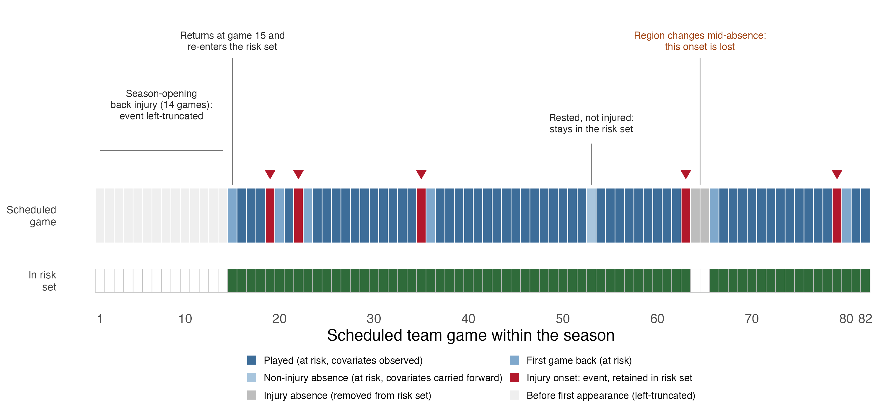
Figure 1. Construction of the counting-process risk set for one player-season (LeBron James, 2025-26), chosen because it contains every case the rules must handle. The upper track classifies each of the 82 scheduled games by player state; the lower band shows whether the resulting interval entered the model; red markers indicate retained injury onsets. Eighty-two scheduled games yield 66 modelled intervals and five retained events from seven onsets. The rest day at game 53 and the return to play at game 15 both remain in the risk set. The season-opening onset is lost to left truncation, and the onset at game 65 begins during an absence for a different region and is removed with it.

2.4 Covariates
Covariates were grouped into three domains, which also define the nested models: workload, schedule congestion, and player context. Every continuous covariate was standardised, so each hazard ratio reads as the multiplicative change in hazard per one standard deviation increase, which is what makes comparison across domains legitimate and easier to interpret.
The primary exposure was on-court external load. Distance (movement) tracked in game was preferred to minutes, distance is what the body absorbed, whereas minutes are a coaching decision. The two correlate at approximately 0.99 here, and Section 3.8 reports the minutes specification. Rolling exposures were summed over trailing calendar-day windows rather than a fixed number of games, so that a window represents the same elapsed recovery time regardless of schedule density:
EQ1: Ait=g∈Git,7​Lig, Cit=g∈Git,28​Lig, ACWRit=AitCit/4
Load is recorded in game and the games each player appeared in during the days to. The 28-day chronic window follows standard in workload literature [7]. Acute and chronic load enter the model as separate covariates rather than as a ratio. Section 4.2 and Appendix A.4
It is realised during the interval likely in which the injury occurs and is reverse caused (a player who breaks down mid-game logs a low distance in that game), so the Load covariate of the at risk event reads protective which is unrelated to protection. Two lagged versions were used instead, the value from the most recently previously played game, and from two played games back. Both are known before the interval opens, so both are prospective. Lag-1 carries some of the load-management/ injury signal pattern, because the appearance immediately preceding a breakdown is frequently a managed one or where injury effects can initially rise, therefore can read protective. Lag-2 is where a genuine fatigue-spike mechanism should be visible. TA player’s first two appearances each season therefore cannot be scored, so the fitted models analyse 3,921 of the 3,981 new-injury events (minor misses)
Schedule congestion was measured two ways, deliberately. Accumulated dose (rolling back-to-back counts, road-trip game number) records what the player absorbed and cannot be manipulated by a single coaching decision. Point-in-time indicators (back-to-back, on road trip, days rest) are contaminated by team decisions about whether a player was fit to play. Both were kept so the contrast is visible in the results rather than hidden by dropping them, and the latter are marked throughout as selection affected.
Player context comprised league tenure and its square, career games missed, prior episodes within the season, return from absence within 14 days, season progress, post-All-Star phase, pre-season participation, height and weight. Tenure was introduced quadratically for two reasons. Under the NBA Player Participation Policy, teams may obtain pre-approved back-to-back rest for star players aged 35 or over, or with > 34,000 Regular Season + Playoff minutes or > 1,000 Regular Season + Playoff games, or a serious injury history [15]. Acute load therefore differs by tenure by rule, while accumulated mileage rises with tenure; two forces in opposite directions, which is the shape a quadratic represents. The literature does not support a linear relationship: no association between injury rate and age or NBA experience has been reported [3], and where differences do appear they are not monotonic, with injury increases under schedule compression largest for players aged 25 to 29 rather than the oldest group [8], and rookie and veteran injury profiles differing [2]
Thirty candidate covariates were screened for redundancy before fitting using Spearman correlations, with one member retained from each family exceeding 0.8. Appendix A.4 reports the screen.

2.5 Model specification
The hazard for player $i$ in season $s$ was modelled as
$${EQ2: h}_{i}\left(t∣X_{i}\left(t\right)\right)=h_{0s}\left(t\right)exp​\left(β^{⊤}X_{i}\left(t\right)\right),$$
with $h_{0s}\left(t\right)$ an unspecified baseline particular to season $s$. Estimation maximises the partial likelihood,
EQ3: Lβ=d=1Dexp​β⊤Xdtdj∈Rstd​exp​β⊤Xjtd,
where $R_{s}\left(t_{d}\right)$ is the risk set of Section 2.3. Two properties matter. The baseline cancels, so no assumption is required about the shape of injury risk across a season. Each factor compares the player who failed against everyone genuinely available to fail at that instant, which is why the at-risk rules carry so much of the design.
Because the baseline is common within a stratum, it also cancels from a ratio of two players’ hazards:
$$EQ4: \frac{h_{A}\left(t\right)}{h_{B}\left(t\right)}=exp​\left(β^{⊤}\left(X_{A}\left(t\right)-X_{B}\left(t\right)\right)\right).$$
Equation 4 is a property of the design rather than a caveat added afterwards. Relative ranking between players requires no baseline and is identified. An absolute probability does require one, and under season stratification there are five, with the observation unit an interval rather than a person. The model is therefore presented throughout as a tool for ranking risk within the league risk set, not for predicting whether an individual will be injured.
Three models were fitted in sequence, adding one at a time, so that the analysis answers which domain contributes rather than producing one large model of 24 coefficients. Each season has its own baseline through stratification. The assumption is that workload acts the same way each season, not that each season carries equal risk. Standard errors were clustered on players, leaving coefficients unchanged and widens their uncertainty to reflect repeated player entries in the risk set. Efron’s approximation handled tied event times.
Blocks were tested with a joint Wald statistic on the newly added coefficients, built from the clustered covariance. A likelihood ratio test is not valid here: clustering does not alter the likelihood that is maximised, only the variance estimated afterwards, so a likelihood ratio test would read the uncorrected working-independence likelihood and silently discard the entire clustering adjustment. A likelihood ratio test requires a correct likelihood; a Wald test requires a correct variance, and this design supplies the second.

2.6 Diagnostics, recurrence, and the mechanism control
Proportionality was used with scaled Schoenfeld residuals [16] on a game-number axis. with 4,000 events near-flat trends tests significant, each flagged covariate was classified by direction of drift. Our assessment included, letting the coefficient change with time, fitting it and judging on whether it improved out-of-sample discrimination (Appendix B.1).
Three recurrent-event specifications were fitted, each answering a different question. Andersen-Gill [17] treats every onset as an event under a common baseline and estimates a marginal effect. Prentice-Williams-Peterson gap time [18] stratifies the baseline by episode order and resets the clock, asking whether a second injury differs from a first. A shared frailty model added a per-player random intercept, $b_{i}∼N\left(0,θ\right)$, whose variance is a single-number estimate of unmeasured model player injury effects.
The mechanism control is the exposure identification strategy. A player carrying high chronic load is on court more and was selected onto the court by being fit, so any load-injury is attributable to both fatigue and exposure, and no number of covariates included at the public level separates them. If workload causes injury through fatigue, its effect must depend on the injury mechanism: strong for overuse, weak for injuries that are random events. New injuries were therefore partitioned/grouped on the IOC mechanism axis [21] into repetitive, acute non-contact and acute impact (the negative control) [26]. The repetitive tier was then split, because only about a fifth of it carries a pathology that were named (the remainder records soreness, tightness or spasm with no diagnosis attached). The two acute tiers are already about 95 per cent named pathology. Tier assignment rests on classification of free text and involves judgement; the split is defensible but not perfect.

2.7 Validation
Two out-of-sample methods were applied, chosen because they work in different ways. A temporal split trained on 2021-22 through 2024-25 and scored the unseen 2025-26 season, mirroring operational use. Player-grouped five-fold cross-validation held out whole players, so that every interval was scored by a model that had never observed that individual; a random row-level split would allow the model to score well by memorising players rather than learning anything transferable. Standardisation constants were computed on training rows only, and season stratification was dropped, since a stratified model has no baseline for an unseen season and discrimination requires only the linear predictor.
A conventional absolute-risk calibration curve is not well defined under this design, for the reasons given at Equation 4. What the design supports, and what a ranking tool requires, is relative-hazard calibration: intervals were grouped by risk score and observed event rates compared across groups.

2.8 Software and reproducibility
Analysis used R 4.5.2 with survival 3.8.3 and coxme 2.2.22. The complete pipeline and the reproducible report generating every figure and table in this article are available at github.com/alexmartin360/Basketball-Workload-Injury-Risk-Profile.

3. Results

3.1 Cohort and model progression
Dataset comprised 176,202 at-risk intervals from 1,029 players, with 3,981 new injury episodes (1,780 overuse, 1,442 acute non-contact, 604 acute impact, and 155 whose mechanism could not be classified) and 5,161 onsets counting reaggravations (Table 1). Within the overuse/repetitive tier, 429 episodes had a named pathology and 1,351 recorded only a symptom. We model 3,921 events on 166,703 intervals, when we account for the lagging load covariates.
Discrimination improved at each step of the sequence, from 0.675 for workload alone to 0.685 with schedule congestion and 0.707 with player context (Table 2). Both added blocks were significant. The increments are small in gains where workload does most of the work but neither remaining domain is redundant. Player context contributes about twice the discrimination that schedule congestion does.
Table 1. Composition of the counting-process dataset.
Quantity | Value
Player-game intervals | 176,202
Distinct players | 1,029
Seasons | 5 (2021-22 to 2025-26)
New-injury events (primary outcome) | 3,981
Overuse (repetitive mechanism) | 1,780
of which pathology named | 429
of which symptom only | 1,351
Acute non-contact | 1,442
Acute impact (negative control) | 604
Mechanism not classifiable | 155
All injury onsets (incl. reaggravation) | 5,161
Intervals entering Model 3 | 166,703
Events entering Model 3 | 3,921
Table 2. Nested model progression. Joint Wald tests use the player-clustered covariance.
Model | Domains | Concordance | p
1 | Workload | 0.675 | —
2 | + Schedule congestion | 0.685 | 3.1e-20
3 | + Player context | 0.707 | 3.1e-51

3.2 Hazard ratios
Table 3 reports Model 3. Chronic 28-day load dominates, at roughly three quarters increase in hazard per standard deviation (HR 1.76, 95% CI 1.59 to 1.94). Lag-2 load two games back (HR 1.53) and acute seven-day load (HR 1.29) follow.
The lagged in-game terms behave exactly as predicted: load in the most recent game was protective (HR 0.48) while load two games back was harmful (HR 1.53). The reversal across a single game is the expected signature of load management and early onset.
Team days rest was protective (HR 0.77), which is what physiology predicts. Three other covariates read as protective in a way no physiological supports: the back-to-back indicator (HR 0.89), the road-trip indicator (HR 0.81) and recent return from absence (HR 0.80). Each is influenced by a team’s judgement about whether the player was fit to play. Among other notable covariates, prior episodes within the season (HR 1.20), career games missed (HR 1.17) and the post-All-Star phase (HR 1.54) were associated with elevated hazard, and experience showed the expected non-linearity.
Table 3. Model 3 hazard ratios by domain, per standard deviation for continuous covariates, with 95% confidence intervals from the clustered covariance. An asterisk marks a selection-affected covariate, not interpreted causally.
Domain | Covariate | HR | 95% CI | p
Workload | In-game load, last game * | 0.483 | 0.441 to 0.529 | 8.6e-56
Workload | Chronic on-court load (28d) | 1.758 | 1.592 to 1.941 | 8.3e-29
Workload | In-game load, 2 games back | 1.534 | 1.435 to 1.639 | 1.5e-36
Workload | Acute on-court load (7d) | 1.286 | 1.130 to 1.464 | 1.4e-4
Workload | Chronic travel load (28d) | 0.912 | 0.860 to 0.966 | 0.002
Workload | Acute games played (7d) | 1.070 | 0.988 to 1.157 | 0.095
Workload | Season cumulative travel | 1.064 | 0.985 to 1.149 | 0.117
Workload | Acute travel load (7d) | 1.007 | 0.965 to 1.052 | 0.740
Schedule | Team days rest | 0.767 | 0.692 to 0.849 | 3.8e-7
Schedule | On road trip (point-in-time) * | 0.806 | 0.721 to 0.900 | 1.4e-4
Schedule | Back-to-back (point-in-time) * | 0.890 | 0.838 to 0.946 | 1.6e-4
Schedule | Chronic back-to-back dose (28d) | 0.921 | 0.872 to 0.972 | 0.003
Schedule | Road-trip game number | 1.049 | 0.999 to 1.102 | 0.054
Schedule | Acute back-to-back dose (7d) | 0.956 | 0.903 to 1.011 | 0.115
Player context | Season progress | 0.538 | 0.420 to 0.688 | 8.0e-7
Player context | Post-All-Star phase | 1.541 | 1.165 to 2.037 | 0.002
Player context | Recently returned (<=14d) * | 0.801 | 0.722 to 0.889 | 2.9e-5
Player context | Prior injury episodes this season | 1.201 | 1.155 to 1.249 | 4.5e-20
Player context | Career games missed (durability) | 1.168 | 1.090 to 1.253 | 1.2e-5
Player context | Experience (seasons) | 1.119 | 1.018 to 1.230 | 0.020
Player context | Played pre-season | 0.925 | 0.806 to 1.061 | 0.263
Player context | Experience squared (inverted-U) | 0.944 | 0.903 to 0.987 | 0.011
Player context | Height | 1.024 | 0.953 to 1.099 | 0.518
Player context | Weight | 1.006 | 0.934 to 1.082 | 0.882

3.3 Proportional hazards
The global test rejected proportionality (χ² = 103.4 on 24 df, p = 7.9e-12) and 12 covariates flagged individually. At 3,921 events this was close to inevitable. The two covariates carrying the substantive workload were among the most clearly proportional in the model: chronic load (p = 0.29) and acute load (p = 0.98), as was days rest (p = 0.85). The injury-history terms did flag, prior episodes (p = 0.002) and career games missed (p = 0.002), and both drift toward zero as a season progresses, which is what frailty compression (at risk set decreasing) looks like rather than a changing physiological effect.
Classifying the twelve violators by direction of drift showed eight moving toward zero throughout the season, showing survivor and frailty compression. Letting the acute-load coefficient change with time was tested for results, gaining nothing out of sample (0.713 against 0.713). Appendix B.1 reports all three analyses. The proportional model is therefore reported, and Section 3.5 shows where the season dynamic is.

3.4 Discrimination, calibration, and mechanism
Model 3 achieved a concordance of 0.707 (95% CI 0.697 to 0.717). Observed injury rates rose across risk-score deciles from 6.9 to 64.7 events per 1,000 intervals, a nine-fold spread with a rank correlation of 1.0 (Figure 2).
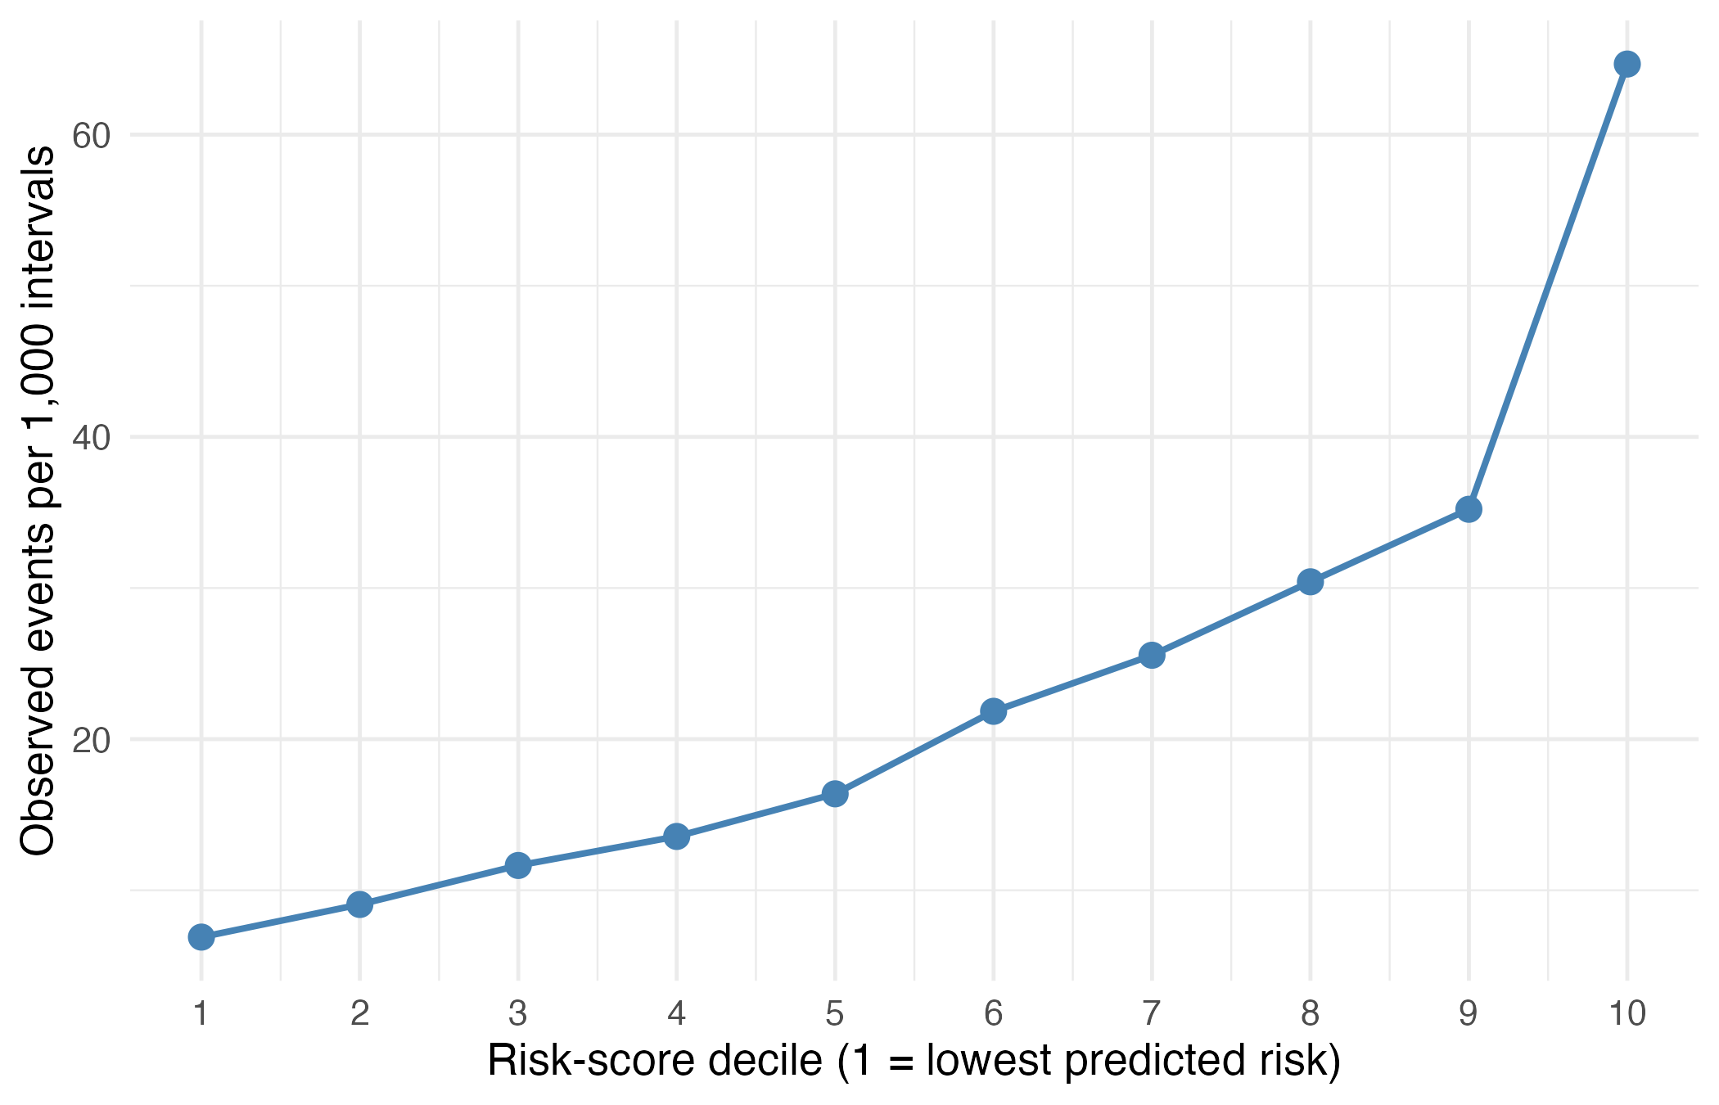
Figure 2. Observed injury rate per 1,000 intervals by risk-score decile, Model 3.
The mechanism split is a central result (Table 4). Chronic load returns HR 1.77 on injuries workload cannot cause, which is larger than the 1.40 it returns on diagnosed overuse/repetitive, the injuries it is supposed to cause. A month of heavy load does not fracture a finger, so that 1.77 cannot be fatigue, what it has detected here is exposure. Players carrying a heavy 28-day load are the ones on court when a loose ball or a stray elbow, and they are carrying that load because they were fit enough to keep being selected and the more they play the more exposure they have to these more probabilistic events.
Acute load shows a different result, and splitting the overuse tier is what makes it visible. Where a pathology is named, acute seven-day load carries HR 1.90 (p = 0.001), larger than for acute non-contact injury (1.42, p = 0.001). Where the report records only that something is sore, it is flat (1.00, p = 0.97), and on the contact control it is indistinguishable from no effect (1.22, p = 0.23). Pooled, the two overuse columns are ambiguous. Effect size and significance agree across all four columns, and that agreement is what makes the pattern read more than just noise.
Only two covariates clear the control at all. Acute load is the clear one at 1.55 times the control estimate; prior injury episodes are the marginal one at 1.04, a modest excess but in the right direction and the term least explicable as court time. Everything else sits at or below 1.0. They are not discriminating between injury mechanisms because they are not measuring a mechanism; they are measuring exposure, and exposure raises the hazard of everything that can happen on a basketball court. This gives great confidence that with the possibility of increased quality of workload and injury data this gap can be bridged where it shows in our model specific covariates that can.
The mechanism split does not weaken the workload result so much as change what can be claimed from it. It resolves the association into two components that a pooled outcome cannot separate; an exposure component, carried by chronic load and the context terms and acting on every injury type including that load cannot cause, and a much narrower fatigue component, carried by acute load and visible only where the outcome is a diagnosed pathology.
Table 4. Mechanism split. Cause-specific models on the Model 3 specification, so estimates are comparable with Table 3 and each other. The overuse tier is reported in two columns according to whether the report named a pathology or recorded only a symptom.
Covariate (per SD) | Overuse (diagnosed) | Overuse (symptom only) | Acute non-contact | Acute impact (control) | Diagnosed ÷ control | Non-contact ÷ control
Chronic load (28d) | 1.40 | 1.69 | 1.88 | 1.77 | 0.79 | 1.06
Acute load (7d) | 1.90 | 1.00 | 1.42 | 1.22 | 1.55 | 1.16
In-game load, 2 games back | 1.19 | 1.34 | 1.79 | 1.47 | 0.81 | 1.22
Prior injury episodes | 1.23 | 1.26 | 1.14 | 1.19 | 1.04 | 0.96
Career games missed | 1.20 | 1.19 | 1.09 | 1.28 | 0.93 | 0.85
Post-All-Star phase | 0.41 | 1.29 | 1.76 | 2.11 | 0.19 | 0.84
Acute load p-value | 0.001 | 0.968 | 0.001 | 0.226 | — | —
Concordance (C) | 0.733 | 0.715 | 0.708 | 0.703 | — | —
Events | 429 | 1351 | 1442 | 604 | — | —

3.5 The season dynamic is in the baseline hazard
Per-game baseline hazard in games 55 to 75 was approximately 1.7 times that in games 5 to 25 (Figure 3), for an average player and independent of any covariate. This is a different claim from Section 3.3. Background risk rises across a season, but the way workload acts on that risk does not change. Only a time-to-event framing separates the two statements.
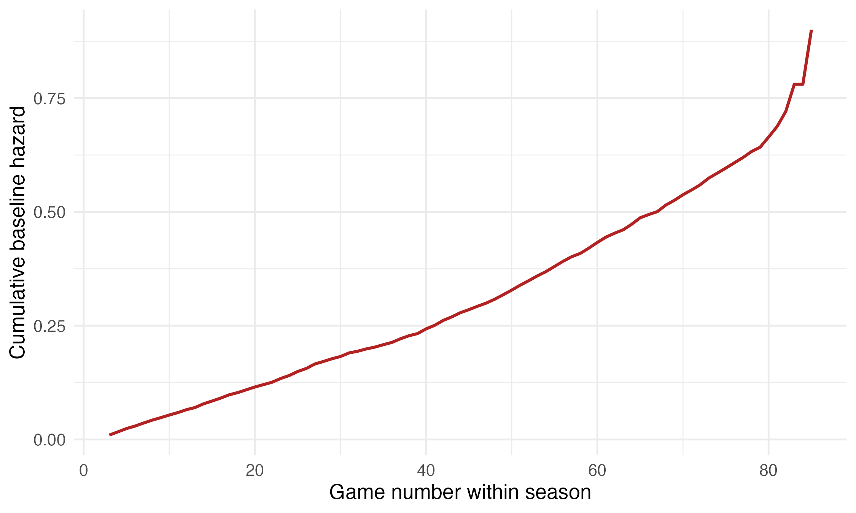
Figure 3. Baseline cumulative hazard by game number within season.

3.6 Recurrence
The three recurrent specifications agreed on workload, with chronic load at 1.55, 1.67 and 1.56 (Andersen-Gill, PWP gap time and shared frailty) (Table 6). Injury burden increased with episode order (1,743, 1,175 and 2,243 events in the first, second and third-or-later episodes). Because the PWP specification stratifies the baseline by episode order, increased risk after episodes can be read off the baseline hazard directly, where no covariate can explain it away: ten games after returning and holding workload, schedule and context equal, a second spell carries 1.60 times the baseline hazard of a first and a third-or-later spell 2.52 times. The frailty variance is θ = 0.316. This says how much players differ in what the model does not observe (remains unexplained), but not how much of the original difference the model removed (Table 5). With no covariates the 90th percentile of proneness carries 12.36 times the hazard of the 10th; with the full covariate set that falls to 4.22. The covariates absorb 67 per cent of the between-player variance. Player context accounts for most of the reduction, taking θ from 0.694 to 0.316, which is more than workload and schedule combined. This is expected given that career history and experience are player-level attributes while workload varies within a player across a season.
Table 5. Between-player heterogeneity as covariate blocks are added. All four models are fitted on the same rows, so the variances are comparable.
Model | θ | SD (log hazard) | Hazard at +1 SD of proneness | 90th vs 10th percentile
No covariates (baseline) | 0.963 | 0.981 | 2.67 | 12.36
+ Workload | 0.763 | 0.873 | 2.39 | 9.38
+ Schedule congestion | 0.694 | 0.833 | 2.30 | 8.46
+ Player context (full) | 0.316 | 0.562 | 1.75 | 4.22

Recent return was protective against a new injury (HR 0.80) but strongly predictive of any onset once reaggravation is counted (HR 1.78 under Andersen-Gill, 1.56 under frailty). They each illustrate a different thing: a returning player is cleared, minutes-restricted and deliberately ramped, which suppresses unrelated new injury, while remaining at elevated risk of the original injury recurring/reaggravating.
Table 6. Covariates under three recurrent-event specifications. PWP additionally stratifies by episode order, which absorbs the prior-episode covariates.
Covariate (per SD) | Andersen-Gill | PWP gap time | Shared frailty
Chronic load (28d) | 1.551 | 1.671 | 1.556
Acute load (7d) | 1.170 | 1.070 | 1.181
Acute games played (7d) | 0.989 | 0.957 | 0.971
Career games missed | 1.110 | 1.124 | 0.981
Experience (seasons) | 1.184 | 1.182 | 1.497
Team days rest | 0.595 | 0.538 | 0.597
Back-to-back * | 0.807 | 0.765 | 0.809
Prior injury episodes | 1.221 | absorbed | 1.076
Recently returned (≤14d) | 1.780 | absorbed | 1.561

3.7 Out-of-sample performance and rolling risk profiles
Concordance was 0.707, against 0.713 on the held-out 2025-26 season and 0.704 under player-grouped cross-validation (Table 7). Neither of which can be considered a failure. Observed rates across held-out risk quintiles rose from 7.1 to 60.1 per 1,000 intervals.
Table 7. Apparent and out-of-sample concordance.
Specification | Apparent | Temporal (2025-26) | Player-grouped 5-fold CV
Primary (on-court load) | 0.707 | 0.713 | 0.704
Minutes (robustness) | 0.707 | 0.713 | 0.704

Across the 450 players with 40 or more modelled intervals in 2025-26, a player’s mean risk score orders their injury count over the season (Spearman rho = 0.62), rising from 0.4 episodes per player in the lowest risk quintile to 3.3 in the highest (Table 8).
Table 8. Player-level mean risk score against injury count, 2025-26 (held-out season), for players with at least 40 modelled intervals.
Risk quintile | Players | Mean games played | Total injury events | Injury events per player
1 (lowest) | 90 | 33.6 | 36 | 0.40
2 | 90 | 51.5 | 103 | 1.14
3 | 90 | 59.5 | 169 | 1.88
4 | 90 | 63.0 | 242 | 2.69
5 (highest) | 90 | 60.5 | 295 | 3.28

Figure 4 presents the operational output: risk score plotted game by game for individual players in the held-out season against the league median and interquartile range. Because the model never saw that season, this risk is prospective.
The three profiles line up. Jalen Johnson sat above the league median in 94 per cent of his games and recorded seven injury episodes. Jamal Shead was the lower edge of the band across 80 games and recorded no injuries absences. LeBron James scored 0.36 with 77 per cent of games above the median and recorded four episodes, correctly in the upper part of the distribution: at 40 his risk is his age and accumulated career mileage as much as by current load, the experienece and durability terms account this. A concordance of 0.707 means the model is correct on average and wrong often enough that no single player’s risk score should be treated as a verdict; the profiles illustrate the ranking rather than validate it.
An observation follows from the low-risk profile. Even Shead, sits only modestly below the median. A player cannot post a very low load-based score and play a full season, because availability is what generates the load the score is built from. The lower scores in the league belong to players barely in the rotation. This is the health-selection constraint of Section 3.4 at the individual level.
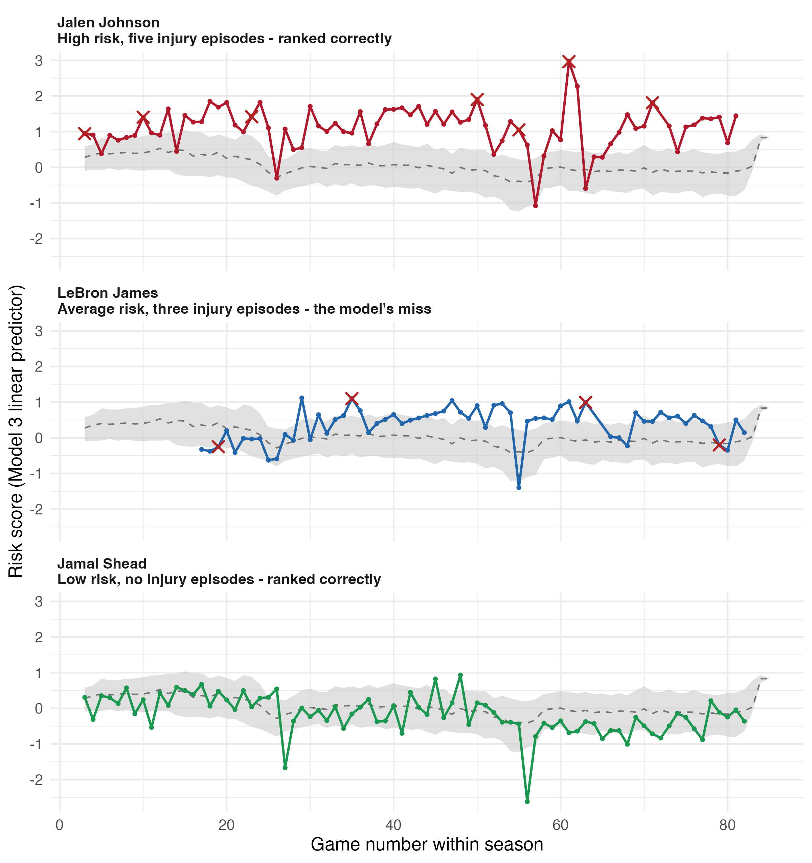
Figure 4. Rolling injury-risk profiles for three players, 2025-26 (held-out season). Grey band is the league interquartile range, dashed line the league median, red markers injury onsets.
Table 9. The three exemplar profiles against observed outcomes.
Player | Games played | Injury events | Mean risk score | % games above league median
Jalen Johnson | 70 | 7 | 1.10 | 94
LeBron James | 58 | 4 | 0.36 | 77
Jamal Shead | 80 | 0 | −0.16 | 31

3.8 Robustness
Reported in Appendix B.2 and B.3 and summarised here. Substituting minutes for tracking distance left almost every result unchanged (concordance 0.7066 against 0.7069, chronic load 1.74 against 1.76), consistent with the two measures correlating at ~0.99. Adding a prospective in-game intensity did not improve the model, concordance was unchanged to three decimals, so the test detects a small departure from zero without intensity adding anything usable.
Restricting to established rotation players (defining an ex-ante on prior-season or career minutes) left the workload hazard ratios close to unchanged, with chronic load at 1.72 against 1.76 and acute load at 1.33 against 1.29, while discrimination fell from 0.707 to 0.670. The restricted cohort is more homogeneous, so the effects are estimated on a cleaner population. The stability of the coefficients indicates the workload result is not an artefact of the deep bench. The full sample is retained as primary because it describes the league rather than a subset of it.
A fourth check on the time axis itself. Re-indexing the clock from a player’s position in their team’s schedule to their healthy games played, which closes the gaps left by injury absences, left every estimate essentially unchanged: chronic load 1.76 against 1.82, acute load 1.29 against 1.25, concordance 0.707 against 0.709, and the mechanism decomposition intact, with acute load still collapsing to 1.20 in the acute-impact control. The two clocks agree on 64.6 per cent of intervals and differ by 2.9 games on average, which is why the risk sets produce the similar results.

4. Discussion

4.1 Principal findings
Four core findings arise from the analysis. Accumulated workload is strongly associated with injury timing, and categorising/grouping injuries by mechanism separates that association into an exposure component and a smaller, better-identified fatigue component that is only visible when a pathology was found. The season becomes more dangerous as it progresses, but that sits in the baseline hazard rather than in any covariate we have identified in our model. Injury risk escalates with each successive episode within a season, and it does so in the baseline where no load covariate reaches it. And the covariates absorb roughly two thirds of the between-player differences in injury proneness, narrowing an unadjusted spread of approximately twelve-fold to just over four-fold.
Team days’ rest, the only schedule covariate that cannot be influenced by a decision of the coaching / team staff, implies 22.3 per cent lower hazard per additional rest day, against the 15.96 per cent reduction in injury reported by Lewis [4]. The two agree in sign and magnitude with a difference of +6.4pp (keeping in mind the literature modelling was done on different seasons, a different outcome definition and a different model). Section 4.5 continues this.
We hypothesised that chronic and acute spiked workload elevate injury hazard through a fatigue pathway, and that the increase in risk should therefore be strongest for overuse injuries and weakest for injuries with no plausible load mechanism. The hypothesis is partially supported, and the part that fails is informative. A fatigue pathway is identifiable and behaves as predicted, by acute load alone and only where the outcome is a diagnosed pathology. The hypothesis treated chronic load as the strongest fatigue proxy, which ultimately turned out to measure exposure. Section 4.2 continues this point.

4.2 The negative control separates exposure from fatigue
Chronic 28-day load had a hazard ratio of 1.76 per standard deviation, the largest effect in the model. That estimate sits within the existing basketball literature. Lewis [4] reported that accumulated minutes raised injury odds, and Orringer and Pandya [5] found minutes per game in the three, five and ten games preceding injury to be four to six per cent above a player’s season average.
Partitioning/categorising injuries by whether accumulated load could plausibly cause them splits the model in two. Acute load is the only covariate that distinguishes the tiers, and it does so only once the overuse tier is separated when a pathology was named. Every other covariate, chronic load included, predicts the contact control at least as strongly as it predicts diagnosed overuse. The model therefore contains an exposure component and a fatigue component, and the negative control is what tells them apart.
The exposure component is not necessarily a downside of the model. For contact injury it is the causal pathway: a collision requires being on the floor to collide, and chronic load returns a high estimate on the control precisely because acute-impact injury is close to a pure function of court time. Exposure is also an aspect load management acts on. A team deciding whether to rest a player is deciding how much exposure to allocate, so an exposure measure that ranks accurately is operationally the more useful to measure than to not. What cannot be done is to call it fatigue.
The fatigue component is smaller and better identified. Acute seven-day load is 1.90 on overuse with a pathology and 1.42 on acute non-contact injury, and collapses to 1.22 and statistical insignificance on the contact control. This is what a physiological mechanism predicts, and an exposure account cannot produce: if the acute-load coefficient merely tracked court time, it would not disappear in one tier while persisting in the others. That contrast is what a negative control creates in value to our findings.
The concordance ordering supports the same. The model discriminates diagnosed overuse at 0.733 and acute non-contact injury at 0.708, against 0.703 for the contact control, so it ranks the injuries workload should play a larger part in modelling more accurately than those it should not. The spread is narrow, so this supports the hazard-ratio evidence rather than standing on its own.
A further result concerns the acute-to-chronic workload ratio, which is not included in the model at all. Andrade and colleagues [7] concluded that ratio findings across team sports are methodologically inconsistent and window dependent. Carrying acute and chronic load separately answers the same question, whether recent load matters given habitual load, and it is conditioning on chronic load that turns the acute term into a measure of load concentration rather than volume. The exposure-fatigue separation above offers a alternative reading of the same literature: low-load players are low-load partly because they are managed, injured or marginal, so a ratio built from two exposure windows inherits whatever selection is present in each.

4.3 The season dynamic lives in the baseline, not the coefficients
Per-game baseline hazard in games 55 to 75 was approximately 1.7 times that in games 5 to 25, while no covariate violated proportionality. These two results may be confused with each other. Background risk rises across a season, the way workload acts on that risk does not change. Heavy chronic load is as dangerous in October as in April; what changes is the level it operates on.
Morikawa and colleagues [8] found injury rates in the condensed 2020 season 42 per cent above a four-season baseline, with accumulation accelerating after game 20 and 500 minutes played. That is rising hazard, but the design used could not determine whether the rise was in background risk or in the workload. Our analysis separates the two and attributes it to the baseline. The same applies to the elevated post-All-Star hazard observed here (HR 1.54), which fits alongside the finding of Menon [19] that season-ending injuries in the NBA concentrate in the third and fourth quartiles of the season rather than the first or second, and is consistent with documented within-season change of basketball players, albeit measured outside the NBA [20].
This changes what should be done about it. If the whole league becomes more injury prone as a season wears on, the response belongs at the season itself: fewer back-to-back and reducing the season congestion, with more recovery built into the calendar. If instead the workload became more harmful late in the season than early, the response would belong at the level of the individual player and would mean cutting the minutes of heavily loaded players in that window.
The evidence here points to the first of these. Background risk rose across the season, while the effect of workload on top of it did not change. What shifts late in the year is therefore the level of risk that every player carries, not how dangerous any workload has become.

4.4 Prior injury: two answers that are both correct
Injury burden escalated with episode order, with 1,743, 1,175 and 2,243 events in the first, second and third-or-later injury episode respectively. The PWP specification puts that escalation in a baseline where the covariates cannot identify. Because the baseline is stratified by episode order and the strata carry no coefficient, the 1.60 and 2.52 multipliers on second and third-or-later spells are not attributable to any of our model domains. The risk increase, from 16.3 events per 1,000 intervals in a first spell to 68.1 in a third, so the covariates do absorb a real share of it; what they cannot absorb is the remainder that sits in the baseline. The frailty variance of θ = 0.316 implies a 4.2-fold spread in hazard between the 90th and 10th percentiles of unmeasured proneness. Fitting the same specification without any covariates gives θ = 0.963, a spread of 12.36. The full model therefore absorbs 67 per cent of the between-player variance.
Player context accounts for most of the reduction, this is to be expected: career games missed, tenure and prior-episode history are player-level attributes, whereas workload varies within a player across a season creates small differences between players. The heterogeneity that remains is comparable to the effects the model measures. One standard deviation of unmeasured proneness multiplies the hazard by 1.75; one standard deviation of chronic load multiplies it by 1.76. The largest measured effect and the largest unmeasured one are essentially the same size, which sets a clear limit on what public data can reach.
Martin and colleagues [2] found that a single injury during a rookie season was not associated with career longevity and called for research into whether cumulative injury burden is. The recurrent-event estimates above speak directly to that question.
Recent return from absence, which reverses sign depending on the outcome definition. A player in the fortnight after returning was at lower risk of a new injury (HR 0.80) and at a higher risk of any injury onset once reaggravation is counted (HR 1.78 under Andersen-Gill, 1.56 under shared frailty).
A returning player has been medically cleared, is typically minutes-restricted, and has their load deliberately ramped, all of which suppress the hazard of an unrelated new problem. The same player is simultaneously at elevated risk of the original problem/injury recurring. Against the literature, the recurrent estimate is the one that corresponds to Fulton and colleagues [11], who found previous hamstring strain raised recurrence risk more than fourfold and that 70 per cent of anterior cruciate ligament injuries occurred on a previously injured limb, Hägglund and colleagues [12], who reported a hazard ratio of 2.7 for prior injury in elite football. Both estimates come from outside basketball, so the closest available test of transfer is Eftekhari and colleagues [25], who followed hamstring injuries across five NBA seasons and found that 81.4 per cent of affected players sustained a subsequent injury in the same or the following season.

4.5 Health-gating, and the one schedule covariate that is clean
Three covariates read as protective where no physiological account supports: the point-in-time back-to-back indicator (HR 0.89), the road-trip indicator (HR 0.81) and recent return from absence (HR 0.80). Playing the second game of a back-to-back is not protective. Each is determined by a decision about whether the player was fit to play, and each varies between team-mates on the same date for many more reasons than just fitness, a covariate that records the schedule should not differ between two players whose team is playing the same fixture. Each therefore measures availability as much as exposure.
Team days rest is protective (HR 0.77), and is what physiology predicts. It is also the one schedule covariate that cannot be health-gated: it is a property of the fixture/schedule, shared by every player on a team on a given date, so no coaching or team staff decision about an individual can move it. The estimate implies 22.3 per cent lower hazard per additional rest day. Lewis [4] reported a 15.96 per cent reduction in injury odds per rest day, on different seasons and using a different model. The two agree in direction and in order of magnitude, which is the closest this study comes to an external check on the existing literature.
Travel showed no association with injury. Acute seven-day travel was flat (HR 1.01) and chronic 28-day travel marginally protective (HR 0.91), which is better read as the other exposure terms: players who accrue travel are players who remained available to travel. This is somewhat consistent with the NBA air-travel literature, which links long-haul and eastward flights to sleep loss and performance impact and injury incidence [10], with chronic travel reading marginally protective it leans so being another protective health selection covariate, and where circadian change and travel distance are associated with NBA game performance [9]. The discrepancy is likely due to distance flown being a coarse proxy for the sleep and circadian disruption those studies implicate, and it is recorded here at team level.
That contrast also assists in the interpretation of the other three. It is not that every protective coefficient is wrong; it is that the ones which vary between team-mates facing the same fixture are, and the one that does not vary behaves as the literature says it should.
Observational data cannot fully separate a load effect from the decision process that generated the load, only the days-rest term is immune with our data.

4.6 What the model is for
The model discriminates at a concordance of 0.707, and 0.713 out of sample on a temporal split and 0.704 under player-grouped cross-validation. It is not a tool for predicting whether a given player will be injured, and it should not be presented as one. Its estimate is relative, because the baseline hazard cancels from a ratio of two players’ hazards (Equation 4), the model identifies who is at elevated risk relative to the risk set without absolute probability.
A team cannot rest every player, and the schedule imposes load regardless of what any team decides. The operational question is comparative between what Is available: given a roster and a week of fixtures, which players carry the most modelled risk relative to the others. Observed injury rates rose across risk deciles from 6.9 to 64.7 per 1,000 intervals, and the ordering transferred to a season the model had never seen, so the ranking is fit for that purpose.
The player profiles in Figure 4 show both the value and the limit. At the level of the squad the ranking holds: mean risk score orders injury count across the league (Spearman rho = 0.62), and the highest-scoring risk scorer recorded the season’s heaviest injury burden while the lowest-scoring played a full season without one. At the level of the individual it does not always hold, a concordance of 0.707 is about populations of pairs, not about any one player, and the appropriate unit of interpretation is therefore at group/team level rather than the individual player.

4.7 Strengths and limitations
The strengths are the design rather than the data. Five complete seasons, with every covariate timed so that it is known before the interval it describes, addresses a timing problem that is rarely handled explicitly in this literature. The injury-type negative control is, to our knowledge, the first application of that logic to basketball workload data, and it is the reason the central claim is stated as exposure rather than fatigue. Three recurrent-event specifications agreeing, two complementary out-of-sample schemes, and a fully reproducible pipeline provide further assurance that the headline results are not artefacts of a modelling choice.
The limitations are substantial. Health-gating is mitigated but unresolved, as Section 4.5 sets out. The outcome is an availability signal rather than a diagnosis: what is observed is that a player was listed as ‘Out’ with a stated reason, not a professional assessment. Section 3.4 shows this, since three quarters of the overuse tier carries no named pathology and the workload association is absent. Discrimination in the range 0.70 to 0.73 is, on this evidence, close to the ceiling for public data, and this study is better understood as establishing that ceiling for public data than as offering a competitive predictive model. The same applies to between-player heterogeneity: the covariates absorb roughly two thirds of it, and the residual four-fold spread in proneness is what public data cannot reach rather than a deficiency of the specification. The lagged in-game covariates come at a cost of coverage, since a player’s first two appearances in a season cannot be scored, which makes early-season injury the blind spot. Assignment of injuries to mechanism tiers rests on regular-expression classification of inconsistent free text and involves judgement; the split is defensible but not perfect. Training load is missing, which is discussed below.

4.8 Future directions
Three directions follow directly from the limitations.
The most valuable addition would be granular training load. Practice and conditioning exposure are not publicly available at NBA level, and their absence is the single largest gap in the exposure measure, since game load is only part of what a player absorbs. A synthetic training-load variable was explored during research and abandoned, it correlated too strongly with league tenure to carry independent information, so the simpler covariate was retained. Teams hold this data, and the same design applied to it would be a materially stronger test.
The second is measurement granularity. High-speed running, accelerations and decelerations are the measures the sports science literature implicates in soft-tissue injury, and they are not resolvable at the granularity of public tracking data. The underload finding of Caparrós and colleagues [6] rests on deceleration counts alongside total distance covered; the distance component is observable here, but the deceleration component is not.
The third is causal design. The health-gating problem is not a data volume problem and will not be solved by more seasons. It requires a far deeper inside team knowledge about players health to appropriately advocate for this part of the research. The NBA Player Participation Policy, which constrains rest eligibility by age and career mileage, may offer a usable discontinuity.
Two smaller extensions are worth noting. Severity-weighted outcomes of injuries would allow a torn Achilles and a one-game ankle sprain to be distinguished and weighted differently, which the present binary onset cannot do.

5. Conclusion
This section should provide a concise summary of study including the main findings.

Acknowledgments: Message to whomever you would like to acknowledge; supervisors, peers, family, industry partners, etc.

References
- Sarlis V, Tjortjis C. Sports analytics: data mining to uncover NBA player position, age, and injury impact on performance and economics. Information. 2024;15(4):242.
- Martin CL, Arundale AJH, Kluzek S, Ferguson T, Collins GS, Bullock GS. Characterization of rookie season injury and illness and career longevity among National Basketball Association players. JAMA Network Open. 2021;4(10):e2128199.
- Drakos MC, Domb B, Starkey C, Callahan L, Allen AA. Injury in the National Basketball Association: a 17-year overview. Sports Health. 2010;2(4):284-290.
- Lewis M. It’s a hard-knock life: game load, fatigue, and injury risk in the National Basketball Association. Journal of Athletic Training. 2018;53(5):503-509. doi:10.4085/1062-6050-243-17
- Orringer MJ, Pandya NK. Acutely increased workload is correlated with significant injuries among National Basketball Association players. International Journal of Sports Science and Coaching. 2022;17(3):568-575.
- Caparrós T, Casals M, Solana Á, Peña J. Low external workloads are related to higher injury risk in professional male basketball games. Journal of Sports Science and Medicine. 2018;17(2):289-297.
- Andrade R, Wik EH, Rebelo-Marques A, et al. Is the acute:chronic workload ratio (ACWR) associated with risk of time-loss injury in professional team sports? A systematic review of methodology, variables and injury risk in practical situations. Sports Medicine. 2020;50(9):1613-1635. doi:10.1007/s40279-020-01308-6
- Morikawa LH, Tummala SV, Brinkman JC, Buckner Petty SA, Chhabra A. Effect of a condensed NBA season on injury risk: an analysis of the 2020 season and player safety. Orthopaedic Journal of Sports Medicine. 2022;10(9):23259671221121116.
- Cook JD, Charest J, Walch O, Bender AM. Associations of circadian change, travel distance, and their interaction with basketball performance. Chronobiology International. 2022.
- Huyghe T, Scanlan AT, Dalbo VJ, Calleja-González J. The negative influence of air travel on health and performance in the National Basketball Association: a narrative review. Sports. 2018;6(3):89.
- Fulton J, Wright K, Kelly M, et al. Injury risk is altered by previous injury: a systematic review of the literature and presentation of causative neuromuscular factors. International Journal of Sports Physical Therapy. 2014;9(5):583-595.
- Hägglund M, Waldén M, Ekstrand J. Previous injury as a risk factor for injury in elite football: a prospective study over two consecutive seasons. British Journal of Sports Medicine. 2006;40(9):767-772.
- Chan C-C, Yung PS-H, Mok K-M. The relationship between training load and injury risk in basketball: a systematic review. Healthcare. 2024;12(18):1829. doi:10.3390/healthcare12181829
- Therneau TM, Grambsch PM. Modeling Survival Data: Extending the Cox Model. New York: Springer; 2000. doi:10.1007/978-1-4757-3294-8
- National Basketball Association. Player Participation Policy. Approved by the NBA Board of Governors, September 2023.
- Grambsch PM, Therneau TM. Proportional hazards tests and diagnostics based on weighted residuals. Biometrika. 1994;81(3):515-526. doi:10.1093/biomet/81.3.515
- Andersen PK, Gill RD. Cox’s regression model for counting processes: a large sample study. Annals of Statistics. 1982;10(4):1100-1120. doi:10.1214/aos/1176345976
- Prentice RL, Williams BJ, Peterson AV. On the regression analysis of multivariate failure time data. Biometrika. 1981;68(2):373-379. doi:10.1093/biomet/68.2.373
- Menon S, Morikawa L, Tummala SV, Buckner-Petty S, Chhabra A. The primary risk factors for season-ending injuries in professional basketball are minutes played per game and later season games. Arthroscopy: The Journal of Arthroscopic and Related Surgery. 2024;40(9):2468-2473. doi:10.1016/j.arthro.2024.01.018
- Ferioli D, Bosio A, Zois J, La Torre A, Rampinini E. Seasonal changes in physical capacities of basketball players according to competitive levels and individual responses. PLOS ONE. 2020.
- Bahr R, Clarsen B, Derman W, et al. International Olympic Committee consensus statement: methods for recording and reporting of epidemiological data on injury and illness in sport 2020 (including the STROBE Extension for Sport Injury and Illness Surveillance, STROBE-SIIS). British Journal of Sports Medicine. 2020;54(7):372-389.
- Toohey LA, Drew MK, Fortington LV, Finch CF, Cook JL. An updated subsequent injury categorisation model (SIC-2.0): data-driven categorisation of subsequent injuries in sport. Sports Medicine. 2018;48(9):2199-2210.
- Fuller CW, Ekstrand J, Junge A, et al. Consensus statement on injury definitions and data collection procedures in studies of football (soccer) injuries. Scandinavian Journal of Medicine & Science in Sports. 2006;16(2):83-92.
- Heiderscheit BC, Sherry MA, Silder A, Chumanov ES, Thelen DG. Hamstring strain injuries: recommendations for diagnosis, rehabilitation, and injury prevention. Journal of Orthopaedic & Sports Physical Therapy. 2010;40(2):67-81.
- Eftekhari A, Cogan C, Pandya N, Feeley B. Hamstring injury epidemiology in the National Basketball Association over a five-year period. Muscles, Ligaments and Tendons Journal. 2022;12(2).
- Lipsitch M, Tchetgen Tchetgen E, Cohen T. Negative controls: a tool for detecting confounding and bias in observational studies. Epidemiology. 2010;21(3):383-388.

Appendix A: Methodological detail

A.1 Data sources
Four web scraping scripts written in Python retrieved all data from public sources. Player game logs, team rosters and career totals came from the NBA Stats API endpoints PlayerGameLog, CommonTeamRoster and PlayerCareerStats. The league schedule, including arena coordinates, tip-off times and derived air / land travel distances, came from ScheduleLeagueV2 and LeagueGameLog. Player tracking measures, including distance covered, came from BoxScoreTraditionalV3, BoxScoreAdvancedV3 and BoxScoreHustleV2. Injury reports were retrieved through the nbainjuries package, which collects the official NBA pre-game filings; approximately 3,000 individual report files were processed across the five seasons. Only regular-season fixtures were retained, identified by the NBA game-identifier prefix.

A.2 Injury classification
Injury report reason strings are unstructured and inconsistent across teams and seasons, containing more than 2,500 distinct types of submissions. They are, however, written to a rough template, Injury/Illness - <SITE>; <PATHOLOGY>, which separates the body site from the described pathology before any classification is applied. Site and pathology were parsed from that structure by regular expression and then mapped onto the IOC standard [21]: body region, tissue type, mechanism and severity. Laterality was attempted as well.
Axis (IOC) | Categories recorded | Distribution across modelled episode onsets (severity across all 5,901 time-loss episodes
Body region | Knee, ankle, foot, hip/groin, lumbosacral, thigh, lower leg, hand, shoulder, wrist, head, elbow, other | Knee 1,031 (26%); ankle 1,024 (26%); foot 490 (13%); hip/groin 465 (12%); lumbosacral 460 (12%); thigh 443 (11%)
Tissue type | Muscle/tendon, ligament/capsule, bone, cartilage/synovium/bursa, nervous, superficial, non-specific, not recorded | Non-specific 1,567 (31%); ligament/capsule 1,110 (22%); muscle/tendon 918 (18%); not recorded 763 (15%); superficial 541 (11%); bone 113 (2%)
Mechanism | Repetitive, acute non-contact, acute impact, unclassified | Repetitive 2,371 (46%); acute non-contact 1,777 (34%); acute impact 697 (14%); unclassified 316 (6%)
Laterality | Left, right, bilateral, unspecified | Right 2,269 (44%); left 2,243 (43%); unspecified 606 (12%); bilateral 43 (1%)
Severity (time loss) | Minimal (1-7 days), moderate (8-28 days), severe (>28 days) | Minimal 4,113 (70%); moderate 1,318 (22%); severe 470 (8%)
Table A1. Injury classification following the IOC consensus statement. Values are episode onsets entering the models. Non-injury categories (load management, illness, G League assignment, roster moves, personal and administrative absences) were excluded from all outcome definitions before this classification was applied.
The mechanism axis defines the tiers used for the negative control. The repetitive mechanism is reported in two tiers according to whether the report named a pathology, because the two behave very differently and pooling them conceals the workload effect.
Tier | Definition | Role
Overuse, diagnosed | Repetitive mechanism where the tissue axis resolves to a named pathology: tendinopathy, plantar fasciopathy, bursitis, stress fracture, stress reaction | Where accumulated load should act most directly if a fatigue pathway exists
Overuse, symptom only | Repetitive mechanism where the report records soreness, tightness or spasm with no diagnosis attached (tissue axis non-specific or not recorded) | Separates incident pathology from precautionary rest recorded as soreness
Acute non-contact | Discrete non-contact events: strains, sprains and non-contact tears | The IOC's mixed case, an acute failure of a cumulatively loaded tissue; fatigue can plausibly set these up
Acute impact | External energy transfer: contusions, lacerations, concussion, and fractures or dislocations at contact-prone sites | The negative control. Accumulated load cannot cause a jammed finger
Table A2. The four tiers used for the cause-specific models, ordered by how plausibly accumulated load could cause the injury.

A.3 Episode construction
Consecutive missed games attributable to one problem/injury were collapsed into a single injury episode. An episode affecting the same region and side as a previous one was classified as a reaggravation if it began before the player had completed eight games played, and as a new injury otherwise. An episode affecting a different region or side from every prior episode in the season was always new. The eight-game threshold is a proxy: full recovery is not observable in these data.
Two refinements were required.
Region-change splitting during an absence. A new episode was triggered not only when a player returned to play and was subsequently re-injured, but also when the affected region changed during an absence. Without this, a back injury followed immediately by a foot injury with no appearance between would have been recorded as one episode.
Any-prior-episode matching. The reaggravation test compared each episode against all prior same-region episodes within the season, rather than against the immediately preceding episode alone. This ensures that a third back injury is correctly identified as a reaggravation even where a different injury occurred.
Where a reason string could not be classified, the absence was treated conservatively as a reaggravation of the prior episode if it fell inside the return window (8 games). This biases against inflating the new-injury count.

A.4 Covariate collinearity screen
Thirty candidate covariates were screened before fitting. Cox models struggle when two covariates carry nearly the same information: coefficients split between them, standard errors inflate, and signs can reverse. Pairwise Spearman rank correlations were used in preference to Pearson, because these workload distributions are strongly skewed.
Twenty-seven pairs exceeded an absolute correlation of 0.8, clustering into three families: overlapping rolling windows of the same exposure, career-length measures, and in-game effort measures.
Variable 1 | Variable 2 | Spearman r
ROLLING_MIN_28D | ROLLING_LOAD_28D | 0.997
ROLLING_MIN_7D | ROLLING_LOAD_7D | 0.995
ACWR_MIN | ACWR_LOAD | 0.994
MIN | DISTANCE | 0.984
ROLLING_MIN_28D | ROLLING_MIN_42D | 0.971
ROLLING_MIN_42D | ROLLING_LOAD_28D | 0.967
ROLLING_INTENSITY_7D | ROLLING_INTENSITY_28D | 0.910
ROLLING_MIN_42D | SEASON_CUMULATIVE_MIN | 0.876
SEASON_CUMULATIVE_MIN | SEASON_CUMULATIVE_DIST | 0.872
ROLLING_GAMES_28D | ROLLING_LOAD_28D | 0.869
ROLLING_MIN_28D | ROLLING_GAMES_28D | 0.862
ROLLING_MIN_7D | ROLLING_MIN_28D | 0.860
SEASONS_IN_LEAGUE | PLAYER_AGE_AT_GAME | 0.856
ROLLING_MIN_7D | ROLLING_LOAD_28D | 0.855
ROLLING_LOAD_7D | ROLLING_LOAD_28D | 0.854
ROLLING_MIN_28D | ROLLING_LOAD_7D | 0.852
ROLLING_MIN_42D | ROLLING_GAMES_28D | 0.834
SEASONS_IN_LEAGUE | CAREER_GAMES_MISSED | 0.834
ROLLING_MIN_7D | MIN | 0.824
ROLLING_INTENSITY_7D | INTENSITY | 0.821
ROLLING_MIN_28D | SEASON_CUMULATIVE_MIN | 0.819
SEASON_CUMULATIVE_MIN | ROLLING_LOAD_28D | 0.816
ROLLING_LOAD_7D | MIN | 0.813
ROLLING_MIN_7D | ROLLING_MIN_42D | 0.812
Table A3. Covariate pairs exceeding an absolute Spearman correlation of 0.8. The twenty-four strongest pairs are shown; three further pairs between 0.80 and 0.81 are removed for space.
The 28-day chronic window was retained over the 42-day window, since 28-days is conventional in the workload literature and keeps results comparable with prior work. League tenure was retained over age and draft year. The 28-day rolling appearance count was dropped, correlating at 0.87 with chronic load and returning a null estimate when fitted, while the seven-day count was retained, since its correlation falls below the threshold and it separates frequency from volume: four games in a week is a different from the same minutes across two. Fourth, neither acute-to-chronic ratio term was carried into the model. The ratio is by construction four times acute over chronic, a deterministic function of two covariates the model already carries separately, so entering all three over-parameterises the workload block: it inflates the chronic-load coefficient and divides the acute effect between two terms that cannot be separately identified.

Appendix B: Supplementary results

B.1 Proportional hazards
The global test rejected proportionality (χ² = 103.4 on 24 degrees of freedom, p = 7.9e-12), with 12 of 24 covariates flagging individually at p < 0.05. At 3,921 events this outcome is inevitable, and Section 3.3 illustrates further. The full test is below, and Figure B1 shows the scaled Schoenfeld curve for every covariate.
Covariate | χ² | df | p
Career games missed | 9.54 | 1 | 0.002 | violates
Prior injury episodes | 9.17 | 1 | 0.002 | violates
In-game load, last game * | 8.48 | 1 | 0.004 | violates
In-game load, 2 games back | 7.82 | 1 | 0.005 | violates
Post-All-Star phase | 7.78 | 1 | 0.005 | violates
Back-to-back * | 6.78 | 1 | 0.009 | violates
Experience (seasons) | 6.77 | 1 | 0.009 | violates
Played pre-season | 5.32 | 1 | 0.021 | violates
Experience squared | 5.10 | 1 | 0.024 | violates
On road trip * | 5.00 | 1 | 0.025 | violates
Road-trip game number | 4.83 | 1 | 0.028 | violates
Season cumulative travel | 4.49 | 1 | 0.034 | violates
Chronic travel load (28d) | 2.98 | 1 | 0.084
Chronic back-to-back dose (28d) | 2.44 | 1 | 0.119
Season progress | 1.65 | 1 | 0.199
Chronic load (28d) | 1.12 | 1 | 0.290
Recently returned (≤14d) | 0.96 | 1 | 0.327
Acute back-to-back dose (7d) | 0.96 | 1 | 0.328
Acute travel load (7d) | 0.89 | 1 | 0.346
Weight | 0.40 | 1 | 0.529
Height | 0.09 | 1 | 0.761
Team days rest | 0.03 | 1 | 0.855
Acute games played (7d) | 0.01 | 1 | 0.943
Acute load (7d) | 0.00 | 1 | 0.981
GLOBAL | 103.39 | 24 | 7.9e-12
Table B1. Scaled Schoenfeld test for proportional hazards, all 24 covariates. The covariates carrying the substantive claims, chronic load and acute load, are the two most clearly proportional terms in the model.
The twelve violators were classified by direction of drift. Eight move toward zero across the season, a sign of survivor and frailty compression as the most injury-prone players leave the risk set. Of the four that move away from zero, they fit more into exposure (made up of availability markers, tenure curvature and accumulated travel).
Covariate | HR (per SD) | Drift | Reading
Career games missed | 1.17 | toward 0 | Durability history - frailty compression
Prior injury episodes | 1.20 | toward 0 | Prior-injury history - frailty compression
In-game load, last game * | 0.48 | toward 0 | Load-management signal - selection
In-game load, 2 games back | 1.53 | toward 0 | Fatigue-spike signal - selection
Post-All-Star phase | 1.54 | toward 0 | Season phase - context, not a risk factor
Back-to-back * | 0.89 | toward 0 | Availability marker - selection
Experience (seasons) | 1.12 | away | Experience - survivor pool
Played pre-season | 0.92 | toward 0 | Pre-season availability - selection
I(SEASONS_IN_LEAGUE^2) | 0.94 | away | Experience curvature
On road trip * | 0.81 | away | Availability marker - sharpening
Road-trip game number | 1.05 | toward 0 | Availability marker
Season cumulative travel | 1.06 | away | Accumulated travel - exposure
Table B2. Violators classified by direction of drift. Every violation sits on a covariate already marked as selection-affected, or on a context term, rather than on a physiological risk factor.
When a covariate violates proportional hazards, the solution is to stop holding its coefficient fixed and let it change with time. Acute load was tested, since it is the covariate the causal argument in Section 4.2 rests on, and season half was used as the time split. It is worth noting that acute load does not itself violate proportionality here (p = 0.98); it is tested because it carries the argument, not because it flagged.
Two versions were fitted, and the difference between them is the point.
The first splits the season at its midpoint and refits the entire model separately on each half. On this fit the drift looks substantial: acute load carries HR 1.43 in the first half of the season against 1.20 in the second. But every coefficient is free to differ between the two halves of the season, so the change in acute load also absorbs changes elsewhere in the model.
The second isolates it properly. A single model is fitted across all intervals in the season half, holding the remaining coefficients. On this fit the drift very nearly disappears: 1.27 in the first half against 1.29 in the second. Almost all of what the split-sample fit attributed to acute load belonged to other covariates.
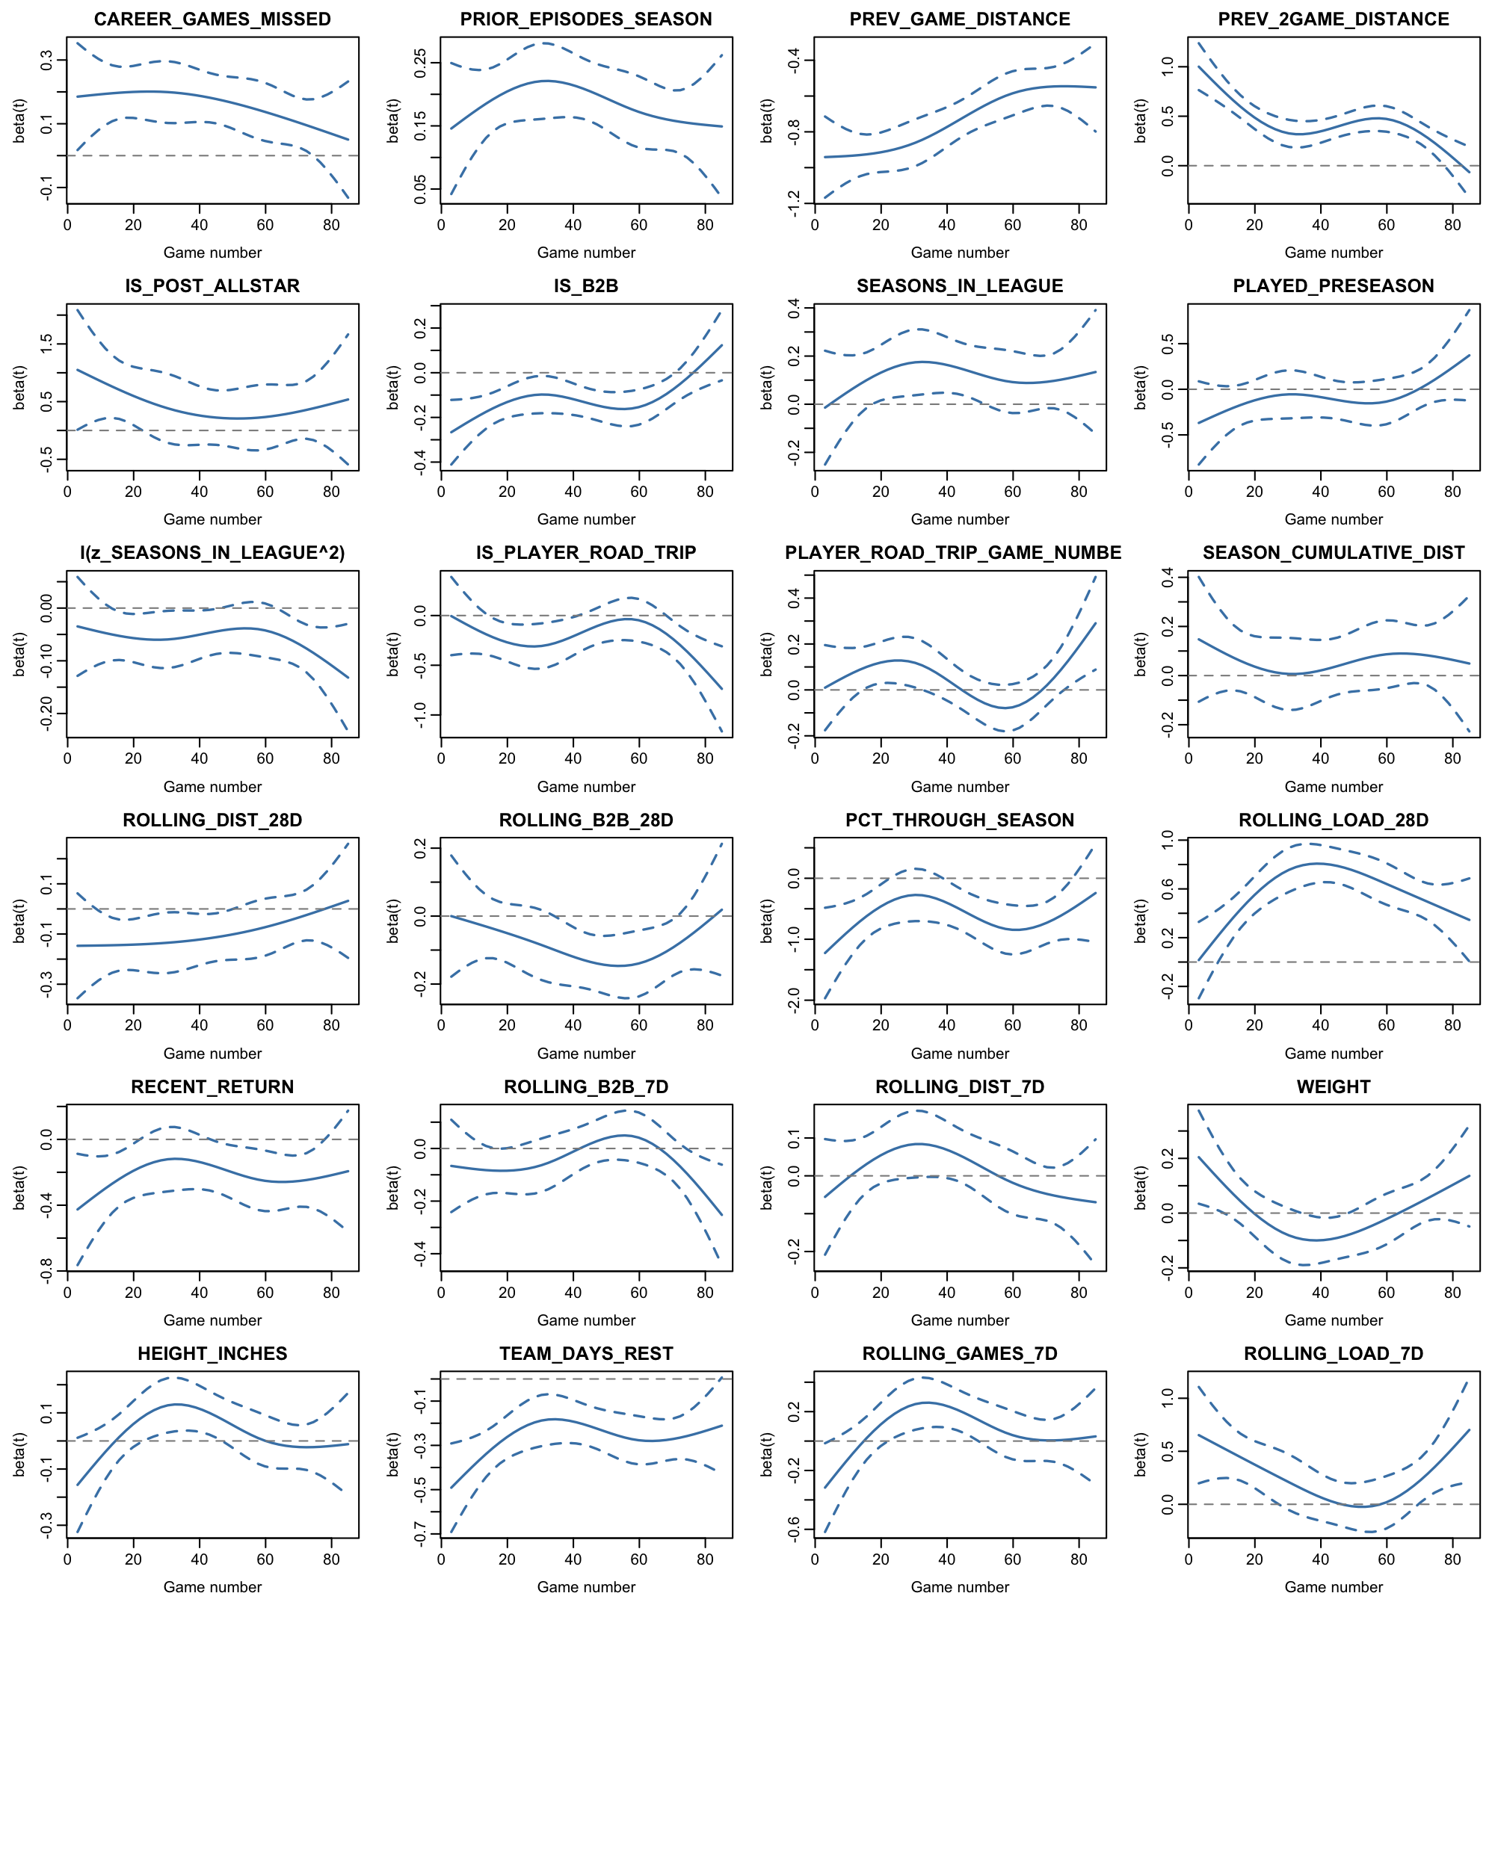
Figure B1. Scaled Schoenfeld residual curves for all 24 covariates, plotted against raw game number. A horizontal line indicates a constant effect. The dashed reference line marks zero.

B.2 Robustness
Metric | On-court load (reported) | Minutes (robustness)
Concordance | 0.7069 | 0.7066
Chronic workload HR (per SD) | 1.758 | 1.744
Acute workload HR (per SD) | 1.286 | 1.356
Table B3. Exposure choice. The full Model 3 refitted with minutes played substituted for tracking distance throughout, including the same lag-1 and lag-2 treatment.
Metric | Model 3 | Model 3 + intensity
Concordance | 0.6926 | 0.6929
Chronic load HR (per SD) | 1.786 | 1.769
Acute load HR (per SD) | 1.390 | 1.380
In-game intensity, last game (per SD) | — | 1.001
In-game intensity, 2 games back (per SD) | — | 0.931
Table B4. In-game intensity. Joint Wald test that both intensity coefficients are zero: p = 0.034. The test rejects, rejection reflects precision at this sample size rather than a usable effect.
Metric | All players (primary) | Established rotation players
Player-intervals (n) | 166,703 | 106,822
Events | 3,921 | 3,239
Concordance | 0.7069 | 0.6699
Chronic load HR (per SD) | 1.758 | 1.724
Acute load HR (per SD) | 1.286 | 1.333
In-game load, last game | 0.483 | 0.469
In-game load, 2 games back | 1.534 | 1.447
Table B5. Cohort composition. Rotation players defined ex ante as at least 15 minutes per game in the prior season, or across their career where no prior season is on record.
Filtering on prior-season minutes alone would exclude 77 non-rookie player-seasons with no prior-season record. These are not low value players: all have valuable NBA history & injury history, and the group comprises players returning from season-long absences. The career-minutes backup clause allows them to remain. Career totals are constructed only from seasons preceding the modelled one therefore there is no condition on the outcome.

B.3 Time-scale robustness
The primary analysis indexes time by a player’s sequential position through their team’s scheduled games, so that a player who misses fixtures through injury re-enters at the schedule position they have reached. An alternative indexes time by the player’s sequential count of at-risk intervals. Under the scheduled clock a player returning from a fourteen-game absence re-enters at interval 15; under the at-risk clock that same appearance is interval 1.
Because it changes the composition of the risk set. The scheduled clock compares players at the same point in the season. The at-risk clock compares players at the same number of available games, who may be weeks apart in the calendar.
Quantity | Scheduled-game clock | At-risk-interval clock
Model 3: chronic load (28d) | 1.758 | 1.822
Model 3: acute load (7d) | 1.286 | 1.247
Model 3: concordance | 0.7069 | 0.7088
Repetitive: chronic / acute | 1.611 / 1.174 | 1.679 / 1.141
Acute non-contact: chronic / acute | 1.88 / 1.422 | 1.936 / 1.37
Acute impact: chronic / acute | 1.768 / 1.223 | 1.785 / 1.198
Table B6. Model estimates under the two time scales.
Diagnostic | Value
Intervals where the two clocks agree | 64.6%
Mean absolute difference | 2.87 games
Largest difference | 73 games
Table B7. Divergence between the two clocks.
The scheduled-game clock is retained as primary. It is the axis on which the baseline hazard carries a season interpretation, which the trajectory result in Section 3.5 depends on. And it places players available on the same night in the same risk set, which is the comparison a teams would make.

B.4 Andersen-Gill comparison
Covariate | New injury (primary) | All onsets (Andersen-Gill)
Acute load (7d) | 1.286 | 1.170
Chronic load (28d) | 1.758 | 1.551
Acute games played (7d) | 1.070 | 0.989
Acute travel load (7d) | 1.007 | 1.016
Chronic travel load (28d) | 0.912 | 0.915
Season cumulative travel | 1.064 | 0.998
In-game load, last game * | 0.483 | 0.581
In-game load, 2 games back | 1.534 | 1.521
Back-to-back * | 0.890 | 0.807
Acute back-to-back dose (7d) | 0.956 | 0.974
Chronic back-to-back dose (28d) | 0.921 | 0.889
Road-trip game number | 1.049 | 1.042
Team days rest | 0.767 | 0.595
On road trip * | 0.806 | 0.820
Experience (seasons) | 1.119 | 1.184
Experience squared | 0.944 | 0.937
Career games missed | 1.168 | 1.110
Prior injury episodes | 1.201 | 1.221
Recently returned (≤14d) | 0.801 | 1.780
Season progress | 0.538 | 0.483
Post-All-Star phase | 1.541 | 1.481
Played pre-season | 0.925 | 0.782
Height | 1.024 | 1.031
Weight | 1.006 | 1.005
Table B8. All 24 covariates under the primary new-injury outcome and the Andersen-Gill all-onsets outcome. The recent-return reversal discussed in Section 4.4 is the clearest difference between the two columns.

B.5 Calibration
Risk decile | Intervals | Events | Events per 1,000 | Mean risk score
1 (lowest) | 16,671 | 115 | 6.90 | −1.570
2 | 16,671 | 151 | 9.06 | −0.922
3 | 16,671 | 194 | 11.64 | −0.578
4 | 16,670 | 226 | 13.56 | −0.300
5 | 16,670 | 273 | 16.38 | −0.062
6 | 16,670 | 364 | 21.84 | 0.159
7 | 16,670 | 426 | 25.55 | 0.377
8 | 16,670 | 507 | 30.41 | 0.609
9 | 16,670 | 587 | 35.21 | 0.889
10 (highest) | 16,670 | 1078 | 64.67 | 1.397
Table B9. Relative-hazard calibration in the full sample. Spearman correlation between decile and observed rate is 1.0.
Risk quintile | Intervals | Events | Events per 1,000
1 (lowest) | 6,620 | 47 | 7.1
2 | 6,620 | 96 | 14.5
3 | 6,619 | 152 | 23.0
4 | 6,619 | 202 | 30.5
5 (highest) | 6,619 | 398 | 60.1
Table B10. Out-of-sample calibration in the held-out 2025-26 season. Quintiles rather than deciles because the test season is smaller.

