Spyglass
Software Requirements Specifications

Version: | 1.0
Print Date: | 1/19/2013
Release Date: | 1/19/2013
Release State: | Initial
Approval State: | Draft
Approved by:
Prepared by:
Reviewed by:
Path Name:
File Name: | spyglass-SRS.odt
Document No: | 1
Document Change Control

Version | Date | Authors | Summary of Changes
1.0 | 19/1/2013 | Alex Mavrogiannis  Gregory Lyras | Initial Print

Document Sign-Off

Name (Position) | Signature | Date
Contents
1 Introduction 6
1.1 Purpose 6
1.2 Overview 6
1.3 References 6
2 Business Scenario Model 7
2.1 Actors 7
2.1.1 Overview 7
2.1.2 Actor Diagram 7
2.1.3 Actor Definitions 8
2.2 Use Case Descriptions 9
2.2.1 Normal End-User Functionality Scenario 9
2.2.2 Normal Developer Configuration Scenario 10
2.2.3 Normal Crawler Functionality Scenario 11
2.2.4 Pathological Scenarios.....................................................................................................12
2.3 Use Case Diagrams 14
3 Domain Model 15
3.1 Domain Model Class Diagram 15
3.2 Domain Model Class Definitions 16
4 Interaction Diagrams 19
4.1 Sequencing Diagrams 19
4.2 Collaboration Diagrams 20
5 Non-Functional Requirements Specification 21
5.1 Overview 21
5.2 Enabling Technologies 21
5.2.1 Target Hardware & Hardware Interfaces 21
5.2.2 Target Development Environment 21
5.2.3 System Interfaces 21
5.3 Capacity Planning 21
5.3.1 Permanent Storage 21
5.4 Network 22
5.5 Workstations 22
5.6 Operational Parameters 22
5.6.1 Useability 22
5.6.2 Reliability 22
5.6.3 Maintainability 22
5.6.4 Portability 22
6 Activities Plan 23

Introduction

Purpose
This document details the requirements of the Spyglass system.

Overview
The spyglass project aims to address the issue of real-time web monitoring.
Instead of searching on one site, we can monitor sites of interest and filter their updates based on keywords provided. If the updates match the search criteria then the end user is notified for the latest developments. The proposed project is a meta-search engine used to monitor sites for required information and provide notifications to its users accordingly.

References
Project Proposal, Description of the Proposed Project
Django, Web Application Framework
Django-Tastypie, REST API Framework
Python, python.org

Business Scenario Model

Actors

Overview
The system is composed of the following actors:
Administrator – human
Developer – human
End User - human
Crawlers – external active system
Notification Engine – external active system
Database – external passive system
External Sites – external passive resources

Actor Diagram

Actor Definitions
                - 2.1.3.1 End User
Description | Uses the system to enter queries, optionally register for an account and receive results from the notification system
Aliases | User
Inherits | Web Application Client
Actor Type | Active, Mandatory, External

2.1.3.2 Developer
Description | Configures the spyglass system and inserts it into his own web application, runs the web server and the crawlers.
Aliases | Dev
Inherits | Human
Actor Type | Active, Mandatory, External

2.1.3.3 Administrator
Description | Manages the database and the deployed application. In many occurrences he is the developer.
Aliases | Admin, Webmaster
Inherits | Human
Actor Type | Active, Mandatory, External

2.1.3.4 Crawler
Description | External software that polls the web application's server for a workload to process and sends back the results.
Aliases | Crawlie
Inherits | REST client
Actor Type | Active, Mandatory, External

2.1.3.5 Database
Description | The Database contains the basic logic behind the application. Given Django's Object-Relation Mapping, the relational design is represented extensively by the class diagram in the corresponding section of the SDD document.
Aliases | DB
Inherits | Database
Actor Type | Passive, Mandatory, Internal

2.1.3.6 External Web Sites
Description | The external websites are the data resources that the crawlers search. They are HTML pages and are crawled as such by the Xpath of their desired contents. They are specified by the developer during the system configuration.
Aliases | Sites
Inherits | Website
Actor Type | Passive, Mandatory, External

Use Case Descriptions

Normal End-User Functionality Scenario
Description:
The User enters the Dev's site, using any optional authentication system provided, and submits a query using the site's form. A crawlie requests workload at some point in the future and receives the user's request. He then accesses the requested site with the given parameters and determines whether a result is available. If so, crawlie sends it back to the system and the user is notified as configured.
Actors:
End User, Crawlie, Sites, Database
Preconditions:
User connectivity to the system's server. Crawler connectivity to the system's server and the sites to be crawled. If the dev requires authentication, the user must be authenticated by their terms of authentication.
Scenario Text:
1. The user visits the system's web address
2. Optionally authenticates with the system
3. Inserts a query in the form provided
4. Clicks “Submit”
5. The system stores the query to the database
6. A crawler requests for workload at some point in the future in the form of a RESTful GET request.
7. The server replies with a JSON-formatted resource containing the sites to be crawled and their respective queries.
8. The crawler visits the sites and performs the queries. If there is any new data matching the query, it is sent back to the server.
9. When data is found, the framework updates the database with the answered request and triggers the notication system
10. The notification system spawns the configured user notification.
Alternative Courses:
8. The crawler visits the sites and performs the queries. If no new data is found, it sends the server an empty dataset.
9. The framework updates the request with the date of the crawler's check on the database.
10. Back to step no. 6 until a result is found
Extends:
None

User Interfaces:
The Developer's web application provides a user interface to the user containing at least a form where the user canprovide his request.
Constraints:
None
Questions:
None
Notes:
None
Authors:
Gregory Lyras
Alex Mavrogiannis
Source Documents:
None

Developer Configuration Scenario
Description:
Before the system is ready for use by the user, the dev has to configure it first. This includes a series of text file editing on the configuration files of the system.
Actors:
Developer, Database
Preconditions:
The developer must have a running web server with his own web application upon which the system is to be run.
Scenario Text:
1. The developer specifies a class of his application which is to be modeled for crawling.
2. He then creates a list of sites which are to be crawled by the crawlers, described by their URL. He also specifies a polling time in minutes that each site will be polled at.
3. For each site, he assigns Xpaths for each of his class's fields.
4. He spawns the amount of crawlers he desires.
5. The system is configured
Alternative Courses:
None.
Extends:
None
User Interfaces:
The Django Admin site is an optional interface that can be used to populate the database. Another alternative is using database fixtures in JSON format.
Constraints:
None
Questions:
None
Notes:
None
Authors:
Gregory Lyras
Alex Mavrogiannis
Source Documents:
None

Normal Crawler Functionality Scenario
Description:
Every crawler is running independently of the system and has to communicate with it over a set of five independent APIs in order to receive and complete its work.
Actors:
Crawlie, Database, Sites
Preconditions:
The system must be up and running and the crawlers need to be connected to both the system and the sites.
Scenario Text:
1. The Crawler is spawned
2. Using the Sites API, it gets the list of possible sites to crawl
3. Using the Paths API, it gets the list of Xpaths for each site
4. Using the Crawler API, it states its availability and receives miscellaneous control options
5. Using the Query API, it gets a list of queries to be crawled
6. The crawler processes each query's specified site with the requested parameters.
7. If a result is found, it uses the Meta API to create an instance of the developer's class in the database with the result's data
8. Go back to no. 4
Alternative Courses:
7. If no result is found, go back to no. 4
Extends:
None
User Interfaces:
None
Constraints:
None
Questions:
None
Notes:
None
Authors:
Gregory Lyras
Alex Mavrogiannis
Source Documents:
None

2.2.4 Pathological Scenarios

2.2.4.1 Web Server Crash Scenario
Description:
In the event that the central web server fails to respond to the actors' requests, the crawlers slow down their contact period to relieve the server from any possible networking overload
Actors:
Crawlie, Database, User
Preconditions:
All components and actors of the system must be up and running before the crash occurs.
Scenario Text:
1. The server crashes, timing out all requests sent to him
2. The crawlers detect the timeout and increase the intervals between each request
Alternative Courses:
None
Extends:
None
User Interfaces:
None
Constraints:
None
Questions:
None
Notes:
None
Authors:
Gregory Lyras
Alex Mavrogiannis
Source Documents:
None

2.2.4.2 Universal Crawler Crash Scenario
Description:
In the event that all Crawlers crash, the administrator is notified about the event by email and/or the notification system.
Actors:
Admin, Crawlers
Preconditions:
All components and actors of the system must be up and running before the crash occurs.
Scenario Text:
1. All crawlers crash for independent reasons
2. The system checks its own connectivity to ensure that the previous scenario did not occur (web server crash)
3. The system notifies the administrator via email and/or the notification system's means
Alternative Courses:
None
Extends:
None
User Interfaces:
None
Constraints:
None
Questions:
None
Notes:
None
Authors:
Gregory Lyras
Alex Mavrogiannis
Source Documents:
None

Use Case Diagrams

Normal End-User Functionality Scenario

Developer Configuration Scenario

Normal Crawler Functionality Scenario

Domain Model

Domain Model Class Diagram
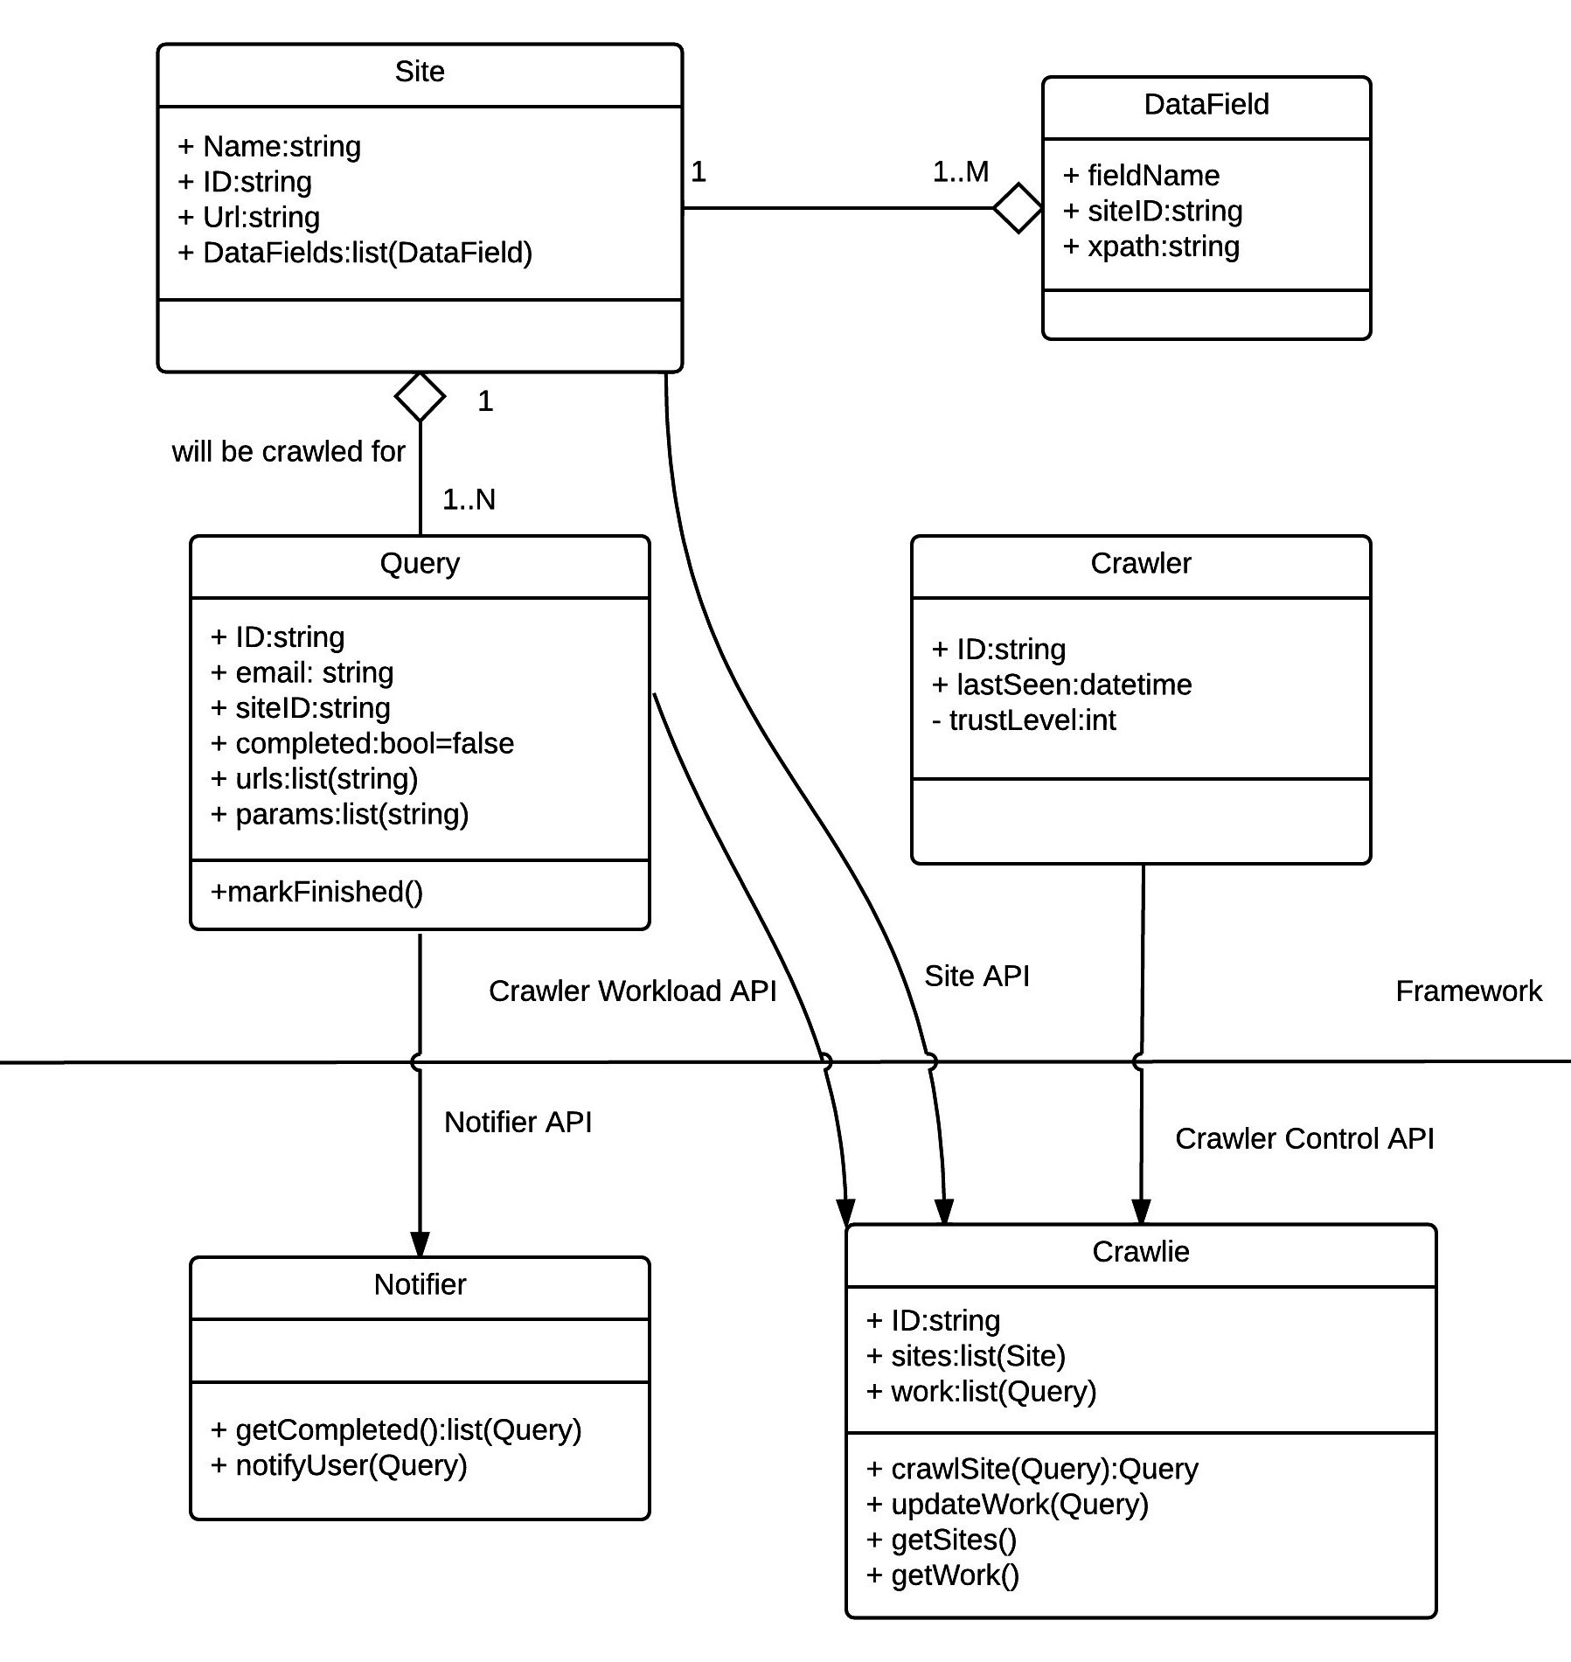

Domain Model Class Definitions

Site
Description | The Site class represents the remote sites to be crawled.
Attributes | Name, URL, Datafields, Polling time
Responsibilities | Contains the URL to the remote site and is a foreign key to its DataField instances.
Business Rules | The polling time should be based on the update time and large enough to prevent undesired traffic to the target website.

DataField
Description | The Datafield class unifies a field name from the Developer's Class with an Xpath expression to a given Site object
Attributes | Site, Xpath, Field_Name
Responsibilities | Datafield Objects are responsible for the creation of instances of the developer's class when a desired result is found
Business Rules | Each field in the Developer's class needs to have a respective DataField object for every Site object.

Query
Description | Objects of the Query class are created by the End User and are passed along to crawlers as part of their workload. They hold vital information regarding the status of the request and its completion.
Attributes | Site, User, Result, Completed, Persistent, Parameters, Last_Modified, Next_Check
Responsibilities | Query objects are timestamped upon saving to the next minimum polling time as defined in the foreign Site object. They also contain the parameters, if any, that define the user's search on the Site. Finally, they are linked to their respective Result (Developer Class) objects to be able to provide accurate notifications to the user.
Business Rules

Crawler
Description | The Crawler class represents all crawlers that are able to connect to the System. They are linked to a user by an API key which is available at user creation and enables easy monitoring and notifications through the user's email.
Attributes | API key, trust level, last_seen
Responsibilities | Crawler objects are touched by their respective crawler to indicate their presence. Possible expansions are available to this class to enable control over the individual crawlers.
Business Rules

Interaction Diagrams

Sequencing Diagrams
Normal Crawler Functionality Diagrams

Collaboration Diagrams
4.2.1 Normal Functionality Scenario

4.2.3 Normal Crawler Functionality Scenario

Non-Functional Requirements Specification

Overview
Provide a brief overview of the non-functional requirements.

Enabling Technologies

Target Hardware & Hardware Interfaces
Any linux-based system able to run a standard web server such as Apache or Nginx.

Target Development Environment
Any Python 2.7 compatible environment. Suggested environment comprises of Linux with Python 2.7, running Django 1.5 compatible development server.

System Interfaces
All communication is performed with HTTP over TCP/IP so all modern interfaces are compatible.

Capacity Planning

Permanent Storage
Varies depending on the developer's policy.

Network
Internet connectivity is vital. Minimum Bandwidth is depended on the entire web application's traffic and usage.

Workstations
Minimum workstation requirements are a 486 or better processor and at least 24 MB of RAM and 150 MB of free hard drive space. If you need to host the development environment, 64 MB of RAM and 300 MB of hard drive space are mandatory.

Operational Parameters

Useability
The system receives input through web-based form interaction, with which most end users are accustomed to.

Reliability
Recoverability & Backup
Regular Database Backups and git version control are enough to ensure total recoverability in even the most catastrophic of failures.
Restart
No restart should be required of the entire system. The web server may need to be restarted after some routine updates.

Maintainability
The system is highly modular and structured in an understandable Model-View-Controller architecture, ensuring easy maintainability and clean code structure. Additionally, the system is expected to be well-tested and documented.

Portability
The only requirement for the system is an installation of Python 2.7 and a Python-compatible web server. This ensures the portability of the server across a plethora of platforms such as Windows NT or newer, OS X, Linux, Solaris, FreeBSD, OpenBSD, NetBSD etc.

Activities Plan
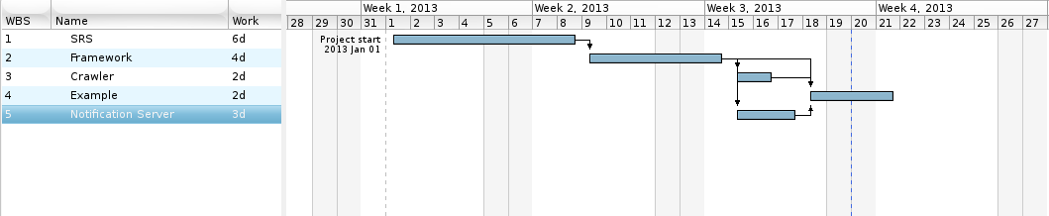
Below, the basic activities plan is illustrated in a Gantt diagram. Given additional delays during the creation of this document, the entire activities planning is pushed back one week.

