System | Client/Server (C coursework)
Author | Alex McBride
Student ID | S1715224
Student Email | AMCBRI206@caledonian.ac.uk
Date | 04/12/2017
Before | It’s required to run both server and client in different terminal windows, so you can see the results side-by-side.

Test | 001
Description | Client connects to server
Input | In first terminal start the server: ./server  In the second terminal start the client: ./client
Expected | The server should display the following:  Waiting for incoming connections...  Waiting for a client to connect...  Connection accepted...  Handler assigned  The client should display:  Connected to server...  >> Welcome to the server!  Main menu:  1. Get student ID  2. Get server time  3. Get uname info  4. Get file list  5. Get file transfer  6. Quit  Choose option:
Actual | As expected
Screen | 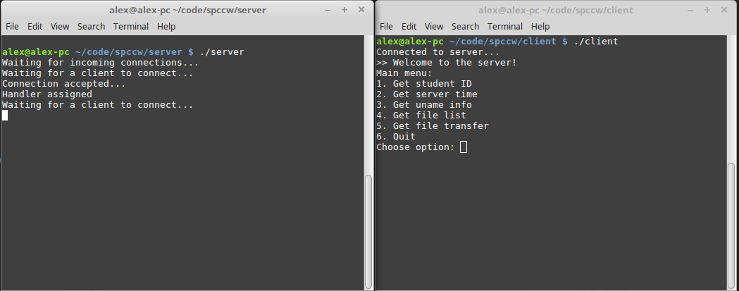

Test | 002
Description | Client disconnects from server
Input | In first terminal start the server: ./server  In the second terminal start the client: ./client  Then press 6 in the client to select the menu option to quit.
Expected | The server should display the following (note the actual thread ID will vary):  Waiting for incoming connections...  Waiting for a client to connect...  Connection accepted...  Handler assigned  Waiting for a client to connect...  Thread 140253004404480 exiting  The client should display:  Connected to server...  >> Welcome to the server!  Main menu:  1. Get student ID  2. Get server time  3. Get uname info  4. Get file list  5. Get file transfer  6. Quit  Choose option: 6  Now exiting!
Actual | As expected
Screen | 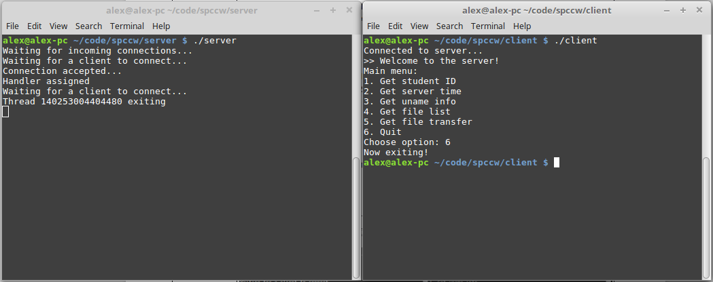

Test | 003
Description | Server closes correctly on interupt
Input | In first terminal start the server: ./server  Then press Ctrl+C to send SIGINT to the server process.
Expected | The server should display the following (note the actual execution time will vary):  Waiting for incoming connections...  Waiting for a client to connect...  ^C  Total execution time: 4.69 seconds  Exiting...
Actual | As expected
Screen | 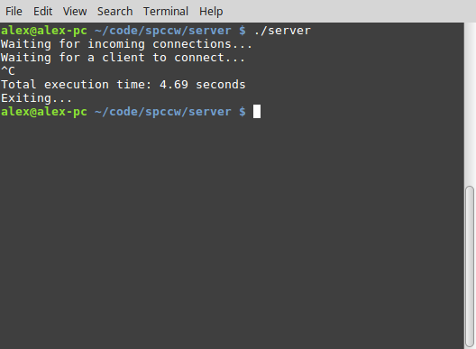

Test | 004
Description | Get student ID works correctly
Input | In first terminal start the server: ./server  In the second terminal start the client: ./client  Then select option 1 from the client menu
Expected | The client should display the following:  Connected to server...  >> Welcome to the server!  Main menu:  1. Get student ID  2. Get server time  3. Get uname info  4. Get file list  5. Get file transfer  6. Quit  Choose option: 1  >> 0.0.0.0:S1715224  Before then displaying the menu again. Note the IP address only works on the lab VM, on this test machine it is returned as 0.0.0.0.
Actual | As expected
Screen | 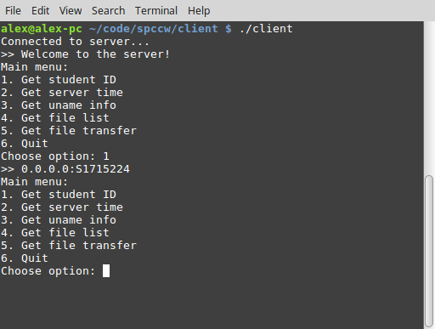

Test | 005
Description | Get server time works correctly
Input | In first terminal start the server: ./server  In the second terminal start the client: ./client  Then select option 2 from the client menu
Expected | The client should display the following:  Connected to server...  >> Welcome to the server!  Main menu:  1. Get student ID  2. Get server time  3. Get uname info  4. Get file list  5. Get file transfer  6. Quit  Choose option: 2  >> Mon Dec 4 12:56:18 2017  Before then displaying the menu again. Note that the current date and time will vary depending on when the test was run.
Actual | As expected
Screen | 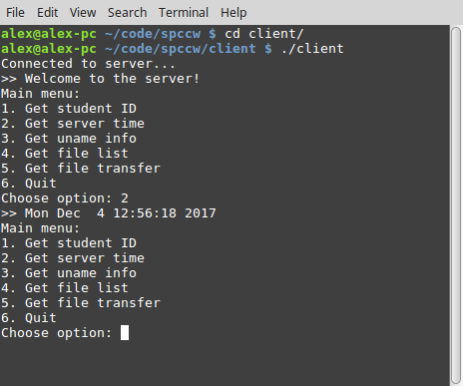

Test | 006
Description | Get uname info works correctly
Input | In first terminal start the server: ./server  In the second terminal start the client: ./client  Then select option 3 from the client menu
Expected | The client should display the following:  Connected to server...  >> Welcome to the server!  Main menu:  1. Get student ID  2. Get server time  3. Get uname info  4. Get file list  5. Get file transfer  6. Quit  Choose option: 3  >> Node name: alex-pc  >> System name: Linux  >> Release: 4.10.0-38-generic  >> Version: #42~16.04.1-Ubuntu SMP Tue Oct 10 16:32:20 UTC 2017  >> Machine: x86_64  Before then displaying the menu again. Note that the actual uname info provided will vary from machine to machine.
Actual | As expected
Screen | 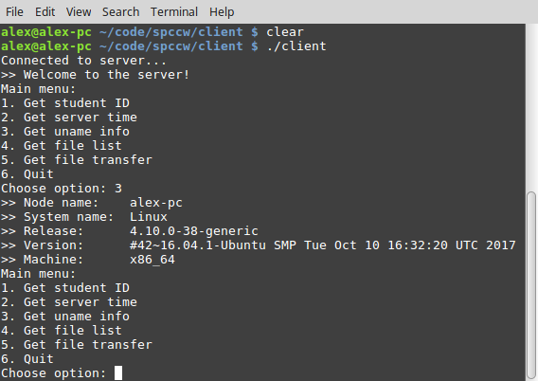
Test | 007
Description | Get file list creates upload directory
Input | Check that the upload directory does not exist for the server: ls  In first terminal start the server: ./server  In the second terminal start the client: ./client  Then select option 4 from the client menu.  Exit from the client by pressing 6 and the server by pressing CTRL+C.  Enter ls to check that the upload directoy has been created.
Expected | The upload directory should now exist in the server directory: ls  The server should display the following:  alex@alex-pc ~/code/spccw/server $ ls  Makefile server server.c server.o  alex@alex-pc ~/code/spccw/server $ ./server  Waiting for incoming connections...  Waiting for a client to connect...  Connection accepted...  Handler assigned  Waiting for a client to connect...  Created upload directory  Thread 140514285491968 exiting  ^C  Total execution time: 10.17 seconds  Exiting...  alex@alex-pc ~/code/spccw/server $ ls  Makefile server server.c server.o upload  alex@alex-pc ~/code/spccw/server $  The client should display:  Connected to server...  >> Welcome to the server!  Main menu:  1. Get student ID  2. Get server time  3. Get uname info  4. Get file list  5. Get file transfer  6. Quit  Choose option: 4  >> List of server files (0):  Main menu:  1. Get student ID  2. Get server time  3. Get uname info  4. Get file list  5. Get file transfer  6. Quit  Choose option: 6  Now exiting!  Note: the thread ID and execution times will vary depending on the test.
Actual | As expected
Screen | 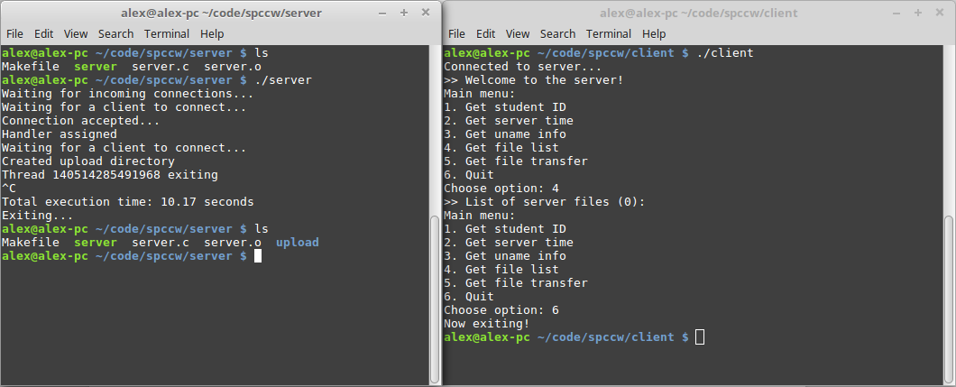

Test | 008
Description | Get file list correctly lists files in upload directory
Input | Add some files to the upload directory named file1, file2, and file3: ls > upload/file1  In first terminal start the server: ./server  In the second terminal start the client: ./client  Then select option 4 from the client menu.
Expected | The upload directory should now exist in the server directory: ls  The client should display the following:  Connected to server...  >> Welcome to the server!  Main menu:  1. Get student ID  2. Get server time  3. Get uname info  4. Get file list  5. Get file transfer  6. Quit  Choose option: 4  >> List of server files (3):  >> file3  >> file2  >> file1
Actual | As expected
Screen | 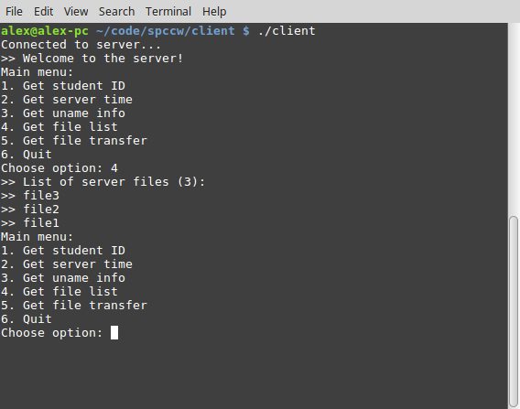
Test | 009
Description | Get file transfer works correctly
Input | In first terminal start the server: ./server  In the second terminal get a list of current files to make sure directory does not contain file1, then start the client: ./client  Then select option 5 from the client menu and enter ‘file1’ and press enter.  Exit the menu (option 6) and run ls again to check that ‘file1’ has been transferred.
Expected | The server should display the following:  Waiting for incoming connections...  Waiting for a client to connect...  Connection accepted...  Handler assigned  Waiting for a client to connect...  Thread 139786179524352 exiting  Before then displaying the menu again. Note that the actual uname info provided will vary from machine to machine.  The client should display:  alex@alex-pc ~/code/spccw/client $ ls  client client.c client.o Makefile  alex@alex-pc ~/code/spccw/client $ ./client  Connected to server...  >> Welcome to the server!  Main menu:  1. Get student ID  2. Get server time  3. Get uname info  4. Get file list  5. Get file transfer  6. Quit  Choose option: 5  Enter filename: file1  >> Transfered 41 of 41 bytes  >> File transfer of 'file1' complete!  Main menu:  1. Get student ID  2. Get server time  3. Get uname info  4. Get file list  5. Get file transfer  6. Quit  Choose option: 6  Now exiting!  alex@alex-pc ~/code/spccw/client $ ls  client client.c client.o file1 Makefile  alex@alex-pc ~/code/spccw/client $  Note: the exact contents of the server and client directories may vary.
Actual | As expected
Screen | 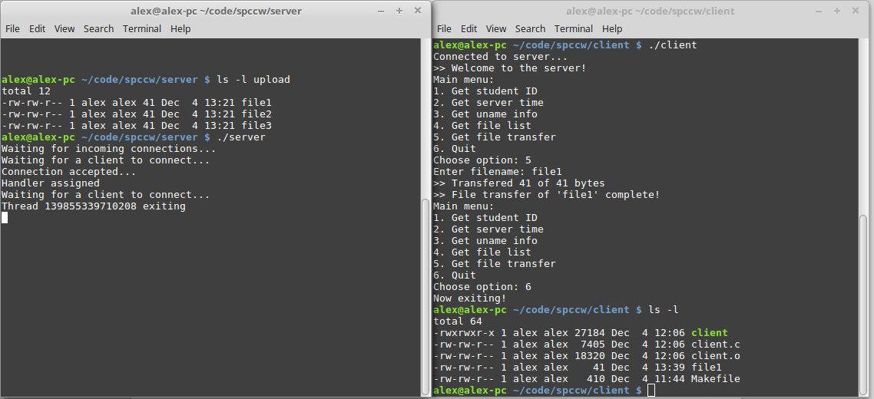

Test | 010
Description | Get file transfer shows file already exists error to transfer file that is already present in client directory
Input | In first terminal start the server: ./server  In the second terminal, run ‘ls’ to check that the file ‘file1’ exists, then start the client: ./client  Then select option 5 from the client menu, enter ‘file1’ and press enter.
Expected | The client should display the following:  Connected to server...  >> Welcome to the server!  Main menu:  1. Get student ID  2. Get server time  3. Get uname info  4. Get file list  5. Get file transfer  6. Quit  Choose option: 5  Enter filename: file1  Error - file 'file1' already exists  Before then displaying the menu again.
Actual | As expected
Screen | 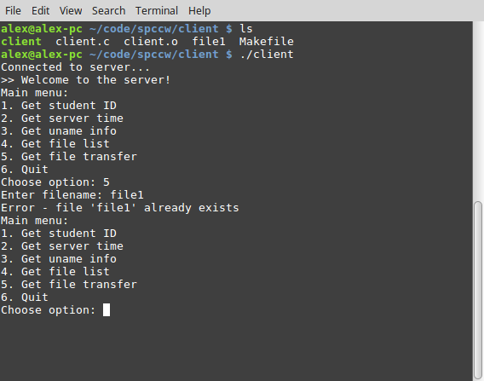

Test | 011
Description | Get file transfer shows file not found error when asked to transfer file not in upload directory
Input | In first terminal start the server: ./server  In the second terminal start the client: ./client  Then select option 5 from the client menu, enter ‘file4’ and press enter.
Expected | The client should display the following:  Connected to server...  >> Welcome to the server!  Main menu:  1. Get student ID  2. Get server time  3. Get uname info  4. Get file list  5. Get file transfer  6. Quit  Choose option: 5  Enter filename: file4  >> Error 'file4' - No such file or directory  Before then displaying the menu again.
Actual | As expected
Screen | 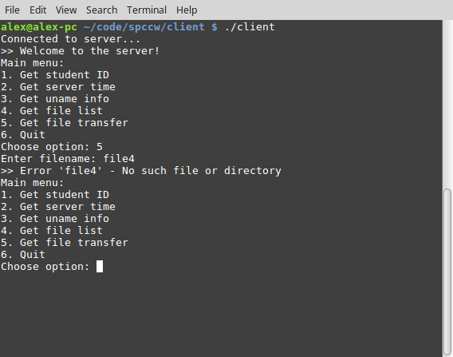

Test | 012
Description | Get file transfer shows permission error when asked to transfer file not in upload directory
Input | Set permission on ‘file3’ in the upload directory to prevent reading: chmod 000 upload/file2  In first terminal start the server: ./server  In the second terminal start the client: ./client  Then select option 5 from the client menu, enter ‘file1’ and press enter.
Expected | The client should display the following:  Connected to server...  >> Welcome to the server!  Main menu:  1. Get student ID  2. Get server time  3. Get uname info  4. Get file list  5. Get file transfer  6. Quit  Choose option: 5  Enter filename: file2  >> Error 'file2' - Permission denied
Actual | As expected
Screen | 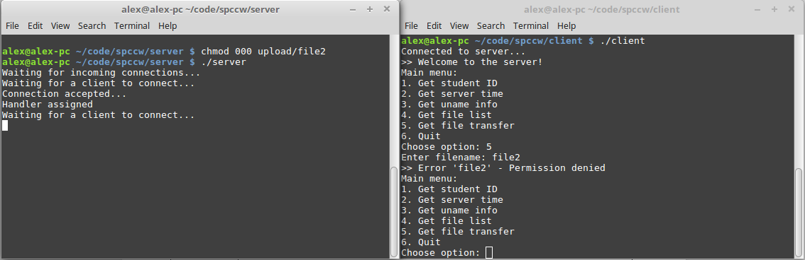

Test | 013
Description | Client deals with losing server connection gracefully
Input | In first terminal start the server: ./server  In the second terminal start the client: ./client  Kill the server with CTRL+C and then select option 1 from client menu.
Expected | The client should display the following:  Connected to server...  >> Welcome to the server!  Main menu:  1. Get student ID  2. Get server time  3. Get uname info  4. Get file list  5. Get file transfer  6. Quit  Choose option: 1  Error - connection lost: Success
Actual | As expected
Screen | 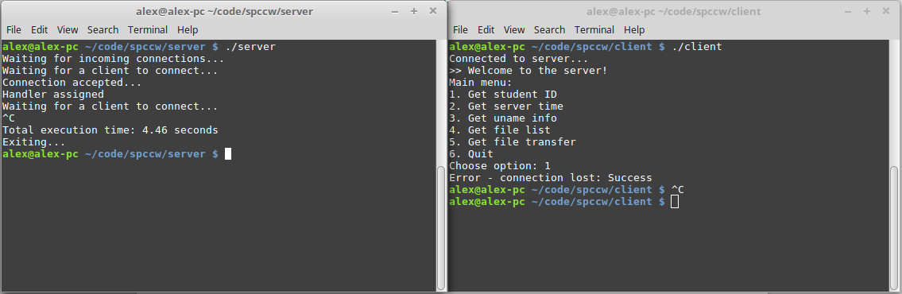

Test | 014
Description | Client deals gracefully with not being able to connect to server
Input | In the second terminal start the client, without the server being active: ./client
Expected | The client should display the following:  Error - connect failed  : Connection refused
Actual | As expected
Screen | 