Name_Hayden Lepla____________________ Mark _____________________/50

[**Instructions**: Remove everything that is not a heading below and fill in with your own diagrams, etc.]

## Brief introduction __/3

My feature is the implementation of the controls of the main character. This involves creating intuitive controls that the user can understand to play the main character in the game.

## Use case diagram with scenario __1

### Use Case Diagrams

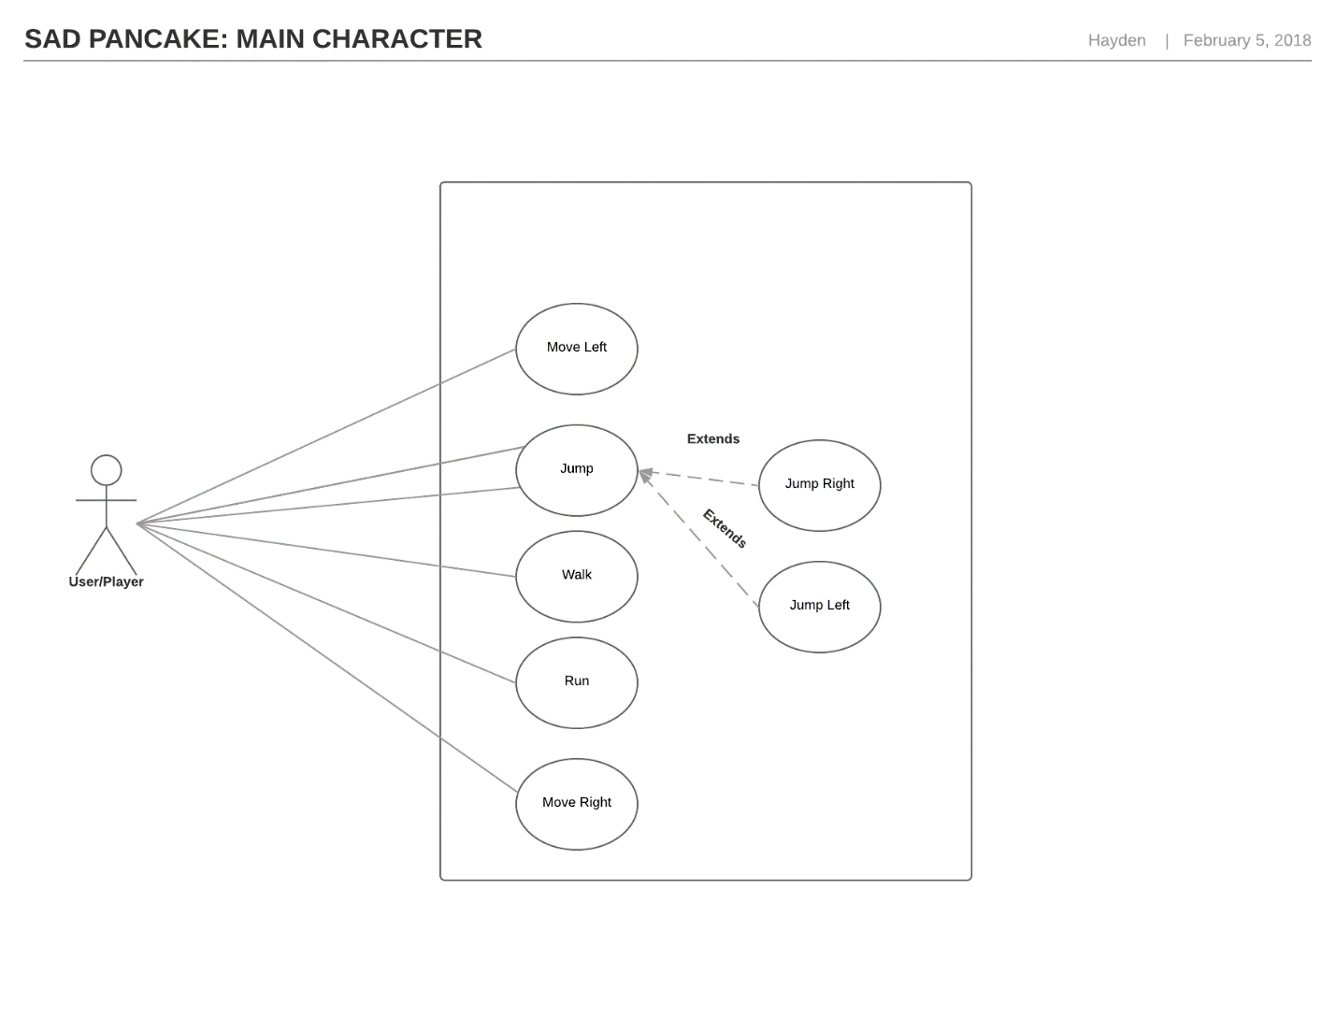

### Scenarios

**Name:** Main Character

**Summary:** The player interacts with user controls to make the character perform actions

**Actors:** The user/player of the game

**Preconditions:** The game, level must be loaded and executing

**Basic sequence:**

**Step 1:** User presses key in correspondence to movement

**Step 2:** Character moves in the direction of the key pressed

**Step 3:** Continue to accept input until input controls are released

**Step 4:** Free character movement upon no input

**Exceptions:**

**Step 1:** User presses key that does not correspond to movement: ignore input

**Post conditions:** Character traverses through the environment

**Priority:** 1*

**ID:** C01

*The priorities are 1 = must have, 2 = essential, 3 = nice to have.

## Data Flow diagram(s) from Level 0 to process description for your feature _______14

### Data Flow Diagrams

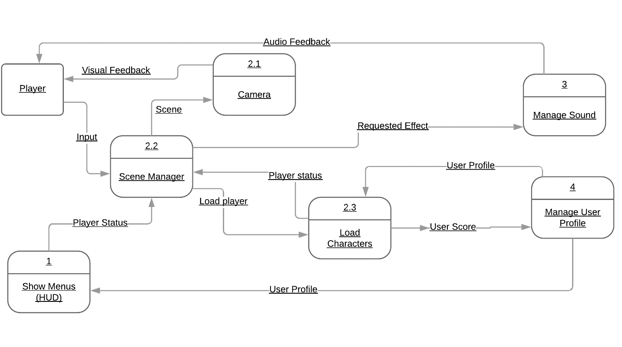

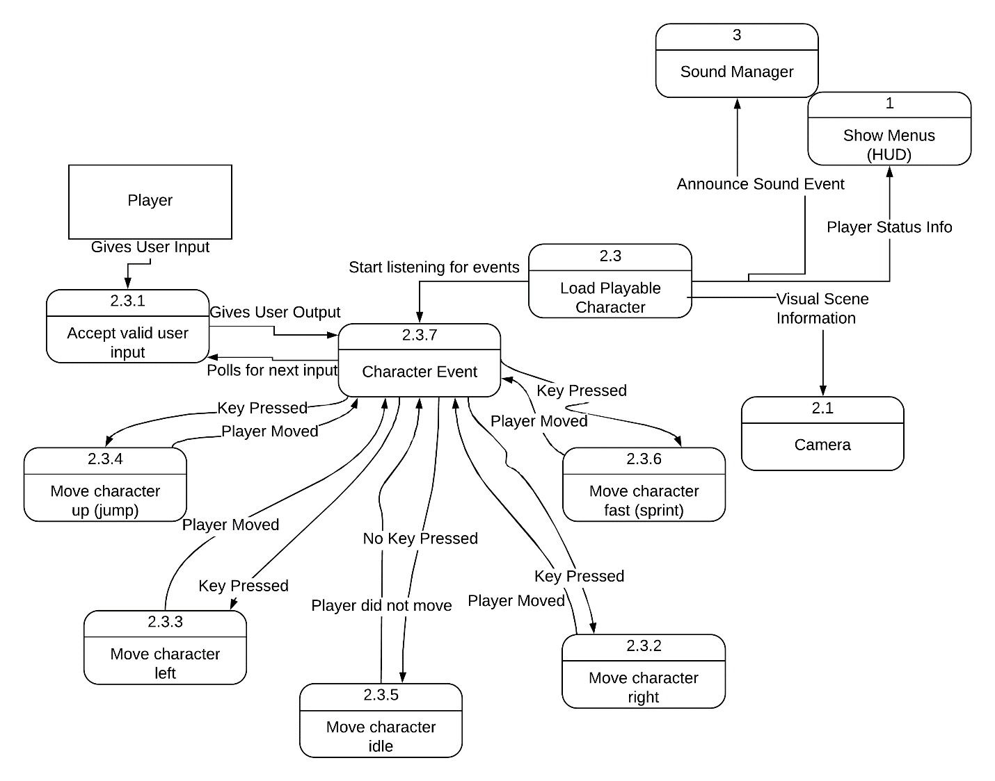

### Process Descriptions

Character Movement*:

WHILE user inputs a key direction;

Move character according to input

If input key is released

Stop character

Go into idle

If no key is pressed

Go into idle

END WHILE

## Acceptance Tests ________9

* When user presses a direction key, character moves in the pressed direction.
* Character should move at “walk” speed unless “run” key is continually pressed.
* When user presses the “jump” key, character should move in the vertical direction in coordination with a direction key.

## Timeline _________/10

### Work items

|  |  |  |
| --- | --- | --- |
| Task | Duration (PWks) | Predecessor Task(s) |
| 1. SA Demo | 1 | - |
| 2. Directory structure defined | 1 | 1 |
| 3. Creating movement class | 1 | 1 |
| 4. Integrating controls with character | 2 | 2,3 |
| 5. Debugging | 3 | 3,4 |
| 6. Present code running | 3 | 5,4 |
| 7. Testing | 3 | 6 |
| 8. Presentation | 1 | 7 |

### Pert diagram

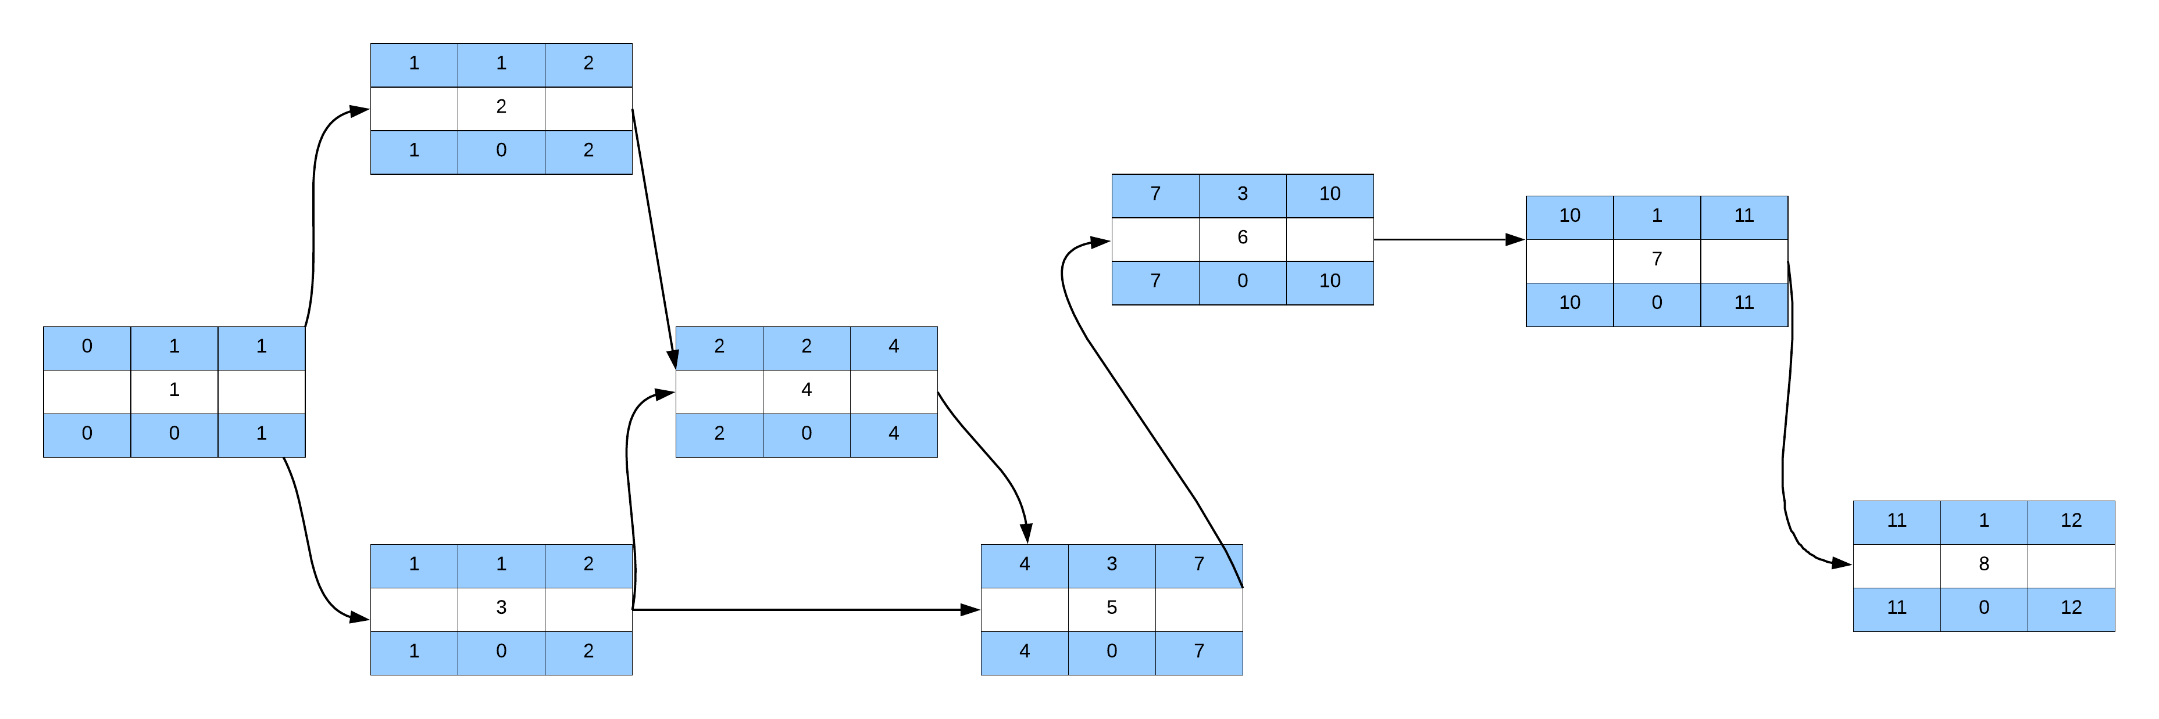

### Gantt timeline

|  |  |  |  |  |  |  |  |  |  |  |  |  |  |  |  |  |  |  |  |  |  |  |  |  |  |  |  |  |  |  |  |
| --- | --- | --- | --- | --- | --- | --- | --- | --- | --- | --- | --- | --- | --- | --- | --- | --- | --- | --- | --- | --- | --- | --- | --- | --- | --- | --- | --- | --- | --- | --- | --- |
| 1 |  |  |  |  |  |  |  |  |  |  | | |  | |  | |  |  | |  | |  | |  |  |  |  |  |  |  |  |
| 2 |  |  |  |  |  | 1 |  |  |  |  |  | | |  | |  |  |  |  | |  | |  | |  |  |  |  |  |  |
| 3 |  |  |  |  |  | 1 |  |  |  |  |  | | |  | |  |  |  |  | |  | |  | |  |  |  |  |  |  |
| 4 |  |  | 2 |  |  |  |  |  |  |  | | |  | |  | |  |  | |  | |  | |  |  |  |  |  |  |  |  |
| 5 |  |  |  |  | 3 |  |  |  |  |  | | |  | |  | |  |  | |  | |  | |  |  |  |  |  |  |  |  |
| 6 |  |  |  |  |  |  |  | 5 |  |  | |  | | |  | |  |  | |  | |  | |  |  |  |  |  |  |  |  |
| 7 |  |  |  |  |  |  |  |  |  | 1 | | |  | |  | |  |  | |  | |  | |  |  |  |  |  |  |  |  |
| 8 |  |  |  |  |  |  |  |  |  |  | | | 1 | |  | |  |  | |  | |  | |  |  |  |  |  |  |  |  |
|  | 1 | 2 | 3 | 4 | 5 | 6 | 7 | 8 | 9 | 10 | | | 11 | | 12 | | 13 | 14 | | 15 | | 16 | |  |  |  |  |  |  |  |  |