Name: Josue Espinosa Mark _____________________/50

## Brief introduction __/3

My main feature is implementing Non-Player Characters and all of the associated actions that come with them. This includes dialog with main character, attacking (for hostile NPCs), and altering player states, potentially including score, inventory, health, and money .

## Use case diagram with scenario __14

## Use Case Diagrams

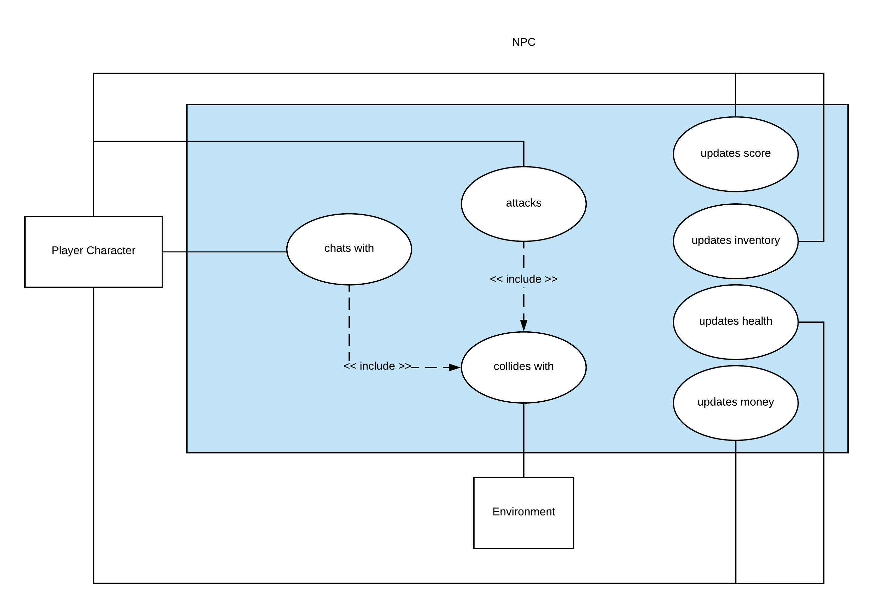

### Scenarios

**Name:** Collision detection

**Summary:** Prevent NPC from falling through environment, send events related to player collision

**Actors:** Player Character, Environment

**Preconditions:** Level has been initialized for NPC to be able to interact with other actors that take up physical space in the game world.

**Basic sequence:**

**Step 1:** NPC collides with environment/player

**Step 2:** NPC sends corresponding event message to allow player/environment to react accordingly

**Exceptions:**

**Step 1:** NPC itself moves and can generate events with an immobile human player

**Post conditions:** n/a

**Priority:** 2*

**ID:** C01

*The priorities are 1 = must have, 2 = essential, 3 = nice to have.

**Name:** Hostile NPC Attack

**Summary:** On collision, apply damage to player character

**Actors:** Player Character

**Preconditions:** Player character collides with NPC

**Basic sequence:**

**Step 1:** Player collides with hostile NPC

**Step 2:** NPC applies damage to player

**Exceptions:**

**Step 1:** Player is in “cooldown state” after being attacked and is briefly immune to further damage

**Post conditions:** Lessened player health

**Priority:** 2*

**ID:** C02

**Name:** Friendly NPC Chat

**Summary:** On collision, give player option to chat

**Actors:** Player Character

**Preconditions:** Player character collides with NPC

**Basic sequence:**

**Step 1:** Player collides with friendly NPC

**Step 2:** NPC chats with player

**Exceptions:**

**Step 1:** Player continues walking past NPC or does not continue conversation

**Post conditions:** Potentially applied player modifier such as quest addition, inventory addition, money addition, health addition

**Priority:** 2*

**ID:** C03

## Data Flow diagram(s) from Level 0 to process description for your feature _______14

## Data Flow Diagrams

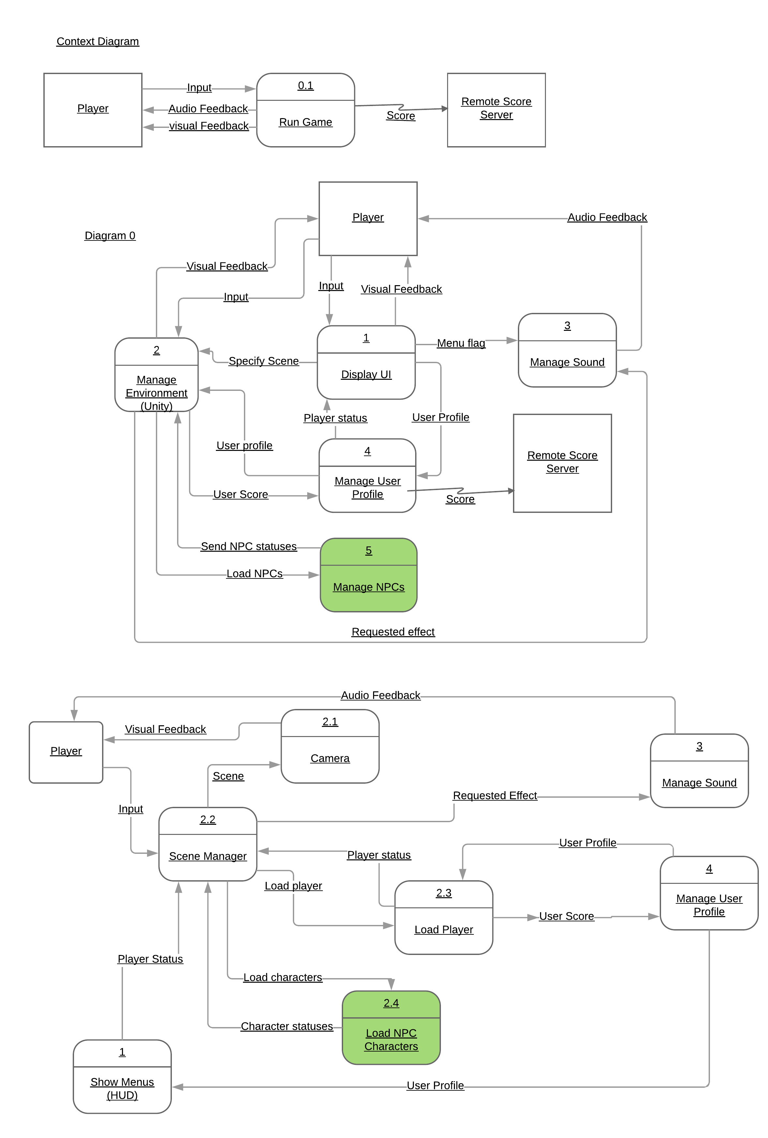

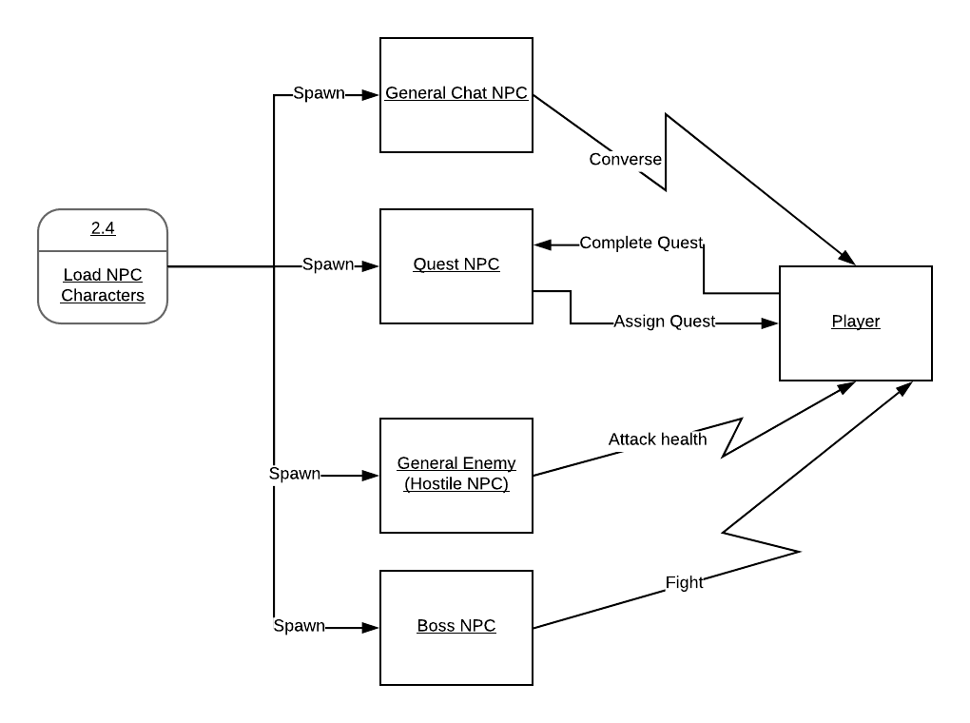

### Process Descriptions

Collision detection:

ON object loop call

IF npc rect overlaps player rect

THEN apply npc role (chat, attack, etc)

ELSE IF npc rect overlaps environment

THEN stop movement

Reverse direction

Resume movement

END IF

## Acceptance Tests ________9

Intersect NPC bounding box and Player bounding box

* NPC will apply its role (converse, assign quest, attack player, fight player)

Player attacks hostile NPC

* NPC health will be lost
* NPC will attempt to attack player
  + If successfully attacks player, player health will be lost

Player attacks hostile NPC until NPC health reaches zero

* NPC removed from environment
* Points awarded to player

Player speaks to the NPC after fulfilling the quest requirements

* Quest is marked as completed

## Timeline _________/10

[Figure out the tasks required to complete your feature]

Example:

### Work items

|  |  |  |
| --- | --- | --- |
| Task | Duration (PWks) | Predecessor Task(s) |
| 1. Requirements Collection | 3 | - |
| 2. Design Architecture | 2 | 1 |
| 3. Function stubs | 2 | 2 |
| 4. User Documentation | 1 | 3 |
| 5. Programming | 2 | 3 |
| 6. Testing | 2 | 5 |
| 7. Installation | 1 | 6 |

### Pert diagram

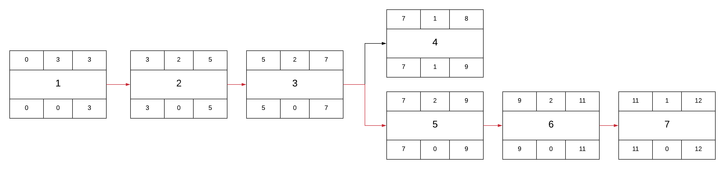

### Gantt timeline

|  |  |  |  |  |  |  |  |  |  |  |  |  |
| --- | --- | --- | --- | --- | --- | --- | --- | --- | --- | --- | --- | --- |
|  |  |  |  |  |  |  |  |  |  |  |  |  |
| 2 |  |  |  | 1 |  |  |  |  |  |  |  |  |
| 3 |  |  |  |  |  | 2 |  |  |  |  |  |  |
| 4 |  |  |  |  |  |  |  | 3 |  |  |  |  |
| 5 |  |  |  |  |  |  |  | 3 |  |  |  |  |
| 6 |  |  |  |  |  |  |  |  |  | 5 |  |  |
| 7 |  |  |  |  |  |  |  |  |  |  |  | 6 |
|  | 1 | 2 | 3 | 4 | 5 | 6 | 7 | 8 | 9 | 10 | 11 | 12 |