Name Simon Barnes\_\_\_\_\_ Mark \_\_\_\_\_\_\_\_\_\_\_\_\_\_\_\_\_\_\_\_\_/50

## Brief introduction \_\_/3

The feature I will be developing will be audio processing for our game. It will handle background music, character sound, enemy sound as well as any sound effects caused by in game interactions.

## Use case diagram with scenario \_\_14

### Use Case Diagram

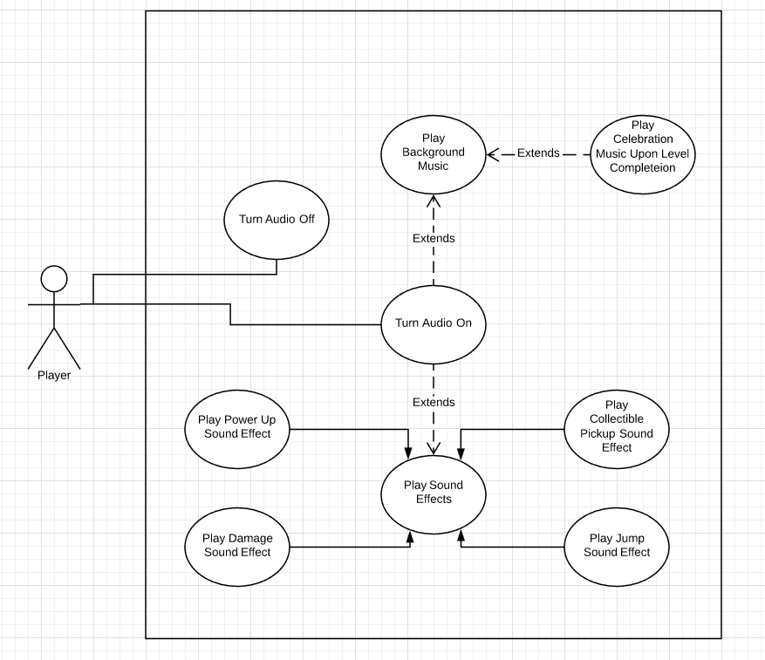

### Scenarios

**Name:** Change Volume

**Summary:** The player enters the menu to change the volume.

**Actors:** Player

**Preconditions:** Game must be in an audio menu screen.

**Basic sequence:**

**Step 1:** Set Volume to either on or off.

**Step 2:** Click “OK” button at the bottom of the menu.

**Exceptions:**

**Step 1:** Audio is on and player tries to apply volume on setting: No Change

**Step 2:** Audio is off and player tries to apply volume off setting: No Change

**Post conditions:** Audio output level is changed.

**Priority:** 3\*

**ID:** C01

**Name:** Play background music

**Summary:** The player launches the game and background music plays.

**Actors:** Player

**Preconditions:** The player is in a menu or game level.

**Basic sequence:**

**Step 1:** Player launches the game or enters a level.

**Step 2:** Background music is played.

**Exceptions:**

**Step 1:** Player finishes a level: Play level complete music

**Post conditions:** Music is played

**Priority:** 2\*

**ID:** C02

**Name:** Play Jump Sound

**Summary:** The player controlled character jumps.

**Actors:** Player

**Preconditions:** The player is in a level and in control of the character.

**Basic sequence:**

**Step 1:** The player presses the jump button.

**Step 2:** Begin playing the jump audio file.

**Step 3:** Stop playing the sound at the end of the sound file or when the player touches the ground.

**Exceptions:**

**Step 1:** There is another, similar priority, sound effect playing: Don’t play the jump sound.

**Step 2:** The Player presses the jump button while already jumping: Don’t start playing the audio clip

**Post conditions:** The jump sound has completed playing.

**Priority:** 1\*

**ID:** C03

**Name:** Play damage sound

**Summary:** Play an audio clip when the player takes damage.

**Actors:** Player

**Preconditions:** The player must be playing a level and collide with an enemy/damaging object.

**Basic sequence:**

**Step 1:** The player takes damage.

**Step 2:** Play the sound effect for taking damage.

**Exceptions:**

**Step 1:** Another sound effect is playing: ignore the damage sound

**Post conditions:** The damage sound has played

**Priority:** 1\*

**ID:** C04

**Name:** Play Power Up Sound

**Summary:** Play an audio clip when the player gains or loses a power up.

**Actors:** Player

**Preconditions:** The player is in control of the normal status character and no other sound effects are playing.

**Basic sequence:**

**Step 1:** The player encounters a power up.

**Step 2:** Play the power up sound effect.

**Exceptions:**

**Step 1:** Another sound effect is playing: ignore the power up sound

**Post conditions:** The full power up sound effect has played

**Priority:** 1\*

**ID:** C05

**Name:** Play Level Completion Music

**Summary:** The player has beaten a level and the corresponding celebratory music plays.

**Actors:** Player

**Preconditions:** The player has successfully beaten a level of the game.

**Basic sequence:**

**Step 1:** The player reaches the end of level trigger/zone.

**Step 2:** Background music and any sound effects are ended.

**Step 3:** Play the level completion music until the next level is loaded.

**Exceptions:**

**Step 1:** Audio is off: Don’t play the sound

**Post conditions:** The level completion music has played and stopped when the next level has loaded

**Priority:** 2\*

**ID:** C05

\*The priorities are 1 = must have, 2 = essential, 3 = nice to have.

## Data Flow diagram(s) from Level 0 to process description for your feature \_\_\_\_\_\_\_14

### Data Flow Diagrams

### C:\Users\Simon\AppData\Local\Microsoft\Windows\INetCache\Content.Word\Diagram_0_First - Copy.png

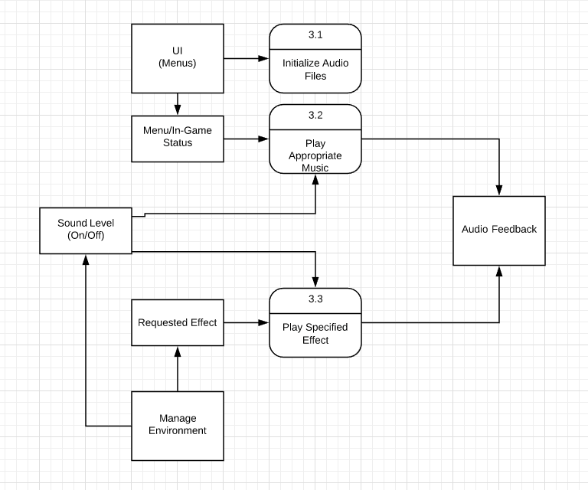

### Process Descriptions

Initialize Audio Files:

Call Upon Program Start

Pull all required audio files into our program for use

Play Appropriate Music:

IF Audio is not turned off

IF in the menu

Play menu background music

ELSE

Play in-game background music

Play Specified Effect:

IF Audio is not turned off

IF The same effect is not already playing

Play the requested effect

Else

Ignore the request

## Acceptance Tests \_\_\_\_\_\_\_\_9

**Initialize Audio Files**

* Test every in-game sound (music and effects) to ensure they are being loaded properly
* Check for error reports if sounds can’t be found or loaded properly

**Playing Background Music**

* Check which music is playing in both the menu as well as in the game’s levels
* Turn audio off and check for background music in either the levels or the menus
* Turn audio back on and make sure that music is playing in the menus and background

**Playing Sound Effects**

* Check that sound effects are playing in the game’s levels
* Turn audio off and check for sounds effects
* Turn audio back on and make sure that sound effects are still playing
* Attempt to trigger sound effects again before they have finished playing

## Timeline \_\_\_\_\_\_\_\_\_/10

### Work items

|  |  |  |
| --- | --- | --- |
| Task | Duration (PWks) | Predecessor Task(s) |
| 1. Requirements Collection | 3 | - |
| 2. Database Construction | 1 | - |
| 3. Audio Collection/Creation | 2 | 2 |
| 4. User Documentation | 2 | 3,1 |
| 5. Programming | 3 | 4 |
| 6. Testing | 3 | 5 |
| 7. Installation | 2 | 6 |

### Pert diagram

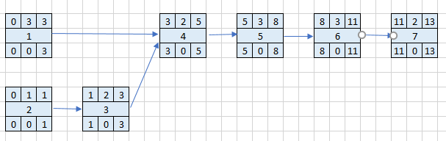

**Gantt timeline**

|  |  |  |  |  |  |  |  |  |  |  |  |  |  |
| --- | --- | --- | --- | --- | --- | --- | --- | --- | --- | --- | --- | --- | --- |
| 1 |  |  |  |  |  |  |  |  |  |  |  |  |  |
| 2 |  |  |  |  |  |  |  |  |  |  |  |  |  |
| 3 |  | 2 |  |  |  |  |  |  |  |  |  |  |  |
| 4 |  |  |  | 1,3 |  |  |  |  |  |  |  |  |  |
| 5 |  |  |  |  |  | 4 |  |  |  |  |  |  |  |
| 6 |  |  |  |  |  |  |  |  | 5 |  |  |  |  |
| 7 |  |  |  |  |  |  |  |  |  |  |  | 6 |  |
|  | 1 | 2 | 3 | 4 | 5 | 6 | 7 | 8 | 9 | 10 | 11 | 12 | 13 |  |  |  |  |