Name: Tori Overholtzer Mark _____________________/50

## Brief introduction __/3

The feature I will manage is the User Interface. This feature will contain menu screens and display the game with its information to the user. The main screens will feature login/load profile options, settings, instructions, level selection, a pause screen and the final game screen. In game, the user interface will display health bars, score and status effects.

## Use case diagram with scenario __14

### Use Case Diagrams

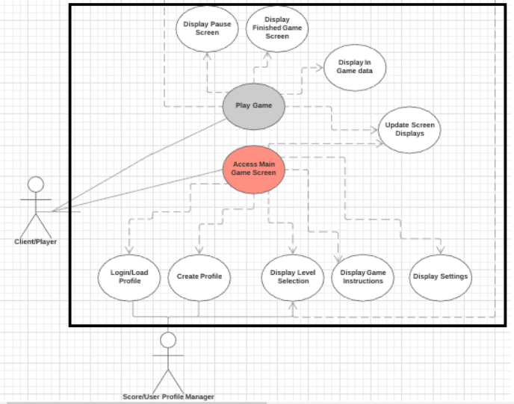

Key : Dotted Line <<includes>>

### Scenarios

**Name:** Login/Load Profile

**Summary:** The user enters their username and password into the login screen to sign onto their user profile loaded from the score/user profile server.

**Actors:** User (Player), Score/User Profile Manager

**Preconditions:** The game and servers are created and published. The game executable has been launched; the score/user profile servers are online.

**Basic sequence:**

**Step 1:** Game loads and displays main menu.

**Step 2:** User accesses the login option from main menu.

**Step 3:** User enters information into the needed corresponding fields  
**Step 4:** User submits data.

**Step 5:** Game checks validity of information by referencing the score/user profile server.   
**Step 6:** If the data provided is correct, load profile and direct to main menu  
**Step 7:** If the data is incorrect, prompt to retry, allow user to use email recovery, or prompt back to main menu to create new account.

**Exceptions:**

**Step 1:** User enters invalid username. The user is asked to correct the information, directed to email username recovery, or asked to make a new account.

**Step 2:** User enters invalid password. The user is asked to correct the information, directed to email password recovery, or asked to make a new account.

**Post conditions:** User is successfully signed into the system

**Priority:** 2*

**ID:** C01   
  
  
**Name:** Create Profile

**Summary:** The user creates a profile to track their statistics by entering a username and password to be saved into the system as their sign in.

**Actors:** User (Player), Score/User Profile Manager

**Preconditions:** The game and servers are created and published. The game executable has been launched; the score/user profile servers are online.

**Basic sequence:**

**Step 1:** Game loads and displays main menu.

**Step 2:** User accesses the create profile option from main menu.

**Step 3:** User enters information into the needed corresponding fields  
**Step 4:** User submits data.

**Step 5:** Game checks validity of data (valid characters) and scans the score/user profile server to see if the data submitted is the same data as any other user profiles.   
**Step 6:** If the data provided is unique, create profile, auto sign in and direct to main menu  
**Step 7:** If the data provided is not unique, prompt to retry.

**Exceptions:**

**Step 1:** User enters invalid characters or non-unique username. User is prompted to create a different username.

**Step 2:** User enters invalid characters in password. The user is prompted to create a different password.

**Post conditions:** User is successfully signed into the system

**Priority:** 2*

**ID:** C02

**Name:** Display Level Selection

**Summary:** The user can select unlocked game levels through the level selection menu.

**Actors:** User (Player), Score/User Profile Manager

**Preconditions:** The game and servers are created and published. The game executable has been launched; the score/user profile servers are online. The user is logged into their profile. Standard settings automatically applied.

**Basic sequence:**

**Step 1:** Game loads and displays main menu.

**Step 2:** User accesses the level selection option from main menu.

**Step 3:** Game communicates with score/user profile to see which levels are unlocked for the user

**Step 3:** Screen changes to show available levels.  
**Step 4:** User selects level.  
**Step 6:** If the level was an unlocked level, load level game data.   
**Step 7:** If the level wasn’t unlocked prompt for level reselection.

**Exceptions:**

**Step 1:** User tries to enter a level that they haven’t unlocked yet. User is prompted to select a different level.

**Post conditions:** User successfully selects level and loads into that game level.

**Priority:** 2*

**ID:** C03

**Name:** Display Game Instructions

**Summary:** The user can select to view game instructions and controls from main menu.

**Actors:** User (Player), Score/User Profile Manager

**Preconditions:** The game and servers are created and published. The game executable has been launched; the score/user profile servers are online. The user is logged into their profile. Standard settings automatically applied.

**Basic sequence:**

**Step 1:** Game loads and displays main menu.

**Step 2:** User accesses the game instructions selection option from main menu.

**Step 3:** Screen changes to show rules and controls.  
**Step 4:** User reads screen.  
**Step 6:** User selects to go to back to main menu when finished.

**Exceptions:**

**None**

**Post conditions:** User successfully accesses instructions and can go back to a screen which the main game can be accessed from.

**Priority:** 2*

**ID:** C04

**Name:** Display Settings  
**Actors:** User (Player), Score/User Profile Manager

**Summary:** The user can select to change game settings and controls in this menu.

**Preconditions:** The game and servers are created and published. The game executable has been launched; the score/user profile servers are online. The user is logged into their profile. Standard settings automatically applied.

**Basic sequence:**

**Step 1:** Game loads and displays main menu.

**Step 2:** User accesses the settings selection option from main menu.

**Step 3:** Screen changes to show setting options.  
**Step 4:** User can use settings buttons and sliders to adjust settings of game  
**Step 6:** User selects to go to back to main menu when finished.

**Exceptions:**

**None**

**Post conditions:** User successfully accesses settings and can alter the settings and revert to the main screen which the game can be accessed from.

**Priority:** 2*

**ID:** C05

**Name:** Display Pause Screen

**Summary:** The user can select to pause gameplay in any level.   
**Actors:** User (Player), Score/User Profile Manager

**Preconditions:** The game and servers are created and published. The game executable has been launched; the score/user profile servers are online. The user is logged into their profile. Standard settings automatically applied. User has loaded into a game level after level selection.

**Basic sequence:**

**Step 1:** Level loads

**Step 2:** User accesses pause menu using specified controls

**Step 3:** Screen changes to show pause screen  
**Step 4:** User can use buttons in the pause screen to revert to game play   
**Step 6:** User can use buttons in the pause screen to terminate level early

**Exceptions:**

**None**

**Post conditions:** User successfully pauses gameplay and can resume or quit the level

**Priority:** 2*

**ID:** C06

**Name:** Display Game Over Screen

**Summary:** The user will be prompted with this screen whenever their characters die in the game or after they have finished all the provided levels.   
**Actors:** User (Player), Score/User Profile Manager

**Preconditions:** The game and servers are created and published. The game executable has been launched; the score/user profile servers are online. The user is logged into their profile. Standard settings automatically applied. User has played game and character has lost all their lives in a level or player has completed all available levels.

**Basic sequence:**

**Step 1:** All levels are completed, or user has no character lives available

**Step 2:** Gameplay is interrupted with a game over pop-up screen.

**Step 3:** User can use buttons to go back to main menu or exit the game

**Exceptions:**

**None**

**Post conditions:** User gets a gameplay termination screen which allows them to go back to the main menu or successfully exit the game.

**Priority:** 2*

**ID:** C07  
  
  
**Name:** Display Game Data

**Summary:** The user will have this data loaded and displayed whenever they play a level. This data includes health bars, number of lives, status effects, and score.   
**Actors:** User (Player), Score/User Profile Manager

**Preconditions:** The game and servers are created and published. The game executable has been launched; the score/user profile servers are online. The user is logged into their profile. Standard settings automatically applied. User has loaded into a game level after level selection.

**Basic sequence:**

**Step 1:** The user selects level

**Step 2:** Level screen loads

**Step 3:** Game data is displayed.

**Step 4:** Game data is relayed back to score/user profile server after level completion

**Exceptions:**

**None**

**Post conditions:** User has game data presented on screen after the level is loaded.

**Priority:** 2*

**ID:** C08

**Name:** Update Screen Displays

**Summary:** The user will have their screens updated when a change is made in settings, when menus are selected and during gameplay.   
**Actors:** User (Player), Score/User Profile Manager

**Preconditions:** The game and servers are created and published. The game executable has been launched; the score/user profile servers are online. The user is logged into their profile. Standard settings automatically applied.

**Basic sequence:**

**Step 1:** Game loads and displays main menu.

**Step 2:** Any menu selected from main menu will cause a screen update to display the new information

**Step 3:** Game is started  
**Step 4:** Screen is constantly updated during gameplay

**Step 5:** Accessing other menus will cause a screen update (pause menu)

**Step 6:** When conditions are meet in gameplay, screen will update (game over)

**Exceptions:**

**None**

**Post conditions:** User will have valid data presented on the screen.

**Priority:** 1

**ID:** C09

*The priorities are 1 = must have, 2 = essential, 3 = nice to have.

## Data Flow diagram(s) from Level 0 to process description for your feature _______14

[Get the Level 0 from your team. Highlight the path to your feature]

Example:

### Data Flow Diagrams

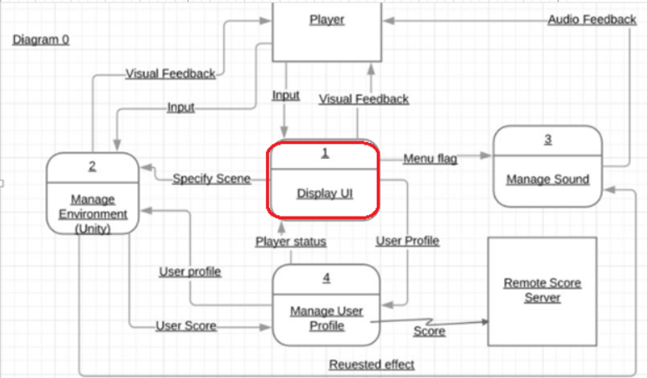

Diagram1: Display UI

### Process Descriptions

Assign rooms*:

WHILE teacher in two places at once OR two classes in the same room

Randomly redistribute classes

END WHILE

**\*Notes**: Yours should be much longer. You could use a decision tree or decision table instead if it is more appropriate.

## Acceptance Tests ________9

[Describe the inputs and outputs of the tests you will run. Ensure you cover all the boundary cases.]

**Example for random number generator feature**

Run feature 1000 times sending output to a file.

The output file will have the following characteristics:

* Max number: 9
* Min number: 0
* Each digit between 0 and 9 appears at least 50 times
* No digit between 0 and 9 appears more than 300 times
* Consider each set of 10 consecutive outputs as a substring of the entire output. No substring may appear more than 3 times.

**Example for divide feature**

|  |  |  |  |
| --- | --- | --- | --- |
| Output | Numerator  (int) | Denominator  (int) | Notes |
| 0.5 | 1 | 2 |  |
| 0.5 | 2 | 3 | We only have 1 bit precision for outputs. Round all values to the nearest .5 |
| 0.0 | 1 | 4 | At the 0.25 mark always round to the nearest whole integer |
| 1.0 | 3 | 4 | At the 0.75 mark always round to the nearest whole integer |
| 255.5 | 5 | 0 | On divide by 0, do not flag an error. Simply return our MAX_VAL which is 255.5. |

## Timeline _________/10

### Work items

|  |  |  |
| --- | --- | --- |
| Task | Duration | Predecessor Task |
| 1. Requirements Collection | 5 | - |
| 2. Documentation | 6 | 1,3,4,5,6 |
| 3. Development/Design | 6 | 1 |
| 4. Programming | 2 | 1,3 |
| 5. Testing | 6 | 1 |
| 6. Integrating | 5 | 1 |

### Pert diagram

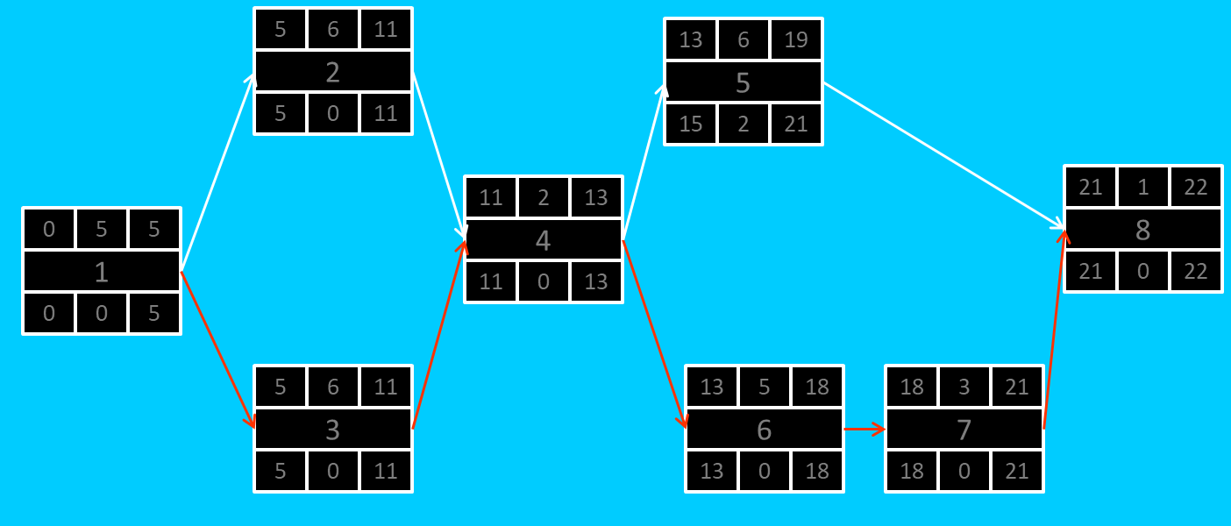

### Gantt timeline

|  |  |  |  |  |  |  |  |  |  |  |  |  |  |  |  |  |  |  |  |  |  |  |  |  |
| --- | --- | --- | --- | --- | --- | --- | --- | --- | --- | --- | --- | --- | --- | --- | --- | --- | --- | --- | --- | --- | --- | --- | --- | --- |
| 1 |  |  |  |  |  |  |  |  |  |  |  |  |  |  |  |  |  |  |  |  |  |  |  |  |
| 2 |  |  |  |  |  | 1 |  |  |  |  |  |  |  |  |  |  |  |  |  |  |  |  |  |  |
| 3 |  |  |  |  |  | 1 |  |  |  |  |  |  |  |  |  |  |  |  |  |  |  |  |  |  |
| 4 |  |  |  |  |  |  |  |  |  |  |  | 3 |  |  |  |  |  |  |  |  |  |  |  |  |
| 5 |  |  |  |  |  |  |  |  |  |  |  |  |  |  |  | 4 |  |  |  |  |  |  |  |  |
| 6 |  |  |  |  |  |  |  |  |  |  |  |  |  |  |  | 4 |  |  |  |  |  |  |  |  |
| 7 |  |  |  |  |  |  |  |  |  |  |  |  |  |  |  |  |  |  |  |  | 6 |  |  |  |
| 8 |  |  |  |  |  |  |  |  |  |  |  |  |  |  |  |  |  |  |  |  |  |  |  | 7 |
|  | 1 | 2 | 3 | 4 | 5 | 6 | 7 | 8 | 9 | 10 | 11 | 12 | 13 | 14 | 15 | 16 | 17 | 18 | 19 | 20 | 21 | 22 | 23 | 24 |